COPMGRR Number | 017 | COPMGRR Title | Creating Subsection 8.2, Settlement Statements and Invoices
Timeline | Normal | Recommended Action |  | Approval
Date of Decision |  | March 30, 2010
Proposed Effective Date |  | To be determined.
Priority and Rank Assigned |  | To be determined.
Commercial Operations Market Guide (COPMG) Section Requiring Revision |  | 8.2, Settlement Statements and Invoices (New)
Revision Description |  | This Commercial Operations Market Guide Revision Request (COPMGRR) creates a new subsection under Section 8, ERCOT Settlement and Invoice Process.
Reason for Revision |  | Provides information concerning the ERCOT Invoicing Process.
Overall Market Benefit |  | Market Participants benefit from being better informed.
Overall Market Impact |  | Improves availability of information concerning the ERCOT Nodal Settlement Statements and Invoices.
Consumer Impact |  | None.
Procedural History |  | - On 12/4/09, COPMGRR017 was posted.  - On 1/29/10, the COPS Communications Working Group (CCWG) considered COPMGRR017.  - On 2/25/10, CCWG again considered COPMGRR017.  - On 3/30/10, CCWG again considered COPMGRR017.
CCWG Decision |  | On 1/29/10, there was consensus at CCWG to table COPMGRR017 for one month.  On 2/25/10, there was consensus at CCWG to table COPMGRR017 for one month.  On 3/30/10, there was consensus at CCWG to recommend approval of COPMGRR017 as revised by CCWG.
Summary of CCWG Discussion |  | On 1/29/10, CCWG members agreed to table COPMGRR017 for one month to allow ERCOT additional time to review and provide comments.  On 2/25/10, CCWG members agreed to table COPMGRR017 for one month to allow additional time to clearly define the Settlements Statements and Invoices language for the COPMG.  On 3/30/10, updates to the proposed guide language revision were made to ensure that Market Participants have the most accurate information for Settlements Statements and Invoices.

Quantitative Impacts and Benefits

Assumptions | 1 | None.
Assumptions | 2
Assumptions | 3
Assumptions | 4
Market Cost |  | Impact Area | Monetary Impact
Market Cost | 1 | None. | None.
Market Cost | 2
Market Cost | 3
Market Cost | 4
Market Benefit |  | Impact Area | Monetary Impact
Market Benefit | 1 | Improve availability of information concerning the ERCOT Nodal Settlement Statements and Invoices. | Time savings in finding information. Relieves ERCOT Client Representatives of some questions.
Market Benefit | 2
Market Benefit | 3
Market Benefit | 4
Additional Qualitative Information | 1
Additional Qualitative Information | 2
Additional Qualitative Information | 3
Additional Qualitative Information | 4
Other Comments | 1 | ERCOT systems will not be impacted.
Other Comments | 2
Other Comments | 3
Other Comments | 4

Sponsor
Name | Michelle Trenary on behalf of the CCWG
E-mail Address | mtrenary@tnsk.com
Company | Tenaska Power Services
Phone Number | 817-303-3613
Cell Number
Market Segment | Independent Power Marketer (IPM)

Market Rules Staff Contact
Name | Sonja B. Mingo
E-Mail Address | smingo@ercot.com
Phone Number | 512-248-6463

Comments Received
Comment Author | Comment Summary
None.

Proposed Protocol Language Revision

8.2 Settlement Statements and Invoices 1
8.2.1 Congestion Revenue Rights (CRR) Settlement Invoices 3
8.2.3.2 Real-Time Market Invoice 11
1
Settlement ror! Bookmdefined.
Statements ices! Boot define.
Statements and Invoices Errt defined.15

8.2 Settlement Statements and Invoices
The Real-Time Market (RTM), the Day-Ahead Market (DAM), and the Congestion Revenue Right (CRR) Auction are settled separately. Each type of Settlement has a unique set of statements and/or Invoices and settles according to a different timeline. Settlement Statements and Invoices can apply to a registered CRR Account Holder (CRRAH), a registered Qualified Scheduling Entity (QSE), or both. The table below provides details regarding the various statements and Invoices.
Type | Invoice or Statement | Recipient | Frequency | Post Timing | Payment Due
CRR | CRR Auction Invoice | - CRRAHs | Monthly | 1st Business Day after completion of a CRR Auction (Monthly and Annual CRR Auctions will be invoiced separately) | 3rd Bank Business Day after invoice posts (or next day that is both Business Day and Bank Business Day)
CRR | CRR Auction Revenue Distribution Invoice | - QSEs (with Load) | Monthly | 1st Business Day after RTM Initial Statement posts for the last day of the relevant month  and  1st Business Day after RTM Final Statement posts for the last day of the relevant month | 5th Bank Business Day after invoice posts (or next day that is both Business Day and Bank Business Day)
CRR | CRR Balancing Account Invoice | - CRRAH (due a shortfall refund)  - QSEs (with load) | Monthly | 1st Business Day after RTM Initial Statement posts for the last day of the relevant month | 1st Bank Business Day after the due date of the RTM Invoice that includes the RTM Initial Settlement statement for the last day of the month (or next day that is both Business Day and Bank Business Day)  *Note: Payout to market only
DAM | DAM Statement | - QSEs  - CRRAHs | Daily | 2nd Business after the Operating Day | n/a
DAM | DAM Resettlement Statement | - QSEs  - CRRAHs | Ad-Hoc | Ad-Hoc (on Business Day)  *Note: Notice posted on MIS Public Area | n/a
DAM | DAM Invoice | - QSEs  - CRRAHs | Daily | 2nd Business after the Operating Day | 4th Bank Business Day after invoice posts (or next day that is both Business Day and Bank Business Day)
DAM | DAM Late Fee Invoice  Charge  Credit | - QSEs  - CRRAHs | Monthly | 10th calendar day after the end of the relevant month (or next Business Day) | 4th Bank Business Day after invoice posts (or next day that is both Business Day and Bank Business Day)
RTM | RTM Initial Settlement Statement | - QSEs  - CRRAHs | Daily | Operating Day + 10 (or next day Business Day) | n/a
RTM | RTM Final Settlement Statement | - QSEs  - CRRAHs | Daily | Operating Day + 59 (or next day Business Day) | n/a
RTM | RTM True-Up Settlement Statement | - QSEs  CRRAHs | Daily | Operating Day + 180 (or next day Business Day) | n/a
RTM | RTM Resettlement Settlement Statement | - QSEs  CRRAHs | Ad-Hoc | Ad-Hoc (on Business Day)  *Note: Notice posted on MIS Public Area | n/a
RTM | RTM Invoice | - QSEs  - CRRAHs | Weekly | Thursdays (or next day Business Day) | 5th Bank Business Day after the invoice posts (or next day that is both Business Day and Bank Business Day)
RTM | RTM Uplift Invoice | - QSEs (with load) | Ad-Hoc | Ad-Hoc (on Business Day)  *Market Notice required | 5th Bank Business Day after the invoice posts, (or next day that is both Business Day and Bank Business Day)
RTM | RTM Late Fee Invoice | - QSEs  - CRRAHs | Monthly | 10th calendar day after the end of the relevant month (or next Business Day) | 4th Business Day after invoice posts (or next day that is both Business Day and Bank Business Day)
 | Miscellaneous Invoice | - QSEs  - CRRAHs | Ad-Hoc | Ad-Hoc (on Business Day)  *Market Notice required | Specified in the Market Notice

Upon approval and posting of Settlement Statements and Invoices, the associated data is sent to the Credit Monitoring & Management (CMM) system for use in credit calculations. Similarly, when payment is made to or from the QSE / CRRAH, the payment data is subsequently sent to the CMM system.
The Settlements Calendar Extract QSE Settlement and CRR Account Holder Statements are available on the Market Information System (MIS). The Settlement Calendar is provided as an extract and can be found on both the MIS Public Area under Settlements Reports and Extracts and on the ERCOT website. Supporting information for the Settlement Calendar (i.e. the Data Definition Language and Xtensible Markup Defintions) are also available on both the MIS Public Area and the ERCOT website.
Settlement details, including the supporting input, intermediate, and output Settlement billing determinants and other data associated with Settlement Statements and Invoices are found in the appropriate extracts and reports. When viewing QSE / CRRAH Settlement Statements, a negative amount represents a payment due to the QSE / CRRAH and a positive amount represents a payment due to ERCOT. More information about the available extracts and reports, as well as example statements and Invoices, are available on the MIS Public Area and on the ERCOT website. Descriptions and definitions for the billing determinants can be found on the ERCOT website in the Settlement Charge Matrix and in the relevant Protocol sections. (Also see Section 10, Extracts and Reports, of the Commercial Operations Market Guide (COPMG))
Information about the Settlements Calendar, statements, and Invoices may be found in Protocol Section 9, Settlement and Billing.
8.2.1 Congestion Revenue Rights (CRR) Settlement Invoices

8.2.1.1 CRR Auction Award Invoices
Refer to Protocol Sections 9.8, CRR Auction Award Invoices, and 9.9, Payment Process for CRR Auction Invoices, for details regarding CRR Auction invoicing. Monthly and Annual CRR Auctions are invoiced separately. Additionally, each year of the two year Annual Auction will be invoiced separately.
CRR Auction Invoice Timeline
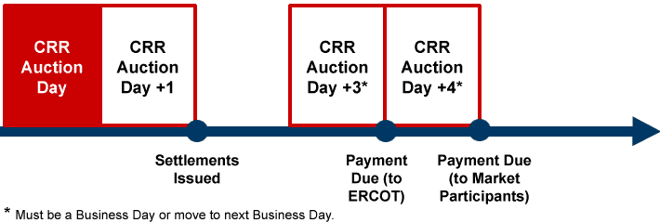

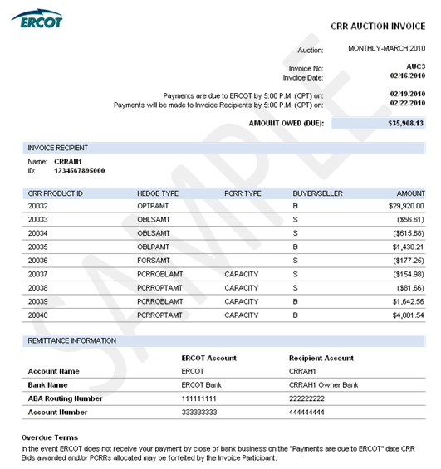
8.2.1.2 CRR Auction Revenue Distribution (CARD) Invoice
Refer to Protocol Sections 9.10, CRR Auction Revenue Distribution Invoices, and 9.11, Payment Process for CRR Auction Revenue Distribution, for details regarding CRR Auction Revenue Distribution (CARD) invoicing. The ‘Time Period’ label on the Invoice indicates the month relevant to the CRR Auction revenue being paid out to QSEs.

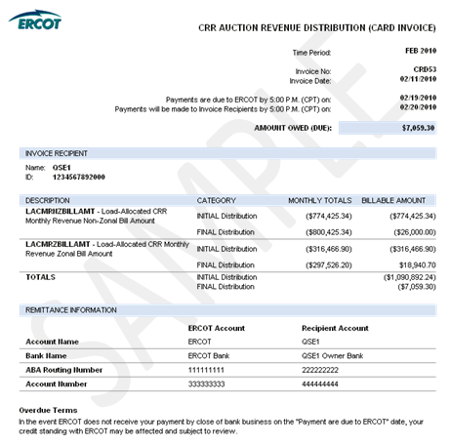

8.2.1.3 CRR Balancing Account (CRRBA) Invoice
Refer to Protocol Sections 9.12, CRR Balancing Account Invoices, and 9.13, Payment Process for CRR Balancing Account, for details regarding CCR Balancing Account (CRRBA) invoicing. The ‘Time Period’ label on the Invoice indicates the month relevant to the balancing account funds being paid out to CRRAHs and/or QSEs.

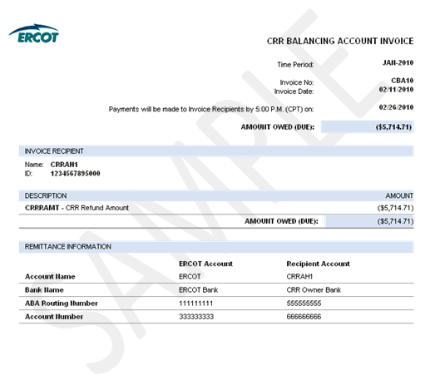

8.2.2 Day-Ahead Market Statements and Invoices
The DAM statements and Invoices for CRR Account Holders and QSEs are issued two days after the Operating Day.
Refer to Protocol Section 9.2, Settlement Statements for the Day-Ahead Market, for details regarding DAM Settlement Statements.
Refer to Protocol Sections 9.3, Settlement Invoices for the DAM, and 9.4, Payment Process for the DAM, for details regarding the DAM invoicing process.

DAM Statement and Invoice Timeline
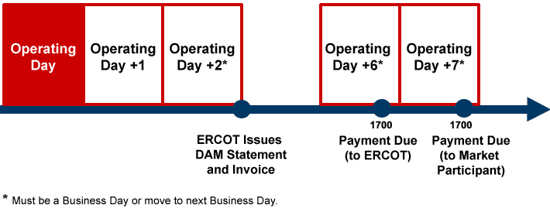
8.2.2.1 DAM Statement
Refer to Protocol Section 9.2, Settlement Statements for the Day-Ahead Market, for details regarding DAM Settlement Statements. In the case of a “No DAM” scenario, where DAM is not successfully executed for an Operating Day, DAM statements will not be generated or posted for that Operating Day.

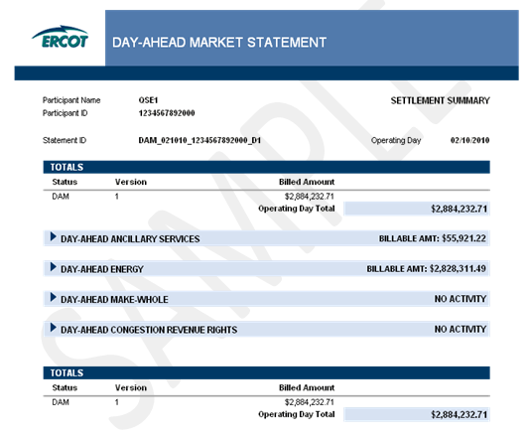
8.2.2.2 DAM Invoice
Refer to Protocol Sections 9.3, Settlement Invoices for the DAM, and 9.4, Payment Process for the DAM, for details regarding DAM invoicing. A DAM Invoice is created separately for each published DAM statement and DAM Resettlement Statement.

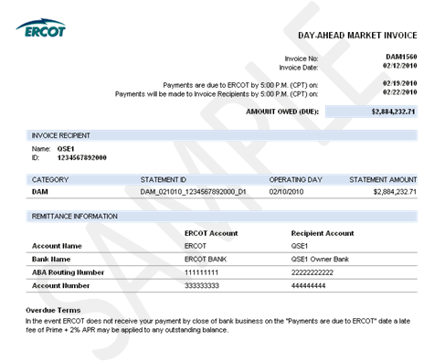

8.2.2.3 DAM Late Fee Invoice
Refer to Protocol Section 9.4.5, Late Fees and Late Fee Invoices for the DAM, for details regarding the DAM late fee invoicing process. To better facilitate verification of relatively small late fee charges and credits, the late fee charge line items have greater precision than the total amount on the Late Fee Invoice.
Late Fee Charge Invoice
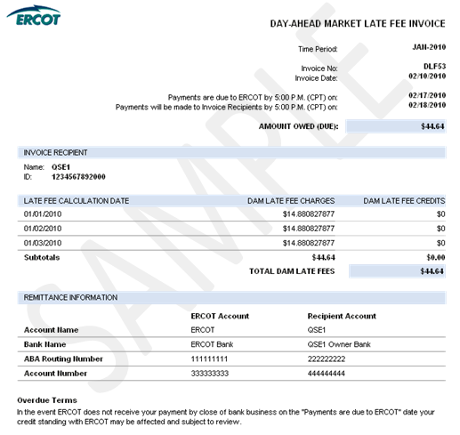

Late Fee Credit Invoice
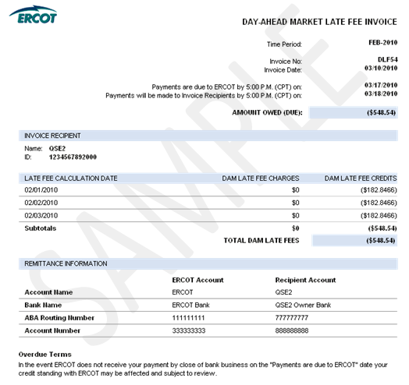
8.2.3 Real-Time Market Statements and Invoices

8.2.3.1 Real-Time Market Statements
Refer to Protocol Section 9.5, Settlement Statements for the RTM, for details regarding RTM Settlement Statements.
There are four types of RTM Settlement Statements: Initial, Final, True-Up and Resettlement.
The figure below illustrates the timing of each statement. Resettlements can occur at any point in accordance with Section 9.5.6, RTM Resettlement Statement.

RTM Statement Timeline

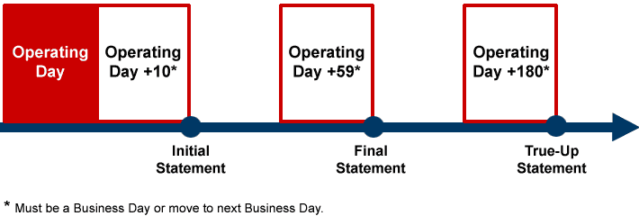

8.2.3.1.1 RTM Initial Statement

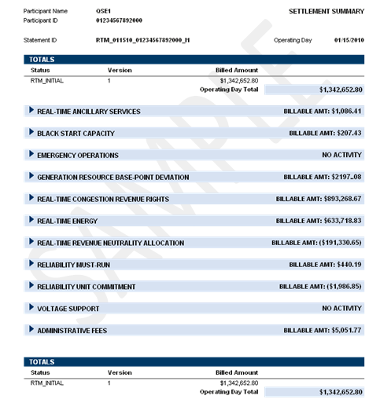

8.2.3.1.2 RTM Final Statement
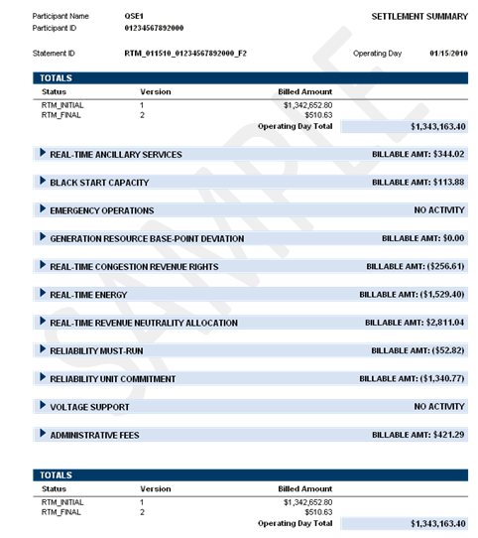

8.2.3.1.3 RTM True-Up Statement

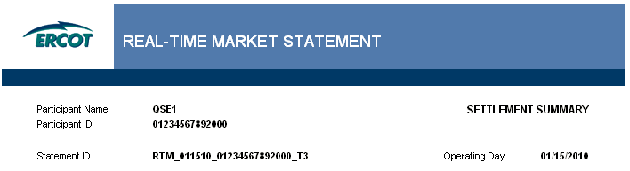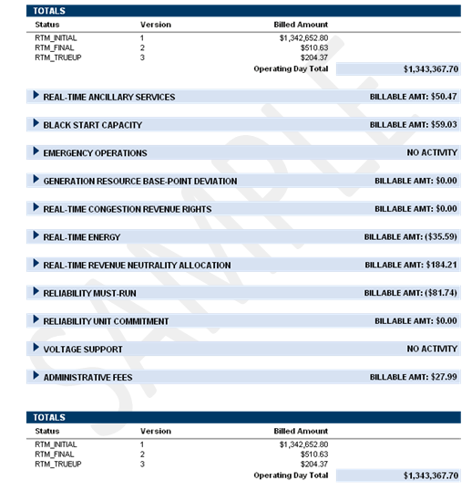
8.2.3.1.4 RTM Resettlement Statement

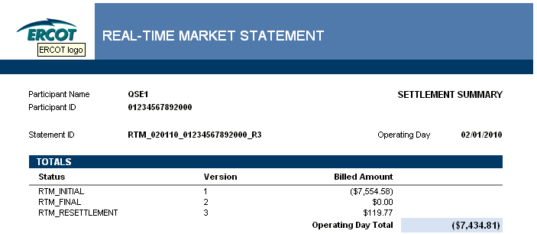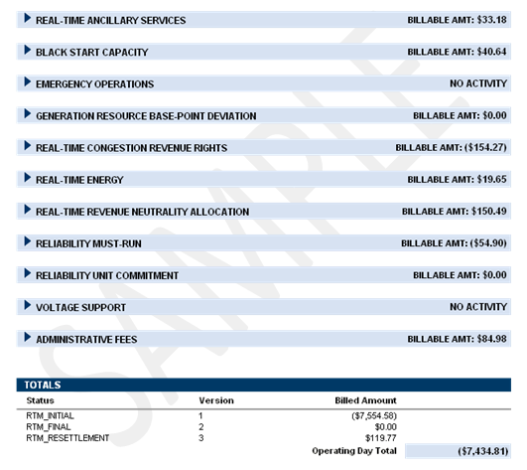

8.2.3.2 Real-Time Market Invoice
Refer to Protocol Section 9.6, Settlement Invoices for the Real-Time Market, for details regarding the RTM invoicing process. Typically, each Thursday the weekly RTM invoicing process finds and includes any RTM Initial, Final, True-Up and/or Resettlement Statements that were generated in the Settlement system from the two Saturdays prior through the previous Friday. (Note: this process is based on the timing of statement generation, not the timing of statement approval/posting.)
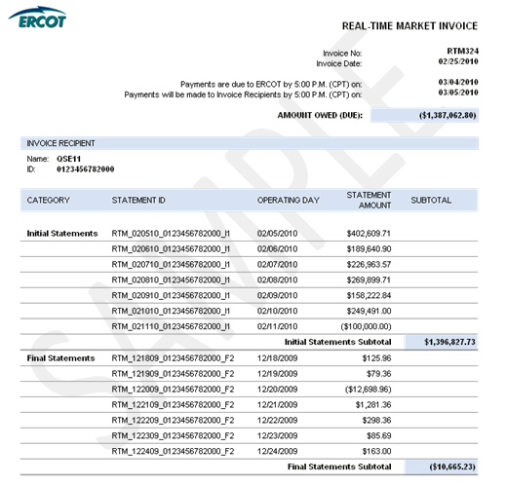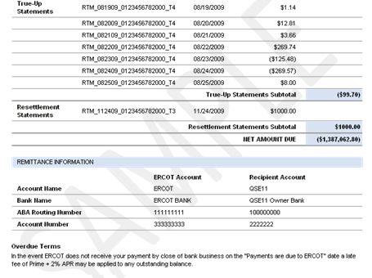

8.2.3.3 RTM Uplift Invoice
Refer to Protocol Section 9.7.3.1, RTM Uplift Invoices, and 9.7.3.2, Payment Process for RTM Uplift Invoices, for details regarding the RTM Uplift Invoicing Process.
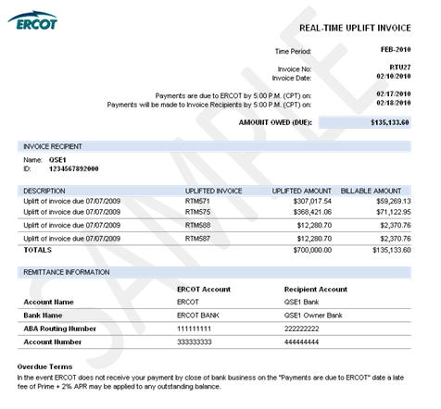

8.2.3.4 RTM Late Fee Invoice
Refer to Protocol Section 9.7.5, Late Fees and Late Fee Invoices, for details regarding the RTM late fee invoicing process. To better facilitate verification of relatively small late fee charges and credits, the late fee charge line items have greater precision than the total amount on the Late Fee Invoice.
RTM Late Fee Charge Invoice

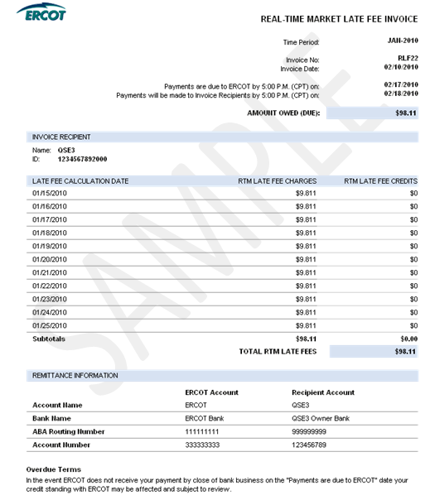

RTM Late Fee Credit Invoice

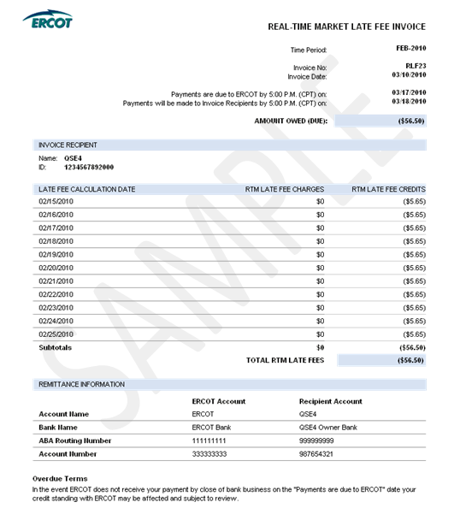
8.2.3.4 Miscellaneous Invoice

In the event that ERCOT cannot reasonably Invoice Market Participants via one of the other Protocol-defined Invoices, ERCOT may utilize the Miscellaneous Invoice. Use of the Miscellaneous Invoice would be noticed to the market and could be in support of any invoicing activity described as “ad-hoc” in Section 8.1, Invoice Process of this document. The Miscellaneous Invoice posts to the same location on MIS as other QSE/CRRAH Invoices. This Invoice is generated out of the Settlements and Billing System using data which is derived and input by analysts. The Invoice format allows for flexibility to communicate descriptive information which varies depending on the nature of the ad-hoc Invoice.
INCLUDEPICTURE "cid:image001.png@01CAC515.8A601C20" \* MERGEFORMATINET 