COPMGRR Number | 019 | COPMGRR Title | Revisions for Texas Nodal Market Implementation and Synchronization with PRR821, Update of Section 21, Process for Protocol Revision
Date Posted |  | March 16, 2010
Commercial Operations Market Guide (COPMG) Sections Requiring Revision |  | 1, Purpose  2, Definitions and Acronyms  3, Organizational Structure  4, Process for Commercial Operations Market Guide Revision  5, Market Notice Communication Process  8, ERCOT Settlement and Invoice Process  10, Extracts and Reports  11, Disputes and Data Extract Variances  12, Renewable Energy Credits  Appendix A, Market Notice Communication Process
Protocol Section(s) Requiring Revision, if any |  | None.
Requested Resolution |  | Normal.
Revision Description |  | This Commercial Operations Market Guide Revision Request (COPMGRR) revises the COPMG in anticipation of Texas Nodal Market implementation. Revisions will be grey-boxed until the Texas Nodal Market Implementation Date (TNMID) where appropriate. This COPMGRR also revises Section 4 to more effectively align with the current stakeholder process, consistent with revisions made to the Protocols pursuant to Protocol Revision Request (PRR) 821, Update of Section 21, Process for Protocol Revision, and with other existing language in Protocol Section 21. Updates to Section 12, Renewable Energy Credits baseline to reflect the revisions made in COPMGRR016, Update to Section 12, Renewable Energy Credits due to PRR 808, Clean-up and Alignment of RECs Trading Program Language with PUCT Rules.
Reason for Revision |  | Preparation for Texas Nodal Market implementation and synchronization with PRR821 to update Section 4 and align with current stakeholder process.
Overall Market Benefit |  | Continuity of COPMG with Nodal Protocols and a clearly defined revision process for transparency.
Overall Market Impact |  | None.
Consumer Impact |  | None.

Quantitative Impacts and Benefits
Assumptions | 1
Assumptions | 2
Assumptions | 3
Assumptions | 4
Market Cost |  | Impact Area | Monetary Impact
Market Cost | 1
Market Cost | 2
Market Cost | 3
Market Cost | 4
Market Benefit |  | Impact Area | Monetary Impact
Market Benefit | 1 | Continuity of COPMG with Nodal Protocols and a clearly defined revision process for transparency.
Market Benefit | 2
Market Benefit | 3
Market Benefit | 4
Additional Qualitative Information | 1
Additional Qualitative Information | 2
Additional Qualitative Information | 3
Additional Qualitative Information | 4
Other Comments | 1
Other Comments | 2
Other Comments | 3
Other Comments | 4

Sponsor
Name | Sonja B. Mingo
E-mail Address | smingo@ercot.com
Company | ERCOT
Phone Number | 512.248-6463
Cell Number | 512.740-6030
Market Segment | Not applicable

Market Rules Staff Contact
Name | Sonja B. Mingo
E-Mail Address | smingo@ercot.com
Phone Number | 512.248+6463

Proposed Guide Language Revision

Commercial Operations Market Guide
[Date]

1 PURPOSE 7
2 DEFINITIONS AND ACRONYMS 10
2.1 Definitions 10
2.2 Acronyms 10
3 ORGANIZATIONAL STRUCTURE 2
3.1 Electric Reliability Council of Texas 2
3.1.1 ERCOT Wholesale Client Services 2
3.1.2 ERCOT Retail Client Services 3
3.1.3 Help Desk 3
3.2 Commercial Operations Subcommittee (COPS) 3
3.2.1 COPS Communications Working Group(CCWG) 3
3.2.2 Settlement and Extracts Working Group (SEWG) 4
3.2.3 Profiling Working Group (PWG) 4
3.2.4 Task Forces 4
4 PROCESS FOR COMMERCIAL OPERATIONS MARKET GUIDE REVISION 8
4.1 Introduction 8
4.2 Submission of a Commercial Operations Market Guide Revision Request 9
4.3 Commercial Operations Subcommittee Communications Working Group 9
4.4 Commercial Operations Market Guide Revision Procedure 10
4.4.1 Review and Posting of Commercial Operations Market Guide Revision Requests 10
4.4.2 Withdrawal of a Commercial Operations Market Guide Revision Request 11
4.4.3 Communication Working Group Review and Action 12
4.4.4 Comments to the Communication Working Group Report 13
4.4.5 Commercial Operations Market Guide Revision Request Impact Analysis 13
4.4.6 COPS Communications Working Group Review of Impact Analysis 14
4.4.7 Commercial Operations Subcommittee Vote 15
4.4.8 ERCOT Impact Analysis Based on Commercial Operations Subcommittee Report 16
4.4.9 Protocol Revision Subcommittee Review of Project Prioritization 16
4.4.10 Technical Advisory Committee Vote 16
4.4.11 ERCOT Board Vote 19
4.5 Appeal of Action 19
4.6 Urgent Requests 21
4.7 Revision Implementation 22
5 MARKET NOTICE COMMUNICATION PROCESS 26
8 ERCOT SETTLEMENT AND INVOICE PROCESS 2
8.1 Invoice Process 2
8.1.1 Overview 2
8.1.2 Types of Ad Hoc Invoices 3
8.1.3 Method of Communication 4
8.1.4 Timing of Communication 4
8.1.5 Content of Communication 5
8.1.6 Market Participants 5
10 EXTRACTS AND REPORTS 1
10.1 Delivery Point 1
10.2 Type of Delivery Element 2
11 DISPUTES AND DATA EXTRACT VARIANCES 3
11.1 ERCOT Disputes 3
11.1 ERCOT Disputes 3
11.1.1 Overview 3
11.1.2 Settlement Calendar 8
11.1.3 Dispute Access 8
11.1.4 Dispute Items 8
11.1.5 Valid Dispute Statuses and Resolutions 9
11.1.6 Dispute Reporting 10
11.2 Data Extract Variances 10
11.2.1 Overview 10
12 RENEWABLE ENERGY CREDITS (RECs) 1
12.1.3 REC Trading Program Overview 2
12.1.4 REC Attributes and Uses 3
12.1.5 REC Offsets 3
12.2 Determining RPS Requirements for Retail Entities 3
12.2.1 Timing for Notification of Final RPS Requirement (FRR) and Mandatory Retirement 3
12.2.3 Process for Determining RPS Requirements for Competitive Retailers 4
12.2.4 Public Data 4
12.3 Texas REC Trading Program and User’s Guide 5
12.3.1 Texas REC User’s Guide 5
12.3.2 REC Trading Program Account Holder Assistance 6

Commercial Operations Market Guide
Section 1: Purpose

[Date]

1 PURPOSE 7

- PURPOSE
(1) The Commercial Operations Market Guide (COPMG) contains information for Market Participants that describes the processes through which the ERCOT commercial operations market data is translated into financial Settlements. These processes include, but are not limited to, the application of Load Profiles, Data Aggregation, Data Extract Variance (DEV) resolutions, Congestion Revenue Rights (CRRs) Settlements, Qualified Scheduling Entity (QSE) Settlements, invoicing and dispute resolution. Commercial operations market data includes, but is not limited to, Electric Service Identifier (ESI ID) and Resource ID (RID) data, registration information, Load Profiles, aggregated Load and generation values, data extracts and market operations data.

(2) The COPMG is not a substitute for the ERCOT Protocols or the Public Utility Commission of Texas (PUCT) Substantive Rules. Each Market Participant shall comply with the ERCOT Protocols and the PUCT Substantive Rules. In the event of a conflict between the ERCOT Protocols or PUCT Substantive Rules, the ERCOT Protocols and PUCT Substantive Rules take precedence over the COPMG.
(3) The most recent version of the COPMG is posted on the ERCOT website.

Commercial Operations Market Guide

Section 2: Definitions and Acronyms

[Date]

2 DEFINITIONS AND ACRONYMS 10
2.1 Definitions 10
2.2 Acronyms 10

2 DEFINITIONS AND ACRONYMS
Relevant terms and definitions used in this document can be found in Protocol Section 2, Definitions and Acronyms. Full text of the document is available on the ERCOT website. Sections 2.1, Definitions, and 2.2, Acronyms, contain definitions and acronyms for terms not defined in the ERCOT Protocols.

2.1 Definitions
[This section intentionally left blank.]

2.2 Acronyms
[This section intentionally left blank.]

Commercial Operations Market Guide
Section 3: Organizational Structure

[Date]

3 ORGANIZATIONAL STRUCTURE 2
3.1 Electric Reliability Council of Texas 2
3.1.1 ERCOT Wholesale Client Services 2
3.1.2 ERCOT Retail Client Services 3
3.1.3 Helpdesk 3
3.2 Commercial Operations Subcommittee (COPS) Working Groups 3
3.2.1 COPS Communication Working Group (CCWG) 3
3.2.2 Settlement and Extracts Working Group (SEWG) 4
3.2.3 Profiling Working Group (PWG) 4
3.2.4 Task Forces 4

3 ORGANIZATIONAL STRUCTURE

3.1 Electric Reliability Council of Texas
The functions of ERCOT are outlined in Protocol Section 1.2, Functions of ERCOT. In addition, Customer registration information can be found in Protocol Section 15, Customer Registration. As part of the certification process Competitive Retailers (CRs) and Transmission and/or Distribution Service Providers (TDSPs) must complete ERCOT registration requirements as described in Protocol Section 16, Registration and Qualification of Market Participants.

3.1.1 ERCOT Wholesale Client Services
(1) ERCOT’s Wholesale Client Services department is available to assist with Market Participant questions and provide education as needed on wholesale issues. Wholesale Account Managers act as the liaison between ERCOT and Market Participants as the primary contact for all wholesale market operational questions and issues and are responsible for maintaining business relationships with all Market Participants to facilitate any issue resolution. Wholesale Account Managers also address the needs of Market Participants during the registration/qualification process and actively participate in the stakeholder process to communicate and resolve issues, and monitor the rules of the market to assist Market Participants with any questions/issues. Wholesale Account Managers are also responsible for researching and resolving Settlement disputes. Wholesale Client Services is also responsible for generating and distributing market notices, Market Participant registration, and market education/training.
(2) In addition, the Wholesale Client Services department also assists with the following:
(a) ERCOT Protocols;
(b) Market Participant registration information;
(c) ERCOT tools such as the ERCOT website and the Market Information System (MIS);
(d) Scheduling;
(e) Reports and extracts;
(f) Training needs; and
(g) Facilitation and general issue resolution.
(3) Existing Market Participants should contact their assigned Wholesale Account Manager. Potential new Market Participants may call the general ERCOT Client Services phone number at (512) 248-3900 or contact ERCOT Client Services via e-mail at ClientRelations@ercot.com.

3.1.2 ERCOT Retail Client Services
The functions of ERCOT’s Retail Client Services department are outlined in Retail Market Guide Section 5.1, ERCOT Retail Client Services and Help Desk.

3.1.3 Help Desk
The ERCOT Helpdesk is available as a 24x7 technical support resource. Any technical issues with ERCOT systems should be reported to the Help Desk. For technical questions about automated communications, connectivity issues such as North American Energy Standards Board (NAESB) Electronic Delivery Mechanism (EDM) or MIS, information technology support, data, and system administration issues, Market Participants should call or e-mail ERCOT's 24-hour Help Desk at (512) 248-6800 or helpdesk@ercot.com.

3.2 Commercial Operations Subcommittee (COPS)
(1) The Commercial Operations Subcommittee (COPS), reporting to the Technical Advisory Committee (TAC), addresses the processes through which ERCOT market data is translated into Settlements. Commercial operations include the application of Load Profiles, Data Aggregation, Data Extract Variances (DEVs), Congestion Revenue Rights (CRRs) Settlements, Qualified Scheduling Entity (QSE) Settlements, invoicing, and dispute resolution.
(2) COPS improves commercial operations by integrating the retail variance and wholesale market Settlements processes, including dispute resolution. COPS also addresses the Settlement Calendar, Settlement-related performance metrics and tracking, Market Participant data needs for shadow Settlements, and the market's overall needs for data extracts, delivery and presentation.
(3) COPS has several working groups that are in place to allow Market Participants the opportunity to participate in developing business rules and practices that govern the commercial operations of the ERCOT electric market. These working groups are described below. Additional information about the working groups is available on the ERCOT website.

3.2.1 COPS Communications Working Group(CCWG)
(1) The COPS Communications Working Group (CCWG), reporting to COPS, is responsible for the development, review and maintenance of the ERCOT Commercial Operations Market Guide (COPMG), with its primary focus on Settlements between ERCOT and QSEs.
(2) CCWG is also responsible for advising ERCOT on the content, format and frequency of communication, which is used by ERCOT to ensure that all Market Participants receive timely and accurate market information regarding commercial operations, market rules and system changes.

3.2.2 Settlement and Extracts Working Group (SEWG)
(1) The Settlement and Extracts Working Group (SEWG), reporting to COPS, is responsible for ensuring COPS involvement in extracts, data delivery, data presentation and reports for financial Settlement and Data Aggregation processes.
(2) SEWG focuses on aiding ERCOT and Market Participants with the following:
(a) Reviewing financial Settlement and Data Aggregation System (DAS) design and operations;
(b) Providing a forum to discuss issues addressing Settlement; and
(c) Reviewing the details and requirements of data extracts and reports.

3.2.3 Profiling Working Group (PWG)
(1) The Profiling Working Group (PWG), reporting to COPS, acts as a forum in which Market Participants may help facilitate changes to the market rules pertaining to Load Profiling issues as reflected in the Protocols and the Load Profiling Guide (LPG).
(2) PWG is involved in all policy issues and some operational aspects of Load Profiling. Responsibilities include:
(a) Developing and maintainingsthe LPG;
(b) Reviewing requested changes to Load Profiles, Load Profiling methodologies, and the implementation of the Load Profiling process;
(c) Reviewing and makinge recommendations for changes to the Profile Decision Tree;
(d) Helping define Weather Zones and Load Profile Types;
(e) Evaluating the impact of Interval Data Recorder (IDR) meter requirements;
(f) Reviewing Time Of Use (TOU) profiling techniques; and
(g) Coordinating with ERCOT in developing Load Profiles for particular Customer segments.

3.2.4 Task Forces
COPS may form ad hoc task forces with representation on each task force being appointed or approved by COPS. The members of the task force elect a chair and vice chair, subject to confirmation by COPS, for a one-year term, on a calendar year basis or until the task force is no longer required. COPS will direct these task forces and make assignments as necessary.

Commercial Operations Market Guide
Section 4: Process for Commercial Operations Market Guide Revision

[Date]

4 PROCESS FOR COMMERCIAL OPERATIONS MARKET GUIDE REVISION 8
4.1 Introduction 8
4.2 Submission of a Commercial Operations Market Guide Revision Request 9
4.3 Commercial Operations Subcommittee Communication Working Group 9
4.4 Commercial Operations Market Guide Revision Procedure 10
4.4.1 Review and Posting of Commercial Operations Market Guide Revision Requests 10
4.4.2 Withdrawal of a Commercial Operations Market Guide Revision Request 11
4.4.3 Communication Working Group Review and Action 12
4.4.4 Comments to the Communication Working Group Recommendation Report 13
4.4.5 Impact Analysis for Commercial Operations Market Guide Revision Request 13
4.4.6 Communication Working Group Review of Impact Analysis 14
4.4.7 Commercial Operations Subcommittee Review and Action 15
4.4.8 ERCOT Impact Analysis Based on Commercial Operations Subcommittee Recommendation Report 16
4.4.9 Protocol Revision Subcommittee Review of Project Prioritization 16
4.4.10 Technical Advisory Committee Review and Action 16
4.4.11 ERCOT Board Review and Action 19
4.5 Appeal of Action 19
4.6 Urgent Requests 21
4.7 Revision Implementation 22

4 PROCESS FOR COMMERCIAL OPERATIONS MARKET GUIDE REVISION

4.1 Introduction
(1) A request to make additions, edits, deletions, revisions, or clarifications to this Commercial Operations Market Guide (COPMG), including any attachments and exhibits to this COPMG, is called a Commercial Operations Market Guide Revision Request (COPMGRR). Except as specifically provided in other sections of the COPMG, this Section 4, Process for Commercial Operations Market Guide Revision, shall be followed for all COPMGRRs. ERCOT Members, Market Participants, Public Utility Commission of Texas (PUCT) Staff, Texas Regional Entity (TRE) Staff, ERCOT, and any other Entities are required to utilize the process described herein prior to requesting, through the PUCT or other Governmental Authority, that ERCOT make a change to this COPMG, except for good cause shown to the PUCT or other Governmental Authority.

(2) The “next regularly scheduled meeting” of the COPS Communications Working Group (CCWG), the Commercial Operations Subcommittee (COPS), the Technical Advisory Committee (TAC) or the ERCOT Board shall mean the next regularly scheduled meeting for which required Notice can be timely given regarding the item(s) to be addressed, as specified in the appropriate ERCOT Board or committee procedures.
(3) Throughout the COPMG, references are made to the ERCOT Protocols. ERCOT Protocols supersede the COPMG and any COPMGRR must be compliant with the ERCOT Protocols. The ERCOT Protocols are subject to the revision process outlined in Protocol Section 21, Process for Nodal Protocol Revision.
(4) ERCOT may make non-substantive corrections at any time during the processing of a particular COMPGRR. Under certain circumstances, however, the COPMG can also be revised by ERCOT rather than using the COPMGRR process outlined in this Section.
(a) This type of revision is referred to as an “Administrative COPMGRR” or “Administrative Changes” and shall consist of non-substantive corrections, such as typos (excluding grammatical changes), internal references (including table of contents), improper use of acronyms, and references to ERCOT Protocols, PUCT Substantive Rules, the Public Utility Regulatory Act (PURA), North American Electric Reliability Corporation (NERC) regulations, Federal Energy Regulatory Commission (FERC) rules, etc.
(b) ERCOT shall post such Administrative COPMGRRs on the ERCOT website and distribute the COPMGRRs to the CCWG at least ten Business Days before implementation. If no Entity submits comments to the Administrative COPMGRR, in accordance with paragraph (1) of Section 4.4.3, COPS Communication Working Group Review and Action, ERCOT shall implement it according to paragraph (4) of Section 4.7, Revision Implementation. If any ECOT Member, Market Participant, PUCT Staff, TRE Staff or ERCOT submits comments to the Administrative COPMGRR, then it shall be processed in accordance with the COPMGRR process outlined in this Section 4.
4.2 Submission of a Commercial Operations Market Guide Revision Request
The following Entities may submit a Commercial Operations Market Guide Revision Request (COPMGRR):
(a) Any Market Participant;
(b) Any ERCOT Member;
(c) Public Utility Commission of Texas (PUCT) Staff;
(d) Texas Regional Entity (TRE) Staff;
(e) ERCOT; and
(f) Any other Entity that meets the following qualifications:
(i) Resides (or represents residents) in Texas or operates in the Texas electricity market; and
(ii) Demonstrates that Entity (or those it represents) is affected by the Customer Registration or Renewable Energy Credit (REC) Trading Program sections of the ERCOT Protocols.
4.3 Commercial Operations Subcommittee Communications Working Group
(1) The Commercial Operations Subcommittee (COPS) Communications Working Group (CCWG) shall review and recommend action on formally submitted Commercial Operations Market Guide Revision Requests (COPMGRRs), provided that:
(a) CCWG meetings are open to ERCOT, ERCOT Members, Market Participants, Texas Regional Entity (TRE) Staff, and the Public Utility Commission of Texas (PUCT) Staff; and
(b) Each Market Segment is allowed to participate.
(2) Where additional expertise is needed, the CCWG may request that COPS refer a COPMGRR to existing Technical Advisory Committee (TAC) subcommittees, working groups or task forces for review and comment on the COPMGRR. Suggested modifications—or alternative modifications if a consensus recommendation is not achieved by a non-voting working group or task force, o the COPMGRR should be submitted by the chair or the chair’s designee on behalf of the commenting subcommittee, working group or task force as comments on the COPMGRR for consideration by CCWG. However, the CCWG shall retain ultimate responsibility for the processing of all COPMGRRs.
(3) The CCWG shall ensure that the COPMG is compliant with the ERCOT Protocols. As such, the CCWG will monitor all changes to the ERCOT Protocols and initiate any COPMGRRs necessary to bring the COPMG in conformance with the ERCOT Protocols. The CCWG shall also initiate a Nodal Protocol Revision Request (NPRR) if such a change is necessary to accommodate a proposed COPMGRR prior to proceeding with that COPMGRR.
(4) ERCOT shall consult with the CCWG chair to coordinate and establish the meeting schedule for the CCWG. The CCWG shall meet at least once per month, unless no COPMGRRs were submitted during the prior 24 days, and shall ensure that reasonable advance notice of each meeting, including the meeting agenda, is posted on the ERCOT website.
4.4 Commercial Operations Market Guide Revision Procedure

4.4.1 Review and Posting of Commercial Operations Market Guide Revision Requests
(1) Commercial Operations Market Guide Revision Requests (COPMGRRs) shall be submitted electronically to ERCOT by completing the designated form provided on the ERCOT website. ERCOT shall provide an electronic return receipt response to the submitter upon receipt of the COPMGRR.
(2) The COPMGRR shall include the following information:
(a) Description of requested revision and reason for suggested change;

(b) Impacts and benefits of the suggested change on ERCOT market structure, ERCOT operations, and Market Participants, to the extent that the submitter may know this information;
(c) Impact Analysis (applicable only for a COPMGRR submitted by ERCOT);
(d) List of affected Commercial Operations Market Guide (COPMG) sections and subsections;
(e) General administrative information (organization, contact name, etc.); and
(f) Suggested language for requested revision.
(3) ERCOT shall evaluate the COPMGRR for completeness and shall notify the submitter, within five Business Days of receipt, if the COPMGRR is incomplete, including the reasons for such status. ERCOT may provide information to the submitter that will correct the COPMGRR and render it complete. An incomplete COPMGRR shall not receive further consideration until it is completed. In order to pursue the COPMGRR, a submitter must submit a completed version of the COPMGRR.
(4) If a submitted COPMGRR is complete or once a COPMGRR is completed, ERCOT shall post the COPMGRR on the ERCOT website and distribute to the COPS Communications Working Group (CCWG) within three Business Days.

4.4.2 Withdrawal of a Commercial Operations Market Guide Revision Request
(1) A submitter may withdraw or request to withdraw a COPMGRR by submitting a completed Request for Withdrawal form provided on the ERCOT website. ERCOT shall post the submitter’s Request for Withdrawal on the ERCOT website within three Business Days of submittal.
(2) The submitter of a COPMGRR may withdraw the COPMGRR at any time before the CCWG recommends approval of the COPMGRR. If the CCWG has recommended approval of the COPMGRR, the Request for Withdrawal must be approved by the Commercial Operations Subcommittee (COPS) if the COPMGRR has not yet been recommended for approval by COPS.
(3) If COPS has recommended approval of the COPMGRR, the Request for Withdrawal must be approved by the Technical Advisory Committee (TAC) if the COPMGRR has not yet been approved or recommended for approval by TAC.
(4) If TAC has recommended approval of a COPMGRR that requires an ERCOT project for implementation, the Request for Withdrawal must be approved by the ERCOT Board if the COPMGRR has not yet been approved by the ERCOT Board.
(4) Once a COPMGRR that requires an ERCOT project for implementation is approved by the ERCOT Board or a COPMGRR that does not require an ERCOT project for implementation is approved by the TAC, such COPMGRR cannot be withdrawn.

4.4.3 COPS Communication Working Group Review and Action
(1) Any ERCOT Member, Market Participant, the Public Utility Commission of Texas (PUCT) Staff, Texas Regional Entity (TRE) Staff or ERCOT may comment on the COPMGRR.
(2) To receive consideration, comments must be delivered electronically to ERCOT in the designated format provided on the ERCOT website within 21 days from the posting date of the COPMGRR. Comments submitted after the 21-day comment period may be considered at the discretion of CCWG after these comments have been posted. Comments submitted in accordance with the instructions on the ERCOT website, regardless of date of submission, shall be posted to the ERCOT website and distributed electronically to the CCWG within three Business Days of submittal.
(3) The CCWG shall consider the COPMGRR at its next regularly scheduled meeting after the end of the 21 day comment period, unless the 21 day comment period ends less than three Business Days prior to the next regularly scheduled CCWG meeting. In that case the COPMGRR will be considered at the next subsequent regularly scheduled CCWG meeting. At such meeting, the CCWG may take action on the COPMGRR. In considering action on a COPMGRR, the CCWG may:
(a) Recommend approval of the COPMGRR as submitted or as modified;
(b) Recommend rejection of the COPMGRR;
(c) If no consensus can be reached on the COPMGRR, present options for COPS consideration;
(d) Defer decision on the COPMGRR; or
(e) Request that COPS refer the COPMGRR to another subcommittee, working group, or task force, as provided in Section 4.3, Commercial Operations Subcommittee Communications Working Group.
(4) Within three Business Days after CCWG takes action, ERCOT shall issue a rCCWG Report reflecting the CCWG action and post it the same to the ERCOT website. The CCWG Report shall contain the following items:
(a) Identification of submitter;
(b) COPMG language recommended by the CCWG, if applicable;
(c) Identification of authorship of comments, if applicable;
(d) Proposed effective date of the COPMGRR;

(e) Recommended priority and rank for any COPMGRRs requiring an ERCOT project for implementation; and
(f) CCWG action.

4.4.4 Comments to the Communication Working Group Report
(1) Any ERCOT Member, Market Participant, PUCT Staff, TRE Staff or ERCOT may comment on the CCWG Report.
Within three Business Days of receipt of comments related to the CCWG Report, ERCOT shall post such comments to the ERCOT website.
Comments submitted in accordance with the instructions on the ERCOT website, regardless of date of submission, shall be posted on the ERCOT website within three Business Days of submittal.
(2) The comments on the CCWG Report will be considered at the next regularly scheduled CCWG or COPS meeting where the COPMGRR is being considered.

4.4.5 Commercial Operations Market Guide Revision Request Impact Analysis
(1) ERCOT shall submit to CCWG an initial Impact Analysis based on the original language in the COPMGRR with any ERCOTsponsored COPMGRR. The initial Impact Analysis will provide CCWG with guidance as to what ERCOT computer systems, operations, or business functions could be affected by the COPMGRR as submitted.

(2) If CCWG recommends approval of a COPMGRR, ERCOT shall prepare an Impact Analysis based on the proposed language in the CCWG Report. If ERCOT has already prepared an Impact Analysis, ERCOT shall update the existing Impact Analysis, if necessary, to accommodate the language recommended for approval in the CCWG Report.
(3) The Impact Analysis shall assess the impact of the proposed COPMGRR on ERCOT computer systems, operations, or business functions and shall contain the following information:
(a) An estimate of any cost and budgetary impacts to ERCOT for both implementation and ongoing operations;
(b) The estimated amount of time required to implement the COPMGRR;
(c) The identification of alternatives to the COPMGRR that may result in more efficient implementation; and
(d) The identification of any manual workarounds that may be used as an interim solution and estimated costs of the workaround.
(4) Unless a longer review period is warranted due to the complexity of the proposed CCWG Report, ERCOT shall issue an Impact Analysis for a COPMGRR for which CCWG has recommended approval of prior to the next regularly scheduled CCWG meeting. ERCOT shall post the results of the completed Impact Analysis on the ERCOT website. If a longer review period is required by ERCOT to complete an Impact Analysis, ERCOT shall submit comments with a schedule for completion of the Impact Analysis to CCWG.

4.4.6 COPS Communications Working Group Review of Impact Analysis
(1) After ERCOT posts the results of the Impact Analysis, CCWG shall review the Impact Analysis at its next regularly scheduled meeting. CCWG may revise its CCWG Report after considering the information included in the Impact Analysis or additional comments received on the CCWG Report.
(2) After consideration of the Impact Analysis and CCWG Report, ERCOT shall issue a revised CCWG Report and post it on the ERCOT website within three Business Days of the CCWG consideration of the Impact Analysis and CCWG Report. If CCWG revises the proposed COPMGRR, ERCOT shall update the Impact Analysis, if necessary, and issue the updated Impact Analysis to COPS. If a longer review period is required for ERCOT to update the Impact Analysis, ERCOT shall submit comments with a schedule for completion of the Impact Analysis to COPS.
(3) If the COPMGRR requires an ERCOT project for implementation, at the same meeting, CCWG shall assign a recommended priority and rank for the associated project.

4.4.7 Commercial Operations Subcommittee Vote
(1) COPS shall consider any COPMGRRs that CCWG has submitted to COPS for consideration for which both a CCWG Report and an Impact Analysis (as updated if modified by CCWG under Section 4.4.6, COPS Communications Working Group Review of Impact Analysis) have been posted on the the public area of the MIS ERCOT websitefor at least three days. The following information must be included for each COPMGRR considered by COPS:
(a) The CCWG Report and Impact Analysis; and
(b) Any comments timely received in response to the CCWG Report.
(2) The quorum and voting requirements for COPS action are set forth in the Technical Advisory Committee Procedures. In considering action on a CCWG Report, COPS shall:
(a) Recommend approval of the COPMGRR as recommended in the CCWG Report or as modified by COPS;
(b) Reject the COPMGRR;
(c) Defer decision on the COPMGRR;
(d) Remand the COPMGRR to the CCWG with instructions; or
(e) Refer the COPMGRR to another COPS working group or task force or another TAC subcommittee with instructions.
(3) If a motion is made to recommend approval of a COPMGRR and that motion fails, the COPMGRR shall be deemed rejected by COPS unless at the same meeting COPS later votes to recommend approval of, defer, remand, or refer the COPMGRR. If a motion to recommend approval of a COPMGRR fails via e-mail vote according to the Technical Advisory Committee Procedures, the COPMGRR shall be deemed rejected by COPS unless at the next regularly scheduled COPS meeting or in a subsequent e-mail vote prior to such meeting, COPS votes to recommend approval of, defer, remand or refer the COPMGRR. The rejected COPMGRR shall be subject to appeal pursuant to Section 4.5, Appeal of Action.
(4) Within three Business Days after COPS takes action on the COPMGRR, ERCOT shall issue a COPS Report reflecting the COPS action and post it on the ERCOT website. The COPS Report shall contain the following items:
(a) Identification of the submitter of the COPMGRR;
(b) Modified COPMG language proposed by COPS, if applicable;
(c) Identification of the authorship of comments, if applicable;
(d) Proposed effective date(s) of the COPMGRR;
(e) Recommended priority and rank for any COPMGRR requiring an ERCOT project for implementation;
(f) CCWG action; and
(g) COPS action.

4.4.8 ERCOT Impact Analysis Based on Commercial Operations Subcommittee Report
ERCOT shall review the COPS Report and, if necessary, update the Impact Analysis as soon as practicable. If the COPMGRR does not require a project assigned to the Unfunded Project List, ERCOT shall issue the updated Impact Analysis, if applicable, to the TAC and post it on the ERCOT website. If a longer review period is required for ERCOT to update the Impact Analysis, ERCOT shall submit comments with a schedule for completion of the Impact Analysis to TAC.

4.4.9 Protocol Revision Subcommittee Review of Project Prioritization
At the next regularly scheduled Protocol Revision Subcommittee (PRS) meeting after COPS recommends approval of a COPMGRR that requires an ERCOT project for implementation, the PRS shall assign a recommended priority and rank for the associated project.

4.4.10 Technical Advisory Committee Vote
(1) Upon issuance of a COPS Report and Impact Analysis to the TAC, TAC shall review the COPS Report and the Impact Analysis at the following month’s regularly scheduled meeting. For Urgent COPMGRRs, TAC shall review the COPS Report and Impact Analysis at the next regularly scheduled meeting unless a special meeting is required due to the urgency of the COPMGRR.

(2) The quorum and voting requirements for TAC action are set forth in the Technical Advisory Committee Procedures. In considering action on a COPS Report, TAC shall:
(a) Approve the COPMGRR as recommended in the COPS Report or as modified by TAC, if the COPMGRR does not require an ERCOT project for implementation;
(b) Recommend approval of the COPMGRR as recommended in the COPS Report or as modified by TAC, if the COPMGRR requires an ERCOT project for implementation:
(c) Reject the COPMGRR;
(d) Defer decision on the COPMGRR;
(e) Remand the COPMGRR to COPS with instructions; or
(f) Refer the COPMGRR to another TAC subcommittee or a TAC working group or task force with instructions.
(3) If a motion is made to approve or recommend approval of a COPMGRR and that motion fails, the COPMGRR shall be deemed rejected by TAC unless at the same meeting TAC later votes to approve, recommend approval of, defer, remand or refer the COPMGRR. If a motion to approve or recommend approval of a COPMGRR fails via e-mail vote according to the Technical Advisory Committee Procedures, the COPMGRR shall be deemed rejected by TAC unless at the next regularly scheduled TAC meeting or in a subsequent e-mail vote prior to such meeting, TAC votes to approve, recommend approval of, defer, remand, or refer the COPMGRR. The rejected COPMGRR shall be subject to appeal pursuant to Section 4.5, Appeal of Action.
(4) If the COPMGRR is approved or recommended for approval by the TAC, as recommended by COPS or as modified by the TAC, the TAC shall review and approve or modify the proposed effective date.
(5) Within three Business Days after TAC takes action on a COPMGRR, ERCOT shall issue a TAC Report reflecting the TAC action and post it on the ERCOT website. The TAC Report shall contain the following items:
(a) Identification of the submitter of the COPMGRR;
(b) Modified COPMG language proposed by TAC, if applicable:
(c) Identification of the authorship of comments, if applicable;
(d) Proposed effective date(s) of the COPMGRR;
(e) Priority and rank for any COPMGRR requiring an ERCOT project for implementation;
(f) COPS action; and
(g) TAC action.
(6) The chair of TAC shall report the results of all votes by TAC related to COPMGRRs to the ERCOT Board at its next regularly scheduled meeting.
(7) TAC shall consider the project priority of each COPMGRR requiring an ERCOT project for implementation and make recommendations to the ERCOT Board. If TAC recommends approval of a COPMGRR that requires an ERCOT project that can be funded in the current ERCOT budget cycle based upon its priority and ranking, ERCOT shall forward the TAC Report to the ERCOT Board for consideration pursuant to Section 4.4.11, ERCOT Board Vote.

(8) If TAC recommends approval of a COPMGRR that requires a project for implementation that cannot be funded within the current ERCOT budget cycle, ERCOT shall prepare a TAC Report and post the report on the ERCOT website within three Business Days of the TAC recommendation concerning the COPMGRR. ERCOT shall assign the COPMGRR recommended for approval to the Unfunded Project List until the ERCOT Board approves an annual ERCOT budget in a manner that indicates funding would be available in the new budget cycle to implement the project if approved by the ERCOT Board; in such case, the TAC Report would be provided at the next ERCOT Board meeting following such budget approval for the ERCOT Board’s consideration under Section 4.4.11.
(9) Notwithstanding the above, a COPMGRR on the Unfunded Project List may be removed from the list and provided to the ERCOT Board for approval, as set forth in Protocol Section 21.9, Review of Project Prioritization, Review of Unfunded Project List, and Annual Budget Process. ERCOT shall maintain the Unfunded Project List to track projects that cannot be funded in the current ERCOT budget cycle. Any COPMGRR approved by TAC but assigned to the Unfunded Project List may be challenged by appeal as otherwise set forth in Section 4.5.

4.4.11 ERCOT Board Vote
(1) For any COPMGRR requiring an ERCOT project for implementation, upon issuance of a TAC Report and Impact Analysis to the ERCOT Board, the ERCOT Board shall review the TAC Report and the Impact Analysis at the following month’s regularly scheduled meeting. For Urgent COPMGRRs, the ERCOT Board shall review the TAC Report and Impact Analysis at the next regularly scheduled meeting, unless a special meeting is required due to the urgency of the COPMGRR.
(2) The quorum and voting requirements for ERCOT Board action are set forth in the ERCOT Bylaws. In considering action on a TAC Report, the ERCOT Board shall:
(a) Approve the COPMGRR as recommended in the TAC Report or as modified by the ERCOT Board;
(b) Reject the COPMGRR;
(c) Defer decision on the COPMGRR; or
(d) Remand the COPMGRR to TAC with instructions.
(3) If a motion is made to approve a COPMGRR and that motion fails, the COPMGRR shall be deemed rejected by the ERCOT Board unless at the same meeting the ERCOT Board later votes to approve, defer, or remand the COPMGRR. The rejected COPMGRR shall be subject to appeal pursuant to Section 4.5, Appeal of Action.
(4) If the COPMGRR is approved by the ERCOT Board, as recommended by TAC or as modified by the ERCOT Board, the ERCOT Board shall review and approve or modify the proposed effective date.
(5) Within three Business Days after the ERCOT Board takes action on a COPMGRR, ERCOT shall issue a Board Report reflecting the ERCOT Board action and post it on the ERCOT website.
4.5 Appeal of Action
(1) Any ERCOT Member, Market Participant, the Public Utility Commission of Texas (PUCT) Staff, Texas Regional Entity (TRE) Staff or ERCOT may appeal a COPS Communications Working Group (CCWG) action to recommend rejection of, defer, or recommend referral of a Commercial Operations Market Guide Revision Request (COPMGRR) directly to the Commercial Operations Subcommittee (COPS). Such appeal to the COPS must be submitted electronically to ERCOT by completing the designated form provided on the ERCOT website within ten Business Days after the date of the relevant CCWG appealable event. ERCOT shall reject appeals made after that time. ERCOT shall post appeals on the ERCOT website within three Business Days of receiving the appeal. If the appeal is submitted to ERCOT at least 11 days before the next regularly scheduled COPS meeting, ERCOT shall place the appeal on the agenda of the next regularly scheduled COPS meeting. If the appeal is submitted to ERCOT less than 11 days before the next regularly scheduled COPS meeting, the COPS will hear he appeal at the next subsequent regularly scheduled COPS meeting. An appeal of a COPMGRR to COPS suspends consideration of the COPMGRR until the appeal has been decided by COPS.
(2) Any ERCOT Member, Market Participant, PUCT Staff, TRE Staff or ERCOT may appeal a COPS action to reject, defer, remand or refer a COPMGRR directly to the Technical Advisory Committee (TAC). Such appeal to the TAC must be submitted electronically to ERCOT by completing the designated form provided on the ERCOT website within ten Business Days after the date of the relevant COPS appealable event. ERCOT shall reject appeals made after that time. ERCOT shall post appeals on the ERCOT website within three Business Days of receiving the appeal. If the appeal is submitted to ERCOT at least 11 days before the next regularly scheduled TAC meeting, ERCOT shall place the appeal on the agenda of the next regularly scheduled TAC meeting. If the appeal is submitted to ERCOT less than 11 days before the next regularly scheduled TAC meeting, TAC will hear the appeal at the next subsequent regularly scheduled TAC meeting. An appeal of a COPMGRR to TAC suspends consideration of the COPMGRR until the appeal has been decided by TAC.
(3) Any ERCOT Member, Market Participant, PUCT Staff, TRE Staff or ERCOT may appeal a TAC action to approve, reject, defer, remand or refer a COPMGRR directly to the ERCOT Board. Appeals to the ERCOT Board shall be processed in accordance with the ERCOT Board Policies and Procedures. An appeal of a COPMGRR to the ERCOT Board suspends consideration of the COPMGRR until the appeal has been decided by the ERCOT Board.
(4) Any ERCOT Member, Market Participant, PUCT Staff or TRE Staff may appeal any decision of the ERCOT Board regarding a COPMGRR to the PUCT or other Governmental Authority. Such appeal to the PUCT or other Governmental Authority must be made within any deadline prescribed by the PUCT or other Governmental Authority, but in any event no later than 35 days of the date of the relevant ERCOT Board appealable event. Notice of any appeal to the PUCT or other Governmental Authority must be provided, at the time of the appeal, to ERCOT’s General Counsel. If the PUCT or other Governmental Authority rules on the COPMGRR, ERCOT shall post the ruling on the ERCOT website.
4.6 Urgent Requests
(1) The party submitting a Commercial Operations Market Guide Revision Request (COPMGRR) may request that the COPMGRR be considered on an urgent timeline (“Urgent”) only when the submitter can reasonably show that an existing Commercial Operations Market Guide (COPMG) provision is impairing or could imminently impair ERCOT System reliability or wholesale or retail market operations, or is causing or could imminently cause a discrepancy between a Settlement formula and a provision of the ERCOT Protocols.
(2) The Commercial Operations Subcommittee (COPS) may designate the COPMGRR for Urgent consideration if a submitter requests Urgent status or upon valid motion in a regularly scheduled meeting of the COPS. Criteria for designating a COPMGRR as Urgent are that the COPMGRR:
(a) Requires immediate attention due to:
(i) Serious concerns about ERCOT System reliability or market operations under the unmodified language; or
(ii) The crucial nature of Settlement activity conducted pursuant to any Settlement formula; and
(b) Is of a nature that allows for rapid implementation without negative consequence to the reliability and integrity of the ERCOT System or market operations.
(3) ERCOT shall prepare an Impact Analysis for Urgent COPMGRRs as soon as practicable.
(4) COPS or the COPS Communications Working Group (CCWG) shall consider the Urgent COPMGRR and Impact Analysis, if available at the next regularly scheduled COPS or CCWG meeting, or at a special meeting called by the COPS or CCWG chair to consider the Urgent COPMGRR.
(5) If the submitter desires to further expedite processing of the COPMGRR, a request for voting via electronic mail may be submitted to the COPS chair. The COPS chair may grant the request for voting via electronic mail. Such voting shall be conducted pursuant to the Technical Advisory Committee Procedures. If COPS recommends approval of the Urgent COPMGRR, ERCOT shall sssue a COPS Report teflecting the COPS action and post it in the ERCOT website within three Business Days after COPS takes action. The COPS chair may request action from COPS to accelerate or alter the procedures described herein, as needed, to address the urgency of the situation.
(6) Any revisions to the COPMG that take effect pursuant to an Urgent request shall be subject to an Impact Analysis pursuant to Section 4.4.8, ERCOT Impact Analysis Based on Commercial Operations Subcommittee Report, and TAC consideration pursuant to Section 4.4.10, Technical Advisory Committee Vote.
4.7 Revision Implementation
(1) For Commercial Operations Market Guide Revision Requests (COPMGRRs) that do not require an ERCOT project for implementation, upon Technical Advisory Committee (TAC) approval, ERCOT shall implement the COPMGRRs on the first day of the month following TAC)approval, unless otherwise provided in the TAC Report for the approved COPMGRR.
(2) For COPMGRRs that require an ERCOT project for implementation, upon ERCOT Board approval, ERCOT shall implement COPMGRRs on the first day of the month following ERCOT Board approval, unless otherwise provided in the Board Report for the approved COPMGRR.
(3) For COPMGRRs for which an effective date other than the first day of the month following TAC or ERCOT Board approval, as applicable, is provided, the ERCOT Impact Analysis shall provide an estimated implementation date and ERCOT shall provide notice as soon as practicable, but no later than ten days prior to actual implementation unless a different notice period is required in the TAC or Board Report, as applicable, for the approved COPMGRR.
(4) ERCOT shall implement an Administrative COPMGRR on the first day of the month following the end of the ten Business Day posting requirement outlined in Section 4.1, Introduction.

Commercial Operations Market Guide
Section 5: Market Notice Communication Process

[Date]

5 MARKET NOTICE COMMUNICATION PROCESS 26

5 MARKET NOTICE COMMUNICATION PROCESS
From time to time ERCOT communicates information to the market via e-mail Notifications for scheduled releases, planned and unplanned service outages, business processing failures and other general information. ERCOT shall communicate information to the market as specified in Appendix A, Market Notice Communication Process, which includes Tables 1-9.
(a)
Table 1: ERCOT Service/System Affected
(b)
Table 2: Market Notice Tracking Codes
(c)
Table 3: Planned Release Notifications
(d)
Table 4: Planned Maintenance Notifications
(e)
Table 5: Business Processing Failures Notifications
(f)
Table 6: Notification of Outage During Business Hours
(g)
Table 7: Notification of Outage Outside of Business Hours
(h)
Table 8: E-mail Notification Subscription Lists
(i)
Table 9: Additional E-mail Notification Lists Matrix
Commercial Operations Market Guide
Section 8: ERCOT Settlement and Invoice Process

_______________________________________________

8 ERCOT SETTLEMENT AND INVOICE PROCESS 2
8.1 Invoice Process 2
8.1.1 Overview 2
8.1.2 Types of Ad Hoc Invoices 3
8.1.3 Method of Communication 4
8.1.4 Timing of Communication 4
8.1.5 Content of Communication 5
8.1.6 Market Participants 5

ERCOT SETTLEMENT AND INVOICE PROCESS
[Placeholder]
[COPMGRR015: Replace Section 8 above, with the following upon system implementation:]
8 ERCOT SETTLEMENT AND INVOICE PROCESS

8.1 Invoice Process
The process for receiving the ERCOT weekly Invoice based on Settlement Statements are documented in Protocol Section 9.3, Settlement Invoice. This Section explains the process for Invoices that are not settled according to the Protocol timeline.

8.1.1 Overview
The following figure illustrates the process flow of ERCOT’s Invoice process, including the ad hoc Invoice process.

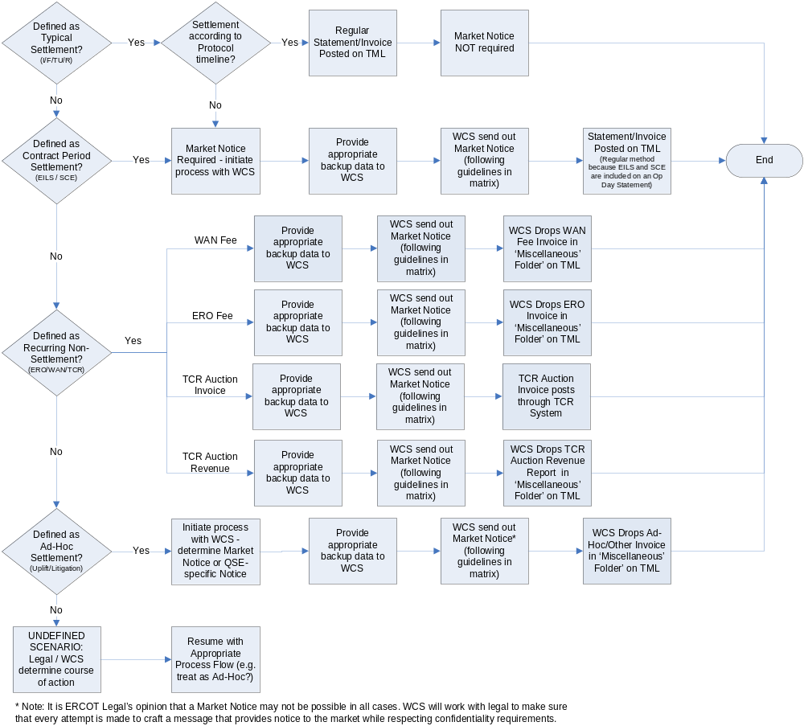

8.1.2 Types of Ad Hoc Invoices
The following are types of Settlements that will be invoiced on an ad hoc basis:
(1) Contract Period
These are Settlements based on a contract period instead of an operating date.
(a) Schedule Control Error (SCE); and
(b) Emergency Interruptible Load Service (EILS).
(2) Recurring Non-Settlement Related Charges
These are routine, non-standard Settlements.
(a) Wide Area Network (WAN) fee;
(b) Electric Reliability Organization (ERO) fee;
(c) Transmission Congestion Rights (TCR) auction Invoice; and
(d) TCR auction revenue.
(3) Ad Hoc Settlement
These are Settlements that occur infrequently and are not a part of standard operations.
(a) Uplift of short pays; and
(b) Litigation.
(4) Undefined Scenarios
These are Settlements for any scenario that is not defined as a typical Settlement that usually originates from the following groups:
(a) ERCOT Legal;
(b) ERCOT Wholesale Client Services (WCS); and
(c) ERCOT Finance.

8.1.3 Method of Communication
The method of communication varies depending on the type of ad hoc Invoice. Although ERCOT WCS will send out Market Notices for ad hoc Invoice circumstances, whenever possible, they are unable to commit to providing Notice in every circumstance. In all scenarios, the following Authorized Representatives registered with ERCOT will receive an email regarding the Invoice. These Authorized Representatives will receive an email from ClientRelations@ercot.com.
(1) Primary Authorized Representative;
(2) Backup Authorized Representative;
(3) Accounts payable; and
(4) Accounts payable backup.

8.1.4 Timing of Communication
ERCOT WCS will send the Market Notice in advance of the Invoice, as many days as possible. However, there could be potential situations when ERCOT WCS is unable to provide a sufficient Market Notice.

8.1.5 Content of Communication
If there is sufficient time, the communication from ERCOT will contain as much detail as possible. In circumstances where an extremely quick turn-around time is required, there may be a need to send a Notice that is light on content but provides an advanced warning of the ad hoc Settlement.
(1) The subject line of the Market Notice will indicate the appropriate urgency and action.
(2) If the ad hoc Invoice does not impact all Qualified Scheduling Entities (QSEs), the Market Notice will define the parameters by which a QSE can determine whether or not they should receive an Invoice (e.g., “all QSEs with Load in February 2005 will receive this Invoice, adjustments made to reflect QSEs with Load who have exited the market” or “all QSEs who were short-paid in March 2003 will receive payment”).
(3) The signature within the Market Notice will include the standard ERCOT signature/contact information.
(4) The Market Notice will indicate when the Invoice will be posted and where the Invoice will be posted. Normally, the Invoice will be posted in the “Miscellaneous” folder on the Market Information System (MIS).

8.1.6 Market Participants
Each Market Participant should ensure that the accounting contacts registered with ERCOT are current to ensure that the Invoices are received and paid in a timely manner.

Commercial Operations Market Guide
Section 10: Extracts and Reports

[Date]

10 EXTRACTS AND REPORTS 1
10.1 Delivery Point 1
10.2 Type of Delivery Element 2

10 EXTRACTS AND REPORTS
(1) ERCOT provides reports and extracts to assist Market Participants in understanding data relating to energy and Ancillary Services, market prices, retail and wholesale activity, Load Profiling, Metering, Data Aggregation, Settlements, and the market in general. Extracts and reports provide supplemental data to allow Market Participants a view into ERCOT’s operational and commercial systems. Extract data is provided in raw form to facilitate the loading of data into a database. Reports are in a formatted presentation which facilitates stand-alone reading.

(2) As a service to the market, ERCOT publishes guides regarding the use of data extracts and applications on the Market Information System (MIS) Public Area, which is located at http://www.ercot.com/services/userguides/index.html. In order to better relay available information, a summary document of extracts and reports is maintained by ERCOT and the Settlements and Extracts Working Group (SEWG). This document, the Extract and Report Matrix, is available at http://www.ercot.com/committees/board/tac/cops/dewg/index.html. Market Participants interested in scheduling extracts and reports should contact their ERCOT Account Manager to receive information on how to use the ERCOT Extract Scheduler on the MIS Certified Area.

10.1 Delivery Point
Each report or extract is delivered via one or more delivery points:

(a) Market Information System (MIS) – When information being provided is private and protected, reports and extracts are generally delivered via the MIS. The MIS is available to registered Market Participants, ERCOT and the Public Utility Commission of Texas (PUCT). A Digital Certificate is required for each user of the MIS, and is used to secure private information for Market Participants and to identify users to ERCOT. Digital Certificates may be obtained from the User Security Administrator (USA) for each Market Participant.

(b) ERCOT.com – ERCOT.com is the standard delivery point for public information. Most public reports and extracts are also available through the MIS.

(c) File Transfer Protocol (FTP) – A Market Participant FTP site may be established to receive large reports. This point of delivery is used for the 867_03 Activity Report. ERCOT Retail Client Services has information regarding this delivery point.

(d) Application Programmatic Interface (API) – A published specification intended to support automated interaction of systems between Market Participants and ERCOT.

(e) E-mail – E-mail is not a standard delivery point and is typically only used for ad hoc report or historical extract requests that are no longer available on the MIS.

10.2 Type of Delivery Element

The data extracts provided by ERCOT are composed of two elements.

(a) The first is a Data Definition Language (DDL) file, which contains the Structured Query Language (SQL) scripts necessary to build database tables designed to hold the extracted data.

(b) The second element of a data extract comprises the data itself. The data is provided in a Comma Separated Value (CSV) format. A CSV file or set of CSV files is zipped to reduce the overall size of the delivered object and posted to the appropriate delivery location. Once retrieved, the files can be extracted from the zip file and loaded into the Market Participant’s database. Two common forms of extracts are as follows:

(i) Initial – An initial extract contains data that is relatively static. In other words, this data is required for the Market Participant’s database to function properly, but the data does not change on a daily basis. As the name implies, the initial data must be used to initialize a new database before any other data can be loaded. When extracts are delivered for the first time, there is usually an initial file containing multiple days of data to bring each Market Participant up to a specific point in time, after which they will begin receiving daily extract files.

(ii) Daily – A daily extract contains mostly transactional data that does change on a daily basis. As new dimensional data is added to ERCOT’s systems, such as new billing determinants or new congestion management zones, these public records are also provided to Market Participants through the daily extract.

Commercial Operations Market Guide
Section 11: Disputes and Data Extract Variances

[Date]

11 DISPUTES AND DATA EXTRACT VARIANCES
11.1 ERCOT Disputes
[Placeholder]
[COPMGRR012: Replace Section 11.1 above with the following upon system implementation:]
11.1 ERCOT Disputes
(1) Protocol Section 9, Settlement and Billing, describes the various requirements for the implementation and maintenance of the Dispute Management Process. Qualified Scheduling Entities (QSEs) in the Day-Ahead Market (DAM) and Real-Time Market (RTM) and QSEs and Congestion Revenue Right (CRR) Account Holders for the DAM, RTM, and CRR markets are responsible for the review of their Settlement Statements and Settlement Invoices to verify the accuracy of the Settlement data used to produce the Settlement Statement and Settlement Invoice. Recipients must submit any dispute related to the Settlement Statement or Settlement Invoice data. All communication to and from ERCOT concerning disputes must be through either the Market Information System (MIS) Certified Area dispute tool or other electronic communications. Recipients shall be able to file the dispute, create the dispute-associated activities and view the progress of the dispute.
(2) In accordance with Protocols, ERCOT will issue Resettlement Statements as soon as possible due to data error other than prices that result in an impact greater than two percent of the total payments due to ERCOT, otherwise ERCOT will wait until the next scheduled Settlement. Protocol Sections 9.2.5, DAM Resettlement Statement, and 9.5.6, RTM Resettlement Statement, describes the timing of resettlements due to Settlement and Billing Ddsputes.
11.1.1 Overview
The following figures illustrate an overview of the process flow of the Dispute Management System, detailed process flows based on the type of statement being disputed, and the process for denied disputes. Protocol Section 9, Settlement and Billing, also describes the timing of disputes.

Figure 1: Dispute Management System Process Flow Overview
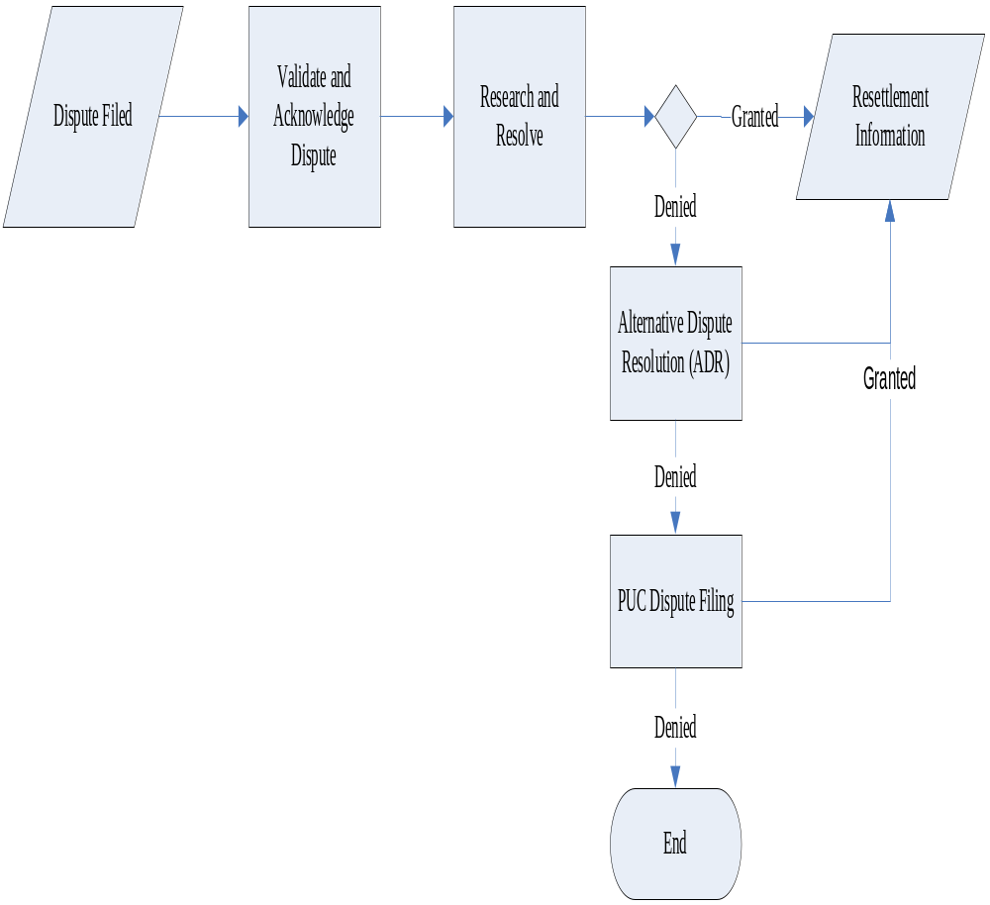

Figure 2: Process for Disputing a Real-Time Statement and Invoice
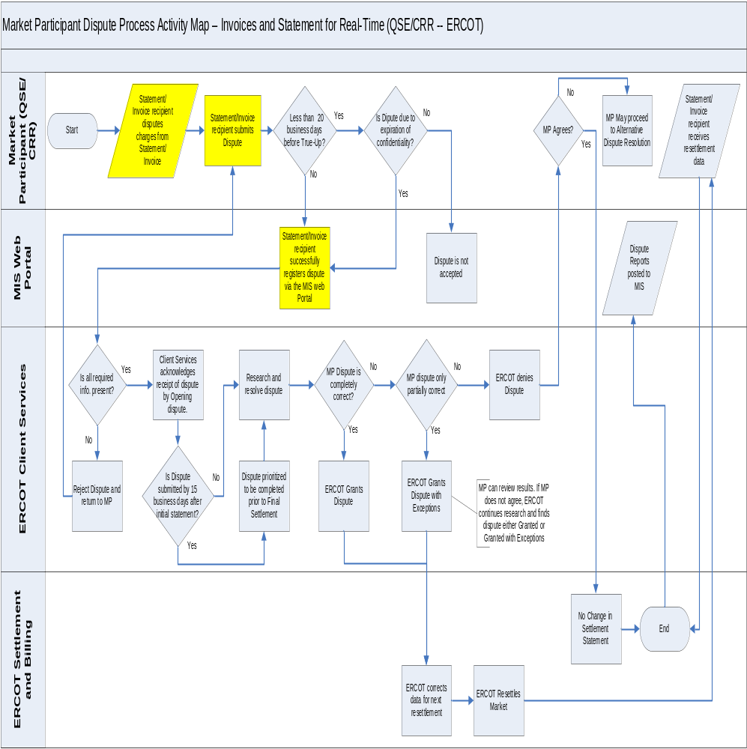

Figure 3: Process for Disputing Statements and Invoices Other than Real-Time

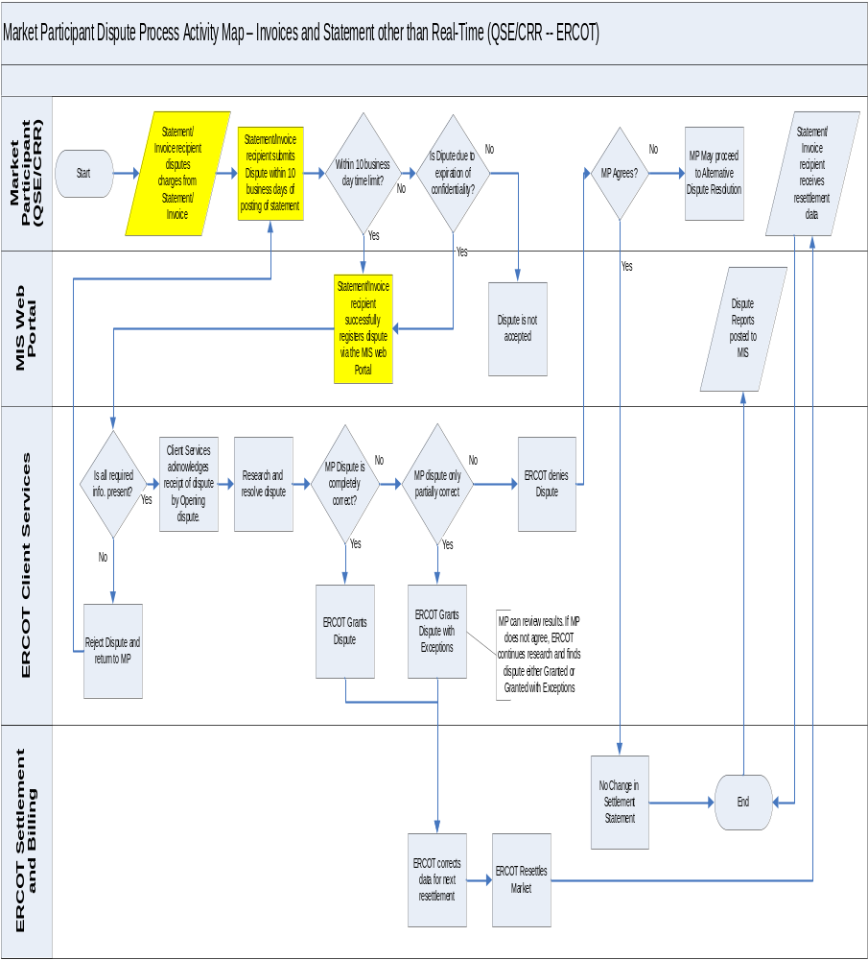

Figure 4: Process for a Denied Dispute

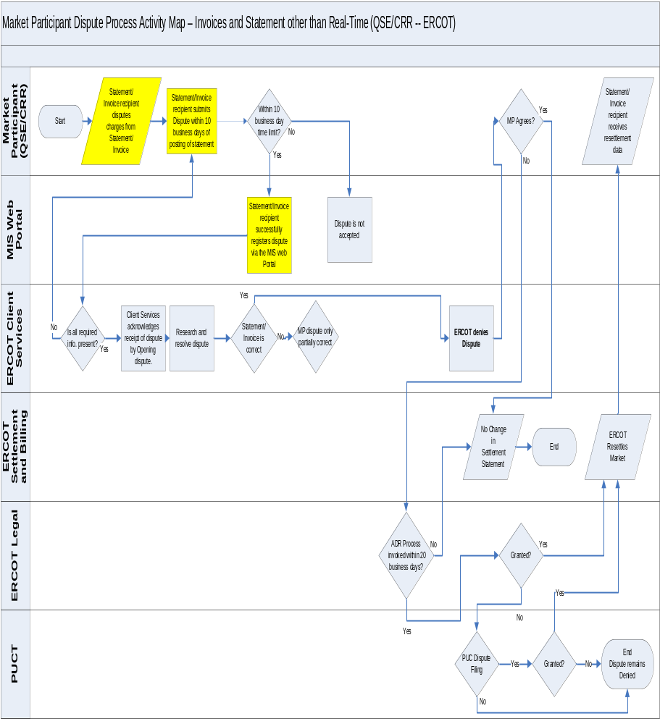

11.1.2 Settlement Calendar
(1) The Settlement Calendar provides the dates by which ERCOT will post, process payments, and administer disputes for Settlement Statements and Invoices, including:
(a) Settlement Statements for the DAM and RTM; and
(b) DAM, RTM, Late Fee, CRR and CRR Auction Revenue Distribution (CARD).
(2) The Settlement Calendar is provided as an extract and can be found on the MIS Public Area under Settlements Information and on the ERCOT website. Supporting information for the Settlement Calendar (i.e., the Data Definition Language (DDL) and Extensible Markup Definitions) are also available on both the MIS Public Area and the ERCOT website.
11.1.3 Dispute Access
There are two methods available for filing a dispute, MIS Web Portal and Application Programmatic Interface (API).
(a) MIS Web Portal – The web portal user interface utilizes the Market Participant’s Digital Certificate for authentication. The disputes area can be found by navigating to the on Markets/Settlements landing page or the applications home page. From either page, you can open the dispute application, based on roles, Create Nodal Settlement Dispute or Find Nodal Settlement Disputes.
Market Participants also have the ability to search for or view disputes using the ‘Find Nodal Settlement Disputes’ function on the Graphic User Interface (GUI). Disputes may be viewed and searched for by dispute IDs and various other criteria.
(b) API – Allows you to utilize a third-party application to submit your disputes to and from ERCOT. See the External Interfaces Specification (EIP) document on the ERCOT website for the API technical requirements.
11.1.4 Dispute Items
The following are a list of the statement and Invoice items that can be disputed. For Invoices, the items not listed on the statements can be disputed, such as interest.
(a) DAM Statement;
(b) DAM Resettlement Statement;
(c) DAM Invoice;
(d) DAM Late Fee Invoice;
(e) RTM Initial Statement;
(f) RTM Final Statement;
(g) RTM True-Up Statement;
(h) Any RTM Resettlement Statement issued after the RTM True-Up Statement;
(i) RTM Invoice;
(j) RTM Uplift Invoice;
(k) CRR Auction Invoice;
(l) CARD Invoice; and
(m) CRR Balancing Account Invoice.
11.1.5 Valid Dispute Statuses and Resolutions
An automatic Notification will be sent to the disputing Entity if there is a change in the dispute resolution or dispute status.
(a) Statuses:
(i) Not Started – The initial status of the dispute when it is submitted to ERCOT.
(ii) Open – ERCOT has begun to work on the issue.
(iii) Alternative Dispute Resolution (ADR) – The Market Participant begins the ADR process once ERCOT has denied a dispute.
(iv) Closed – The dispute has been resolved.
(v) Withdrawn – Market Participant withdraws the dispute.
(b) Resolutions:
(i) Granted – ERCOT grants the dispute and the adjustments display on the next Settlement Statement for the Operating Day.
(ii) Granted with Exceptions – ERCOT grants a partial adjustment of the disputed amount. The Market Participant is notified of the exception(s).
(iii) Denied – ERCOT rejects the dispute. An automatic Notification will be sent to the disputing Market Participant.
11.1.6 Dispute Reporting
ERCOT will post a summary level dispute report and a Market Participant specific dispute extract on the MIS Certified Area.
(a) Market Participant Dispute Extract – This certified extract provides QSEs and CRR Account Holders with the current status of all of their Entity-specific disputes that are not closed or withdrawn, as well as all disputes closed or withdrawn within the last 120 days.
(b) ERCOT Summary Dispute Report – This report is a summary by Operating Day, status and market type (DAM and RTM) with resolution and count of disputes, as disputes move to a ‘Closed’ or ‘Withdrawn’ status, the data will remain available on the report for 30 days before ‘rolling off.’

11.2 Data Extract Variances
11.2.1 Overview
(1) The Data Extract Variance or “DEV” is a type of MarkeTrak used to assist in the expedited resolution of Electric Service Identifier (ESI ID) level data variances between ERCOT and Market Participant systems. The DEV should only be utilized after transactions have been attempted by comparing the information provided in the daily ERCOT ESI ID Service History & Usage Extract (727 Data Extract) and the Market Participants internal system data. The ESI ID Service History & Usage Extract is provided by ERCOT through the Market Information System (MIS). The Data Definition Language (DDL) description file for this extract is located on the ERCOT website under DDLs. Manual intervention will only be accepted after all other resolution paths have been exhausted.
(2) If a variance submitted according to the ERCOT MarkeTrak User Guide is not resolved prior to the True-Up Settlement, a Market Participant may seek correction of the ESI ID service history, usage information and resettlement pursuant to the provisions of ProtocolsSection 20, Alternative Dispute Resolution Procedure. The True-Up Settlement timelines and variance request deadlines are available on the True-Up Settlement and Variance Request Calendar located on the ERCOT website.
(3) For more information on types and subtypes of DEV issues and the DEV resolution process, refer to the Retail Market Guide (RMG) Section 7.1.3, MarkeTrak Data Extract Variance Processes, and the MarkeTrak Users Guide, Sections 5, DEV LSE, and 6, Non LSE DEV are available on the ERCOT website.
(4) The MarkeTrak User Guide can be found on ERCOT website:
(a) Select Services.
(b) Select Client Services.
(c) Select MarkeTrak Information.
(d) Select MarkeTrak Users Guide.

Commercial Operations Market Guide
Section 12: Renewable Energy Credits

[Date]

12 RENEWABLE ENERGY CREDITS (RECS) 1
12.1 Purpose and History 1
12.1.1 PUCT 1
12.1.2 Renewable Resource Generation 1
12.1.3 REC Program Overview 2
12.1.4 REC Attributes and Uses 3
12.1.5 REC Offsets 3
12.2 Determining REC Requirements for Competitive Retailers 3
12.2.1 Timing for Notification of Final REC Requirement (FRR) and Mandatory Retirement 3
12.2.2 ERCOT Reporting to the PUCT and PUCT Penalties and Enforcement 4
12.2.3 Process for Determining REC Requirements for Competitive Retailers 4
12.2.4 Public Data 4
12.3 Texas REC System and User’s Guide 5
12.3.1 TexasREC User’s Guide 5
12.3.2 REC Account Holder Assistance 6

12 RENEWABLE ENERGY CREDITS
The State of Texas Renewable Energy Credit Trading Program is addressed in Protocol Section 14, State of Texas Renewable Energy Credit Trading Program.
In support of the State of Texas’ goals related to installation of generating capacity from renewable energy technologies, ERCOT administers the Renewable Energy Credit (REC) Trading Program. As part of the REC Trading Program each competitive Retail Entity with Load in Texas is assigned an annual REC requirement.

12.1 Purpose and History
The State of Texas Renewable Energy Credit (REC) Trading Program was developed as a result of legislative action in Senate Bill 7, Texas Electricity Energy Restructuring. The objective of this part of Senate Bill 7 was to increase the capacity of renewable resource generation in Texas to 2,880 MWs by the year 2009 from an already existing 880 MWs.
The State of Texas’ REC Trading Program was extended and expanded on September 1, 2005 as a result of legislative action in Senate Bill 20, 79th Legislature, 1st Called Session (2005), which amended Public Utility Regulatory Act (PURA) § 39.904, relating to the Goal for Renewable Energy. Senate Bill 20 increased the goal of capacity of renewable resource generation in Texas to 5,880 MWs by 2015 and 10,000 MWs by 2025. Senate Bill 20 also stipulates a goal that 500 MWs of the target MWs will be from non-wind renewable generation. This goal is to further promote solar power and biomass technologies.
Due to the optimum locations of Wind-powered Generation Resources (WGRs) in Texas, transmission congestion can limit the flow of renewable generation to the ERCOT Transmission Grid. In July 2007, the Public Utility Commission of Texas (PUCT) announced its approval for additional transmission lines that can deliver 10,000 more MWs of renewable power by 2012. The goal of the Energy Transmission Plan is to increase transmission capacity to get clean energy from remote areas to cities. Competitive Renewable Energy Zones (CREZs) were designated in the optimum areas in the state and it is to these locations that electric transmission infrastructure will be constructed.

12.1.1 Public Utility Commission of Texas (PUCT)
For more information on the PUCT ruling and goals see P.U.C. Subst. R. 25.173, Goal for Renewable Energy.

12.1.2 Renewable Resource Generation
Renewable resource generation is generation that is not derived from fossil fuels, waste products from fossil fuels, or waste products from inorganic sources. Renewable resource generation technology relies on an energy source that is naturally regenerated, for example, the sun, wind, geothermal, hydroelectric, tidal energy, biomass, and biomass-based waste products.

12.1.3 REC Trading Program Overview
Program rate Retail Eniuired
The statewide Texas REC Trading Program applies to competitive Retail Entities that offer Customer Choice, as defined by the P.U.C. Subst. R. 25.173, Goal for Renewable Energy, including:
(1) Retail Electric Providers (REPs);
(2) Opt-in Municipally Owned Utilities (MOUs) and distribution Cooperatives;
(3) Investor Owned Utilities (IOUs) that have unbundled pursuant to PURA Chapter 39, Restructuring of Electric Utility Industry.
Competitive Retail Entities are required to obtain and retire RECs based on their Load Ratio Share (LRS) of the competitive retail Load served in Texas, and the annual statewide REC mandate.
Any renewable resource generator, as defined by the P.U.C. Subst. R. 25.173, in Texas can earn RECs.
The statewide Texas REC Trading Program is open to anyone wanting to trade (buy or sell) RECs.
Opt-out Notice – Beginning with the 2008 Compliance Period, a Customer receiving electrical service at transmission-level voltage (60 kV or higher or that receives electric service directly through a utility-owned substation that is connected to the transmission network at 60 kV or higher) who files an opt-out notice with the PUCT and provides the information to ERCOT for the applicable Compliance Period shall have its Load excluded from the Renewable Portfolio Standard (RPS) calculation. For detailed information about the opt-out notice exemption see P.U.C. Subst. R. 25.173, Goal for Renewable Energy. Renewable resource generators wishing to participate are required to be certified by the PUCT. The PUCT certification forms are available at the PUCT’s website at http://www.puc.state.tx.us/electric/business/rec/rec.cfm. See Protocol Section 14, State of Texas Renewable Energy Credit Trading Program, for reporting requirements of REC generators and REC offset generators and the process for the awarding of RECs.

12.1.3.1 Participant Responsibilities
Participant responsibilities for ERCOT, the PUCT, REC generators, competitive Retail Entities, and other Entities are described in Protocol Section 14, State of Texas Renewable Energy Credit Trading Program. Other Entities may participate if they are legal Entities in the State of Texas, sign an agreement with ERCOT to participate in the market, and establish a REC trading account with ERCOT.

12.1.4 REC Attributes and Uses
Attributes of RECs, including how they are defined and how they are described by vintage year, quarter, technology type, resource, facility identification, quantity, and REC number, may be found in Protocol Section 14, State of Texas Renewable Energy Credit Trading Program.
RECs have a useful life of three (3) Compliance Periods. A Compliance Period is a calendar year beginning January 1 and ending December 31 of a year in which RECs are required to be retired by a competitive Retail Entity. See the Protocol Section 14 for an example.
Uses for RECs include, but are not limited to:
(1) Annual RPS compliance requirements for competitive Retail Entities.
(2) Financial instrument tradable on the REC market.
(3) PUCT labeling initiative: RECs can be used for verification of advertising claims for green power programs.

12.1.5 REC Offsets
See Protocol Section 14, State of Texas Renewable Energy Credit Trading Program, for more information on how generators qualified for REC offsets prior to June 1, 2001 in the REC Trading Program.

12.2 Determining RPS Requirements for Retail Entities
As the Renewable Energy Credit (REC) Trading Program Administrator, ERCOT determines the annual Renewable Portfolio Standard (RPS) requirement for each competitive Retail Entity in Texas using the formulas set forth in Protocol Section 14, State of Texas Renewable Energy Credit Trading Program.

12.2.1 Timing for Notification of Final RPS Requirement (FRR) and Mandatory Retirement
As set forth in subsection (n) (1) of P.U.C. Subst. R.25.173, Goal for Renewable Energy, ERCOT will notify each competitive Retail Entity of its total final adjusted RPS requirement for the previous Compliance Period on January 31st.
As set forth in subsection (n)(2) of P.U.C. Subst. R.25.173, each competitive Retail Entity must submit to ERCOT a quantity of RECs equal to its Final RPS Requirement (FRR) for the previous Compliance Period by March 31st. This is done by retiring the RECs in the competitive Retail Entity’s REC trading account.

12.2.2 ERCOT Reporting to the PUCT and PUCT Penalties and Enforcement
See Protocol Section 14, State of Texas Renewable Energy Credit Trading Program, for more information about ERCOT reporting to the Public Utility Commission of Texas (PUCT) and PUCT penalties and enforcement.
12.2.3 Process for Determining RPS Requirements for Competitive Retailers
First, a Statewide RPS Requirement (SRR) is determined, using the Annual Capacity Target (ACT), the number of hours in a year, 8,760 hours, and the Capacity Conversion Factor (CCF). Plus, the Compliance Premiums used for the previous year’s mandate are added back into the SRR. See Section 12.2.4, Public Data, below for more information on the CCF.
Second, a Preliminary RPS Requirement for each competitive Retail Entity is determined, using the SRR, the sales of the specific competitive Retail Entity, Customer Retail Sales (CRSRES), in MWhs, to Texas Customers during the Compliance Period excluding opt-out noticed Customer Loads, and the Total Sales (TS) of all competitive Retail Entities, in MWhs, to Texas Customers during the Compliance Period, excluding opt-out noticed Customer Loads. The sum of the Preliminary RPS Requirement for all competitive Retail Entities will equal the SRR.
Third, ERCOT determines the Adjusted RPS Requirement (ARR) due to offsets assigned to competitive Retail Entities, using the Preliminary RPS Requirement and the Total Offsets. The competitive Retail Entity is entitled to Eligible Offsets (EOs) received during the Compliance Period. ERCOT also determines the Total Usable Offsets (TUO), using the SRR and the sum of all of the ARRs.
Last, ERCOT determines the FRR for each competitive Retail Entity, using the ARR, TUO, CRSRES, TS, and any previous year’s adjustments.
This is an iterative process that will solve until the optimal allocation is reached with all FRRs resolved to the nearest whole REC.

12.2.4 Public Data
A Texas REC trading account is not required to access the following public data:
- Total Competitive Energy Sales in Texas
The Total Competitive Energy Sales in Texas can be found at https://www.texasrenewables.com under ‘Public Reports’ under ‘Load’ is the Total Competitive Energy sales in Texas. Total Competitive Energy Sales is the total Un-Adjusted Metered Load (AML) of all competitive retail sales of competitive Retail Entities (in MWh) to Texas Customers. The Load meter data is provided by year, both monthly and year-to-date, and is updated each month by ERCOT. The posted values will change as Load changes with consecutive settlements and will become constant when used in the FRR calculation.
- Current Capacity Conversion Factor (CCF)
ERCOT revises the CCF every two years. The CCF is used in the calculation to determine the SRR. The SRR is used in the calculations to determine the Preliminary RPS Requirement for competitive Retail Entities, the TUOs, and the FRR. The current CCF may be found at https://www.texasrenewables.com located on the REC Message Board.
- Quarterly/Annual Renewable Energy Generation in Texas by Technology Type
The Quarter & Annual Renewable Energy Generation in Texas by Technology Type can be found at https://www.texasrenewables.com under Public Reports under Generator is the Quarter & Annual Renewable Energy Generation in Texas by Technology Type. Other Public Information available includes:
(a) List of account holders;
(b) Accounts by type;
(c) Accounts by technology type;
(d) REC generators, repowered Facilities;
(e) Existing/New Capacity;
(f) Quarter and Annual Renewable Energy Generation in Texas by technology type; and
(g) REC message board.

12.3 Texas REC Trading Program and User’s Guide
The texasrenewables.com website provides a secure portal for Renewable Energy Credit (REC) Trading Account Holders to manage their REC inventory. Account holders may view, sort, batch or singly identify RECs to transfer or retire. All activities are available online, including account registration. There are no limits on the number of REC trading accounts. All data is available online for at least three (3) years.
The texasrenewables.com website may be accessed directly at https://texasernewables.com or from the ERCOT website under VIEW OTHER ERCOT WEBSITES and Renewable Energy Credits.

12.3.1 Texas REC User’s Guide
Texas REC User’s Guide is available on the texasrenewables.com website, under the headings Public Reports and Help Guide. The User’s Guide outlines the functionality of the REC Trading Program including account management, generator, and aggregator registration and how to submit generator meter data. .

12.3.2.1 Micro-generators and REC Aggregators
Registration and the reporting of production meter data for micro-generators and REC aggregators are addressed in paragraph (q) of P.U.C. Subst. R.25.173, Goal for Renewable Energy. Micro-generators are encouraged to find an aggregation company to associate themselves with, however, if they choose, they may register and participate on their own.

12.3.2 REC Trading Program Account Holder Assistance
Contact the ERCOT RPS Administrator via email, Info@ercot.com for REC Trading Account Holder assistance.
The Help function, located at the top right of the screen, in the Texas-REC Trading Program is an excellent online reference.

Commercial Operations Market Guide
Appendix A: Market Notice Communication Process

[Date]
_______________________________________________

(1) Definition of Terms - For the purposes of Appendix A, Market Notice Communication Process, the following definitions prevail:
(a) Business Area – Indicates the type of Market Participant affected (Market-Wide, Wholesale, or Retail (see Table 1, ERCOT System/Service Affected).
(b) E-mail Notification Subscription Lists – To subscribe to the appropriate list on the ERCOT website (see Table 8, E-mail Notification Subscription Lists).
(c) Escalation – Escalation of Notifications is based on duration of event and cross-system impact.
(d) Notice Content – Dependent on the phase of the Notice, duration and complexity of the issue. Minimal content will include the service that is unavailable and may include the time the issue was identified, if known. Standard content provides start and stop times for the issue, actions taken to resolve the issue or progress of service restoration and follow-up information, if needed. All Notification timing refers to calendar days, unless specified as Business Days.
(e) Phases of Notification – Communication phase
(i) Initial Notice may contain only minimal content which is defined as the service that is not available and the time the issue was identified.
(ii) Follow-up Notices may have multiple updates depending on duration of event and will contain progress reports and impacts.
(iii) Completion Notice will provide a timeline for the end of the event but may not contain root cause analysis or actions taken to restore service.
(iv) Final Notice will provide root cause and describe the mitigation action taken to resolve the issue within seven days following the end of the event.
(v) Lessons Learned and Mitigation Action Notice will be sent at the end of the event plus a reasonable time for completion of root cause analysis, not to exceed 45 days without at least an interim report.
(2) Types of Outage/Processing Impact Notifications
(a) Planned Scheduled Release – fourth weekend of each month – 1200 Saturday until 0000 Monday (36 hours) as defined in the Retail Market IT Services Service Level Agreement (SLA), located on the ERCOT website.
(b) Planned Maintenance Outage – first and second Sunday of each month – 0600 until 2100 (15 hours) and third and fifth Sunday of each month – 0800 until 2000 (12 hours) as defined in the Retail Market IT Services SLA located on the ERCOT website.
(c) Unplanned Outage or Business Processing Impacts – unplanned events that occur during Business Hours or during non-Business Hours. Exceptions for extended maintenance and release windows will be requested by ERCOT at a Commercial Operations Subcommittee (COPS) and/or Retail Market Subcommittee (RMS) meeting (as appropriate) prior to the extended outage. Unplanned retail and wholesale system outages will be identified on the ERCOT website under the “View Data And Reports” category heading. A red flag icon will appear immediately to the right of the “Notices” header when an ERCOT retail or wholesale system is currently unavailable. This flag will be removed when the retail or wholesale system has been restored. If the outage occurs outside of normal Business Hours, ERCOT will generate an automated Market Notice that will communicate the unplanned system outage to the market. If the outage occurs during normal Business Hours, ERCOT may generate an automated Market Notice that will communicate the unplanned system outage to the market. The system-generated Notices will be sent to the Notice_Release_Retail@lists.ercot.com and/or the Notice_Release_Wholesale@lists.ercot.com mailing lists. ERCOT will generate a Follow-up Notice during normal business hours in these instances if the outage lasts 30 minutes or longer.
(i) Data Extract and Report Incidents – Certain extracts and reports are subject to a SLA. These extracts and reports can be found in the Extract and Report Information Matrix posted in the Settlement and Extracts Working Group (SEWG) section of the ERCOT website. This file contains where each extract or report is posted (delivery point), whether it is public or Market Participant-specific, on what timeline (how often posted), and the assigned SLA Level.
(A) Incidents impacting the timeliness, completeness, or accuracy of SLA Level-1 data extracts and reports are reported in the ERCOT IT Incident Summary Data Extracts & Reports and IT Applications Services). The log will be updated monthly and made available on the ERCOT website by the 15th day of the following month
(B) For incidents involving SLA Level-1 data extracts impacting ten or more Market Participants or as determined by ERCOT to warrant full market notification, a Market Notice will be sent. Incidents involving SLA Level-1 data extracts will be reported via the Market Notice process in the following manner:
(1) A Market Notice will be sent out if incident involves extracts posted with missing data or incorrect data (completeness or accuracy). See item (1)(d) above for details on content.
(2) A Market Notice will be sent if incident involves timeliness of SLA Level-1 extract later than 23:59 or otherwise specified by the Protocols. Such incidents will be reported on the Extract and Report Incident Log on a monthly basis.
(3) All incidents not reported via the Market Notice process will be included in the ERCOT IT Incident Summary Data Extracts & Reports and IT Applications Services.
(4) These incidents will be identified on the ERCOT website under the “View Data And Reports” category heading. A red flag icon will appear immediately to the right of the “Notices” header to facilitate communication of the issue to the market. This flag will be removed when the extract issue has been resolved. If the extract issue occurs outside of normal Business Hours, ERCOT will generate an automated Market Notice that will communicate the issue to the market. These automated Notices will be sent to the Notice_Release_Retail@lists.ercot.com and/or the Notice_Release_Wholesale@lists.ercot.com mailing lists. ERCOT will generate a Follow-up Notice during normal Business Hours to provide additional details when warranted.
(ii) For incidents involving data extracts other than SLA Level-1, ERCOT will determine whether to report via Market Notice. All incidents, including those not reported via Market Notice process, will be included .
(3) Coding of Notices
Notice Codes – Market Notices that are not system generated will be given a unique identification code that identifies, at a high level, the impacted Market Segment (retail, wholesale or market), the date and sequence of the Notice and the number of Notices in a series a particular Notice represents. This code will appear in the Notice Type section of the Notice (See Table 2, Market Notice Tracking Codes).

Table 1: ERCOT Service/System Affected
 | Business Area | Service/System | Description | Requirement
 | Market-Wide | Data Retrieval | Public and private extracts.
 | Market-Wide | Data Storage | Storage of archive data used for extracts.
 | Market-Wide | Digital Certificate Administration | Ability for User Security Administrators (USAs) to enroll, pick up, renew and delete Digital Certificates.
 | Market-Wide | E-mail Communications | Phone call updates to primary contacts if e-mail is down.
 | Market-Wide | Forecasted Profiles | Load Profile Forecasts, back-casts (operational postings). | Protocol Section 18.3.3, Load Profiles
 | Market-Wide | Forecasted Transmission Loss Factors (TLF) | Forecasted TLF for each 15 minute settlement interval of each Operating Day. | Protocol Section 13.2.1, Forecasted Transmission Loss Factors
 | Market-Wide | ERCOT-Polled Settlement (EPS) Metering | Polling of EPS Meters. | Protocol Section 10, Metering
 | Market-Wide | Commercial Programmatic Interface | PI, commercial API, PI App, automatic download of commercial information.
 | Market-Wide | Public Market Information | Public information required to be posted (Scheduling information, Ancillary Service information, other commercially significant information, current system conditions) | Protocol Section 12, Market Information System
 | Market-Wide | Renewable Energy Program | View, sort, batch, or singly identify Renewable Energy Credits (RECs) to transfer or retire. | Protocol Section 14, State of Texas Renewable Energy Credit Trading Program
 | Market-Wide | Congestion Revenue Right (TCRR) informtion | Billing and invoicing of CRR, CRR Auctions and monthly information on Shift Factors. | Protocol Section 7, Congestion Revenue Rights
 | Market-Wide | Texas Market Link (TML) | Service to provide access to Market Participant-specific information on ERCOT’s portal, plus sub services. | Use most stringent criteria for all services under TML.
 | Market-Wide | ERCOT Website | Market Information System (MIS) Public Area.
 | Market-Wide | Phone Lines | Commercial phone lines (example: Help Desk).
 | Retail | Electronic Data Interchange (EDI) Electronic Delivery Mechanism/ orth American Energy Standards Board (NAESB) | Method used to connect and transmit electronic data. | NAESB Protocols require notification if delay of > 15 minutes
 | Retail | Retail Siebel Batch | Retail Siebel batch must complete by 0600 in order to meet guaranteed window for stacking. Expectation is Market Notice sent if batch does not complete by 0600.
 | Retail | Retail Testing | Ability to provide services to the retail test flights.
 | Retail | Retail Transaction Variances | Transactional issues and inquiries submitted to the MarkeTrak system.
 | Retail | Retail Transaction Processing | Retail Transactions are processed by ERCOT during Retail Business Days/Hours. (Paperfree, TCH, Siebel). | The most stringent business processing timeline for retail transactions is one Retail Business Hour after processing the initiating transaction. (Protocol Section 15, Customer Registration)
 | Retail | TML Retail Components | Delete CSA, Establish CSA, Create Drop, Create Enrollment, Create Move-In, Create Move-Out, Find ESI ID, Find Transactions.
 | Wholesale | Market Operations Application Programmatic Interface (API) | Scheduling Ancillary Service and energy, bids and information query via API, deployments and Notices.
 | Wholesale | Market Operations Test Environment | Provide testing and qualifications to Market Participants. | Protocol Section 16, Registration and Qualification of Market Participants
 | Wholesale | Operational Notifications | Balancing Energy Service B requirement, A/cillary Service Obligations, Cconestion Notifications, EECPgy Emergency Alert (EEA) Notifications.
 | Wholesale | Operational Telemetry | Supervisory Control and Data Acquisition (SCADA), Real-Time telemetry.
 | Wholesale | Transmission/ Generation Outage Requests | Transmission and generation Outage requests and information. | Protocol Section 3.1, Outage Coordination
 | Wholesale | Settlement Statement and Invoices | Creation, posting and collection of statements and Invoices. | Protocol Section 9, Settlement and Billing
 | Wholesale | Settlement Disputes/ Service Requests | Entry and retrieval of Settlement dispute from TML, Create Service Request, Find Service Request. (This includes Electrical System Modifications Requests). | Protocol Section 9.14, Settlement and Billing Dispute Process
 | Wholesale | Market Operations TML | Scheduling Ancillary Service and energy, bids and information query via TML.
 | Wholesale | Wide Area Network | Secure connectivity to EROCT and hotline.

Table 2: Market Notice Tracking Codes
 |  | Unique Identifier | Notice Date | Sequence Number
 | System Generated | N/A | N/A | N/A
 | W = Wholesale | A = First topic Notice of a day | February 27, 2007 = 022707 | 01 = Initial Notice
 | R= Retail | B = Second topic Notice of a day | March 15, 2007 = 031507 | 02 = Second Notice (update)
 | M = Market-Wide | C = Third topic Notice of a day, etc. | April 3, 2007 = 040307 | 03 = Third Notice (update)

(i) Tracking Code Example 1:
(A) R-A022707-01 (Retail, First topic Notice for February 27, 2007, initial Notice)
(B) R-A022707-02 (Follow-up same day)
(C) R-A022707-03 (Follow-up next day)

(ii) Tracking Code Example 2:
(A) R-B022707-01 (Retail, Second topic for February 27, 2007, initial Notice)

(iii) Tracking Code Example 3:
(A) M-A022707-01 (Market-Wide, First topic for February 27, 2007, initial Notice)
(B) W-A022707-01 (Wholesale, First topic for February 27, 2007, initial Notice)
(4) Sample Notices

(a) System Generated Notice

Subject: INITIAL NOTICE - System Outage – Texas Market Link
NOTICE DATE: 12/29/08 13:10:39
NOTICE TYPE: Initial Texas Market Link Notice
INTENDED AUDIENCE: LSEs and TDSPs
DAY AFFECTED: 12/29/08 13:00:04
DESCRIPTION: ERCOT is currently experiencing an outage of Texas Market Link.
ERCOT is working on resolving this issue and will provide additional information as it becomes available.
CONTACT: If you have any questions, please contact your ERCOT Account Manager. You may also call the general ERCOT Client Services phone number at (512) 248-3900 or contact ERCOT Client Services via e-mail at ClientRelations@ercot.com.
If you are receiving e-mail from an ERCOT distribution list that you no longer wish to receive, please follow this link in order to unsubscribe from this list: http://lists.ercot.com.

(b) Non System Generated Notice

Subject: R-A022107-01 Planned Outage –Retail
NOTICE DATE: February 21, 2007
NOTICE TYPE: R-A022107-01 Planned Outage – Retail
SHORT DESCRIPTION: ERCOT has scheduled a Maintenance Outage on Sunday, March 4, 2007
INTENDED AUDIENCE: Market Participants
DAY AFFECTED: Sunday, March 4, 2007 from 8:00 AM to 8:00 PM
LONG DESCRIPTION: ERCOT has a planned Maintenance Outage scheduled from 8:00 AM to
8:00 PM on Sunday, March 4, 2007.
ADDITIONAL INFORMATION: During the Outage the following functions will be affected . . .
CONTACT: If you have any questions, please contact your ERCOT Account Manager. You may also call the general ERCOT Client Services phone number at (512) 248-3900 or contact ERCOT Client Services via e-mail at ClientRelations@ercot.com.
If you are receiving e-mail from an ERCOT distribution list that you no longer wish to receive, please follow this link in order to unsubscribe from this list: http://lists.ercot.com.

(c) Non System Generated Notice

Subject: R-A022107-02 UPDATE: Planned Outage –Retail
NOTICE DATE: February 28, 2007
NOTICE TYPE: R-A022107-02 UPDATE: Planned Outage – Retail
SHORT DESCRIPTION: ERCOT has not changed plans to have a scheduled Maintenance Outage on Sunday, March 4, 2007
INTENDED AUDIENCE: Market Participants
DAY AFFECTED: Sunday, March 4, 2007 from 8:00 AM to 8:00 PM
LONG DESCRIPTION: ERCOT has a planned Maintenance Outage scheduled from 8:00 AM to 8:00 PM on Sunday, March 4, 2007.
ADDITIONAL INFORMATION: During the Outage the following functions will be affected:
CONTACT: If you have any questions, please contact your ERCOT Account Manager. You may also call the general ERCOT Client Services phone number at (512) 248-3900 or contact ERCOT Client Services via e-mail at ClientRelations@ercot.com.
If you are receiving e-mail from an ERCOT distribution list that you no longer wish to receive, please follow this link in order to unsubscribe from this list: http://lists.ercot.com.

Table 3: Planned Release Notifications
Timing of Market Notification | Phases of Notice | Notice Content | Listserv
30 days prior to release | I – Initial General Market Notification | Standard content plus background material. | Distribution lists and primary and secondary contacts.
Ten days prior to release | II – Follow-Up | Same as previous. | Same as previous.
One day prior to release | II – Follow-Up | Same as previous. | Same as previous.
End of event as soon as possible (ASAP) | III – Completion | Completion. | Same as previous.

Table 4: Planned Maintenance Notifications
 | Timing of Market Notification | Phases of Notice | Notice Content | Listserv
 | Target three days prior to maintenance. | I – Initial General Market Notification | Standard Content plus background material. | Distribution lists and primary and secondary contacts.
 | Target one day prior to maintenance. | II – Follow-Up | Same as previous. | Same as previous.
 | End of event ASAP. | III – Completion | Completion. | Same as previous.

Table 5: Business Processing Failures Notifications
 | Timing of Market Notification | Phases of Notice | Escalation | Notice Content | Listserv
 | Business Day 1 ASAP. | I – Initial General Market Notification | None. | Minimal. | Distribution lists and primary and secondary contacts.
 | By close of business (COB) Day 2. | II – Follow-Up | None. | Standard content plus e-mail applicable Market Participant spreadsheets as available. | Same as previous,  plus Market Participant specific.
 | End of event  occurring before escalation begins. | IV – Final | None. | Normal processing /root cause. | Same as previous,  plus Market Participant specific
 | By COB Day 3. | II – Follow-Up | Yes. | Same as previous, plus updates. | Same as previous,  plus Technical Advisory Committee (TAC) Subcommittees,  plus TAC, and  Market Participant specific.
 | By COB Day 4. | II - Follow-Up | Yes. | Same as previous, plus updates. | Same as previous.
 | Business Day 5 and beyond. | II –Follow-Up | None. | Market  Participant specific. | Market Participant specific.
 | End of event. | IV – Final | Yes | Normal processing /root cause. | Same as last General, plus escalation lists if required.
 | End of event, plus reasonable time for completion of root cause analysis not to exceed 45 days without at least an interim report. | V – Lessons Learned & Mitigation Action | TAC subcommittee update | Same as previous, plus lessons learned and mitigation actions; additional follow-up communications. | Appropriate TAC subcommittees.

Table 6: Notification of Outage During Business Hours
 | Duration of Outage |  | Timing of Market Notification | Phases of Notice | Escalation | Notice Content | Listserv
>= 30 minutes |  | ERCOT logs outage, posts instance to ERCOT website, and may send a system generated Notice to Notice_Release_Retail@lists.ercot.com and/or Notice_Release_Wholesale@lists.ercot.com.
 |  |  | Business Day 1 ASAP after notification. | I – Initial Notification | None. | Minimal. | Distribution lists and primary and secondary contacts.
 |  |  | By COB Day 1. | II – Follow-Up | None. | Standard content. | Same as previous.
 |  |  | Business Day 2 by 0900. | II – Follow-Up | None. | Same as previous, plus updates. | Same as previous.
 |  |  | ASAP  after restoration. | III – Completion | Same as last message sent. | Minimal. | Same as last message sent.
 |  |  | End of outage. | III – Completion | None. | Service restored. | Same as last message sent.
 |  |  | By COB Day 2. | II – Follow-Up and initiate daily conference calls to begin on day 3 | Yes. | Same as previous, plus conference call information. | Same as previous, plus TAC subcommittees and  TAC.
 |  |  | Business Day 3 by 0900. | II – Follow-Up | Yes. | Same as previous. | Same as previous.
 |  |  | By COB Day 3. | II – Follow-Up | Yes. | Same as previous. | Same as previous.
 |  |  | End of outage. | III – Completion | Same as last message sent. | Service restored. | Same as last message sent.
 |  |  | End of outage, plus seven days. | IV – Final | TAC subcommittee update. | Same as previous, plus mitigation actions; additional follow-up communications. | Appropriate TAC subcommittees
 |  |  | End of outage, plus reasonable time for completion of root cause analysis not to exceed 45 days without at least an interim report. | V – Lessons Learned & Mitigation Action | TAC subcommittee update. | Same as previous, plus lessons learned and mitigation actions; additional follow-up communications. | Appropriate TAC subcommittees

Table 7: Notification of Outage Outside of Business Hours
 | Duration of Outage |  | Timing of Market Notification | Phases of Notice | Escalation | Notice Content | Listserv
>= 30 minutes |  | ERCOT logs outage, posts instance to ERCOT website, and sends a system generated Notice to Notice_Release_Retail@lists.ercot.com and/or Notice_Release_Wholesale@lists.ercot.com.  If ERCOT IT and Business, Client Services determines a weekend/holiday outside of Business Hours event to be of major significance, Initial Notices will be sent as soon as possible with follow-up Notifications as necessary.
 |  |  | Business Day 1 by 0900. | I – Initial Notification | None. | Minimal. | Distribution lists and primary and secondary contacts.
 |  |  | Business Day 1 – If outage restoration complete by 0900, then by 1200. | I – Initial Notification and IV - Final | None. | Standard content. | Same as previous.
 |  |  | By COB Day 1. | II – Follow-Up | None. | Standard content. | Same as previous.
 |  |  | Business Day 2 by 0900. | II – Follow-Up | None. | Same as previous, plus updates. | Same as previous.
 |  |  | ASAP  after restoration. | III – Completion | Same as last message sent. | Minimal. | Same as last message sent.
 |  |  | End of outage. | III – Completion | None. | Service restored. | Same as last message sent.
 |  |  | By COB Day 2. | II – Follow-Up and initiate daily conference calls to begin on day 3. | Yes. | Same as previous plus conference call information. | Same as previous, plus TAC subcommittees and  TAC.
 |  |  | Business Day 3 by 0900. | II – Follow-Up | Yes. | Same as previous. | Same as previous.
 |  |  | By COB Day 3. | II – Follow-Up | Yes. | Same as previous. | Same as previous.
 |  |  | End of outage. | III – Completion | Same as last message sent. | Service restored. | Same as last message sent.
 |  |  | End of outage plus seven days. | IV – Final | TAC subcommittee  update. | Same as previous plus mitigation actions; additional follow-up communications. | Appropriate TAC  subcommittees.
 |  |  | End of outage plus time for completion of root cause analysis not to exceed 45 days without at least an interim report. | V – Lessons Learned & Mitigation Action | TAC subcommittee  update. | Same as previous plus lessons learned and mitigation actions; additional follow-up communications. | Appropriate TAC  subcommittees.

Table 8: E-mail Notification Subscription Lists
List Name | List Title | List Description
Notice_General | Notice_General | Notices of a general nature intended for distribution to the ERCOT market, but not applicable to any other specific mailing list.
Notice_Release_Wholesale | Notice Release Wholesale | Notices concerning system outages or upgrade releases, testing, and system generated Notices that affect wholesale market functions.
System Outages/Releases – Retail | Notice_Release_Retail@lists.ercot.com | Notices concerning system outages, upgrade releases, and system-generated Notices that affect retail market functions.
Testing - Retail | Notice_Testing_Retail@lists.ercot.com | Distribution list for information regarding Market Participant testing with respect to retail test flights and retail systems testing.
Retail Processing | Notice_Retail_Processing@lists.ercot.com | Notices concerning the processing of retail transactions.
Operations | Notice_Operations@lists.ercot.com | Notices concerning power operations and technical issues at ERCOT
Extracts - Wholesale | Notice_Extracts_Wholesale@lists.ercot.com | Notices of interest to wholesale parties utilizing data extracts and reports, including procedures, postings or changes.
Extracts -Retail | Notice_Extracts_Retail@lists.ercot.com | Notices of interest to retail parties utilizing data extracts and reports, including procedures, postings or changes.
Legal Notification | Notice_Legal_Notification@lists.ercot.com | Notices to the ERCOT market of a legal nature
TCR | Notice_TCR@lists.ercot.com | Notices concerning Congestion Revenue Rights (CRRs).
PRR/SCR | Notice_PRR_SCR@lists.ercot.com | Notices of system change that include the implementation of Protocol Revision Requests (PRRs) or System Change Requests (SCRs).
Settlements – Public | Notice_Settlements@lists.ercot.com | Notices concerning the wholesale Settlements issued by ERCOT that are public in nature.
Contracts/RFP | Notice_Contracts@lists.ercot.com | Notices of Requests for Proposal and Requests for Information that are issued by ERCOT and contracted services such as Reliability Must-Run (RMR) and Black Start.
Market and Power Operations Bulletins | Notice_Bulletins@lists.ercot.com | Distribution list for Market Operations Bulletins, Power Operations Bulletins.
Training | Notice_Training@lists.ercot.com | Distribution list for Notices of ERCOT-provided training events.

Table 9: Additional E-mail Notification Lists Matrix
External Mailing List:  Non-system-generated Notices sent to these lists….. | Internal Mailing List:  ….will also be sent to these ERCOT maintained lists
General | Entire Mail Container - If Necessary
System Outages/Releases/Testing – Wholesale | Qualified Scheduling Entity (QSE) Project Managers, QSE Primary Contacts as necessary
System Outages/Releases – Retail | RMC, CRPC, TDSPPC
Testing - Retail | RMC, CRPC, TDSPPC, TTPT, (Entire Mail Container as necessary)
Retail Processing | RMC, CRPC, TDSPPC
Extracts - Wholesale | QSE Financial Contacts
Extracts - Retail | RMC, CRPC, TDSPPC
Legal Notification | QSE,LSE,RES,TDSP Primary Contacts, as appropriate
CRR | QSE,LSE,RES,TDSP Primary Contacts, as appropriate
PRR/SCR | QSE,LSE,RES,TDSP Primary Contacts, as appropriate
Settlements – Public | QSE Financial Contacts
Contracts/Request for Proposal (RFP) | QSE,LSE,RES,TDSP Primary Contacts, as appropriate
Operations | QSE Project Managers, QSE Primary Contacts as necessary
Market and Power Operations Bulletins | QSE Project Managers
Market and Power Operations Bulletins | QSE,LSE,RES,TDSP Primary Contacts, as appropriate
Training | RMC, CRPS, TDSPPC, RMS

