 |  |  |  | System Planning Division
Monthly Status Report
to
Reliability and Operations Subcommittee
for
February 2010

 |  | Report Highlights
Item
1. | - ERCOT is currently tracking 219 active generation interconnection requests totaling over 73,000 MW. This includes over 45,000 MW of wind generation.
2. | - Regional Planning is currently reviewing proposed transmission improvements with a total of $798.0 Million  - Transmission Projects approved in 2009 total $405.1 Million  - All projects (in engineering, routing, licensing and construction) total approximately $9.5 Billion  - Transmission Projects energized in 2009 total about $538.6 million

Table of Contents
1. Generation Interconnection 1
1.1 New Generation Beginning Commercial Operations 1
1.2 New Generation Interconnection Agreements 1
1.3 Summary of Active Generation Interconnection Requests 1
1.4 Publicly Disclosed Generation Interconnection Projects 4
1.5 Generation Projects Undergoing Full Interconnection Studies 6
1.6 Wind Generation 8
2. Regional Planning Group Project Reviews 10
3. Other Notable Activities 16

1. Generation Interconnection
Additional information regarding detailed generation interconnection and impact studies is contained in the “Generation Project Interconnection Information” folder in the “Operations and System Planning” area on the ERCOT website: http://planning.ercot.com/login/login.

New Generation Registering for Commercial Operations

Sandhill Peakers (09INR0045) Gas Turbines in Travis County for 90 MW

The total installed wind capacity remains at 8,916 MW, of which 7,958 MW (89%) is located within the Western Congestion Management Zone.

New Generation Interconnection Agreements - none

Summary of Active Generation Interconnection Requests

GENERATION INTERCONNECTION REQUESTS CURRENTLY BEING PROCESSED
Currently tracking 219 active generation interconnection or change requests
As of February 28, 2010 | North | South | West | Total
Security Screening Study | 3 | 5 | 14 | 22
SSS Completed | 11 | 8 | 12 | 31
Full Interconnect Study | 23 | 22 | 87 | 132
FIS Completed | 3 | 11 | 2 | 16
Interconnect Agreement Completed | 6 | 7 | 5 | 18
Capacity under Interconnection Agreements | 3,632 | 1,165 | 626 | 5,423
Capacity for Grid, MW | 19,945 | 18,979 | 34,642 | 73,566
Wind Capacity, MW | 4,681 | 8,136 | 32,277 | 45,094

Fuel Type | Confidential Projects (MW) | Projects Under Full Study (MW) | Projects w/ Interconnect Agreement/Public Letter (MW) | Grand Total (MW)
Gas-CC |  |  | 3,554 | 13,575
Gas-CT |  |  | 150 | 450
Total Gas | 1,879 | 8,442 | 3,704 | 14,025
Nuclear |  |  | 5,900 | 5,900
Coal | 15 | 3,712 | 1,353 | 5,080
Wind | 7,524 | 31,432 | 6,138 | 45,094
Solar | 629 | 489 |  | 1,118
Biomass | 58 | 50 | 145 | 253
Other | 156 | 1,940 |  | 2,096
Grand Total | 10,261 | 46,065 | 17,240 | 73,566

Publicly Disclosed Generation Interconnection Projects
The table below summarizes the publicly disclosed generation projects for the ERCOT region.
(Status: IA=Interconnect Agreement, PL=Public Letter, XX= cancelled)
Generation Interconnections as of February 28, 2010
INR | SiteName | Status | County | Region | COD | Fuel Type | MW For Grid | Change from Last Report
08INR0038 | M Bar Wind | PL | Andrews | West | TBD | Wind | 194
08INR0033 | Lufkin | IA | Angelina | North | Apr-10 | Biomass | 45
09INR0082 | Cedro Hill Wind | IA | Webb | South | May-10 | Wind | 150
11INR0014 | TECO Central Plant | IA | Harris | South | Jun-10 | Gas-CC | 50 | Date
09INR0079b | Pearsall Expansion | IA | Frio | South | Jun-10 | Gas-CT | 100
10INR0070 | Greenville Engine Plant | PL | Hunt | North | Jul-10 | Gas-CT | 50 | New
06INR0012b | Sherbino Mesa Wind Farm 2 | IA | Pecos | West | Jul-10 | Wind | 150
05INR0015c | Gulf Wind 3 | PL | Kenedy | South | Sep-10 | Wind | 400
05INR0015b | Gulf Wind 2 | PL | Kenedy | South | Oct-10 | Wind | 400
09INR0029 | CFB Power Plant Units 11&12 | IA | Calhoun | South | Dec-10 | Coal | 263
04INR0011b | Cedar Elm | IA | Shackelford | West | Dec-10 | Wind | 136
12INR0003 | Throckmorton Wind Farm | PL | Throckmorton | West | Dec-10 | Wind | 400
08INR0012b | Papalote Creek Phase 2 | IA | San Patricio | South | Dec-10 | Wind | 198
06INR0022c | Penascal Wind Farm 2 | IA | Kenedy | South | Dec-10 | Wind | 202
08INR0065 | Buffalo Gap 4 and 5 | PL | Nolan | West | Mar-11 | Wind | 465
10INR0020 | Panda Temple Power | PL | Bell | North | May-11 | Gas-CC | 1,092
10INR0010 | Jack County 2 | IA | Jack | North | Jun-11 | Gas-CC | 620
08INR0018 | Gunsight Mountain | IA | Howard | West | Aug-11 | Wind | 120
08INR0011 | Senate Wind Project | IA | Jack | North | Nov-11 | Wind | 150
04INR0011c | Cottonwood Wind | IA | Shackelford | West | Dec-11 | Wind | 100
09INR0034 | Gatesville Wind Farm | PL | Coryell | North | Dec-11 | Wind | 200
06INR0026 | Wild Horse Mountain | IA | Howard | West | Dec-11 | Wind | 120
08INR0025 | Pistol Hill Energy Center | PL | Ector | West | Dec-11 | Wind | 300
06INR0022b | Penascal Wind Farm 3 | IA | Kenedy | South | Dec-11 | Wind | 202
09INR0007 | Nacogdoches Project | IA | Nacogdoches | North | Apr-12 | Biomass | 100
07INR0004 | Pampa Energy Center | PL | Gray | West | May-12 | Coal | 165
09INR0037 | Scurry County Wind III | PL | Scurry | West | Jun-12 | Wind | 350
09INR0001 | Sandy Creek 1 | IA | McLennan | North | Jun-12 | Coal | 925
09INR0024 | B&B Panhandle Wind | PL | Carson | West | Jun-12 | Wind | 1,001
12INR0004 | Fort Concho Wind Farm | PL | Tom Green | West | Jul-12 | Wind | 400
09INR0036 | McAdoo Energy Center II | PL | Dickens | West | Dec-12 | Wind | 500
06INR0006 | Cobisa-Greenville | IA | Hunt | North | May-13 | Gas-CC | 1,792
15INR0002 | Comanche Peak 3 and 4 | PL | Somervel | North | Jan-15 | Nuclear | 3,200
15INR0008 | STP 3 and 4 | PL | Matagorda | South | Jan-15 | Nuclear | 2,700
 |  |  |  |  |  | Total | 17,240

County Location of Installed Generation and Interconnection Requests (all fuels)

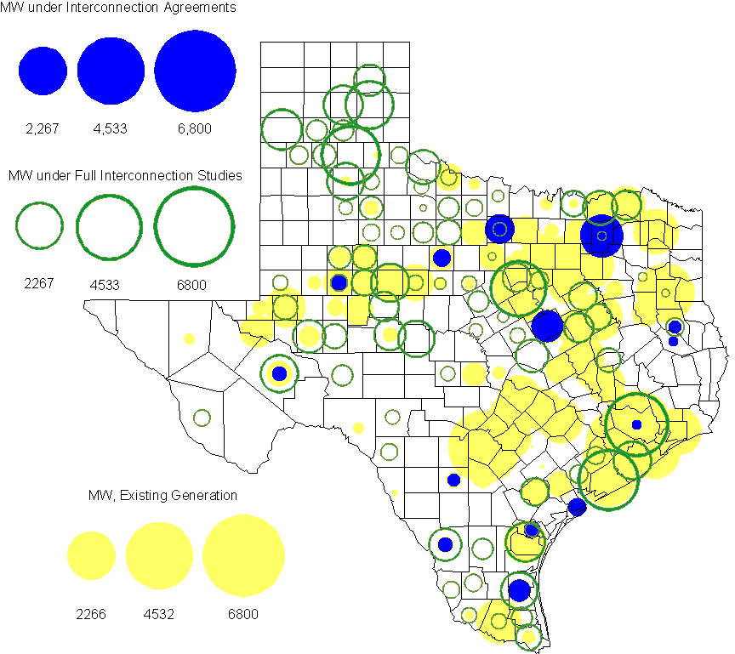

Generation Projects Undergoing Full Interconnection Studies
INR | County | Capacity | COD | Fuel |  | INR | County | Capacity | COD | Fuel
08INR0049 | Clay | 50 | TBD | Wind |  | 09INR0073 | Scurry | 200 | TBD | Wind
08INR0039 | Hamilton | 90 | TBD | Wind |  | 08INR0022 | Floyd | 100 | TBD | Wind
08INR0023 | Floyd | 100 | TBD | Wind |  | 09INR0051 | Borden | 249 | TBD | Wind
09INR0054 | Stonewall | 149 | TBD | Wind |  | 09INR0061 | Kent | 258 | TBD | Wind
09INR0065 | Webb | 150 | TBD | Wind |  | 10INR0048 | Hardeman | 1,000 | TBD | Wind
10INR0045 | Webb | 734 | Apr-10 | Wind |  | 10INR0046 | Jim Hogg | 264 | Apr-10 | Wind
10INR0054 | Palo Pinto | 36 | May-10 | Wind |  | 09INR0018 | Concho | 249 | May-10 | Wind
09INR0035 | Concho | 750 | May-10 | Wind |  | 07INR0032 | Tom Green | 249 | May-10 | Wind
10INR0016 | Childress | 150 | May-10 | Wind |  | 10INR0023 | Haskell | 386 | May-10 | Wind
09INR0069 | Reagan | 36 | May-10 | Wind |  | 09INR0070 | Reagan | 42 | May-10 | Wind
10INR0062a | Pecos | 50 | May-10 | Wind |  | 10INR0079 | Nolan | 60 | May-10 | Wind
10INR0069 | Rusk | 818 | May-10 | Coal |  | 10INR0029 | Hood | 810 | Jun-10 | Gas
09INR0081 | Rusk | 818 | Jun-10 | Coal |  | 10INR0035 | Harris | 416 | Jun-10 | Gas
10INR0013 | Upton | 400 | Jul-10 | Wind |  | 10INR0052a | Knox | 21 | Jul-10 | Wind
10INR0057 | Taylor | 200 | Jul-10 | Wind |  | 10INR0012 | Nacogdoches | 300 | Jul-10 | Gas
10INR0089 | Harris | 40 | Oct-10 | Other |  | 10INR0015 | Mitchell | 350 | Oct-10 | Wind
09INR0074 | Motley | 70 | Oct-10 | Wind |  | 10INR0041 | Floyd | 135 | Oct-10 | Wind
10INR0081a | Clay | 30 | Oct-10 | Wind |  | 11INR0029 | Throckmorton | 200 | Nov-10 | Wind
10INR0032 | Navarro | 800 | Dec-10 | Gas |  | 10INR0042 | Mason | 170 | Dec-10 | Wind
10INR0082 | Travis | 30 | Dec-10 | Solar |  | 09INR0076 | Jackson | 300 | Dec-10 | Wind
10INR0051 | Brazoria | 200 | Dec-10 | Wind |  | 07INR0013 | Coke | 200 | Dec-10 | Wind
07INR0015 | Foard | 180 | Dec-10 | Wind |  | 10INR0008 | Pecos | 500 | Dec-10 | Wind
07INR0026 | Baylor | 400 | Dec-10 | Wind |  | 07INR0035 | Tom Green | 270 | Dec-10 | Wind
08INR0061 | Hardeman | 200 | Dec-10 | Wind |  | 08INR0062 | Archer | 249 | Dec-10 | Wind
10INR0019 | Deaf Smith | 609 | Dec-10 | Wind |  | 10INR0033 | Armstrong | 420 | Dec-10 | Wind
10INR0080 | Presidio | 144 | Dec-10 | Solar |  | 10INR0056 | Borden | 249 | Dec-10 | Wind
10INR0077 | Callahan | 101 | Dec-10 | Wind |  | 11INR0012 | Duval | 400 | Dec-10 | Wind
10INR0060 | Willacy | 401 | Dec-10 | Wind |  | 09INR0041 | Mitchell | 300 | Dec-10 | Wind
11INR0050 | Crosby | 149 | Mar-11 | Wind |  | 11INR0037 | Smith | 55 | May-11 | Biomass
11INR0062 | Nueces | 149 | May-11 | Wind |  | 11INR0048 | Harris | 300 | May-11 | Gas
10INR0009 | Castro | 300 | May-11 | Wind |  | 10INR0062b | Pecos | 50 | May-11 | Wind
11INR0058 | Pecos | 135 | May-11 | Solar |  | 11INR0060 | Tom Green | 90 | May-11 | Solar
11INR0061 | Presidio | 90 | May-11 | Solar |  | 11INR0033a | Cameron | 200 | May-11 | Wind
11INR0033b | Cameron | 200 | May-11 | Wind |  | 09INR0050 | Fannin | 1,200 | Jun-11 | Gas
11INR0054 | San Patricio | 161 | Jun-11 | Wind |  | 11INR0057 | Cameron | 165 | Jun-11 | Wind
11INR0065 | Nueces | 240 | Jun-11 | Wind |  | 08INR0020 | Eastland | 200 | Jun-11 | Wind
11INR0019 | Upton | 200 | Jun-11 | Wind |  | 11INR0006 | Lamar | 579 | Jul-11 | Gas
11INR0040 | freestone | 749 | Aug-11 | Gas |  | 11INR0039 | Starr | 201 | Sep-11 | Wind
11INR0008a | Roberts | 1,000 | Sep-11 | Wind |  | 11INR0047 | Deaf Smith | 600 | Sep-11 | Wind
07INR0014a | Wilbarger | 140 | Oct-11 | Wind |  | 07INR0014b | Wilbarger | 70 | Oct-11 | Wind
10INR0081b | Clay | 19 | Oct-11 | Wind |  | 10INR0021 | Grayson | 646 | Nov-11 | Gas
11INR0013 | Mills | 150 | Dec-11 | Wind |  | 06INR0022d | Kenedy | 200 | Dec-11 | Wind
11INR0067 | Cameron | 78 | Dec-11 | Wind |  | 11INR0005 | Upton | 500 | Dec-11 | Wind
11INR0025 | Crockett | 400 | Dec-11 | Wind |  | 11INR0043 | Coke | 300 | Dec-11 | Wind
12INR0034 | Borden | 342 | Dec-11 | Wind |  | 09INR0048 | Jack | 150 | Dec-11 | Wind
09INR0075 | Kinney | 248 | Dec-11 | Wind |  | 12INR0021 | Edwards | 165 | Jan-12 | Wind
12INR0033 | Motley | 150 | Jan-12 | Wind |  | 10INR0018 | Madison | 550 | Mar-12 | Gas
12INR0007 | Lamar | 296 | May-12 | Gas |  | 11INR0049 | Wharton | 275 | May-12 | Gas
09INR0031 | Ector | 275 | May-12 | Gas |  | 10INR0062c | Pecos | 201 | May-12 | Wind
12INR0006 | Limestone | 875 | Jun-12 | Coal |  | 08INR0031 | Childress | 100 | Jun-12 | Wind
10INR0022 | Harris | 1,380 | Jun-12 | Gas |  | 12INR0002 | Briscoe | 750 | Jul-12 | Wind
08INR0041 | Coke | 200 | Oct-12 | Wind |  | 12INR0026 | Randall | 400 | Oct-12 | Wind
12INR0027 | Gray | 200 | Oct-12 | Wind |  | 12INR0035 | Nueces | 249 | Nov-12 | Wind
08INR0019a | Gray | 250 | Nov-12 | Wind |  | 08INR0019b | Gray | 250 | Nov-12 | Wind
08INR0019c | Gray | 250 | Nov-12 | Wind |  | 08INR0044 | Concho | 200 | Nov-12 | Wind
12INR0016 | Nueces | 1,200 | Nov-12 | Other |  | 08INR0054 | Comanche | 401 | Dec-12 | Wind
06INR0022f | Kenedy | 200 | Dec-12 | Wind |  | 12INR0022 | Hidalgo | 200 | Dec-12 | Wind
08INR0042 | Coke | 200 | Dec-12 | Wind |  | 09INR0025 | Concho | 180 | Dec-12 | Wind
08INR0056 | Nolan | 149 | Dec-12 | Wind |  | 12INR0005 | Floyd | 1,100 | Dec-12 | Wind
12INR0018 | Gray | 600 | Dec-12 | Wind |  | 12INR0029 | Swisher | 500 | Dec-12 | Wind
10INR0024 | Briscoe | 3,000 | Jan-13 | Wind |  | 09INR0058 | Howard | 250 | Mar-13 | Wind
13INR0005 | Carson | 600 | Oct-13 | Wind |  | 13INR0004 | Deaf Smith | 500 | Oct-13 | Wind
13INR0006 | Gray | 750 | Oct-13 | Wind |  | 06INR0022e | Kenedy | 200 | Dec-13 | Wind
09INR0077 | Reagan | 500 | Dec-13 | Wind |  | 14INR0002 | Goliad | 756 | Feb-14 | Coal
14INR0003 | Nolan | 850 | Jun-14 | Coal |  | 14INR0005 | Matagorda | 1,200 | Jul-14 | Coal
14INR0001 | Pecos | 500 | Dec-14 | Wind |  | 16INR0002 | Brazoria | 1,000 | Jun-17 | Other

Wind Generation
Wind Capacity Installed by Year

County Location of Installed Capacity and Interconnection Requests (Wind only)

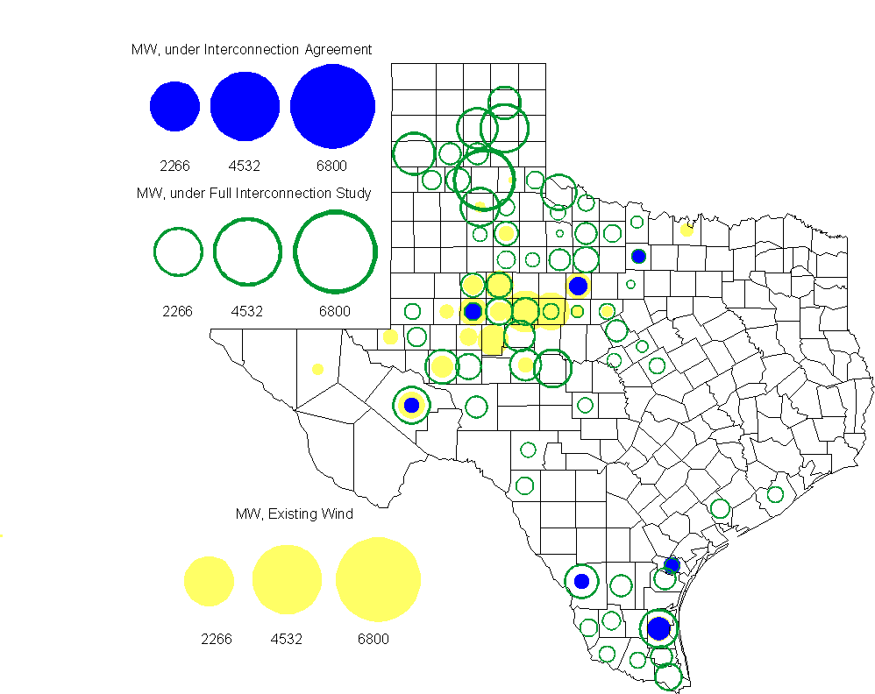

Regional Planning Group Project Reviews

Oncor submitted a project to relieve congestion related to new wind units in the Lamesa area. The project will upgrade the Lamesa to Bluff Creek 138 kV line, rebuild the Bluff Creek to China Grove 138 kV line, rebuild the Lamesa to Ackerly Vealmoor 69 kV line to 138/69 kV double circuit, rebuild the Lamesa 138 kV switching station, build a new 138 kV Ackerly Vealmoor station, add second circuits to all rebuilt lines and include station upgrades at China Grove and Big Spring. The cost of this project is $ 80.8 M. This project will be reviewed to ensure that the improvements fit into the likely CREZ transmission solution for the area. This project is in ERCOT Independent Review.

Oncor submitted a project to add several 345 kV circuits to support the addition of Comanche Peak units 3 and 4 in 2015 at an estimated cost of $ 133 M. These upgrades include a new 345 kV double circuit line with one circuit in place from Comanche to Whitney, a new 345 kV line from Comanche to Johnson Switch, a new circuit on existing structures from Johnson Switch to Everman, a new 345 kV double circuit with one circuit in place from Comanche to DeCordova, and a new 345 kV line on existing structures from Comanche to Parker Switch. This project is in ERCOT Independent Review and will be studied when the 2009 Five-Year Transmission Plan is complete.

Sharyland Utilities submitted a project to construct and operate the ERCOT Southeast Loop facilities consisting of a 345 kV double circuit from Lufkin to Canal 345 kV substation on the northeast side of Houston. This project will cost $359 M with an estimated completion date of summer 2013. This project is in ERCOT Independent Review.

Centerpoint Energy has submitted a project to construct a new 345 kV double circuit line to allow greater power imports into the Houston area. The project involves expanding the Fayetteville and Zenith substations and constructing a new 345 kV double circuit from Fayetteville to Zenith. The proposal also includes looping the Fayette Power Project to Salem 345 kV circuit into Fayetteville and upgrading the Fayette Power Project to Fayetteville 345 kV double circuit lines. The project is estimated to be complete by September 2014 at a cost of $222 M. This project is in ERCOT Independent Review.

Luminant Energy has submitted the Comanche Peak Area Congestion Mitigation Plan project to loop the future Parker to Everman 345 kV CREZ line into the Comanche Peak 345 kV switch station. Luminant Energy’s estimated completion date for this project is April 2010 and the estimated cost is $3 M. This project is in ERCOT Independent Review.

Luminant Energy submitted a proposal to either accelerate the Waco West to Waco Atco 138 kV line rebuild that is currently scheduled to be completed by the fall of 2010 or to open the line in order to prevent congestion. This project is in study mode.

Congestion Costs
Dollars shown in graphs are settlement quality.

OOMC – last 13 months in million$

OOM Down – last 13 months in million$

Local Balancing Energy Down – last 13 months in million$

OOM Up – last 13 months in million$

Local Balancing Energy Up – last 13 months in million$

Replacement Reserve – last 13 months in thousand$

Binding Constraints & Capacity Shortages– January, 2010

Contingency | Binding Element | Estimated Costs | Transmission Project | Clearance
 | Capacity Shortage | $ 1,710,015
Garfield-Onion & Hicross 138kV | Lytton Springs Autos | $ 1,065,839 | Lytton Springs Autotransformer Addition (10TPIT0058) | Outage:  Lytton Springs 345kV circuit breakers & 138kV ckt breakers
Basecase |  | $ 922,430 |  | Outage:  Center bus
 | Voltage - DFW | $ 769,116
WA Parish - O'Brien 345kV  Oasis - PH Robinson 345kV | Garrott - Midtown 138KV | $ 533,835 | Garrott - Midtown - Polk Ckt. 90 (11TPIT0072) | Outage:  Garrott – Blogett 138KV
Abilene Mulberry Creek - Bitter Creek & Long Creek - Sweetwater Cogen 345kV | Sterling County - Sterling City 69kV | $ 486,262 | CREZ | Outage:  Divide Switchyard - Twin Butte 345KV
Garfield - Onion & Hicross 138kV  Graham - Long Creek - Cook Field Rd 345kV | Abilene South - Potosi Tap 138kV | $ 411,094 | CREZ
 | RPRS | $ 400,001
 | Voltage Stability - Valley | $ 373,329
Dilley Switch – San Miguel Switch 138kV | Derby Sub – Pearsall Switch 69kV | $ 324,919 | Pearsall to Dilley 69 kV (09TPIT0189) | Outage:  Sonora - Cauthorn 138KV

Inter-zonal Congestion

Other Notable Activities
Five-Year Transmission Plan Update:
The 2009 Five-Year Transmission Plan report is undergoing final edits. Work on the 2010 Five-Year Transmission Plan has begun. The analysis is currently focused on identifying reliability concerns in the 2015 summer peak case and finding solutions for identified issues.

TPIT updates have begun. This marks the end of the one month delay in TPIT to better align with SSWG case building efforts. TPIT will resume its quarterly updates from this point forward.

Nodal Network Model Management System work has begun in earnest to prepare a Planning case for use in Annual Planning Studies and CRR Auctions in accordance with Nodal Protocols section 3.10. The key initial goal for this activity is to produce a Planning (Bus/Branch) model consistent with the Network Operations (Breaker) model for use in CRR Monthly Auctions during Market Trials and for CRR Monthly Auctions starting in October 2010.

Voltage Ride Through Study Update:
The vendor has reported their data collection efforts for Phase II has been completed. ERCOT is reviewing Phase II deliverables to ensure that sufficient data has been collected to model existing wind plants for Phase III of the study and for future VRT reliability tests. Phase III has started with preparation of a dynamic flat-start base case with (Phase II) wind models using PSSe v.31.

Voltage Stability Study for 2015 Summer on-peak conditions:
In preparation for the annual NERC Long-Term Reliability Assessment reporting, a voltage stability study has begun using the SSWG 2015 year summer on-peak base case to assess the reliability of the network. The study results will allow an assessment of the 2015 network model to meet voltage stability margin requirements for NERC B and NERC C contingencies.

