ERCOT Operations Report
February 2010 ROS & OWG

Frequency Control
Time | Freq(Hz) | Duration (s)
2/4/2010 6:42 | 59.89 | 15 | Unit trip with 225 MW
2/6/2010 20:37 | 59.89 | 4 | Unit trip with 500 MW
2/11/2010 13:40 | 59.85 | 44 | Unit trip with 640 MW
2/12/2010 10:20 | 59.86 | 56 | Unit trip with 640 MW
2/13/2010 1:22 | 59.82 | 55 | Unit trip with 613 MW
2/13/2010 3:10 | 60.11 | 95 | SCE +1181 MW in 15 min. Out of Down Regulation. Wind generation increased 1100 MW in 10 minutes.
2/14/2010 20:55 | 59.88 | 7 | Unit trip with 340 MW
2/15/2010 14:33 | 59.85 | 60 | Unit trip with 519 MW
2/18/2010 23:07 | 60.11 | 42 | Incorrect offset calculation. Out of Down Regulation.
2/19/2010 16:32 | 59.80 | 128 | Unit trip with 833 MW and 95 MW
2/24/2010 8:09 | 59.89 | 8 | Unit trip with 650 MW
2/24/2010 23:02 | 59.84 | 16 | Unit trip with 610 MW
2/25/2010 7:40 | 59.87 | 21 | Unit trip with 887 MW
2/27/2010 0:03 | 60.10 | 17 | SCE +874 MW in 7 min. Out of Down Regulation.
2/27/2010 22:55 | 59.79 | 85 | Unit trip with 800 MW
Note: Time of frequency excursions outside the range of +/- 0.1 Hz.

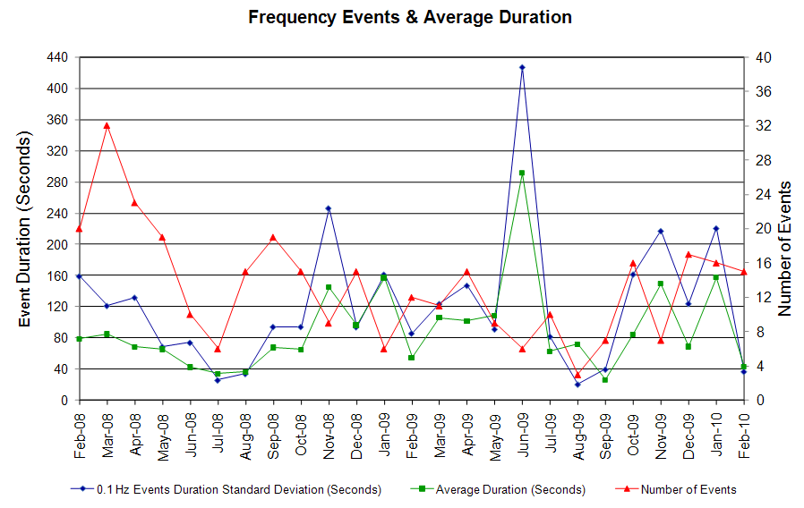

Deployed Responsive (Reported Above)
Time deployed | Stop Time | Duration | Max | Details
2/3 10:35:12 | 2/3 10:41:58 | 0:06:46 | 341.52 | Units Trip
2/4 06:42:56 | 2/4 06:55:56 | 0:13:00 | 416.22
2/4 09:41:14 | 2/4 09:51:56 | 0:10:42 | 325.50 | Units Trip
2/6 20:37:10 | 2/6 20:46:58 | 0:09:48 | 448.22
2/11 13:40:08 | 2/11 13:54:28 | 0:14:20 | 640.33
2/12 10:20:50 | 2/12 10:41:30 | 0:20:40 | 608.32
2/13 01:22:14 | 2/13 01:59:02 | 0:36:48 | 779.06
2/13 05:04:22 | 2/13 05:16:26 | 0:12:04 | 341.52 | SCE -1000 MW in 10 min
2/14 12:06:25 | 2/14 12:25:58 | 0:19:33 | 325.50 | SCE -830 MW in 15 min and out of up regulation
2/14 20:55:36 | 2/14 21:08:06 | 0:12:30 | 464.24
2/15 14:33:48 | 2/15 14:58:12 | 0:24:24 | 613.65
2/19 16:32:14 | 2/19 16:50:25 | 0:18:11 | 896.46
2/24 08:09:10 | 2/24 08:16:32 | 0:07:22 | 426.89
2/24 23:02:41 | 2/24 23:20:58 | 0:18:17 | 693.69
2/25 07:40:40 | 2/25 08:16:58 | 0:36:18 | 544.28
2/27 00:18:00 | 2/27 00:22:19 | 0:04:19 | 346.85 | SCE - 600 MW in 7 min
2/27 22:55:00 | 2/27 23:03:19 | 0:08:19 | 939.15

Day-Ahead OOMC and RPRS Capacity Purchases
Details | OOMC | RPRS S1 | RPRS S2 | RPRS S1+S2 | RMR | Total
DFW | 30 | 0 | 8 | 8 | 0 | 38
Austin | 16 | 6 | 10 | 16 | 0 | 32
North | 5 | 9 | 4 | 13 | 0 | 18
Houston | 0 | 2 | 16 | 18 | 0 | 18
W RIO | 11 | 4 | 0 | 4 | 0 | 15
Western | 0 | 1 | 7 | 8 | 7 | 15
E RIO | 1 | 2 | 1 | 3 | 0 | 4
South | 0 | 1 | 2 | 3 | 0 | 3
Corpus | 0 | 0 | 1 | 1 | 0 | 1
San Antonio | 0 | 0 | 0 | 0 | 0 | 0
Bryan Area | 0 | 0 | 0 | 0 | 0 | 0
Laredo | 0 | 0 | 0 | 0 | 0 | 0
Northeast | 0 | 0 | 0 | 0 | 0 | 0
Total | 63 | 25 | 49 | 74 | 7 | 144

Historical Totals | Feb-10 | Feb-09 | Jan-10
Austin | 22 | 6 | 25
Bryan Area | 0 | 0 | 0
Corpus | 0 | 0 | 0
DFW | 30 | 43 | 48
E RIO | 3 | 3 | 0
Houston | 2 | 11 | 16
Laredo | 0 | 6 | 0
North | 14 | 17 | 5
Northeast | 0 | 5 | 1
San Antonio | 0 | 1 | 5
South | 1 | 1 | 4
W RIO | 15 | 93 | 90
Western | 8 | 8 | 5
Total | 95 | 194 | 199
http://www.ercot.com/mktinfo/services/rprsdr/index.html

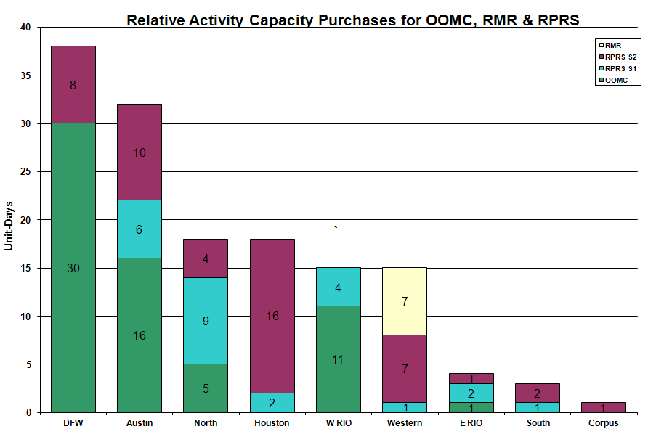

OOME and Congestion Management Activity
Congestion affected by outages Remedial action plan has been developed for the element
Contingency | Overloaded Element | Days
Garfield - Onion Creek & Hicross AEN 138KV | Lytton Springs 345/138KV AT #1 | 15
Dilley Switch - San Miguel 138KV | Derby - Pearsall 69KV | 13
Graham SES - Parker Switch 345KV | Flat Creek - Leon Switch 138KV | 13
San Miguel - Pearsall 138KV | Pearsall 138/69KV AT | 10
Hamilton Road - Sonora 138KV | Sonora - Friess Ranch 69KV | 10
Batesville - Pearsall 138KV | Pearsall 138/69KV AT | 7
Abilene Mulberry Creek - Bitter Creek and Long Creek - Sweetwater Cogen 345KV | Anson - Radium 69KV | 7
WA Parish - Obrien 345KV | Garrott - Midtown 138KV | 6
Base Case | Matador - Paducah REA Tap 69KV | 5
Morgan Creek SES - Quail Switch and Longshore Switching Station 345 kV | Morgan Creek SES 345/138KV At | 4
Graham - Parker Switch 345KV | Barton Switch - Oran TU 138KV | 4
Abilene Mulberry Creek - Bitter Creek and Long Creek - Sweetwater Cogen 345KV | Sterling County - Sterling City 69KV | 3
Base Case | Matador - Spur 69KV | 3
Oasis - PH Robinson 345KV | Garrott - Midtown 138KV | 3
Aspermont - Spur 138KV | Spur 138/69KV Auto | 2
Barney Davis - Airline and Rodd Field 138KV | Nelson Sharpe - Alazan 138KV | 2
Base Case | Notrees - Notrees Switch 138KV | 2
Duke - North Edinburg 138KV | Duke - Aderhold 138KV | 2
Graham - Long Creek - Cook Field Road Switch 345KV | Abilene South - Potosi Tap 138KV | 2
Grant - Thermal Energy Coop 138KV | Garrott - Midtown 138KV | 2
Sandow Switch - Austrop 345KV | Taylor West - Taylor 138KV | 2
STP - Hillje - Whitepoint 345KV | Blessing - Lolita 138KV | 2
Big Brown SES - Venus Switch 345KV | Richland Chambers - Trinidad SES 345KV | 1
Big Brown SES - Venus Switch 345KV | Crane LCRA - Crane Arco Tap 138KV | 1
Abilene Mulberry Creek - Bitter Creek and Long Creek - Sweetwater Cogen 345KV | San Angelo College Hills - Grape Creek Tap 69KV | 1
Abilene Mulberry Creek - Bitter Creek and Long Creek - Sweetwater Cogen 345KV | Abilene South - Potter 138KV | 1
Austrop - Sandow Switch 345KV | Hearne 138/69KV AT | 1
Base Case | Long Creek 2 Series Device | 1
Base Case | Divide autotransformer 1 | 1
Base Case | WKN Breaker - MEC Plainview Tap 69KV | 1
Enterprise - Trinidad & Martin Lake - Stryker Creek 345KV | Nacogdoches SE 345/138KV AT 1 | 1
Graham - Parker Switch 345KV | Barton Chapel - Crane 138KV | 1
Graham SES - Long Creek Switching Station & Graham SES - Cook Field Road Switch 345 kV | Putnam - Leon Switch 138 kV | 1
Hamilton - Sonora 138KV | Campwood - Rocksprings 69KV | 1
PH Robinson 345/138KV T2 autotransformer | Garrott - Midtown 138KV | 1
Temple Pecan Creek - Tradinghouse and Temple Switch - Lake Creek 345KV | Goldthwaite 138/69KV Auto | 1

Zonal OC1
CSC | Days
West – North | 12

New RAP, PCAP (Date indicates last update of RAP, PCAP not implementation date.)
None

New Procedures/Forms/Operations Bulletins
Date | Subject | Bulletin No.
02/26/2010 | Request for Unit Testing Form V1 Rev 1 | 463
02/02/2010 | Transmission and Security Desk V4 Rev 11 | 462
02/02/2010 | Shift Supervisor Desk V4 Rev 11 | 461
02/02/2010 | Operating Period Desk V3 Rev 7 | 460
02/02/2010 | Frequency Control Desk V4 Rev 10 | 459
02/02/2010 | Day-Ahead V4 Rev 9 | 458

Blackout/Load Shed Incidences
None

EEA
None

Major System Voltage Problems
None

Major Computer Problems, Enhancements & Fixes
None

Communication
None

ERCOT peak (Unofficial)
2/24 08:00 47,169 MW

Yearly MTLF Error Comparison
Yearly Mid-Term (Hourly) Load Forecast Error Comparison for the ERCOT Forecast
Month | MAPE for MTLF at 16:00 Day-Ahead
Month | 2007 | 2008 | 2009 | 2010
January | 4.55 | 3.30 | 4.11 | 3.78
February | 3.75 | 3.59 | 3.49 | 3.79
March | 2.70 | 3.29 | 3.24 | NA
April | 3.00 | 2.45 | 2.66 | NA
May | 3.22 | 3.01 | 2.90 | NA
June | 4.46 | 2.81 | 2.89 | NA
July | 4.29 | 2.55 | 2.83 | NA
August | 3.11 | 3.66 | 3.07 | NA
September | 3.78 | 4.99 | 3.68 | NA
October | 3.08 | 2.79 | 2.92 | NA
November | 2.95 | 2.60 | 1.93 | NA
December | 3.74 | 4.54 | 3.70 | NA
Annual Average | 3.55 | 3.29 | 3.11 | 3.78

OCN, Advisory, Watch & Emergency Notices
Capacity
Date | Start | End | Event
2/1/10 | 4:49 | 8:15 | OCN issued for a projected reserve capacity shortage for hours 07:00 to 10:00.
2/1/10 | 10:15 | 15:56 | BLT at Childress West transferring up to 17 MW of SPP load to ERCOT due to forced transmission outage.
2/6/10 | 2:02 | 4:25 | Advisory issued due to ARRS below 3000 MW.
2/6/10 | 2:55 | 4:25 | OCN issued due to a projected Reserve capacity shortage for HE 0900 - 1200.
2/6/10 | 19:15 | 0:00 | Advisory issued due to ARRS below 3000 MW.
2/7/10 | 0:15 | 7:00 | Advisory issued for ARRS below 3000 MW.
2/7/10 | 4:00 | 11:05 | OCN issued due to a projected Reserve capacity shortage for HE 0900 - 1000.
2/13/10 | 9:15 | 11:30 | Advisory issued for ARRS below 3000 MW.
2/14/10 | 20:50 | 22:50 | Advisory issued due to ARRS below 3000 MW.
2/15/10 | 5:00 | 9:30 | OCN issued for projected reserve capacity shortage for HE 07:00 - 11:00.
2/15/10 | 6:00 | 9:30 | Watch issued for projected reserve capacity shortage for HE 07:00 - 11:00.
2/15/10 | 7:21 | 9:30 | Advisory issued for ARRS below 3000 MW.
2/16/10 | 2:00 | 8:00 | OCN issued for projected reserve capacity shortage for HE 07:00 - 08:00.
2/16/10 | 4:00 | 9:00 | Watch issued for projected reserve capacity shortage for HE 07:00 - 11:00.
2/16/10 | 6:30 | 9:00 | Advisory issued for ARRS below 3000 MW.
2/22/10 | 10:20 | 10:50 | Advisory issued for ARRS below 3000 MW.
2/27/10 | 1:43 | 9:00 | Advisory issued for ARRS below 3000 MW.
2/27/10 | 3:26 | 9:00 | OCN issued for Projected Reserve Capacity Shortage for HE 10:00.
2/28/10 | 18:50 | 22:42 | Advisory issued for ARRS below 3000 MW.

Transmission Watch
None

Emergency Notice
None

Texas RE Event Analysis
2/14 14:24 Whirlwind SPS activated.

2/25 21:42 Lost connection to Market Operations Interface to C and D servers.

Others
2/03 13:38 Held Real-Time Balancing Market IE 12:45 and resumed with IE 13:15 due to operator not able to enter offset.

2/18 03:00 Held IE 0245 Balancing energy deployments for IE 0300 due to incorrect offset calculation. Resumed with IE 0315 deployments.

2/25 21:55 Held IE 22:00 deployment and resumed with IE 23:15 deployment.

