COPMGRR Number | 017 | COPMGRR Title | Creating Subsection 8.2, Settlement Statements and Invoices
Date
Submitter’s Information
Name |  | Amanda Bauld
E-mail Address |  | abauld@ercot.com
Company |  | ERCOT
Phone Number |  | 512-248-6455
Cell Number |  | 512-905.7646
Market Segment

Revised Proposed Guide Language Revision

8.2 Settlement Statements and Invoices
The Real-Time Market (RTM), the Day-Ahead Market (DAM), and the Congestion Revenue Right (CRR) Auction are settled separately. Each type of settlement has a unique set of statements and/or invoices and settles according to a different timeline. Settlement Statements and Invoices can apply to a registered CRR Account Holder (CRRAH), a registered Qualified Scheduling Entity (QSE), or both. The table below provides details regarding the various statements and invoices.
Type | Invoice or Statement | Recipient | Frequency | Post Timing | Payment Due
CRR | CRR Auction Invoice | - CRRAHs | Monthly | 1st Business Day after completion of a CRR Auction (Monthly and Annual CRR Auctions will be invoiced separately) | 3rd Bank Business Day after invoice posts (or next day that is both Business Day and Bank Business Day)
CRR | CRR Auction Revenue Distribution Invoice | - QSEs (with Load) | Monthly | 1st Business Day after RTM Initial Statement posts for the last day of the relevant month  and  1st Business Day after RTM Final Statement posts for the last day of the relevant month | 5th Bank Business Day after invoice posts (or next day that is both Business Day and Bank Business Day)
CRR | CRR Balancing Account Invoice | - CRRAH (due a shortfall refund)  - QSEs (with load) | Monthly | 1st Business Day after RTM Initial Statement posts for the last day of the relevant month | 1st Bank Business Day after the due date of the RTM Invoice that includes the RTM Initial Settlement statement for the last day of the month (or next day that is both Business Day and Bank Business Day)  Note: Payout to market only
DAM | DAM Statement | - QSEs  - CRRAHs | Daily | Operating Day + 2 (or next day Business Day) | n/a
DAM | DAM Resettlement Statement | - QSEs  - CRRAHs | Ad-Hoc | Ad-Hoc (on Business Day)  Note: Notice posted on MIS Public Area | n/a
DAM | DAM Invoice | - QSEs  - CRRAHs | Daily | Operating Day + 2 (or next day Business Day) | 4th Bank Business Day after invoice posts (or next day that is both Business Day and Bank Business Day)
DAM | DAM Late Fee Invoice  Charge  Credit | - QSEs  - CRRAHs | Monthly | 10th calendar day after the end of the relevant month (or next Business Day) | 4th Bank Business Day after invoice posts (or next day that is both Business Day and Bank Business Day)
RTM | RTM Initial Settlement Statement | - QSEs  - CRRAHs | Daily | Operating Day + 10 (or next day Business Day) | n/a
RTM | RTM Final Settlement Statement | - QSEs  - CRRAHs | Daily | Operating Day + 59 (or next day Business Day) | n/a
RTM | RTM True-Up Settlement Statement | - QSEs  - CRRAHs | Daily | Operating Day + 180 (or next day Business Day) | n/a
RTM | RTM Resettlement Settlement Statement | - QSEs  CRRAHs | Ad-Hoc | Ad-Hoc (on Business Day)  Note: Notice posted on MIS Public Area | n/a
RTM | RTM Invoice | - QSEs  - CRRAHs | Weekly | Thursdays (or next day Business Day) | 5th Bank Business Day after the invoice posts (or next day that is both Business Day and Bank Business Day)
RTM | RTM Uplift Invoice | - QSEs (with load) | Ad-Hoc | Ad-Hoc (on Business Day)  *Market Notice required | 5th Bank Business Day after the invoice posts, (or next day that is both Business Day and Bank Business Day)
RTM | RTM Late Fee Invoice  Charge  Credit | - QSEs  - CRRAHs | Monthly | 10th calendar day after the end of the relevant month (or next Business Day) | 4th Business Day after invoice posts (or next day that is both Business Day and Bank Business Day)
 | Miscellaneous Invoice | - QSEs  - CRRAHs | Ad-Hoc | Ad-Hoc (on Business Day)  *Market Notice required | Specified in the Market Notice

Upon approval and posting of statements and invoices, the associated data is sent to the Credit Monitoring & Management (CMM) system for use in credit calculations. Similarly, when payment is made to or from the QSE / CRRAH, the payment data is subsequently sent to the CMM system.
The Settlements Calendar Extract Qualified Scheduling Entity (QSE) Settlement and CRR Account Holder Statements are available on the Market Information System (MIS). The Settlement Calendar is provided as an extract and can be found on both the MIS Public Area under Settlements Reports and Extracts and on the ERCOT website. Supporting information for the Settlement Calendar (i.e. the Data Definition Language and Xtensible Markup Defintions) are also available on both the MIS Public Area and the ERCOT website.
Settlement details, including the supporting input, intermediate, and output settlement billing determinants and other data associated with Settlement Statements and Invoices are found in the appropriate extracts and reports. When viewing QSE / CRRAH Settlement Statements, a negative amount represents a payment due to the QSE / CRRAH and a positive amount represents a payment due to ERCOT. More information about the available extracts and reports, as well as example statements and invoices, are available on the MIS Public Area and on the ERCOT website. Descriptions and definitions for the billing determinants can be found on the ERCOT website in the Settlement Charge Matrix and in the relevant Protocol sections. (Also see Section 10, Extracts and Reports, of the Commercial Operations Market Guide (COPMG))
Information about the Settlements Calendar, Statements, and Invoices may be found in Protocol Section 9, Settlement and Billing.
8.2.1 Congestion Revenue Rights (CRR) Settlement Invoices

8.2.1.1 CRR Auction Award Invoices
Refer to Protocol Section 9.8, CRR Auction Award Invoices, and 9.9, Payment Process for CRR Auction Invoices, for details regarding CRR Auction invoicing. Monthly and Annual CRR Auctions are invoiced separately. Additionally, each year of the 2-year Annual Auction will be invoiced separately.
CRR Auction Invoice Timeline
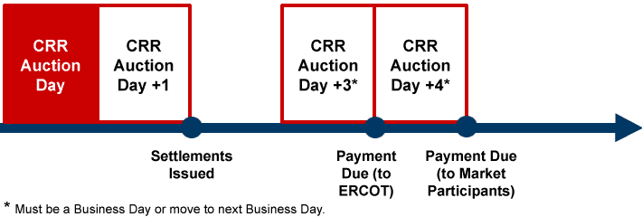

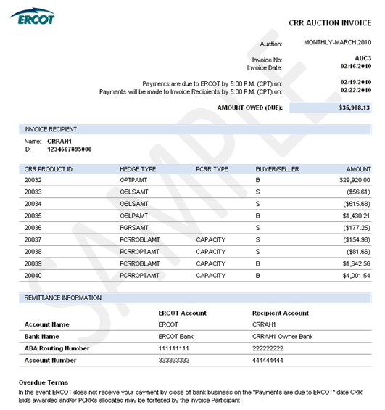
8.2.1.2 CRR Auction Revenue Distribution (CARD) Invoice
Refer to Protocol Section 9.10, CRR Auction Revenue Distribution Invoices, and 9.11, Payment Process for CRR Auction Revenue Distribution, for details regarding CARD invoicing. The ‘Time Period’ label on the invoice indicates the month relevant to the CRR Auction revenue being paid out to QSEs.

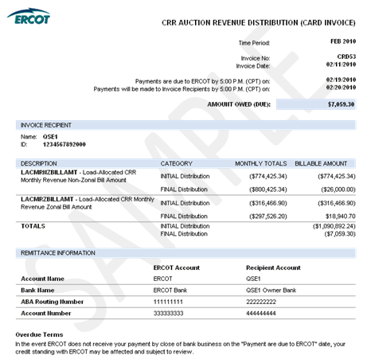

8.2.1.3 CRR Balancing Account (CRRBA) Invoice
Refer to Protocol Section 9.12, CRR Balancing Account Invoices, and 9.13, Payment Process for CRR Balancing Account, for details regarding CRRBA invoicing. The ‘Time Period’ label on the invoice indicates the month relevant to the Balancing Account funds being paid out to CRRAHs and/or QSEs.

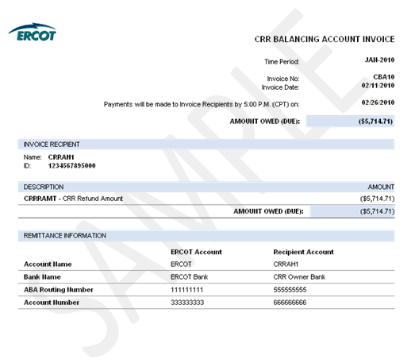

8.2.2 Day-Ahead Market Statements and Invoices
The DAM statements and Invoices for CRR Account Holders and QSEs are issued two days after the Operating Day.
Refer to Protocol Section 9.2, Settlement Statements for the Day-Ahead Market, for details regarding DAM Settlement Statements.
Refer to Protocol Section 9.3, Settlement Invoices for the DAM, and 9.4, Payment Process for the DAM, for details regarding the DAM invoicing process.

DAM Statement and Invoice Timeline
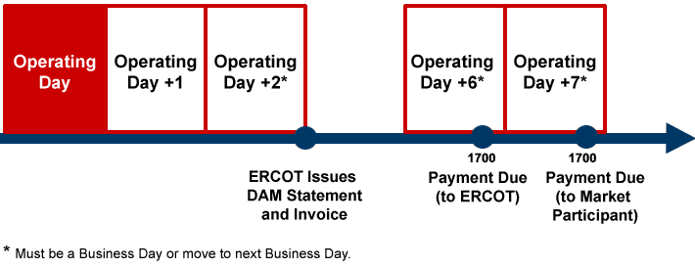
8.2.2.1 DAM Statement
Refer to Protocol Section 9.2, Settlement Statements for the Day-Ahead Market, for details regarding DAM Settlement Statements.

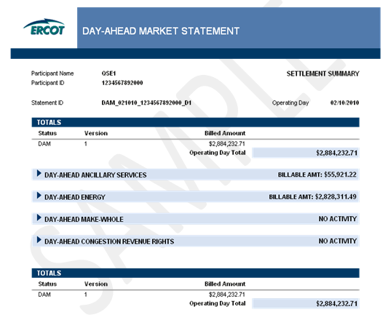

8.2.2.2 DAM Resettlement Statement
<Add text describing DAM Resettlement Statement>
8.2.2.3 DAM Invoice
Refer to Protocol Section 9.3, Settlement Invoices for the DAM, and 9.4, Payment Process for the DAM, for details regarding DAM invoicing.

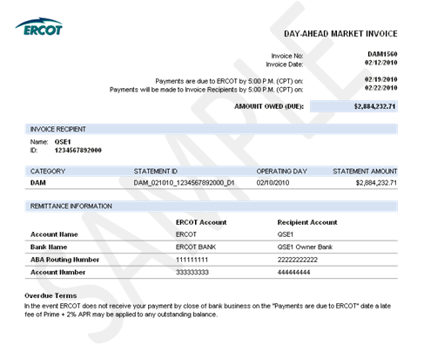
8.2.2.4 DAM Resettlement Invoice

<Add text describing DAM Resettlement Invoice>

8.2.2.5 DAM Late Fee Invoice
Refer to Protocol Section 9.4.5, Late Fees and Late Fee Invoices for the DAM, for details regarding the DAM Late Fee invoicing process.
Late Fee Charge Invoice
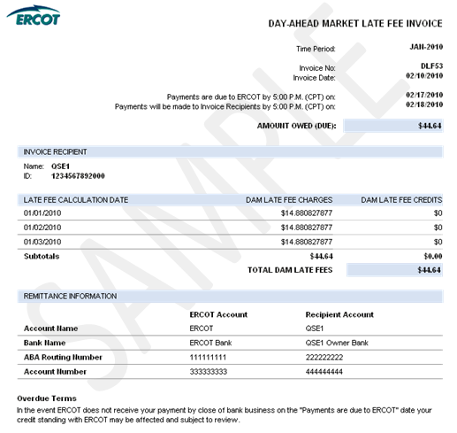

Late Fee Credit Invoice
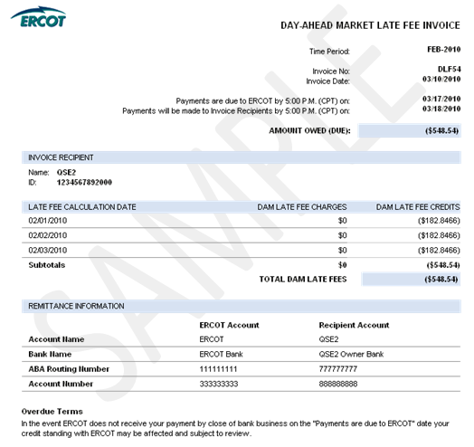
8.2.3 Real-Time Market Statements and Invoices

8.2.3.1 Real-Time Market Statements
Refer to Protocol Section 9.5, Settlement Statements for the RTM, for details regarding RTM Settlement Statements.
There are four types of RTM Settlement Statements: Initial, Final, True-Up and Resettlement.
The figure below illustrates the timing of each. Resettlements can occur at any point in accordance with Section 9.5.6, RTM Resettlement Statement.

RTM Statement Timeline

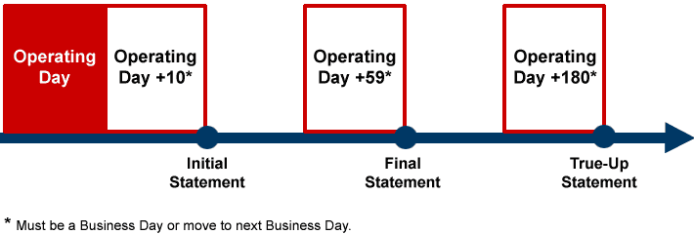

8.2.3.1.1 RTM Initial Statement

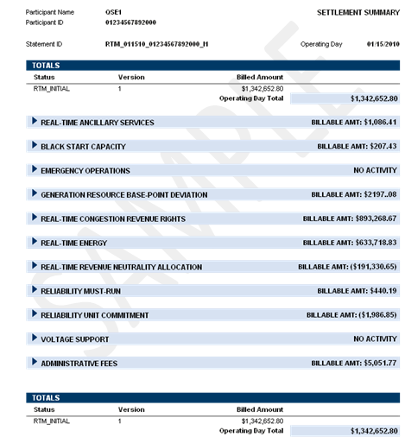

8.2.3.1.2 RTM Final Statement
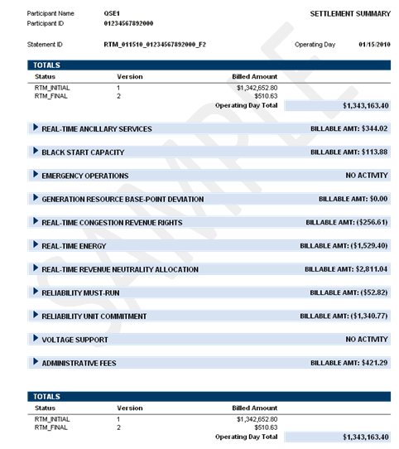

8.2.3.1.3 RTM True-Up Statement

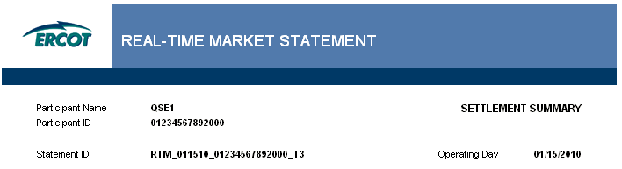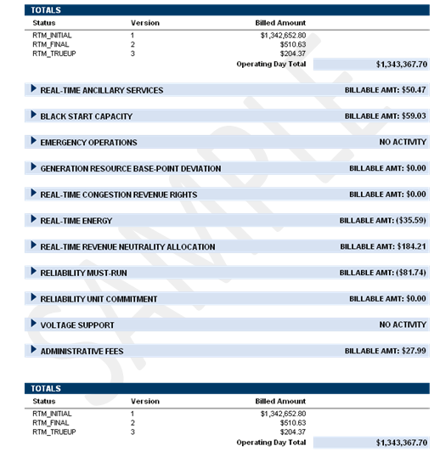
8.2.3.1.4 RTM Resettlement Statement

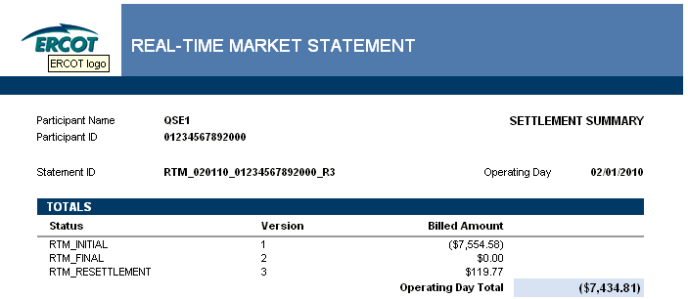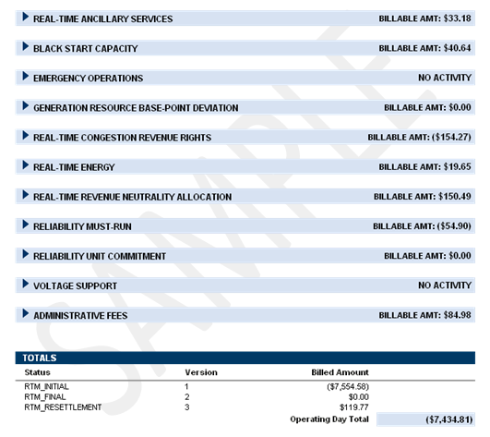

8.2.3.2 Real-Time Market Invoice
Refer to Protocol Section 9.6, Settlement Invoices for the Real-Time Market, for details regarding the RTM invoicing process.

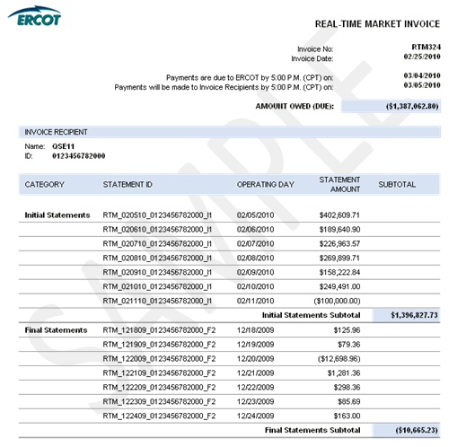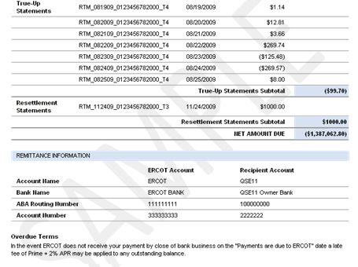

8.2.3.3 RTM Uplift Invoice
Refer to Protocol Section 9.7.3.1, RTM Uplift Invoices, and 9.7.3.2, Payment Process for RTM Uplift Invoices, for details regarding the RTM Uplift Invoicing Process.
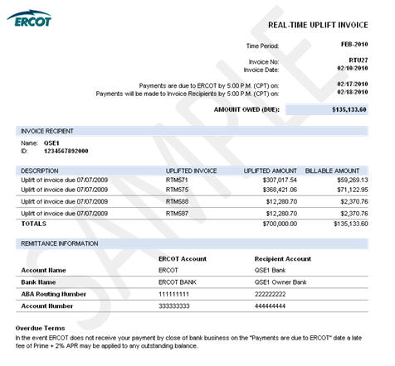

8.2.3.4 RTM Late Fee Invoice
Refer to Protocol Section 9.7.5, Late Fees and Late Fee Invoices, for details regarding the RTM Late Fee Invoicing Process.
RTM Late Fee Charge Invoice

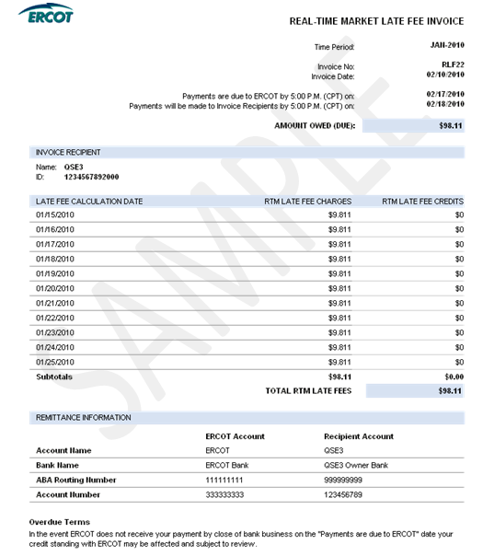

RTM Late Fee Credit Invoice

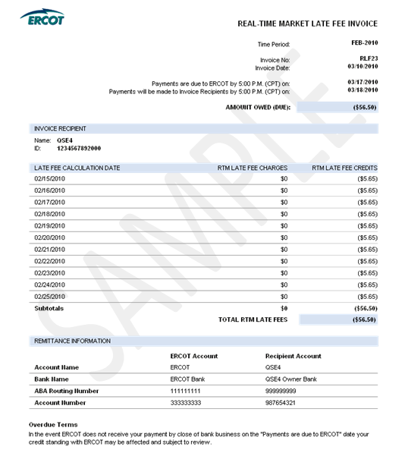

8.2.4 Miscellaneous Invoice

<Reference Section 8.1 and add generic sample>

