 |  |  |  | System Planning Division
Monthly Status Report
to
Reliability and Operations Subcommittee
for
January 2010

 |  | Report Highlights
Item
1. | - ERCOT is currently tracking 219 active generation interconnection requests totaling over 73,000 MW. This includes almost 45,000 MW of wind generation.
2. | - Regional Planning is currently reviewing proposed transmission improvements with a total of $798.0 Million  - Transmission Projects approved in 2009 total $405.1 Million  - All projects (in engineering, routing, licensing and construction) total approximately $9.5 Billion  - Transmission Projects energized in 2009 total about $538.6 million

Table of Contents
1. Generation Interconnection 1
1.1 New Generation Beginning Commercial Operations 1
1.2 New Generation Interconnection Agreements 1
1.3 Summary of Active Generation Interconnection Requests 1
1.4 Publicly Disclosed Generation Interconnection Projects 4
1.5 Generation Projects Undergoing Full Interconnection Studies 6
1.6 Wind Generation 8
2. Regional Planning Group Project Reviews 10
3. Other Notable Activities 16

1. Generation Interconnection
Additional information regarding detailed generation interconnection and impact studies is contained in the “Generation Project Interconnection Information” folder in the “Operations and System Planning” area on the ERCOT website: http://planning.ercot.com/login/login.

New Generation Registering for Commercial Operations

Comanche Peak 1&2 Upgrade (09INR0015) Nuclear in Somervell County for 86 MW

VH Braunig (09INR0028) Gas-CT in Bexar County for 185 MW

The total installed wind capacity remains at 8,916 MW, of which 7,958 MW (89%) is located within the Western Congestion Management Zone. Realignment of 2010 CM Zones accounted for this increase in percentage.

New Generation Interconnection Agreements - none

Summary of Active Generation Interconnection Requests

GENERATION INTERCONNECTION REQUESTS CURRENTLY BEING PROCESSED
Currently tracking 219 active generation interconnection or change requests
As of January 31, 2010 | North | South | West | Total
Security Screening Study | 7 | 6 | 12 | 25
SSS Completed | 7 | 8 | 12 | 27
Full Interconnect Study | 23 | 22 | 86 | 131
FIS Completed | 3 | 11 | 3 | 17
Interconnect Agreement Completed | 6 | 8 | 5 | 19
Capacity under Interconnection Agreements | 3,632 | 1,259 | 626 | 5,517
Capacity for Grid, MW | 19,945 | 19,148 | 34,245 | 73,338
Wind Capacity, MW | 4,681 | 8,211 | 31,980 | 44,872

Fuel Type | Confidential Projects (MW) | Projects Under Full Study (MW) | Projects w/ Interconnect Agreement/Public Letter (MW) | Grand Total (MW)
Gas-CC |  |  | 3,554 | 13,575
Gas-CT |  |  | 194 | 544
Total Gas | 1,879 | 8,492 | 3,748 | 14,119
Nuclear |  |  | 5,900 | 5,900
Coal | 15 | 3,712 | 1,353 | 5,080
Wind | 7,476 | 31,258 | 6,138 | 44,872
Solar | 529 | 489 |  | 1,018
Biomass | 58 | 50 | 145 | 253
Other | 156 | 1,940 |  | 2,096
Grand Total | 10,113 | 45,941 | 17,284 | 73,338

Publicly Disclosed Generation Interconnection Projects
The table below summarizes the publicly disclosed generation projects for the ERCOT region.
(IA=Interconnect Agreement, PL=Public Letter, XX= cancelled)

Generation Interconnections as of January 31, 2010
INR |  | SiteName | Status | County | Region | COD | Fuel Type | MW For Grid | Change from Last Report
08INR0038 |  | M Bar Wind | PL | Andrews | West | TBD | Wind | 194 | Date
11INR0014 |  | TECO Central Plant | IA | Harris | South | Feb-10 | Gas-CC | 50
08INR0033 |  | Lufkin | IA | Angelina | North | Apr-10 | Biomass | 45
09INR0082 |  | Cedro Hill Wind | IA | Webb | South | May-10 | Wind | 150
09INR0079b |  | Pearsall Expansion | IA | Frio | South | Jun-10 | Gas-CT | 100
09INR0045 |  | Sand Hill Peakers | IA | Travis | South | Jul-10 | Gas-CT | 94
06INR0012b |  | Sherbino Mesa Wind Farm 2 | IA | Pecos | West | Jul-10 | Wind | 150
05INR0015c |  | Gulf Wind 3 | PL | Kenedy | South | Sep-10 | Wind | 400
05INR0015b |  | Gulf Wind 2 | PL | Kenedy | South | Oct-10 | Wind | 400
08INR0011 |  | Senate Wind Project | IA | Jack | North | Nov-10 | Wind | 150
04INR0011b |  | Cedar Elm | IA | Shackelford | West | Dec-10 | Wind | 136
09INR0029 |  | CFB Power Plant Units 11&12 | IA | Calhoun | South | Dec-10 | Coal | 263
12INR0003 |  | Throckmorton Wind Farm | PL | Throckmorton | West | Dec-10 | Wind | 400
06INR0022c |  | Penascal Wind Farm 2 | IA | Kenedy | South | Dec-10 | Wind | 202
08INR0065 |  | Buffalo Gap 4 and 5 | PL | Nolan | West | Mar-11 | Wind | 465
10INR0020 |  | Panda Temple Power | PL | Bell | North | May-11 | Gas-CC | 1092
10INR0010 |  | Jack County 2 | IA | Jack | North | Jun-11 | Gas-CC | 620
08INR0018 |  | Gunsight Mountain | IA | Howard | West | Aug-11 | Wind | 120
04INR0011c |  | Cottonwood Wind | IA | Shackelford | West | Dec-11 | Wind | 100
06INR0026 |  | Wild Horse Mountain | IA | Howard | West | Dec-11 | Wind | 120
09INR0034 |  | Gatesville Wind Farm | PL | Coryell | North | Dec-11 | Wind | 200 | Date
08INR0025 |  | Pistol Hill Energy Center | PL | Ector | West | Dec-11 | Wind | 300
06INR0022b |  | Penascal Wind Farm 3 | IA | Kenedy | South | Dec-11 | Wind | 202
09INR0007 |  | Nacogdoches Project | IA | Nacogdoches | North | Apr-12 | Biomass | 100
07INR0004 |  | Pampa Energy Center | PL | Gray | West | May-12 | Coal | 165
09INR0001 |  | Sandy Creek 1 | IA | McLennan | North | Jun-12 | Coal | 925
09INR0024 |  | B&B Panhandle Wind | PL | Carson | West | Jun-12 | Wind | 1001
09INR0037 |  | Scurry County Wind III | PL | Scurry | West | Jun-12 | Wind | 350 | Date
12INR0004 |  | Fort Concho Wind Farm | PL | Tom Green | West | Jul-12 | Wind | 400
09INR0036 |  | McAdoo Energy Center II | PL | Dickens | West | Dec-12 | Wind | 500
06INR0006 |  | Cobisa-Greenville | IA | Hunt | North | May-13 | Gas-CC | 1792
15INR0002 |  | Comanche Peak 3 and 4 | PL | Somervel | North | Jan-15 | Nuclear | 3200
15INR0008 |  | STP 3 and 4 | PL | Matagorda | South | Jan-15 | Nuclear | 2700
08INR0012b |  | Papalote Creek Phase 2 | IA | San Patricio | South | Dec-10 | Wind | 198
09INR0026a |  | Sterling Energy Center | XX | Sterling | West | Jun-12 | Wind | 200
09INR0026 |  | Sterling Energy Center | XX | Sterling | West | Jun-12 | Wind | 300
08INR0040 |  | Lenorah Project | XX | Martin | West | Sep-12 | Wind | 251
 |  |  |  |  |  |  | Total | 17,284

County Location of Installed Generation and Interconnection Requests (all fuels)

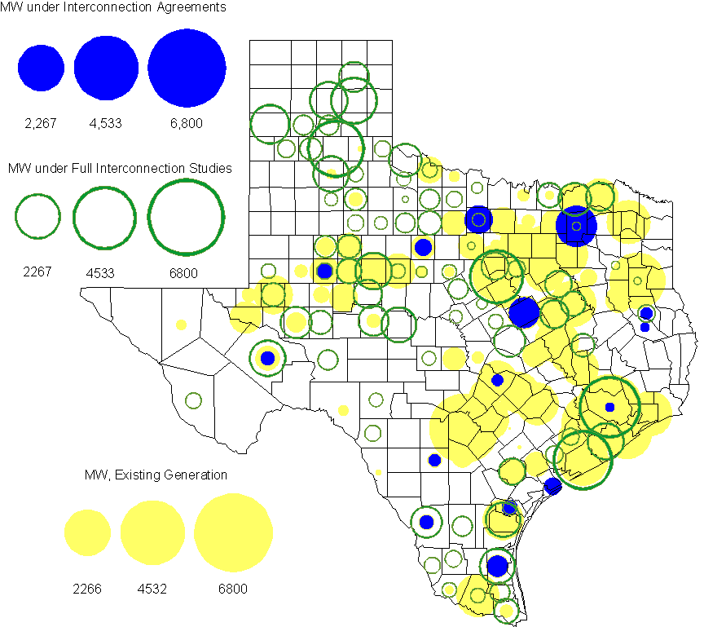

Generation Projects Undergoing Full Interconnection Studies
INR | County | Capacity | COD | Fuel |  | INR | County | Capacity | COD | Fuel
08INR0049 | Clay | 50 | TBD | Wind |  | 09INR0073 | Scurry | 200 | TBD | Wind
08INR0022 | Floyd | 100 | TBD | Wind |  | 08INR0023 | Floyd | 100 | TBD | Wind
08INR0039 | Hamilton | 90 | TBD | Wind |  | 08INR0056 | Nolan | 149 | TBD | Wind
09INR0051 | Borden | 249 | TBD | Wind |  | 09INR0054 | Stonewall | 148.5 | TBD | Wind
09INR0061 | Kent | 258 | TBD | Wind |  | 09INR0065 | Webb | 150 | TBD | Wind
10INR0048 | Hardeman | 1000 | TBD | Wind |  | 10INR0045 | Webb | 734 | Apr-10 | Wind
10INR0046 | Jim Hogg | 264 | Apr-10 | Wind |  | 09INR0018 | Concho | 249 | May-10 | Wind
09INR0035 | Concho | 750 | May-10 | Wind |  | 07INR0032 | Tom Green | 249 | May-10 | Wind
10INR0016 | Childress | 150 | May-10 | Wind |  | 10INR0023 | Haskell | 386 | May-10 | Wind
09INR0069 | Reagan | 36 | May-10 | Wind |  | 09INR0070 | Reagan | 42 | May-10 | Wind
10INR0054 | Palo Pinto | 36 | May-10 | Wind |  | 10INR0062a | Pecos | 49.5 | May-10 | Wind
10INR0079 | Nolan | 60 | May-10 | Wind |  | 10INR0069 | Rusk | 818 | May-10 | Coal
10INR0029 | Hood | 810 | Jun-10 | Gas |  | 10INR0035 | Harris | 416 | Jun-10 | Gas
09INR0081 | Rusk | 818 | Jun-10 | Coal |  | 10INR0013 | Upton | 400 | Jul-10 | Wind
10INR0012 | Nacogdoches | 300 | Jul-10 | Gas |  | 10INR0052a | Knox | 21 | Jul-10 | Wind
10INR0057 | Taylor | 200 | Jul-10 | Wind |  | 10INR0070 | Hunt | 50 | Jul-10 | Gas
10INR0015 | Mitchell | 350 | Oct-10 | Wind |  | 09INR0074 | Motley | 70 | Oct-10 | Wind
10INR0041 | Floyd | 135 | Oct-10 | Wind |  | 10INR0081a | Clay | 30.4 | Oct-10 | Wind
10INR0089 | Harris | 40 | Oct-10 | Other |  | 11INR0029 | Throckmorton | 200 | Nov-10 | Wind
07INR0013 | Coke | 200 | Dec-10 | Wind |  | 07INR0015 | Foard | 180 | Dec-10 | Wind
10INR0008 | Pecos | 500 | Dec-10 | Wind |  | 07INR0026 | Baylor | 400 | Dec-10 | Wind
07INR0035 | Tom Green | 270 | Dec-10 | Wind |  | 08INR0061 | Hardeman | 200 | Dec-10 | Wind
08INR0062 | Archer | 249 | Dec-10 | Wind |  | 10INR0019 | Deaf Smith | 609 | Dec-10 | Wind
11INR0012 | Duval | 400 | Dec-10 | Wind |  | 10INR0032 | Navarro | 800 | Dec-10 | Gas
10INR0033 | Armstrong | 420 | Dec-10 | Wind |  | 10INR0042 | Mason | 170 | Dec-10 | Wind
09INR0076 | Jackson | 300 | Dec-10 | Wind |  | 10INR0080 | Presidio | 144 | Dec-10 | Solar
10INR0056 | Borden | 249 | Dec-10 | Wind |  | 10INR0060 | Willacy | 400.5 | Dec-10 | Wind
10INR0077 | Callahan | 101 | Dec-10 | Wind |  | 10INR0051 | Brazoria | 200 | Dec-10 | Wind
10INR0082 | Travis | 30 | Dec-10 | Solar |  | 09INR0041 | Mitchell | 300 | Dec-10 | Wind
11INR0050 | Crosby | 149 | Mar-11 | Wind |  | 10INR0009 | Castro | 300 | May-11 | Wind
11INR0062 | Nueces | 149 | May-11 | Wind |  | 11INR0037 | Smith | 55 | May-11 | Biomass
10INR0062b | Pecos | 49.5 | May-11 | Wind |  | 11INR0048 | Harris | 300 | May-11 | Gas
11INR0058 | Pecos | 135 | May-11 | Solar |  | 11INR0060 | Tom Green | 90 | May-11 | Solar
11INR0061 | Presidio | 90 | May-11 | Solar |  | 11INR0033a | Cameron | 200 | May-11 | Wind
11INR0033b | Cameron | 200 | May-11 | Wind |  | 08INR0020 | Eastland | 200 | Jun-11 | Wind
09INR0050 | Fannin | 1200 | Jun-11 | Gas |  | 11INR0019 | Upton | 200 | Jun-11 | Wind
11INR0054 | San Patricio | 161 | Jun-11 | Wind |  | 11INR0057 | Cameron | 165 | Jun-11 | Wind
11INR0065 | Nueces | 240 | Jun-11 | Wind |  | 11INR0006 | Lamar | 579 | Jul-11 | Gas
11INR0040 | freestone | 749 | Aug-11 | Gas |  | 11INR0008a | Roberts | 1000 | Sep-11 | Wind
11INR0039 | Starr | 201 | Sep-11 | Wind |  | 11INR0047 | Deaf Smith | 600 | Sep-11 | Wind
07INR0014a | Wilbarger | 140 | Oct-11 | Wind |  | 07INR0014b | Wilbarger | 70 | Oct-11 | Wind
10INR0081b | Clay | 19.2 | Oct-11 | Wind |  | 10INR0021 | Grayson | 646 | Nov-11 | Gas
06INR0022d | Kenedy | 200 | Dec-11 | Wind |  | 11INR0005 | Upton | 500 | Dec-11 | Wind
11INR0013 | Mills | 150 | Dec-11 | Wind |  | 11INR0025 | Crockett | 400 | Dec-11 | Wind
11INR0043 | Coke | 300 | Dec-11 | Wind |  | 10INR0071 | Matagorda | 75 | Dec-11 | Wind
11INR0067 | Cameron | 78 | Dec-11 | Wind |  | 12INR0034 | Borden | 342 | Dec-11 | Wind
09INR0048 | Jack | 150 | Dec-11 | Wind |  | 09INR0075 | Kinney | 248 | Dec-11 | Wind
12INR0021 | Edwards | 165 | Jan-12 | Wind |  | 12INR0033 | Motley | 150 | Jan-12 | Wind
10INR0018 | Madison | 550 | Mar-12 | Gas |  | 09INR0031 | Ector | 275 | May-12 | Gas
12INR0007 | Lamar | 296 | May-12 | Gas |  | 10INR0062c | Pecos | 201 | May-12 | Wind
11INR0049 | Wharton | 275 | May-12 | Gas |  | 08INR0031 | Childress | 100 | Jun-12 | Wind
12INR0006 | Limestone | 875 | Jun-12 | Coal |  | 10INR0022 | Harris | 1380 | Jun-12 | Gas
12INR0002 | Briscoe | 750 | Jul-12 | Wind |  | 08INR0041 | Coke | 200 | Oct-12 | Wind
12INR0026 | Randall | 400 | Oct-12 | Wind |  | 12INR0027 | Gray | 200 | Oct-12 | Wind
08INR0019a | Gray | 250 | Nov-12 | Wind |  | 08INR0019b | Gray | 250 | Nov-12 | Wind
08INR0019c | Gray | 250 | Nov-12 | Wind |  | 08INR0044 | Concho | 200 | Nov-12 | Wind
12INR0016 | Nueces | 1200 | Nov-12 | Other |  | 06INR0022f | Kenedy | 200 | Dec-12 | Wind
08INR0054 | Comanche | 401 | Dec-12 | Wind |  | 08INR0042 | Coke | 200 | Dec-12 | Wind
09INR0025 | Concho | 180 | Dec-12 | Wind |  | 12INR0005 | Floyd | 1100 | Dec-12 | Wind
12INR0018 | Gray | 600 | Dec-12 | Wind |  | 12INR0022 | Hidalgo | 200 | Dec-12 | Wind
12INR0029 | Swisher | 500 | Dec-12 | Wind |  | 10INR0024 | Briscoe | 3000 | Jan-13 | Wind
09INR0058 | Howard | 250 | Mar-13 | Wind |  | 13INR0004 | Deaf Smith | 500 | Oct-13 | Wind
13INR0005 | Carson | 600 | Oct-13 | Wind |  | 13INR0006 | Gray | 750 | Oct-13 | Wind
06INR0022e | Kenedy | 200 | Dec-13 | Wind |  | 09INR0077 | Reagan | 500 | Dec-13 | Wind
14INR0002 | Goliad | 756 | Feb-14 | Coal |  | 14INR0003 | Nolan | 850 | Jun-14 | Coal
14INR0005 | Matagorda | 1200 | Jul-14 | Coal |  | 14INR0001 | Pecos | 500 | Dec-14 | Wind
16INR0002 | Brazoria | 1000 | Jun-17 | Other

Wind Generation
Wind Capacity Installed by Year

County Location of Installed Capacity and Interconnection Requests (Wind only)

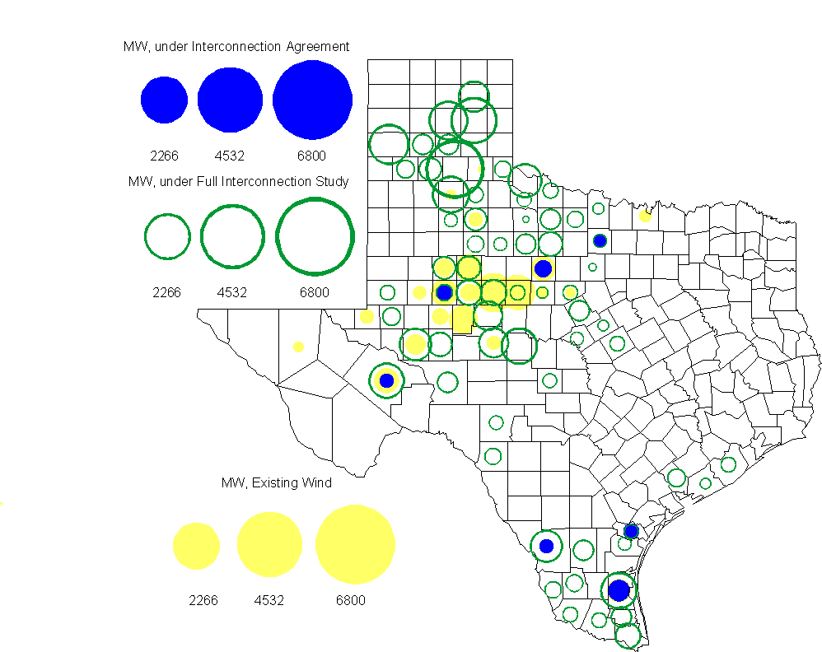

Regional Planning Group Project Reviews

Oncor submitted a project to relieve congestion related to new wind units in the Lamesa area. The project will upgrade the Lamesa to Bluff Creek 138 kV line, rebuild the Bluff Creek to China Grove 138 kV line, rebuild the Lamesa to Ackerly Vealmoor 69 kV line to 138/69 kV double circuit, rebuild the Lamesa 138 kV switching station, build a new 138 kV Ackerly Vealmoor station, add second circuits to all rebuilt lines and include station upgrades at China Grove and Big Spring. The cost of this project is $ 80.8 M. This project will be reviewed to ensure that the improvements fit into the likely CREZ transmission solution for the area. This project is in ERCOT Independent Review.

Oncor submitted a project to add several 345 kV circuits to support the addition of Comanche Peak units 3 and 4 in 2015 at an estimated cost of $ 133 M. These upgrades include a new 345 kV double circuit line with one circuit in place from Comanche to Whitney, a new 345 kV line from Comanche to Johnson Switch, a new circuit on existing structures from Johnson Switch to Everman, a new 345 kV double circuit with one circuit in place from Comanche to DeCordova, and a new 345 kV line on existing structures from Comanche to Parker Switch. This project is in ERCOT Independent Review and will be studied when the 2009 Five-Year Transmission Plan is complete.

Sharyland Utilities submitted a project to construct and operate the ERCOT Southeast Loop facilities consisting of a 345 kV double circuit from Lufkin to Canal 345 kV substation on the northeast side of Houston. This project will cost $359 M with an estimated completion date of summer 2013. This project is in ERCOT Independent Review.

Centerpoint Energy has submitted a project to construct a new 345 kV double circuit line to allow greater power imports into the Houston area. The project involves expanding the Fayetteville and Zenith substations and constructing a new 345 kV double circuit from Fayetteville to Zenith. The proposal also includes looping the Fayette Power Project to Salem 345 kV circuit into Fayetteville and upgrading the Fayette Power Project to Fayetteville 345 kV double circuit lines. The project is estimated to be complete by September 2014 at a cost of $222 M. This project is in ERCOT Independent Review.

Luminant Energy has submitted the Comanche Peak Area Congestion Mitigation Plan project to loop the future Parker to Everman 345 kV CREZ line into the Comanche Peak 345 kV switch station. Luminant Energy’s estimated completion date for this project is April 2010 and the estimated cost is $3 M. This project is in ERCOT Independent Review.

Luminant Energy submitted a proposal to either accelerate the Waco West to Waco Atco 138 kV line rebuild that is currently scheduled to be completed by the fall of 2010 or to open the line in order to prevent congestion. This project is in study mode.

Congestion Costs
Dollars shown in graphs are settlement quality.

OOMC – last 13 months in million$

OOM Down – last 13 months in million$

Local Balancing Energy Down – last 13 months in million$

OOM Up – last 13 months in million$

Local Balancing Energy Up – last 13 months in million$

Replacement Reserve – last 13 months in thousand$

Binding Constraints & Capacity Shortages– January, 2010

Contingency | Binding Element | Estimated Costs | Transmission Project | Clearance
 | Capacity Shortage | $ 5,755,464
Garfield-Onion & Hicross 138kV | Lytton Springs Autos | $ 3,664,450 |  | Outage:  Lytton Springs 345kV circuit breakers & 138kV ckt breakers
 | Voltage - DFW | $ 2,112,194
Graham SES – Parker Switch 345kV | Graham Auto | $ 2,073,749 |  | Outage:  Jacksboro Switching to Bowman Switch, Jacksboro Switching to West Denton, Willow Creek - Parker Switch, Willow Creek - Wise Tractebel (East Line) 345kV circuits 345 kV
Graham SES – Parker Switch 345kV | Leon Switch – Putnam 138kV | $ 2,066,180 |  | Outage:  Jacksboro Switching to Bowman Switch, Jacksboro Switching to West Denton, Willow Creek - Parker Switch, Willow Creek - Wise Tractebel (East Line) 345kV circuits 345 kV
 | Voltage Stability - Valley | $ 1,586,198
Dilley Switch – San Miguel Switch 138kV | Derby Sub – Pearsall Switch 69kV | $ 918,930 |  | Outage:  Lobo 138kV  Low generation
 | RPRS | $ 608,489
Watermill Switch-Limestone | Trinidad-Richland Chambers 345kV | $ 502,968 |  | Outages:  both Venus Switch - Big Brown SES 345kV circuits
Twin Buttes-San Angelo 345kV | Twin Buttes Auto | $ 489,427 |  | Outage:  Divide - Gasconades Creek 345 kV

Inter-zonal Congestion

Other Notable Activities
Five-Year Transmission Plan Update:
The 2009 Five-Year Transmission Plan report is under review by the Transmission Owners. Work on the 2010 Five-Year Transmission Plan has just begun. The SSWG 2010 Data Set B base cases are being conditioned for starting the 2010 Five-Year Transmission Plan reliability analysis.

Voltage Ride Through Study Update:
Progress continues in collecting wind plant data for Phase II. For each wind farm, an aggregation model is being developed by the consultant. Validation of PSSe v.31 compatible models for Phase III is complete. Next step is to test all models at once within an ERCOT base case.

Voltage Stability Study for 2010 Summer on-peak conditions:
In preparation for the annual NERC Summer Assessment reporting, a voltage stability study was performed on the Five Year Plan’s 2010 AC case to assess the reliability of the network. The study found that the planning 2010 network model shows sufficient voltage stability margin to NERC B and NERC C contingencies.

CREZ Implementation Technical Conference
ERCOT System Planning hosted a Technical Conference on CREZ implementation issues on January 26, 2010 at the Taylor Operations facility. Presentations were made on several topics related to the challenges that remain in implementing the CREZ plan.

The meeting was grouped into four general topics. Dr. Greg Reed presented an introductory discussion of the CREZ project in the context of other large planned transmission improvements and the current status of the CREZ Reactive Study. This presentation led into the first set of discussions, which were focused on remaining planning-level CREZ issues, including the proposed changes to the NERC TPL standards, implications of wind turbine voltage-ride-through capability, and line transposition strategies. The second set of discussions was focused on other applications for CREZ lines, such as synchrophasor technologies. The third set of discussions centered on System Protection issues, included protection for rare fault conditions (such as cross-country faults), protection equipment testing procedures, and advantages from line-differential protection. The final discussion dealt with current operational issues, specifically the potential causes of recent wind turbine damage in South Texas following a system fault leading to a radial connection on a series compensated circuit. The final presentation on possible strategies for reactive control of the CREZ system had to be left for a future meeting.

There was general agreement at the end of the meeting that several issues warranted further stakeholder discussion. Some of these issues will be addressed at the Regional Planning Group meeting on March 12, when ABB representatives will present interim findings from their study.

Presentations from this conference are posted at:

http://www.ercot.com/calendar/2010/01/20100126-TECH

