ERCOT Operations Report
January 2010 ROS & OWG

Frequency Control
Time | Freq(Hz) | Duration (s)
1/2/2010 5:19 | 59.849 | 96 | Unit trip with 585 MW
1/5/2010 17:32 | 59.852 | 62 | Unit trip with 700 MW
1/6/2010 17:35 | 60.104 | 21 | Out of Down Regulation. 300 MW fleet down.
1/9/2010 10:28 | 59.767 | 132 | Unit trip with 1231 MW
1/9/2010 10:34 | 60.135 | 134 | SCE +2590 MW in 5 min. Out of Down Regulation due to the deployment of LaaRs.
1/9/2010 13:11 | 59.89 | 6 | Unit trip with 754 MW
1/9/2010 13:50 | 60.129 | 793 | Out of Down Regulation
1/11/2010 5:54 | 59.877 | 4 | Unit trip with 598 MW
1/20/2010 13:25 | 59.898 | 5 | Unit trip with 471 MW
1/20/2010 16:00 | 59.789 | 104 | Unit trip with 765 MW
1/26/2010 1:58 | 59.743 | 110 | Unit trip with 789 MW
1/26/2010 4:17 | 60.138 | 239 | SCE +1280 MW in 21 min. Out of Down Regulation.
1/28/2010 10:04 | 60.123 | 104 | Wind trending down but stopped after offset was entered. Slow responsive recall.
1/28/2010 13:15 | 60.167 | 587 | Out of Down Regulation. Wind generation increased 1000 MW after offset was calculated for Real-Time Balancing Market.
1/28/2010 13:55 | 59.895 | 6 | Out of Up Regulation Service. Wind generation dropped 1120 MW after offset was calculated for RTBM.
1/28/2010 17:32 | 59.774 | 115 | Unit trip with 810 MW
Note: Time of frequency excursions outside the range of +/- 0.1 Hz.

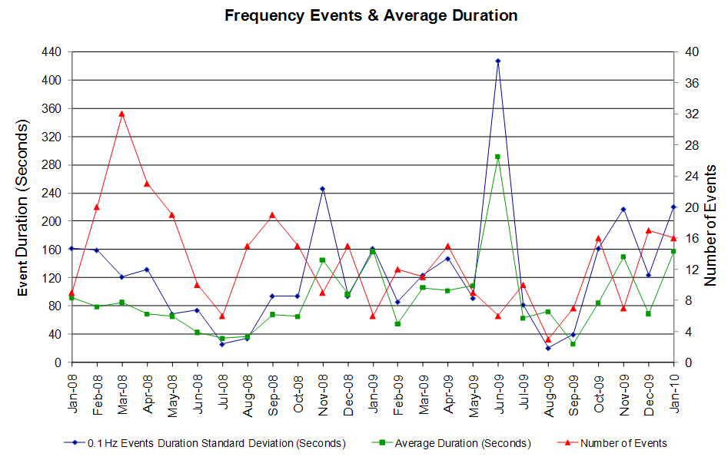

Deployed Responsive (Reported Above)
Time deployed | Stop Time | Duration | Max | Details
1/1 00:02:49 | 1/1 00:24:49 | 0:22:00 | 402.61 | No offset entered due to MOI failure during midnight database load.
1/2 05:19:49 | 1/2 05:35:37 | 0:15:48 | 638.89
1/5 17:32:12 | 1/5 17:44:12 | 0:12:00 | 629.65
1/5 21:05:48 | 1/5 21:22:32 | 0:16:44 | 336.17 | Out of Up Regulation.
1/7 09:51:30 | 1/7 09:58:38 | 0:07:08 | 357.52 | Unit Trip
1/8 06:53:38 | 1/8 07:03:06 | 0:09:28 | 368.19 | Unit Trip
1/9 03:29:24 | 1/9 03:43:12 | 0:13:48 | 325.50 | Unit Trip
1/9 10:28:54 | 1/9 10:49:18 | 0:20:24 | 1083.2
1/9 13:01:11 | 1/9 13:32:02 | 0:30:51 | 634.98
1/11 05:54:22 | 1/11 06:02:02 | 0:07:40 | 496.26
1/13 19:24:40 | 1/13 19:31:12 | 0:06:32 | 336.17 | Unit Trip
1/19 13:14:14 | 1/19 13:27:48 | 0:13:34 | 346.85 | Out of Up Regulation.
1/20 13:25:58 | 1/20 13:35:06 | 0:09:08 | 384.20
1/20 16:00:30 | 1/20 16:28:54 | 0:28:24 | 965.81
1/26 01:58:14 | 1/26 03:06:34 | 1:08:20 | 1162
1/28 09:39:38 | 1/28 10:07:36 | 0:27:58 | 389.54 | Out of Up Regulation.(Wind generation decreased 800 MW after offset calculated)
1/28 13:55:00 | 1/28 14:32:24 | 0:37:24 | 400.2
1/28 17:32:20 | 1/28 17:54:40 | 0:22:20 | 1045.9
1/30 22:47:09 | 1/30 23:16:12 | 0:29:03 | 373.52 | Out of Up Regulation.

Day-Ahead OOMC and RPRS Capacity Purchases
Details | OOMC | RPRS S1 | RPRS S2 | RPRS S1+S2 | RMR | Total
W RIO | 90 | 0 | 0 | 0 | 0 | 90
DFW | 42 | 6 | 18 | 24 | 0 | 66
Houston | 16 | 0 | 28 | 28 | 0 | 44
Austin | 20 | 5 | 6 | 11 | 0 | 31
Western | 1 | 2 | 8 | 10 | 2 | 13
North | 2 | 3 | 5 | 8 | 0 | 10
San Antonio | 0 | 5 | 1 | 6 | 0 | 6
South | 0 | 4 | 0 | 4 | 0 | 4
Northeast | 1 | 0 | 0 | 0 | 0 | 1
Corpus | 0 | 0 | 1 | 1 | 0 | 1
Bryan Area | 0 | 0 | 1 | 1 | 0 | 1
E RIO | 0 | 0 | 0 | 0 | 0 | 0
Laredo | 0 | 0 | 0 | 0 | 0 | 0
Total | 172 | 25 | 68 | 93 | 2 | 267

Historical Totals | Jan-10 | Jan-09 | Dec-09
Austin | 25 | 19 | 9
Bryan Area | 0 | 0 | 0
Corpus | 0 | 2 | 2
DFW | 48 | 28 | 16
E RIO | 0 | 22 | 1
Houston | 16 | 1 | 0
Laredo | 0 | 16 | 0
North | 5 | 8 | 5
Northeast | 1 | 0 | 3
San Antonio | 5 | 0 | 4
South | 4 | 0 | 4
W RIO | 90 | 137 | 79
Western | 5 | 3 | 15
Total | 199 | 243 | 102

http://www.ercot.com/mktinfo/services/rprsdr/index.html

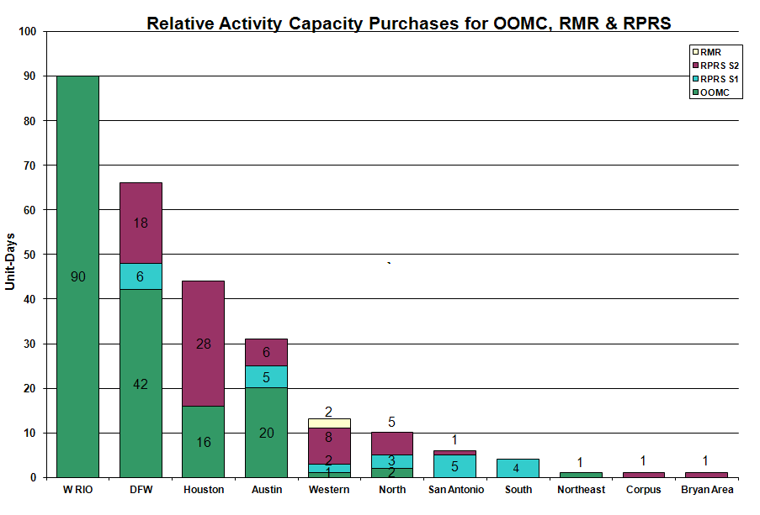

OOME and Congestion Management Activity
Congestion affected by outages Remedial action plan has been developed for the element
Contingency | Overloaded Element | Days
Dilley Switch - San Miguel Switch 138 kV | Derby - Pearsall 69 kV | 14
Garfield - Onion Creek & Hicross AEN 138 kV | Lytton Springs 345/138 kV #1 | 11
Abilene Mulberry Creek - Bitter Creek and Long Creek Switching Station - Sweetwater Generating Plant 345 kV | Anson - Radium 69 kV | 11
Graham - Parker Switch 345 kV | Barton Switch - Oran 138 kV | 10
Graham SES - Parker Switch 345 kV | Flat Creek - Leon Switch 138 kV | 10
Garfield - Onion Creek & Hicross AEN 138 kV | Lytton Springs 345/138 kV #2 | 9
Hamilton Road - Sonora 138 kV | Sonora - Friess Ranch 69 kV | 8
Twin Buttes - San Angelo 345 kV | Twin Buttes transformer 345/138 kV T1 | 8
Whitney - Bosque Switch 138 kV | Lake Whitney - Whitney 138 kV | 6
Base Case | Stanton East Switching Station - Midland East 138 kV | 6
Graham - Parker Switch 345 kV | Graham 345/138 kV AT | 5
Base Case | Matador - Spur 69 kV | 5
Sandow Switch - Temple Switch 345 kV | Hearne 138/69 kV transformer | 5
Abilene South - Eskota 138 kV | Trent - Merkel 69 kV | 4
McDonald - Big Spring Switch 138 kV | Sprayberry Switch - Midland Downtown 138 kV | 3
Abilene Mulberry Creek - Bitter Creek and Long Creek Switching Station - Sweetwater Generating Plant 345 kV | Merkel - Trent 69 kV | 3
Base Case | Matador - Paducah REA Tap 69 kV | 3
Batesville - Pearsall 138 kV | Pearsall Switch 138/69 kV AT | 3
Temple Pecan Creek - Tradinghouse SES and Temple Switch - Lake Creek SES 345 kV | San Angelo Power Station - Yellow Jacket 138 kV | 3
Aspermont - Spur 138KV | Matador - Paducah 69 kV | 2
McDonald - Big Spring 138 kV | Forsan Tap - Sprayberry 138 kV | 2
Pearsall - San Miguel 138 kV | Pearsall 138/69 kV AT | 2
PH Robinson 345/138 kV T2 AT | Garrott - Midtown 138 kV | 2
San Angelo - Ballinger 138 kV | Humble Ballinger - Novice 69 kV | 2
Watermill Switch - Limestone 345 kV | Trinidad - Richland Chambers 345 kV | 2
Menard - Fort Mason - Yellow Jacket - Gilles 138 kV | Gillespie - Phillips Mason 69 kV | 2
Odessa EHV - Morgan SES and Quail Switch 345 kV | Big Spring Switch - Big Spring West 138 kV | 2
Abilene Mulberry Creek - Bitter Creek and Long Creek Switching Station - Sweetwater Generating Plant 345 kV | Matador - Paducah Rea 69 kV | 2
Aspermont - Paint Creek 138 kV | Matador - Spur 69 kV | 2
Base Case | Palmhurst - Magic Valley EC 138 kV | 2
Graham SES - Long Creek Switching Station and Cook Field Road Switching Station 345 kV | San Angelo Power Station - Yellow Jacket 138 kV | 2
Danevang transformer 138/69 kV | Blessing - Palacios 69 kV | 1
Graham - Parker Switch 345 kV | Graham - Graham East 138 kV | 1
Kendall 345/138 kV T2 | Kendall 345/138 kV T1 | 1
Whitney - Bosque SW 138 kV | Bosque - Lake Whitney 138 kV | 1
Austrop - Lost Pines 345 kV | Lytton Springs 345/138 kV #1 AT | 1
Live Oak - Sonora 138 kV | Live Oak - Eldorado 69 kV | 1
Morgan Creek - Quail Switch & Longshore Switch 345 kV | Morgan Creek SES 345/138 kV AT #1 | 1
Odessa EHV - Morgan SES and Quail Switch 345 kV | Morgan Creek SES 345/138 kV AT#1 | 1
Abilene Mulberry Creek - Bitter Creek and Long Creek Switching Station - Sweetwater Generating Plant 345 kV | Sterling County - Sterling City 69KV | 1
Abilene South - Eskota Switch 138 kV | Eskota Switch 138/69 kV AT | 1
Aspermont - Spur 138 kV | Spur 138/69 kV AT | 1
Base Case | Enas Snyder - MEC Plainview Tap 69 kV | 1
Base Case | San Angelo - Yellow Jacket 138 kV | 1
Euless - Liggett Switch 138 kV | DFW B East - Hackberry 138 kV | 1
Graham - Parker Switch 345 kV | Leon Switch - Putnam 138 kV | 1
Graham - Parker Switch 345 kV | San Angelo - Yellow Jacket 138 kV | 1
McDonald - Big Spring Switch 138 kV | Forsan Tap - Colorado Municipal District 138 kV | 1

Zonal OC1
CSC | Days
West – North | 13
North – Houston | 1
North – South | 1

New RAP, PCAP (Date indicates last update of RAP, PCAP not implementation date.)
None

New Procedures/Forms/Operations Bulletins
Date | Subject | Bulletin No.
01/06/2010 | Transmission and Security Desk V4 Rev 10 | 457
01/06/2010 | Shift Supervisor Desk V4 Rev 10 | 456
01/06/2010 | Frequency Control Desk V4 Rev 9 | 455
01/06/2010 | Day-Ahead Desk V4 Rev 8 | 454

Blackout/Load Shed Incidences
None

EEA
None

Major System Voltage Problems
None

Major Computer Problems, Enhancements & Fixes
None

Communication
None

ERCOT peak (Unofficial)
1/08 08:00 55,856 MW

Yearly MTLF Error Comparison
Yearly Mid-Term (Hourly) Load Forecast Error Comparison for the ERCOT Forecast
Month | MAPE for MTLF at 16:00 Day-Ahead
Month | 2007 | 2008 | 2009 | 2010
January | 4.55 | 3.30 | 4.11 | 3.78
February | 3.75 | 3.59 | 3.49 | NA
March | 2.70 | 3.29 | 3.24 | NA
April | 3.00 | 2.45 | 2.66 | NA
May | 3.22 | 3.01 | 2.90 | NA
June | 4.46 | 2.81 | 2.89 | NA
July | 4.29 | 2.55 | 2.83 | NA
August | 3.11 | 3.66 | 3.07 | NA
September | 3.78 | 4.99 | 3.68 | NA
October | 3.08 | 2.79 | 2.92 | NA
November | 2.95 | 2.60 | 1.93 | NA
December | 3.74 | 4.54 | 3.70 | NA
Annual Average | 3.55 | 3.29 | 3.11 | 3.78

OCN, Advisory, Watch & Emergency Notices
Capacity
Date | Start | End | Event
1/02/10 | 5:05 | 11:00 | OCN issued due to a projected reserve capacity shortage for HE 0800 - HE 1100.
1/02/10 | 5:25 | 12:00 | Advisory issued due to ARRS below 3000 MW.
1/03/10 | 10:15 | 13:50 | Advisory issued due to ARRS below 3000 MW.
1/05/10 | 7:32 | 0:00 | Advisory issued for extreme winter weather with temperatures expected to be in the teens to low 20’s for most of the state starting Thursday 01/7/10 – 01/9/10.
1/06/10 | 0:15 | 0:00 | Advisory issued for extreme winter weather with temperatures expected to be in the teens to low 20’s for most of the state starting Thursday 01/7/10 – 01/9/10.
1/07/10 | 0:15 | 0:00 | Advisory issued for extreme winter weather with temperatures expected to be in the teens to low 20’s for most of the state starting Thursday 01/7/10 – 01/9/10.
1/08/10 | 0:15 | 24:00 | Advisory issued for extreme winter weather with temperatures expected to be in the teens to low 20’s for most of the state starting Thursday 01/7/10 – 01/9/10.
1/09/10 | 0:15 | 24:00 | Advisory issued for extreme winter weather with temperatures expected to be in the teens to low 20’s for most of the state starting Thursday 01/7/10 – 01/9/10.
1/10/10 | 0:15 | 13:00 | Advisory issued for extreme winter weather with temperatures expected to be in the teens to low 20’s for most of the state starting Thursday 01/7/10 – 01/10/10.
1/14/10 | 10:47 | 21:00 | Operating Condition Notice (OCN) issued for a potential capacity shortage for HE 19:00 - 23:00.
1/15/10 | 5:41 | 12:18 | Advisory issued due to ARRS below 3000 MW.
1/15/10 | 22:07 | 0:00 | Advisory issued due to ARRS below 3000 MW.
1/15/10 | 22:40 | 23:59 | Watch issued due to ARRS below 2500 MW.
1/16/10 | 0:15 | 13:10 | Advisory issued due to ARRS below 3000 MW.
1/16/10 | 10:39 | 23:14 | OCN issued for projected reserve capacity shortage for hours 19:00 to 24:00.
1/16/10 | 18:22 | 23:14 | Advisory issued due to ARRS below 3000 MW.
1/26/10 | 3:20 | 7:35 | Advisory issued for ARRS below 3000 MW.
1/26/10 | 4:00 | 7:30 | OCN issued for projected capacity shortage for HE 07:00 through HE 09:00.
1/28/10 | 9:52 | 11:10 | Advisory issued for ARRS below 3000 MW.
1/28/10 | 12:05 | 21:00 | Advisory issued for ARRS below 3000 MW.

Transmission Watch
1/08 07:35 Transmission Watch issued for the post contingency loss of Dilley Switch - San Miguel Switch 138KV overloads Derby - Pearsall 69KV. ERCOT received emergency energy from CFE across the Laredo VFT and Eagle Pass DC tie.

1/09 00:15 Transmission Watch issued for the post contingency loss of Dilley Switch - San Miguel Switch 138KV overloads Derby - Pearsall 69KV. ERCOT received emergency energy from CFE across the Laredo VFT.

Emergency Notice
1/08 18:00 Market Emergency Notice issued due to Replacement Reserve Service Market did not meet the required time-line.

1/09 10:28 Emergency Notice issued for NERC Reportable Disturbance Control Standard (DCS) Event. Load acting as a Resource (LaaR) were deployed to recover frequency.

Texas RE Event Analysis
1/08 18:00 Market Emergency Notice issued due to RPRS Market failed to meet timeline.

1/09 10:28 Emergency Notice issued for NERC Reportable Disturbance Control Standard (DCS) Event due to loss of one unit.

Others
1/26 02:00 Held Real-Time Balancing Market IE 2:15 and resumed with IE 2:45 due to scheduled generation changed after offset input.

