COPMGRR Number | 017 | COPMGRR Title | Creating Subsection 8.2, Settlement Statements and Invoices
Date Posted |  | December 4, 2009
Commercial Operations Market Guide (COPMG) Section Requiring Revision |  | 8.2, Settlement Statements and Invoices (New)
Protocol Section(s) Requiring Revision, if any |  | Not applicable.
Requested Resolution |  | Normal.
Revision Description |  | This Commercial Operations Market Guide Revision Request (COPMGRR) creates a new subsection under Section 8, ERCOT Settlement and Invoice Process.
Reason for Revision |  | Provides information concerning the ERCOT Invoicing Process.
Overall Market Benefit |  | Market Participants benefit from being better informed.
Overall Market Impact |  | Improves availability of information concerning the ERCOT Nodal Settlement Statements and Invoices.
Consumer Impact |  | None.

Quantitative Impacts and Benefits

Assumptions | 1 | None.
Assumptions | 2
Assumptions | 3
Assumptions | 4
Market Cost |  | Impact Area | Monetary Impact
Market Cost | 1 | None. | None.
Market Cost | 2
Market Cost | 3
Market Cost | 4
Market Benefit |  | Impact Area | Monetary Impact
Market Benefit | 1 | Improve availability of information concerning the ERCOT Nodal Settlement Statements and Invoices. | Time savings in finding information. Relieves ERCOT Client Representatives of some questions.
Market Benefit | 2
Market Benefit | 3
Market Benefit | 4
Additional Qualitative Information | 1
Additional Qualitative Information | 2
Additional Qualitative Information | 3
Additional Qualitative Information | 4
Other Comments | 1 | ERCOT systems will not be impacted.
Other Comments | 2
Other Comments | 3
Other Comments | 4

Sponsor
Name | Michelle Trenary on behalf of the COPS Communications Working Group (CCWG)
E-mail Address | mtrenary@tnsk.com
Company | Tenaska Power Services
Phone Number | 817-303-3613
Cell Number
Market Segment | Independent Power Marketer (IPM)

Market Rules Staff Contact
Name | Sonja B. Mingo
E-Mail Address | smingo@ercot.com
Phone Number | 512-248-6463

Proposed Guide Language Revision

8.2 Settlement Statements and Invoices 1
8.2.1 Congestion Revenue Rights (CRR) Settlement Statement and Invoice Examples 1
8.2.2 Day Ahead Market Statement/Invoice 6
8.2.3 RTM Invoices 15

8.2 Settlement Statements and Invoices
The Real-Time Market (RTM), Day-Ahead Market (DAM), and the Congestion Revenue Right (CRR) Auction are settled separately. There are three different Settlement Statements, three different Invoices, and three different Settlement timelines – Initial, Final and True-Up.
The Settlements Calendar Extract Qualified Scheduling Entity (QSE) Settlement and CRR Account Holder Statements are available on the Market Information System (MIS). The Settlement Calendar is provided as an extract and can be found on both the MIS Public Area under Settlements Reports and Extracts and on the ERCOT website. Supporting information for the Settlement Calendar (i.e. the Data Definition Language and Xtensible Markup Defintions) are also available on both the MIS Public Area and the ERCOT website.
Details, including quantities and prices associated with Settlement Statements and Invoices are found in the appropriate extracts and reports. When viewing QSE Settlement Statements, a negative amount represents a payment due to the QSE and a positive amount represents a payment due to ERCOT. More information about the available extracts and reports is available on the MIS Public Area and on the ERCOT website. Descriptions and definitions for the billing determinants can be found on the ERCOT website in the Settlement Charge Matrix and in the relevant Protocol sections. (Also see Section 10, Extracts and Reports, of the Commercial Operations Market Guide (COPMG))
Information about the Settlements Calendar, statements, and Invoices may be found in Protocol Section 9, Settlement and Billing.
8.2.1 Congestion Revenue Rights (CRR) Settlement Statement and Invoice Examples
8.2.1.1 CRR Invoices
Refer to Protocol Section 9.8, CRR Auction Award Invoices, for details regarding CRR Auction award Invoices.
CRR Statement/Invoice Timeline
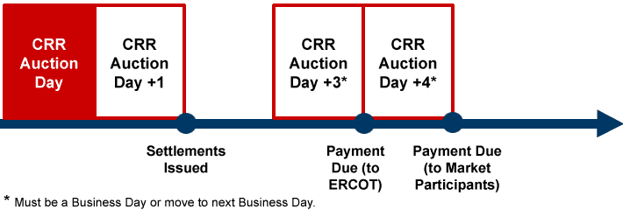

8.2.1.1.1 CRR Annual Auction Invoice
Monthly and annual auction Invoices are issued as separate Invoices; however, the formatting is the same for each. The Invoice will indicate whether it pertains to a monthly or an annual auction.

8.2.1.1.2 CRR Monthly Auction Invoice Example
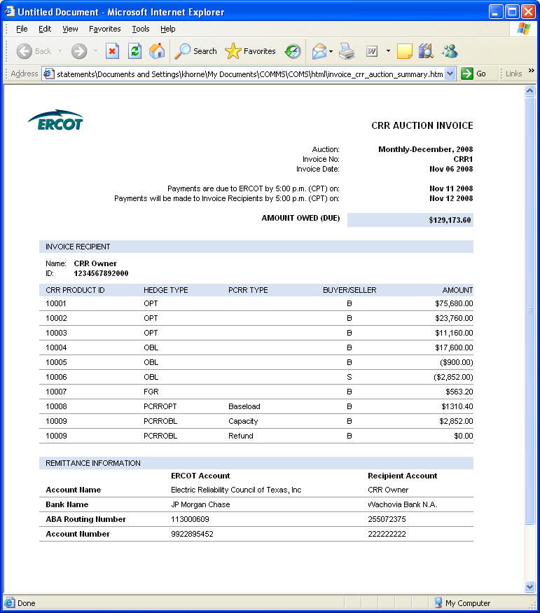
8.2.1.1.3 CRR Auction Revenue Distribution (CARD) Invoice Example
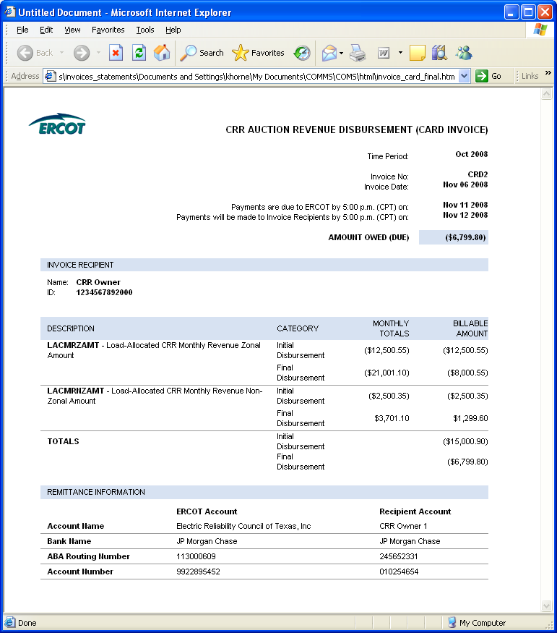

8.2.1.1.4 CRR Balancing Account Invoice Example
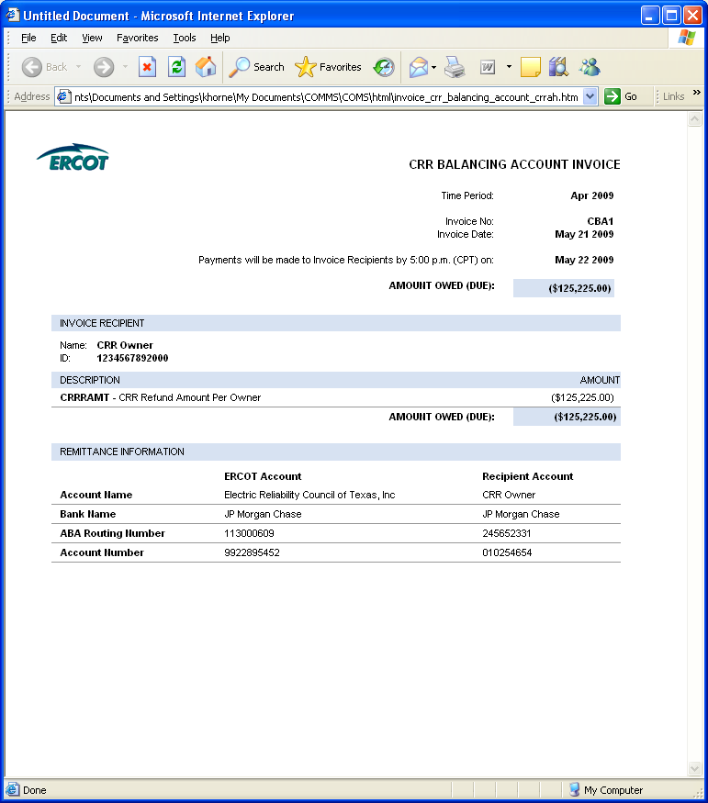

8.2.2 Day Ahead Market Statement/Invoice
The DAM statements and Invoices for CRR Account Holders and QSEs are issued two days after the Operating Day.
Refer to Protocol Section 9.2, Settlement Statements for the Day-Ahead Market, for details regarding DAM Settlement Statements.
Refer to Protocol Section 9.3, Settlement Invoices for the DAM, for details regarding DAM Settlement Invoices.

DAM Statement/Invoice Timeline
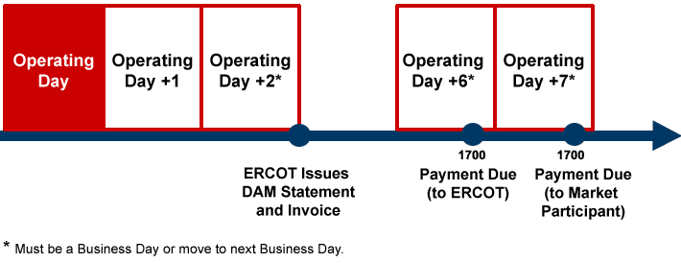
8.2.2.1 DAM Statement/Invoice Example
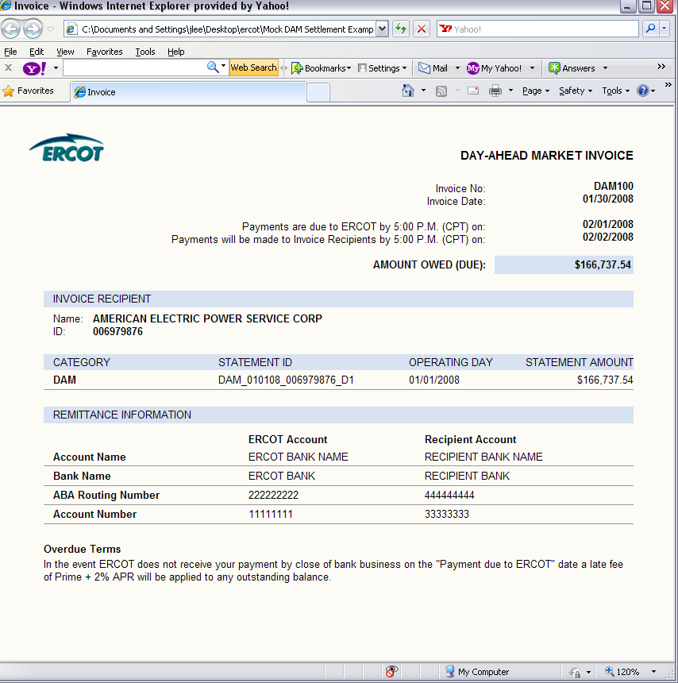

8.2.2.2 DAM Late Fee Invoice Example 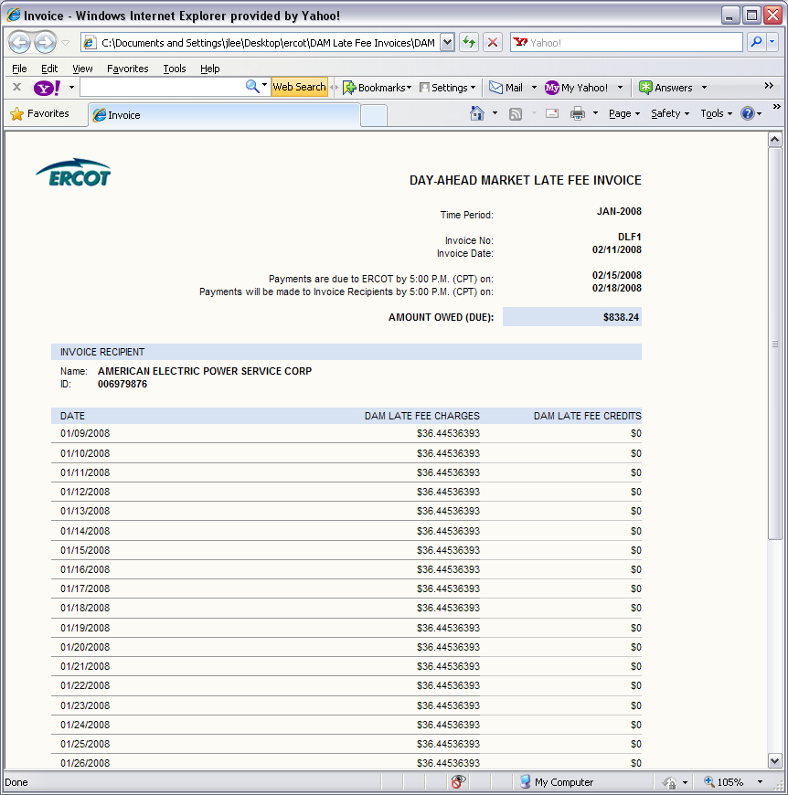
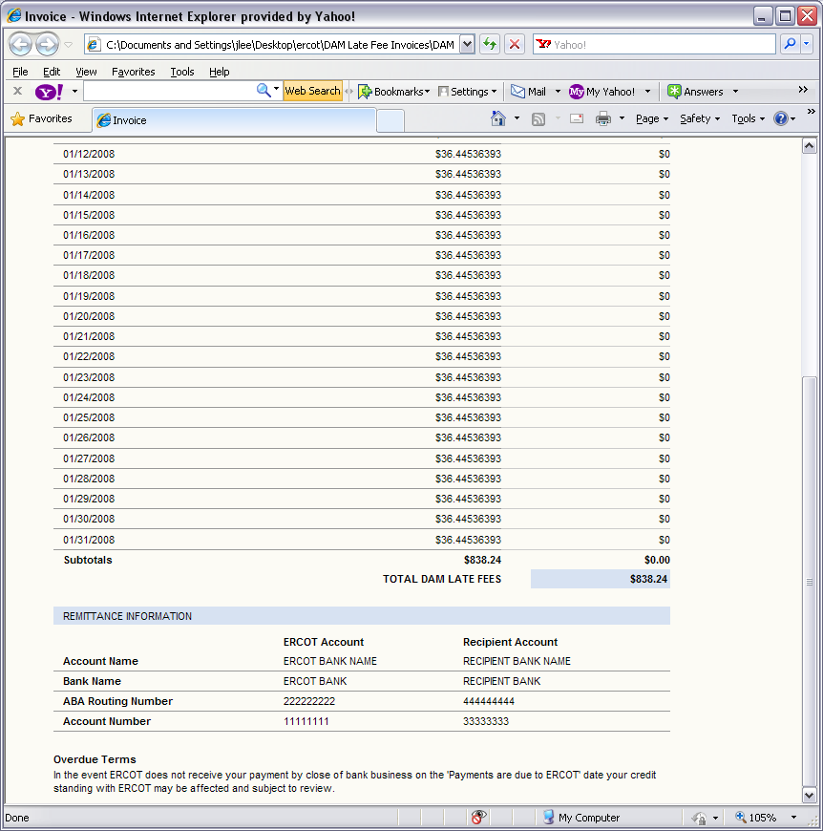

Real-Time Market Statements and Invoices
Refer to Protocol Section 9.5.2, Settlement Statements for the RTM, for details regarding RTM Settlement Statements.

RTM Statement/Invoice Timeline

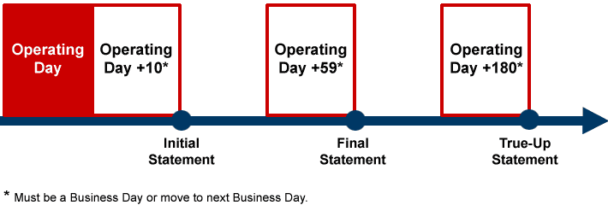

8.2.2.4 RTM Statements

There are four types of RTM Settlement Statements: Initial, Final, True-Up and Resettlement.
8.2.2.4.1 RTM Initial Statement Example
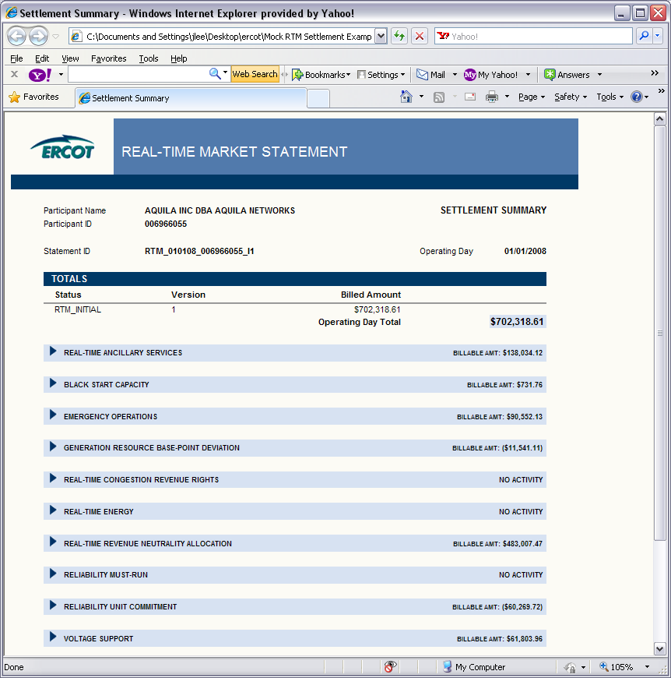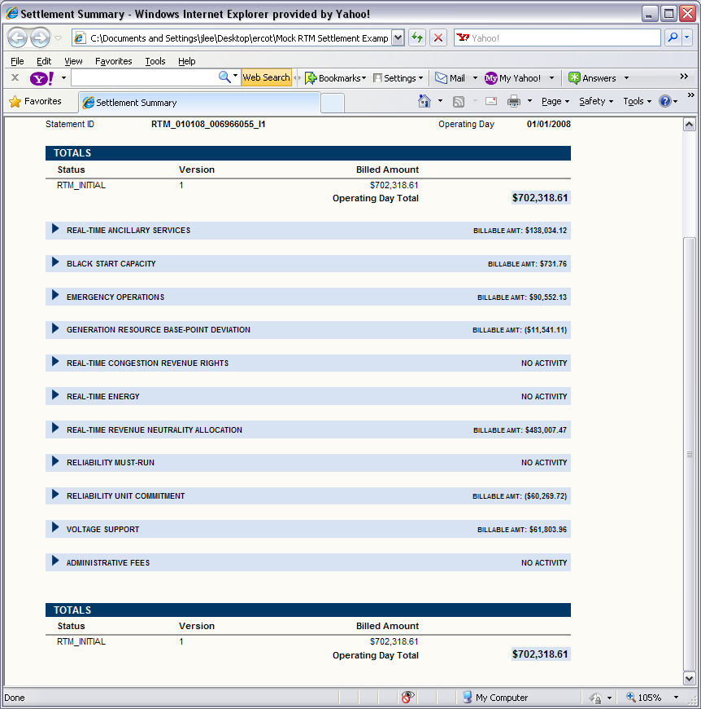

8.2.2.4.2 RTM Final Statement Example
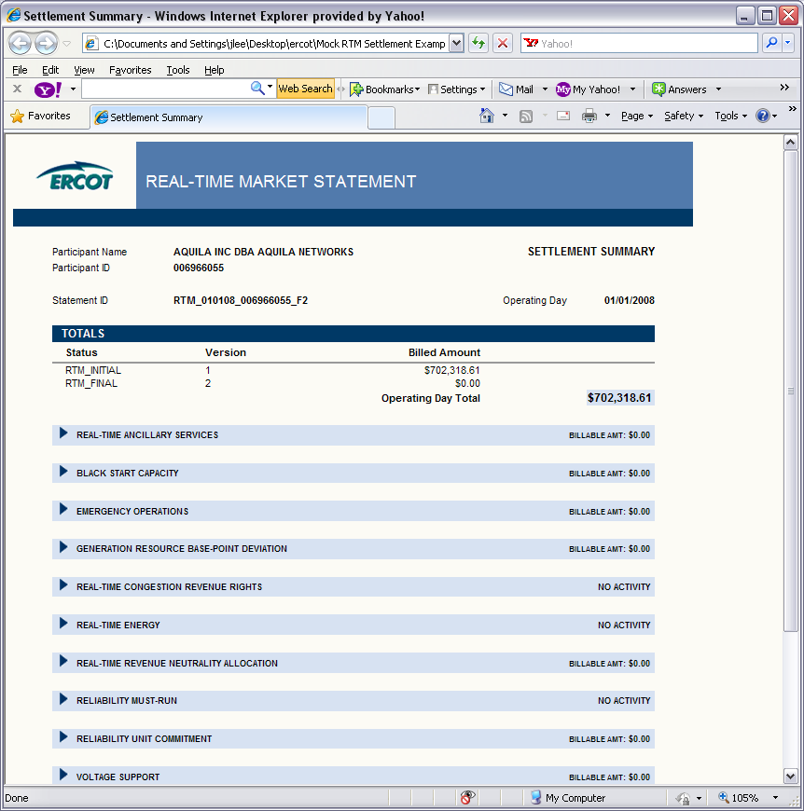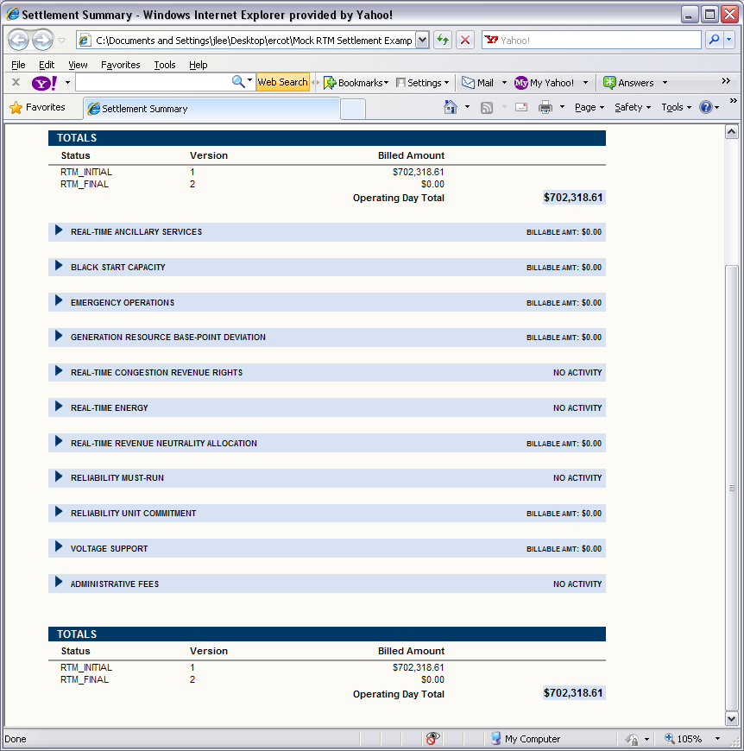
8.2.2.4.3 RTM True-Up Statement Example
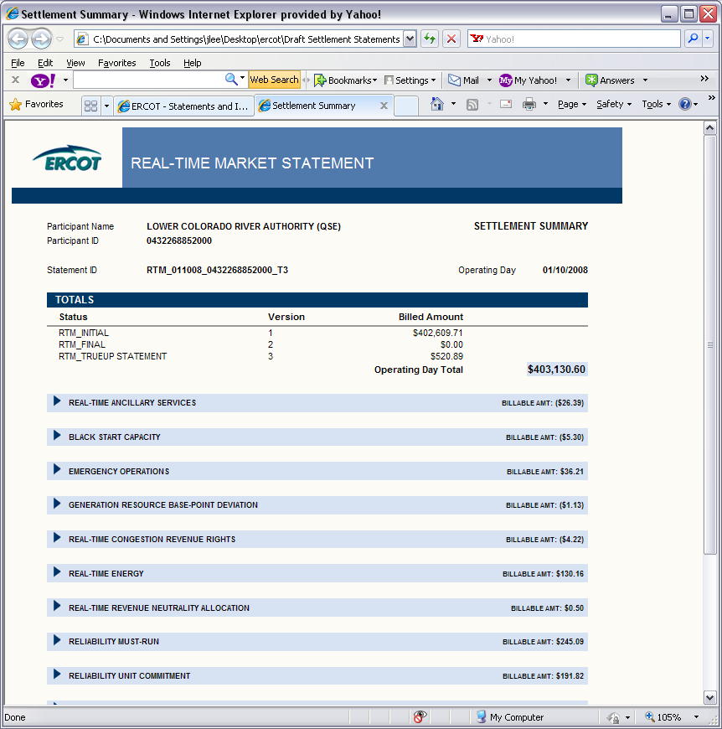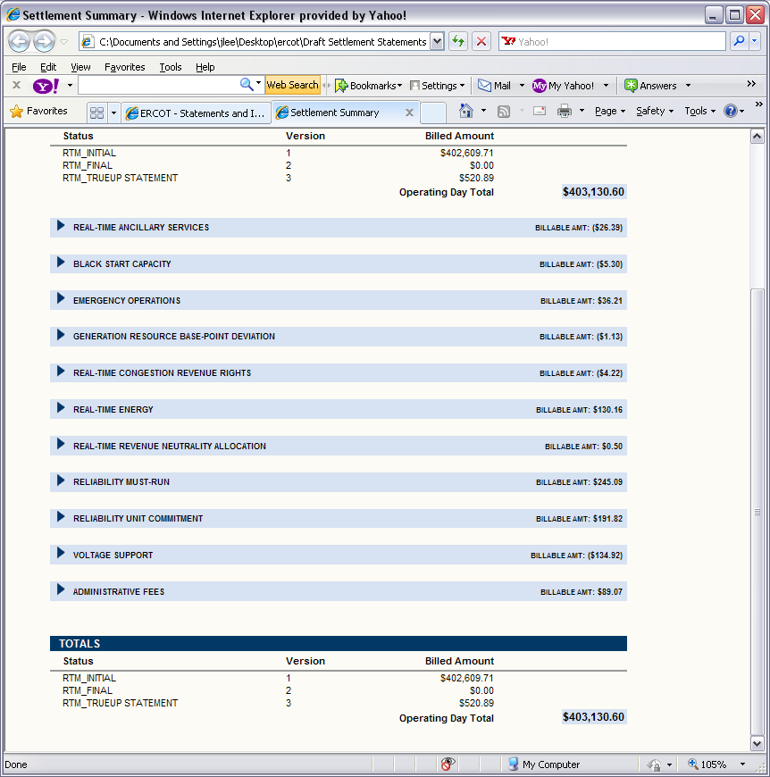
8.2.2.4.4 RTM Resettlement Statement Example
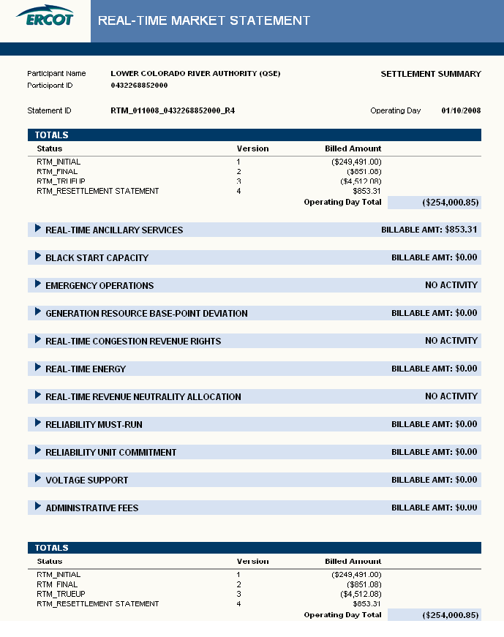

8.2.3 RTM Invoices
Refer to Protocol Section 9.6, Settlement Invoices for the Real-Time Market, for details regarding RTM Invoices.
8.2.3.1 RTM Settlement Invoice Example
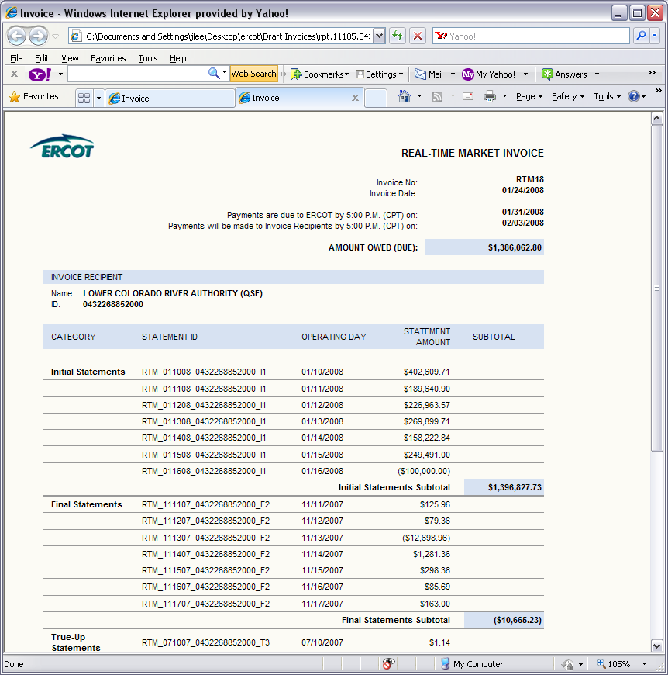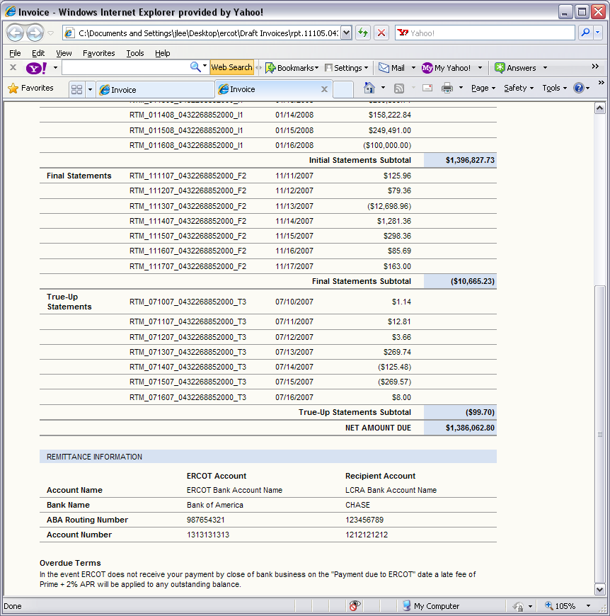

8.2.3.2 RTM Uplift Invoice Example
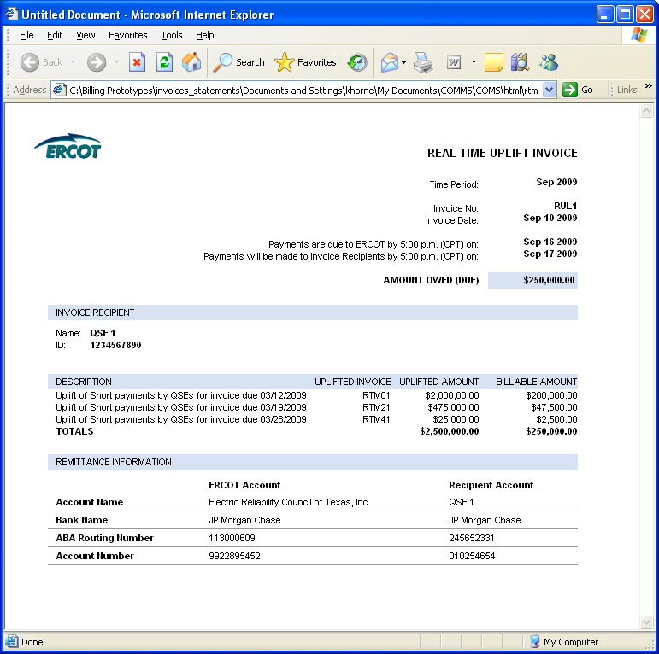
8.2.3.3 RTM Late Fee Invoice Example
