ERCOT Operations Report
December 2009 ROS & OWG

Frequency Control
Time | Freq(Hz) | Duration (s)
12/1/2009 7:37 | 60.10400009 | 183 | Units coming online and Non-Spin Deployed
12/4/2009 1:13 | 59.89500046 | 4 | Unit trip with 530 MW
12/5/2009 10:51 | 60.10200119 | 20 | SCE +531 MW in 10 min. Out of Down Regulation.
12/5/2009 22:37 | 59.89599991 | 4 | Unit trip with 390 MW
12/8/2009 11:03 | 59.89799881 | 6 | Unit trip with 200 MW
12/10/2009 6:36 | 59.83000183 | 8 | Unit trip with 920 MW
12/10/2009 8:34 | 59.875 | 8 | Unit trip with 750 MW
12/11/2009 20:33 | 59.893 | 4 | Unit trip with 450 MW
12/14/2009 22:04 | 60.136 | 371 | Out of Down Regulation
12/17/2009 16:05 | 60.104 | 10 | Out of Down Regulation
12/17/2009 20:26 | 59.895 | 2 | Unit trip with 406 MW
12/22/2009 17:04 | 59.885 | 4 | Unit trip with 470 MW
12/24/2009 2:12 | 60.101 | 5 | Out of Down Regulation. Wind was moving faster than regulation.
12/24/2009 4:22 | 60.124 | 137 | Out of Down Regulation. Wind was moving faster than regulation.
12/24/2009 5:04 | 59.879 | 4 | Unit trip with 300 MW
12/30/2009 4:46 | 60.129 | 368 | Slow load pick up and high SCE, SCE +400 MW in 8 min.
12/30/2009 22:43 | 59.805 | 40 | Unit trip with 641 MW
Note: Time of frequency excursions outside the range of +/- 0.1 Hz.

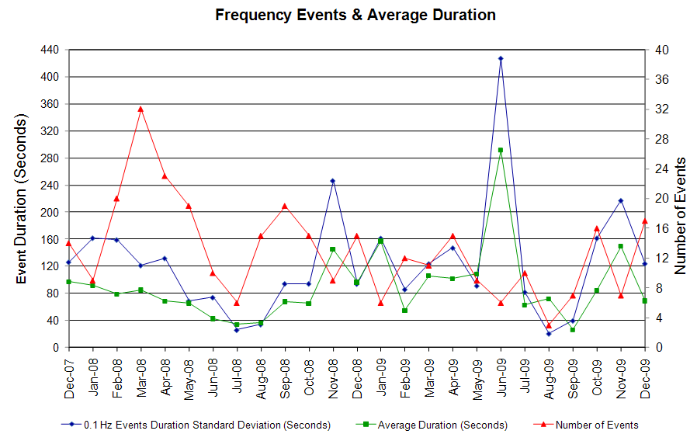

Deployed Responsive (Reported Above)
Time deployed | Stop Time | Duration | Max | Details
12/1 06:06:12 | 12/1 06:20:30 | 0:14:18 | 327.36 | Unit Trip
12/2 16:46:28 | 12/2 16:55:32 | 0:09:04 | 327.36 | Unit Trip
12/4 01:13:20 | 12/4 01:24:20 | 0:11:00 | 396.00
12/5 22:37:08 | 12/5 22:49:28 | 0:12:20 | 390.73
12/8 11:03:20 | 12/8 11:20:14 | 0:16:54 | 380.17
12/9 06:36:16 | 12/9 06:50:11 | 0:13:55 | 327.36 | SCE change -930 MW in 13 m. Large schedule change.
12/10 06:36:32 | 12/10 06:52:18 | 0:15:46 | 739.20
12/10 8:34:28 | 12/10 8:53:44 | 0:19:16 | 501.61
12/11 20:33:48 | 12/11 20:42:30 | 0:08:42 | 406.56
12/17 20:26:35 | 12/17 20:36:51 | 0:10:16 | 396.00
12/20 14:31:31 | 12/20 14:41:19 | 0:09:48 | 332.64 | Unit Trip
12/22 17:04:51 | 12/22 17:18:39 | 0:13:48 | 448.82
12/23 21:51:06 | 12/23 22:05:54 | 0:14:48 | 364.32 | Out of Up Reg (610 MW).
12/24 05:04:21 | 12/24 05:16:01 | 0:11:40 | 480.48
12/24 06:02:11 | 12/24 06:32:56 | 0:30:45 | 348.49 | SCE change -1780 MW in 15 m. Large schedule change.
12/30 22:43:58 | 12/30 23:06:12 | 0:22:14 | 1089

Day-Ahead OOMC and RPRS Capacity Purchases
Details | OOMC | RPRS S1 | RPRS S2 | RPRS S1+S2 | RMR | Total
W RIO | 72 | 7 | 0 | 7 | 0 | 79
DFW | 10 | 6 | 26 | 32 | 0 | 42
Western | 5 | 8 | 22 | 30 | 2 | 37
Austin | 6 | 3 | 18 | 21 | 0 | 27
Northeast | 3 | 0 | 11 | 11 | 0 | 14
North | 2 | 3 | 9 | 12 | 0 | 14
Houston | 0 | 0 | 14 | 14 | 0 | 14
San Antonio | 3 | 1 | 2 | 3 | 0 | 6
South | 0 | 4 | 1 | 5 | 0 | 5
Corpus | 0 | 2 | 0 | 2 | 0 | 2
E RIO | 0 | 1 | 0 | 1 | 0 | 1
Bryan Area | 0 | 0 | 0 | 0 | 0 | 0
Laredo | 0 | 0 | 0 | 0 | 0 | 0
Total | 101 | 35 | 103 | 138 | 2 | 241

Historical Totals | Dec-09 | Dec-08 | Nov-09
Austin | 9 | 9 | 5
Bryan Area | 0 | 0 | 2
Corpus | 2 | 1 | 1
DFW | 16 | 24 | 19
E RIO | 1 | 8 | 4
Houston | 0 | 1 | 10
Laredo | 0 | 14 | 1
North | 5 | 17 | 2
Northeast | 3 | 0 | 0
San Antonio | 4 | 0 | 2
South | 4 | 10 | 3
W RIO | 79 | 107 | 44
Western | 15 | 7 | 9
Total | 138 | 198 | 102
http://www.ercot.com/mktinfo/services/rprsdr/index.html

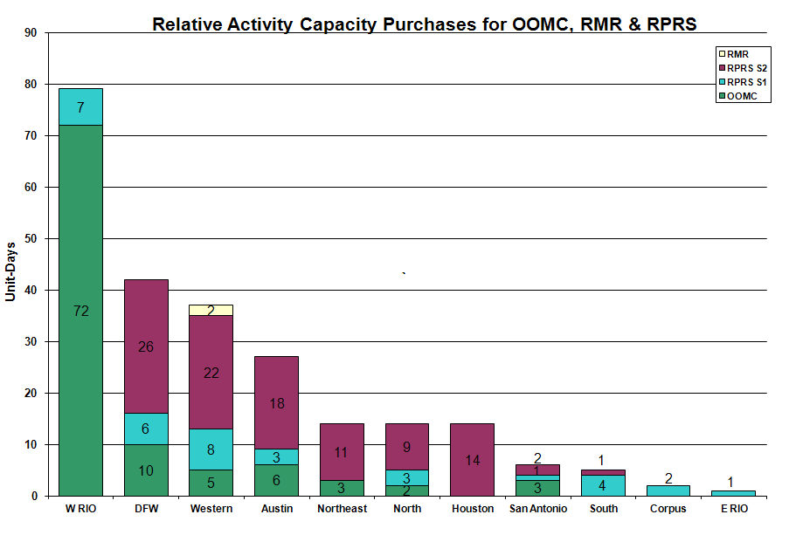

OOME and Congestion Management Activity
Congestion affected by outages Remedial action plan has been developed for the element
Contingency | Overloaded Element | Days
Dilley Switch - San Miguel Switch 138KV | Derby - Pearsall 69KV | 15
Hamilton Road - Sonora 138KV | Sonora - Friess Ranch 69KV | 12
Abilene South - Eskota 138KV | Trent - Merkel 69KV | 9
Kendal 345/138KV AT 2 | Raymond Barker 138/69KV AT 2 | 9
Austrop - Daffin and Decker 138KV | Austrop - Decker Plant | 8
Aspermont - Spur 138KV | Spur 138/69KV AT | 7
Base Case | Matador - Paducah REA Tap 69KV | 7
Santa Anna - Ballinger 138KV | Ballinger - Humble 69KV | 7
Abilene Mulberry - Bitter Creek & Long Creek - Sweetwater Cogen 345KV | Anson - Radium 69kV | 3
Graham SES - Long Creek 345KV | Abilene South - Putnam 138KV | 3
Abilene South - Eskota 138KV | Merkel - Scott REA Tap 69KV | 3
Bosque Switch - Whitney 345KV | Lake Whitney - Whitney 138KV | 3
Comanche Peak SES G1 and G2 345KV | Mason CSW - Fort Mason 69KV | 3
Nicole - Oak Creek 138KV | Nicole - Orient 138KV | 3
Odessa EHV Switch - MGSES and Quail Switch 345KV | Big Spring Switch - Big Spring West 138KV | 3
South Texas Nuclear Project - Hillje & Whitepoint 345KV | Blessing - Palacios 69KV | 3
Abilene South - Eskota Switch 138KV | Trent - Scott Rea Tap 69KV | 2
Sandow Switch - Austrop 345KV | Austrop 345/138KV Transformer T1 | 2
STP - Elm Creek 345KV | Spur 138/69KV AT | 2
Coit Road - Kirkland Park 138KV | Kirkland Park - Judd Court Tap 138KV | 2
ENA SNYDER | Snyder - WKN 69KV | 2
Graham - Long Creek - Cook Field Road Switch 345KV | San Angelo Power Station - Shrew Tap 138KV | 2
Graham SES - Parker Switch 345KV | Flat Creek - Leon Switch 138KV | 2
Graham SES - Long creek - Cook Field Road Switch 345KV | Abilene South - Putman 138KV | 2
Grant - H.O. Clarke 138KV | Midtown - Polk 138KV | 2
Morgan - Longshore Switch 345KV | Morgan 345/138KV Auto #2 | 2
Abilene Mulberry - Bitter Creek 345KV | Morgan Creek 345/138KV AT1 | 1
Garfield - Onion & Hicross 138KV | Lytton Springs Auto #1 | 1
Holt Switch - Permian Basin 138KV | Odessa North 138/69KV Transformer | 1
Horse Hollow 345/138KV #1 | Horse Hollow 345/138KV #2 | 1
Kirby - Beck - Calaveras 138KV | Merida - Calaveras 138KV | 1
La Palma - Military Highway 138KV | La Palma - Loma Alta 138KV | 1
Royse Switch 345/138KV AT #1 | Forney Switch 345/138KV autotransformer #3 | 1
STP - Elm Creek 345KV | Blessing - Lolita 138KV | 1
Austrop - Lost Pines 345KV | Fayetteville 345/138KV AT #2 | 1
Graham SES - Parker Switch 345KV | Barton Switch - Oran TU 138KV | 1
Base Case | ENA Snyder – MEC Plainview Tap 69KV | 1
Base Case | Snyder - WKN 69KV | 1
Base Case | Plainview Tap - WKN Breaker 69KV | 1
Base Case | San Angelo Power Station - Shrew Tap 138KV | 1
Denton 138/69KV autotransformer | North Denton - King County 69KV | 1
Garfield - Onion & Hicross 138KV | Austrop 345/138KV | 1
Garfield - Onion Creek - Hicross 138KV | Austrop - Daffin 138KV | 1
Garfield 345/138KV T1 | Garfield 345/138KV T2 | 1
Grant - Plaza 138KV | Garrett - Midtown 138KV | 1
Hackberry - Carrollton 345KV | Hackberry - DFW B - East 138KV | 1
Ingleside Dupont - Whitepoint 138KV | Whitepoint - Rincon 138KV | 1
Lytton Springs - Zorn and Austrop - Zorn 345KV | Garfield - Onion Creek 138KV | 1
Morgan Creek - Eskota Switch 138KV | Merkel - Trent 69KV | 1
Odessa EHV - Morgan Creek SES and Quail Switch 345KV | Stanton Switch - Midland East 138KV | 1
Paris Switch - Tenaska TU 138KV | Paris East Tap - Lamar Tap 138KV | 1
Sandow Switch - Austrop 345KV | Garfield - Hicross 138KV | 1
Sandow Switch - Austrop 345KV | Garfield 345/138KV | 1
STP - Elm Creek 345KV | Zorn - Lytton Springs 345KV | 1
Twin Butte - San Angelo Red Creek 345KV | Twin Butte AT 1L 345/138KV | 1

Zonal OC1
CSC | Days
West – North | 9
South – North | 3
North - South | 1

New RAP, PCAP (Date indicates last update of RAP, PCAP not implementation date.)
None

New Procedures/Forms/Operations Bulletins
Date | Subject | Bulletin No.
12/01/2009 | Transmission and Security Desk V4 Rev 9 | 453
12/01/2009 | Shift Supervisor Desk V4 Rev 9 | 452
12/01/2009 | Operating Period Desk V3 Rev 7 | 451
12/01/2009 | Frequency Control Desk V4 Rev 8 | 450
12/01/2009 | Day-Ahead Desk V4 Rev7 | 449

Blackout/Load Shed Incidences
None

EEA
None

Major System Voltage Problems
None

Major Computer Problems, Enhancements & Fixes
None

Communication
None

ERCOT peak (Unofficial)
12/10 08:00 46,240 MW

Yearly MTLF Error Comparison
Yearly Mid-Term (Hourly) Load Forecast Error Comparison for the ERCOT Forecast
Month | MAPE for MTLF at 16:00 Day-Ahead
Month | 2006 | 2007 | 2008 | 2009
January | 4.79 | 4.55 | 3.30 | 4.11
February | 4.81 | 3.75 | 3.59 | 3.49
March | 4.95 | 2.70 | 3.29 | 3.24
April | 5.59 | 3.00 | 2.45 | 2.66
May | 3.59 | 3.22 | 3.01 | 2.90
June | 2.65 | 4.46 | 2.81 | 2.89
July | 2.62 | 4.29 | 2.55 | 2.83
August | 2.09 | 3.11 | 3.66 | 3.07
September | 4.03 | 3.78 | 4.99 | 3.68
October | 3.63 | 3.08 | 2.79 | 2.92
November | 3.28 | 2.95 | 2.60 | 1.93
December | 3.44 | 3.74 | 4.54 | 3.70
Annual Average | 3.79 | 3.55 | 3.29 | 3.11

OCN, Advisory, Watch & Emergency Notices
Capacity
Date | Start | End | Event
12/1/2009 | 7:00 | 7:35 | Advisory issued for ARRS below 3000 MW.
12/1/2009 | 7:06 | 7:35 | Watch issued for ARRS below 2500 MW.
12/1/2009 | 18:56 | 21:36 | Advisory issued for ARRS below 3000 MW.
12/2/2009 | 17:34 | 21:40 | Advisory issued for ARRS below 3000 MW.
12/5/2009 | 23:10 | 23:59 | Advisory issued for ARRS below 3000 MW.
12/7/2009 | 9:10 | 22:05 | Advisory due to ARRS below 3000 MW.
12/7/09 | 9:10 | 11:00 | OCN issued due to projected capacity reserve shortage for HE 1800 - 2100 and 2300.
12/7/2009 | 11:00 | 13:00 | Watch issued due to projected capacity reserve shortage for HE 1900 - 2000.
12/7/2009 | 17:42 | 22:05 | Watch issued for ARRS below 2500 MW.
12/8/09 | 0:50 | 2:00 | OCN issued for projected Reserve Capacity shortage for HE 0700 - HE 2300.
12/8/2009 | 1:05 | 11:30 | Advisory issued for ARRS below 3000 MW.
12/8/2009 | 2:00 | 19:45 | Watch issued for projected Reserve Capacity shortage for HE 0700 - HE 2300.
12/8/09 | 22:00 | 0:00 | OCN issued due to projected capacity reserve shortage for HE 08:00 - 12:00 and 18:00 - 24:00 for operating day 12/09/09.
12/9/2009 | 0:00 | 14:00 | Watch issued due to projected capacity reserve shortage for HE 08:00 - 12:00 and 18:00 - 24:00 for operating day 12/09/09.
12/9/2009 | 6:27 | 14:00 | Advisory issued for ARRS below 3000 MW.
12/9/2009 | 6:35 | 8:15 | Watch issued due to ARRS below 2500 MW.
12/9/09 | 7:35 | 18:00 | OCN issue for a projected shortage of Up Balancing Bids.
12/10/09 | 4:00 | 12:30 | OCN issued due to projected capacity reserve shortage for HE 19:00 - 21:00.
12/10/2009 | 6:26 | 12:05 | Advisory issued for ARRS below 3000 MW.
12/12/2009 | 0:45 | 6:00 | Advisory issued for ARRS below 3000 MW.
12/12/2009 | 4:31 | 6:00 | Watch issued for ARRS below 2500 MW.
12/12/2009 | 9:27 | 20:00 | Advisory issued for ARRS below 3000 MW.
12/13/2009 | 1:20 | 13:30 | Advisory issued for ARRS below 3000 MW.
12/14/2009 | 7:05 | 12:20 | Advisory issued for ARRS below 3000 MW.
12/16/2009 | 7:01 | 9:19 | Advisory issued for ARRS below 3000 MW.
12/19/09 | 5:00 | 24:00:00 | OCN issued for projected reserve capacity shortage for HE 19:00 through 24:00.
12/19/2009 | 9:00 | 14:30 | Advisory issued for ARRS below 3000 MW.
12/19/2009 | 18:00 | 0:00 | Advisory issued for ARRS below 3000 MW.
12/20/2009 | 0:15 | 1:41 | Advisory issued for ARRS below 3000 MW.
12/20/2009 | 17:55 | 20:49 | Advisory issued for ARRS below 3000 MW.
12/23/2009 | 8:24 | 14:04 | Advisory issued for ARRS below 3000 MW.
12/25/2009 | 2:05 | 5:51 | Advisory issued for ARRS below 3000 MW.
12/31/2009 | 3:05 | 6:15 | Advisory issued for ARRS below 3000 MW.

Transmission Watch
12/4 07:00 Transmission Watch issued due to the loss of a generating unit. The loss of Dilley Switch - San Miguel Switch 138KV overloads Derby - Pearsall 69KV. ERCOT received emergency energy from CFE across the Laredo VFT.

12/5 05:50 Transmission Watch issued due to the loss of a generating unit. The loss of Dilley Switch - San Miguel Switch 138KV overloads Derby - Pearsall 69KV. ERCOT received emergency energy from CFE across the Laredo VFT and Railroad DC Ties.

12/9 17:51 Transmission Watch issued for the forced outage of a transmission element resulting in the contingency loss of Sweeney Cogen - West Columbia Main 138KV overloads Old Ocean - Sweeney 69KV.

12/16 18:30 Transmission Watch issued due to the forced outage of a transmission element. The loss of La Palma - Military Highway 138KV overloads La Palma - Loma Alta 138KV.

12/23 23:26 Transmission Watch issued due to forced transmission outage. ERCOT initiated a Block Load Transfer (BLT) at Presidio Substation transferring up to 2 MW of ERCOT load to CFE.

12/24 00:01 Transmission Watch issued due to forced transmission outage. ERCOT initiated a Block Load Transfer (BLT) at Presidio Substation transferring up to 2 MW of ERCOT load to CFE.

Emergency Notice
None

Texas RE Event Analysis
None

Others
12/31 23:45 Held Real-time Balancing Market IE 23:45 for IE 24:00 due to RTBM did not execute in time, resumed with IE 00:15.

