 |  |  |  | System Planning Division
Monthly Status Report
to
Reliability and Operations Subcommittee
for
November 2009

 |  | Report Highlights
Item
1. | - ERCOT is currently tracking 228 active generation interconnection requests totaling almost 78,000 MW. This includes over 45,000 MW of wind generation.
2. | - ERCOT is currently tracking 228 active generation interconnection requests totaling almost 78,000 MW. This includes over 45,000 MW of wind generation.  - Regional Planning is currently reviewing proposed transmission improvements with a total of $1,031.95 Million  - Transmission Projects approved in 2009 total $405.1 Million  - All projects (in engineering, routing, licensing and construction) total approximately $9.5 Billion  - Transmission Projects energized in 2009 total about $538.6 million

Table of Contents
1. Generation Interconnection 1
1.1 New Generation Beginning Commercial Operations 1
1.2 New Generation Interconnection Agreements 1
1.3 Summary of Active Generation Interconnection Requests 1
1.4 Publicly Disclosed Generation Interconnection Projects 4
1.5 Generation Projects Undergoing Full Interconnection Studies 6
1.6 Wind Generation 7
2. Regional Planning Group Project Reviews 10
3. Other Notable Activities 11

1. Generation Interconnection
Additional information regarding detailed generation interconnection and impact studies is contained in the “Generation Project Interconnection Information” folder in the “Operations and System Planning” area on the ERCOT website: http://planning.ercot.com/login/login.

New Generation Registering for Commercial Operations

JK Spruce (09INR0002) Coal in Bexar County for 750 MW

The total installed wind capacity remains at 8,916 MW, of which 7,393 MW (83%) is located within the Western Congestion Management Zone.

New Generation Interconnection Agreements
- Papalote Creek Wind Farm Phase II (08INR0012b) for 198 MW in San Patricio County

Summary of Active Generation Interconnection Requests
GENERATION INTERCONNECTION REQUESTS CURRENTLY BEING PROCESSED
Currently tracking 228 active generation interconnection or change requests
As of November 30, 2009 | North | South | West | Total
Security Screening Study | 9 | 10 | 4 | 23
SSS Completed | 6 | 8 | 17 | 31
Full Interconnect Study | 25 | 22 | 87 | 134
FIS Completed | 3 | 11 | 2 | 16
Interconnect Agreement Completed | 7 | 10 | 7 | 24
Capacity under Interconnection Agreements | 4,487 | 2,194 | 1,177 | 7,858
Capacity for Grid, MW | 21,841 | 21,649 | 34,448 | 77,938
Wind Capacity, MW | 4,681 | 8,787 | 32,198 | 45,666

Fuel Type | Confidential Projects (MW) | Projects Under Full Study (MW) | Projects w/ Interconnect Agreement/Public Letter (MW) | Grand Total (MW)
Gas-CC |  |  | 3,554 | 16,650
Gas-CT |  |  | 379 | 1,029
Total Gas | 1,279 | 12,467 | 3,933 | 17,679
Nuclear |  |  | 5,986 | 5,986
Coal | 15 | 3,712 | 2,208 | 5,935
Wind | 7,476 | 31,301 | 6,889 | 45,666
Solar | 544 | 459 |  | 1,003
Biomass | 58 | 50 | 145 | 253
Other | 216 | 1,200 |  | 1,416
Grand Total | 9,588 | 49,189 | 19,161 | 77,938

Publicly Disclosed Generation Interconnection Projects
The table below summarizes the publicly disclosed generation projects for the ERCOT region.
(IA=Interconnect Agreement, PL=Public Letter, XX= cancelled)
Generation Interconnections as of November 30, 2009
INR | SiteName | Status | County | Region | COD | Fuel Type | MW For Grid | Change From Last Report
09INR0015 | Comanche Peak 1&2 Upgrade | PL | Somervell | North | Dec-09 | Nuclear | 86 | Date
09INR0028 | V H Braunig 6 | IA | Bexar | South | Dec-09 | Gas-CT | 185 | Date
09INR0034 | Gatesville Wind Farm | PL | Coryell | North | Dec-09 | Wind | 200
08INR0038 | M Bar Wind | PL | Andrews | West | Dec-09 | Wind | 194
11INR0014 | TECO Central Plant | IA | Harris | South | Feb-10 | Gas-CC | 50
09INR0037 | Scurry County Wind III | PL | Scurry | West | Mar-10 | Wind | 350
08INR0033 | Lufkin | IA | Angelina | North | Apr-10 | Biomass | 45
09INR0006b | Oak Grove SES 2 | IA | Robertson | North | May-10 | Coal | 855
09INR0082 | Cedro Hill Wind | IA | Webb | South | May-10 | Wind | 150
09INR0079b | Pearsall Expansion | IA | Frio | South | Jun-10 | Gas-CT | 100
09INR0045 | Sand Hill Peakers | IA | Travis | South | Jul-10 | Gas-CT | 94
06INR0012b | Sherbino Mesa Wind Farm 2 | IA | Pecos | West | Jul-10 | Wind | 150
05INR0015c | Gulf Wind 3 | PL | Kenedy | South | Sep-10 | Wind | 400
05INR0015b | Gulf Wind 2 | PL | Kenedy | South | Oct-10 | Wind | 400
08INR0011 | Senate Wind Project | IA | Jack | North | Nov-10 | Wind | 150
09INR0029 | CFB Power Plant Units 11&12 | IA | Calhoun | South | Dec-10 | Coal | 263
12INR0003 | Throckmorton Wind Farm | PL | Throckmorton | West | Dec-10 | Wind | 400
08INR0012b | Papalote Creek Phase 2 | IA | San Patricio | South | Dec-10 | Wind | 198
04INR0011b | Cedar Elm | IA | Shackelford | West | Dec-10 | Wind | 136
06INR0022c | Penascal Wind Farm 2 | IA | Kenedy | South | Dec-10 | Wind | 202
08INR0065 | Buffalo Gap 4 and 5 | PL | Nolan | West | Mar-11 | Wind | 465
10INR0020 | Panda Temple Power | PL | Bell | North | May-11 | Gas-CC | 1,092
10INR0010 | Jack County 2 | IA | Jack | North | Jun-11 | Gas-CC | 620
08INR0018 | Gunsight Mountain | IA | Howard | West | Aug-11 | Wind | 120
04INR0011c | Cottonwood Wind | IA | Shackelford | West | Dec-11 | Wind | 100
06INR0026 | Wild Horse Mountain | IA | Howard | West | Dec-11 | Wind | 120
08INR0025 | Pistol Hill Energy Center | PL | Ector | West | Dec-11 | Wind | 300
06INR0022b | Penascal Wind Farm 3 | IA | Kenedy | South | Dec-11 | Wind | 202
09INR0007 | Nacogdoches Project | IA | Nacogdoches | North | Apr-12 | Biomass | 100
07INR0004 | Pampa Energy Center | PL | Gray | West | May-12 | Coal | 165
09INR0026a | Sterling Energy Center | PL | Sterling | West | Jun-12 | Wind | 200
09INR0026 | Sterling Energy Center | IA | Sterling | West | Jun-12 | Wind | 300
09INR0024 | B&B Panhandle Wind | PL | Carson | West | Jun-12 | Wind | 1,001
09INR0001 | Sandy Creek 1 | IA | McLennan | North | Jun-12 | Coal | 925
12INR0004 | Fort Concho Wind Farm | PL | Tom Green | West | Jul-12 | Wind | 400
08INR0040 | Lenorah Project | IA | Martin | West | Sep-12 | Wind | 251
09INR0036 | McAdoo Energy Center II | PL | Dickens | West | Dec-12 | Wind | 500
06INR0006 | Cobisa-Greenville | IA | Hunt | North | May-13 | Gas-CC | 1,792
15INR0008 | STP 3 and 4 | PL | Matagorda | South | Jan-15 | Nuclear | 2,700
15INR0002 | Comanche Peak 3 and 4 | PL | Somervel | North | Jan-15 | Nuclear | 3,200
 |  |  |  |  |  | Total | 19,161

County Location of Installed Generation and Interconnection Requests (all fuels)

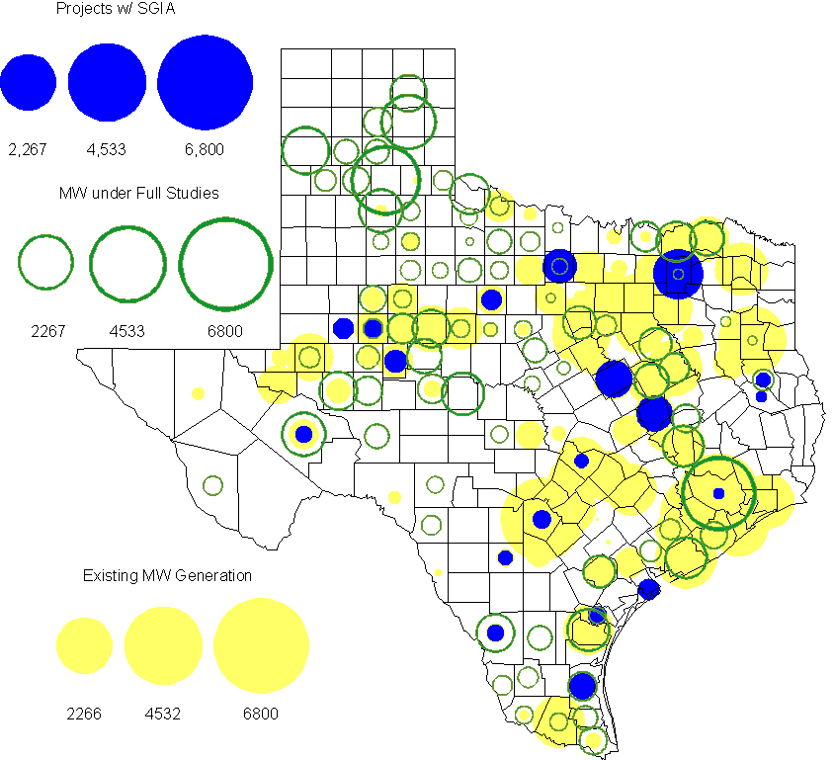

Generation Projects Undergoing Full Interconnection Studies
INR | County | Capacity | COD | Fuel |  | INR | County | Capacity | COD | Fuel
11INR0013 | Mills | 150 | Dec-09 | Wind |  | 09INR0077 | Reagan | 500 | Dec-09 | Wind
09INR0058 | Howard | 250 | Dec-09 | Wind |  | 09INR0061 | Kent | 258 | Dec-09 | Wind
09INR0051 | Borden | 249 | Dec-09 | Wind |  | 09INR0054 | Stonewall | 149 | Dec-09 | Wind
08INR0039 | Hamilton | 90 | Dec-09 | Wind |  | 08INR0056 | Nolan | 149 | Dec-09 | Wind
08INR0022 | Floyd | 100 | Dec-09 | Wind |  | 08INR0023 | Floyd | 100 | Dec-09 | Wind
10INR0048 | Hardeman | 1,000 | Jan-10 | Wind |  | 10INR0011 | Johnson | 275 | Jan-10 | Gas
10INR0024 | Briscoe | 2,940 | Jan-10 | Wind |  | 11INR0033a | Cameron | 200 | Jan-10 | Wind
10INR0062a | Pecos | 50 | May-10 | Wind |  | 10INR0079 | Nolan | 60 | May-10 | Wind
09INR0070 | Reagan | 42 | May-10 | Wind |  | 10INR0054 | Palo Pinto | 36 | May-10 | Wind
10INR0023 | Haskell | 386 | May-10 | Wind |  | 09INR0069 | Reagan | 36 | May-10 | Wind
09INR0035 | Concho | 750 | May-10 | Wind |  | 10INR0016 | Childress | 150 | May-10 | Wind
07INR0032 | Tom Green | 249 | May-10 | Wind |  | 09INR0018 | Concho | 249 | May-10 | Wind
09INR0081 | Rusk | 18 | Jun-10 | Coal |  | 10INR0069 | Rusk | 13 | May-10 | Coal
10INR0070 | Hunt | 50 | Jul-10 | Gas |  | 10INR0029 | Hood | 810 | Jun-10 | Gas
10INR0052a | Knox | 21 | Jul-10 | Wind |  | 10INR0057 | Taylor | 200 | Jul-10 | Wind
10INR0071 | Matagorda | 88 | Sep-10 | Wind |  | 10INR0013 | Upton | 400 | Jul-10 | Wind
09INR0074 | Motley | 70 | Oct-10 | Wind |  | 10INR0081a | Clay | 30 | Oct-10 | Wind
10INR0015 | Mitchell | 350 | Oct-10 | Wind |  | 10INR0041 | Floyd | 135 | Oct-10 | Wind
10INR0039 | Dickens | 200 | Nov-10 | Wind |  | 11INR0029 | Throckmorton | 200 | Nov-10 | Wind
10INR0080 | Presidio | 144 | Dec-10 | Solar |  | 10INR0032 | Navarro | 775 | Dec-10 | Gas
10INR0060 | Willacy | 401 | Dec-10 | Wind |  | 10INR0077 | Callahan | 101 | Dec-10 | Wind
10INR0051 | Brazoria | 200 | Dec-10 | Wind |  | 10INR0056 | Borden | 249 | Dec-10 | Wind
10INR0042 | Mason | 170 | Dec-10 | Wind |  | 09INR0076 | Jackson | 300 | Dec-10 | Wind
10INR0019 | Deaf Smith | 609 | Dec-10 | Wind |  | 10INR0033 | Armstrong | 399 | Dec-10 | Wind
08INR0061 | Hardeman | 200 | Dec-10 | Wind |  | 08INR0062 | Archer | 249 | Dec-10 | Wind
07INR0035 | Tom Green | 270 | Dec-10 | Wind |  | 10INR0008 | Pecos | 500 | Dec-10 | Wind
07INR0015 | Foard | 180 | Dec-10 | Wind |  | 07INR0026 | Baylor | 400 | Dec-10 | Wind
09INR0041 | Mitchell | 300 | Dec-10 | Wind |  | 07INR0013 | Coke | 200 | Dec-10 | Wind
11INR0050 | Crosby | 149 | Mar-11 | Wind |  | 11INR0033b | Cameron | 200 | Jan-11 | Wind
11INR0048 | Harris | 300 | May-11 | Gas |  | 11INR0037 | Smith | 50 | May-11 | Biomass
11INR0058 | Pecos | 135 | May-11 | Solar |  | 11INR0061 | Presidio | 90 | May-11 | Solar
11INR0062 | Nueces | 149 | May-11 | Wind |  | 11INR0060 | Tom Green | 90 | May-11 | Solar
10INR0009 | Castro | 300 | May-11 | Wind |  | 10INR0062b | Pecos | 50 | May-11 | Wind
11INR0057 | Cameron | 144 | Jun-11 | Wind |  | 09INR0050 | Fannin | 1,200 | Jun-11 | Gas
11INR0019 | Upton | 200 | Jun-11 | Wind |  | 11INR0054 | San Patricio | 161 | Jun-11 | Wind
11INR0006 | Lamar | 579 | Jul-11 | Gas |  | 08INR0020 | Eastland | 200 | Jun-11 | Wind
11INR0047 | Deaf Smith | 600 | Sep-11 | Wind |  | 11INR0040 | freestone | 640 | Aug-11 | Gas
11INR0008a | Roberts | 1,000 | Sep-11 | Wind |  | 11INR0039 | Starr | 201 | Sep-11 | Wind
07INR0014b | Wilbarger | 70 | Oct-11 | Wind |  | 10INR0081b | Clay | 19 | Oct-11 | Wind
10INR0021 | Grayson | 646 | Nov-11 | Gas |  | 07INR0014a | Wilbarger | 140 | Oct-11 | Wind
11INR0043 | Coke | 300 | Dec-11 | Wind |  | 11INR0067 | Cameron | 78 | Dec-11 | Wind
11INR0005 | Upton | 500 | Dec-11 | Wind |  | 11INR0025 | Crockett | 400 | Dec-11 | Wind
09INR0048 | Jack | 150 | Dec-11 | Wind |  | 06INR0022d | Kenedy | 200 | Dec-11 | Wind
12INR0021 | Edwards | 165 | Jan-12 | Wind |  | 12INR0033 | Motley | 150 | Jan-12 | Wind
11INR0049 | Wharton | 275 | May-12 | Gas |  | 10INR0018 | Madison | 550 | Mar-12 | Gas
09INR0031 | Ector | 275 | May-12 | Gas |  | 12INR0007 | Lamar | 296 | May-12 | Gas
12INR0006 | Limestone | 875 | Jun-12 | Coal |  | 10INR0062c | Pecos | 201 | May-12 | Wind
08INR0031 | Childress | 100 | Jun-12 | Wind |  | 10INR0022 | Harris | 3,500 | Jun-12 | Gas
12INR0027 | Gray | 200 | Oct-12 | Wind |  | 12INR0002 | Briscoe | 750 | Jul-12 | Wind
08INR0041 | Coke | 200 | Oct-12 | Wind |  | 12INR0026 | Randall | 400 | Oct-12 | Wind
08INR0019b | Gray | 250 | Nov-12 | Wind |  | 08INR0044 | Concho | 200 | Nov-12 | Wind
08INR0019c | Gray | 250 | Nov-12 | Wind |  | 08INR0019a | Gray | 250 | Nov-12 | Wind
12INR0018 | Gray | 600 | Dec-12 | Wind |  | 12INR0022 | Hidalgo | 200 | Dec-12 | Wind
08INR0054 | Comanche | 401 | Dec-12 | Wind |  | 12INR0005 | Floyd | 1,100 | Dec-12 | Wind
08INR0042 | Coke | 200 | Dec-12 | Wind |  | 09INR0025 | Concho | 180 | Dec-12 | Wind
12INR0029 | Swisher | 500 | Dec-12 | Wind |  | 06INR0022f | Kenedy | 200 | Dec-12 | Wind
13INR0004 | Deaf Smith | 500 | Oct-13 | Wind |  | 13INR0005 | Carson | 600 | Oct-13 | Wind
14INR0003 | Nolan | 850 | Jun-14 | Coal |  | 06INR0022e | Kenedy | 200 | Dec-13 | Wind
14INR0001 | Pecos | 500 | Dec-14 | Wind |  | 14INR0005 | Matagorda | 1,200 | Jul-14 | Coal
09INR0073 | Scurry | 200 | TBD | Wind

Wind Generation
Wind Capacity Installed by Year

County Location of Installed Capacity and Interconnection Requests (Wind only)

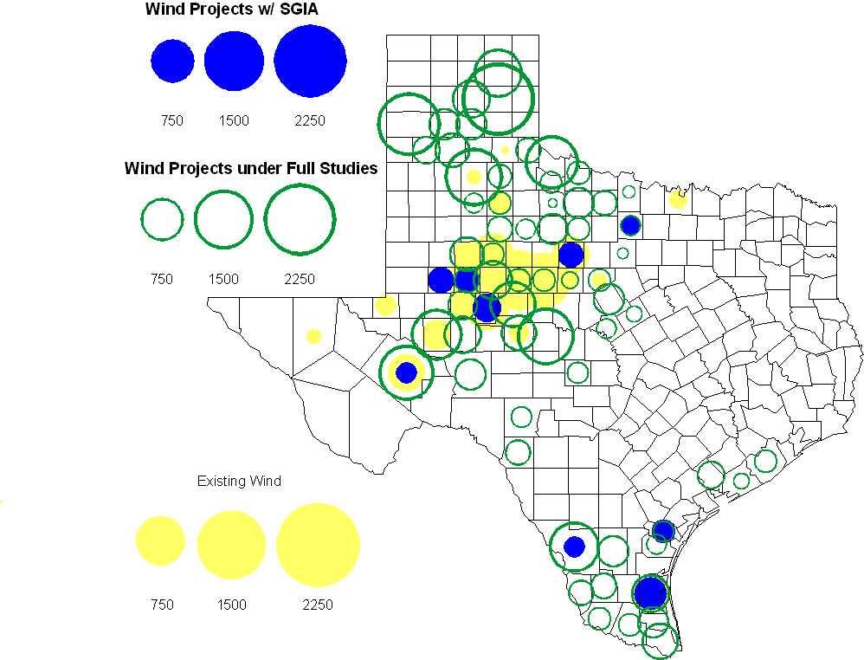

Regional Planning Group Project Reviews

Oncor submitted a project to relieve congestion related to new wind units in the Lamesa area. The project will upgrade the Lamesa to Bluff Creek 138 kV line, rebuild the Bluff Creek to China Grove 138 kV line, rebuild the Lamesa to Ackerly Vealmoor 69 kV line to 138/69 kV double circuit, rebuild the Lamesa 138 kV switching station, build a new 138 kV Ackerly Vealmoor station, add second circuits to all rebuilt lines and include station upgrades at China Grove and Big Spring. The cost of this project is $ 80.8 M. This project will be reviewed to ensure that the improvements fit into the likely CREZ transmission solution for the area. This project is in ERCOT Independent Review and will be studied as part of the 2009 Five-Year Transmission Plan.

Oncor submitted a project to add several 345 kV circuits to support the addition of Comanche Peak units 3 and 4 in 2015 at an estimated cost of $ 133 M. These upgrades include a new 345 kV double circuit line with one circuit in place from Comanche to Whitney, a new 345 kV line from Comanche to Johnson Switch, a new circuit on existing structures from Johnson Switch to Everman, a new 345 kV double circuit with one circuit in place from Comanche to DeCordova, and a new 345 kV line on existing structures from Comanche to Parker Switch. This project is in ERCOT Independent Review and will be studied when the 2009 Five-Year Transmission Plan is complete.

Sharyland Utilities submitted a project to construct and operate the ERCOT Southeast Loop facilities consisting of a 345 kV double circuit from Lufkin to Canal 345 kV substation on the northeast side of Houston. This project will cost $359 M with an estimated completion date of summer 2013. This project is in ERCOT Independent Review and will be studied as part of the 2009 Five-Year Transmission Plan.

American Electric Power Service Corporation submitted a project to construct several improvements in the Corpus Christi area. The estimated completion date of this project is June 2012 and estimated cost is $ 100.2 M. The ERCOT Independent Review has been completed and the project was endorsed by the ERCOT Board of Directors in November.

Centerpoint Energy has submitted a project to construct a new 345 kV double circuit line to allow greater power imports into the Houston area. The project involves expanding the Fayetteville and Zenith substations and constructing a new 345 kV double circuit from Fayetteville to Zenith. The proposal also includes looping the Fayette Power Project to Salem 345 kV circuit into Fayetteville and upgrading the Fayette Power Project to Fayetteville 345 kV double circuit lines. The project is estimated to be complete by September 2014 at a cost of $222 M. This project is in ERCOT Independent Review.

Luminant Energy has submitted the Comanche Peak Area Congestion Mitigation Plan project to loop the future Parker to Everman 345 kV CREZ line into the Comanche Peak 345 kV switch station. Luminant Energy’s estimated completion date for this project is April 2010 and the estimated cost is $3 M. This project is in ERCOT Independent Review.

Brazos Electric Cooperative has submitted a project to rebuild the Kruegerville to Frisco 138 kV line. The estimated cost of this project is $19.7 M and it is expected to be completed by the end of 2010. The comment period for this project has been completed and an RPG acceptance letter has been sent to Brazos Electric Cooperative.

Luminant Energy submitted a proposal to either accelerate the Waco West to Waco Atco 138 kV line rebuild that is currently scheduled to be completed by the fall of 2010 or to open the line in order to prevent congestion. This project is in study mode.

Luminant Energy submitted a proposal to uprate the Bell County to Salado 138 kV line by operating it at an elevated temperature. This project is in study mode.

Congestion Costs
Dollars shown in graphs are settlement quality.

OOMC – last 13 months in million$

OOM Down – last 13 months in million$

Local Balancing Energy Down – last 13 months in million$

OOM Up – last 13 months in million$

Local Balancing Energy Up – last 13 months in million$

Replacement Reserve – last 13 months in thousand$

Binding Constraints – October, 2009 – DATA PENDING

Contingency | Binding Element | Estimated Costs | Transmission Project
RENNER SWITCH - CARROLLTON EAST 138KV | HEBRON TMPP - AUSTIN RANCH 138KV | $ 1,925,064 | 06TPIT0037  Carrollton East - Renner 138kV line
 | Capacity Shortage | $ 1,622,568
Oak Creek – Ballinger 138kV | Abilene South – Ballinger 69kV | $ 819,234 | Ballinger to Abilene South 69kV, rebuild (08TPIT0080)
Temple Pecan Creek - Tradinghouse & Temple Switch - Lake Creek SES | San Angelo Power Station -Shrew Tap | $ 370,342 | Yellow Jacket Phase Shifting Transformer addition (08TPIT0135)
Garfield - Onion Creek & Hicross AEN 138kV | Lytton Springs 345/138kV Autotransformer #4 | $ 338,471 | Lytton Springs Autotransformer, addition (10TPIT0058)
Tradinghouse SES - Venus Switch 345kV | Rogers Hill TU - Elm Mott 138kV | $ 327,011 | Elm Mott – Waco Northcrest 138kV, upgrade (10TPIT0091)
Dilley Switch - San Miguel 138kV | Derby - Pearsall 69kV | $ 199,939 | Pearsall to Dilley 69 kV Line Upgrade  (09TPIT0189)
Everman Switch - Sherry Switch 345kV | Everman Switch - Oak Hill 2 Tap 138kV | $ 129,597
Hillje - Holman 345kV | Columbus - Stafford Hill 69kV | $ 79,526
North Denton 138/69kV Autotransformer | North Denton 138/69kV Autotransformer | $ 69,064

Inter-zonal Congestion

Other Notable Activities
2009 Five-Year Transmission Plan Update:
The 2009 Five-Year Transmission Plan is nearly complete. Projects to eliminate unserved energy and reduce congestion in 2010-2014 have been identified. The final steps in the assessment are to create a security constrained AC case for each study year and to document the results of the analysis.

Voltage Ride Through Study Update:
The Phase I report for public dissemination is being reviewed by System Planning. As part of Phase II, WGRs data submission of VRT capability data continues, together with validation of data received. WGRs with no response to the second reminder email have been put in direct contact with ERCOT in order to facilitate timely data collection for Phase II. For each wind farm, an aggregation model is being developed by the consultant. Validation of PSSe v.31 compatible models as needed for Phase III is almost completed.

West-to-North Stability Limit study Phase II Update:
With the revisions from the revised Operations Planning W-N stability limit study applied, the Planning study to test the effect of Power System Stabilizers (PSS) on the W-N Stability Limit is now nearing completion. The study runs and the full analysis of results have been completed and System Planning is currently reviewing the draft of the report.

The ERCOT TPIT update for November 2009 has been completed and was posted December 1, 2009.

