ERCOT Operations Report
November 2009 ROS & OWG

Frequency Control
Time | Freq(Hz) | Duration (s)
11/2/2009 23:19 | 60.13 | 329 | Out of down reg. Incorrect offset
11/3/2009 4:17 | 59.90 | 4 | Unit trip with 380 MW
11/15/2009 5:57 | 60.14 | 562 | SCE +570 MW in 20 min. Out of down reg.
11/23/2009 9:51 | 59.79 | 122 | Unit trip with 790 MW
11/23/2009 19:52 | 59.89 | 8 | Unit trip with 490 MW
11/30/2009 23:05 | 59.86 | 12 | Unit ran back with 550 MW
11/30/2009 23:08 | 60.10 | 8 | SCE +1245 MW in 2 min.
Note: Time of frequency excursions outside the range of +/- 0.1 Hz.

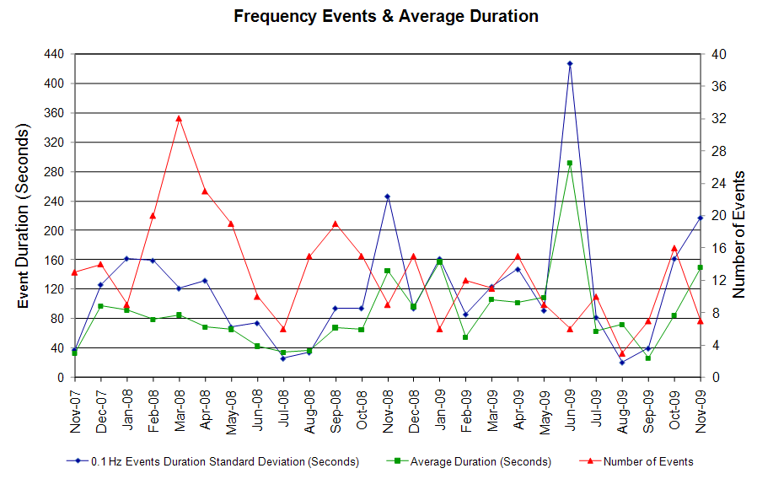

Deployed Responsive (Reported Above)
Time deployed | Stop Time | Duration | Max | Details
11/2 23:04:22 | 11/2 23:15:52 | 0:11:30 | 337.94 | Out of Up Reg.
11/3 04:17:50 | 11/3 04:31:06 | 0:13:16 | 385.45
11/13 20:03:18 | 11/13 20:25:03 | 0:21:45 | 353.77 | SCE change -1000 MW in 10m, slow regulation response
11/15 18:04:05 | 11/15 18:17:18 | 0:13:13 | 332.64 | Out of Up Reg.
11/18 23:58:00 | 11/19 00:09:20 | 0:11:20 | 332.64 | SCE change -630 MW in 5m, slow regulation response
11/23 09:51:17 | 11/23 10:24:51 | 0:33:34 | 960.98
11/23 19:52:31 | 11/23 20:01:26 | 0:08:55 | 401.28
11/28 20:05:55 | 11/28 20:23:33 | 0:17:38 | 327.36 | Out of Up Reg.
11/30 05:06:29 | 11/30 05:29:31 | 0:23:02 | 337.94 | Out of Up Reg.
11/30 23:05:59 | 11/30 23:16:37 | 0:10:38 | 559.69

Day-Ahead OOMC and RPRS Capacity Purchases
Details | OOMC | RPRS S1 | RPRS S2 | RPRS S1+S2 | RMR | Total
W RIO | 44 | 0 | 0 | 0 | 0 | 44
DFW | 19 | 0 | 5 | 5 | 0 | 24
Western | 0 | 5 | 15 | 20 | 4 | 24
Houston | 0 | 10 | 5 | 15 | 0 | 15
Austin | 0 | 5 | 4 | 9 | 0 | 9
North | 0 | 2 | 7 | 9 | 0 | 9
San Antonio | 1 | 1 | 3 | 4 | 0 | 5
Northeast | 0 | 0 | 5 | 5 | 0 | 5
E RIO | 4 | 0 | 0 | 0 | 0 | 4
South | 0 | 3 | 1 | 4 | 0 | 4
Bryan Area | 0 | 2 | 0 | 2 | 0 | 2
Corpus | 0 | 1 | 0 | 1 | 0 | 1
Laredo | 0 | 1 | 0 | 1 | 0 | 1
Total | 68 | 30 | 45 | 75 | 4 | 147

Historical Totals | Nov-09 | Nov-08 | Oct-09
Austin | 5 | 4 | 5
Bryan Area | 2 | 1 | 2
Corpus | 1 | 0 | 3
DFW | 19 | 6 | 95
E RIO | 4 | 2 | 9
Houston | 10 | 0 | 10
Laredo | 1 | 3 | 1
North | 2 | 3 | 2
Northeast | 0 | 0 | 5
San Antonio | 2 | 8 | 6
South | 3 | 2 | 3
W RIO | 44 | 65 | 4
Western | 9 | 6 | 9
Total | 102 | 100 | 154
http://www.ercot.com/mktinfo/services/rprsdr/index.html

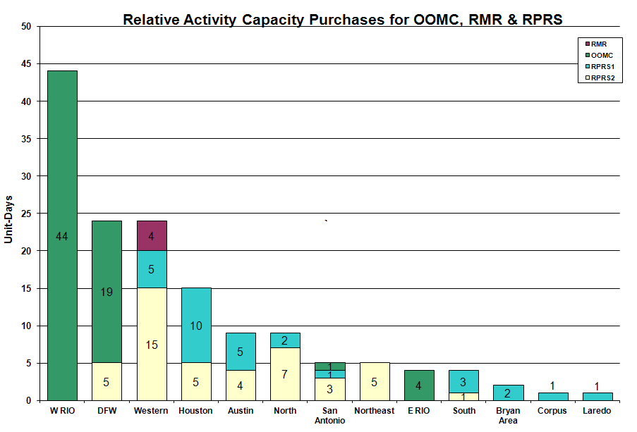

OOME and Congestion Management Activity
Congestion affected by outages Remedial action plan has been developed for the element
Contingency | Overloaded Element | Days
Abilene South - Eskota 138KV | Trent - Merkel 69KV | 10
Renner Switch - Carrollton East 138KV | Hebron TMPP - Austin Ranch 138KV | 8
Graham SES - Benbrook Switch & Parker Switch 345KV | Leon Switch - Flat Creek 138KV | 6
Graham - Benbrook Switch and Graham - Parker Switch 345KV | Barton Switch - Oran TU 138KV | 5
Aspermont - Spur 138KV | Spur 138/69KV AT | 5
Base Case | MEC Plainview Tap - WKN Breaker 69KV | 5
Graham SES - Parker Switch 345KV | Flat Creek - Leon Switch 138KV | 5
Graham SES - Long Creek 345KV | San Angelo Power Station - Shrew 138KV | 4
Base Case | Ena Snyder - MEC Plainview TAP 69KV | 4
Dilley Switch - North Laredo 138KV | Asherton - North Laredo 138KV | 4
Graham SES - Long Creek and Cook Field Road Switching 345KV | Abilene South - Putnam 138KV | 3
Ajo - Rio Hondo 345KV | Raymondville #1 - Raymondville #2 69KV | 3
Allen Switch - Royse Switch and Monticello SES 345KV | Kirkland - Judd Court 138KV | 3
Graham SES - Long Creek and Cook Field Road Switching 345KV | Cauthorn - Sonora 138KV | 3
Nicole - Oak Creek 138KV | San Angelo Concho - Veribest 69KV | 3
Oak Creek - Ballinger 138KV | Abilene South - Cedar Gap 69KV | 3
Graham SES - Long Creek and Cook Field Road Switching 345KV | San Angelo Power Station - Shrew Tap 138KV | 2
Temple Pecan Creek - Tradinghouse SES & Temple Switch - Lake Creek SES 345KV | Goldthwaite - Evant 138KV | 2
Roanoke Switch - West Denton and Lewisville Switch 345KV | Teasley - West Denton 138KV | 2
Abilene South - Eskota 138KV | Scott REA - Trent 69KV | 2
Aspermont - Paint Creek 138KV | Aspermont 138/69KV Auto #1 | 2
Base Case | Friend Ranch - Sonora 138KV | 2
Base Case | San Angelo - Shrew Tap 138KV | 2
Base Case | Snyder - Wkn Breaker 69KV | 2
Garfield - Lytton Springs and Austrop - Zorn 345KV | Garfield AEN - Garfield LCRA 345KV | 2
Graham SES - Parker Switch 345KV | San Angelo - Shrew 138KV | 2
Nicole - Oak Creek 138KV | Miles - Rowena 69KV | 2
San Angelo Red Creek - Comanche Switch 345KV | San Angelo Concho - Veribest | 2
San Miguel 138/69KV AT | Derby - Pearsall 69KV | 2
Santa Anna - Ballinger 138KV | Ballinger - Humble 69KV | 2
Temple Pecan Creek - Tradinghouse & Temple Switch - Lake Creek 345KV | San Angelo Power Station - Shrew 138KV | 2
Baytown Energy Center - Chambers 345KV | Baytown Energy Center 345/138KV Autotransformer #1 | 1
DuPont Ingleside - Whitepoint 138KV | Whitepoint - Rincon 138KV | 1
Elm Creek - Hill Country - Skyline 345KV | Cibolo - Schertz 138KV | 1
Graham SES - Long Creek and Cook Field Road Switching 345KV | Abilene South - Potosi Tap 138KV | 1
Graham SES - Benbrook Switch and Graham SES - Parker Switch 345KV | San Angelo Power Station - Shrew 138KV - | 1
Lon Hill - North Edinburg 345KV | Raymondville #1 - Raymondville #2 69KV | 1
San Miguel 138/69 KV AT | Derby - Pearsall 69KV | 1
Austrop - Lost Pines 345KV | Fayette 1 - Fayette 2 138KV | 1
W.A. Parish - Obrien 345KV | Midtown - Polk 138KV | 1
Base Case | Matador - Paducah 69KV | 1
Base Case | Sonora - Cauthorn 138KV | 1
Dilley Switch - San Miguel 138KV | Derby - Pearsall 69KV | 1
Graham SES - Benbrook Switch & Parker Switch 345KV | Graham SES 345/138 kV AT | 1
Holt Switch - Permian Basin SES 138KV | Odessa North 138/69KV AT | 1
Jack County - Reno 138KV | Rhome - Decatur Tap 138KV | 1
Oak Creek - Ballinger 138KV | San Angelo Concho - Veribest 69KV | 1
Royse Switch 345/138KV AT 1 | Forney Switch 345/138KV AT 3 | 1
Sonora - Friend Ranch 138KV | San Angelo Concho - Veribest | 1
Sweeny 138/69KV autotransformer | Sweeny - Old Ocean Sub 69KV | 1
Watermill - Tricorner and Trinidad 345KV | Hebron TMPP - Austin Ranch 138KV | 1

Zonal OC1
CSC | Days
West – North | 2
North - South | 2
North – Houston | 1

New RAP, PCAP (Date indicates last update of RAP, PCAP not implementation date.)
None

New Procedures/Forms/Operations Bulletins
Date | Subject | Bulletin No.
11/02/2009 | Shift Supervisor Desk Ver 4 Rev 8 | 448
11/02/2009 | Frequency Control Desk Ver 4 Rev 7 | 447
11/02/2009 | Transmission and Security Desk Ver 4 Rev 8 | 446
11/02/2009 | Operating Period Desk Ver 3 Rev 5 | 445
11/02/2009 | Day-Ahead Desk Ver 4 Rev6 | 444

Blackout/Load Shed Incidences
None

EEA
None

Major System Voltage Problems
None

Major Computer Problems, Enhancements & Fixes
None

Communication
None

ERCOT peak (Unofficial)
11/30 19:00 36,840 MW

Yearly MTLF Error Comparison
Yearly Mid-Term (Hourly) Load Forecast Error Comparison for the ERCOT Forecast
Month | MAPE for MTLF at 16:00 Day-Ahead
Month | 2006 | 2007 | 2008 | 2009
January | 4.79 | 4.55 | 3.30 | 4.11
February | 4.81 | 3.75 | 3.59 | 3.49
March | 4.95 | 2.70 | 3.29 | 3.24
April | 5.59 | 3.00 | 2.45 | 2.66
May | 3.59 | 3.22 | 3.01 | 2.90
June | 2.65 | 4.46 | 2.81 | 2.89
July | 2.62 | 4.29 | 2.55 | 2.83
August | 2.09 | 3.11 | 3.66 | 3.07
September | 4.03 | 3.78 | 4.99 | 3.68
October | 3.63 | 3.08 | 2.79 | 2.92
November | 3.28 | 2.95 | 2.60 | 1.93
December | 3.44 | 3.74 | 4.54 | NA
Annual Average | 3.79 | 3.55 | 3.29 | 3.06

OCN, Advisory, Watch & Emergency Notices
Capacity
Date | Start | End | Event
11/2/2009 | 8:51 | 14:20 | Advisory issued for ARRS below 3000 MW.
11/3/2009 | 12:20 | 16:10 | Advisory issued for ARRS below 3000 MW.
11/4/2009 | 3:00 | 10:10 | OCN issued for projected reserve capacity shortage for HE 14:00 & 20:00
11/5/2009 | 2:30 | 10:30 | OCN issued for projected reserve capacity shortage for HE 14:00 - 20:00
11/8/2009 | 8:50 | 21:00 | OCN issued for projected reserve capacity shortage for HE 15:00-20:00.
11/9/2009 | 0:44 | 7:30 | OCN issued for projected reserve capacity shortage for HE 14:00-20:00.
11/9/2009 | 4:33 | 13:50 | Advisory issued for ARRS below 3000 MW.
11/9/2009 | 7:30 | 9:15 | Watch issued for projected reserve capacity shortage for HE 18:00 - 21:00.
11/9/2009 | 23:04 | 24:00 | Advisory issued for ARRS below 3000 MW.
11/10/2009 | 11:55 | 21:00 | Advisory issued for ARRS below 3000 MW.
11/11/2009 | 14:40 | 20:30 | Advisory issued for ARRS below 3000 MW.
11/15/2009 | 1:45 | 10:30 | Advisory issued for ARRS below 3000 MW.
11/17/2009 | 6:53 | 11:00 | Advisory issued for ARRS below 3000 MW.
11/18/2009 | 5:38 | 8:10 | Advisory issued for ARRS below 3000 MW.
11/19/2009 | 3:15 | 18:40 | OCN issued for projected reserve capacity shortage for HE 16:00-20:00.
11/19/2009 | 14:33 | 18:40 | Advisory issued for ARRS below 3000 MW.
11/21/2009 | 8:10 | 15:15 | Advisory issued for ARRS below 3000 MW.
11/22/2009 | 17:50 | 23:40 | Advisory issued for ARRS below 3000 MW.
11/24/2009 | 8:15 | 12:10 | Advisory issued for ARRS below 3000 MW.
11/26/2009 | 8:15 | 12:00 | Advisory issued for ARRS below 3000 MW.
11/29/2009 | 18:47 | 21:20 | Advisory issued for ARRS below 3000 MW.
11/30/2009 | 18:22 | 21:45 | Advisory issued for ARRS below 3000 MW.

Transmission Watch
None

Emergency Notice
11/09 13:30 Market Emergency Notice issued due to the procurement of Ancillary Services for 11/10/09 did not meet the required timeline.

11/16 18:00 Market Emergency Notice issued due to RPRS Market failed to meet timeline.

Texas RE Event Analysis
11/09 13:30 Market Emergency Notice issued due to the procurement of Ancillary Services for 11/10/09 did not meet the required timeline.

11/10 12:11 Simultaneous Loss of five 138KV circuits.

11/16 18:00 Market Emergency Notice issued due to RPRS Market failed to meet timeline.

11/24 10:59 The primary EMS servers ERPEMSB and ERPEMSA failed.

Others
11/02 23:00 Held Real-time Balancing Market deployments IE 23:00 for IE 23:15 due to incorrect offset, resumed with IE 23:30.

