
User Guide:
Market Data Transparency User Guide
ESIID Data Requests

Version 1.4
11/17/09

Table of Contents
1. Overview 1
1.1 Background 1
1.2 Document Purpose 1
1.3 Applicable Documents, Standards, and Policies 1
1.3.1 Market Guides and Protocol References 1
1.3.2 Service Level Agreements 1
2. Summary 2
2.1 About ERCOT Data Extracts 2
2.2.1 Data Definition Language (DDL) 2
2.2.2 Data Extract Distributions 2
2.2 Overview of Market Data Transparency 2
2.2.1 General Report Information 2
2.2.2 Report Recipients 2
3. Content 3
3.1 Provide ESIID Account Records 3
3.2 Provide ESIIDs I own for a trade date 10
3.3 Provide CMZONE assignments for a trade date 12
3.4 Provide Non-IDR transaction data for ESIIDs I own 13
3.5 Provide Non-IDR transaction data for a trade date 15
3.6 Provide ESIIDs where Non-IDR transaction data not loaded for a trade date 17
3.7 Provide IDR usage data for a trade date (IDR required) 18
3.8 Provide ESIIDs where IDR usage data not loaded for a trade date (IDR required) 20
3.9 Provide Non-IDR transaction data by meter type for ESIIDs I own 23
3.10 Provide IDR usage data for ESIIDs I own (IDR required) 25
3.11 Provide all extract records for ESIID Service History and Usage extract 26
3.12 Provide extract records for Logical Keys for ESIID Service History and Usage extract 28
3.13 Provide public data extract 29
3.14 Provide AMS interval data for a trade date 30
3.15 Provide ESIIDs where AMS interval data not loaded for a trade date 31
3.16 Provide AMS interval data for ESIIDs I own 33
3.17 Security Requirements 35
Delivery 36
3.18 Service Level Agreement – Delivery 36
3.19 API/Web Services 36
3.20 Accessing the Web Services 36
3.2.1 Data Request - Schedule 36
3.2.2 Data Request - Status 38
6.4 Appendix D- Acronyms Dictionary 45

Overview

Background
In 2003, SCR 727 (ESIID Service History & Usage Extract) instituted daily extracts which provided LSEs, MREs, and TDSPs with ESIID-level data necessary to perform comparisons and determine data discrepancies on data used for settlements. While providing a much needed service ,the extract lacked functionality and audit capabilities.

In 2005, the Market submitted SCR 740 requesting a Phase II release to the ESIID Service History & Usage Extract. ERCOT and Market Participants worked together to identify the changes needed for the extract and gather business requirements. In an effort to provide more flexibility to Market Participants for ESIID data research, the market agreed to SCR 740 providing the capability to query ESIID data in an ad-hoc fashion via Web Services from ERCOT systems and to provide audit capabilities to confirm the accuracy of Market Participant ESIID service history & usage data. This Phase II Web Services effort is referred to as Market Data Transparency or known as Data Requests on the Texas Market Link.

For LSEs that encounter backdated LSE date changes or additions, usage loaded prior to the relationship correction are not provided in the ESIID Service History & Usage Extract. Therefore, any additional ESIID information needed outside of the original delivery of the ESIID Service History & Usage extract must be requested and fulfilled outside of the extract process. In addition, some Market Participants do not currently maintain an ESIID Service History & Usage Extract database. Information regarding ESIID data, however, is still necessary for validating data on the Market Participant side. As a result, a need has arisen to acquire ESIID data on an ad-hoc request basis.

Document Purpose
This user guide is intended for Market Participants and can be broken into two main sections. First, there will be a high level overview of how Market Data Transparency came to fruition and what the system architecture looks like. Second, each of the fifteen data requests offered will be discussed in detail.

Applicable Documents, Standards, and Policies

Market Guides and Protocol References
The following Nodal Protocol(s) and market guides apply to the Market Data Transparency web services:

- Protocol Section for Market Data Transparency – 12.4.4.2.3.2
- Retail Market Guide – Section 7.1.3 (SCR 740)

Service Level Agreements

The Settlement and Extracts Working Group (SEWG) which falls under the Commercial Operations Subcommittee (COPS) is responsible for helping to maintain and manage the Data Extract and Reports SLA. This extract currently falls under the Extract and Reporting SLA. Please refer to the SLA section on ERCOT.com for the most up to date information on this extract.

Summary

About ERCOT Data Extracts
ERCOT data extracts and reports provide a framework that allows Market Participants to retrieve ERCOT market data for analysis. This framework is comprised of two elements: DDL and Data Extract distributions.

Data Definition Language (DDL)
ERCOT provides the structures for Market Participants to load ERCOT data into their own environment in the form of data definition language (DDL). This DDL provides the metadata information for the data type of each field, the table primary and foreign key constraints, and a brief description of the data that is to be loaded into each column.

Data Extract Distributions
ERCOT utilizes a standard comma-separated value file format (CSV) for extract/report data delivery to ensure portability across most platforms and architectures. These CSV files are distributed to the Market through the Texas Market Link (TML) website packaged in zip files.

While data extracts and reports are not intended to provide a single solution to resolve all Market Participant needs, they are meant to provide Market Participants with the data sets used by ERCOT to manage various types of information.

Overview of Market Data Transparency
The implementation of Market Data Transparency/SCR 740 allows Market Participants ad-hoc request access to public and Market Participant specific data tables. The intention of this web service is to provide Market Participants the ability to research ESIID level data through self-service. The fifteen different data requests presented will allow Market Participants to do such things as validating the ownership of a single ESIID to generating a full historical data dump from all public and private tables provided in the extract.

General Report Information
The Market Data Transparency Web Services builds on the existing ESIID Service History and Usage Extract provided to Market Participants to increase transparency for ESIID level data that ERCOT utilizes in market settlement. The Web Services are an on demand query tool that allows Market Participants to request specific data needed to further analyze and utilize their shadow settlement systems. The layout and availability of the specific types of data offered is detailed below in the ‘Content’ section of this document.

Report Recipients
The Web Services, similar to the ESIID Service History and Usage extract are available to TDSPs and LSEs via the Texas Market Link application.

Content

Provide ESIID Account Records

Purpose: The purpose of this request is to provide the user with the ability to verify ownership of a set of ESIIDs or UIDESIIDs as of a particular point-in-time (PITS).

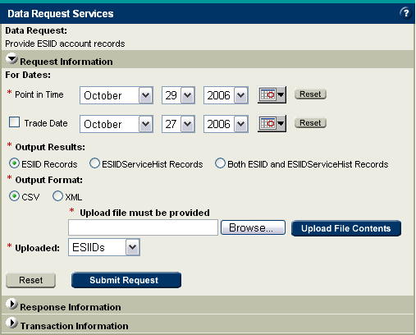

All data request screens share basic common functions and formats. Required fields are always denoted with a red asterisk (*). The grey “Reset” button will clear the data request screen and reset all defaults. Each data request screen has a blue help button located in the top right hand corner which displays explanations of all buttons and input fields.

Required Inputs: Point-in-time is a required input as this data request is Market Participant specific and only ESIIDs owned by the Market Participant for that particular historical date will be returned. The point-in-time date boxes default to the most current date available for research. As an added option, trade date can also be used in conjunction with PITS and the upload file to further narrow down the area of research. The user is also required to provide a list of 1,000 or less ESIIDs or UIDESIIDs as an upload file (either TXT or CSV) with each ESIID or UIDESIID separated by a carriage return. The “Uploaded” drop down menu defaults to ESIID. Once the file has been chosen, the user must click “Upload File Contents” to be recognized and validated as an input.

Optional Inputs: Trade date has a check box that must be checked to include it as an input parameter of the data request. The trade date boxes also default to the most current date available for research.

Upload File: All Upload File fields are required and must be in upper case. The Upload File must be in CSV and formatted as follows:

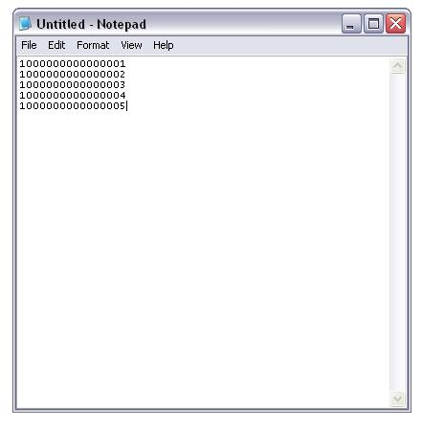
Output Types: There are three different types of output content that can be chosen in either CSV or XML format. Please refer to Appendix A for a complete list of output fields for “ESIID Records” and “ESIIDServiceHist Records”. For “Both ESIID and ESIIDServiceHist Records”, both output data files are returned as a result.

After choosing the output results and output format, click the “Submit” button to place the data request in queue. A return screen will verify that the request has been submitted successfully and provide the user with an audit ID. The audit ID is similar to an order number and should be recorded to identify your data request once completed. Selecting the “Clear” button will reset the web form to its default settings.

ActiveX for upload files: The ActiveX technology is used to upload files from your desktop to the Web Service. Depending on your ActiveX browser setting you may be prompted as to whether you want to allow interaction with ActiveX or you may get an error message.

If you are prompted for ActiveX interaction, simply click the “Yes” button to allow the upload to occur:

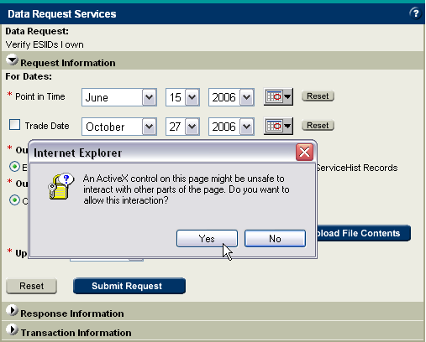

If your browser has ActiveX disabled, then you will receive an error message that notifies you of the settings. If this is the case, simple click the “OK” button, and the Web Service will display a text box where you can simply paste your upload file contents:
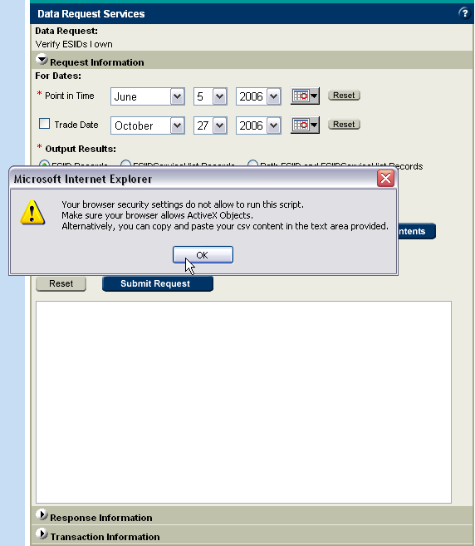

After pasting in your file contents, simply click the “Upload File Contents” button and continue.

Changing your browser’s ActiveX settings: To change your browser’s ActiveX settings, go to Tools>Internet Options and select the Security tab:
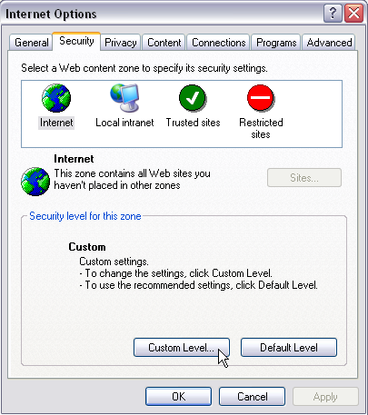

Then, click the Custom Level button at the bottom. The first 5 settings in the Settings list are ActiveX settings. Simply change all 5 to “Enable” to activate your browser’s ActiveX functions:

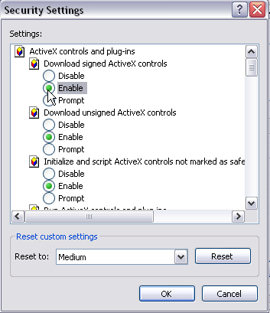

If the browser security settings are still too high, simply reset the level from “Medium” to “Medium-Low”.

Delivery: The data request output files will be posted to the TML for download. The turnaround time is less than three business days.

Example use of request:
- Verify ownership of a list of ESIIDs with ESIIDServiceHist output option – provides the user with all of the ESIIDServiceHist rows existing as of the PITS for the input list of ESIIDs; provides all data rows for continuous and non-continuous relationships (LSE owned an ESIID for 01/15/2005 – 10/10/2005 and 03/12/2006 to current)
- Verify ownership of a list of ESIIDs for a specific trade date – provides the user with ESIIDs owned; used to verify a Siebel Service Instance relationship exists in Lodestar as a result of a transaction completing a Siebel Service Order or a change resulting from a Data Extract Variance (DEV) or Day to Day (D2D) issue
- Verify ESIID added by 814_20
- Verify ESIID retired by 814_20

Help screens: Every Web Service has a help screen that is accessible via the blue “?” in the top right corner of the screen:

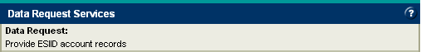

The top three categories of every help screen contain information specific to the Web Service you are using. The rest of the help screen contains information which may or may not be required depending on the Web Service you are using:

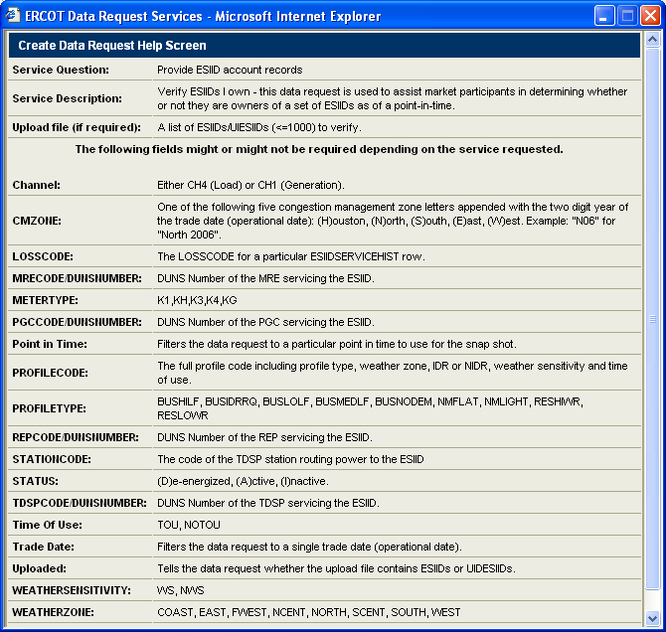

Provide ESIIDs I own for a trade date
Purpose: The purpose of this request is to provide the user with a list of ESIIDs owned, on a particular trade date, as of a particular point-in-time (PITS).

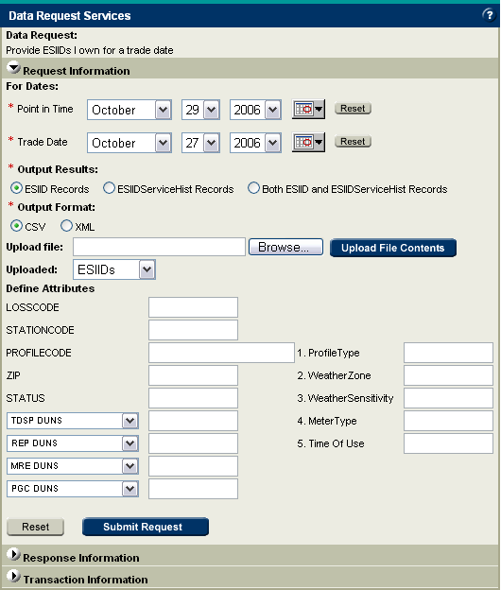

Required Inputs: The user is required to provide the point in time and the trade date in question. Both the point in time and trade date boxes will default to the most current dates available. All data for input fields must be capitalized.

Optional Inputs: The user can narrow the search by leveraging any one of a number of optional fields including a list of 1,000 or less ESIIDs or UIDESIIDs. In the case of PROFILECODE, the user can either provide the PROFILECODE or any combination of the five components (PROFILETYPE, WEATHERZONE, WEATHERSENSITIVITY, METERTYPE, Time Of Use).

Upload File: All Upload File fields are required and must be in upper case. The Upload File must be in CSV and formatted as follows:

Output Types: There are four different types of output content that can be chosen in either CSV or XML format. Selecting “List” will provide a list of distinct ESIIDs. Please refer to Appendix A for a complete list of output fields for “ESIID Records” and “ESIIDServiceHist Records”. For “Both ESIID and ESIIDServiceHist Records”, both output data files are returned as a result.

After choosing the output results and output format, clicking the “Submit” button will place the data request in queue. A return screen will verify that the request has been submitted successfully and provide the user with an audit ID. The audit ID is similar to an order number and should be recorded to identify the data request going forward. Selecting the “Clear” button will reset the web form to its default settings.

Delivery: The output files will be posted to the TML for download. The turnaround time is less than three business days from the date of submission.

Example use of request:
- Verify ownership of a list of ESIIDs for a specific trade date – provides the user with ESIIDs owned; used to verify a Siebel Service Instance relationship exists in Lodestar as a result of a transaction completing a Siebel Service Order or a change resulting from a Data Extract Variance (DEV) or Day to Day (D2D) issue (same request can be performed with ‘Verify ESIIDs I own’ request)
- Determine ESIIDs by specifying ESIID characteristics – provides the user with ESIIDs owned for specific trade date and ESIID characteristics provided
- Determine ESIID characteristics for ESIIDs – provides user with ESIID characteristics for owned ESIIDs provided for specific trade date; used to verify an 814_20 ESIID Characteristic update
- Verify ESIID added by 814_20 by providing ESIID and effective date as Trade Date
- Verify ESIID retired by 814_20 by providing ESIID and effective date as Trade Date

Provide CMZONE assignments for a trade date
Purpose: The purpose of this request is to provide the user with a list of ESIIDs owned and their CMZONE assignments on a particular trade date, as of a particular point-in-time (PITS).

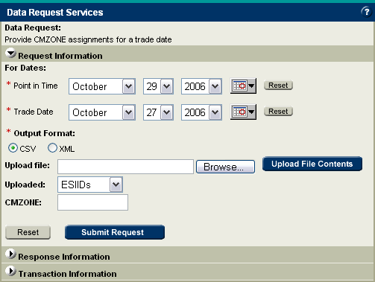

Required Inputs: The user is required to provide the point in time and the trade date in question. Both the point in time and trade date boxes will default to the most current dates available.

Optional Inputs: The user can narrow the search by uploading a list of 1,000 or less ESIIDs or UIDESIIDs. Additionally, the request can be further narrowed to include only a specific CMZONE.

Upload File: All Upload File fields are required and must be in upper case. The Upload File must be in CSV and formatted as follows:

Output Types: This data request has a single type of output that can be received in either CSV or XML format. Please refer to Appendix A for a complete list of output fields for “CMZONE Assignments” data request.

After choosing the output results and output format, clicking the “Submit” button will place the data request in queue. A return screen will verify that the request has been submitted successfully and provide the user with an audit ID. The audit ID is similar to an order number and should be recorded to identify the data request going forward. Selecting the “Clear” button will reset the web form to its default settings.

Delivery: The output files will be posted to the TML for download. The turnaround time is less than three business days.

Example use of request:
- Determine ESIIDs for specific CMZONE and trade date
- Determine CMZONE assignment for all ESIIDs owned for a specific trade date
- Determine CMZONE assignment for specified ESIIDs owned for a specific trade date

Provide Non-IDR transaction data for ESIIDs I own
Purpose: The purpose of this request is to verify Non-IDR transaction data loaded for a set of ESIIDs and specific transactions owned as of a particular point-in-time (PITS).

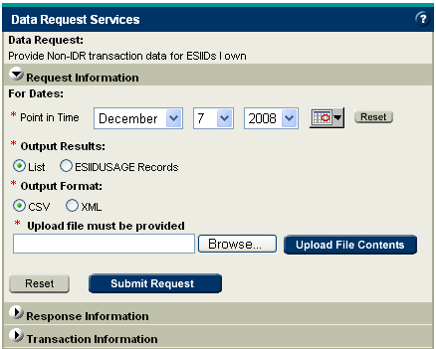

Required Inputs: The user is required to provide the point in time, which will default to the most current date available and an upload file. The upload file must contain ESIID, Transaction ID, STARTTIME, STOPTIME and METERTYPE. Please see Appendix A for input file formats.

Upload File: All Upload File fields are required and must be in upper case. The Upload File must be in CSV and formatted as follows:

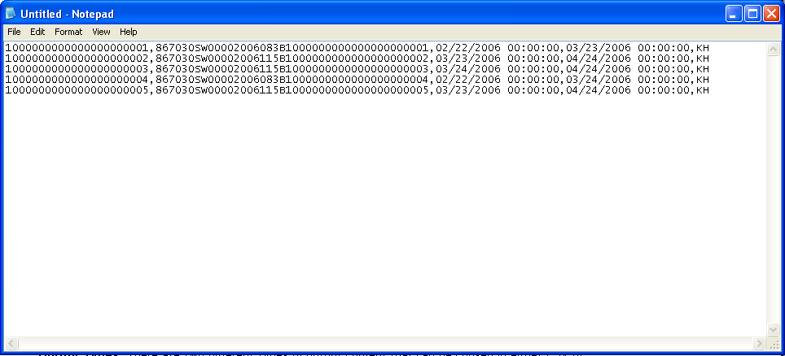

Output Types: There are two different types of output content that can be chosen in either CSV or XML format. Selecting “List” will provide a list of the ESIID and transaction combination loaded in ERCOT systems. Selecting “ESIIDUSAGE Records” will yield the detailed usage data from the ESIIDUSAGE data table including the GLOBALPROCID. Please refer to Appendix A for a complete list of output fields for “ESIID Usage Records”.

After choosing the output results and output format, clicking the “Submit” button will place the data request in queue. A return screen under “Transaction Information” will verify that the request has been submitted successfully and provide the user with an audit ID. The audit ID is similar to an order number and should be recorded to identify the data request going forward. Selecting the “Clear” button will reset the web form to its default settings.

Delivery: The output files will be posted to the TML for download. The turnaround time is less than three business days.

Example use of request:
- Verify NIDR 867_03 was loaded into ERCOT systems based on ESIID and transaction information

Provide Non-IDR transaction data for a trade date
Purpose: The purpose of this request is to provide the user with Non-IDR transaction data for ESIIDs owned as of a particular point-in-time (PITS), for a certain meter type, for a particular trade date (operation date.)

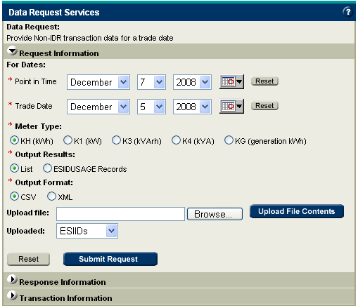

Required Inputs: The user is required to provide the point in time and the trade date in question. Both the point in time and trade date boxes will default to the most current dates available. Additionally, the user is required to specify the NIDR meter type which will default to KH (kWh). The user must also provide an upload file consisting of a list of 1,000 or less ESIIDs or UIDESIIDs.

Upload File: All Upload File fields are required and must be in upper case. The Upload File must be in CSV and formatted as follows:

Output Types: There are two different types of output content that can be chosen in either CSV or XML format. Selecting “List” will provide a list of distinct ESIIDs. Selecting “ESIIDUSAGE Records” will yield the detailed transaction data from the ESIIDUSAGE data table including the GLOBALPROCID. Please refer to Appendix A for a complete list of output fields for “ESIIDUSAGE Records”.

After choosing the output results and output format, click the “Submit” button to place the data request in the queue. A return screen will verify that the request has been submitted successfully and provide the user with an audit ID. The audit ID is similar to an order number and should be recorded to identify the data request going forward. Selecting the “Clear” button will reset the web form to its default settings.

Delivery: The output files will be posted to the TML for download. The turnaround time is less than three business days.

Example use of request:
- Determine usage data loaded for a specific trade date for all ESIIDs owned
- Verify 867_03 transaction data loaded based for ESIIDs for a specific trade date

Provide ESIIDs where Non-IDR transaction data not loaded for a trade date
Purpose: The purpose of this request is to provide the user with a list of ESIIDs owned that do not have Non-IDR transaction data loaded as of a particular point-in-time (PITS), for a certain meter type, for a particular trade date (operation date.)

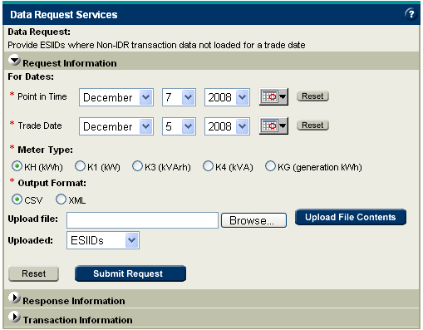

Required Inputs: The user is required to provide the point in time and the trade date in question. Both the point in time and trade date boxes will default to the most current dates available. Additionally, the user is required to specify the meter type which will default to KH (kWh). The user must also provide an upload file consisting of a list of 1,000 or less ESIIDs or UIDESIIDs.

Upload File: All Upload File fields are required and must be in upper case. The Upload File must be in CSV and formatted as follows:

Output Types: This data request provides an output file which is a list of ESIIDs that do not have NIDR transaction data loaded for the trade date and point in time in question.

After choosing the output results and output format, click the “Submit” button to place the data request in the queue. A return screen will verify that the request has been submitted successfully and provide the user with an audit ID. The audit ID is similar to an order number and should be recorded to identify the data request going forward. Selecting the “Clear” button will reset the web form to its default settings.

Delivery: The output files will be posted to the TML for download. The turnaround time is less than three business days.

Example use of request:
- Determine transction data not loaded for a specific trade date for all ESIIDs owned
- Verify 867_03 cancelled transaction data for ESIIDs for a specific trade date

Provide IDR usage data for a trade date (IDR required)
Purpose: The purpose of this request is to provide the user with IDR 867_03 transaction data for ESIIDs owned as of a particular point-in-time (PITS), for a certain channel, for a particular trade date (operation date) having a profile type of BUSIDRRQ only.
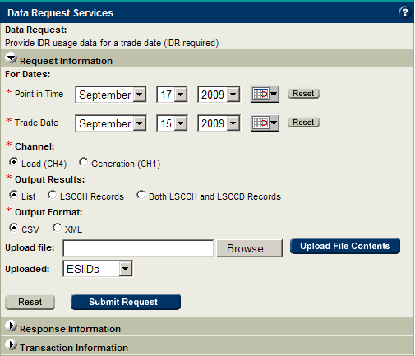

Required Inputs: The user is required to provide the point in time and the trade date in question. Both the point in time and trade date boxes will default to the most current dates available. Additionally, the user is required to specify the channel which will default to Load (CH4).

Optional Inputs: The user can narrow the search by uploading a list of 1,000 or less ESIIDs or UIDESIIDs.

Upload File: All Upload File fields are required and must be in upper case. The Upload File must be in CSV and formatted as follows:

Output Types: There are three different types of output content that can be chosen in either CSV or XML format. Selecting “List” will provide a list of distinct ESIIDs. Selecting “LSCCH Records” will yield the detailed usage data from the LSCHANNELCUTHEADER data table. Selecting “LSCCH and LSCCD Records” will yield the data from both the LSCHANNELCUTHEADER data table and the LSCHANNELCUTDATA data table (the actual interval data.) Please refer to Appendix A for a complete list of output fields for “LSCCH Records” and “LSCCH and LSCCD Records”.

After choosing the output results and output format, click the “Submit” button to place the data request in the queue. A return screen will verify that the request has been submitted successfully and provide the user with an audit ID. The audit ID is like an order number and should be recorded to identify the data request going forward. Selecting the “Clear” button will reset the web form to its default settings.

Delivery: The output files will be posted to the TML for download. The turnaround time is less than three business days.

Example use of request:
- Determine generation/usage data loaded for a specific trade date for all IDR (IDR Required) ESIIDs owned
- Verify IDR 867_03 generation/usage data loaded based for ESIIDs for a specific trade date

Provide ESIIDs where IDR usage data not loaded for a trade date (IDR required)
Purpose: The purpose of this request is to provide the user with a list of ESIIDs owned that do not have IDR usage data loaded as of a particular point-in-time (PITS), for a certain channel, for a particular trade date (operating day.)

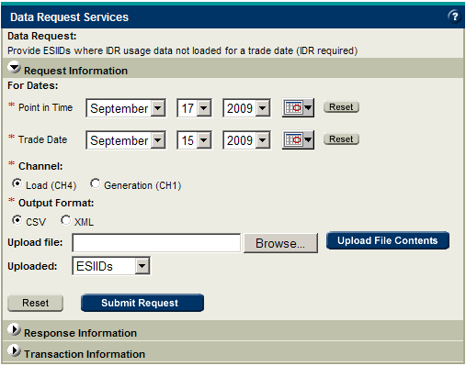

Required Inputs: The user is required to provide the point in time and the trade date in question. Both the point in time and trade date boxes will default to the most current dates available. Additionally, the user is required to specify the channel which will default to Load (CH4).

Optional Inputs: The user can narrow the search by uploading a list of 1,000 or less ESIIDs or UIDESIIDs.

Upload File: All Upload File fields are required and must be in upper case. The Upload File must be in CSV and formatted as follows:

Output Types: This data request provides an output file which is a list of ESIIDs that do not have IDR 867_03 usage data loaded for the trade date in question.

After choosing the output results and output format, click the “Submit” button to place the data request in the queue. A return screen will verify that the request has been submitted successfully and provide the user with an audit ID. The audit ID is similar to an order number and should be recorded to identify the data request going forward. Selecting the “Clear” button will reset the web form to its default settings.

Delivery: The output files will be posted to the TML for download. The turnaround time is less than three business days.

Example use of request:
- Determine usage data not loaded for a specific trade date for all (IDR Required) ESIIDs owned
- Verify IDR 867_03 cancelled usage data for ESIIDs for a specific trade date

Provide Non-IDR transaction data by meter type for ESIIDs I own
Purpose: The purpose of this request is to provide the user with Non-IDR transaction data for a set of ESIIDs owned as of a particular point-in-time (PITS), for a selected meter type, for a range of trade dates.

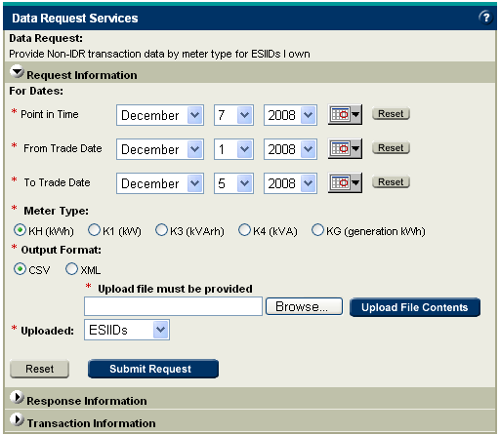

Required Inputs: The user is required to provide the point in time and range of trade dates in question, as well as a meter type. Both the point in time and the trade date boxes will default to the most current dates available. Additionally, a file of 1,000 or less ESIIDs or UIDESIIDs is required.

Upload File: All Upload File fields are required and must be in upper case. The Upload File must be in CSV and formatted as follows:

Output Types: This data request provides an output file which is transaction data from the ESIIDUSAGE data table including the GLOBALPROCID.

After choosing the output format, click the “Submit” button to place the data request in the queue. A return screen will verify that the request has been submitted successfully and provide the user with an audit ID. The audit ID is similar to an order number and should be recorded to identify the data request going forward. Selecting the “Clear” button will reset the web form to its default settings.

Delivery: The output files will be posted to the TML for download. The turnaround time is less than three business days.

Example use of request:
- Determine transaction data loaded for specific trade date(s) for provided list of NIDR ESIIDs owned
- Verify NIDR 867_03 transaction data loaded for ESIIDs for specific trade date(s)

Provide IDR usage data for ESIIDs I own (IDR required)
Purpose: The purpose of this request is to provide the user with IDR 867_03 transaction data for all or a set of ESIIDs owned as of a particular point-in-time (PITS), for a certain channel, for a particular range of trade dates (operation dates). This service can be used by Market Participants to re-baseline their data for the LSCHANNELCUTHEADER and LSCHANNELCUTDATA data tables.

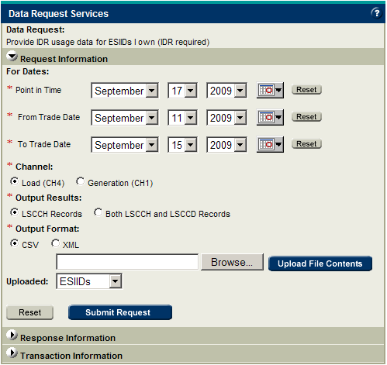

Required Inputs: The user is required to provide the point in time and a range of trade dates in question. The range of Trade dates cannot be greater than 31 days. Both the point in time and the trade date boxes will default to the most current dates available. Additionally, the user is required to specify the channel which will default to Load (CH4).

Upload File: All Upload File fields must be in upper case. The Upload File must be in CSV and formatted as follows:

Output Types: There are two different types of output content that can be chosen in either CSV or XML format. Selecting “LSCCH Records” will yield the detailed usage data from the LSCHANNELCUTHEADER data table. Selecting “LSCCH and LSCCD Records” will yield the data from both the LSCHANNELCUTHEADER data table and the LSCHANNELCUTDATA data table (the actual interval data.) Please refer to Appendix A for a complete list of output fields for “LSCCH Records” and “LSCCH and LSCCD Records”.

After choosing the output results and output format, click the “Submit” button to place the data request in the queue. A return screen will verify that the request has been submitted successfully and provide the user with an audit ID. The audit ID is similar to an order number and should be recorded to identify the data request going forward. Selecting the “Clear” button will reset the web form to its default settings.

Delivery: The output files will be posted to the TML for download. The turnaround time is less than three business days.

Example use of request:
- Determine generation/usage data loaded for specific trade date(s) for provided list of IDR 867_03 ESIIDs owned
- Verify IDR 867_03 generation/usage data loaded for ESIIDs for specific trade date(s)

Provide all extract records for ESIID Service History and Usage extract
Purpose: The purpose of this request is to provide Market Participants with the ability to audit their onsite ESIID Service History & Usage Extract database with ERCOT’s ESIID data.

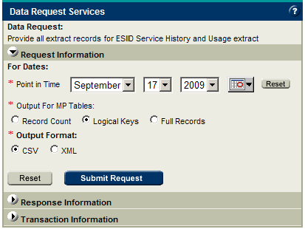

Required Input: The user is required to provide the point in time which will default to the most current date available.

Output Types: There are three different types of output content that can be chosen in either CSV or XML format. Selecting “Record Count” will yield a count of all ESIID records. This output option is to be used when the Market Participant simply wants to verify if a discrepancy exists between the two systems. There are no restrictions on how many times a record count may be requested.

Selecting “Logical Keys” will yield the logical key records for all ESIIDSERVICEHISTORY records for Market Participant specific data. Depending on the where in the current quarter the day that you are making the request falls, you will receive between 8 and 9 quarters of transaction data, including all transaction data within the current day’s quarter. For example, if a request is made on 09/09/2008 which falls in the third quarter of 2008, the transaction data will include records that were inserted or updated in ERCOT systems between 07/01/2006 – 09/09/2008. If that same request was made on 07/01/2008, the Market Participant would receive record sets falling in the same quarter range.

Logical keys are the combination of table columns which create row uniqueness. Due to the volume of data this output option produces, it may only be requested twice per year per DUNS Number. If the output is too large to be posted on the TML, you will be contacted by your Account Manager for additional delivery options. The “Logical Keys” option is an abbreviated full data dump. For Market Participants to complete a refresh of their ESIID Service History & Usage Extract database, a comparison between the Logical Keys provided by ERCOT for each table and what is loaded in their current database would have to occur. In this comparison, Market Participants will determine what records need to be deleted from their database and what records are missing. To retrieve the full record for the identified missing records, the Market Participant will utilize data request “Provide ESIID extract records for Logical Keys”.

Selecting “Full Records” will yield a total data dump of all ESIIDSERVICEHISTORY records for Market Participant specific data and all current public reference data. Depending on the where in the current quarter the day that you are making the request falls, you will receive between 8 and 9 quarters of transaction data, including all transaction data within the current day’s quarter. For example, if a request is made on 09/09/2008 which falls in the third quarter of 2008, the transaction data will include records that were inserted or updated in ERCOT systems between 07/01/2006 – 09/09/2008. If that same request was made on 07/01/2008, the Market Participant would receive record sets falling in the same quarter range.

Due to the volume of data this output option produces, it may only be requested once per year per DUNS Number. If the output is too large to be posted on TML, you will be contacted by your Account Manager for additional delivery options. The “Full Records” option gives the Market Participant all the data necessary to completely refresh their ESIID Service History & Usage Extract database.
The “Logical Keys” and “Full Records” options are intended to be used by Market Participants to determine any discrepancies between ERCOT data and Market Participant databases.

After choosing the output results and output format, click the “Submit” button to place the data request in the queue. A return screen will verify that the request has been submitted successfully and provide the user with an audit ID. The audit ID is similar to an order number and should be recorded to identify the data request going forward. Selecting the “Clear” button will reset the web form to its default settings. In the case of “Logical Keys” or “Full Records” a DVD containing the data will mailed to the Market Participant.

Delivery: Only the output files for the Record count requests will be posted to TML for download with a turnaround time less than three business days. The output files for the “Logical Keys” and “Full Records” will be mailed to Market Participants on DVD if the files are too large to post to the TML with a turnaround time of less than ten business days.

Provide extract records for Logical Keys for ESIID Service History and Usage extract
Purpose: The purpose of this request is to provide Market Participants with the ability to audit an onsite ESIID Service History & Usage database table with an ERCOT ESIID Service History & Usage Extracts database table.

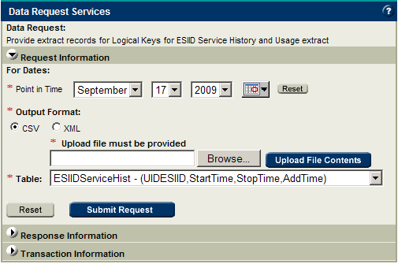

Required Inputs: The user is required to provide the point in time which will default to the most current date available. This point in time should be equivalent to what was used in the original data request for the “Logical Keys” to ensure receipt of all records requested. Additionally, the user is required to specify the table to extract the detailed data from and provide a file of logical key rows for that table (see page 5 for logical key layouts for each Market Participant table). It is assumed that the Market Participant has already determined a set of missing records through an onsite audit with the “Logical Key” output from data request number 13 “Provide all ESIID extract records”. There is no record limit in the upload file provided for this data request. If a Market Participant is missing 5000 data records, all records may be requested within one data request.

Upload File: All Upload File fields are required and must be in upper case. The Upload File for this data request should be in exactly the same format as the Logical Key output file from #13 Provide ESIID extract records for Logical Keys.

Output Types: The output from this data request will contain all the records from the table and logical keys in question and there are no restrictions on transaction data..

Delivery: The output files will be mailed to Market Participants on DVD if the files are too large to post to the TML with a turnaround time of less than ten business days.

Provide public data extract
Purpose: The purpose of this request is to provide Market Participants with the ability to audit their onsite public data tables.

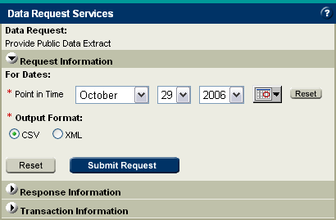

Required Inputs: The user is required to provide the point in time which will default to the most current date available.

Output Types: The output from this data request is a full records dump of all the public data tables. The public data tables include CMZONE, MRE, PGC, PROFILECLASS, REP, STATION, STATIONSERVICEHIST and TDSP. This is public information and there are no restrictions on transaction data.

After choosing the output results and output format, click the “Submit” button to place the data request in the queue. A return screen will verify that the request has been submitted successfully and provide the user with an audit ID. The audit ID is similar to an order number and should be recorded to identify the data request going forward. Selecting the “Clear” button will reset the web form to its default settings.

Delivery: The output files will be posted to the TML for download. The turnaround time is less than three business days.

Provide AMS interval data for a trade date
Purpose: The purpose of this request is to provide the user with AMS data for ESIIDs owned as of a particular point-in-time (PITS), for a certain channel, for a particular trade date (operation date.)

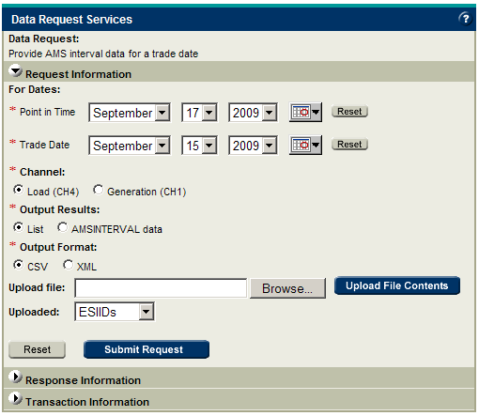

Required Inputs: The user is required to provide the point in time and the trade date in question. Both the point in time and trade date boxes will default to the most current dates available. Additionally, the user is required to specify the channel which will default to Load (CH4).

Optional Inputs: The user can narrow the search by uploading a list of 1,000 or less ESIIDs or UIDESIIDs.

Upload File: All Upload File fields are required and must be in upper case. The Upload File must be in CSV and formatted as follows:

Output Types: There are two different types of output content that can be chosen in either CSV or XML format. Selecting “List” will provide a list of distinct ESIIDs. Selecting “AMSINTERVAL data” will yield the detailed AMS data from the AMSINTERVAL data table. Please refer to Appendix A for a complete list of output fields for “AMSINTERVAL data”.

After choosing the output results and output format, click the “Submit” button to place the data request in the queue. A return screen will verify that the request has been submitted successfully and provide the user with an audit ID. The audit ID is like an order number and should be recorded to identify the data request going forward. Selecting the “Clear” button will reset the web form to its default settings.

Delivery: The output files will be posted to the TML for download. The turnaround time is less than three business days.

Provide ESIIDs where AMS interval data not loaded for a trade date
Purpose: The purpose of this request is to provide the user with a list of ESIIDs owned that do not have AMS data loaded as of a particular point-in-time (PITS), for a certain channel, for a particular trade date (operating day.)

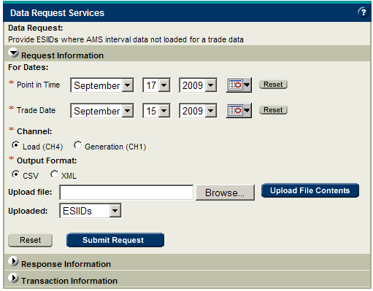

Required Inputs: The user is required to provide the point in time and the trade date in question. Both the point in time and trade date boxes will default to the most current dates available. Additionally, the user is required to specify the channel which will default to Load (CH4).

Optional Inputs: The user can narrow the search by uploading a list of 1,000 or less ESIIDs or UIDESIIDs.

Upload File: All Upload File fields are required and must be in upper case. The Upload File must be in CSV and formatted as follows:

Output Types: This data request provides an output file which is a list of ESIIDs that do not have AMS interval data loaded for the trade date in question.

After choosing the output results and output format, click the “Submit” button to place the data request in the queue. A return screen will verify that the request has been submitted successfully and provide the user with an audit ID. The audit ID is similar to an order number and should be recorded to identify the data request going forward. Selecting the “Clear” button will reset the web form to its default settings.

Delivery: The output files will be posted to the TML for download. The turnaround time is less than three business days.

Provide AMS interval data for ESIIDs I own
Purpose: The purpose of this request is to provide the user with AMS data for a set of ESIIDs owned as of a particular point-in-time (PITS), for a certain channel, for a particular range of trade dates (operation dates).
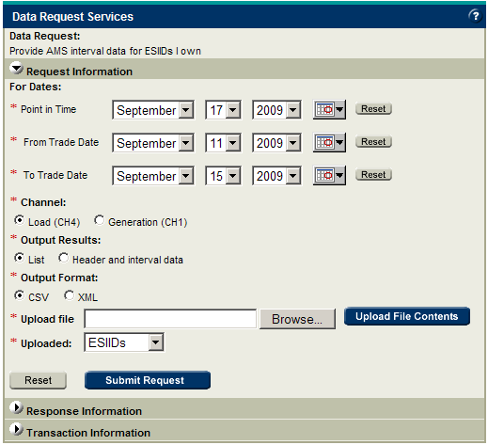

Required Inputs: The user is required to provide the point in time and a range of trade dates in question. The range of Trade dates cannot be greater than 31 days. Both the point in time and the trade date boxes will default to the most current dates available. Additionally, the user is required to specify the channel which will default to Load (CH4).

Upload File: All Upload File fields must be in upper case. The Upload File must be in CSV and formatted as follows:

Output Types: The output content can be chosen in either CSV or XML format. This service will yield the detailed AMS interval data from the AMSINTERVAL data table. Please refer to Appendix A for a complete list of output fields for “AMSINTERVAL data”.

After choosing the output results and output format, click the “Submit” button to place the data request in the queue. A return screen will verify that the request has been submitted successfully and provide the user with an audit ID. The audit ID is similar to an order number and should be recorded to identify the data request going forward. Selecting the “Clear” button will reset the web form to its default settings.

Note: Due to the volume of data this output option produces, it may only be requested once per calendar month per DUNS Number.

Delivery: The output files will be posted to the TML for download. The turnaround time is less than three business days.

Security Requirements
The Market Data Transparency web services are a private classification of data available on the TML and API. In order to access the report, a Digital Certificate is required. A Digital Certificate must be obtained from your entity’s User Security Administrator. If you are unsure who your company’s USA is, please contact you Account Manager or contact the ERCOT helpdesk for addition information

Delivery

Service Level Agreement – Delivery
The new Market Data Transparency Web services/Data Request will be available via the Texas Market Link (TML).
Delivery: The data request output files will be posted to the TML for download. The turnaround time is for each service is listed above under the individual service. The timing is typically ess than three business days for all but the full record sets.

Note: The output files will be mailed to Market Participants on DVD if the files are too large to post to the TML with a turnaround time of less than ten business days.

API/Web Services
. The term Web services describes a standardized way of integrating Web-based applications using the XML, SOAP, WSDL and UDDI open standards over an Internet protocol backbone. XML is used to tag the data, SOAP is used to transfer the data, WSDL is used for describing the services available and UDDI is used for listing what services are available. Used primarily as a means for businesses to communicate with each other and with clients, Web services allow organizations to communicate data without intimate knowledge of each other's IT systems behind the firewall.

Unlike traditional client/server models, such as a Web server/Web page system, Web services do not provide the user with a GUI. Web services instead share business logic, data and processes through a programmatic interface across a network. Developers can then add the Web service to a GUI (such as a Web page or an executable program) to offer specific functionality to users.
Web services allow different applications from different sources to communicate with each other without time-consuming custom coding, and because all communication is in XML, Web services are not tied to any one operating system or programming language. For example, Java can talk with Perl and Windows applications can talk with UNIX applications. Web services do not require the use of browsers or HTML. Web services are sometimes referred to as “application services”. Market Data Transparency is thus a collection of fifteen independent Web services as opposed to one GUI.

Accessing the Web Services

Data Request - Schedule
The new Market Data Transparency Web services/Data Request will be available via the Texas Market Link (TML). There are two links on TML which cover these services:

“Data Request – Schedule” – this is the main index of data requests available.
“Data Request – Status” – this is the main status area where users can check on the status of their request, download results, and get additional information.

Once logged into the TML, access the “Archive” tab in the top/middle of the page. From the Archive tab, the user will click on “Data Request - Schedule” which is under the “Schedule an Extract” menu item. You will then be directed to the main table of available Web Services.

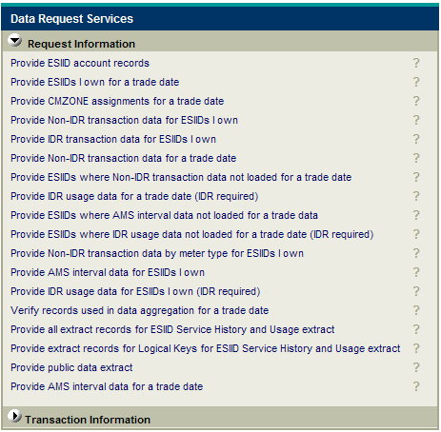

A description of each data request can be toggled by clicking on the “?” to the right.

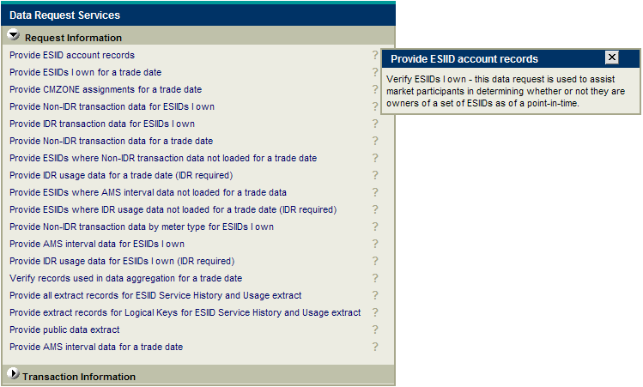

All Market Participants will be required to have a digital certificate to access the Data Requests. The digital certificate you use to log in to TML contains your DUNS Number. When scheduling any data request for Market Participant specific information (like ESIIDs, transaction data ), this digital certificate will be used by TML to determine what data you may and may not access. For example, if you want to request transaction data for ESIID = 1000000000001, the service would use the DUNS Number in the digital certificate, coupled with the point in time chosen, to make sure that you actually owned that ESIID (at that particular point in history) before returning the transaction data.

Please note that the same digital certificate can be used for all TML services. For example, the MarketTrak certificate would also be used to access TML. Your access is defined by user roles. In order to access Data Requests, the user must have the role “Entity Type_Extracts” assigned to their profile. For example, a TDSP user’s role would be TDSP_Extracts. The entity type is based on the type of entity you are in the Market. The options are ERCOT, PUCT, QSE, TDSP, REP and PGC.

To request a digital certificate or make an update to your assigned role you must contact your User Security Administrator (USA) assigned to your company. For additional questions regarding this, please contact your assigned ERCOT Account Manager.

Data Request - Status
The “Data Request – Status” link takes the user to the main status area. Here, users can check the status of outstanding data requests and download output files up to 14 days after the request status is first posted.

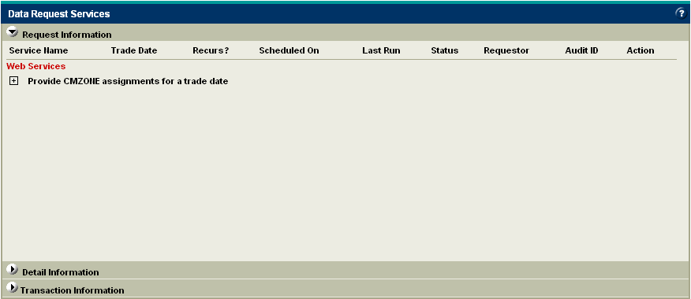

The status screen will display all data requests submitted in the last 14 days including requests that have not yet completed. All data requests are organized by the data request name. In the example below, there is a single request for “Provide CMZONE assignments for a trade date” which is in its INITIALIZED state (please see Appendix B for definitions of all the available status states).

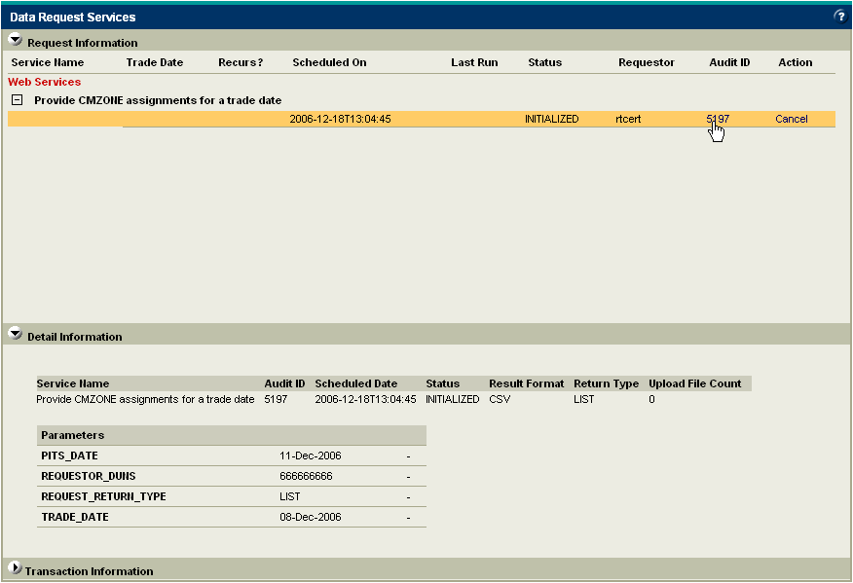

By expanding the “Provide CMZONE assignments for a trade date”, users will be able to see the following information:

Service Name – The name of the data request submitted.
Scheduled On – This is the date and time the data request was originally submitted by the user.
Status – This is the current status of the data request
Requestor – This is the requestor’s identification as specified in the digital certificate
Audit ID – The Audit ID is like a receipt. It is given at the bottom of the data request to use to track submissions.
Action – Before a data request begins to process, users will have the option of canceling the request. Once the data request status changes to RUNNING, this option will disappear.

The following displayed columns will be null for data requests as they only apply to scheduled extracts which are out of scope for this project:

Trade Date – the trade date for which the regular extract is run
Recurs? – Identifies the scheduled extract as daily or not (ad-hoc)
Last Run – The last time the scheduled extract was run

By clicking on the Audit ID, users can view more detailed information under “Detail Information”. The following additional information will appear:

Result Format – The requested output format
Return Type – The type of output selected, in this case a list of ESIIDs.
Upload File Count – The number of rows uploaded, in this case zero as there was no upload file
Parameters – Listing of the parameters submitted for this particular audit ID.

NOTE: If an Audit ID is lost or misplaced, the user can quite easily determine what the parameters are for each Audit ID by clicking the Audit ID and viewing the submission parameters.

Once a data request is complete, the results will be downloadable via a ZIP icon under the status heading. The status in the “Detail Information” section will also change to POSTING COMPLETE.

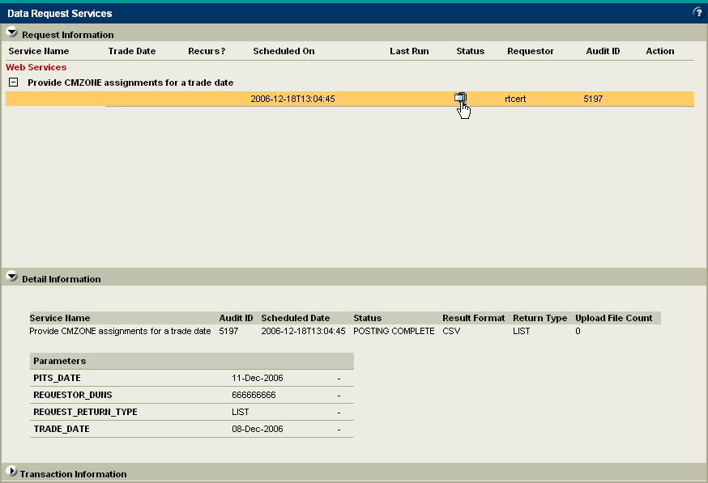

Every output file will contain a parameter file which lists the options selected in the original data request. The parameter file will always have the phrase “PARAMS” in the file name.

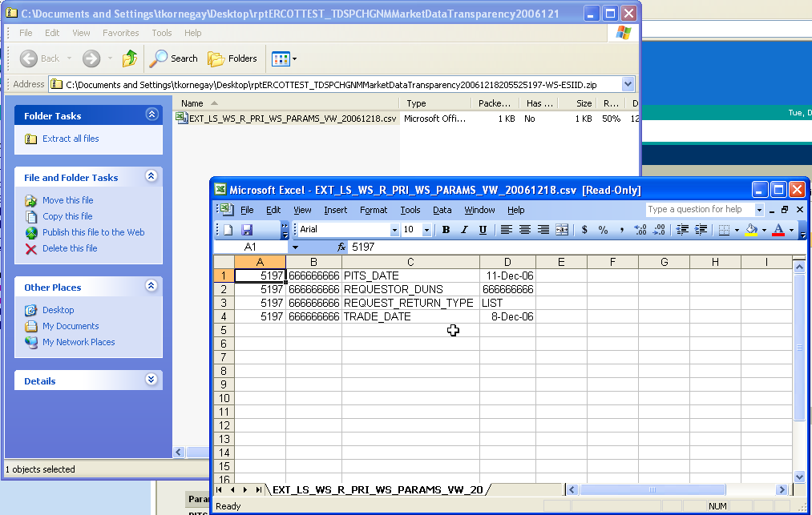
If an upload file was provided, then the upload file will also be returned in the output file with the type of upload specified in the output file name. In the below example, the user uploaded a list of UIDESIIDs.

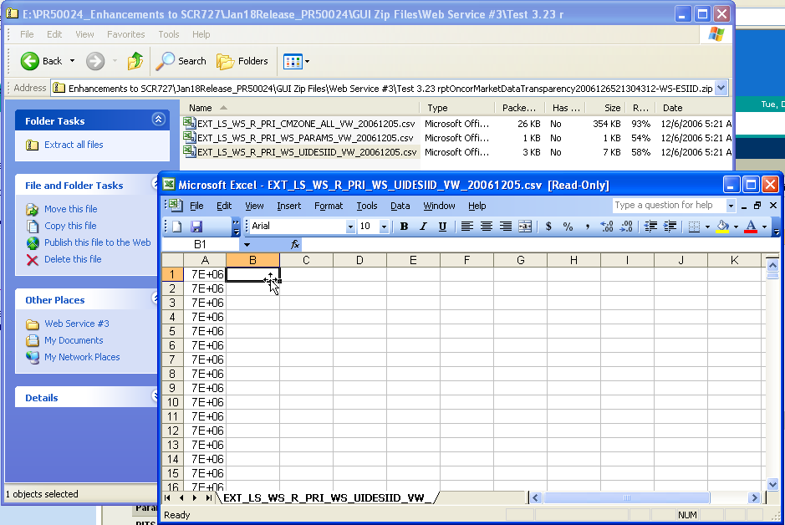

If the data request submitted yielded data results, then the data will be provided in additional output files. In the below example, the user received output from the “Provide CMZONE assignments for a trade date” data request.

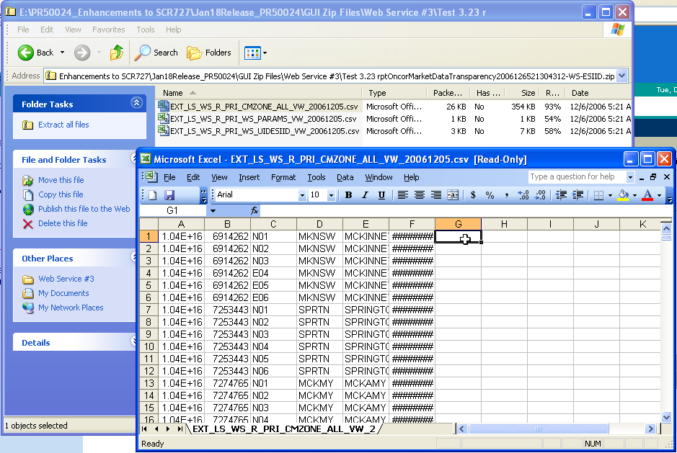
Report Explorer

Once your entity’s first Data Request has posted, a new folder will be created in the Report Explorer. This folder will be titled “Market Data Transparency”. Your output file will also be available in this location for 14 days from the day it posts. However, the information contained here does not contain the metadata that is found by utilizing the Data Request – Status link.
Please note that ERCOT recommends picking up files via the Data Request – Status link.

6. Appendices

6.1 Appendix A- Input & Output File Formats

Input File Formats – Limited to a maximum of 1,000 per data request.
Data Request Screen | Input Fields
1. Verify ESIIDs I own | ESIID,  or  UIDESIID,
2. Provide ESIIDs I own for a trade date | ESIID,  or  UIDESIID,
3. Provide CMZONE assignments for a trade date | ESIID,  or  UIDESIID,
4. Provide Non-IDR transaction data for ESIIDs I own | ESIID, TRANSACTIONID, STARTTIME, STOPTIME, METERTYPE,
5. Provide Non-IDR transaction data for a trade date | ESIID,  or  UIDESIID,
6. Provide ESIIDs where Non-IDR transaction data not loaded for a trade date | ESIID,  or  UIDESIID,
7. Provide IDR usage data for a trade date (IDR required) | ESIID,  or  UIDESIID,
8. Provide ESIIDs where IDR usage data not loaded for a trade date (IDR required) | ESIID,  or  UIDESIID,
9. Provide Non-IDR transaction data by meter type for ESIIDs I own | ESIID,  or  UIDESIID,
10. Provide IDR usage data for ESIIDs I own (IDR required) | ESIID,  or  UIDESIID,
11. Provide all extract records for ESIID Service History and Usage extract | N/A
12. Provide extract records for logical keys for ESIID Service History and Usage extract | for ESIID table: UIDESIID, ADDTIME,  for ESIIDSERVICEHIST table: UIDESIID, STARTTIME, STOPTIME, ADDTIME,  for ESIIDUSAGE table: UIDESIID, STARTTIME, STOPTIME, METERTYPE, TIMESTAMP
13. Provide public data extract | N/A
15. Provide AMS interval data for a trade date | ESIID,  or  UIDESIID,
15. Provide ESIIDs where AMS interval data not loaded for a trade date | ESIID,  or  UIDESIID,
16. Provide AMS interval data for ESIIDs I own | ESIID,  or  UIDESIID,

Output File Formats – No limit on number of rows returned.
Data Request Screen | Output Fields
1. Verify ESIIDs I own | ESIID Records: UIDESIID, ESIID, STARTTIME, STOPTIME, ADDTIME  ESIIDServiceHist Records: UIDESSID, SERVICECODE, STARTTIME, STOPTIME, REPCODE, STATIONCODE, PROFILECODE, LOSSCODE, ADDTIME, DISPATCHFL, MRECODE, TDSPCODE, REGIONCODE, DISPATCHASSETCODE, STATUS, ZIP, PGCCODE, DISPATCHTYPE, REP.REPNAME, REP.DUNSNUMBER, TDSP,TDSPNAME, TDSP.DUNSNUMBER, MRE.MRENAME, MRE.DUNSNUMBER, PGC.PGCNAME, PGC.DUNSNUMBER, ESIID.ESIID
2. Provide ESIIDs I own for a trade date | ESIID Records: UIDESIID, ESIID, STARTTIME, STOPTIME, ADDTIME  ESIIDServiceHist Records: UIDESSID, SERVICECODE, STARTTIME, STOPTIME, REPCODE, STATIONCODE, PROFILECODE, LOSSCODE, ADDTIME, DISPATCHFL, MRECODE, TDSPCODE, REGIONCODE, DISPATCHASSETCODE, STATUS, ZIP, PGCCODE, DISPATCHTYPE, REP.REPNAME, REP.DUNSNUMBER, TDSP,TDSPNAME, TDSP.DUNSNUMBER, MRE.MRENAME, MRE.DUNSNUMBER, PGC.PGCNAME, PGC.DUNSNUMBER, ESIID.ESIID
3. Provide CMZONE assignments for a trade date | ESIID.ESIID, ESIID.UIDESIID, CMZONE.CMZONECODE, ESIIDSERVICEHIST.STATIONCODE, STATION.STATIONCODE, STATION.STATIONNAME, TRADEDATE (from input file)
4. Provide Non-IDR transaction data for ESIIDs I own | List: ESIID, TRANSACTIONID, STARTTIME, STOPTIME, METERTYPE  ESIID Usage Records: UIDESIID, STARTTIME, STOPTIME, BILLMONTH, METERTYPE, TOTAL, READSTATUS, AVGDAILYUSG, ONPK, OFFPK, MDPK, SPK, ONPKADU, OFFPKADU, MDPKADU, SPKADU, ADDTIME, GLOBPROCID, TIMESTAMP, ESIID.ESIID
6. Provide Non-IDR transaction data for a trade date | List: ESIID.ESIID  ESIID Usage Records: UIDESIID, STARTTIME, STOPTIME, BILLMONTH, METERTYPE, TOTAL, READSTATUS, AVGDAILYUSG, ONPK, OFFPK, MDPK, SPK, ONPKADU, OFFPKADU, MDPKADU, SPKADU, ADDTIME, GLOBPROCID, TIMESTAMP, ESIID.ESIID
7. Provide ESIIDs where Non-IDR transaction data is not loaded for a trade date | List: ESIID.ESIID
8. Provide IDR usage data for a trade date (IDR required) | List: ESIID.ESIID  LSCCH Records: UIDCHANNELCUT, UIDCHANNEL, RECORDER, CHANNEL, STARTTIME, STOPTIME, SPI, UOMCODE, DSTPARTICIPANT, TIMEZONE, ORIGIN, STARTREADING STOPREADING, METERMULTIPLIER, METEROFFSET, PULSEMULTIPLIER, PULSEOFFSET, EDITED, INTERNALVALIDATION, EXTERNALVALIDATION, MERGEFLAG, DELETEFLAG, VALFLAGE, VALFLAGI, VALFLAGO, VALFLAGN, TKWRITTENFLAG, DCFLOW, ACCEPTREJECTSTATUS, TRANSLATIONTIME, DESCRIPTOR, ADDTIME, INTERVALCOUNT, CHNLCUTTIMESTAMP  LSCCH and LSCCD Records: UIDCHANNELCUT, ADDTIME, TRADE_DATE, INT001 – INT100 (this refers to 100 columns of data, one for each interval)
9. Provide ESIIDs where IDR usage data not loaded for a trade date (IDR required) | List: ESIID.ESIID
10. Provide Non-IDR transaction data by meter type for ESIIDs I own | ESIID Usage Records: UIDESIID, STARTTIME, STOPTIME, BILLMONTH, METERTYPE, TOTAL, READSTATUS, AVGDAILYUSG, ONPK, OFFPK, MDPK, SPK, ONPKADU, OFFPKADU, MDPKADU, SPKADU, ADDTIME, GLOBPROCID, TIMESTAMP, ESIID.ESIID
11. Provide IDR usage data for ESIIDs I own (IDR required) | LSCCH Records: UIDCHANNELCUT, UIDCHANNEL, RECORDER, CHANNEL, STARTTIME, STOPTIME, SPI, UOMCODE, DSTPARTICIPANT, TIMEZONE, ORIGIN, STARTREADING STOPREADING, METERMULTIPLIER, METEROFFSET, PULSEMULTIPLIER, PULSEOFFSET, EDITED, INTERNALVALIDATION, EXTERNALVALIDATION, MERGEFLAG, DELETEFLAG, VALFLAGE, VALFLAGI, VALFLAGO, VALFLAGN, TKWRITTENFLAG, DCFLOW, ACCEPTREJECTSTATUS, TRANSLATIONTIME, DESCRIPTOR, ADDTIME, INTERVALCOUNT, CHNLCUTTIMESTAMP  LSCCH and LSCCD Records: UIDCHANNELCUT, ADDTIME, TRADE_DATE, INT001 – INT100 (this refers to 100 columns of data, one for each interval)
13. Provide all extract records for ESIID Service History and Usage extract | Outputs all fields for all private Market Participant data tables including ESIID, ESIIDSERVICEHIST, ESIIDUSAGE.
14. Provide extract records for logical keys for ESIID Service History and Usage extract | ESIID Records: UIDESIID, ADDTIME  ESIIDServiceHist Records: UIDESSID, STARTTIME, STOPTIME, ADDTIME  ESIID Usage Records: UIDESIID, STARTTIME
15. Provide public data extract | Outputs all fields for all public data tables including CMZONE, MRE, PGC, PROFILECLASS, REP, STATION, STATIONSERVICEHIST and TDSP.
16. Provide AMS interval data for a trade date | List: ESIID.ESIID  AMSINTERVAL data: UIDAMSINTERVAL , UIDESIID, UIDAMSREGISTEREDFILE, UIDAMSDATATYPE, STARTTIME, STOPTIME, UIDAMSREGISTEREDFILE, PROXYDAY, SPI, UOMCODE, DSTPARTICIPANT, ORIGIN, METERREADTS, TZSTDNAME, TOTAL, MAXIMUM, MINIMUM, INTERVALCOUNT, VALUECODES (Actual interval data), LSUSER
17. Provide ESIIDs where AMS interval data not loaded for a trade date | List: ESIID.ESIID
18. Provide AMS interval data for ESIIDs I own | AMSINTERVAL data: UIDAMSINTERVAL , UIDESIID, UIDAMSREGISTEREDFILE, UIDAMSDATATYPE, STARTTIME, STOPTIME, PROXYDAY, SPI, UOMCODE, DSTPARTICIPANT, ORIGIN, METERREADTS, TZSTDNAME, TOTAL, MAXIMUM, MINIMUM, INTERVALCOUNT, VALUECODES (Actual interval data), LSUSER

6.2 Appendix B- Status Screen Definitions

Data Request – Status” screen status list.
Status | Definition
INITIALIZED | The request has been received and is in queue for processing.
RUNNING | The request is not processing. The payload file is currently being created.
FAILED | The request fulfillment has failed. The payload file was not generated.
AWAITING POSTING | Requested payload file has successfully been created. It is waiting to be made available for web download.
POSTING COMPLETE | Request successfully processed. Payload is available for web download.
POSTING FAILED | An error occurred while making the payload file available for web download.
CANCELED | The request has been cancelled. It will not be processed.
INVALID | Request was submitted with insufficient or invalid data. Request will not be processed.

6.3 Appendix C- Status Screen Error Definitions

Error codes and descriptions.
Error Code | Description
1007 | Invalid input data.
1121 | Invalid SOAP Action.
1122 | Timed out. Service not available.
9999 | Service not available.

6.4 Appendix D- Acronyms Dictionary
Acronyms used in this user guide.
Acronyms | Description
CMZONE | Congestion Management Zone
CWS | Composite Web Service
DDM | Data Delivery Module
DEV | Data Extract Variance
ESIID | Electric Service Identifier ID
IDR | Interval Data Record
KH | Kilowatt Hour
LSCCD | LSCHANNELCUTDATA
LSCCH | LSCHANNELCUTHEADER
LSE | Load Serving Entity
MP | Market Participant
MRE | Meter Reading Entity
NIDR | Non-Interval Data Record
ODS | Operational Data Store
PIT(S) | Point In Time (Selectivity)
SCR | System Change Request
SOAP | Simple Object Access Protocol
TDSP | Transmission and Distribution Service Provider
TML | Texas Market Link
WSDL | Web Services Description Language
WSEP | Web Service End Points
XML | eXtensible Markup Language
XSD | XML Schema Definition

