PRR Number | 830 | PRR Title | Reactive Power Capability Requirement
Date |  | 11/10/2009
Submitter’s Information
Name |  | Robert L. Sims
E-mail Address |  | robert.sims@aes.com
Company |  | AES Corporation
Phone Number |  | (858) 573-2054
Cell Number |  | (619) 992-8381
Market Segment |  | Independent Generator

Comments

PRR 830 should not be implemented in the present form for a number of reasons. The following are 3 issues important to the AES Corporation.

1) PRR 830 requires voltage and power factor capabilities higher than the requirements of FERC 661A “Interconnection Requirements for Wind Energy implemented in December of 2005. ERCOT has not demonstrated the need for voltage and power factor support capabilities higher than the accepted National standard.

Many existing wind projects, and particularly those that use type 3 and 4 turbines from General Electric and Siemens can provide substantial voltage support now without retrofits. The systems in these turbines have been designed to conform to the voltage and power factor requirements mandated by FERC in order 661A and by many other regulatory bodies around the world. These regulatory requirements and turbine capabilities are based on numerous system studies performed specific to wind turbine interaction and integration with utility power systems.

ERCOT has arbitrarily required a higher level of voltage and power factor support than what is required under FERC 661A. No studies have been conducted and no justification has been provided by ERCOT as to why this higher level of voltage support is needed, or if it can even be utilized by the ERCOT System.

Technical studies conducted by AES indicate that wind projects will hit their over and under voltage limits and trigger protective relaying at the levels of voltage support required under PRR 830. AES suggests that existing and future wind generators will be required to spend millions of dollars to enhance the voltage and power factor capabilities and these systems will never be utilized.

ERCOT should be required to demonstrate the need and ability of the ERCOT transmission system to utilize voltage and power factor support at levels above those required under the accepted national standard of FERC 661A.

2) PRR 830 is incomplete and a piecemeal approach to providing the ERCOT System with additional reliability and support from wind turbines. ERCOT should take a comprehensive approach to studying and specifying the need for voltage and power factor support along with Low Voltage Ride Through (LVRT) for wind turbines.

ERCOT is presently studying the need for LVRT capability for wind turbines as directed by the ERCOT Board under OGRR 208, Voltage Ride-Through (VRT) Requirement. Should this study result in additional requirements for wind turbines it would involve the same voltage and power factor systems within the turbines and wind projects that may require modification under PRR 830. This very well may result in a situation where existing projects spend substantial capital to retrofit existing turbines to conform to PRR 830 only to find that additional or different retrofits may be required to conform to new LVRT requirements. A comprehensive analysis of what is needed and can be utilized by the ERCOT system from the installed fleet of wind turbines is recommended.

3) PRR 830 retroactively changes the interconnection requirements for thousands of megawatts of operating wind projects with no technical basis, no system studies, and no documented need.

Prior to PRR 830, the “cone” reactive requirement was clearly defined in the Protocols and related ERCOT documents and has been accepted by ERCOT as detailed in the individual generator registrations (RARF).

a) The current ERCOT Protocols state the reactive “cone” requirement in paragraph (5) of Section 6.7.6, Deployment of Voltage Support Service (below). PRR 830 deletes this paragraph entirely and effectively changes the reactive requirement retroactively for operating projects.

(5) At all times a Generation Resource unit required to provide VSS is On-line, the URL must be available for utilization at the generating unit's continuous rated active power output, and Reactive Power up to the unit's operating capability must be available for utilization at lower active power output levels. In no event shall the Reactive Power available be less than the required installed reactive capability multiplied by the ratio of the lower active power output to the generating unit’s continuous rated active power output, and any Reactive Power available for utilization must be fully deployed to support system voltage upon request by ERCOT, or a TSP

b) The ERCOT Resource Registration Guide as recently as June 2009 illustrated the “cone” requirement in section 7.4. As noted in the diagram from page # 30 below the purple line illustrates the “Minimum Reactive Required” as the “cone”

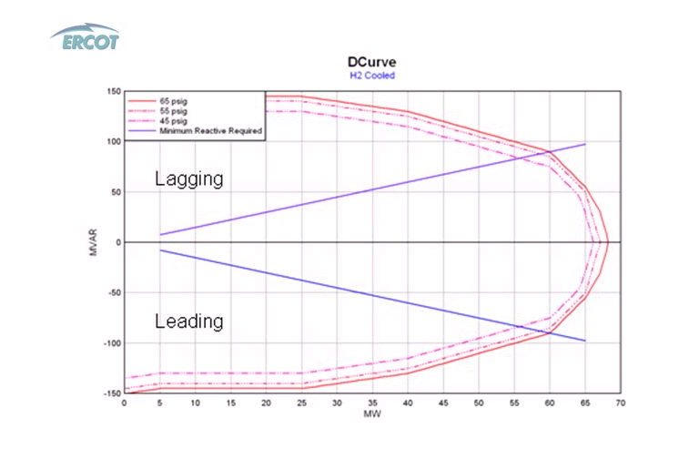

c) Virtually all wind projects installed in ERCOT prepared and submitted Resource Asset Registration Forms (RARFs) that clearly stated their reactive capability as the “cone”. These detailed official registration documents convey the operating parameters and capabilities of the generation projects to ERCOT. The RARF forms were reviewed and accepted by ERCOT with the “cone” parameters as each generator connected to the ERCOT system.

As stated above, ERCOT should be required to demonstrate the need and ability of the ERCOT transmission system to utilize voltage and power factor support at levels above those required under the accepted national standard of FERC 661A. These needs should be studied along with LVRT requirements also defined in FERC 661A to provide a comprehensive and technically sound set of requirements for Wind Generators.

