 |  |  |  | System Planning Division
Monthly Status Report
to
Reliability and Operations Subcommittee
for
October 2009

 |  | Report Highlights
Item
1. | - ERCOT is currently tracking 222 active generation interconnection requests totaling over 77,000 MW. This includes over 44,000 MW of wind generation.
2. | - Regional Planning is currently reviewing proposed transmission improvements with a total cost of $1,031.70 Million  - Transmission Projects approved in 2009 total $284.4 Million  - All projects (in engineering, routing, licensing and construction) total approximately $9.2 Billion  - Transmission Projects energized in 2009 total about $416 million

Table of Contents
1. Generation Interconnection 1
1.1 New Generation Beginning Commercial Operations 1
1.2 New Generation Interconnection Agreements 1
1.3 Summary of Active Generation Interconnection Requests 1
1.4 Publicly Disclosed Generation Interconnection Projects 3
1.5 Generation Projects Undergoing Full Interconnection Studies 6
1.6 Wind Generation 7
2. Regional Planning Group Project Reviews 9
3. Other Notable Activities 9

1. Generation Interconnection
Additional information regarding detailed generation interconnection and impact studies is contained in the “Generation Project Interconnection Information” folder in the “Operations and System Planning” area on the ERCOT website: http://planning.ercot.com/login/login.

New Generation Registering for Commercial Operations

Pearsall Gas Engine Plant Phase 1 (09INR0079a) in Frio County for 100 MW

Dansby Unit 3 – Gas (09INR0072) in Brazos County for 48 MW

Nueces Bay Repowering - Gas (09INR0039) in Nueces County for 701 MW (includes NB7 return to service)

Langford Wind Power (10INR0026) in Tom Green County for 150 MW

Lorraine Windpark (09INR0047) in Mitchell County for 251 MW

The total installed wind capacity is now 8,916 MW, of which 7,393 MW (83%) is located within the Western Congestion Management Zone.

New Generation Interconnection Agreements – none for October

Summary of Active Generation Interconnection Requests
GENERATION INTERCONNECTION REQUESTS CURRENTLY BEING PROCESSED
Currently tracking 224 active generation interconnection or change requests
As of September 30, 2009 | North | South | West | Total
Security Screening Study | 5 | 9 | 11 | 25
SSS Completed | 6 | 8 | 13 | 27
Full Interconnect Study | 25 | 22 | 84 | 131
FIS Completed | 3 | 11 | 2 | 16
Interconnect Agreement Completed | 7 | 9 | 7 | 23
Capacity under Interconnection Agreements | 4,487 | 1,996 | 1,177 | 7,660
Capacity for Grid, MW | 21,575 | 21,813 | 34,278 | 77,636
Wind Capacity, MW | 4,415 | 8,241 | 31,998 | 44,654

Fuel Type | Confidential Projects (MW) | Projects Under Full Study (MW) | Projects w/ Interconnect Agreement/Public Letter (MW) | Grand Total (MW)
Gas-CC |  |  | 3,554 | 16,650
Gas-CT |  |  | 379 | 1,029
Total Gas | 1,279 | 12,467 | 3,933 | 17,679
Nuclear |  |  | 5,986 | 5,986
Coal | 15 | 3,712 | 2,958 | 6,685
Wind | 7,922 | 30,041 | 6,691 | 44,654
Solar | 544 | 459 |  | 1,003
Biomass | 58 | 50 | 145 | 253
Other | 176 | 1,200 |  | 1,376
Grand Total | 9,994 | 47,929 | 19,713 | 77,636

Publicly Disclosed Generation Interconnection Projects
The table below summarizes the publicly disclosed generation projects for the ERCOT region.
(IA=Interconnect Agreement, PL=Public Letter, XX= cancelled)

Generation Interconnections as of October 31, 2009
INR | SiteName | Status | County | Region | COD | FT | MWForGrid | Change From Last Report
09INR0015 | Comanche Peak 1&2 Upgrade | PL | Somervell | North | Oct-09 | Nuclear | 86
09INR0028 | V H Braunig 6 | IA | Bexar | South | Oct-09 | Gas-CT | 185
09INR0002 | J K Spruce 2 | IA | Bexar | South | Nov-09 | Coal | 750 | Date
09INR0034 | Gatesville Wind Farm | PL | Coryell | North | Dec-09 | Wind | 200
08INR0038 | M Bar Wind | PL | Andrews | West | Dec-09 | Wind | 194
11INR0014 | TECO Central Plant | IA | Harris | South | Feb-10 | Gas-CC | 50
09INR0037 | Scurry County Wind III | PL | Scurry | West | Mar-10 | Wind | 350
08INR0033 | Lufkin | IA | Angelina | North | Apr-10 | Biomass | 45
09INR0082 | Cedro Hill Wind | IA | Webb | South | May-10 | Wind | 150
09INR0006b | Oak Grove SES 2 | IA | Robertson | North | May-10 | Coal | 855
09INR0079b | Pearsall Expansion Phase 2 | IA | Frio | South | Jun-10 | Gas-CT | 100 | Date/MW
09INR0045 | Sand Hill Peakers | IA | Travis | South | Jul-10 | Gas-CT | 94
06INR0012b | Sherbino Mesa Wind Farm 2 | IA | Pecos | West | Jul-10 | Wind | 150
05INR0015c | Gulf Wind 3 | PL | Kenedy | South | Sep-10 | Wind | 400
05INR0015b | Gulf Wind 2 | PL | Kenedy | South | Oct-10 | Wind | 400
08INR0011 | Senate Wind Project | IA | Jack | North | Nov-10 | Wind | 150
04INR0011b | Cedar Elm | IA | Shackelford | West | Dec-10 | Wind | 136
09INR0029 | CFB Power Plant Units 11&12 | IA | Calhoun | South | Dec-10 | Coal | 263
12INR0003 | Throckmorton Wind Farm | PL | Throckmorton | West | Dec-10 | Wind | 400
06INR0022c | Penascal Wind Farm 2 | IA | Kenedy | South | Dec-10 | Wind | 202
08INR0065 | Buffalo Gap 4 and 5 | PL | Nolan | West | Mar-11 | Wind | 465
10INR0020 | Panda Temple Power | PL | Bell | North | May-11 | Gas-CC | 1,092
10INR0010 | Jack County 2 | IA | Jack | North | Jun-11 | Gas-CC | 620
08INR0018 | Gunsight Mountain | IA | Howard | West | Aug-11 | Wind | 120
04INR0011c | Cottonwood Wind | IA | Shackelford | West | Dec-11 | Wind | 100
06INR0026 | Wild Horse Mountain | IA | Howard | West | Dec-11 | Wind | 120
08INR0025 | Pistol Hill Energy Center | PL | Ector | West | Dec-11 | Wind | 300
06INR0022b | Penascal Wind Farm 3 | IA | Kenedy | South | Dec-11 | Wind | 202
09INR0007 | Nacogdoches Project | IA | Nacogdoches | North | Apr-12 | Biomass | 100
07INR0004 | Pampa Energy Center | PL | Gray | West | May-12 | Coal | 165
09INR0024 | B&B Panhandle Wind | PL | Carson | West | Jun-12 | Wind | 1,001
09INR0001 | Sandy Creek 1 | IA | McLennan | North | Jun-12 | Coal | 925
09INR0026 | Sterling Energy Center | IA | Sterling | West | Jun-12 | Wind | 300
09INR0026a | Sterling Energy Center | PL | Sterling | West | Jun-12 | Wind | 200
12INR0004 | Fort Concho Wind Farm | PL | Tom Green | West | Jul-12 | Wind | 400
08INR0040 | Lenorah Project | IA | Martin | West | Sep-12 | Wind | 251
09INR0036 | McAdoo Energy Center II | PL | Dickens | West | Dec-12 | Wind | 500
06INR0006 | Cobisa-Greenville | IA | Hunt | North | May-13 | Gas-CC | 1,792
15INR0002 | Comanche Peak 3 and 4 | PL | Somervel | North | Jan-15 | Nuclear | 3,200
15INR0008 | STP 3 and 4 | PL | Matagorda | South | Jan-15 | Nuclear | 2,700
 |  |  |  |  |  | Total | 19,713

County Location of Installed Generation and Interconnection Requests (all fuels)

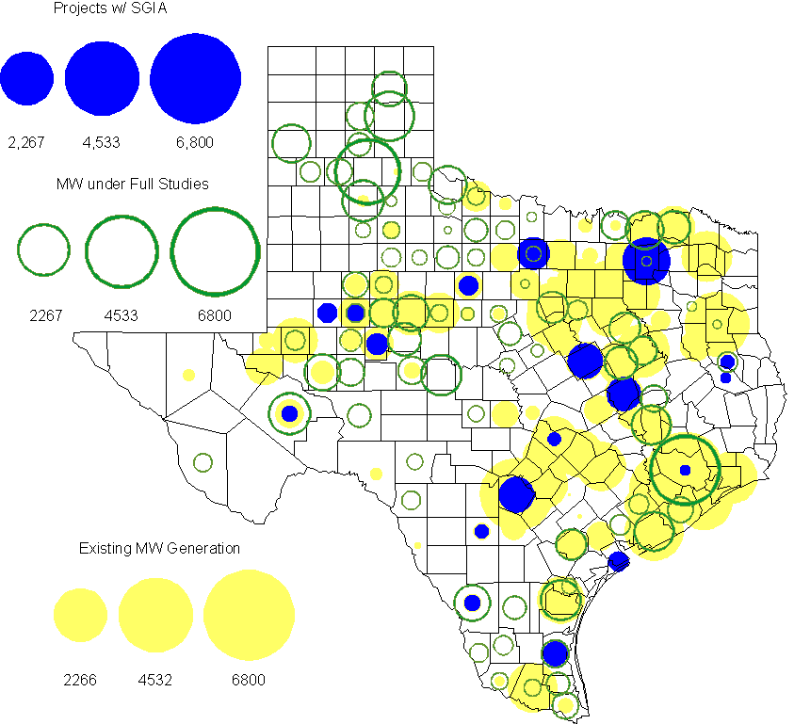

Generation Projects Undergoing Full Interconnection Studies
INR | County | Capacity | COD | Fuel |  | INR | County | Capacity | COD | Fuel
08INR0049 | Clay | 50 | TBD | Wind |  | 09INR0073 | Scurry | 200 | TBD | Wind
09INR0077 | Reagan | 500 | Dec-09 | Wind |  | 09INR0051 | Borden | 249 | Dec-09 | Wind
08INR0022 | Floyd | 100 | Dec-09 | Wind |  | 08INR0023 | Floyd | 100 | Dec-09 | Wind
09INR0058 | Howard | 250 | Dec-09 | Wind |  | 08INR0056 | Nolan | 149 | Dec-09 | Wind
11INR0012 | Duval | 400 | Dec-09 | Wind |  | 08INR0039 | Hamilton | 90 | Dec-09 | Wind
11INR0013 | Mills | 150 | Dec-09 | Wind |  | 08INR0012b | San Patricio | 151 | Dec-09 | Wind
09INR0054 | Stonewall | 149 | Dec-09 | Wind |  | 09INR0065 | Webb | 150 | Dec-09 | Wind
09INR0061 | Kent | 258 | Dec-09 | Wind |  | 10INR0011 | Johnson | 275 | Jan-10 | Gas
10INR0048 | Hardeman | 1,000 | Jan-10 | Wind |  | 11INR0033a | Cameron | 200 | Jan-10 | Wind
10INR0024 | Briscoe | 2,940 | Jan-10 | Wind |  | 10INR0045 | Webb | 734 | Apr-10 | Wind
10INR0046 | Jim Hogg | 264 | Apr-10 | Wind |  | 09INR0070 | Reagan | 42 | May-10 | Wind
10INR0023 | Haskell | 386 | May-10 | Wind |  | 09INR0069 | Reagan | 36 | May-10 | Wind
10INR0054 | Palo Pinto | 36 | May-10 | Wind |  | 10INR0062a | Pecos | 50 | May-10 | Wind
09INR0018 | Concho | 249 | May-10 | Wind |  | 09INR0035 | Concho | 750 | May-10 | Wind
10INR0079 | Nolan | 60 | May-10 | Wind |  | 10INR0016 | Childress | 150 | May-10 | Wind
07INR0032 | Tom Green | 249 | May-10 | Wind |  | 10INR0069 | Rusk | 13 | May-10 | Coal
09INR0082 | Webb | 150 | May-10 | Wind |  | 09INR0081 | Rusk | 18 | Jun-10 | Coal
10INR0035 | Harris | 416 | Jun-10 | Gas |  | 10INR0029 | Hood | 810 | Jun-10 | Gas
10INR0070 | Hunt | 50 | Jul-10 | Gas |  | 10INR0012 | Nacogdoches | 300 | Jul-10 | Gas
10INR0057 | Taylor | 200 | Jul-10 | Wind |  | 10INR0052a | Knox | 21 | Jul-10 | Wind
10INR0013 | Upton | 400 | Jul-10 | Wind |  | 10INR0071 | Matagorda | 88 | Sep-10 | Wind
09INR0074 | Motley | 70 | Oct-10 | Wind |  | 10INR0015 | Mitchell | 350 | Oct-10 | Wind
10INR0081a | Clay | 30 | Oct-10 | Wind |  | 10INR0041 | Floyd | 135 | Oct-10 | Wind
10INR0039 | Dickens | 200 | Nov-10 | Wind |  | 11INR0029 | Throckmorton | 200 | Nov-10 | Wind
10INR0032 | Navarro | 775 | Dec-10 | Gas |  | 10INR0080 | Presidio | 144 | Dec-10 | Solar
08INR0062 | Archer | 249 | Dec-10 | Wind |  | 07INR0015 | Foard | 180 | Dec-10 | Wind
07INR0035 | Tom Green | 270 | Dec-10 | Wind |  | 07INR0013 | Coke | 200 | Dec-10 | Wind
10INR0019 | Deaf Smith | 609 | Dec-10 | Wind |  | 08INR0061 | Hardeman | 200 | Dec-10 | Wind
10INR0077 | Callahan | 101 | Dec-10 | Wind |  | 09INR0076 | Jackson | 300 | Dec-10 | Wind
10INR0042 | Mason | 170 | Dec-10 | Wind |  | 10INR0056 | Borden | 249 | Dec-10 | Wind
10INR0033 | Armstrong | 399 | Dec-10 | Wind |  | 10INR0008 | Pecos | 500 | Dec-10 | Wind
07INR0026 | Baylor | 400 | Dec-10 | Wind |  | 10INR0051 | Brazoria | 200 | Dec-10 | Wind
10INR0060 | Willacy | 401 | Dec-10 | Wind |  | 10INR0059 | Zapata | 251 | Dec-10 | Wind
09INR0041 | Mitchell | 300 | Dec-10 | Wind |  | 11INR0033b | Cameron | 200 | Jan-11 | Wind
08INR0014 | Webb | 183 | Mar-11 | Wind |  | 11INR0050 | Crosby | 149 | Mar-11 | Wind
11INR0037 | Smith | 50 | May-11 | Biomass |  | 11INR0046 | Brazoria | 300 | May-11 | Gas
11INR0028 | Grimes | 1,280 | May-11 | Gas |  | 11INR0048 | Harris | 300 | May-11 | Gas
11INR0058 | Pecos | 135 | May-11 | Solar |  | 11INR0061 | Presidio | 90 | May-11 | Solar
11INR0060 | Tom Green | 90 | May-11 | Solar |  | 09INR0075 | Kinney | 248 | May-11 | Wind
10INR0009 | Castro | 300 | May-11 | Wind |  | 10INR0062b | Pecos | 50 | May-11 | Wind
11INR0062 | Nueces | 149 | May-11 | Wind |  | 09INR0050 | Fannin | 1,200 | Jun-11 | Gas
11INR0057 | Cameron | 144 | Jun-11 | Wind |  | 08INR0020 | Eastland | 200 | Jun-11 | Wind
11INR0019 | Upton | 200 | Jun-11 | Wind |  | 11INR0006 | Lamar | 579 | Jul-11 | Gas
11INR0040 | freestone | 640 | Aug-11 | Gas |  | 11INR0047 | Deaf Smith | 600 | Sep-11 | Wind
11INR0008a | Roberts | 1,000 | Sep-11 | Wind |  | 11INR0039 | Starr | 201 | Sep-11 | Wind
07INR0014a | Wilbarger | 140 | Oct-11 | Wind |  | 07INR0014b | Wilbarger | 70 | Oct-11 | Wind
10INR0081b | Clay | 19 | Oct-11 | Wind |  | 10INR0021 | Grayson | 646 | Nov-11 | Gas
11INR0025 | Crockett | 400 | Dec-11 | Wind |  | 11INR0067 | Cameron | 78 | Dec-11 | Wind
06INR0022d | Kenedy | 200 | Dec-11 | Wind |  | 11INR0043 | Coke | 300 | Dec-11 | Wind
11INR0005 | Upton | 500 | Dec-11 | Wind |  | 09INR0048 | Jack | 150 | Dec-11 | Wind
12INR0021 | Edwards | 165 | Jan-12 | Wind |  | 10INR0018 | Madison | 550 | Mar-12 | Gas
11INR0049 | Wharton | 275 | May-12 | Gas |  | 12INR0007 | Lamar | 296 | May-12 | Gas
09INR0031 | Ector | 275 | May-12 | Gas |  | 10INR0062c | Pecos | 201 | May-12 | Wind
12INR0006 | Limestone | 875 | Jun-12 | Coal |  | 10INR0022 | Harris | 3,500 | Jun-12 | Gas
08INR0031 | Childress | 100 | Jun-12 | Wind |  | 12INR0002 | Briscoe | 750 | Jul-12 | Wind
08INR0041 | Coke | 200 | Oct-12 | Wind |  | 12INR0016 | Nueces | 1,200 | Nov-12 | Other
08INR0044 | Concho | 200 | Nov-12 | Wind |  | 08INR0019a | Gray | 250 | Nov-12 | Wind
08INR0019b | Gray | 250 | Nov-12 | Wind |  | 08INR0019c | Gray | 250 | Nov-12 | Wind
09INR0025 | Concho | 180 | Dec-12 | Wind |  | 12INR0005 | Floyd | 1,100 | Dec-12 | Wind
08INR0042 | Coke | 200 | Dec-12 | Wind |  | 12INR0018 | Gray | 600 | Dec-12 | Wind
06INR0022f | Kenedy | 200 | Dec-12 | Wind |  | 08INR0054 | Comanche | 401 | Dec-12 | Wind
12INR0022 | Hidalgo | 200 | Dec-12 | Wind |  | 12INR0029 | Swisher | 500 | Dec-12 | Wind
13INR0005 | Carson | 600 | Oct-13 | Wind |  | 13INR0006 | Gray | 750 | Oct-13 | Wind
06INR0022e | Kenedy | 200 | Dec-13 | Wind |  | 14INR0002 | Goliad | 756 | Feb-14 | Coal
14INR0003 | Nolan | 850 | Jun-14 | Coal |  | 14INR0005 | Matagorda | 1,200 | Jul-14 | Coal
14INR0001 | Pecos | 500 | Dec-14 | Wind

Wind Generation
Wind Capacity Installed by Year

County Location of Installed Capacity and Interconnection Requests (Wind only)

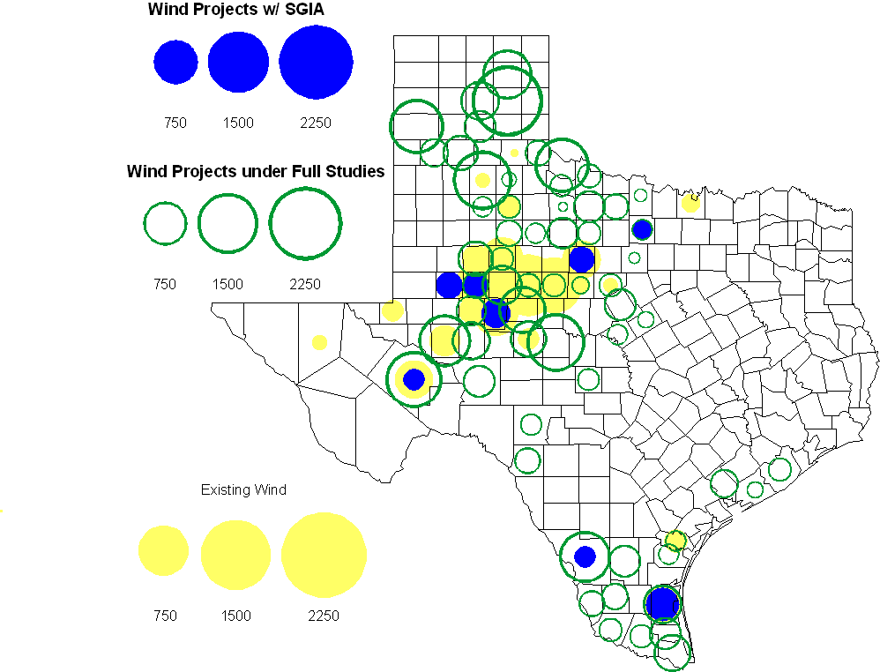

Regional Planning Group Project Reviews

Oncor submitted a project to relieve congestion related to new wind units in the Lamesa area. The project will upgrade the Lamesa to Bluff Creek 138 kV line, rebuild the Bluff Creek to China Grove 138 kV line, rebuild the Lamesa to Ackerly Vealmoor 69 kV line to 138/69 kV double circuit, rebuild the Lamesa 138 kV switching station, build a new 138 kV Ackerly Vealmoor station, add second circuits to all rebuilt lines and include station upgrades at China Grove and Big Spring. The cost of this project is $ 80.8 M. This project will be reviewed to ensure that the improvements fit into the likely CREZ transmission solution for the area. This project is in ERCOT Independent Review and will be studied as part of the 2009 Five-Year Transmission Plan.

Oncor submitted a project to add several 345 kV circuits to support the addition of Comanche Peak units 3 and 4 in 2015 at an estimated cost of $ 133 M. These upgrades include a new 345 kV double circuit line with one circuit in place from Comanche to Whitney, a new 345 kV line from Comanche to Johnson Switch, a new circuit on existing structures from Johnson Switch to Everman, a new 345 kV double circuit with one circuit in place from Comanche to DeCordova, and a new 345 kV line on existing structures from Comanche to Parker Switch. This project is in ERCOT Independent Review and will be studied when the 2009 Five-Year Transmission Plan is complete.

Sharyland Utilities submitted a project to construct and operate the ERCOT Southeast Loop facilities consisting of a 345 kV double circuit from Lufkin to Canal 345 kV substation on the northeast side of Houston. This project will cost $359 M with an estimated completion date of summer 2013. This project is in ERCOT Independent Review and will be studied as part of the 2009 Five-Year Transmission Plan.

American Electric Power Service Corporation submitted a project to construct several improvements in the Corpus Christi area. The estimated completion date of this project is June 2012 and estimated cost is $ 100.2 M. The ERCOT Independent Review has been completed and the project will be presented to TAC and the ERCOT Board of Directors in November.

Centerpoint Energy has submitted a project to construct a new 345 kV double circuit line to allow greater power imports into the Houston area. The project involves expanding the Fayetteville and Zenith substations and constructing a new 345 kV double circuit from Fayetteville to Zenith. The proposal also includes looping the Fayette Power Project to Salem 345 kV circuit into Fayetteville and upgrading the Fayette Power Project to Fayetteville 345 kV double circuit lines. The project is estimated to be complete by September 2014 at a cost of $222 M. This project is in ERCOT Independent Review.

Luminant Energy has submitted the Comanche Peak Area Congestion Mitigation Plan project to loop the future Parker to Everman 345 kV CREZ line into the Comanche Peak 345 kV switch station. Luminant Energy’s estimated completion date for this project is April 2010 and the estimated cost is $3 M. This project is in ERCOT Independent Review.

Brazos Electric Cooperative has submitted a project to rebuild the Kruegerville to Frisco 138 kV line. The estimated cost of this project is $19.7 M and it is expected to be completed by the end of 2010. This project is in the comment period.

Luminant Energy submitted a proposal to either accelerate the Waco West to Waco Atco 138 kV line rebuild that is currently scheduled to be completed by the fall of 2010 or to open the line in order to prevent congestion. This project is in the comment period.

Congestion Costs
Dollars shown in graphs are settlement quality.

OOMC – last 13 months in million$

OOM Down – last 13 months in million$

Local Balancing Energy Down – last 13 months in million$

OOM Up – last 13 months in million$

Local Balancing Energy Up – last 13 months in million$

Replacement Reserve – last 13 months in thousand$

Binding Constraints – October, 2009
Contingency | Binding Element | Estimated Costs | Transmission Project | Clearances/Reason
Oak Creek-Ballinger 138kV | Miles-Rowena 69kV | $2,950,839 | Yellow Jacket (08TPIT0135) | High wind generation
 | DFW Security | $2,754,979
 | Capacity Shortage | $2,311,036
Graham-Long Creek 345kV | San Angelo Power Station -Shrew Tap | $2,035,161 | San Angelo Power Station, to Menard 138 kV line improvements (09TPIT0212) | High wind generation  Outage:  Comanche Peak SES to Johnson Switch 345 kV
Abilene-Mulberry Creek-Bitter Creek | Trent-Merkel 69kV | $1,085,179 | Abilene So. – Leon (TPIT0054) | Outage:  Bluff Creek - Abilene South 138 kV
Twin Butte-San Angelo Red Creek 345kV | Twin Butte 345/138kV Autotransformer | $ 919,814 |  | High wind generation
Whitney Bus  SE Edinburg-Azteca  BOMSW#1/Autotransformer-1H  LEG-Watermill  Pueblo-Rosita Creek | Various Outages | $ 797,670
Morgan Creek SES-Eskota Switch 138kV | Eskota Switch 138/69kV Autotransformer | $ 532,079 |  | Outage:  Abilene South to Potter 138 kV
San Angelo Red Creek-Comanche Switch 345kV | San Angelo Concho-Veribest 69kV | $ 184,175 | Abilene So. – Leon (TPIT0054) | Outage:  Bluff Creek - Abilene South 138 kV
Tradinghouse-Venus 345kV | Elm Mott-Rogers Hill | $ 168,124 | Elm Mott-Wach Northcrest (10TPIT0091) | Outages:  Whitney 138 kV bus  Bosque SW - Whitney 138 kV

Inter-zonal Congestion Costs – last 13 months

Other Notable Activities

The initial reliability analysis and the congestion analysis of the 2009 Five-Year Transmission Plan is nearly complete. Projects to eliminate unserved energy and reduce congestion in 2010-2014 have been identified. The final steps in the assessment are to create a security constrained AC case for each study year and to document the results of the analysis.

Voltage Ride Through Study Update:

The analysis of the engineering study results has been included in a Phase I draft report documentation. This Phase I draft report is near completion.

WGRs data submission of VRT capability data continues, together with validation of data received. WGRs with no response to the second reminder email have been put in direct contact with ERCOT in order to facilitate timely data collection for Phase II. Preparation of PSSe v.31 compatible models has started.
- The West-to-North Stability Limit study Phase II Update: The planning study to test the effect of Power System Stabilizers (PSS) on the W-N Stability Limit is now well under way. The study runs are nearing completion and should be done by mid- second week of November. The full analysis of results and compilation of the report will be completed in the time that remains within the original time-frame set for the project.

The ERCOT TPIT update for November 2, 2009 is in progress. This update will be posted December 1, 2009.

