ERCOT Operations Report
October 2009 ROS & OWG

Frequency Control
Time | Freq(Hz) | Duration (s)
10/1/2009 16:28 | 59.85 | 34 | Unit trip with 580 MW
10/1/2009 18:01 | 60.12 | 644 | SCE + 1278 MW in 12 min. Out of Down Regulation
10/3/2009 19:00 | 59.87 | 36 | Unit trip with 525 MW
10/6/2009 21:46 | 59.89 | 4 | Unit trip with 260 MW
10/7/2009 22:05 | 59.90 | 6 | SCE - 1550 MW in 12 min.
10/8/2009 10:48 | 60.13 | 185 | SCE + 880 MW in 5 min.
10/9/2009 0:03 | 60.11 | 44 | SCE + 1000 MW in 10 min. Out of Down Regulation
10/11/2009 18:06 | 59.86 | 94 | Unit trip with 655 MW
10/12/2009 2:27 | 59.83 | 104 | Multiple unit trips with 733 MW
10/13/2009 10:38 | 59.89 | 2 | Unit trip with 173 MW
10/14/2009 18:05 | 60.10 | 4 | Load dropped by 611 MW in 10 min, Wind +211 Mw in 10 min. Out of Down Regulation
10/15/2009 6:43 | 59.90 | 4 | Unit trip with 585 MW
10/26/2009 4:56 | 59.90 | 6 | Unit trip with 395 MW
10/29/2009 20:05 | 60.12 | 187 | Out of Down Regulation
10/30/2009 21:23 | 59.84 | 4 | Unit trip with 600 MW
Note: Time of frequency excursions outside the range of +/- 0.1 Hz.

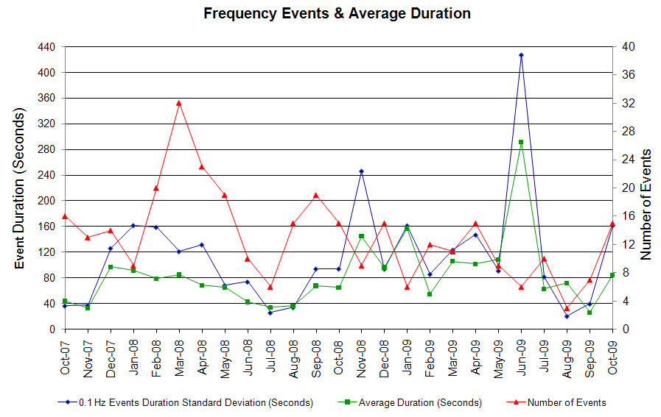

Deployed Responsive (Reported Above)
Time deployed | Stop Time | Duration | Max | Details
10/1 16:28:00 | 10/1 16:43:56 | 0:15:56 | 612.49
10/3 19:00:28 | 10/3 19:12:44 | 0:12:16 | 506.88
10/6 21:46:54 | 10/6 22:02:12 | 0:15:18 | 401.28
10/7 22:05:54 | 10/7 22:15:40 | 0:09:46 | 385.45
10/11 18:06:21 | 10/11 18:27:23 | 0:21:02 | 596.65
10/12 02:27:26 | 10/12 02:51:47 | 0:24:21 | 718.09
10/13 10:38:32 | 10/13 11:01:58 | 0:23:26 | 401.28
10/15 06:43:20 | 10/15 06:53:18 | 0:09:58 | 385.45
10/16 00:04:21 | 10/16 00:13:23 | 0:09:02 | 343.21 | SCE change -500 MW in 8m and slow unit response.
10/21 14:40:04 | 10/21 14:54:16 | 0:14:12 | 327.36 | Unit Trip
10/25 21:02:32 | 10/25 21:14:36 | 0:12:04 | 337.94 | Slow unit response and Cat. 2 OOME VDI's for transmission security
10/26 04:55:56 | 10/26 05:12:32 | 0:16:36 | 374.90
10/26 06:08:32 | 10/26 06:25:56 | 0:17:24 | 332.64 | SCE change -500 in 10m, slow unit response
10/29 08:06:06 | 10/29 08:23:10 | 0:17:04 | 327.36 | SCE change -500 MW in 4m
10/29 14:04:14 | 10/29 14:24:42 | 0:20:28 | 327.36 | SCE change -500 MW in 7m, slow unit response
10/29 17:06:38 | 10/29 17:19:50 | 0:13:12 | 343.21 | Unit Trip
10/30 18:51:06 | 10/30 19:02:47 | 0:11:41 | 343.21 | Out of up regulation, SCE change -450 in 13m
10/30 21:23:26 | 10/30 21:47:29 | 0:24:03 | 691.68

Day-Ahead OOMC and RPRS Capacity Purchases
Details | OOMC | RPRS S1 | RPRS S2 | RPRS S1+S2 | RMR | Total
DFW | 95 | 0 | 5 | 5 | 0 | 100
Western | 0 | 5 | 12 | 17 | 4 | 21
Houston | 0 | 10 | 5 | 15 | 0 | 15
Northeast | 5 | 0 | 5 | 5 | 0 | 10
E RIO | 9 | 0 | 0 | 0 | 0 | 9
San Antonio | 5 | 1 | 3 | 4 | 0 | 9
Austin | 0 | 5 | 4 | 9 | 0 | 9
North | 0 | 2 | 7 | 9 | 0 | 9
W RIO | 4 | 0 | 0 | 0 | 0 | 4
South | 2 | 1 | 1 | 2 | 0 | 4
Corpus | 2 | 1 | 0 | 1 | 0 | 3
Bryan Area | 0 | 2 | 0 | 2 | 0 | 2
Laredo | 0 | 1 | 0 | 1 | 0 | 1
Total | 122 | 28 | 42 | 70 | 4 | 196

Historical Totals | Oct-09 | Oct-08 | Sep-09
Austin | 5 | 2 | 1
Bryan Area | 2 | 0 | 0
Corpus | 3 | 19 | 0
DFW | 95 | 0 | 7
E RIO | 9 | 5 | 1
Houston | 10 | 0 | 3
Laredo | 1 | 2 | 2
North | 2 | 2 | 12
Northeast | 5 | 0 | 0
San Antonio | 6 | 0 | 1
South | 3 | 2 | 1
W RIO | 4 | 95 | 0
Western | 9 | 6 | 11
Total | 154 | 133 | 39
http://www.ercot.com/mktinfo/services/rprsdr/index.html

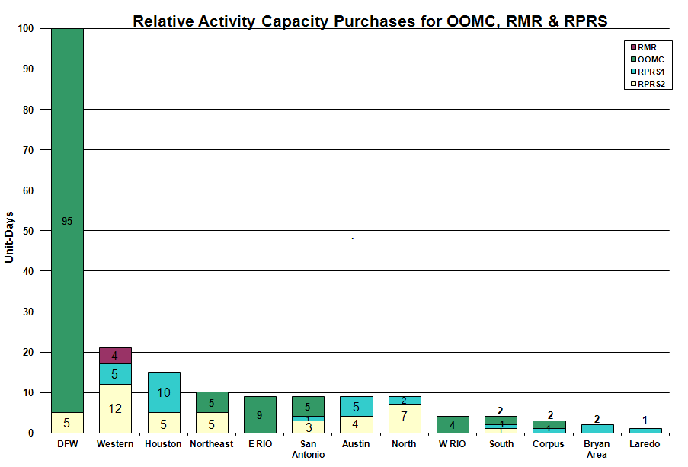

OOME and Congestion Management Activity
Congestion affected by outages Remedial action plan has been developed for the element
Contingency | Overloaded Element | Days
Oak Creek - Ballinger 138KV | Miles - Rowena 69KV | 10
Graham - Long Creek 345KV | San Angelo Power Station - Shrew 138KV | 8
Austrop- Daffin - Decker 138KV | Austrop - Decker 138KV | 8
Base Case Overload | Ena Snyder - MEC Plainview TAP 69KV | 7
Morgan Creek - Eskota 138KV | Eskota Switch 138/69KV Autotransformer | 6
Twin Butte - San Angelo Red Creek 345KV | Twin Butte 345/138KV transformer | 6
Abilene South - Eskota 138KV | Trent - Merkel 69KV | 6
Nicole - Oak Creek 138KV | San Angelo Concho - Veribest 69KV | 6
Abilene Mulberry Creek - Bitter Creek & Long Creek 345KV | Trent - Merkel 69KV | 5
Dilley Switch - San Miguel Switch 138KV | Derby - Pearsall 69KV | 5
Elm Mott - Bosque Switch 345KV | Bosque Switch - Lake Whitney 138KV | 5
Base Case | Magic Valley Electric Cooperative Palmhurst - Magic Valley Electric Cooperative Merrit - Magic Valley Electric Cooperative Pharr 138KV | 4
Oak Creek - Ballinger 138KV | San Angelo Concho - Veribest 69KV | 4
Bosque Switch - Lake Whitney 138KV | Olsen - Bosque Switch 138KV | 3
Dilley Switch - North Laredo 138KV | Asherton - North Laredo 138KV | 3
Tradinghouse - Elm Mott 345KV | Whitney TU autotransformer 345/138 kV | 3
Abilene Mulberry Creek - Bitter Creek & Long Creek - Sweetwater Generating Plant 345KV | Radium - Anson 69KV | 3
Aspermont - Paint Creek 138KV | Aspermont 138/69KV autotransformer | 3
Base Case | San Angelo Power Station - Shrew 138KV - 102% of 143 MVA rating. | 3
Base Case | Sonora - Cauthorn 138KV - 100% of 151 MVA rating. | 3
Hill Country 345/138KV Transformer T3 | Hill Country 345/138KV Transformer T2 | 3
Tradinghouse - Venus 345KV | Elm Mott - Rogers Hill | 3
Fisher Road 345/138KV AT | Certain Teed - Wichita Falls Cogen Switch 138KV | 2
Spur 138/69KV autotransformer | Jayton CSW - Spur 69KV1 | 2
Spur 138/69KV autotransformer | Spur - Girard tap 69KV | 2
Abilene - Eskota South West 138KV | Eskota Switch - Merkel 69KV | 2
Aspermont - Spur 138KV | Jayton - Spur 69KV | 2
Base Case | No Trees - No Trees Switch 138KV | 2
Base Case | Friend Ranch - Sonora 138KV | 2
Garfield - Onion Creek - Hicross AEN 138KV | Lytton Springs 345/138KV Autotransformer #2 | 2
Graham - Bowman Switch - Parker Switch 345KV | Willow Creek - Parker Switch 345KV | 2
Graham - Long Creek 345KV | Abilene South - Putnam 138KV | 2
Lobo - Laredo VFT North 138KV | North Laredo - Wormser Road 138KV | 2
Nicole - Oak Creek 138KV | San Angelo Concho - Miles 69KV | 2
Roma Southwest- Falcon Switch 138KV | Freer - San Diego 69KV | 2
San Angelo Red Creek - Comanche Switch 345KV | San Angelo Concho - Veribest 69KV | 2
San Angelo Red Creek - San Angelo North 138KV | Twin Butte 345/138KV T1 XFMR | 2
Sandow Switch - Temple Switch 345KV | Hearne 138/69KV Auto AT1 | 2
Singleton - Obrien and Singleton - TH Wharton 345KV | San Angelo - Shrew 138KV | 2
Baytown Energy Center - Chambers 345KV | Baytown Energy Center 345/138KV Autotransformer #1 | 1
Comanche Peak SES - Decordova SES and Wolf Hollow - Rocky Creek 345KV | San Angelo Power Station - Shrew Tap | 1
Falfurrias - North Edinburg 138KV | Alice - North Ella 69KV | 1
Trinidad - Stryker Creek & Mt Enterprise 345KV | Lufkin Switch - Lufkin Chipper Mill 138KV | 1
Lon Hill - North Edinburg 345KV | Harlingen Switch - Raymondville 69KV | 1
Base Case Overload | Magic Valley - Palm 4 138KV | 1
Big Brown - Jewett 345KV | Jewett - Big Brown 345KV | 1
Dilley Switch - North Laredo 138KV | Asherton - North Laredo 138KV | 1
Garfield - Hicross and Onion Creek - Pilot Knob 138KV | Grove - Advance Ckt_946 138KV | 1
Ingleside DuPoint - Whitepoint 138KV | Whitepoint - Rincon 138KV | 1
Luling - Lockhart 138KV | Lockhart 138/69KV transformer | 1
Morgan Creek - Eskota 138KV | Trent - Merkel 69KV | 1
Oak Creek - Ballinger 138KV | Abilene South - Cedar Gap TEC 69KV | 1
Santa Anna - Ballinger 138KV | Ballinger - Humble Ballinger 69KV - 111% | 1

Zonal OC1
CSC | Days
West – North | 8
North – Houston | 7

New RAP, PCAP (Date indicates last update of RAP, PCAP not implementation date.)
None

New Procedures/Forms/Operations Bulletins
Date | Subject | Bulletin No.
10/01/2009 | Shift Supervisor Desk V 4 Rev 7 | 443
10/01/2009 | Transmission and Security Desk V 4 Rev 7 | 442
10/01/2009 | Frequency Control Desk V4 Rev 6 | 441

Blackout/Load Shed Incidences
None

EEA
None

Major System Voltage Problems
None

Major Computer Problems, Enhancements & Fixes
None

Communication
None

ERCOT peak (Unofficial)
10/08 17:00 49,100 MW

Yearly MTLF Error Comparison
Yearly Mid-Term (Hourly) Load Forecast Error Comparison for the ERCOT Forecast
Month | MAPE for MTLF at 16:00 Day-Ahead
Month | 2006 | 2007 | 2008 | 2009
January | 4.79 | 4.55 | 3.30 | 4.11
February | 4.81 | 3.75 | 3.59 | 3.49
March | 4.95 | 2.70 | 3.29 | 3.24
April | 5.59 | 3.00 | 2.45 | 2.66
May | 3.59 | 3.22 | 3.01 | 2.90
June | 2.65 | 4.46 | 2.81 | 2.89
July | 2.62 | 4.29 | 2.55 | 2.83
August | 2.09 | 3.11 | 3.66 | 3.07
September | 4.03 | 3.78 | 4.99 | 3.68
October | 3.63 | 3.08 | 2.79 | 2.92
November | 3.28 | 2.95 | 2.60 | NA
December | 3.44 | 3.74 | 4.54 | NA
Annual Average | 3.79 | 3.55 | 3.29 | 3.18

OCN, Advisory, Watch & Emergency Notices
Capacity
Date | Start | End | Event
10/4/09 | 19:45 | 21:00 | Advisory issued for ARRS below 3000 MW.
10/8/09 | 9:00 | 20:20 | OCN Issued for Projected Reserve Capacity Shortage for HE 16:00-22:00.
10/11/09 | 19:12 | 21:36 | Advisory issued for ARRS below 3000 MW.
10/12/09 | 7:15 | 10:55 | Advisory issued for ARRS below 3000 MW.
10/12/09 | 11:50 | 18:20 | Advisory issued for ARRS below 3000 MW.
10/14/09 | 9:15 | 11:00 | OCN issued for projected capacity shortage for HE 16 - 18.
10/14/09 | 11:00 | 18:00 | Watch issued due to a projected reserve capacity shortage for HE 16 - 18.
10/14/09 | 11:20 | 20:00 | Advisory issued for ARRS below 3000 MW.
10/15/09 | 14:02 | 19:40 | Advisory issued for ARRS below 3000 MW.
10/21/09 | 7:24 | 11:05 | Advisory issued for ARRS below 3000 MW.
10/21/09 | 20:12 | 22:10 | Advisory issued for ARRS below 3000 MW.
10/25/09 | 10:05 | 14:30 | OCN issued due to projected reserve capacity shortage for hours 17:00 - 20:00.
10/25/09 | 11:30 | 20:05 | Advisory issued due to ARRS below 3000 MW.
10/29/09 | 3:30 | 7:15 | OCN issued for projected reserve capacity shortage for hours 13:00 to 17:00 and HE 20:00.
10/29/09 | 5:52 | 8:45 | OCN issued for projected Balancing Energy Service up bids for hours HE 08:00, 11:00 to 17:00, 20:00 and 21:00.
10/29/09 | 6:56 | 8:45 | Advisory issued for ARRS below 3000 MW.

Transmission Watch
10/05 16:05 Transmission Watch issued due to a forced generator outage causing the post contingency loss of San Miguel 138KV - San Miguel 69KV overloads Derby - Pearsall 69KV. ERCOT received emergency energy from CFE across the Laredo VFT.

10/13 09:15 Transmission Watch issued due to forced transmission outage. ERCOT initiated a Block Load Transfer (BLT) at Presidio Substation transferring up to 5 MW of ERCOT load to CFE.

Emergency Notice
10/28 13:38 Market Emergency Notice issued due to failure to meet the Ancillary Service Market timeline.

Texas RE Event Analysis

10/06 10:33 Drumwright SPS activated.

10/12 10:05 ERCOT EMS System down due to the application database Memory Replication Service (MRS) slowing and becoming out-of-date, which caused the standby EMS to become unavailable before the primary EMS fails.

10/18 15:20 ERCOT EMS System down due to the application database Memory Replication Service (MRS) slowing and becoming out-of-date, which caused the standby EMS to become unavailable before the primary EMS fails.

10/28 13:38 Market Emergency Notice issued for Ancillary Services Market delay.
Others
10/13 10:30 ERCOT Held IE 10:30 Real-time Balancing deployments for IE 10:45 due to short-term load forecast error and resumed with IE 11:00.

10/19 07:30 ERCOT initiated a Block Load Transfer (BLT) at Estelline Substation transferring up to 1 MW of ERCOT load to Southwest Power Pool (SPP) for a planned transmission outage.

10/20 00:15 ERCOT initiated a Block Load Transfer (BLT) at Estelline Substation transferring up to 1 MW of ERCOT load to Southwest Power Pool (SPP) for a planned transmission outage.

10/21 00:15 ERCOT initiated a Block Load Transfer (BLT) at Estelline Substation transferring up to 1 MW of ERCOT load to Southwest Power Pool (SPP) for a planned transmission outage.

10/22 00:15 ERCOT initiated a Block Load Transfer (BLT) at Estelline Substation transferring up to 1 MW of ERCOT load to Southwest Power Pool (SPP) for a planned transmission outage.

10/29 07:20 ERCOT initiated a Block Load Transfer (BLT) at Estelline Substation transferring up to 1.5 MW from ERCOT to Southwest Power Pool (SPP) for a planned transmission outage.

10/21 20:45 ERCOT held IE 20:45 Real-time Balancing deployments and resumed with IE 21:15.

