PRR Number | 830 | PRR Title | Reactive Power Capability Requirement
Date |  | 10/28/2009
Submitter’s Information
Name |  | Randy Jones
E-mail Address |  | rajones@calpine.com
Company |  | Calpine
Phone Number |  | 713.830.8846
Cell Number |  | 832.385.3322
Market Segment |  | Independent Generators

Comments

NextEra’s comments of October 22, 2009 propose that PRR830, Reactive Power Capability Requirement, be remanded to ROS for further study. Such a move would be inadvisable and would improperly redirect the stakeholders’ focus away from the real issue of Reactive Power and voltage support – should stakeholders relieve Wind-powered Generation Resources (WGRs) of half of their obligation to support voltage and the reliability of the network. If the answer to that is “yes”, then should the obligation simply be shifted to other technologies, or to the Loads in Transmission Cost of Service (TCOS), or both?

NextEra, obviously without consulting the Operating Guides, asserts that there are vast amounts of untapped Reactive Power capability on other units that cannot be accessed by the ISO and wants ROS to run off and find out where it is and how it’s been made unavailable. They also go on to propose that PRR830 should mandate the availability of this reactive to the system. Operating Guides Section 2.10.4.2, Unit Dispatch Beyond the Unit Reactive Limit, (provided below), makes it clear that resources must respond to voltage Dispatch Instructions; including exceeding their Unit Reactive Limit (URL) (please note that URL is used in the singular, clearly indicating that it is the same value across the entire range of real power output).

2.10.4.2 Unit Dispatch Beyond the Unit Reactive Limit
Each generator shall respond to ERCOT instructed voltage control, including exceeding its URL, as specified in Protocol Section 6.8.4, Capacity Payments for Voltage Support Provided to ERCOT. For multi-generator busses, ERCOT shall not instruct any single generator to operate beyond its URL until all generators on line and interconnected at the same transmission bus have been instructed to their respective URLs.

Note in the diagram below the green range of reactive capability above the URL line that the ISO can dispatch if conditions warrant. We chose MW4 as the Net Demonstrated Capability to use in determining the resource’s URL, since MW5 would yield a URL of 0 MVars and operation at the knee of the curve is never advisable under normal conditions for machine stability reasons. Please also note that the language sets as a goal the equalizing of reactive Dispatch of units connected to a common bus in an effort to ensure that all units are providing their fair share of the obligation to supply voltage support, an unpaid/community service.

The statement, “If the PRR instead required all generators to simply make available whatever level of reactive power capability is inherently provided by their units….” is an interesting one to be sure. Although reactive production, from a fuel standpoint, is relatively inexpensive, the long term wear and tear and initial capital costs are the components typically cited in Federal Energy Regulatory Commission (FERC) approved reactive tariffs in other jurisdictions where reactive is a paid service. NextEra’s proposed solution would have them placing a free call option on other resource owners’ capital and long term exciter and generator maintenance costs as a way of shifting wind’s reactive obligation to the rest of the system. Even though this approach is entirely unacceptable, it is noteworthy that in it NextEra effectively admits that reactive obligations are not being met and searches for another party to carry that responsibility.

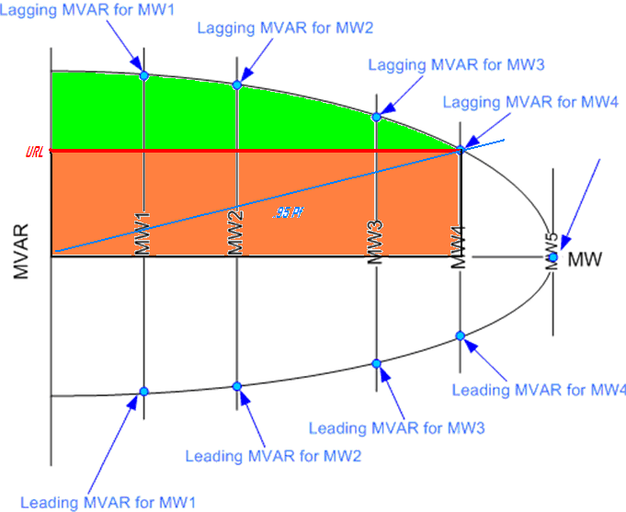

Calpine strongly supports ERCOT’s efforts to maintain system reliability and the fairness found in PRR830. We ask that TAC members look to the overwhelming endorsement of PRR830 by ROS (73.3% FOR and 26.7% AGAINST; of 5 NO votes, 4 came from wind-owning entities), the subcommittee tasked with reliability matters, and significantly lopsided segment vote of PRS (5.75 FOR, 1.25 AGAINST), the subcommittee that listened to both reliability and commercial points, in passing the PRR on October 22, 2009.

Revised Proposed Protocol Language
None proposed.

