SLA MarkeTrak stats from ERCOT on 10.02.2009

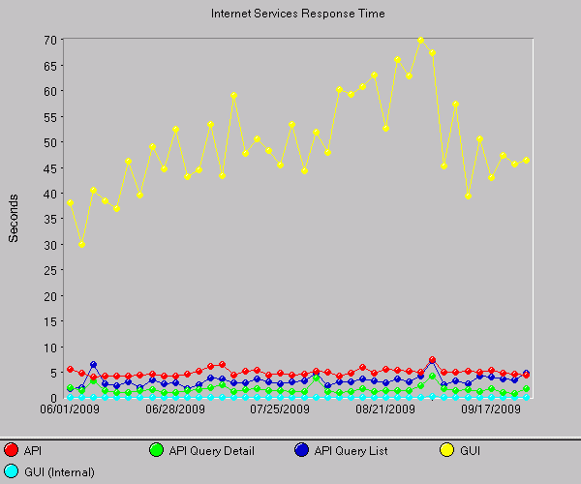

 | Target | Apr '09 | May '09 | Jun '09 | Jul '09 | Aug '09 | Sep '09 | Total
API Query List (Response time < 3.75 sec) | 98.00% | 97.90% | 96.50% | 93.18% | 71.18% |  | 61.69% | 84.09%
API Query Detail (Response time < 2 sec) | 98.00% | 97.90% | 97.92% | 91.40% | 92.16% | 87.30% | 87.45% | 92.36%
API Update (Response time < 7 sec) | 98.00% | 97.72% | 98.47% | 97.76% | 93.54% | 94.08% | 93.32% | 95.82%
GUI (Response time < 40 sec) | 98.00% | 91.80% | 89.72% | 70.00% | 73.60% |  | 60.16% | 77.06%

