COPS Market Guide
Load Aggregation
V0.1

Revision History
Date | Version | Description | Author
03/01/09 | 0.1 | Initial Draft | Calvin Opheim

Table of Contents
1. Load Aggregation 4
1.1 Overview 4
1.2 Protocol References 4
1.3 Document Assumptions 4
2. Load Aggregation for Non-IDR ESI IDs 5
2.1 ESI ID Attributes 5
2.2 Retrieve Non-IDR ESI IDs 7
2.3 Retrieve Non-IDR, Non-TOU ESI IDs 8
2.4 NOTOU, NIDR ESI ID Usage Groupings 9
2.5 Create Load Segment Groupings for Non-IDR, Non-TOU ESI IDs with usage for the Operating Day 12
2.6 Create Load Segment Groupings for Non-IDR, Non-TOU ESI IDs with no usage data for the Operating Day but have usage data within one year prior to the Operating Day 14
2.7 Create Load Segment Groupings for Non-IDR, Non-TOU ESI IDs with no usage data for the Operating Day nor usage data within the 365 days prior to the Operating Day 16
2.8 Retrieve Non-IDR, TOU ESI IDs 19
2.9 TOU, NIDR ESI ID Usage Groupings 20
2.10 Create Load Segment Groupings for Non-IDR, TOU ESI IDs with usage for the Operating Day 22
2.11 Create Load Segment Groupings for Non-IDR, TOU ESI IDs with no usage data for the Operating Day but have usage data within one year prior to the Operating Day 25
The process for creating load segment groupings for Non-IDR, TOU ESI IDs with no usage data for the Operating Day begins with retrieving the most recent usage data for each ESI ID with a start meter reading date that is less than the Operating Day. If the start meter reading date is within one year of the Operating Day, then the following process is followed. If the start meter reading data is not within 365 days of the Operating Day or if there is no usage data for the ESI ID, then refer to Section 2.12 Create Load Segment Groupings for Non-IDR, TOU ESI IDs with no usage data for the Operating Day nor within 365 days prior to the Operating Day. 25
2.12 Create Load Segment Groupings for Non-IDR, TOU ESI IDs with no usage data for the Operating Day nor within 365 days prior to the Operating Day 28
2.13 Converting Non-IDR Load Segment Groups to 15 minute settlement interval Data 30
3. Distribution Loss Factors 37
3.1 Distribution Loss Factors Submission by DSPs 37
3.2 Actual Distribution Loss Factor Calculation in Real Time Settlements 37
3.3 Forecast Distribution Loss Factor Calculation 39
3.4 Calculation of Distribution Loss Adjusted Load Segments(LSEGDL) 42
4. Transmission Loss Factors 44
4.1 Actual Transmission Loss Factors 44
4.2 Monthly Transmission Loss Factor Calculation 44
4.3 Actual Transmission Loss Factor Calculation in Real Time Settlements 45
4.4 Forecast Transmission Loss Factor Calculation 47
4.5 Calculation of Transmission Loss Adjusted Load Segments(LSEGTL) 49
4.6 Calculation of UFE 50
4.7 Allocation of UFE 51
4.8 Data Agg Bill Determinant Calculations 69

Software Requirements Specification

Load Aggregation

Overview
Load Aggregation is the process of netting, grouping and summing Load consumption data, applying appropriate profiles, Transmission Loss Factors and Distribution Loss Factors and calculating and allocating Unaccounted For Energy (UFE) to determine each QSE and/or Load Serving Entities Adjusted Metered Load (AML) by Settlement Interval by Load Zone and by other prescribed aggregation determinants. The process of aggregating Load data provides the determinants used in settlement.

Protocol References
This document defines all data aggregation load determinants that are required for Settlement Calculations for the Real-Time Energy Operations.

The following Data Aggregation determinants are included in real-time energy settlement and are included in the scope of this document:

- Real-Time Adjusted Metered Load per QSE per Settlement Point (RTAML) (PR 6.6.2.1, PR 6.6.2.2, PR 6.6.2.3, PR 6.6.3.2)

- Real-Time Adjusted Metered Load Total (RTAMLTOT) (PR 6.6.2.1, PR 6.6.2.2, PR 6.6.2.3)

- Load Ratio Share per QSE (LRS) (PR 6.6.2.2, PR 6.6.5.4, PR 6.6.7.2, PR 6.6.9.2 (though it’s listed as LSR), PR 6.6.10 (though it’s listed as LSR)

- Hourly Load Ratio Share per QSE (HLRS) (PR 6.6.2.3, PR 6.6.6.5, PR 6.6.8.2)

- Monthly Load Ratio Share per QSE (MLRS) (PR 7.5.7, PR 7.9.3.5)

- Monthly Load Ratio Share Zonal per QSE (MLRSZ) (PR 7.5.7)

Document Assumptions
A1) All existing zonal Data Aggregation bill determinants will continue to be produced in the nodal system unless noted otherwise in this document.

A2) All ESI IDs will be mapped to substations.

A3) All substations will be mapped to Load Zones.

A4) The Settlement System should not store zero value data cuts for a Data Aggregation bill determinant, unless the zero data cut is a result of a calculation or a requirement specifies that the cut be saved.

A5) The Data Aggregation bill determinant calculations are documented using the proposed format. The following list defines the nomenclature used for the bill determinants, though not all of these bill determinant elements may apply to each bill determinant within this document):

<Q> = QSE
<CO> = CRR Owner
<SP> = Settlement Point
<REP> = Retail Electric Provider
<LSE> = Load Serving Entity
<PI> = Profile ID
<LC> = Loss Code
<UFE> = UFE Settlement Zone
<CM> = Congestion Management Zone is this still needed in nodal
<DSP> = Distribution Service Provider
<TSP> = Transmission Service Provider
<TDSP> = Transmission and/or Distribution Service Provider
<BLTP> = Block Load Transfer Point
<NC> = NOIE Code
<L> = Load Zone (<L> or <LZ> ??)
<WZ> = Weather Zone
<PT> = Profile Type
<MET> = Methodology

ESI ID Attributes

The following is a listing of ESI ID attributes that are stored in ERCOT’s Settlement System. Note that ESI ID attributes are in effect for complete Operating Days (i.e., no ESI ID attributes can be changed in the middle of any Operating Day):

- Start-Time (mm/dd/yyyy hh:mm:ss) – indicates the effective start date and time for the data record. The time value will always be 00:00:00 (hh:mm:ss) since ESI ID attributes are in effect for the complete Operating Day.

- Stop-Time (mm/dd/yyyy 23:59:59) – indicates the effective end date and time for the data record. The time value will always be 23:59:59 (hh:mm:ss) since ESI ID attributes are in effect for the complete Operating Day. ERCOT’s Settlement System uses 23:59:59 to represent the last second of any Operating Day.

- LSE Code – a unique code assigned by ERCOT to the LSE that is responsible for serving the ESI ID’s load. ERCOT has also assigned LSE Codes to the DC-Ties.

- Station Code – a unique code assigned by ERCOT to the substation that the ESI ID is associated with. Each Station is mapped to a Load Zone and to a Settlement UFE zone.

- Profile ID - The Profile ID includes the following attributes:

- Profile Type – Currently there are 10 profile types. They are as follows: need to add DG to this list

  - BUSIDRRQ – Business Interval Data Recorder (IDR) required,
  - BUSHILF – Business high load factor,
  - BUSLOLF – Business low load factor,
  - BUSMEDLF – Business medium load factor,
  - BUSNODEM – Business no demand,
  - BUSOGFLT – Business Oil and Gas Flat,
  - NMFLAT – Non metered flat,
  - NMLIGHT – Non metered lighting,
  - RESHIWR – Residential high winter ratio, and
  - RESLOWR – Residential low winter ratio.

Refer to Section 18 of Protocols or the Load Profiling Guide for more details on Profile Types.

- Weather Zone – Currently there are 8 weather zones. They are as follows:

  - COAST,
  - EAST,
  - FWEST,
  - NCENT,
  - NORTH,
  - SCENT,
  - SOUTH, and
  - WEST.

- Weather Sensitivity Code – Currently there are two weather sensitivity codes. They are as follows:

  - NWS – non weather sensitive and
  - WS – weather sensitive.

All Non-IDR ESI IDs are assigned as non weather sensitive (NWS). IDR ESI IDs are classified as NWS or WS depending on … per protocols … needs more explanation

- Meter Data Type – Currently there are two meter data types. They are as follows:

  - IDR – which indicates that interval data is used for settlement purposes for the ESI ID
  - NIDR – which indicates that non-interval (scalar) data is used for settlement purposes for the ESI ID

- TOU Schedule – Currently there are 13 approved Time Of Use (TOU) schedules.

  - NOTOU - ESI ID is to be settled without using a TOU schedule
  - TOUxx – ESI ID is to be settled using an ERCOT approved TOU schedule, where xx represents 01, 02, 03, 04, 05, 06, 07, 08, 09, 10, 11, 12, or 13.

- Loss Code – Loss codes are used to indicate which distribution loss factor should be applied to the energy usage for the ESI ID. Currently there are 6 approved loss codes. They are as follows:

- A,
- B,
- C,
- D,
- E, and
- T.

- TDSP Code – the unique code assigned by ERCOT for the TDSP responsible for the ESI ID. (Do we want to list these?)

- Status Code – Currently there are three status codes. They are as follows:

- Active,
- De-energized, and
- Inactive.

Only ESI IDs with a Status code of Active are settled for a specific Operating Day.

Load Aggregation for Non-IDR ESI IDs

The purpose of this process is to convert non-interval consumption data, reported by the Meter Reading Entities, into aggregated 15 minute settlement interval data over an Operating Day for settlement purposes.

Retrieve Non-IDR ESI IDs

The process of aggregating Non-IDR ESI IDs begins with retrieving all active and energized Non-IDR ESI IDs for the Operating Day. Active ESI IDs are identified by having a Status Code of Active for the Operating Day. Non-IDR ESI IDs are identified as those ESI IDs with a meter data type of NIDR.

Also retrieved for each ESI ID are the following seven attributes which were in effect for the Operating Day:

- QSE,
- LSE,
- TDSP,
- Profile ID,
- Distribution Loss Factor Code,
- Load Zone, and
- UFE Settlement Zone.

Process Flow:

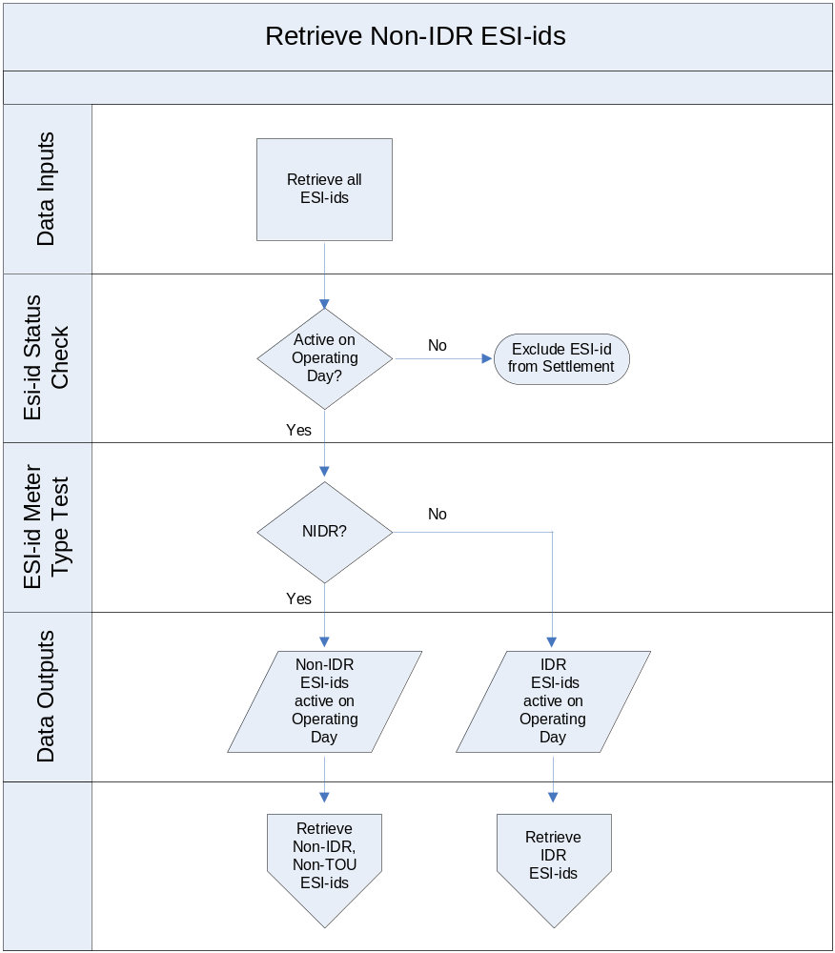
Change this diagram to reflect Retrieve Non-IDR ESI IDs. Next section separates out the Non-TOU.

Retrieve Non-IDR, Non-TOU ESI IDs

The group of Non-IDR ESI IDs which are active for the Operating Day (Section 3.1) is then separated into two subgroups:

- Those with a TOU Schedule value of NOTOU and
- Those with a TOU Schedule value that is not equal to NOTOU (TOU01, TOU02, …,TOU12, and TOU13).

The process for profiling Non-IDR ESI IDs that are settled without using a TOU schedule is described in Section 3.3. The process for profiling Non-IDR ESI IDs that are settled using a TOU schedule is described in Section 3.7.

Process Flow:

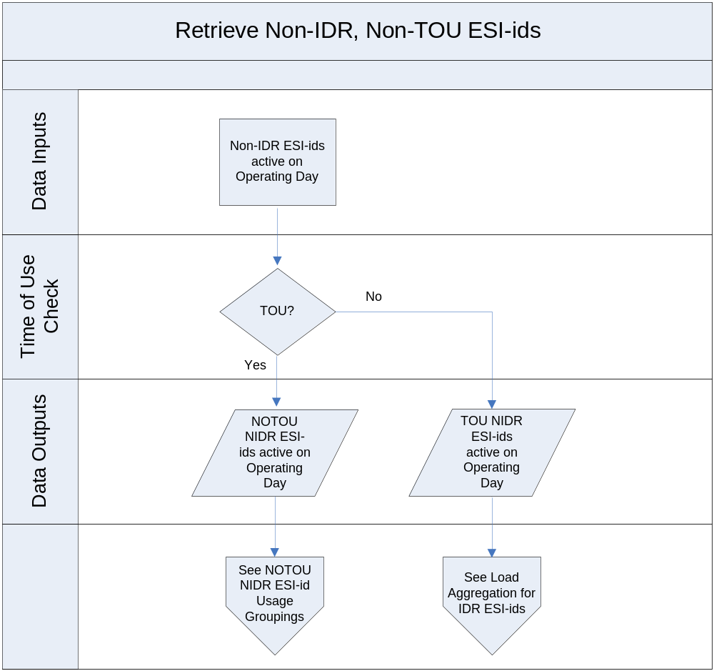

may have an error in the above chart, should only include NIDR ESI IDs and error in TOU decision box
should remove the bottom row to be consistent with other process flow diagrams

NOTOU, NIDR ESI ID Usage Groupings

ESI IDs in the NIDR, NOTOU data set are further divided into three distinct groups:

- The first group consists of those ESI IDs which have usage data for the Operating Day,
- The second group consists of those ESI IDs which do not have usage data for the Operating Day but do have usage data within the last 12 months prior to the Operating Day,
- The third group consists of those ESI IDs which have no usage data for the timeframe from one year before the Operating Day through the Operating Day.

Process Flow:

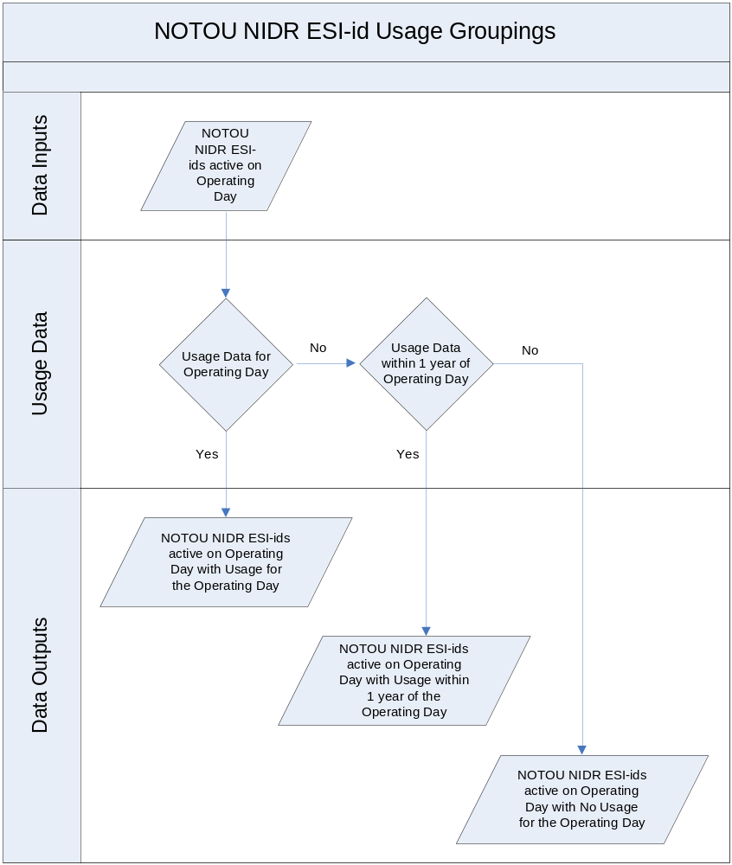

The following sections detail how Load Segments are created for each of the three distinct ESI IDs datasets:

- Non-IDR, Non-TOU ESI IDs with usage data for the Operating Day (Section 3.4),
- Non-IDR, Non-TOU ESI IDs with no usage data for the Operating Day but have usage data within 1 year prior to the Operating Day (Section 3.5), and
- Non-IDR, Non-TOU ESI IDs with no usage data for the Operating Day nor usage data within 365 days prior to the Operating Day (Section 3.6).

Create Load Segment Groupings for Non-IDR, Non-TOU ESI IDs with usage for the Operating Day

ESI IDs which are included in this step of the load aggregation process:

- Are active and energized for the particular Operating Day,
- Have a meter data type of NIDR,
- Have a TOU Schedule value of NOTOU, and
- Have usage data which includes the Operating Day (i.e., the Operating Day is greater than or equal to the Start Meter Reading Date and the Operating Day is less than the Stop Meter Reading Date).

This process groups ESI IDs which have the same values for all of the following:

- QSE,
- LSE,
- TDSP,
- Profile ID,
- Distribution Loss Factor Code,
- Load Zone,
- UFE Settlement Zone,
- Start Meter Reading Date, and
- Stop Meter Reading Date.

This process also calculates the total kWh consumption for the group by summing the usage values, and calculates the total number of ESI IDs which are included in the group.

The output of this process is groups of ESI IDs with the following attributes: should method be included below

- QSE,
- LSE,
- TDSP,
- Profile ID,
- Distribution Loss Factor Code,
- Load Zone,
- UFE Settlement Zone,
- Start Meter Reading Date,
- Stop Meter Reading Date,
- kWh Consumption, and
- Number of ESI IDs.

Example 1 and Example 2 illustrate this process.

EXAMPLE 1 - ESI ID Attributes:
Table A below lists five ESI IDs which are active for Operating Day 1/1/2009 and their attributes. All of these ESI IDs have usage for the Operating Day 1/1/2009.

TABLE – A
ESI IDs active on Operating Day 1/1/2009

ESI ID | QSE  Code | L  SE  C  o  d  e | TDSP  C  o  d  e | Profile ID | D  L  F  C  o  d  e | Load  Zone  Code | UFE  Code | Start  Meter  Reading  Date | Stop  Meter  Reading  Date | kWh
1234 | 1 | 7 | 1 | RESLOWR_NORTH_NIDR_NWS_NOTOU | A | N08 | U01 | 12/4/2008 | 1/3/2009 | 1,500
1589 | 1 | 7 | 1 | RESLOWR_NORTH_NIDR_NWS_NOTOU | A | N08 | U01 | 12/4/2008 | 1/3/2009 | 1,200
4566 | 3 | 12 | 4 | BUSMEDLF_SCENT_NIDR_NWS_NOTOU | A | S08 | U01 | 12/6/2008 | 1/5/2009 | 40,000
5879 | 3 | 12 | 4 | BUSMEDLF_SCENT_NIDR_NWS_NOTOU | A | S08 | U01 | 12/6/2008 | 1/5/2009 | 60,000
6879 | 3 | 12 | 4 | BUSMEDLF_SCENT_NIDR_NWS_NOTOU | A | S08 | U01 | 12/6/2008 | 1/5/2009 | 50,000

Seeing that ESI IDs 1234 and 1589 have the exact same attributes, they will be grouped together in the same load segment group. Also ESI IDs 4566, 5879, and 6879 have the exact same attributes and they will be grouped together in the same load segment group.

EXAMPLE 2 – Create Load Segment Groupings:
Using the data from Table A (above), the following Table B below lists the two load segment groups that were created for Operating Day 1/1/2009 and the attributes for each load segment group:

TABLE – B
Load Segment Groupings for Operating Day 1/1/2009

QSE  Code | L  SE  C  o  d  e | TDSP  C  o  d  e | Profile ID | D  L  F  C  o  d  e | Load  Zone  Code | UFE  Code | Start  Meter  Reading  Date | Stop  Meter  Reading  Date | Total  kWh | Total  ESI IDs
1 | 7 | 1 | RESLOWR_NORTH_NIDR_NWS_NOTOU | A | N08 | U01 | 12/4/2008 | 1/3/2009 | 2,700 | 2
3 | 12 | 4 | BUSMEDLF_SCENT_NIDR_NWS_NOTOU | A | S08 | U01 | 12/6/2008 | 1/5/2009 | 150,000 | 3

Create Load Segment Groupings for Non-IDR, Non-TOU ESI IDs with no usage data for the Operating Day but have usage data within one year prior to the Operating Day

The process for creating load segment groupings for Non-IDR, Non-TOU ESI IDs with no usage data for the Operating Day begins with retrieving the most recent usage data for each ESI ID with a start meter reading date that is less than the Operating Day. If the start meter reading date is within one year of the Operating Day, then the following process is followed. If the start meter reading data is not within 365 days of the Operating Day or if there is no usage data for the ESI ID, then refer to Section 3.6 Create Load Segment Groupings for Non-IDR, Non-TOU ESI IDs with no usage data for the Operating Day nor usage data within 365 days prior to the Operating Day.

ESI IDs which are included in this step of the load aggregation process:

- Are active and energized for the particular Operating Day,
- Have a meter data type of NIDR,
- Have a TOU Schedule value of NOTOU, and
- Have no usage data which includes the Operating Day.
- The most recent usage data has a start meter reading date that is less than the Operating Day and is within one year of the Operating Day.

This process groups ESI IDs which have the same values for all of the following:

- QSE,
- LSE,
- TDSP,
- Profile ID,
- Distribution Loss Factor Code,
- Load Zone,
- UFE Settlement Zone,
- Start Meter Reading Date, and
- Stop Meter Reading Date.

This process also calculates the total kWh consumption for the group by summing the usage values, and calculates the total number of ESI IDs which are included in the group.

The output of this process is groups of ESI IDs with the following attributes: should method be included below

- QSE,
- LSE,
- TDSP,
- Profile ID,
- Distribution Loss Factor Code,
- Load Zone,
- UFE Settlement Zone,
- Start Meter Reading Date,
- Stop Meter Reading Date,
- kWh Consumption, and
- Number of ESI IDs.

Example 3 and Example 4 illustrate this process.

EXAMPLE 3 – ESI ID Attributes:
Table C below lists five ESI IDs which are active for Operating Day 1/1/2009 and their attributes. The Start and Stop Meter Reading Dates represent the most recent consumption data that is stored in ERCOT’s settlement system when Operating Day 1/1/2009 is settled.

TABLE – C
ESI IDs active on Operating Day 1/1/2009

ESI ID | QSE  Code | L  SE  C  o  d  e | TDSP  C  o  d  e | Profile ID | D  L  F  C  o  d  e | Load  Zone  Code | UFE  Code | Start  Meter  Reading  Date | Stop  Meter  Reading  Date | kWh
4758 | 8 | 21 | 3 | BUSLOLF_EAST_NIDR_NWS_NOTOU | B | N08 | U01 | 10/4/2008 | 11/3/2008 | 11,500
3547 | 8 | 21 | 3 | BUSLOLF_EAST_NIDR_NWS_NOTOU | B | N08 | U01 | 10/4/2008 | 11/3/2008 | 9,500
2888 | 2 | 17 | 2 | RESHIWR_SOUTH_NIDR_NWS_NOTOU | A | S08 | U01 | 6/6/2008 | 7/5/2008 | 2,800
6541 | 2 | 17 | 2 | RESHIWR_SOUTH_NIDR_NWS_NOTOU | A | S08 | U01 | 6/6/2008 | 7/5/2008 | 2,200
7747 | 2 | 17 | 2 | RESHIWR_SOUTH_NIDR_NWS_NOTOU | A | S08 | U01 | 9/12/2008 | 10/13/2008 | 3,000

Seeing that ESI IDs 4758 and 3547 have the exact same attributes, they will be grouped together in the same load segment group. ESI IDs 2888 and 6541 have the exact same attributes and they will be grouped together in the same load segment group. ESI ID 7747 is its own load segment group seeing that the Start-Date and Stop-Date are different from ESI IDs 2888 and 6541.

EXAMPLE 4 – Create Load Segment Groupings:
Using the data from Table C (above), the following Table D below lists the three load segments that were created for Operating Day 1/1/2009 and the attributes for each load segment:

TABLE – D
Load Segment Groupings for Operating Day 1/1/2009

QSE  Code | L  SE  C  o  d  e | TDSP  C  o  d  e | Profile ID | D  L  F  C  o  d  e | Load  Zone  Code | UFE  Code | Start  Meter  Reading  Date | Stop  Meter  Reading  Date | Total  kWh | Total  ESI IDs
8 | 21 | 3 | BUSLOLF_EAST_NIDR_NWS_NOTOU | B | N08 | U01 | 10/4/2008 | 11/3/2008 | 21,000 | 2
2 | 17 | 2 | RESHIWR_SOUTH_NIDR_NWS_NOTOU | A | S08 | U01 | 6/6/2008 | 7/5/2008 | 5,000 | 2
2 | 17 | 2 | RESHIWR_SOUTH_NIDR_NWS_NOTOU | A | S08 | U01 | 9/12/2008 | 10/13/2008 | 3,000 | 1

Create Load Segment Groupings for Non-IDR, Non-TOU ESI IDs with no usage data for the Operating Day nor usage data within the 365 days prior to the Operating Day

The process for creating load segments for Non-IDR, Non-TOU ESI IDs with no usage data for the Operating Day begins with retrieving the most recent usage data for each ESI ID with a start meter reading date that is less than the Operating Day. If the start meter reading data is not within 365 days of the Operating Day or if there is no usage data for the ESI ID, then the following process is followed.

ESI IDs which are included in this step of the load aggregation process:

- Are active and energized for the particular Operating Day,
- Have a meter data type of NIDR,
- Have a TOU Schedule value of NOTOU, and
- Have no usage data which includes the Operating Day.
- The most recent usage data with a start meter reading date that is less than the Operating Day is not within 365 days of the Operating Day or there is no usage data available.

This process groups ESI IDs which have the same values for all of the following:

- QSE,
- LSE,
- TDSP,
- Profile ID,
- Distribution Loss Factor Code,
- Load Zone, and
- UFE Settlement Zone.

This process also calculates the total number of ESI IDs which are included in each group.

The output of this process is groups of ESI IDs with the following attributes: should method be included

- QSE,
- LSE,
- TDSP,
- Profile ID,
- Distribution Loss Factor Code,
- Load Zone,
- UFE Settlement Zone, and
- Number of ESI IDs.

Example 5 and Example 6 illustrate this process.

EXAMPLE 5 – ESI ID Attributes:
Table E below lists five ESI IDs which are active for Operating Day 1/1/2009 and their attributes. The Start and Stop Meter Reading Dates represent the most recent consumption data that is stored in ERCOT’s settlement system when Operating Day 1/1/2009 is settled.

TABLE – E
ESI IDs active on Operating Day 1/1/2009

ESI ID | QSE  Code | L  SE  C  o  d  e | TDSP  C  o  d  e | Profile ID | D  L  F  C  o  d  e | Load  Zone  Code | UFE  Code | Start  Meter  Reading  Date | Stop  Meter  Reading  Date | kWh
4758 | 8 | 21 | 3 | BUSLOLF_EAST_NIDR_NWS_NOTOU | B | N08 | U01 | 9/1/2006 | 9/28/2006 | 11,500
3547 | 8 | 21 | 3 | BUSLOLF_EAST_NIDR_NWS_NOTOU | B | N08 | U01 | None | None | N/A
2888 | 2 | 17 | 2 | RESHIWR_SOUTH_NIDR_NWS_NOTOU | A | S08 | U01 | 6/3/2006 | 7/5/2006 | 2,800
6541 | 2 | 17 | 2 | RESHIWR_SOUTH_NIDR_NWS_NOTOU | A | S08 | U01 | 6/6/2006 | 7/8/2006 | 2,200
7747 | 2 | 17 | 2 | RESHIWR_SOUTH_NIDR_NWS_NOTOU | A | S08 | U01 | None | None | N/A

Seeing that ESI IDs 4758 and 3547 have the exact same attributes, they will be grouped together in the same load segment group (remember that when processing ESI IDs with no usage within 365 days of the Operating Day or with no usage at all, the Start Meter Reading Date and Stop Meter Reading Date are not considered as grouping attributes). ESI IDs 2888, 6541, and 7747 have the exact same attributes and they will be grouped together in the same load segment group.

EXAMPLE 6 – Create Load Segment Groupings:
Using the data from Table E (above), the following Table D below lists the two load segment groupings that were created for Operating Day 1/1/2009 and the attributes for each load segment group:

TABLE – F
Load Segments for Operating Day 1/1/2009

QSE  Code | L  SE  C  o  d  e | TDSP  C  o  d  e | Profile ID | D  L  F  C  o  d  e | Load  Zone  Code | UFE  Code | Total  ESI IDs
8 | 21 | 3 | BUSLOLF_EAST_NIDR_NWS_NOTOU | B | N08 | U01 | 2
2 | 17 | 2 | RESHIWR_SOUTH_NIDR_NWS_NOTOU | A | S08 | U01 | 3

Retrieve Non-IDR, TOU ESI IDs

Remembering back to Section 3.2, the group of Non-IDR ESI IDs which are active for the Operating Day (Section 3.1) was divided into two subgroups:

- Those with a TOU Schedule value of NOTOU and

- Those with a TOU Schedule value that is not equal to NOTOU (TOU01, TOU02, …, TOU12, and TOU13).

The process for profiling Non-IDR ESI IDs that are settled using a TOU schedule is described in the sections below. PROBABLY NEED TO REFER TO CHARTS IN SECTION 2.3 ABOVE, PROCESS FLOWS ETC.

Process Flow:

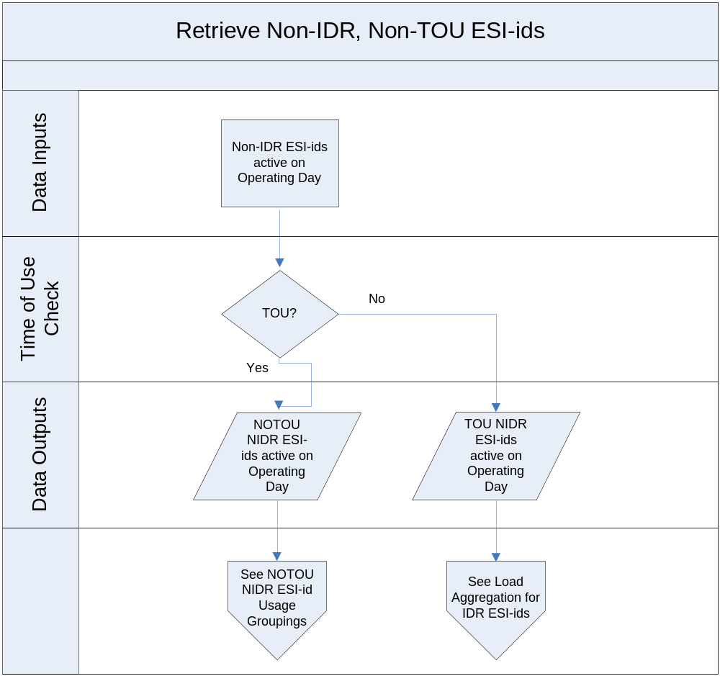

may have an error in the above chart, should only include NIDR ESI IDs and error in TOU decision box (Agree need to make chart for ‘Retrieve Non-IDR, TOU ESI IDs. Need to swap the Data Outputs.)

TOU, NIDR ESI ID Usage Groupings

ESI IDs in the NIDR, TOU data set are further divided into three distinct groups:

- The first group consists of those ESI IDs which have usage data for the Operating Day,
- The second group consists of those ESI IDs which do not have usage data for the Operating Day but do have usage data within the last 12 months prior to the Operating Day,
- The third group consists of those ESI IDs which have no usage data for the timeframe from one year before the Operating Day through the Operating Day.

Process Flow:

THE ABOVE CHART NEEDS TO BE CHANGED TO REFLECT TOU (Agree)

The following sections detail how Load Segments are created for each of the three distinct ESI IDs datasets:

  - Non-IDR, TOU ESI IDs with usage data for the Operating Day (Section 3.9),
  - Non-IDR, TOU ESI IDs with no usage data for the Operating Day but have usage data within 1 year prior to the Operating Day (Section 3.10), and
  - Non-IDR, TOU ESI IDs with no usage data for the Operating Day nor usage data within 365 days prior to the Operating Day (Section 3.11).

Create Load Segment Groupings for Non-IDR, TOU ESI IDs with usage for the Operating Day

ESI IDs which are included in this step of the load aggregation process:

- Are active and energized for the particular Operating Day,
- Have a meter data type of NIDR,
- Have a TOU Schedule value of TOU01, TOU02, TOU03, … TOU12, or TOU13
- Have usage data which includes the Operating Day (i.e., the Operating Day is greater than or equal to the Start Meter Reading Date and the Operating Day is less than the Stop Meter Reading Date).

This process groups ESI IDs which have the same values for all of the following:

- QSE,
- LSE,
- TDSP,
- Profile ID,
- Distribution Loss Factor Code,
- Load Zone,
- UFE Settlement Zone,
- Start Meter Reading Date, and
- Stop Meter Reading Date.

This process also calculates total kWh consumption for the group by summing: (Need definitions of on-peak, off-peak, mid-peak, and super-peak or a reference to where to find the definitions).

- total usage kWh values,
- on-peak kWh values (if applicable to the corresponding TOU schedule),
- off-peak kWh values (if applicable to the corresponding TOU schedule),
- mid-peak kWh values (if applicable to the corresponding TOU schedule), and
- super-peak kWh values (if applicable to the corresponding TOU schedule).

The total number of ESI IDs which are included in the group is also summed.

The output of this process is groups of ESI IDs with the following attributes: should method be included

- QSE,
- LSE,
- TDSP,
- Profile ID,
- Distribution Loss Factor Code,
- Load Zone,
- UFE Settlement Zone,
- Start Meter Reading Date,
- Stop Meter Reading Date,
- Total kWh Consumption,
- Total On-Peak kWh Consumption,
- Total Off-Peak kWh Consumption,
- Total Mid-Peak kWh Consumption,
- Total Super-Peak kWh Consumption, and
- Number of ESI IDs.

Example 7 and Example 8 illustrate this process.

EXAMPLE 7 - ESI ID Attributes:
Table G below lists five ESI IDs which are active for Operating Day 1/1/2009 and their attributes. All of these ESI IDs have usage for the Operating Day 1/1/2009.

TABLE – G
ESI IDs active on Operating Day 1/1/2009

ESI ID | QSE  Code | L  SE  C  o  d  e | TDSP  C  o  d  e | Profile ID | D  L  F  C  o  d  e | Load  Zone  Code | UFE  Code | Start  Meter  Reading  Date | Stop  Meter  Reading  Date | On-Peak  kWh | Off-Peak  kWh | kWh
1234 | 1 | 7 | 1 | RESLOWR_NORTH_NIDR_NWS_TOU01 | A | N08 | U01 | 12/4/2008 | 1/3/2009 | 1,000 | 500 | 1,500
1589 | 1 | 7 | 1 | RESLOWR_NORTH_NIDR_NWS_TOU01 | A | N08 | U01 | 12/4/2008 | 1/3/2009 | 800 | 400 | 1,200
4566 | 3 | 12 | 4 | BUSMEDLF_SCENT_NIDR_NWS_TOU12 | A | S08 | U01 | 12/6/2008 | 1/5/2009 | 20,000 | 20,000 | 40,000
5879 | 3 | 12 | 4 | BUSMEDLF_SCENT_NIDR_NWS_TOU12 | A | S08 | U01 | 12/6/2008 | 1/5/2009 | 10,000 | 50,000 | 60,000
6879 | 3 | 12 | 4 | BUSMEDLF_SCENT_NIDR_NWS_TOU12 | A | S08 | U01 | 12/6/2008 | 1/5/2009 | 5,000 | 45,000 | 50,000

Seeing that ESI IDs 1234 and 1589 have the exact same attributes, they will be grouped together in the same load segment group. Also ESI IDs 4566, 5879, and 6879 have the exact same attributes and they will be grouped together in the same load segment group.

EXAMPLE 8 – Create Load Segment Groupings:
Using the data from Table G (above), the following Table H below lists the two load segment groups that were created for Operating Day 1/1/2009 and the attributes for each load segment group:

TABLE – H
Load Segment Groupings for Operating Day 1/1/2009

QSE  Code | L  SE  C  o  d  e | TDSP  C  o  d  e | Profile ID | D  L  F  C  o  d  e | Load  Zone  Code | UFE  Code | Start  Meter  Reading  Date | Stop  Meter  Reading  Date | On-Peak  kWh | Off-Peak  kWh | Total  kWh | Total  ESI IDs
1 | 7 | 1 | RESLOWR_NORTH_NIDR_NWS_TOU01 | A | N08 | U01 | 12/4/2008 | 1/3/2009 | 1,800 | 900 | 2,700 | 2
3 | 12 | 4 | BUSMEDLF_SCENT_NIDR_NWS_TOU12 | A | S08 | U01 | 12/6/2008 | 1/5/2009 | 35,000 | 115,000 | 150,000 | 3

Create Load Segment Groupings for Non-IDR, TOU ESI IDs with no usage data for the Operating Day but have usage data within one year prior to the Operating Day

The process for creating load segment groupings for Non-IDR, TOU ESI IDs with no usage data for the Operating Day begins with retrieving the most recent usage data for each ESI ID with a start meter reading date that is less than the Operating Day. If the start meter reading date is within one year of the Operating Day, then the following process is followed. If the start meter reading data is not within 365 days of the Operating Day or if there is no usage data for the ESI ID, then refer to Section 3.11 Create Load Segment Groupings for Non-IDR, TOU ESI IDs with no usage data for the Operating Day nor within 365 days prior to the Operating Day.

ESI IDs which are included in this step of the load aggregation process:

- Are active and energized for the particular Operating Day,
- Have a meter data type of NIDR,
- Have a TOU Schedule value of TOU01, TOU02, TOU03, … TOU12, or TOU13,
- Have no usage data which includes the Operating Day,
- The most recent usage data has a start meter reading date that is less than the Operating Day and is within one year of the Operating Day.

This process groups ESI IDs which have the same values for all of the following:

- QSE,
- LSE,
- TDSP,
- Profile ID,
- Distribution Loss Factor Code,
- Load Zone,
- UFE Settlement Zone,
- Start Meter Reading Date, and
- Stop Meter Reading Date.

This process also calculates total kWh consumption for the group by summing:

- total usage kWh values,
- on-peak kWh values (if applicable to the corresponding TOU schedule),
- off-peak kWh values (if applicable to the corresponding TOU schedule),
- mid-peak kWh values (if applicable to the corresponding TOU schedule), and
- super-peak kWh values (if applicable to the corresponding TOU schedule).

The total number of ESI IDs which are included in the group is also summed.

The output of this process is groups of ESI IDs with the following attributes: should method be included (Yes)

- QSE,
- LSE,
- TDSP,
- Profile ID,
- Distribution Loss Factor Code,
- Load Zone,
- UFE Settlement Zone,
- Start Meter Reading Date,
- Stop Meter Reading Date,
- Total kWh Consumption,
- Total On-Peak kWh Consumption,
- Total Off-Peak kWh Consumption,
- Total Mid-Peak kWh Consumption,
- Total Super-Peak kWh Consumption, and
- Number of ESI IDs.

Example 9 and Example 10 illustrate this process.

EXAMPLE 9 – ESI ID Attributes:
Table I below lists five ESI IDs which are active for Operating Day 1/1/2009 and their attributes. The Start and Stop Meter Reading Dates represent the most recent consumption data that is stored in ERCOT’s settlement system when Operating Day 1/1/2009 is settled.

TABLE – I
ESI IDs active on Operating Day 1/1/2009

ESI ID | QSE  Code | L  SE  C  o  d  e | TDSP  C  o  d  e | Profile ID | D  L  F  C  o  d  e | Load  Zone  Code | UFE  Code | Start  Meter  Reading  Date | Stop  Meter  Reading  Date | On-Peak  kWh | Off-Peak  kWh | kWh
1234 | 1 | 7 | 1 | RESLOWR_NORTH_NIDR_NWS_TOU01 | A | N08 | U01 | 2/1/2008 | 3/2/2008 | 1,000 | 500 | 1,500
1589 | 1 | 7 | 1 | RESLOWR_NORTH_NIDR_NWS_TOU01 | A | N08 | U01 | 2/1/2008 | 3/2/2008 | 200 | 1,800 | 2,000
4566 | 3 | 12 | 4 | BUSMEDLF_SCENT_NIDR_NWS_TOU12 | A | S08 | U01 | 8/1/2008 | 9/1/2008 | 2,000 | 20,000 | 22,000
5444 | 3 | 12 | 4 | BUSMEDLF_SCENT_NIDR_NWS_TOU12 | A | S08 | U01 | 8/6/2008 | 9/4/2008 | 5,000 | 15,000 | 20,000
6879 | 3 | 12 | 4 | BUSMEDLF_SCENT_NIDR_NWS_TOU12 | A | S08 | U01 | 8/1/2008 | 9/1/2008 | 5,000 | 45,000 | 50,000

Seeing that ESI IDs 1234 and 1589 have the exact same attributes, they will be grouped together in the same load segment group. ESI IDs 4566 and 6879 have the exact same attributes and they will be grouped together in the same load segment group. ESI ID 5444 is its own load segment group seeing that the Start-Date and Stop-Date are different from ESI IDs 4566 and 6879.

EXAMPLE 10 – Create Load Segment Groupings:
Using the data from Table I (above), the following Table J below lists the three load segments that were created for Operating Day 1/1/2009 and the attributes for each load segment:

TABLE – J
Load Segment Groupings for Operating Day 1/1/2009

QSE  Code | L  SE  C  o  d  e | DSP  C  o  d  e | Profile ID | D  L  F  C  o  d  e | Load  Zone  Code | UFE  Code | Start  Meter  Reading  Date | Stop  Meter  Reading  Date | On-Peak  kWh | Off-Peak  kWh | Total  kWh | Total  ESI IDs
1 | 7 | 1 | RESLOWR_NORTH_NIDR_NWS_TOU01 | A | N08 | U01 | 2/1/2008 | 3/2/2008 | 1,200 | 2,300 | 3,500 | 2
3 | 12 | 4 | BUSMEDLF_SCENT_NIDR_NWS_TOU12 | A | S08 | U01 | 8/1/2008 | 9/1/2008 | 7,000 | 65,000 | 72,000 | 2
3 | 12 | 4 | BUSMEDLF_SCENT_NIDR_NWS_TOU12 | A | S08 | U01 | 8/6/2008 | 9/4/2008 | 5,000 | 15,000 | 20,000 | 1

Create Load Segment Groupings for Non-IDR, TOU ESI IDs with no usage data for the Operating Day nor within 365 days prior to the Operating Day

The process for creating load segments for Non-IDR, TOU ESI IDs with no usage data for the Operating Day begins with retrieving the most recent usage data for each ESI ID with a start meter reading date that is less than the Operating Day. If the start meter reading data is not within 365 days of the Operating Day or if there is no usage data for the ESI ID, then the following process is followed.

ESI IDs which are included in this step of the load aggregation process:

- Are active and energized for the particular Operating Day,
- Have a meter data type of NIDR,
- Have a TOU Schedule value of TOU01, TOU02, TOU03, … TOU12, or TOU13,
- Have no usage data which includes the Operating Day.
- The most recent usage data with a start meter reading date that is less than the Operating Day is not within 365 days of the Operating Day or there is no usage data available.

This process groups ESI IDs which have the same values for all of the following:

- QSE,
- LSE,
- TDSP,
- Profile ID,
- Distribution Loss Factor Code,
- Load Zone, and
- UFE Settlement Zone.

This process also calculates the total number of ESI IDs which are included in each group.

The output of this process is groups of ESI IDs with the following attributes: should method be included

- QSE,
- LSE,
- TDSP,
- Profile ID,
- Distribution Loss Factor Code,
- Load Zone,
- UFE Settlement Zone, and
- Number of ESI IDs.

Example 11 and Example 12 illustrate this process.

EXAMPLE 11 – ESI ID Attributes:
Table K below lists five ESI IDs which are active for Operating Day 1/1/2009 and their attributes. The Start and Stop Meter Reading Dates represent the most recent consumption data that is stored in ERCOT’s settlement system when Operating Day 1/1/2009 is settled.

TABLE – K
ESI IDs active on Operating Day 1/1/2009

ESI ID | QSE  Code | L  SE  C  o  d  e | DSP  C  o  d  e | Profile ID | D  L  F  C  o  d  e | Load  Zone  Code | UFE  Code | Start  Meter  Reading  Date | Stop  Meter  Reading  Date | kWh
4758 | 8 | 21 | 3 | BUSLOLF_EAST_NIDR_NWS_TOU05 | B | N08 | U01 | 9/1/2006 | 9/28/2006 | 11,500
3547 | 8 | 21 | 3 | BUSLOLF_EAST_NIDR_NWS_TOU05 | B | N08 | U01 | None | None | N/A
2888 | 2 | 17 | 2 | RESHIWR_SOUTH_NIDR_NWS_TOU01 | A | S08 | U01 | 6/3/2006 | 7/5/2006 | 2,800
6541 | 2 | 17 | 2 | RESHIWR_SOUTH_NIDR_NWS_TOU01 | A | S08 | U01 | 6/6/2008 | 7/8/2006 | 2,200
7747 | 2 | 17 | 2 | RESHIWR_SOUTH_NIDR_NWS_TOU01 | A | S08 | U01 | None | None | N/A

Seeing that ESI IDs 4758 and 3547 have the exact same attributes, they will be grouped together in the same load segment group (remember that when processing ESI IDs with no usage within 365 days of the Operating Day or with no usage at all, the Start Meter Reading Date and Stop Meter Reading Date are not considered as grouping attributes). ESI IDs 2888, 6541, and 7747 have the exact same attributes and they will be grouped together in the same load segment group.

EXAMPLE 12 – Create Load Segment Groupings:
Using the data from Table K (above), the following Table L below lists the two load segment groupings that were created for Operating Day 1/1/2009 and the attributes for each load segment group:

TABLE – F
Load Segments for Operating Day 1/1/2009

QSE  Code | L  SE  C  o  d  e | DSP  C  o  d  e | Profile ID | D  L  F  C  o  d  e | Load  Zone  Code | UFE  Code | Total  ESI IDs
8 | 21 | 3 | BUSLOLF_EAST_NIDR_NWS_TOU05 | B | N08 | U01 | 2
2 | 17 | 2 | RESHIWR_SOUTH_NIDR_NWS_TOU01 | A | S08 | U01 | 3

Converting Non-IDR Load Segment Groups to 15 minute settlement interval Data

The next step is to process all of the load segment groups. The six load segment groups which have been created are:

- Non-IDR, Non-TOU ESI IDs with usage data for the Operating Day (Section 3.4) (Actual),
- Non-IDR, Non-TOU ESI IDs with no usage data for the Operating Day but have usage data within 1 year prior to the Operating Day (Section 3.5) (Historical),
- Non-IDR, Non-TOU ESI IDs with no usage data for the Operating Day nor usage data within 365 days prior to the Operating Day (Section 3.6) (Default),
- Non-IDR, TOU ESI IDs with usage data for the Operating Day (Section 3.9) (Actual),
- Non-IDR, TOU ESI IDs with no usage data for the Operating Day but have usage data within 1 year prior to the Operating Day (Section 3.10) (Historical), and
- Non-IDR, TOU ESI IDs with no usage data for the Operating Day nor usage data within in 365 days prior to the Operating Day (Section 3.11) (Default).

Converting Non-IDR, Non-TOU Load Segment Groups with Start and Stop Meter Reading Dates to 15 minute settlement interval Data

For each Non-IDR, Non-TOU load segment group that has a Start Meter Reading Date and a Stop Meter Reading Date:

- Retrieve the start meter reading date and the stop meter reading date.
- Determine the start meter reading time. The start meter reading time for all NIDR consumption values is assumed to be at 00:00:00 (hh:mm:ss) for the start meter reading date. For example, a start meter reading date of 12/4/2008 would mean that the consumption value represents usage beginning at 12/4/2008 00:00:00.
- Determine the stop meter reading time. The stop meter reading time for all NIDR consumption values is assumed to end at 23:59:59 (hh:mm:ss) of the day prior to the stop meter reading date. For example a stop meter reading date of 1/3/2009 is assumed to represent consumption through 1/2/2009 at 23:59:59.
- Determine the Profile class for the load segment group. The Profile Class is determined from the Profile ID by using the Profile Type and Weather Zone (for example, RESLOWR_NORTH, BUSMEDLF_SCENT, etc).

Calculate Profile Class Total Usage

Requirement ID
Source Mapping (Protocol/NERC/FERC and other binding documents Ref #)
Traceability to Sub-Process Maps | TBD
Description: Calculate Profile Class Total Usage (PCTU)

For each Non-IDR, Non-TOU load segment group g that have both a start meter reading date and a stop meter reading date, sum all 15-minute values for the corresponding Profile Class Load Profile from the start meter reading time through the stop meter reading time.

PCTU_{g} =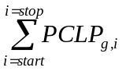
Where:
PCTU_{g} = Profile Class Total Usage (kWh) for load segment group g.
PCLP_{g,i} = Profile Class Load Profile for load segment group g, 15 minute settlement interval i.
start = start meter reading time
stop = stop meter reading time
i = 15 minute settlement interval15 minute settlement interval
g = load segment group

The above variables are defined below:

Input Bill Determinants
Variable | Unit | Definition | Source
PCLP | kWh | Profile Class Load Profile - A representation of the energy usage of a group of Customers on a 15-minute basis. | Settlement System
Interval Frequency: 4 / hour

Additional Comments: PCLP will be saved in the form of <PT>_<WZ>.

Intermediate Bill Determinants
Variable | Unit | Definition | Destination
PCTU | kWh | Profile Class Total Usage | Settlement System
Interval Frequency: scalar

Additional Comments: PCTU is not saved.

Calculate Usage Scaling Factor

Requirement ID
Source Mapping (Protocol/NERC/FERC and other binding documents Ref #)
Traceability to Sub-Process Maps | TBD
Description: Calculate Usage Scaling Factor (USF)

For each load segment group, divide the total kWh consumption value for the load segment group by the Profile Class Total Usage for the load segment group.

USF_{g} = KWH_{g} / PCTU_{g}
Where:
USF_{g} = Usage Scaling Factor for load segment group g
KWH_{g} = The total kWh consumption value for load segment group g
PCTU_{g} = Profile Class Total Usage (kWh) for load segment group g
g = load segment group

The above variables are defined below:

Input Bill Determinants
Variable | Unit | Definition | Source
KWH | kWh | The total kWh consumption. | Settlement System
Interval Frequency: scalar

Additional Comments: This is saved in the scalarstaging table in Lodestar per David Hill (Need to substitute Lodestar for description aggregation system or something like that.)
PCTU | kWh | Profile Class Total Usage | Settlement System
Interval Frequency: scalar

Additional Comments: PCTU is not saved.

Intermediate Bill Determinants
Variable | Unit | Definition | Destination
USF | kWh | Usage Scaling Factor | Settlement System
Interval Frequency: scalar

Additional Comments: USF is not saved.

Create Load Segment Group Interval Data

Requirement ID
Source Mapping (Protocol/NERC/FERC and other binding documents Ref #)
Traceability to Sub-Process Maps | TBD
Description: Create Load Segment Group Interval Data (LSGID)

Retrieve the Profile Class load profile for the Operating Day. (Where and how is the Profile Class load profile for the Operating Day retrieved, file name, location?) Multiply all 15-minute values of the Profile Class load profile for the given Operating Day by the usage scaling factor.

For all intervals i of Operating Day d,

LSGID_{g,d,i} = PCLP_{g,d,i} * USF_{g}
Where:
LSGID_{g,d,I} = Load Segment Group Interval Data for load segment group g, Operating Day d, 15 minute settlement interval15 minute settlement interval i.
PCLP_{g,d,i} = Profile Class Load Profile for load segment group g, Operating Day d,
15 minute settlement interval15 minute settlement interval i.
USF_{g} = Usage Scaling Factor for load segment group g
i = 15 minute settlement interval15 minute settlement interval
g = load segment group

This results in a 15 minute settlement interval15 minute settlement interval data cut being created for each NIDR NOTOU load segment grouping for the Operating Day. This 15 minute settlement interval15 minute settlement interval data cut has the following attributes:

- QSE,
- LSE,
- TDSP,
- Profile ID,
- Distribution Loss Factor Code,
- Load Zone,
- UFE Settlement Zone, and
- Method.

Current Method values are: (Use these terms in previous descriptions, see Section 3.12)
  - Actual – indicates that usage data was available for the Operating Day,
  - Historical - indicates that no usage data was available for the Operating Day but that usage data was available for a date within 365 days prior to the Operating Day, and
  - Default – indicates that no usage data was available for the Operating Day and no usage data was available for any date within 365 days prior to the Operating Day.

The above variables are defined below:

Input Bill Determinants
Variable | Unit | Definition | Source
PCLP | kWh | Profile Class Load Profile - A representation of the energy usage of a group of Customers on a 15-minute basis. | Settlement System
Interval Frequency: 4 / hour

Additional Comments: PCLP will be saved in the form of <PT>_<WZ>.
USF | kWh | Usage Scaling Factor | Settlement System
Interval Frequency: scalar

Additional Comments: USF is not saved.

Intermediate Bill Determinants
Variable | Unit | Definition | Destination
LSGID | kWh | Load Segment Group Interval Data | Settlement System
Interval Frequency: 4 / hour

Additional Comments: LSGID has the form LSGID_<LSE>_<QSE>_<PI> <DLFC>_<UFE>_<LZ>_<TDSP>_<MET>. LSGID is not saved.

Converting Non-IDR, TOU Load Segment Groups to 15 minute settlement interval15 minute settlement interval Data

For each Non-IDR, TOU load segment group that has a Start Meter Reading Date and a Stop Meter Reading date:

- Retrieve the start meter reading date and the stop meter reading date. (Retrieve from where, 727 Extract?)
- Determine the start meter reading time. The start meter reading time for all NIDR consumption values is assumed to be at 00:00:00 (hh:mm:ss) for the start meter reading date. For example, a start meter reading date of 12/4/2008 would mean that the consumption value represents usage beginning at 12/4/2008 00:00:00.
- Determine the stop meter reading time. The stop meter reading time for all NIDR consumption values is assumed to end at 23:59:59 (hh:mm:ss) of the day prior to the stop meter reading date. For example a stop meter reading date of 1/3/2009 is assumed to represent consumption through 1/2/2009 at 23:59:59.
- Determine the Profile class for the load segment group. The Profile Class is determined from the Profile ID by using the Profile Type and Weather Zone (for example, RESLOWR_NORTH, BUSMEDLF_SCENT, etc).

Calculate Profile Class Total On-Peak Usage

Requirement ID
Source Mapping (Protocol/NERC/FERC and other binding documents Ref #)
Traceability to Sub-Process Maps | TBD
Description: Calculate Profile Class Total On-Peak Usage (PCTU_{on})

For each Non-IDR, TOU load segment group g that have both a start meter reading date and a stop meter reading date, sum all 15-minute values that occur during the on-peak period for the corresponding Profile Class load profile from the start meter reading date and time through the stop meter reading date and time.

For all intervals i which belong to the on-peak time period,

PCTU_{on} =
Where:
PCTU_{on} = Profile Class Total On-Peak Usage (kWh) for load segment group g.
PCLP_{g,i} = Profile Class Load Profile for load segment group g, 15 minute settlement interval15 minute settlement interval i.
start = start meter reading date and time
stop = stop meter reading date and time
i = 15 minute settlement interval15 minute settlement interval
g = load segment group

The above variables are defined below:

Input Bill Determinants
Variable | Unit | Definition | Source
PCLP | kWh | Profile Class Load Profile - A representation of the energy usage of a group of Customers on a 15-minute basis. | Settlement System
Interval Frequency: 4 / hour

Additional Comments: PCLP will be saved in the form of <PT>_<WZ>.

Intermediate Bill Determinants
Variable | Unit | Definition | Destination
PCTU_{on} | kWh | Profile Class Total Usage for the on-peak time period. | Settlement System
Interval Frequency: scalar

Additional Comments: PCTU_{on} is not saved.

Calculate Profile Class Total Off-Peak Usage

Requirement ID
Source Mapping (Protocol/NERC/FERC and other binding documents Ref #)
Traceability to Sub-Process Maps | TBD
Description: Calculate Profile Class Total Off-Peak Usage (PCTU_{off})

For each Non-IDR, TOU load segment group g that have both a start meter reading date and a stop meter reading date, sum all 15-minute values that occur during the off-peak period for the corresponding Profile Class load profile from the start meter reading date and time through the stop meter reading date and time.

For all intervals i which belong to the off-peak time period,

PCTU_{off} =
Where:
PCTU_{off} = Profile Class Total Off-Peak Usage (kWh) for load segment group g.
PCLP_{g,i} = Profile Class Load Profile for load segment group g, 15 minute settlement interval15 minute settlement interval i.
start = start meter reading date and time
stop = stop meter reading date and time
i = 15 minute settlement interval15 minute settlement interval
g = load segment group

The above variables are defined below:

Input Bill Determinants
Variable | Unit | Definition | Source
PCLP | kWh | Profile Class Load Profile - A representation of the energy usage of a group of Customers on a 15-minute basis. | Settlement System
Interval Frequency: 4 / hour

Additional Comments: PCLP will be saved in the form of <PT>_<WZ>.

Intermediate Bill Determinants
Variable | Unit | Definition | Destination
PCTU_{off} | kWh | Profile Class Total Usage for the off-peak time period. | Settlement System
Interval Frequency: scalar

Additional Comments: PCTU_{off} is not saved.

Calculate Profile Class Total Mid-Peak Usage

Requirement ID
Source Mapping (Protocol/NERC/FERC and other binding documents Ref #)
Traceability to Sub-Process Maps | TBD
Description: Calculate Profile Class Total Mid-Peak Usage (PCTU_{mid})

For each Non-IDR, TOU load segment group g that have both a start meter reading date and a stop meter reading date, sum all 15-minute values that occur during the mid-peak period for the corresponding Profile Class load profile from the start meter reading date and time through the stop meter reading date and time.

For all intervals i which belong to the mid-peak time period,

PCTU_{mid} =
Where:
PCTU_{off} = Profile Class Total Mid-Peak Usage (kWh) for load segment group g.
PCLP_{g,i} = Profile Class Load Profile for load segment group g, 15 minute settlement interval15 minute settlement interval i.
start = start meter reading date and time
stop = stop meter reading date and time
i = 15 minute settlement interval15 minute settlement interval
g = load segment group

The above variables are defined below:

Input Bill Determinants
Variable | Unit | Definition | Source
PCLP | kWh | Profile Class Load Profile - A representation of the energy usage of a group of Customers on a 15-minute basis. | Settlement System
Interval Frequency: 4 / hour

Additional Comments: PCLP will be saved in the form of <PT>_<WZ>.

Intermediate Bill Determinants
Variable | Unit | Definition | Destination
PCTU_{mid} | kWh | Profile Class Total Usage for the mid-peak time period. | Settlement System
Interval Frequency: scalar

Additional Comments: PCTU_{mid} is not saved.

Calculate Profile Class Total Super-Peak Usage

Requirement ID
Source Mapping (Protocol/NERC/FERC and other binding documents Ref #)
Traceability to Sub-Process Maps | TBD
Description: Calculate Profile Class Total Super-Peak Usage (PCTU_{super})

For each Non-IDR, TOU load segment group g that have both a start meter reading date and a stop meter reading date, sum all 15-minute values that occur during the super-peak period for the corresponding Profile Class load profile from the start meter reading date and time through the stop meter reading date and time.

For all intervals i which belong to the super-peak time period,

PCTU_{super} =
Where:
PCTU_{off} = Profile Class Total Super-Peak Usage (kWh) for load segment group g.
PCLP_{g,i} = Profile Class Load Profile for load segment group g, 15 minute settlement interval15 minute settlement interval i.
start = start meter reading date and time
stop = stop meter reading date and time
i = 15 minute settlement interval
g = load segment group

The above variables are defined below:

Input Bill Determinants
Variable | Unit | Definition | Source
PCLP | kWh | Profile Class Load Profile - A representation of the energy usage of a group of Customers on a 15-minute basis. | Settlement System
Interval Frequency: 4 / hour

Additional Comments: PCLP will be saved in the form of <PT>_<WZ>.

Intermediate Bill Determinants
Variable | Unit | Definition | Destination
PCTU_{super} | kWh | Profile Class Total Usage for the mid-peak time period. | Settlement System
Interval Frequency: scalar

Additional Comments: PCTU_{super} is not saved.

Calculate On-Peak Usage Scaling Factor

Requirement ID
Source Mapping (Protocol/NERC/FERC and other binding documents Ref #)
Traceability to Sub-Process Maps | TBD
Description: Calculate On-Peak Usage Scaling Factor (USF_{on})

For each load segment group, divide the total on-peak kWh consumption value for the load segment group by the Profile Class Total On-Peak Usage for the load segment group.

USF_{g,on} = KWH_{g,on} / PCTU_{g,on}
Where:
USF_{g,on} = On-peak Usage Scaling Factor for load segment group g
KWH_{g,on} = The total on-peak kWh consumption value for load segment group g
PCTU_{g,on} = On-peak Profile Class Total Usage (kWh) for load segment group g
g = load segment group

The above variables are defined below:

Input Bill Determinants
Variable | Unit | Definition | Source
KWH_{on} | kWh | The total on-peak kWh consumption. | Settlement System
Interval Frequency: scalar

Additional Comments: This is saved in the scalarstaging table in Lodestar per David Hill
PCTU_{on} | kWh | Profile Class Total On-Peak Usage | Settlement System
Interval Frequency: scalar

Additional Comments: PCTU is not saved.

Intermediate Bill Determinants
Variable | Unit | Definition | Destination
USF_{on} | kWh | On-Peak Usage Scaling Factor | Settlement System
Interval Frequency: scalar

Additional Comments: USF is not saved.

Calculate Off-Peak Usage Scaling Factor

Requirement ID
Source Mapping (Protocol/NERC/FERC and other binding documents Ref #)
Traceability to Sub-Process Maps | TBD
Description: Calculate Off-Peak Usage Scaling Factor (USF_{off})

For each load segment group, divide the total off-peak kWh consumption value for the load segment group by the Profile Class Total Off-Peak Usage for the load segment group.

USF_{g,off} = KWH_{g,off} / PCTU_{g,off}
Where:
USF_{g,off} = Off-peak Usage Scaling Factor for load segment group g
KWH_{g,off} = The total off-peak kWh consumption value for load segment group g
PCTU_{g,off} = Off-peak Profile Class Total Usage (kWh) for load segment group g
g = load segment group

The above variables are defined below:

Input Bill Determinants
Variable | Unit | Definition | Source
KWH_{off} | kWh | The total off-peak kWh consumption. | Settlement System
Interval Frequency: scalar

Additional Comments: This is saved in the scalarstaging table in Lodestar per David Hill
PCTU_{off} | kWh | Profile Class Total Off-Peak Usage | Settlement System
Interval Frequency: scalar

Additional Comments: PCTU is not saved.

Intermediate Bill Determinants
Variable | Unit | Definition | Destination
USF_{off} | kWh | Off-Peak Usage Scaling Factor | Settlement System
Interval Frequency: scalar

Additional Comments: USF is not saved.

Calculate Mid-Peak Usage Scaling Factor

Requirement ID
Source Mapping (Protocol/NERC/FERC and other binding documents Ref #)
Traceability to Sub-Process Maps | TBD
Description: Calculate Mid-Peak Usage Scaling Factor (USF_{mid})

For each load segment group, divide the total mid-peak kWh consumption value for the load segment group by the Profile Class Total Mid-Peak Usage for the load segment group.

USF_{g,mid} = KWH_{g,mid} / PCTU_{g,mid}
Where:
USF_{g,mid} = Mid-peak Usage Scaling Factor for load segment group g
KWH_{g,mid} = The total mid-peak kWh consumption value for load segment group g
PCTU_{g,mid} = Mid-peak Profile Class Total Usage (kWh) for load segment group g
g = load segment group

The above variables are defined below:

Input Bill Determinants
Variable | Unit | Definition | Source
KWH_{mid} | kWh | The total mid-peak kWh consumption. | Settlement System
Interval Frequency: scalar

Additional Comments: This is saved in the scalarstaging table in Lodestar per David Hill
PCTU_{mid} | kWh | Profile Class Total Mid-Peak Usage | Settlement System
Interval Frequency: scalar

Additional Comments: PCTU is not saved.

Intermediate Bill Determinants
Variable | Unit | Definition | Destination
USF_{mid} | kWh | Mid-Peak Usage Scaling Factor | Settlement System
Interval Frequency: scalar

Additional Comments: USF is not saved.

Calculate Super-Peak Usage Scaling Factor

Requirement ID
Source Mapping (Protocol/NERC/FERC and other binding documents Ref #)
Traceability to Sub-Process Maps | TBD
Description: Calculate Super-Peak Usage Scaling Factor (USF_{super})

For each load segment group, divide the total super-peak kWh consumption value for the load segment group by the Profile Class Total Super-Peak Usage for the load segment group.

USF_{g,super} = KWH_{g,super} / PCTU_{g,super}
Where:
USF_{g,super} = Super-peak Usage Scaling Factor for load segment group g
KWH_{g,super} = The total super-peak kWh consumption value for load segment group g
PCTU_{g,super} = Super-peak Profile Class Total Usage (kWh) for load segment group g
g = load segment group

The above variables are defined below:

Input Bill Determinants
Variable | Unit | Definition | Source
KWH_{super} | kWh | The total super-peak kWh consumption. | Settlement System
Interval Frequency: scalar

Additional Comments: This is saved in the scalarstaging table in Lodestar per David Hill
PCTU_{super} | kWh | Profile Class Total Super-Peak Usage | Settlement System
Interval Frequency: scalar

Additional Comments: PCTU is not saved.

Intermediate Bill Determinants
Variable | Unit | Definition | Destination
USF_{super} | kWh | Super-Peak Usage Scaling Factor | Settlement System
Interval Frequency: scalar

Additional Comments: USF is not saved.

Create Load Segment Group Interval Data

Requirement ID
Source Mapping (Protocol/NERC/FERC and other binding documents Ref #)
Traceability to Sub-Process Maps | TBD
Description: Create Load Segment Group Interval Data (LSGID)

Retrieve the Profile Class load profile for the Operating Day. For each 15 minute settlement interval of the Operating Day:
- Determine what TOU period the 15 minute settlement interval belongs to for the given Operating Day,
- Multiply the 15-minute value of the Profile Class load profile by the corresponding TOU usage scaling factor (i.e., use the on-peak usage scaling factor for time intervals which are included in the on-peak period, use the off-peak usage scaling factor for time intervals which are included in the off-peak period, use the mid-peak usage scaling factor for time intervals which are included in the mid-peak period, use the super-peak usage scaling factor for time intervals which are included in the super-peak period).

For all intervals i of Operating Day d,

- if i is included in the on-peak period then

LSGID_{g,d,i} = PCLP_{g,d,i} * USF_{on,g}

- if i is included in the off-peak period then

LSGID_{g,d,i} = PCLP_{g,d,i} * USF_{off,g}

- if i is included in the mid-peak period then

LSGID_{g,d,i} = PCLP_{g,d,i} * USF_{mid,g}

- if i is included in the super-peak period then

LSGID_{g,d,i} = PCLP_{g,d,i} * USF_{super,g}

Where:
LSGID_{g,d,I} = Load Segment Group Interval Data for load segment group g, Operating Day d, 15 minute settlement interval i.
PCLP_{g,d,i} = Profile Class Load Profile for load segment group g, Operating Day d,
15 minute settlement interval i.
USF_{on,g} = Usage Scaling On-Peak Factor for load segment group g.
USF_{off,g} = Usage Scaling Off-Peak Factor for load segment group g.
USF_{mid,g} = Usage Scaling Mid-Peak Factor for load segment group g.
USF_{super,g} = Usage Scaling Super-Peak Factor for load segment group g

i = 15 minute settlement interval
g = load segment group

This results in a 15 minute settlement interval data cut being created for each NIDR TOU load segment grouping for the Operating Day. This 15 minute settlement interval data cut has the following attributes:

- QSE,
- LSE,
- TDSP,
- Profile ID,
- Distribution Loss Factor Code,
- Load Zone,
- UFE Settlement Zone, and
- Method.

Current Method values are:
  - Actual – indicates that usage data was available for the Operating Day,
  - Historical - indicates that no usage data was available for the Operating Day but that usage data was available for a date within 365 days prior to the Operating Day, and
  - Default – indicates that no usage data was available for the Operating Day and no usage data was available for any date within 365 days prior to the Operating Day.

The above variables are defined below:

Input Bill Determinants
Variable | Unit | Definition | Source
PCLP | kWh | Profile Class Load Profile - A representation of the energy usage of a group of Customers on a 15-minute basis. | Settlement System
Interval Frequency: 4 / hour

Additional Comments: PCLP will be saved in the form of <PT>_<WZ>.
USF | kWh | Usage Scaling Factor for TOU period (either on, off, mid, or super TOU period). | Settlement System
Interval Frequency: scalar

Additional Comments: USF is not saved.

Intermediate Bill Determinants
Variable | Unit | Definition | Destination
LSGID | kWh | Load Segment Group Interval Data | Settlement System
Interval Frequency: 4 / hour

Additional Comments: LSGID has the form LSGID_<LSE>_<QSE>_<PI> <DLFC>_<UFE>_<LZ>_<TDSP>_<MET>. LSGID is not saved.

Creating Load Segment Groups that do not have a Start Meter Reading Date and a Stop Meter Reading Date to 15 minute settlement interval Data

Requirement ID
Source Mapping (Protocol/NERC/FERC and other binding documents Ref #)
Traceability to Sub-Process Maps | TBD
Description: Create Load Segment Group Interval Data (LSGID)

For each Non-IDR load segment group (includes both TOU and NOTOU) that does not have a Start Meter Reading Date and a Stop Meter Reading date:

- Retrieve the Profile Class load profile for the Operating Day.
- Multiple all 15-minute values of the Profile Class load profile for the given Operating Day by the number of ESI IDs in the load segment group (TOTESI).

For all intervals i of Operating Day d,

LSGID_{g,d,i} = PCLP_{g,d,i} * TOTESI_{g}
Where:
LSGID_{g,d,I} = Load Segment Group Interval Data for load segment group g, Operating Day d, 15 minute settlement interval i.
PCLP_{g,d,i} = Profile Class Load Profile for load segment group g, Operating Day d,
15 minute settlement interval i.
TOTESI_{g} = Total number of ESI IDs in load segment group g
i = 15 minute settlement interval
g = load segment group
d = Operating Day

This results in a 15 minute settlement interval data cut being created for each load segment grouping. This 15 minute settlement interval data cut has the following attributes:

- QSE,
- LSE,
- TDSP,
- Profile ID,
- Distribution Loss Factor Code,
- Load Zone,
- UFE Settlement Zone, and
- Usage Type.

Current usage type values are:
  - Actual – indicates that usage data was available for the Operating Day,
  - Historical - indicates that no usage data was available for the Operating Day but that usage data was available for a date within 365 days prior to the Operating Day, and
  - Default – indicates that no usage data was available for the Operating Day and no usage data was available for any date within 365 days prior to the Operating Day.

The above variables are defined below:

Input Bill Determinants
Variable | Unit | Definition | Source
PCLP | kWh | Profile Class Load Profile - A representation of the energy usage of a group of Customers on a 15-minute basis. | Settlement System
Interval Frequency: 4 / hour

Additional Comments: PCLP will be saved in the form of <PT>_<WZ>.
TOTESI | none | Total number of ESI IDs in the load segment group. | Settlement System
Interval Frequency: scalar

Additional Comments: This is saved in the scalarstaging table in Lodestar per David Hill

Intermediate Bill Determinants
Variable | Unit | Definition | Destination
LSGID | kWh | Load Segment Group Interval Data | Settlement System
Interval Frequency: 4 / hour

Additional Comments: LSGID has the form LSGID_<LSE>_<QSE>_<PI> <DLFC>_<UFE>_<LZ>_<TDSP>_<MET>. LSGID is not saved.

Creating LSEGUNADJ cuts

Requirement ID
Source Mapping (Protocol/NERC/FERC and other binding documents Ref #)
Traceability to Sub-Process Maps | TBD
Description: Create LSEGUNADJ cuts

Retrieve all of the LSGID interval cuts for the Operating Day (from Sections 3.12.1, 3.12.2.9, and 3.12.3 above also includes LSGID cuts from the IDR process which has not been created yet). If all of the attributes are the same, then sum the LSGID interval cuts to create the LSEGUNADJ cuts.

For each LSE (l), QSE (q), Profile ID (p), Distribution Loss Factor Code (d), UFE Settlement Zone (u), Load Zone (z), and TDSP (t) combination:,
LSEGUNADJ_{l,q,p,d,u,z,t,c,i} = 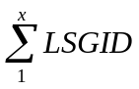_{l,q,p,d,u,z,t,c,i}
Where:
l = LSE,
q = QSE,
p = Profile ID,
d = Distribution Loss Code,
u = UFE Settlement Zone,
z = Load Zone,
t = TDSP, and
c = Method
i = 15 minute settlement interval
x = number of LSGID cuts

The resultant LSEGUNADJ cuts have the following 8 attributes:
- LSE,
- QSE,
- Profile ID,
- Distribution Loss Factor Code,
- UFE Settlement Zone,
- Load Zone,
- TDSP. And
- Method

The above variables are defined below:

Input Bill Determinants
Variable | Unit | Definition | Source
LSGID | kWh | Load Segment Group Interval Data | Settlement System
Interval Frequency: 4 / hour

Additional Comments: LSGID has the form LSGID_<LSE>_<QSE>_<PI> <DLFC>_<UFE>_<LZ>_<TDSP>_<MET>. LSGID is not saved.

Output Bill Determinants
Variable | Unit | Definition | Destination
LSEGUNADJ | MWh | Lowest Level Load Segment or base load segment??? | Settlement System
Interval Frequency: 4 / hour

Additional Comments: LSEGUNADJ will be saved in the form of LSEGUNADJ_<LSE>_<QSE>_<PI> <DLFC>_<UFE>_<LZ>_<TDSP>_<MET>.

Insert a section here for IDR processing. Includes proxy day info and how to create IDR load segments Activity 3. Aggregate Interval Data for All ESI-IDESI IDs

Distribution Loss Factors (DLFs)

Distribution Loss Factors Submission by DSPs

Each Distribution Service Provider (DSP) except Non-Opt-In Entities (NOIEs) will calculate and provide to ERCOT the Annual Distribution Loss Factors that will be applied to distribution voltage level Loads in its area of certification. ERCOT shall review and approve the Distribution Loss Factor methodology and supporting calculations submitted by each DSP prior to the loss factors being used for settlement. Loss factor variables submitted by the DSP shall include:
(1) The annual DLF coefficients (F₁, F₂, and F₃) for each DLF code; and
(2) The methodology upon which the calculation of the coefficients (F₁, F₂, and F₃) was made.

The DSP shall assign a Distribution Loss Factor Code to each ESI ID. A maximum of five Distribution Loss Factor codes may be submitted for each Distribution Service Provider based upon ERCOT approved parameters, such as service voltages or number of transformations.

The following coding standards will be used to identify the Distribution Loss Factor code applicable to each ESI ID:
- T =Transmission connected Customers (no distribution loss factor applied)
- A through E = TDSP defined Customer segment(s)

ERCOT will post the Distribution Loss Factor methodology, including any equations and constants, for each DSP. See Protocols Section 13.3 for details.

Actual Distribution Loss Factor Calculation in Real Time Settlements

Requirement ID
Source Mapping (Protocol/NERC/FERC and other binding documents Ref #)
Traceability to Sub-Process Maps | TBD
Description: Calculate Distribution Loss Factors

DLFs will be calculated from the data provided by DSPs as follows using the following equation:
For each DSP (d) and DLF Code (c) combination,
ACTDISTLOSSFACT_{d,c,i} = F_{1,c} * (LACTERCOT_{i}/AAL) + F_{2,c} + F_{3,c} / (LACTERCOT_{i}/AAL)
Where:
ACTDISTLOSSFACT_{d,c,i} = Actual DLF for DSP (d), DLF code (c ), settlement interval (i),
F_{1,c ,} F_{2,c ,} F_{3,c} = Annual DLF coefficients (F₁, F₂, and F₃) for each DLF code (c ),
LACTERCOT_{i} = Actual ERCOT System Load for settlement interval (i),
AAL = Annual Interval Average LACTERCOT converted to MWh,
d = DSP,
c = DLF code, and
i = 15 minute settlement interval

The above variables are defined below:

Input Bill Determinants
Variable | Unit | Definition | Source
F1, F2, and F3 | MWh | Annual DLF coefficients required for each DLF code. | Settlement System
Interval Frequency: scalar

Additional Comments: F1, F2, and F3 will be saved in the Annual DLF table in Lodestar.
LACTERCOT | MWh | Actual ERCOT Load | Settlement System
Interval Frequency: 4 / hour

Additional Comments: LACTERCOT will be saved in the form of LACTERCOT (i.e., has no other attributes)
AAL | MW | Annual Interval Average LACTERCOT based on the most recent settlement for Operating Days of September 1 of the prior year through August 31 of the current year. This calculation is typically performed in mid October. | Settlement System
Interval Frequency: scalar

Additional Comments: AAL is saved in the Factor Value Table in Lodestar as ERCOT_ANNUAL_AVG_LOAD as an average MW value.

Output Bill Determinants
Variable | Unit | Definition | Destination
ACTDISTLOSSFACT | none | Actual Distribution Loss Factors | Settlement System
Interval Frequency: 4 / hour

Additional Comments: ACTDISTLOSSFACT will be saved in the form of ACTDISTLOSSFACT_<DSP>_<DLFC>.

Actual Distribution Loss Factor (DLF) Posting

This report displays the actual distribution loss factors for each DSP for each Settlement Interval. The ERCOT actual load (MWh) is also displayed. It is posted in .CSV (comma-separated value) format.

Examples 13 and 14 below show a sample CSV file that was created on 1/26/09.

EXAMPLE 13 - Actual DLF CSV file viewed as text:

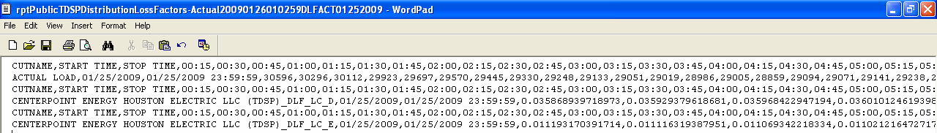

EXAMPLE 14 - Actual DLF CSV file as viewed by Excel:

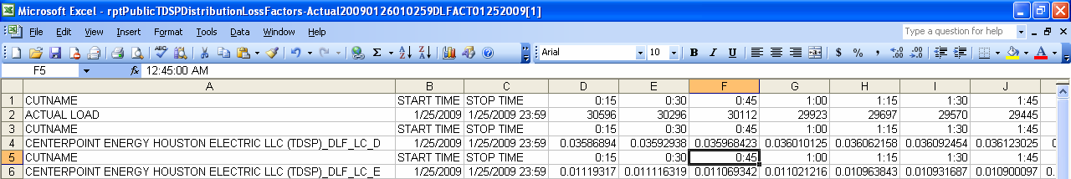

Forecast Distribution Loss Factor Calculation

ERCOT shall use the DLFs submitted by the DSP to calculate forecast Settlement Interval DLFs. ERCOT shall calculate and post the forecast Distribution Loss Factors (DLFs) to the MIS Public Area by 0600 of the Day Ahead period.

Requirement ID
Source Mapping (Protocol/NERC/FERC and other binding documents Ref #)
Traceability to Sub-Process Maps | TBD
Description: Calculate Distribution Loss Factors

DLFs will be calculated from the data provided by DSPs as follows using the following equation:
For each DSP (d) and DLF Code (c) combination,
DISTLOSSFACT_{d,c,i} = F_{1,c} * (LFORERCOT_{i}/AAL) + F_{2,c} + F_{3,c} / (LFORERCOT_{i}/AAL)
Where:
d = DSP,
c = DLF code,
i = 15 minute settlement interval
DISTLOSSFACT_{d,c,i} = Forecast DLF for DSP (d), DLF code (c ), 15 minute settlement interval (i)
LFORERCOT_{i} = Forecast ERCOT System Load converted to MWh for 15 minute settlement interval (i)
AAL = Annual Interval Average LACTERCOT

F_{1,c ,} F_{2,c ,} F_{3,c} = Annual DLF coefficients (F₁, F₂, and F₃) for each DLF code (c ).

The above variables are defined below:

Input Bill Determinants
Variable | Unit | Definition | Source
F1, F2, and F3 | MWh | Annual DLF coefficients required for each DLF code. | Settlement System
Interval Frequency: scalar

Additional Comments: F1, F2, and F3 will be saved in the Annual DLF table in Lodestar.
LFORERCOT | MW | Forecast ERCOT Load | Settlement System
Interval Frequency: 1 / hour

Additional Comments: LFORERCOT will be saved in the form of LFORERCOT (i.e., has no other attributes)
AAL | MWh | Annual Interval Average LACTERCOT based on the most recent settlement for Operating Days of September 1 of the prior year through August 31 of the current year. This calculation is typically performed in mid October. | Settlement System
Interval Frequency: scalar

Additional Comments: AAL is saved in the Factor Value Table in Lodestar as ERCOT_ANNUAL_AVG_LOAD as an average MW value.

Output Bill Determinants
Variable | Unit | Definition | Destination
DISTLOSSFACT | none | Forecast Distribution Loss Factors | Settlement System
Interval Frequency: 4 / hour

Additional Comments: DISTLOSSFACT will be saved in the form of DISTLOSSFACT_<DSP>_<DLFC>.

Need to check if any paragraphs are justified formatted should be left formatted

Forecast Distribution Loss Factor Posting

This report displays the forecast distribution loss factors for each DSP for each Settlement Interval. The ERCOT forecast load (MWh) is also displayed for each hour. It is posted in .CSV (comma-separated value) format.

Examples 15 and 16 below show a sample CSV file that was created on 1/26/09.

EXAMPLE 15 - Forecast DLF CSV file viewed as text:

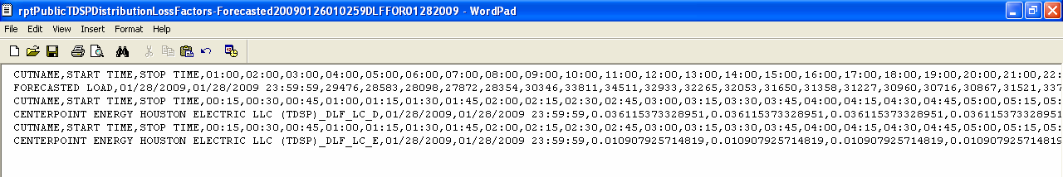

EXAMPLE 16 - Forecast DLF CSV file as viewed by Excel:

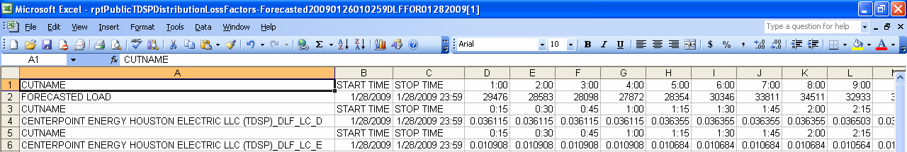

Calculation of Distribution Loss Adjusted Load Segments (LSEGDL)

A calculation is performed for each LSEGUNADJ data cut in order to allocate distribution losses. The Distribution Loss Factor Code for the associated TDSP code is used to determine which Distribution Loss Factors are to be applied to each LSEGUNADJ data cut.

There are currently six possible values for the Distribution Loss Factor Code. Distribution Loss Factor Codes A, B, C, D, and E indicate which distribution loss factor for the corresponding TDSP is associated with the LSEGUNADJ data cut. A Distribution Loss Factor Code of T indicates that no distribution losses are to be applied to the LSEGUNADJ cut (i.e., the ESI IDs that have been aggregated are transmission connected and no distribution losses should be applied).

This process begins by retrieving all of the LSEGUNADJ cuts. LSEGUNADJ cuts have 8 attributes:
- LSE,
- QSE,
- Profile ID,
- Distribution Loss Factor Code,
- UFE Settlement Zone,
- Load Zone,
- TDSP, and
- Method.

Requirement ID
Source Mapping (Protocol/NERC/FERC and other binding documents Ref #)
Traceability to Sub-Process Maps | TBD
Description: Calculate Distribution Loss Adjusted Load Segments (LSEGDL).

For LSEGUNADJ data cuts with a Distribution Loss Factor Code of A, B, C, D, or E, Distribution Loss Adjusted Load Segments (LSEGDL) are calculated as follows:

For each DSP (d) and DLF Code (c) combination
LSEGDL_{d,c,i} = LSEGUNADJ _{d,c,i} x ( 1 / ( 1 – ACTDISTLOSSFACT_{d,c,i}) )

Where:
LSEGDL_{d,c,i} = Distribution Loss Adjusted Load Segment for DSP (d), DLF code (c ), 15 minute settlement interval (i)
LSEGUNADJ_{d,c,i} = Lowest Level Load Segment for DSP (d), DLF code (c ), 15 minute settlement interval (i)
ACTDISTLOSSFACT_{d,c,i} = Actual DLF for DSP d, DLF code c, 15 minute settlement interval i
d = DSP,
c = DLF code,
i = 15 minute settlement interval

For LSEGUNADJ data cuts with a Distribution Loss Factor Code of T, Distribution Loss Adjusted Load Segments (LSEGDL) are calculated as follows:

LSEGDL_{i} = LSEGUNADJ_{i}

Before the LSEGDL cuts are saved, the following calculation is performed:

For each LSE (l), QSE (q), Profile ID (p), Distribution Loss Factor Code (d), UFE Settlement Zone (u), Load Zone (z), and TDSP (t) combination:,
LSEGDL_{l,q,p,d,u,z,t,i} = 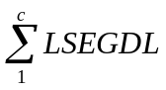_{l,q,p,d,u,z,t,c,i}
Where: this section may not be valid if the market decides to keep method attribute
l = LSE,
q = QSE,
p = Profile ID,
d = Distribution Loss Code,
u = UFE Settlement Zone,
z = Load Zone,
t = TDSP, and
c = Usage Type
i = 15 minute settlement interval
MARKET needs to decide if method field is included on LSEGDL, TL, UFE cuts if method attribute is kept the the above yellow section can be removed
The resultant LSEGDL cuts have the following 7 attributes: add method based on market decision
- LSE,
- QSE,
- Profile ID,
- Distribution Loss Factor Code,
- UFE Settlement Zone,
- Load Zone, and
- TDSP.

The above variables are defined below:

Input Bill Determinants
Variable | Unit | Definition |  |  | Source
LSEGUNADJ | MWh | Lowest Level Load Segment |  |  | Settlement System
Interval Frequency: 4 / hour

Additional Comments: LSEGUNADJ will be saved in the form of LSEGUNADJ_<LSE>_<QSE>_<PI> <DLFC>_<UFE>_<LZ>_<TDSP>_<MET>.
ACTDISTLOSSFACT |  |  | ??? | Actual Distribution Loss Factor | Settlement System
Interval Frequency: 4 / hour

Additional Comments: DLF will be saved in the form of ACTDISTLOSSFACT_<TDSP>_<DLFC>

Output Bill Determinants
Variable | Unit | Definition | Destination
LSEGDL | MWh | Distribution Loss Adjusted Load Segment | Settlement System
Interval Frequency: 4 / hour

Additional Comments: LSEGDL will be saved in the form of LSEGDL_<LSE>_<QSE>_<PI> <DLFC>_<UFE>_<LZ>_<TDSP>_<MET>.

Transmission Loss Factors (TLFs)

Monthly on-peak and off-peak TLFs are derived from the monthly updated ERCOT on-peak and off-peak load flow base cases analysis by ERCOT. Base cases reflect the most current data on the transmission system and Generation Resource dispatch. The ERCOT Transmission Grid topology and related Generation Resource dispatch in the base cases are the critical factors in calculating losses.
ERCOT shall calculate monthly TLFs by dividing ERCOT monthly case transmission losses (60 kV system and higher) by the ERCOT monthly base Load adjusted (reduced) for self serve Load modeled in the case. The resulting loss factors are expressed as a percentage of Load.

Actual Transmission Loss Factors

ERCOT shall determine the deemed actual TLF for each interval in the Operating Day, by use of a linear interpolation or extrapolation using the on-peak and the off-peak TLFs corresponding to the actual ERCOT System Load during the interval.
The day after the Operating Day, ERCOT shall calculate deemed actual TLFs for each Settlement Interval of the Operating Day and publish the TLFs to be used in settlement calculations.
ERCOT shall use the TLFs corresponding to the on-peak and off-peak base case ERCOT System Loads during the applicable months as the basis for the ERCOT-wide deemed actual TLFs. ERCOT will post TLFs to the Market Information System (MIS) Public Area by 0600 two days after the Operating Day (see Section 5.3.1 Actual Transmission Loss Factor Posting below).

Actual Transmission Loss Factor Calculation in Real Time Settlements

Requirement ID
Source Mapping (Protocol/NERC/FERC and other binding documents Ref #)
Traceability to Sub-Process Maps | TBD
Description: Calculate Actual Transmission Loss Factors

The following formulas shall be used to translate the monthly on-peak and off-peak TLFs into Settlement Interval actual TLFs.

For all LACTERCOT values that are in calendar month m:
ACTLOSSFACT_{i} = (MSC_{m} * LACTERCOT_{i}) + MIC_{m}
MSC_{m} = (MONLF_{m} – MOFFLF_{m})/(MONL_{m}-MOFFL_{m})
MIC_{m} = [(MOFFLF_{m}*MONL_{m})-(MONLF_{m}*MOFFL_{m})]/(MONL_{m}-MOFFL_{m})
Where:
m = calendar month,
i = 15 minute settlement interval in calendar month (m),

ACTLOSSFACT_{m,i} = Transmission Loss factors for settlement interval (i) in month (m),
LACTERCOT_{i} = Actual ERCOT System Load for settlement interval (i)
MSC_{m} = Monthly Slope Coefficient for calendar month (m),
MIC_{m} = Monthly Intercept Coefficient for calendar month (m),
MONLF_{m} = Monthly on-peak percent loss factor for calendar month (m),
MOFFLF_{m} = Monthly off-peak percent loss factor for calendar month (m),
MONL_{m} = Monthly on-peak Load value for calendar month (m), and
MOFFL_{m} = Monthly off-peak Load value for calendar month (m).
Note: MONLF_{m} ,MOFFLF_{m} , MONL_{m} , and MOFFL_{m} are calculated by System Planning.

The above variables are defined below:

Input Bill Determinants
Variable | Unit | Definition | Source
MIC | None | Monthly Intercept Coefficient for calendar month (m), | System Planning
Interval Frequency: scalar

Additional Comments: MIC will be saved in the TRANSLOSSFTR table in Lodestar.
MSM | None | Monthly Slope Coefficient for calendar month (m) | System Planning
Interval Frequency: scalar

Additional Comments: MSM will be saved in the TRANSLOSSFTR table in Lodestar.
LACTERCOT | MWh | Actual ERCOT Load | Settlement System
Interval Frequency: 4 / hour

Additional Comments: LACTERCOT will be saved in the form of LACTERCOT (i.e., has no other attributes)

Output Bill Determinants
Variable | Unit | Definition | Destination
ACTLOSSFACT | none | Actual Transmission Loss Factor | Settlement System
Interval Frequency: 4 / hour

Additional Comments: ACTLOSSFACT will be saved in the form of ACTLOSSFACT (no additional attributes).

Actual Transmission Loss Factor Posting

This report displays the actual transmission loss factors for each Settlement Interval. The ERCOT actual load (MWh) is also displayed. It is posted in .CSV (comma-separated value) format.

Examples 17 and 18 below show a sample CSV file that was created on 1/26/09.

EXAMPLE 17 - Actual TLF CSV file viewed as text:

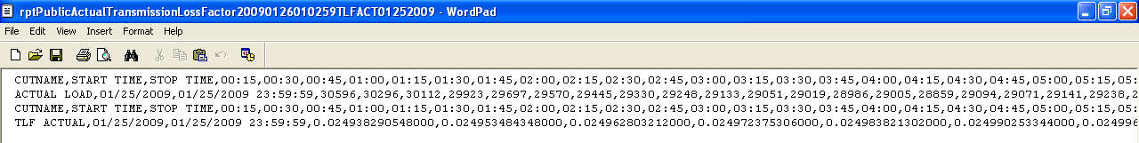

EXAMPLE 18 - Actual TLF CSV file as viewed by Excel:

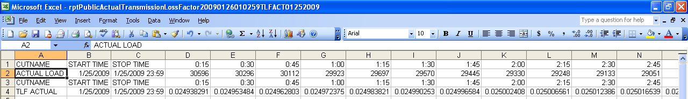

Forecast Transmission Loss Factor Calculation

Requirement ID
Source Mapping (Protocol/NERC/FERC and other binding documents Ref #)
Traceability to Sub-Process Maps | TBD
Description: Calculate Forecast Transmission Loss Factors

The following formulas shall be used to translate the monthly on-peak and off-peak TLFs into Settlement Interval forecast TLFs.

For all LFORERCOT values that are in calendar month (m):
FORTLOSSFACT_{i} = (MSC_{m} * LFORERCOT_{i}) + MIC_{m}
MSC_{m} = (MONLF_{m} – MOFFLF_{m})/(MONL_{m}-MOFFL_{m})
MIC_{m} = [(MOFFLF_{m}*MONL_{m})-(MONLF_{m}*MOFFL_{m})]/(MONL_{m}-MOFFL_{m})
Where:
m = calendar month,
i = 15 minute settlement interval in calendar month m,

FORTLOSSFACT_{m,i} = Transmission Loss factors for settlement interval (i) in month (m),
LFORERCOT_{i} = Forecast ERCOT System Load converted to MWh for 15 minute settlement interval (i)
MSC_{m} = Monthly Slope Coefficient for calendar month (m),
MIC_{m} = Monthly Intercept Coefficient for calendar month (m),
MONLF_{m} = Monthly on-peak percent loss factor for calendar month (m),
MOFFLF_{m} = Monthly off-peak percent loss factor for calendar month (m),
MONL_{m} = Monthly on-peak Load value for calendar month (m), and
MOFFL_{m} = Monthly off-peak Load value for calendar month (m).
Note: MONLF_{m} ,MOFFLF_{m} , MONL_{m} , and MOFFL_{m} are calculated by System Planning.

The above variables are defined below:

Input Bill Determinants
Variable | Unit | Definition | Source
MIC | None | Monthly Intercept Coefficient for calendar month (m), | System Planning
Interval Frequency: scalar

Additional Comments: MIC will be saved in the TRANSLOSSFTR table in Lodestar.
MSC | None | Monthly Slope Coefficient for calendar month m | System Planning
Interval Frequency: scalar

Additional Comments: MSM will be saved in the TRANSLOSSFTR table in Lodestar.
LFORERCOT | MW | Forecast ERCOT Load | Settlement System
Interval Frequency: 1 / hour

Additional Comments: LFORERCOT will be saved in the form of LFORERCOT (i.e., has no other attributes)

Output Bill Determinants
Variable | Unit | Definition | Destination
FORTLOSSFACT | none | Forecast Transmission Loss Factors | Settlement System
Interval Frequency: 4 / hour

Additional Comments: FORTLOSSFACT will be saved in the form of FORTLOSSFACT (no additional attributes).

Need to check if any paragraphs are justified formatted should be left formatted

Forecast Transmission Loss Factor Posting

ERCOT shall post to the MIS Public Area monthly TLFs 30 days prior to the start of the month. The posting will include monthly on-peak and off-peak cases for 18 months in the future. This report displays the forecast transmission loss factors for each Settlement Interval. The ERCOT forecast load (MW) is also displayed. It is posted in .CSV (comma-separated value) format.

Examples 19 and 20 below show a sample CSV file that was created on 1/26/09.

EXAMPLE 19 - Forecast TLF CSV file viewed as text:

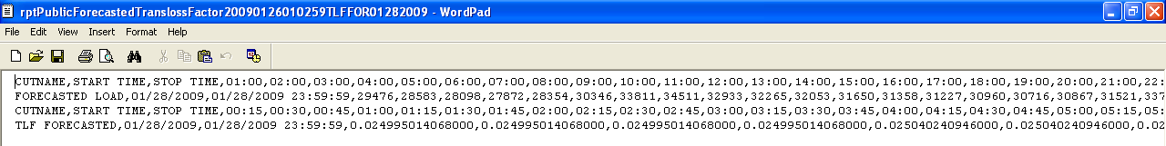

EXAMPLE 20 - Forecast TLF CSV file as viewed by Excel:

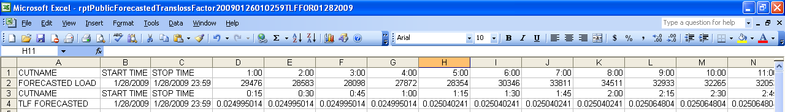

Calculation of Transmission Loss Adjusted Load Segments (LSEGTL)

A calculation is performed for each LSEGTL data cut in order to allocate transmission losses.

Requirement ID
Source Mapping (Protocol/NERC/FERC and other binding documents Ref #)
Traceability to Sub-Process Maps | TBD
Description: Calculate Transmission Loss Adjusted Load Segments (LSEGTL).

For LSEGTL data cuts, Transmission Loss Adjusted Load Segments (LSEGTL) are calculated as follows:
LSEGTL_{i} = LSEGTL _{i} x ( 1 / ( 1 – ACTLOSSFACT_{i}) )

Where:
i = 15 minute settlement interval
ACTLOSSFACT_{i} = Actual Transmission Loss Factor for 15-minute settlement interval (i)
LSEGTL_{i} = Transmission Loss Adjusted Load Segment for 15-minute settlement interval (i)
MARKET needs to decide if method field is included on LSEGDL, TL, UFE cuts

The above variables are defined below:

Input Bill Determinants (Input Bill Determinant and Output Bill Determinant are the same, need to fix)
Variable | Unit | Definition |  |  | Source
LSEGTL | MWh | Transmission Loss Adjusted Load Segment |  |  | Settlement System
Interval Frequency: 4 / hour

Additional Comments: LSEGTL will be saved in the form of LSEGTL_<LSE>_<QSE>_<Profile ID> <DLFC>_<UFE>_<LZ>_<TDSP>. What about the method field?
ACTLOSSFACT |  |  | ??? | Actual Transmission Loss Factor | Settlement System
Interval Frequency: 4 / hour

Additional Comments: ACTLOSSFACT will be saved in the form of ACTLOSSFACT (no additional attributes).

Output Bill Determinants
Variable | Unit | Definition | Destination
LSEGTL | MWh | Transmission Loss Adjusted Load Segment | Settlement System
Interval Frequency: 4 / hour

Additional Comments: LSEGTL will be saved in the form of LSEGTL_<LSE>_<QSE>_<Profile ID> <DLFC>_<UFE>_<LZ>_<TDSP>. What about the method field?

Calculation of UFE

UFE is the difference between the total ERCOT generation and the total ERCOT Load that has been adjusted for distribution losses and transmission losses during each Settlement Interval for each UFE Settlement Zone. Currently there is only one UFE Settlement Zone in ERCOT. UFE may be positive or negative in any Settlement Interval.

Requirement ID
Source Mapping (Protocol/NERC/FERC and other binding documents Ref #)
Traceability to Sub-Process Maps | TBD
Description: Calculate UFE.

For each UFE Settlement Zone z,

TOTUFE_{z,i} = GTOTUFE_{z,i} - LTOTUFE_{z,i}

Where:
z = UFE Settlement Zone
i = 15 minute settlement interval
GTOTUFE_{z,i} = Total Generation in UFE Settlement Zone z for 15-minute settlement interval i
LTOTUFE_{z,i} = Total Load Adjusted for Distribution and Transmission Losses in UFE Settlement Zone z for 15-minute settlement interval i
TOTUFE_{z,i} = Total UFE in UFE Settlement Zone z for 15-minute settlement interval i
MARKET needs to decide if method field is included on LSEGDL, TL, UFE cuts

The above variables are defined below:

Input Bill Determinants
Variable | Unit | Definition | Source
GTOTUFE | MWh | Total Generation in UFE Settlement Zone | Settlement System
Interval Frequency: 4 / hour

Additional Comments: GTOTUFE will be saved in the form of GTOTUFE_<UFE>
LTOTUFE | MWh | Total Load Adjusted for Distribution and Transmission Losses in UFE Settlement Zone | Settlement System
Interval Frequency: 4 / hour

Additional Comments: LTOTUFE will be saved in the form of LTOTUFE_<UFE>.

Output Bill Determinants
Variable | Unit | Definition | Destination
TOTUFE | MWh | Total UFE in UFE Settlement Zone | Settlement System
Interval Frequency: 4 / hour

Additional Comments: TOTUFE will be saved in the form of TOTUFE_<UFE>

Allocation of UFE

Transmission Loss adjusted load cuts (LSEGTL) are aggregated by UFE Settlement Zone to determine the total load for each of the following categories:

- Transmission Voltage level IDR Non Opt-in Entities,
- Transmission Voltage level IDR Premises,
- Distribution Voltage level IDR Premises, and
- Distribution Voltage level Profiled Premises.

Total Load for Transmission Voltage level IDR Non Opt-in Entities

Requirement ID
Source Mapping (Protocol/NERC/FERC and other binding documents Ref #)
Traceability to Sub-Process Maps | TBD
Description: Total Load for Transmission Voltage level IDR Non Opt-in Entities

Transmission Voltage level IDR Non-Opt in Entities

LSEGTL data cuts that belong to the Transmission Voltage level IDR Non-Opt in Entity group must have:
- TDSP Code belonging to a NOIE and
- Profile ID Meter Type of IDR and
- Distribution Loss Factor Code of T.

For each UFE Settlement Zone (z), for every LSEGTL with a NOIE TDSP Code, Profile ID Meter Type of IDR, and a Distribution Loss Factor Code of T:
LTNOIETL_{z,i} = 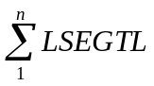TDSP = NOIE, Profile ID Meter Type = IDR, DLF Code = T,z,i
Seeing that there is currently only one UFE Settlement Zone in ERCOT, the above formula can be simplified to:
LTNOIETL_{i} = TDSP = NOIE, Profile ID Meter Type = IDR, DLF Code = T,i
Where:
n = total number of LSEGTL cuts with a NOIE TDSP code and a Profile ID Meter Type of IDR and a Distribution Loss Factor Code of T.
z = UFE Settlement Zone,
i = 15 minute settlement interval
LSEGTL_{i} = Transmission Loss Adjusted Load Segment for Settlement Interval (i)
LTNOIETL_{i} = Transmission Loss Adjusted Load Segment for Transmission Voltage level IDR Non-Opt in Entities for Settlement Interval (i)
MARKET needs to decide if method field is included on LSEGDL, TL, UFE cuts

The above variables are defined below:

Input Bill Determinants
Variable | Unit | Definition | Source
LSEGTL | MWh | Transmission Loss Adjusted Load Segment | Settlement System
Interval Frequency: 4 / hour

Additional Comments: LSEGTL will be saved in the form of LSEGTL_<LSE>_<QSE>_<Profile ID> <DLFC>_<UFE>_<LZ>_<TDSP>. What about the method field?

Output Bill Determinants
Variable | Unit | Definition | Destination
LTNOIETL | MWh | Transmission Loss Adjusted Load Segment for Transmission Voltage level IDR Non-Opt in Entities has an exemptions in the bill determinant Excel file??? | Settlement System
Interval Frequency: 4 / hour

Additional Comments: LTNOIETL will be saved in the form of LTNOIETL_<UFE>.

Total Load for Transmission Voltage Level IDR Premises

Requirement ID
Source Mapping (Protocol/NERC/FERC and other binding documents Ref #)
Traceability to Sub-Process Maps | TBD
Description: Total Load for Transmission Voltage level IDR Premises

Transmission Voltage level IDR Premises

LSEGTL data cuts that belong to the Transmission Voltage level IDR group must have:
- TDSP Code not belonging to a NOIE and
- Profile ID Meter Type of IDR and
- Distribution Loss Factor Code of T.

For each UFE Settlement Zone, for every LSEGTL with a TDSP Code that does not belong to a NOIE, Profile ID Meter Type of IDR, and a Distribution Loss Factor Code of T:
LTRANSTL_{z,i} = TDSP <> NOIE, Profile ID Meter Type = IDR, DLF Code = T,z,i
Seeing that there is currently only one UFE Settlement Zone in ERCOT, the above formula can be simplified to:
LTRANSTL_{i} = TDSP <> NOIE, Profile ID Meter Type = IDR, DLF Code = T,i
Where:
n = total number of LSEGTL cuts with a TDSP code that does not belong to a NOIE and a Profile ID Meter Type of IDR and a Distribution Loss Factor Code of T.
z = UFE Settlement Zone,
i = 15 minute settlement interval,
LSEGTL_{i} = Transmission Loss Adjusted Load Segment for Settlement Interval (i)
LTRANSTL_{i} = Transmission Loss Adjusted Load Segment for Transmission Voltage level IDR Premises for Settlement Interval (i)
MARKET needs to decide if method field is included on LSEGDL, TL, UFE cuts

The above variables are defined below:

Input Bill Determinants
Variable | Unit | Definition | Source
LSEGTL | MWh | Transmission Loss Adjusted Load Segment | Settlement System
Interval Frequency: 4 / hour

Additional Comments: LSEGTL will be saved in the form of LSEGTL_<LSE>_<QSE>_<Profile ID> <DLFC>_<UFE>_<LZ>_<TDSP>. What about the method field?

Output Bill Determinants
Variable | Unit | Definition | Destination
LTRANSTL | MWh | Transmission Loss Adjusted Load Segment for Transmission Voltage level IDR Premises has an exemptions in the bill determinant Excel file??? | Settlement System
Interval Frequency: 4 / hour

Additional Comments: LTRANSTL will be saved in the form of LTRANSTL_<UFE>.

Total Load for Distribution Voltage level IDR Premises

Requirement ID
Source Mapping (Protocol/NERC/FERC and other binding documents Ref #)
Traceability to Sub-Process Maps | TBD
Description: Total Load for Distribution Voltage level IDR Premises

Distribution Voltage level IDR Premises

LSEGTL data cuts that belong to the Distribution Voltage level IDR group must have:
- TDSP Code not belonging to a NOIE and
- Profile ID Meter Type of IDR and
- Distribution Loss Factor Code <> T (A,B,C,D,E).

For each UFE Settlement Zone, for every LSEGTL with a TDSP Code that does not belong to a NOIE (Need to state why), Profile ID Meter Type of IDR, and a Distribution Loss Factor Code <> T:
LIDRTL_{z,i} = TDSP <> NOIE, Profile ID Meter Type = IDR, DLF Code <> T,z,i
Seeing that there is currently only one UFE Settlement Zone in ERCOT, the above formula can be simplified to:
LIDRTL_{i} = TDSP <> NOIE, Profile ID Meter Type = IDR, DLF Code <> T,i
Where:
n = total number of LSEGTL cuts with a TDSP code that does not belong to a NOIE and a Profile ID Meter Type of IDR and a Distribution Loss Factor Code <> T.
z = UFE Settlement Zone,
i = 15 minute settlement interval
LSEGTL_{i} = Transmission Loss Adjusted Load Segment for Settlement Interval (i)
LIDRTL_{i} = Transmission Loss Adjusted Load Segment for Distribution Voltage level IDR Premises for Settlement Interval (i)
MARKET needs to decide if method field is included on LSEGDL, TL, UFE cuts

The above variables are defined below:

Input Bill Determinants
Variable | Unit | Definition | Source
LSEGTL | MWh | Transmission Loss Adjusted Load Segment | Settlement System
Interval Frequency: 4 / hour

Additional Comments: LSEGTL will be saved in the form of LSEGTL_<LSE>_<QSE>_<PI> <DLFC>_<UFE>_<LZ>_<TDSP>. What about the method field?

Output Bill Determinants
Variable | Unit | Definition | Destination
LIDRTL | MWh | Transmission Loss Adjusted Load Segment for Distribution Voltage level IDR Premises has an exemptions in the bill determinant Excel file??? | Settlement System
Interval Frequency: 4 / hour

Additional Comments: LIDRTL will be saved in the form of LIDRTL_<UFE>.

Total Load for Distribution Voltage level Profiled Premises

Requirement ID
Source Mapping (Protocol/NERC/FERC and other binding documents Ref #)
Traceability to Sub-Process Maps | TBD
Description: Total Load for Distribution Voltage level Profiled Premises

Distribution Voltage level Profiled Premises

LSEGTL data cuts that belong to the Distribution Voltage level Profiled group must have:
- TDSP Code not belonging to a NOIE and
- Profile ID Meter Type of NIDR

For each UFE Settlement Zone, for every LSEGTL with a TDSP Code that does not belong to a NOIE and Profile ID Meter Type of NIDR:
LNIDRTL_{z,i} = TDSP <> NOIE, Profile ID Meter Type =NIDR, z,i
Seeing that there is currently only one UFE Settlement Zone in ERCOT, the above formula can be simplified to:
LNIDRTL_{i} = TDSP <> NOIE, Profile ID Meter Type =NIDR,i
Where:
n = total number of LSEGTL cuts with a TDSP code that does not belong to a NOIE and a Profile ID Meter Type of NIDR,
z = UFE Settlement Zone,
i = 15 minute settlement interval
LSEGTL_{i} = Transmission Loss Adjusted Load Segment for Settlement Interval (i)
LNIDRTL_{i} = Transmission Loss Adjusted Load Segment for Distribution Voltage level NIDR Profiled Premises for Settlement Interval i
MARKET needs to decide if method field is included on LSEGDL, TL, UFE cuts

The above variables are defined below:

Input Bill Determinants
Variable | Unit | Definition | Source
LSEGTL | MWh | Transmission Loss Adjusted Load Segment | Settlement System
Interval Frequency: 4 / hour

Additional Comments: LSEGTL will be saved in the form of LSEGTL_<LSE>_<QSE>_<Profile ID> <DLFC>_<UFE>_<LZ>_<TDSP>. What about the method field?

Output Bill Determinants
Variable | Unit | Definition | Destination
LNIDRTL | MWh | Transmission Loss Adjusted Load Segment for Distribution Voltage level Profiled Premises has an exemptions in the bill determinant Excel file??? | Settlement System
Interval Frequency: 4 / hour

Additional Comments: LNIDRTL will be saved in the form of LNIDRTL_<UFE>.

Determine Adjusted Load per UFE Category

ERCOT will allocate UFE to the following categories based upon adjusted Load Ratio Share:

- Transmission Voltage level IDR Non Opt-in Entities (LTNOIETL),
- Transmission Voltage level IDR Premises (LTRANSTL),
- Distribution Voltage level IDR Premises (LIDRTL), and
- Distribution Voltage level Profiled Premises (LNIDRTL).

The adjusted Load Ratio Share will be determined using the following UFE category weighting factors:
(a) 0.0 - Transmission voltage level IDR Non-Opt-In Entities (NOIEs);
This factor is called TNOIE_UFE_ALLOC_FACTOR.
This factor is applied to LTNOIETL.

(b) 0.10 - Transmission voltage level IDR Premises;
This factor is called T_UFE_ALLOC_FACTOR.
This factor is applied to LTRANSTL.

(c) 0.50 - Distribution voltage level IDR Premises; (Exemptions?)
This factor is called IDR_UFE_ALLOC_FACTOR.
This factor is applied to LIDRTL.

(d) 1.00 - Distribution voltage level profiled Premises. (Exemptions?)
This factor is called NIDR_UFE_ALLOC_FACTOR.
This factor is applied to LNIDRTL.

Requirement ID
Source Mapping (Protocol/NERC/FERC and other binding documents Ref #) | 11.4.6.2 Allocation of Unaccounted For Energy
Traceability to Sub-Process Maps | TBD
Description: Determine Adjusted Load per UFE Category

For each UFE Settlement Zone, for each Premise category and for each Settlement interval, the adjusted Load per UFE category is calculated as follows:
LUFEALLOC _{iz} = NIDR_UFE_ALLOC_FACTOR * LNIDRTL_{iz} + IDR_UFE_ALLOC_FACTOR * LIDRTL_{iz} + T_UFE_ALLOC_FACTOR * LTRANSTL_{iz} + TNOIE_UFE_ALLOC_FACTOR * LTNOIETL_{iz}
Substituting in the actual factors for each UFE category:
LUFEALLOC _{iz} = (1..00) * LNIDRTL_{iz} + (0.50) * LIDRTL_{iz} + (0.10) * LTRANSTL_{iz} + (0.00) * LTNOIETL_{iz}
Because there is currently only one UFE Settlement Zone in ERCOT, the above formula can be simplified to:
LUFEALLOC_{i} = (1.00) * LNIDRTL_{i} + (0.50) * LIDRTL_{i} + (0.10) * LTRANSTL_{i} + (0.00) * LTNOIETL_{i}
Where:
z = UFE Settlement Zone,
i = 15 minute settlement interval
NIDR_UFE_ALLOC_FACTOR = UFE Category weighting factor for Distribution voltage level profiled Premises. Current value is 1.00.
IDR_UFE_ALLOC_FACTOR = UFE Category weighting factor for Distribution voltage level IDR Premises. Current value is 0.50.
T_UFE_ALLOC_FACTOR = UFE Category weighting factor for Transmission voltage level IDR Premises. Current value is 0.10.
TNOIE_UFE_ALLOC_FACTOR = UFE Category weighting factor for Transmission voltage level IDR Non-Opt-In Entities (NOIEs). Current value is 0.00.
LNIDRTL_{iz} = Transmission Loss Adjusted Load Segment for Distribution Voltage level NIDR Profiled Premises for Settlement Interval (i) and UFE Settlement Zone (z).
LIDRTL_{i} = Transmission Loss Adjusted Load Segment for Distribution Voltage level IDR Premises for Settlement Interval (i) and UFE Settlement Zone (z).
LTRANSTL_{i} = Transmission Loss Adjusted Load Segment for Transmission Voltage level IDR Premises for Settlement Interval (i) and UFE Settlement Zone (z).
LTNOIETL_{i} = Transmission Loss Adjusted Load Segment for Transmission Voltage level IDR Non-Opt in Entities for Settlement Interval (i) and UFE Settlement Zone (z).
LUFEALLOC_{iz} = Adjusted total UFE allocation reference Load for Settlement Interval (i) and Settlement UFE zone (z).

MARKET needs to decide if method field is included on LSEGDL, TL, UFE cuts

The above variables are defined below:

Input Bill Determinants
Variable | Unit | Definition |  |  | Source
LNIDRTL | MWh | Transmission Loss Adjusted Load Segment for Distribution Voltage level Profiled Premises has an exemptions in the bill determinant Excel file??? |  |  | Settlement System
Interval Frequency: 4 / hour

Additional Comments: LNIDRTL will be saved in the form of LNIDRTL_<UFE>.
LIDRTL | MWh | Transmission Loss Adjusted Load Segment for Distribution Voltage level IDR Premises has an exemptions in the bill determinant Excel file??? |  |  | Settlement System
Interval Frequency: 4 / hour

Additional Comments: LIDRTL will be saved in the form of LIDRTL_<UFE>.
LTRANSTL | MWh | Transmission Loss Adjusted Load Segment for Transmission Voltage level IDR Premises has an exemptions in the bill determinant Excel file??? |  |  | Settlement System
Interval Frequency: 4 / hour

Additional Comments: LTRANSTL will be saved in the form of LTRANSTL_<UFE>.
LTNOIETL | MWh | Transmission Loss Adjusted Load Segment for Transmission Voltage level IDR Non-Opt in Entities has an exemptions in the bill determinant Excel file??? |  |  | Settlement System
Interval Frequency: 4 / hour

Additional Comments: LTNOIETL will be saved in the form of LTNOIETL_<UFE>.
Variable |  |  | Unit | Definition | Source
NIDR_UFE_ALLOC_FACTOR |  |  | None | UFE Category weighting factor for Distribution voltage level profiled Premises. Current value is 1.00. | Settlement System
Interval Frequency: scalar

Additional Comments: will be saved in the Factor Value table in Lodestar
IDR_UFE_ALLOC_FACTOR |  |  | None | UFE Category weighting factor for Distribution voltage level IDR Premises. Current value is 0.50. | Settlement System
Interval Frequency: scalar

Additional Comments: will be saved in the Factor Value table in Lodestar.
T_UFE_ALLOC_FACTOR |  |  | None | UFE Category weighting factor for Transmission voltage level IDR Premises. Current value is 0.10. | Settlement System
Interval Frequency: scalar

Additional Comments: will be saved in the Factor Value table in Lodestar.
TNOIE_UFE_ALLOC_FACTOR |  |  | None | UFE Category weighting factor for Transmission voltage level IDR Non-Opt-In Entities (NOIEs). Current value is 0.00. | Settlement System
Interval Frequency: scalar

Additional Comments: will be saved in the Factor Value table in Lodestar.

Output Bill Determinants
Variable | Unit | Definition | Destination
LUFEALLOC | MWh | Adjusted total UFE allocation reference Load. has an exemptions in the bill determinant Excel file??? | Settlement System
Interval Frequency: 4 / hour

Additional Comments: LUFEALLOC is not saved.

Unaccounted For Energy Allocation to Unaccounted For Energy Categories:

Requirement ID
Source Mapping (Protocol/NERC/FERC and other binding documents Ref #) | 11.4.6.3 Unaccounted For Energy Allocation to Unaccounted For Energy Categories
Traceability to Sub-Process Maps | TBD
Description: UFE Allocation to UFE Categories

For each Premise category and for each Settlement interval, the UFE allocated to each UFE category is calculated as follows:
UFENIDR_{iz} = TOTUFE_{iz} * [(NIDR_UFE_ALLOC_FACTOR * LNIDRTL_{iz} )/ LUFEALLOC_{iz}]
UFEIDR_{iz} = TOTUFE_{iz} * [(IDR_UFE_ALLOC_FACTOR * LIDRTL_{iz} )/ LUFEALLOC_{iz}]
UFETRANS_{iz} = TOTUFE_{iz} * [(T_UFE_ALLOC_FACTOR * LTRANSTL_{iz} )/ LUFEALLOC_{iz}]
UFETNOIE_{iz} = TOTUFE_{iz} * [(TNOIE_UFE_ALLOC_FACTOR * LTNOIETL_{iz} )/ LUFEALLOC_{iz}]
Seeing that there is currently only one UFE Settlement Zone in ERCOT, the above formulas can be simplified to:
UFENIDR_{i} = TOTUFE_{i} * [(NIDR_UFE_ALLOC_FACTOR * LNIDRTL_{i} )/ LUFEALLOC_{i}]
UFEIDR_{i} = TOTUFE_{i} * [(IDR_UFE_ALLOC_FACTOR * LIDRTL_{i} )/ LUFEALLOC_{i}]
UFETRANS_{i} = TOTUFE_{i} * [(T_UFE_ALLOC_FACTOR * LTRANSTL_{i} )/ LUFEALLOC_{i}]
UFETNOIE_{i} = TOTUFE_{i} * [(TNOIE_UFE_ALLOC_FACTOR * LTNOIETL_{i} )/ LUFEALLOC_{i}]
Where:
z = UFE Settlement Zone,
i = 15 minute settlement interval
NIDR_UFE_ALLOC_FACTOR = UFE Category weighting factor for Distribution voltage level profiled Premises. Current value is 1.00.
IDR_UFE_ALLOC_FACTOR = UFE Category weighting factor for Distribution voltage level IDR Premises. Current value is 0.50.
T_UFE_ALLOC_FACTOR = UFE Category weighting factor for Transmission voltage level IDR Premises. Current value is 0.10.
TNOIE_UFE_ALLOC_FACTOR = UFE Category weighting factor for Transmission voltage level IDR Non-Opt-In Entities (NOIEs). Current value is 0.00.
LNIDRTL_{iz} = Transmission Loss Adjusted Load Segment for Distribution Voltage level NIDR Profiled Premises for Settlement Interval (i) and UFE Settlement Zone (z).
LIDRTL_{i} = Transmission Loss Adjusted Load Segment for Distribution Voltage level IDR Premises for Settlement Interval (i) and UFE Settlement Zone (z).
LTRANSTL_{i} = Transmission Loss Adjusted Load Segment for Transmission Voltage level IDR Premises for Settlement Interval (i) and UFE Settlement Zone (z).
LTNOIETL_{i} = Transmission Loss Adjusted Load Segment for Transmission Voltage level IDR Non-Opt in Entities for Settlement Interval (i) and UFE Settlement Zone (z).
LUFEALLOC_{iz} = Adjusted total UFE allocation reference Load for Settlement Interval (i) and Settlement UFE zone (z).
TOTUFE_{iz} = Total UFE for Settlement Interval (i) and Settlement UFE zone (z).
UFENIDR_{iz} = UFE allocated to Distribution Voltage level NIDR Profiled Premises for Settlement Interval (i) and UFE Settlement Zone (z).
UFEIDR_{iz} = UFE allocated to Distribution Voltage level IDR Premises for Settlement Interval (i) and UFE Settlement Zone (z).
UFETRANS_{iz} = UFE allocated to Transmission Voltage level IDR Premises for Settlement Interval (i) and UFE Settlement Zone (z).
UFETNOIE_{iz} = UFE allocated to Transmission Voltage level IDR Non-Opt in Entities for Settlement Interval (i) and UFE Settlement Zone (z).

MARKET needs to decide if method field is included on LSEGDL, TL, UFE cuts

The above variables are defined below:

Input Bill Determinants
Variable | Unit | Definition |  |  | Source
LNIDRTL | MWh | Transmission Loss Adjusted Load Segment for Distribution Voltage level Profiled Premises has an exemptions in the bill determinant Excel file??? |  |  | Settlement System
Interval Frequency: 4 / hour

Additional Comments: LNIDRTL will be saved in the form of LNIDRTL_<UFE>.
LIDRTL | MWh | Transmission Loss Adjusted Load Segment for Distribution Voltage level IDR Premises has an exemptions in the bill determinant Excel file??? |  |  | Settlement System
Interval Frequency: 4 / hour

Additional Comments: LIDRTL will be saved in the form of LIDRTL_<UFE>.
LTRANSTL | MWh | Transmission Loss Adjusted Load Segment for Transmission Voltage level IDR Premises has an exemptions in the bill determinant Excel file??? |  |  | Settlement System
Interval Frequency: 4 / hour

Additional Comments: LTRANSTL will be saved in the form of LTRANSTL_<UFE>.
LTNOIETL | MWh | Transmission Loss Adjusted Load Segment for Transmission Voltage level IDR Non-Opt in Entities has an exemptions in the bill determinant Excel file??? |  |  | Settlement System
Interval Frequency: 4 / hour …..

Additional Comments: LTNOIETL will be saved in the form of LTNOIETL_<UFE>.
Variable |  |  | Unit | Definition | Source
NIDR_UFE_ALLOC_FACTOR |  |  | None | UFE Category weighting factor for Distribution voltage level profiled Premises. Current value is 1.00. | Settlement System
Interval Frequency: scalar

Additional Comments: will be saved in the Factor Value table in Lodestar
IDR_UFE_ALLOC_FACTOR |  |  | None | UFE Category weighting factor for Distribution voltage level IDR Premises. Current value is 0.50. | Settlement System
Interval Frequency: scalar

Additional Comments: will be saved in the Factor Value table in Lodestar.
T_UFE_ALLOC_FACTOR |  |  | None | UFE Category weighting factor for Transmission voltage level IDR Premises. Current value is 0.10. | Settlement System
Interval Frequency: scalar

Additional Comments: will be saved in the Factor Value table in Lodestar.
TNOIE_UFE_ALLOC_FACTOR |  |  | None | UFE Category weighting factor for Transmission voltage level IDR Non-Opt-In Entities (NOIEs). Current value is 0.00. | Settlement System
Interval Frequency: scalar

Additional Comments: will be saved in the Factor Value table in Lodestar.
LUFEALLOC |  |  | MWh | Adjusted total UFE allocation reference Load per Settlement Interval per Settlement UFE zone. has an exemptions in the bill determinant Excel file??? | Settlement System
Interval Frequency: 4 / hour

Additional Comments: LUFEALLOC is not saved.
TOTUFE |  |  | MWh | Total UFE. | Settlement System
Interval Frequency: 4 / hour

Additional Comments: TOTUFE will be saved in the form of TOTUFE_<UFE>.

Output Bill Determinants
Variable | Unit | Definition | Source
UFENIDR | MWh | UFE allocated to Distribution Voltage level NIDR Profiled Premises. | Settlement System
Interval Frequency: 4 / hour

Additional Comments: UFENIDR will be saved in the form of UFENIDR_<UFE>.
UFEIDR | MWh | UFE allocated to Distribution Voltage level IDR Premises. | Settlement System
Interval Frequency: 4 / hour

Additional Comments: UFEIDR will be saved in the form of UFEIDR_<UFE>.
UFETRANS | MWh | UFE allocated to Transmission Voltage level IDR Premises. | Settlement System
Interval Frequency: 4 / hour

Additional Comments: UFETRANS will be saved in the form of UFETRANS_<UFE>.
UFETNOIE | MWh | UFE allocated to Transmission Voltage level IDR Non-Opt in Entities. | Settlement System
Interval Frequency: 4 / hour

Additional Comments: UFETNOIE is not saved because all Settlement Interval values are 0.

Unaccounted For Energy (LUFE) within Unaccounted For Energy Categories:
UFE load cuts (LUFE) are calculated from LSEGTL data cuts which have been grouped into the following categories:

- Transmission Voltage level IDR Non Opt-in Entities,
- Transmission Voltage level IDR Premises,
- Distribution Voltage level IDR Premises, and
- Distribution Voltage level Profiled Premises.

Load Ratio Shares for each LSEGTL are also calculated within each category.

Unaccounted For Energy Allocation for Transmission Voltage level IDR Non Opt-in Entities

Requirement ID
Source Mapping (Protocol/NERC/FERC and other binding documents Ref #)
Traceability to Sub-Process Maps | TBD
Description: Create LUFE cuts for Transmission Voltage level IDR Non Opt-in Entities

Transmission Voltage level IDR Non-Opt in Entities

LSEGTL data cuts that belong to the Transmission Voltage level IDR Non-Opt in Entity group must have:
- TDSP Code belonging to a NOIE and
- Profile ID Meter Type of IDR and
- Distribution Loss Factor Code of T.

For each UFE Settlement Zone, for every LSEGTL with a NOIE TDSP Code, Profile ID Meter Type of IDR, and a Distribution Loss Factor Code of T:
LRSUFEALLOC_{z,i} = LSEGTL TDSP = NOIE, Profile ID Meter Type = IDR, DLF Code = T,z,i / LTNOIETL_{i}
LUFE_{i} = LRSUFEALLOC_{i} x UFETNOIE_{i}

Seeing that there is currently only one UFE Settlement Zone in ERCOT, the above formulas can be simplified to:
LRSUFEALLOC_{i} = LSEGTL TDSP = NOIE, Profile ID Meter Type = IDR, DLF Code = T,i / LTNOIETL_{i}
LUFE_{i} = LRSUFEALLOC_{i} x UFETNOIE_{i}

Where:
i = 15 minute settlement interval
z = UFE Settlement Zone,
LSEGTL_{i} = Transmission Loss Adjusted Load Segment for Settlement Interval i
LTNOIETL_{i} = Transmission Loss Adjusted Load Segment for Transmission Voltage level IDR Non-Opt in Entities for Settlement Interval i
LRSUFEALLOC_{i} = UFE allocation Load Ratio Share for LSEGTL cut for Settlement Interval i.
UFETNOIE_{i} = UFE allocated to Transmission Voltage level IDR Non-Opt in Entities for Settlement Interval i..
LUFE_{i} = UFE for Settlement Interval i
MARKET needs to decide if method field is included on LSEGDL, TL, UFE cuts

The above variables are defined below:

Input Bill Determinants
Variable | Unit | Definition | Source
LSEGTL | MWh | Transmission Loss Adjusted Load Segment | Settlement System
Interval Frequency: 4 / hour

Additional Comments: LSEGTL will be saved in the form of LSEGTL_<LSE>_<QSE>_<Profile ID> <DLFC>_<UFE>_<LZ>_<TDSP>. What about the method field?
LTNOIETL | MWh | Transmission Loss Adjusted Load Segment for Transmission Voltage level IDR Non-Opt in Entities has an exemptions in the bill determinant Excel file??? | Settlement System
Interval Frequency: 4 / hour

Additional Comments: LTNOIETL will be saved in the form of LTNOIETL_<UFE>.
UFETNOIE | MWh | UFE allocated to Transmission Voltage level IDR Non-Opt in Entities. | Settlement System
Interval Frequency: 4 / hour

Additional Comments: UFETNOIE is not saved because all Settlement Interval values are 0.

Intermediate Bill Determinants
Variable | Unit | Definition | Destination
LRSUFEALLOC | None | UFE allocation Load Ratio Share | Settlement System
Interval Frequency: 4 / hour

Additional Comments: LRSUFEALLOC is not saved.

Output Bill Determinants
Variable | Unit | Definition | Destination
LUFE | MWh | UFE Load Segment | Settlement System
Interval Frequency: 4 / hour

Additional Comments: LUFE will be saved in the form of LSEGUFE_<LSE>_<QSE>_<Profile ID> <DLFC>_<UFE>_<LZ>_<TDSP>. What about the method field?

Unaccounted For Energy Allocation for Transmission Voltage level IDR Premises

Requirement ID
Source Mapping (Protocol/NERC/FERC and other binding documents Ref #)
Traceability to Sub-Process Maps | TBD
Description: Create LUFE cuts for Transmission Voltage level IDR Premises

Transmission Voltage level IDR Premises

LSEGTL data cuts that belong to the Transmission Voltage level IDR group must have:
- TDSP Code not belonging to a NOIE and
- Profile ID Meter Type of IDR and
- Distribution Loss Factor Code of T.

For each UFE Settlement Zone, For every LSEGTL with a TDSP Code that does not belong to a NOIE, Profile ID Meter Type of IDR, and a Distribution Loss Factor Code of T:

LRSUFEALLOC_{z,i} = LSEGTL TDSP <> NOIE, Profile ID Meter Type = IDR, DLF Code = T,z,i / LTRANSTL_{i}
LUFE_{i} = LRSUFEALLOC_{i} x UFETRANS_{i}

Seeing that there is currently only one UFE Settlement Zone in ERCOT, the above formulas can be simplified to:
LRSUFEALLOC_{i} = LSEGTL TDSP <> NOIE, Profile ID Meter Type = IDR, DLF Code = T,i / LTRANSTL_{i}
LUFE_{i} = LRSUFEALLOC_{i} x (UFETRANS_{i}

Where:
i = 15 minute settlement interval,
z = UFE Settlement Zone,
LSEGTL_{i} = Transmission Loss Adjusted Load Segment for Settlement Interval (i)
LTRANSTL_{i} = Transmission Loss Adjusted Load Segment for Transmission Voltage level IDR Premises for Settlement Interval (i)
LRSUFEALLOC_{i}= UFE allocation Load Ratio Share for LSEGTL cut for Settlement Interval (i).
UFETRANS_{i} = UFE allocated to Transmission Voltage level IDR Premises for Settlement Interval (i),
LUFE_{i} = UFE for Settlement Interval (i)
MARKET needs to decide if method field is included on LSEGDL, TL, UFE cuts

The above variables are defined below:

Input Bill Determinants
Variable | Unit | Definition | Source
LSEGTL | MWh | Transmission Loss Adjusted Load Segment | Settlement System
Interval Frequency: 4 / hour

Additional Comments: LSEGTL will be saved in the form of LSEGTL_<LSE>_<QSE>_<Profile ID> <DLFC>_<UFE>_<LZ>_<TDSP>. What about the method field?
LTRANSTL | MWh | Transmission Loss Adjusted Load Segment for Transmission Voltage level IDR Premises has an exemptions in the bill determinant Excel file??? | Settlement System
Interval Frequency: 4 / hour

Additional Comments: LTRANSTL will be saved in the form of LTRANSTL_<UFE>.
UFETRANS | MWh | UFE allocated to Transmission Voltage level IDR Premises. | Settlement System
Interval Frequency: 4 / hour

Additional Comments: UFETRANS will be saved in the form of UFETRANS_<UFE>.

Intermediate Bill Determinants
Variable | Unit | Definition | Destination
LRSUFEALLOC | None | UFE allocation Load Ratio Share | Settlement System
Interval Frequency: 4 / hour

Additional Comments: LRSUFEALLOC has the form of LRSUFEALLOC_<LSE>_<QSE>_<Profile ID> <DLFC>_<UFE>_<LZ>_<TDSP>. What about the method field?LRSUFEALLOC is not saved.

Output Bill Determinants
Variable | Unit | Definition | Destination
LUFE | MWh | UFE Load Segment | Settlement System
Interval Frequency: 4 / hour

Additional Comments: LUFE will be saved in the form of LSEGUFE_<LSE>_<QSE>_<Profile ID> <DLFC>_<UFE>_<LZ>_<TDSP>. What about the method field?

Unaccounted For Energy Allocation for Distribution Voltage level IDR Premises

Requirement ID
Source Mapping (Protocol/NERC/FERC and other binding documents Ref #)
Traceability to Sub-Process Maps | TBD
Description: Create LUFE cuts for Distribution Voltage level IDR Premises

Distribution Voltage level IDR Premises

LSEGTL data cuts that belong to the Distribution Voltage level IDR group must have:
- TDSP Code not belonging to a NOIE and
- Profile ID Meter Type of IDR and
- Distribution Loss Factor Code of <> T (A,B,C,D,E).

For each UFE Settlement Zone, For every LSEGTL with a TDSP Code that does not belong to a NOIE, Profile ID Meter Type of IDR, and a Distribution Loss Factor Code <> T:

LRSUFEALLOC_{z,i} = LSEGTL TDSP <> NOIE, Profile ID Meter Type = IDR, DLF Code <> T,z,i / LIDRTL_{i}
LUFE_{i} = LRSUFEALLOC_{i} x UFEIDR_{i}

Seeing that there is currently only one UFE Settlement Zone in ERCOT, the above formulas can be simplified to:
LRSUFEALLOC_{i} = LSEGTL TDSP <> NOIE, Profile ID Meter Type = IDR, DLF Code <> T,i / LIDRTL_{i}
LUFE_{i} = LRSUFEALLOC_{i} x UFEIDR_{i}

Where:
i = 15 minute settlement interval,
z = UFE Settlement Zone,
LSEGTL_{i} = Transmission Loss Adjusted Load Segment for Settlement Interval (i)
LIDRTL_{i} = Transmission Loss Adjusted Load Segment for Distribution Voltage level IDR Premises for Settlement Interval (i)
LRSUFEALLOC_{i} = UFE allocation Load Ratio Share for LSEGTL cut for Settlement Interval (i).
UFEIDR_{i} = UFE allocated to Distribution Voltage level IDR Premises for Settlement Interval (i),
LUFE_{i} = UFE for Settlement Interval (i)
MARKET needs to decide if method field is included on LSEGDL, TL, UFE cuts

The above variables are defined below:

Input Bill Determinants
Variable | Unit | Definition | Source
LSEGTL | MWh | Transmission Loss Adjusted Load Segment | Settlement System
Interval Frequency: 4 / hour

Additional Comments: LSEGTL will be saved in the form of LSEGTL_<LSE>_<QSE>_<Profile ID> <DLFC>_<UFE>_<LZ>_<TDSP>. What about the method field?
LIDRTL | MWh | Transmission Loss Adjusted Load Segment for Distribution Voltage level IDR Premises has an exemptions in the bill determinant Excel file??? | Settlement System
Interval Frequency: 4 / hour

Additional Comments: LIDRTL will be saved in the form of LIDRTL_<UFE>.
UFEIDR | MWh | UFE allocated to Distribution Voltage level IDR Premises. | Settlement System
Interval Frequency: 4 / hour

Additional Comments: UFEIDR will be saved in the form of UFEIDR_<UFE>.

Intermediate Bill Determinants
Variable | Unit | Definition | Destination
LRSUFEALLOC | None | UFE allocation Load Ratio Share | Settlement System
Interval Frequency: 4 / hour

Additional Comments: LRSUFEALLOC has the form of LRSUFEALLOC_<LSE>_<QSE>_<Profile ID> <DLFC>_<UFE>_<LZ>_<TDSP>. What about the method field?LRSUFEALLOC is not saved.

Output Bill Determinants
Variable | Unit | Definition | Destination
LUFE | MWh | UFE Load Segment | Settlement System
Interval Frequency: 4 / hour

Additional Comments: LUFE will be saved in the form of LSEGUFE_<LSE>_<QSE>_<Profile ID> <DLFC>_<UFE>_<LZ>_<TDSP>. What about the method field?

Unaccounted For Energy Allocation for Distribution Voltage level Profiled Premises

Requirement ID
Source Mapping (Protocol/NERC/FERC and other binding documents Ref #)
Traceability to Sub-Process Maps | TBD
Description: Create LUFE cuts for Distribution Voltage level Profiled Premises

Distribution Voltage level Profiled Premises

LSEGTL data cuts that belong to the Distribution Voltage level Profiled group must have:
- TDSP Code not belonging to a NOIE and
- Profile ID Meter Type of NIDR

For each UFE Settlement Zone, For every LSEGTL with a TDSP Code that does not belong to a NOIE and Profile ID Meter Type of NIDR:

LRSUFEALLOC_{z,i} = LSEGTL TDSP <> NOIE, Profile ID Meter Type = NIDR,z,i / LNIDRTL_{i}
LUFE_{i} = LRSUFEALLOC_{i} x UFENIDR_{i}

Seeing that there is currently only one UFE Settlement Zone in ERCOT, the above formulas can be simplified to:
LRSUFEALLOC_{i} = LSEGTL TDSP <> NOIE, Profile ID Meter Type = NIDR,i / LNIDRTL_{i}
LSEGUFE_{i} = LRSUFEALLOC_{i} x UFENIDR_{i}

Where:
i = 15 minute settlement interval,
z = UFE Settlement Zone,
LSEGTL_{i} = Transmission Loss Adjusted Load Segment for Settlement Interval i
LNIDRTL_{i} = Transmission Loss Adjusted Load Segment for Distribution Voltage level NIDR Profiled Premises for Settlement Interval i
LRSUFEALLOC_{z,i} = UFE allocation Load Ratio Share for LSEGTL cut for Settlement Interval (i).
UFENIDR_{iz} = UFE allocated to Distribution Voltage level NIDR Profiled Premises for Settlement Interval (i),
LUFE_{i} = UFE for Settlement Interval (i)
MARKET needs to decide if method field is included on LSEGDL, TL, UFE cuts

The above variables are defined below:

Input Bill Determinants
Variable | Unit | Definition | Source
LSEGTL | MWh | Transmission Loss Adjusted Load Segment | Settlement System
Interval Frequency: 4 / hour

Additional Comments: LSEGTL will be saved in the form of LSEGTL_<LSE>_<QSE>_<Profile ID> <DLFC>_<UFE>_<LZ>_<TDSP>. What about the method field?
LNIDRTL | MWh | Transmission Loss Adjusted Load Segment for Distribution Voltage level Profiled Premises has an exemptions in the bill determinant Excel file??? | Settlement System
Interval Frequency: 4 / hour

Additional Comments: LNIDRTL will be saved in the form of LNIDRTL_<UFE>.
UFENIDR | MWh | UFE allocated to Distribution Voltage level NIDR Profiled Premises. | Settlement System
Interval Frequency: 4 / hour

Additional Comments: UFENIDR will be saved in the form of UFENIDR_<UFE>.

Intermediate Bill Determinants
Variable | Unit | Definition | Destination
LRSUFEALLOC | None | UFE allocation Load Ratio Share | Settlement System
Interval Frequency: 4 / hour

Additional Comments: LRSUFEALLOC has the form of LRSUFEALLOC_<LSE>_<QSE>_<Profile ID> <DLFC>_<UFE>_<LZ>_<TDSP>. What about the method field?LRSUFEALLOC is not saved.

Output Bill Determinants
Variable | Unit | Definition | Destination
LUFE | MWh | UFE Load Segment | Settlement System
Interval Frequency: 4 / hour

Additional Comments: LUFE will be saved in the form of LSEGUFE_<LSE>_<QSE>_<Profile ID> <DLFC>_<UFE>_<LZ>_<TDSP>. What about the method field?

Creating Distribution, Transmission, and UFE Adjusted Load Cuts (LSEGUFE)

Requirement ID
Source Mapping (Protocol/NERC/FERC and other binding documents Ref #)
Traceability to Sub-Process Maps | TBD
Description: Create LSEGUFE cuts

LSEGUFE data cuts are created by retrieving all LSEGTL data cuts and all LUFE data cuts.
For each LSEGTL cut with corresponding REP (r), QSE (q), Profile ID (p), Distribution Loss Factor Code (d), UFE Settlement Zone (u), Load Zone (l), TDSP (t), and Method (m), add the LUFE cut with the exact same attributes (i.e., REP (r), QSE (q), Profile ID (p), Distribution Loss Factor Code (d), UFE Settlement Zone (u), Load Zone (l), TDSP (t), and Method (m)).

LSEGUFE_{r,q,p,d,u,l,t,m,i} = LUFE_{r,q,p,d,u,l,t,m,i} + LSEGTL_{r,q,p,d,u,l,t,m,i}

Where:
i = 15 minute settlement interval
r = REP
q = QSE
p = Profile ID
d = Distribution Loss Factor Code
u = UFE Settlement Zone
l = Load Zone
t = TDSP
m = Method
LSEGTL_{i} = Transmission Loss Adjusted Load Segment for Settlement Interval (i)
LUFE_{i} = UFE for Settlement Interval (i),
LSEGUFE_{i} = UFE Loss Adjusted Load Segment for Settlement Interval (i)
MARKET needs to decide if method field is included on LSEGDL, TL, UFE cuts

The above variables are defined below:

Input Bill Determinants
Variable | Unit | Definition | Source
LUFE | MWh | UFE Load Segment | Settlement System
Interval Frequency: 4 / hour

Additional Comments: LUFE will be saved in the form of LSEGUFE_<LSE>_<QSE>_<Profile ID> <DLFC>_<UFE>_<LZ>_<TDSP>. What about the method field?
LSEGTL | MWh | Transmission Loss Adjusted Load Segment | Settlement System
Interval Frequency: 4 / hour

Additional Comments: LSEGTL will be saved in the form of LSEGTL_<LSE>_<QSE>_<Profile ID> <DLFC>_<UFE>_<LZ>_<TDSP>. What about the method field?

Output Bill Determinants
Variable | Unit | Definition | Destination
LSEGUFE | MWh | UFE Loss Adjusted Load Segment | Settlement System
Interval Frequency: 4 / hour

Additional Comments: LSEGUFE will be saved in the form of LSEGUFE_<LSE>_<QSE>_<Profile ID> <DLFC>_<UFE>_<LZ>_<TDSP>. What about the method field?

ALL LSEGUFE CUTS HAVE BEEN CREATED AS OF HERE … REST OF DOCUMENT SHOULD BE DESCRIBING ADDITIONAL BILL DETERMINANTS WHICH SHOULD JUST BE A SUMMATION OF THE ABOVE

Also missing IDR section, NOIE section, DCTIE section

Data Agg Bill Determinant Calculations

ERCOT-Wide Load Cuts

ERCOT Total UFE Loss Adjusted Load for IDR Premises (LIDRTOT)

Requirement ID
Source Mapping (Protocol/NERC/FERC and other binding documents Ref #)
Traceability to Sub-Process Maps | TBD
Description: Create LIDRTOT cuts for IDR Premises

LSEGUFE data cuts that belong to the IDR Premises group must have a Profile ID Meter Type of IDR.

For every LSEGUFE with a Profile ID Meter Type of IDR:
LIDRTOT_{i} = 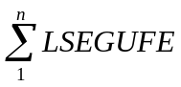 _{Profile ID Meter Type =IDR,i}
Where:
n = total number of LSEGUFE cuts with a Profile ID Meter Type of IDR,
i = 15 minute settlement interval,
LSEGUFE_{i} = UFE Loss Adjusted Load Segment for Settlement Interval (i)
LIDRTOT_{i} = ERCOT Total UFE Loss Adjusted Load Segment for IDR Premises for Settlement Interval (i)

The above variables are defined below:

Input Bill Determinants
Variable | Unit | Definition | Source
LSEGUFE | MWh | UFE Loss Adjusted Load Segment | Settlement System
Interval Frequency: 4 / hour

Additional Comments: LSEGUFE will be saved in the form of LSEGUFE_<LSE>_<QSE>_<PI> <DLFC>_<UFE>_<LZ>_<TDSP>. What about the method field?

Output Bill Determinants
Variable | Unit | Definition | Destination
LIDRTOT | MWh | ERCOT Total UFE Loss Adjusted Load Segment for IDR Premises | Settlement System
Interval Frequency: 4 / hour

Additional Comments: LIDRTOT will be saved in the form of LIDRTOT_<UFE>.

ERCOT Total UFE Loss Adjusted Load for NIDR Premises (LNIDRTOT)

Requirement ID
Source Mapping (Protocol/NERC/FERC and other binding documents Ref #)
Traceability to Sub-Process Maps | TBD
Description: Create LNIDRTOT cuts for NIDR Premises

LSEGUFE data cuts that belong to the NIDR Premises group must have a Profile ID Meter Type of NIDR.

For every LSEGUFE with a Profile ID Meter Type of NIDR:
LNIDRTOT_{i} = _{Profile ID Meter Type =NIDR,i}
Where:
n = total number of LSEGUFE cuts with a Profile ID Meter Type of NIDR,
i = 15 minute settlement interval,
LSEGUFE_{i} = UFE Loss Adjusted Load Segment for Settlement Interval (i)
LNIDRTOT_{i} = ERCOT Total UFE Loss Adjusted Load Segment for NIDR Premises for Settlement Interval (i)

The above variables are defined below:

Input Bill Determinants
Variable | Unit | Definition | Source
LSEGUFE | MWh | UFE Loss Adjusted Load Segment | Settlement System
Interval Frequency: 4 / hour

Additional Comments: LSEGUFE will be saved in the form of LSEGUFE_<LSE>_<QSE>_<PI> <DLFC>_<UFE>_<LZ>_<TDSP>. What about the method field?

Output Bill Determinants
Variable | Unit | Definition | Destination
LNIDRTOT | MWh | ERCOT Total UFE Loss Adjusted Load Segment for NIDR Premises | Settlement System
Interval Frequency: 4 / hour

Additional Comments: LNIDRTOT will be saved in the form of LNIDRTOT_<UFE>.

ERCOT Total Competitive UFE Loss Adjusted Load (LERCOTCOMPETITIVE)

Requirement ID
Source Mapping (Protocol/NERC/FERC and other binding documents Ref #)
Traceability to Sub-Process Maps | TBD
Description: Create LERCOTCOMPETITIVE

For every LSEGUFE that is associated with a REP:
LERCOTCOMPETITIVE_{i} = _{LSE=REP,i}
Where:
n = total number of LSEGUFE cuts associate with a REP,
i = 15 minute settlement interval,
LSEGUFE_{i} = UFE Loss Adjusted Load Segment for Settlement Interval i
LERCOTCOMPETITIVE_{i} = ERCOT Total Competitive UFE Loss Adjusted Load for Settlement Interval (i)

The above variables are defined below:

Input Bill Determinants
Variable | Unit | Definition | Source
LSEGUFE | MWh | UFE Loss Adjusted Load Segment | Settlement System
Interval Frequency: 4 / hour

Additional Comments: LSEGUFE will be saved in the form of LSEGUFE_<LSE>_<QSE>_<PI> <DLFC>_<UFE>_<LZ>_<TDSP>. What about the method field?

Output Bill Determinants
Variable | Unit | Definition | Destination
LERCOTCOMPETITIVE | MWh | ERCOT Total Competitive UFE Loss Adjusted Load | Settlement System
Interval Frequency: 4 / hour

Additional Comments: LERCOTCOMPETITIVE will be saved in the form of LERCOTCOMPETITIVE.

ERCOT Total Distribution Loss Adjusted Load (LERCOTDL)

Requirement ID
Source Mapping (Protocol/NERC/FERC and other binding documents Ref #)
Traceability to Sub-Process Maps | TBD
Description: Create LERCOTDL

Total all LSEGDL cuts:
LERCOTDL_{i} = 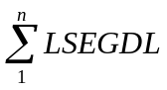
Where:
n = total number of LSEGDL cuts,
i = 15 minute settlement interval,
LSEGDL_{i} = Distribution Loss Adjusted Load Segment for 15 minute settlement interval (i),
LERCOTDL_{i} = ERCOT Total Distribution Loss Adjusted Load for Settlement Interval (i)

The above variables are defined below:

Input Bill Determinants
Variable | Unit | Definition | Source
LSEGDL | MWh | Distribution Loss Adjusted Load Segment | Settlement System
Interval Frequency: 4 / hour

Additional Comments: LSEGDL will be saved in the form of LSEGDL_<LSE>_<QSE>_<PI> <DLFC>_<UFE>_<LZ>_<TDSP>_<MET>.

Output Bill Determinants
Variable | Unit | Definition | Destination
LERCOTDL | MWh | ERCOT Total Distribution Loss Adjusted Load | Settlement System
Interval Frequency: 4 / hour

Additional Comments: LERCOTDL will be saved in the form of LERCOTDL_<UFE>.

ERCOT Total Unadjusted Load (LERCOTUNADJ)

Requirement ID
Source Mapping (Protocol/NERC/FERC and other binding documents Ref #)
Traceability to Sub-Process Maps | TBD
Description: Create LERCOTUNADJ

Total all LSEGDL cuts:
LERCOTUNADJ_{i} = 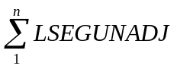
Where:
n = total number of LSEGUNADJ cuts,
i = 15 minute settlement interval,
LSEGUNADJ_{i} = Base Load Segment for 15 minute settlement interval (i), (I like base better than LLS)
LERCOTUNADJ_{i} = ERCOT Total Unadjusted Load for Settlement Interval (i)

The above variables are defined below:

Input Bill Determinants
Variable | Unit | Definition | Source
LSEGUNADJ | MWh | Lowest Level Load Segment or base load segment??? | Settlement System
Interval Frequency: 4 / hour

Additional Comments: LSEGUNADJ will be saved in the form of LSEGUNADJ_<LSE>_<QSE>_<PI> <DLFC>_<UFE>_<LZ>_<TDSP>_<MET>.

Output Bill Determinants
Variable | Unit | Definition | Destination
LERCOTUNADJ | MWh | ERCOT Total Unadjusted Load | Settlement System
Interval Frequency: 4 / hour

Additional Comments: LERCOTUNADJ will be saved in the form of LERCOTUNADJ_<UFE>.

ERCOT Total UFE Loss Adjusted Load by Profile Type (LPROFTYPE)

Requirement ID
Source Mapping (Protocol/NERC/FERC and other binding documents Ref #)
Traceability to Sub-Process Maps | TBD
Description: Create LPROFTYPE

Group all LSEGUFE data cuts by Profile Type. Sum all of the LSEGUFE data cuts for each Profile Type.

For each Profile Type (p), sum all LSEGUFE data cuts:
LPROFTYPE_{p,i} = _{for all n that belong to p}
Where:
p = Profile Type,
n = total number of LSEGUFE cuts for Profile Type p,
i = 15 minute settlement interval,
LSEGUFE_{i} = UFE Loss Adjusted Load Segment for Settlement Interval i,
LPROFTYPE_{p,i} = ERCOT Total UFE Loss Adjusted Load for Profile Type p for Settlement Interval i

The above variables are defined below:

Input Bill Determinants
Variable | Unit | Definition | Source
LSEGUFE | MWh | UFE Loss Adjusted Load Segment | Settlement System
Interval Frequency: 4 / hour

Additional Comments: LSEGUFE will be saved in the form of LSEGUFE_<LSE>_<QSE>_<Profile ID> <DLFC>_<UFE>_<LZ>_<TDSP>. What about the method field?

Output Bill Determinants
Variable | Unit | Definition | Destination
LPROFTYPE | MWh | ERCOT Total UFE Loss Adjusted Load for Profile Type | Settlement System
Interval Frequency: 4 / hour

Additional Comments: LPROFTYPE will be saved in the form of LPROFTYPE_<PROFILE TYPE>.

