PRR Number | 830 | PRR Title | Reactive Power Capability Requirement
Date |  | October 22, 2009
Submitter’s Information
Name |  | Todd Kimbrough
E-mail Address |  | todd.kimbrough@fpl.com
Company |  | NextEra Energy Resources
Phone Number |  | 512.466.3190
Cell Number |  | 512.466.3190
Market Segment |  | Independent Generator

Comments

NextEra Energy Resources respectfully submits these comments regarding PRR 830 and recommends the PRS reject the PRR and instead recommend approval of PRR 835, which addresses the same subject matter in a superior manner.

In the alternative, NextEra recommends PRS table PRR 830 and, as described below, refer certain issues to the appropriate stakeholder groups for resolution.

PRR 830 mandates wasteful spending and harms consumers.

The “one-size-fits-all” approach inherent in the PRR is not an efficient approach to ensuring sufficient reactive power capability exists to meet system needs. The PRR 830 approach has many deficiencies, including:

- PRR 830 adds costs to generation projects in some instances where the benefits are minimal or non-existent. These additional costs are ultimately borne by consumers through market prices.
- PRR 830 can actually create costly reliability problems during periods when generators are operating in low load conditions. These problems will require additional expensive measures by TSPs, causing consumers to unnecessarily suffer higher transmission costs – effectively paying a second time to mitigate the problems caused equipment they paid for in the first place due to the PRR 830 requirement. Moreover, this approach fails to consider how such problems will be greatly exacerbated in West Texas by the coming CREZ buildout.

- PRR 830 not only fails to consider actual system needs but also ignores deliverability issues. Reactive power is a geographically sensitive product. Adding reactive power capability near West Texas wind farms does nothing to address the reactive power needs of far away load centers like Dallas or Houston.

PRR 830 ignores existing unused reactive power capability on the system.

Although arguments have been presented that a universal requirement to provide the “rectangle” is desirable to ensure that ERCOT has an abundance of reactive power capability at its disposal, PRR 830 actually leaves a tremenduos amount of existing reactive capability untapped by all the generation units currently on the system which provide more than the rectangle, as illustrated in the “D curve” example below.

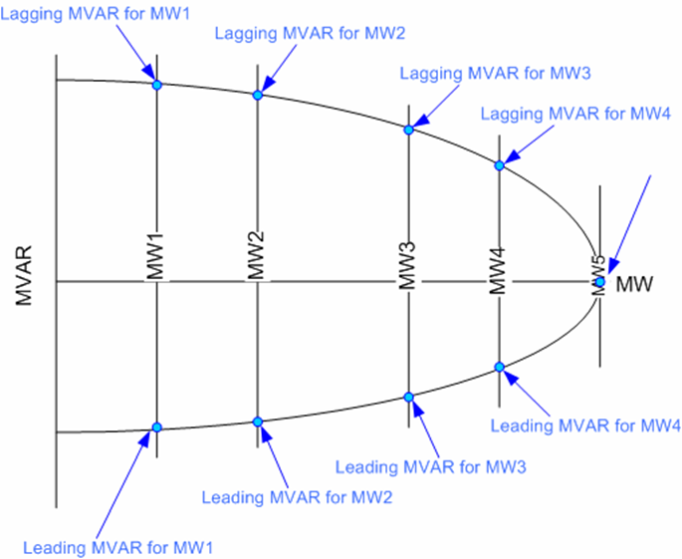

If the PRR instead required all generators to simply make available whatever level of reactive power capability is inherently provided by their units, ERCOT would get an immediate increase in available reactive capability across the system without a penny of additional cost passed to consumers.

PRR 830 is antithetical to a long-held philosophy of the ERCOT market rules and directly contradicts precedent set by the ERCOT Board of Directors.

Although arguments have been presented that ERCOT reactive capability requirements have been crystal clear to all market participants since the dawn of time, NextEra observes that the number of litigants in PUCT Docket No. 36482 and the very fact ERCOT felt moved to “clarify” the requirements indicates otherwise. Since the appropriate interpretation of this section of the Protocols is under active dispute, it is inappropriate for ERCOT and/or any stakeholders to circumvent the processes now underway to resolve legacy issues. What the stakeholders can and should do is provide a clear and unambiguous standard effective from the effective date of PRR 830 going forward to draw a line in the sand which ensures future capacity installations meet the requirements necessary for system security in an efficient manner.

Moreover, PRR 830 makes exactly the same mistake which caused the ERCOT Board of Directors to overrule the recommendation of TAC, ROS, and ERCOT Staff regarding OGRR 208. In that instance, Staff and stakeholders recommended universal application of a voltage ride-through standard which would have forced a number of generators to perform extensive retrofitting of existing units. The recommendation was based on a sense that more capability would be better for the system but there was no study or evidence to support the contention that the benefit would meet or exceed the costs. The Board noted the complete lack of rational basis for the recommendation. Moreover, the Board recognized the danger of sending a signal to investors and developers that no pro forma was safe from arbitrary action ex post facto action and that all investment decisions in ERCOT should be made with the understanding that future financial and capital risk could be boundless.

The Board, therefore, made a reasonable policy decision that retroactive application of technical standards can be applied only when a body of evidence indicates such application is required to maintain system reliability. The Board amended OGRR 208 such that the new VRT standard applied only to units installed after the effective date of the rule change and directed ERCOT to perform a study to determine which specific existing units, if any, should be required to perform retrofits. NextEra recommends stakeholders amend PRR 830 in a similar manner before presenting a recommendation to the Board for approval because evidence has yet to be presented that the tens of millions of dollars required for retrofits to comply with PRR 830 will yield commensurate system reliability benefits.

PRR 830 fails to resolve ambiguity.

NextEra appreciates the effort put forth by ERCOT to clarify Section 6.5.7.1 but believes further work is need to resolve the ambiguity of existing Protocols language. In particular, the phrase, “established by ERCOT,” in the first sentence of 6.5.7.1(1) should be more granularly defined or should refer to procedures set forth in the Operating Guide so that project developers and generation owners understand how and when ERCOT shall establish the Voltage Profile to be maintained. Is the profile to be established during the interconnection process? Can the profile requirement be changed one or more times at one or more points in the future? If it is changed, how much time does the generation owner have to effectuate the change? What are the criteria or standards by which ERCOT will establish the profile?

PRR 830 creates unintended consequences.

Whether the triangle, the rectangle, the D curve, or some combination of the three become the new standard for reactive power capability in ERCOT on a prospective and/or retroactive basis, NextEra agrees with Wind Coalition comments that ERCOT’s proposed revision to the definition of Wind-powered Generation Resource (WGR) in Section 2 creates more problems than it solves. Although NextEra understands the convenience such a definition would achieve for ERCOT modeling purposes related to the reactive power capability issue, the ripple effect throughout the Protocols of defining WGRs as consisting of only a single turbine type would cause numerous problems for interconnection, metering, settlement, reporting, and compliance.

Furthermore, such a definition change would effectively stifle innovation and investment in technologies which are coming to the fore and which could provide effective solutions to some of the greatest challenges of variable generation technologies – namely the co-siting of solar generation facilities at wind farms or the integration of energy storage solutions at or behind the point of interconnection. ERCOT’s proposed change would also effectively prohibit repowering a wind facility with new (and more technically capable) wind turbines unless the entire site were repowered at once or separate interconnections were established.

ERCOT’s reactive power modeling issues can be addressed by other means, such as provision through SCADA of real time updates to Pmax, Qmax, and Qmin. NextEra provides redline language below to address this issue. Interestingly, NextEra notes that the same issue presents itself every time a CCGT unit reconfigures its gas and steam turbine combinations but ERCOT does not seem concerned with capturing those variances in reactive capability. NextEra urges ERCOT and stakeholders to spend more time on PRR 830 to comprehensively address the reactive power capability issues and provide unobtrusive, effective, and efficient solutions across all technology types.

PRR 830 should be remanded to ROS with instructions

While NextEra does not disagree with the stakeholders’ decision to grant ERCOT’s request for Urgent status, it is abundantly clear that PRR 830 is insufficiently vetted to move forward at this time. NextEra recommends the PRR be remanded to ROS for further deliberation with special emphasis on the following tasks:

- Provide a study or body of evidence which indicates the sufficiency or insufficiency of the existing reactive power capability available to ERCOT and, if possible, provide some indication of likely reactive power capability needs for a reasonable range of scenarios in the future. If such a study or evidence is not available or cannot be completed in a reasonable timeframe, provide an estimated timeline to develop and complete such a study, a reasonable estimate of the cost of such a study, and a brief statement of the ROS as to why such a study would or would not be a good use of ERCOT and stakeholder resources.

- Identify the best practice for ERCOT to model the reactive power capability of generators which use multiple turbine technologies or configurations behind the point of interconnection.

- Determine how much existing generation unit reactive power capability is currently unavailable to ERCOT. Determine why it is unavailable. Assess how that unavailable capability compares to the capability which would be made available by retrofitting units currently providing the triangle rather than the rectangle.

- As currently drafted, PRR 830 distinguishes between WGRs and all other forms of generation. Assess how the reactive power capability requirements of PRR 830 affect solar generation technologies, other non-wind forms of renewable generation, or other emerging technologies such as energy storage devices.

- Describe the process by which ERCOT establishes a voltage profile in accordance with Section 6.5.7.1(1). Reference the documents or procedures which currently guide this practice. Provide a recommendation to clarify this process in PRR 830.

NextEra further suggests PRS may wish to consider asking the QMWG to respond to Question No. 2 and the RTWG to respond to Question No. 4 to ensure the appropriate subject matter experts are engaged in this important discussion.

Revised Proposed Protocol Language
See PRR 835 as filed by NextEra for alternative proposed Protocols language.

