ERCOT Operations Report
September 2009 ROS & OWG

Frequency Control
Time | Freq(Hz) | Duration (s)
9/5/2009 14:38 | 59.89400101 | 6 | Unit trip with 385 MW
9/13/2009 12:20 | 60.10100174 | 4 | Generation Schedules changed after offset was entered.
9/16/2009 20:12 | 59.87099838 | 10 | Unit trip with 635 MW
9/25/2009 11:18 | 59.84000015 | 40 | Unit trip with 530 MW
9/26/2009 18:43 | 59.84799957 | 8 | Unit trip with 565 MW
9/29/2009 0:38 | 59.88999939 | 6 | East DC Tie trip, loss of 480 MW net import into ERCOT.
9/30/2009 14:35 | 59.88800049 | 112 | Unit trip with 580 MW
Note: Time of frequency excursions outside the range of +/- 0.1 Hz.

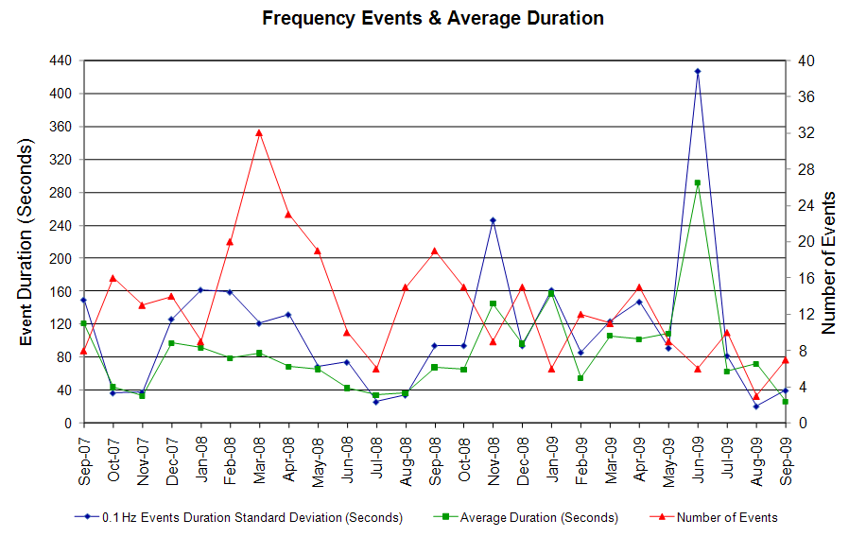
Deployed Responsive (Reported Above)
Time deployed | Stop Time | Duration | Max | Details
9/2 06:38:00 | 9/2 06:46:00 | 0:08:00 | 354.00 | Offset calculation error
9/3 18:02:32 | 9/3 18:32:56 | 0:30:24 | 332.64 | Unit trip
9/5 14:38:43 | 9/5 15:04:14 | 0:25:31 | 401.28
9/14 15:00:21 | 9/14 15:16:09 | 0:15:48 | 332.64 | Unit trip
9/14 15:50:26 | 9/14 16:02:10 | 0:11:44 | 332.64 | Out of up regulation
9/14 20:08:34 | 9/14 20:22:18 | 0:13:44 | 332.64 | Out of up regulation
9/16 13:03:35 | 9/16 13:20:56 | 0:17:21 | 353.77 | SCE change -920 MW in 9m. Out of up regulation at 13:00
9/16 20:12:46 | 9/16 20:27:12 | 0:14:26 | 586.08
9/21 11:04:49 | 9/21 11:20:15 | 0:15:26 | 348.49 | Out of up regulation
9/21 22:26:53 | 9/21 22:40:45 | 0:13:52 | 327.36 | Unit trip
9/25 11:18:09 | 9/25 11:44:01 | 0:25:52 | 686.41
9/26 18:43:09 | 9/26 19:02:21 | 0:19:12 | 644.17
9/27 09:06:07 | 9/27 09:30:09 | 0:24:02 | 337.94 | Out of up regulation
9/28 06:46:01 | 9/28 06:58:09 | 0:12:08 | 327.36 | Unit trip
9/28 11:06:13 | 9/28 11:24:25 | 0:18:12 | 343.21 | Out of up regulation
9/29 00:38:16 | 9/29 00:57:57 | 0:19:41 | 422.41
9/30 14:35:33 | 9/30 14:59:43 | 0:24:10 | 723.37

Day-Ahead OOMC and RPRS Capacity Purchases
Details | OOMC | RPRS S1 | RPRS S2 | RPRS S1+S2 | RMR | Total
Western | 0 | 7 | 28 | 35 | 4 | 39
DFW | 3 | 4 | 25 | 29 | 0 | 32
North | 0 | 12 | 18 | 30 | 0 | 30
Austin | 1 | 0 | 26 | 26 | 0 | 27
Houston | 0 | 3 | 7 | 10 | 0 | 10
San Antonio | 0 | 1 | 3 | 4 | 0 | 4
Laredo | 0 | 2 | 0 | 2 | 0 | 2
Northeast | 0 | 0 | 2 | 2 | 0 | 2
E RIO | 0 | 1 | 0 | 1 | 0 | 1
South | 0 | 1 | 0 | 1 | 0 | 1
Bryan Area | 0 | 0 | 0 | 0 | 0 | 0
Corpus | 0 | 0 | 0 | 0 | 0 | 0
W RIO | 0 | 0 | 0 | 0 | 0 | 0
Total | 4 | 31 | 109 | 140 | 4 | 148

Historical Totals | Sep-09 | Sep-08 | Aug-09
Austin | 1 | 9 | 14
Bryan Area | 0 | 0 | 0
Corpus | 0 | 8 | 0
DFW | 7 | 21 | 40
E RIO | 1 | 2 | 7
Houston | 3 | 14 | 9
Laredo | 2 | 8 | 0
North | 12 | 26 | 42
Northeast | 0 | 0 | 0
San Antonio | 1 | 0 | 5
South | 1 | 1 | 0
W RIO | 0 | 0 | 0
Western | 11 | 2 | 19
Total | 39 | 91 | 136

http://www.ercot.com/mktinfo/services/rprsdr/index.html
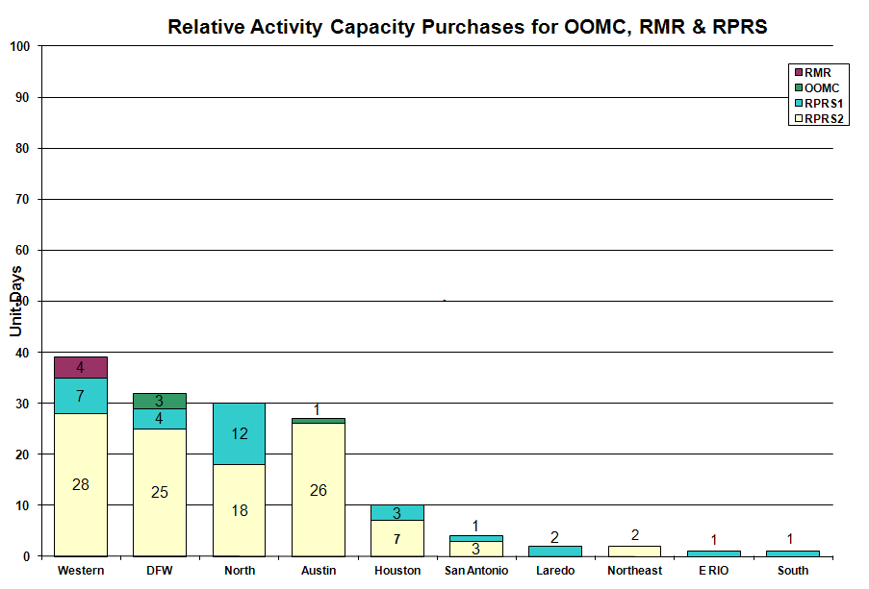

OOME and Congestion Management Activity
Congestion affected by outages Remedial action plan has been developed for the element
Contingency | Overloaded Element | Days
Dilley Switch - San Miguel Switch 138KV | Pearsall Switch - Derby Sub 69KV | 19
Austrop - Daffin & Decker 138KV | Austrop - Decker 138KV | 9
Oak Creek - Ballinger 138KV | Miles - Rowena 69KV | 8
Garfield - Onion Creek - Hicross AEN 138KV | Lytton Springs 345/138KV Autotransformer #2 | 4
Temple Pecan Creek - Tradinghouse SES & Temple Switch - Lake Creek SES 345KV | San Angelo Power Station - Shrew Tap | 4
Moss - Holt 138KV | Odessa North 138/69KV Auto | 3
Oak Creek - Ballinger 138KV | Abilene South - Ballinger 69KV | 3
Comanche Peak 1 and 2 345kV | Lake Whitney - Whitney TU 138KV | 2
DuPont Switch - Whitepoint 138KV | DuPont Switch Ingleside - Whitepoint 138KV | 2
Marion - Zorn - Clear Springs 345KV | Schertz - Parkway 138KV | 2
Tradinghouse SES - Venus Switch 345KV | Rogers Hill TU - Elm Mott 138KV | 2
Tradinghouse SES - Venus Switch 345KV | Bosque Switch - Rogers Hill 138KV | 2
Base Case Overload | Ena Snyder - MEC Plainview TAP 69KV | 2
Falfurrias - Crestonio 138KV | Freer - San Diego 69KV | 2
Garfield - Onion - Hicross 138KV | Lytton Springs - Pilot Knob 138KV | 2
Graham SES - Long Creek Switching Station 345KV | San Angelo Power Station - Shrew Tap 138KV | 2
Morgan Creek SES - Quail Switch and Longshore Switching Station 345KV | Midland East - Stanton East 138KV | 2
North Denton 138/69KV autotransformer #1 | North Denton 138/69KV autotransformer #2 | 2
San Angelo Red Creek - Comanche 345KV | San Angelo Concho - Veribest 69KV | 2
Tradinghouse SES - Venus 345KV | Lake Whitney - Whitney TNP 69KV | 2
Trinidad - Stryker Creek and Mount Enterprise 345KV | Stryker Creek - Stryker Cherokee POI 138KV | 2
Trinidad - Stryker Creek and Mount Enterprise 345KV | Lufkin Switch - Lufkin Chipper Mill 138KV | 2
Victoria - Victoria DuPont Switch 138KV | Formosa - Lolita 138KV | 2
Waxahachie - Ennis West 138KV | Trumbull Auto Transformer 1 138/69KV | 2
Ballinger - San Angelo Red Creek 138KV | Sonora - Friend Ranch 138KV | 1
Elm Creek - STP 345KV | Lockhart 138/69KV Auto | 1
Miller - Weatherford West 138KV | Bunker 138/69KV transformer | 1
Odessa EHV - Morgan Creek & Odessa EHV - Quail Switch 345KV | Big Spring - Big Spring West | 1
Tradinghouse SES - Venus Switch 345KV | Lake Whitney - Whitney TU 138KV | 1
West Levee Switch 345/138KV T1 | Industrial - Compton Street 138KV | 1
Austrop - Sandow & Sandow auto transformer #2 | Austrop - Sandow 345KV | 1
Austrop - Daffin and Decker 138KV | Pilot - Lytton 138KV | 1
Lobo - Laredo VFT North 138KV | Wormser Road - Santo Nino 138KV | 1
Lobo - Laredo VFT North 138KV | North Laredo - Wormser Road 138KV | 1
Roanoke Switch - West Denton and Lewisville Switch 345KV | West Denton - Teasley 138KV | 1
Abilene South - Eskota Switch 138KV | Trent - Scott REA Tap 69KV | 1
Abilene South - Eskota Switch138KV | Merkel - Trent 69KV | 1
Ballinger - San Angelo Red Creek 138KV | Sonora - Friend Ranch 138KV | 1
Big Brown SES - Jewett 345KV | Big Brown SES - Jewett 345KV | 1
Comanche Peak - Decordova & Wolf Hollow - Rock Creek 345KV | Comanche Peak - Johnson Switch 345KV | 1
Comanche Peak 1 and 2 345KV | Sandow - Temple Switch 345KV | 1
Elm Mott - Whitney TU 138KV | Bosque Switch - Lake Whitney 138KV | 1
Everman Switch - Sherry Switch 345KV | Everman Switch - Oak Hill 2 Tap 138KV | 1
Hillje - Homan 345KV | Columbus - Stafford Hill 69KV | 1
Ingleside DuPont Switch - Whitepoint 138KV | Rincon - Whitepoint 138KV | 1
Marion - Zorn - Clear 345KV | Seguin - Seguin West 138KV | 1
Morgan Creek SES - Quail Switch & Morgan Creek SES - Longshore Switching Station 345KV | Stanton Switch - Big Spring West 138KV | 1
North Denton Auto #1 | North Denton Auto #2 | 1
Sandow Switch - Temple Switch 345KV | Hearne AT1 transformer 138/69KV | 1
Skyline - Marion and Skyline - Elm Creek 345KV | Schertz - Parkway LCRA 138KV | 1
South Lane City - Lane City 138KV | West Colombia - Pledger 138KV | 1
South Texas Nuclear Project - Hillje & Whitepoint 345KV | Blessing - Lolita 138KV | 1
STP - Blessing 345KV | Columbus - Stafford Hill 69KV | 1
STP - Elm Creek 345KV | Blessing - Lolita 138KV | 1
STP - Elm Creek 345KV | Turner - Goforth 138KV | 1
STP - Elm Creek 345KV | Blessing - Palacios 69KV | 1
Turner - Goforth 138KV | Turnersville - Buda | 1
Twin Butte - San Angelo Red Creek 345KV | Twin Butte 345/138KV autotransformer | 1
Watermill - Tricorner and Trinidad 345KV | Seagoville - Kleberg Tap 138KV | 1

Zonal OC1
CSC | Days
North – Houston | 8
West – North | 5
North – South | 2
South – North | 1

New RAP, PCAP (Date indicates last update of RAP, PCAP not implementation date.)
None

New Procedures/Forms/Operations Bulletins
Date | Subject | Bulletin No.
09/03/2009 | Transmission and Security Desk V4 Rev 6 | 440
09/03/2009 | Shift Supervisor Desk V4 Rev 6 | 439
09/01/2009 | Desktop Reference Guide V1 Rev1 | 438
09/01/2009 | Shift Supervisor Desk V4 Rev 5 | 437
09/01/2009 | Frequency Control Desk V4 Rev 5 | 436
09/01/2009 | Day-Ahead Desk V4 Rev 5 | 435
09/01/2009 | Transmission and Security Desk V4 Rev 5 | 434

Blackout/Load Shed Incidences
None

EEA
None

Major System Voltage Problems
None

Major Computer Problems, Enhancements & Fixes
None

Communication
None

ERCOT peak (Unofficial)
09/03 17:00 55,210 MW

Yearly MTLF Error Comparison
Yearly Mid-Term (Hourly) Load Forecast Error Comparison for the ERCOT Forecast
Month | MAPE for MTLF at 16:00 Day-Ahead
Month | 2006 | 2007 | 2008 | 2009
January | 4.79 | 4.55 | 3.30 | 4.11
February | 4.81 | 3.75 | 3.59 | 3.49
March | 4.95 | 2.70 | 3.29 | 3.24
April | 5.59 | 3.00 | 2.45 | 2.66
May | 3.59 | 3.22 | 3.01 | 2.90
June | 2.65 | 4.46 | 2.81 | 2.89
July | 2.62 | 4.29 | 2.55 | 2.83
August | 2.09 | 3.11 | 3.66 | 3.07
September | 4.03 | 3.78 | 4.99 | 3.68
October | 3.63 | 3.08 | 2.79 | NA
November | 3.28 | 2.95 | 2.60 | NA
December | 3.44 | 3.74 | 4.54 | NA
Annual Average | 3.79 | 3.55 | 3.29 | 3.20

OCN, Advisory, Watch & Emergency Notices
Capacity
Date | Start | End | Event
9/2/09 | 4:00 | 15:00 | ERCOT issued a Watch for a projected reserve capacity shortage for HE16, HE17 and HE18.
9/2/09 | 10:30 | 15:00 | ERCOT issued a Watch for a projected reserve capacity shortage for HE16, 17 and 18.
9/2/09 | 16:30 | 20:35 | Advisory issued for ARRS below 3000 MW.
9/3/09 | 3:00 | 14:45 | ERCOT issued an OCN for a projected reserve capacity shortage for HE16, HE17 and HE18.
9/5/09 | 13:28 | 14:40 | Advisory issued for ARRS below 3000 MW.
9/5/09 | 14:40 | 18:00 | Watch issued for ARRS below 2500 MW.
9/6/09 | 9:11 | 11:10 | OCN issued for potential Capacity shortage for HE 16, 17 and 18.
9/6/09 | 11:10 | 17:15 | Watch issued for projected Capacity shortage for HE 16, 17 and 18.
9/7/09 | 13:38 | 16:08 | Advisory issued for ARRS below 3000 MW.
9/7/09 | 16:08 | 21:15 | Watch issued for ARRS below 2500 MW.
9/10/09 | 10:13 | 11:25 | Advisory issued for ARRS below 3000 MW.
9/15/09 | 3:00 | 15:15 | OCN issued for projected reserve capacity shortage for HE 1700.
9/15/09 | 20:05 | 21:00 | Advisory issued for ARRS below 3000 MW.
9/18/09 | 16:45 | 18:15 | Advisory issued for ARRS below 3000 MW.
9/19/09 | 13:15 | 18:30 | Advisory issued for ARRS below 3000 MW.
9/20/09 | 13:23 | 18:00 | Advisory issued for ARRS below 3000 MW.
9/21/09 | 3:25 | 18:15 | OCN issued for a projected reserve capacity shortage for HE 13:00 - 21:00.
9/21/09 | 9:50 | 18:15 | Advisory issued for ARRS below 3000 MW.
9/30/09 | 14:47 | 18:30 | Advisory issued for ARRS below 3000 MW.

Transmission Watch
None

Emergency Notice
09/01 13:30 Market Emergency Notice issued due to the procurement of the Ancillary Service Market for 9/2/09 did not meet the time requirement.

Texas RE Event Analysis
09/01 13:30 Market Emergency Notice issued due to the procurement of the Ancillary Service Market for 9/2/09 did not meet the time requirement.

09/14 14:38 Simultaneous loss of units, auto transformer and two 138 kV lines

Others
09/05 23:30 ERCOT held IE 00:15 Real-time Balancing deployments and resumed with IE 00:30.

09/28 23:00 ERCOT held IE 23:00 Real-time Balancing deployments and resumed with IE 23:30 due to incorrect offset calculation.

