Commercial Operations Market Guide
Section 8: Settlement Statements and Invoices
Month XX, 2009

8. Settlement Statements and Invoices 1
8.1 Congestion Revenue Rights (CRR) Settlement Statement and Invoice Examples 1
8.1.1 CRR Invoices 1
8.2 Day Ahead Market Statement/Invoice 4
8.2.1 DAM Statement/Invoice 6
8.2.2 DAM Late Fee Invoice 7
8.3 Real-Time Market Statements and Invoices 7
8.3.1 RTM Statements 8
8.3.2 RTM Invoices 13

Settlement Statements and Invoices
The Real-Time Market (RTM), Day–Ahead Market (DAM), and the Congestion Revenue Right (CRR)Auction are settled separately. There are three different settlement statements, three different invoices, and three different settlement timelines – Initial, Final and True-up.

The Settlements Calendar and Qualified Scheduling Entity (QSE) Settlement and CRR Account Holder Statements are available on the MIS. The Settlement Calendar is provided as an extract and can be found on both the MIS under Settlements Information (Public) and on the ERCOT Public Website. Supporting information for the Settlement Calendar (i.e. the Data Definition Language and Xtensible Markup Defintions) are also available on both the MIS and the ERCOT Public Website. When viewing QSE Settlement Statements, a negative amount represents a payment due to the QSE and a positive amount represents a payment due to ERCOT.

Details, including quantities and prices associated with Settlement Statements and Invoices are found in the appropriate extracts and reports. More information about the available extracts and reports is available on the MIS and on the ERCOT Public Website. Descriptions and definitions for the billing determinants can be found on the ERCOT website in the Settlement Charge Matrix and in the relevant Protocol sections.

Information about the Settlements Calendar, Statements, and Invoices may be found in Protocol Section 9, Settlement and Billing.

8.1 Congestion Revenue Rights (CRR) Settlement Statement and Invoice Examples

CRR Invoices
Refer to Protocol Section 9.8, CRR Auction Award Invoices, for details regarding CRR Auction Award Invoices.
CRR Statement/Invoice Timeline
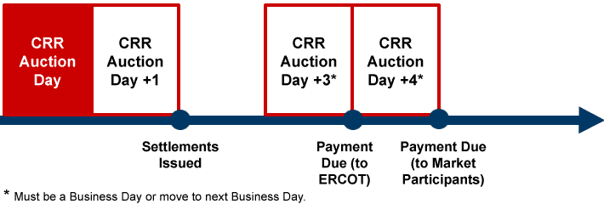

8.1.1.1 CRR Annual Auction Invoice
Monthly and Annual Invoices are issued as separate invoices, however the formatting is the same for each. The invoice will indicate whether it pertains to Monthly or Annual Auction.

8.1.1.2 CRR Monthly Auction Invoice
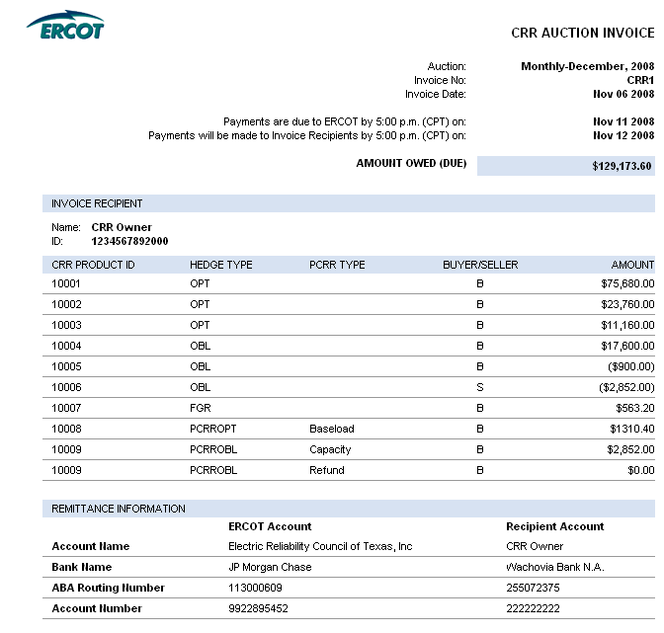
8.1.1.3 CRR Auction Revenue Distribution (CARD) Invoice
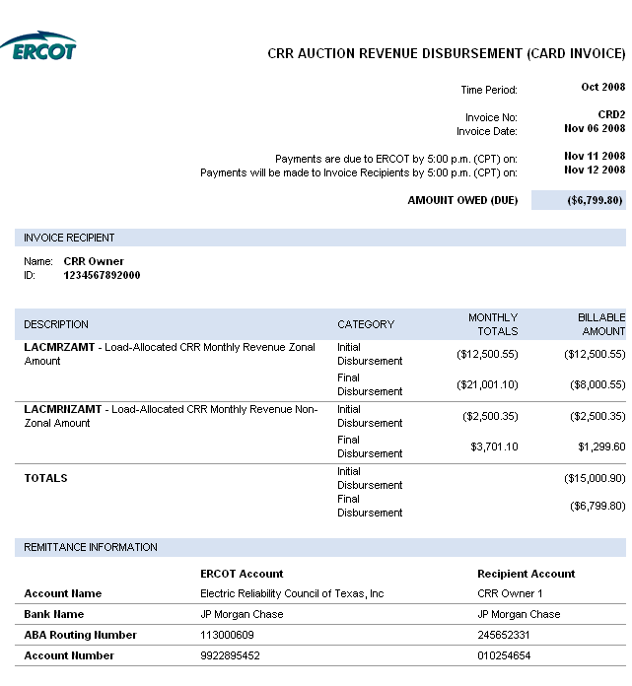

      - CRR Balancing Account Invoice
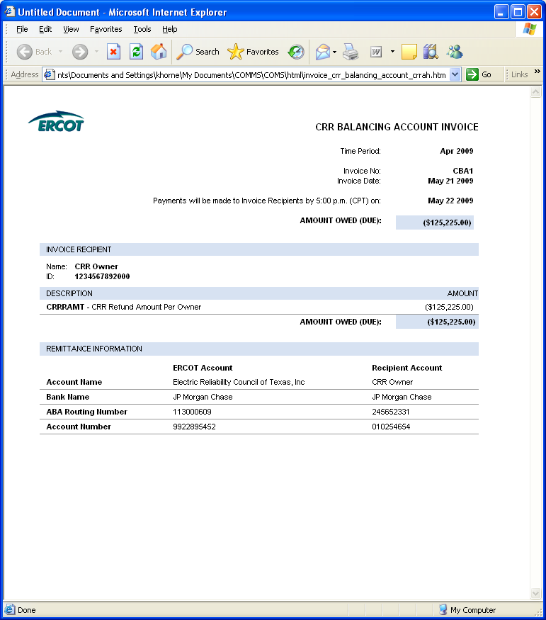

  - Day Ahead Market Statement/Invoice
The Day-Ahead Market (DAM) statements and invoices for CRR Account Holders and QSEs are issued two days after the operating day.
Refer to Protocol Section 9.2, Settlement Statements for the Day-Ahead Market, for details regarding DAM Settlement Statements.
Refer to Protocol Section 9.3, Settlement Invoices for the DAM, for details regarding DAM Settlement Invoices.

DAM Statement/Invoice Timeline
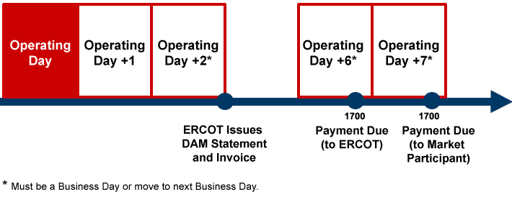

    - DAM Statement/Invoice
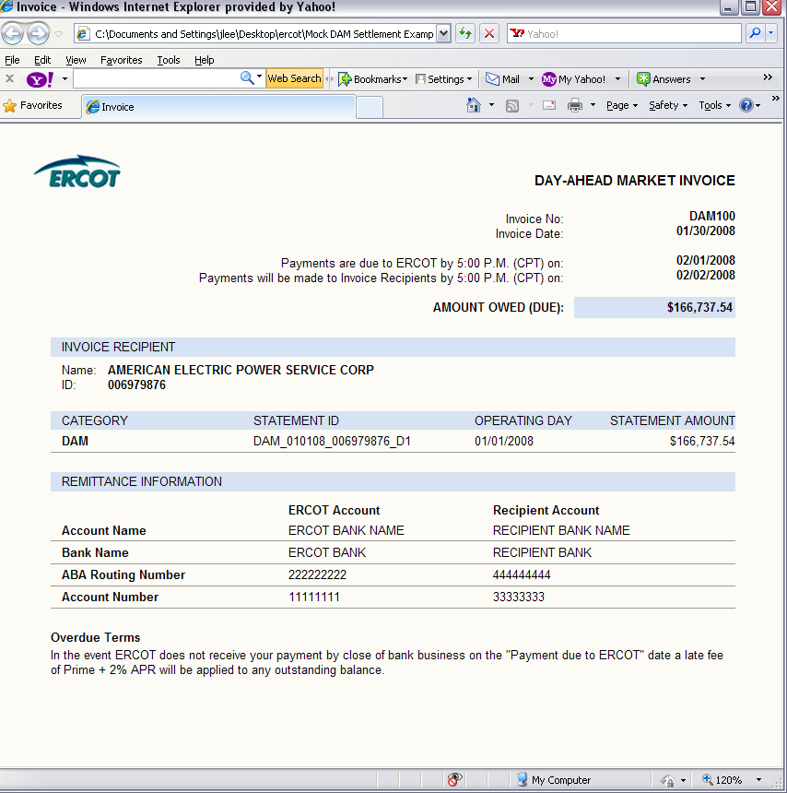

    - DAM Late Fee Invoice
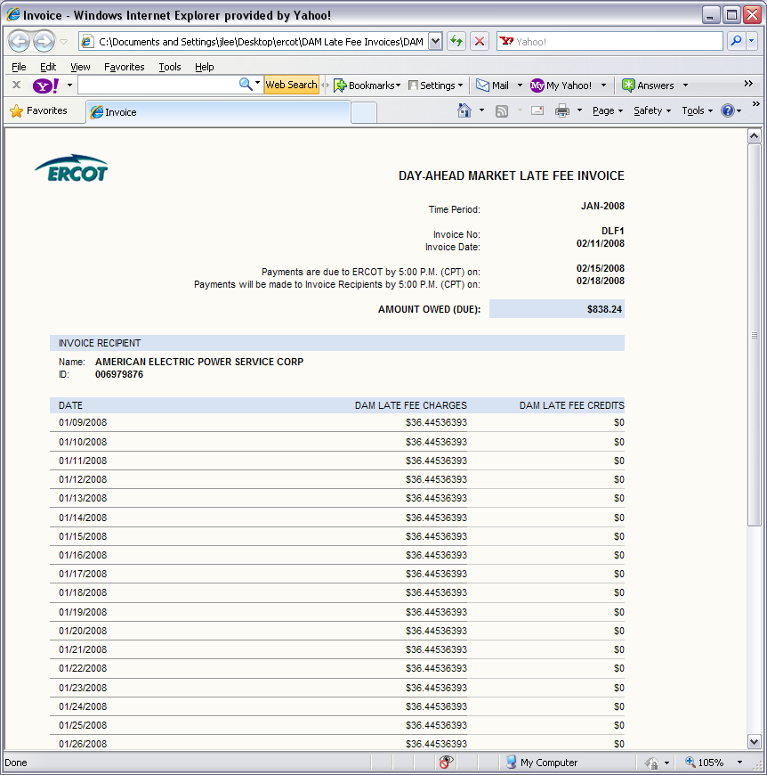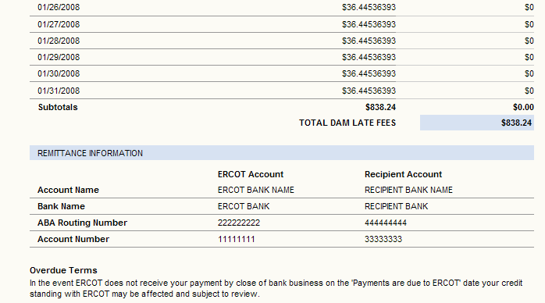

8.3 Real-Time Market Statements and Invoices
Refer to Protocol Section 9.5.2, Settlement Statements for the RTM, for details regarding RTM Settlement Statements.

RTM Statement/Invoice Timeline

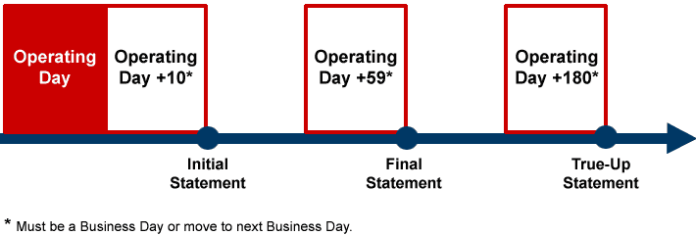

RTM Statements

There are four types of real-time settlement statements; initial, final, true-up and resettlement.
8.3.1.1 RTM Initial Statement
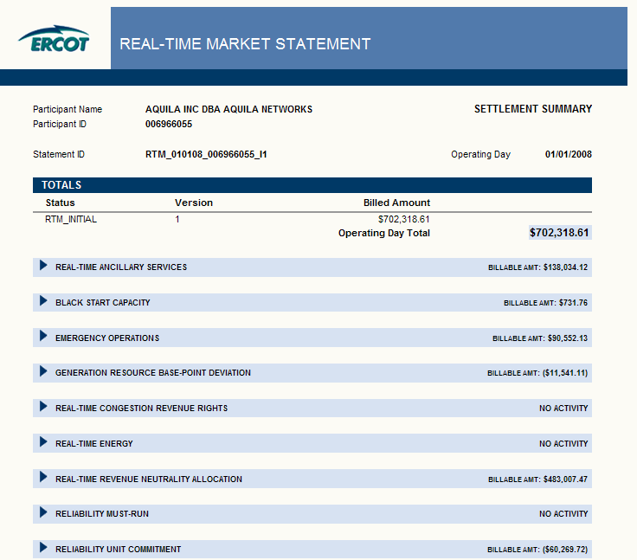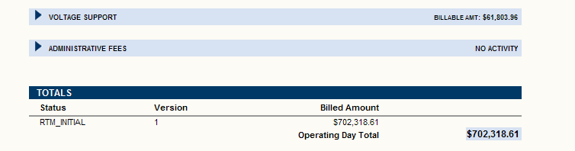

8.3.1.2 RTM Final Statement
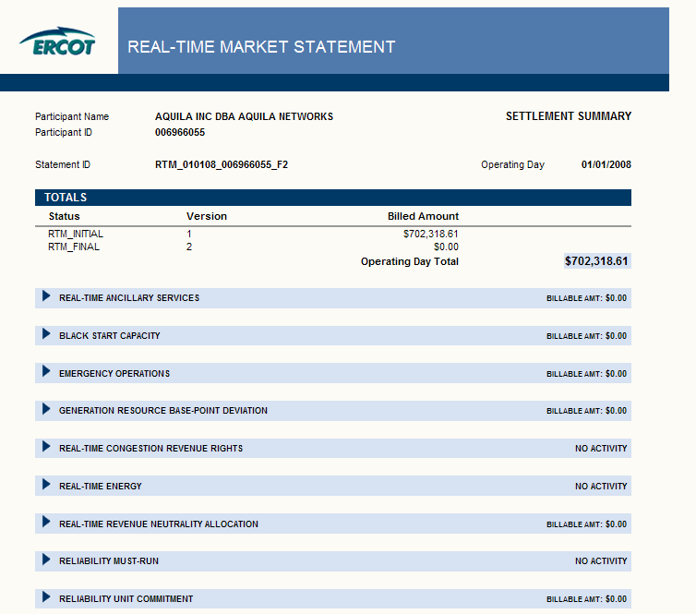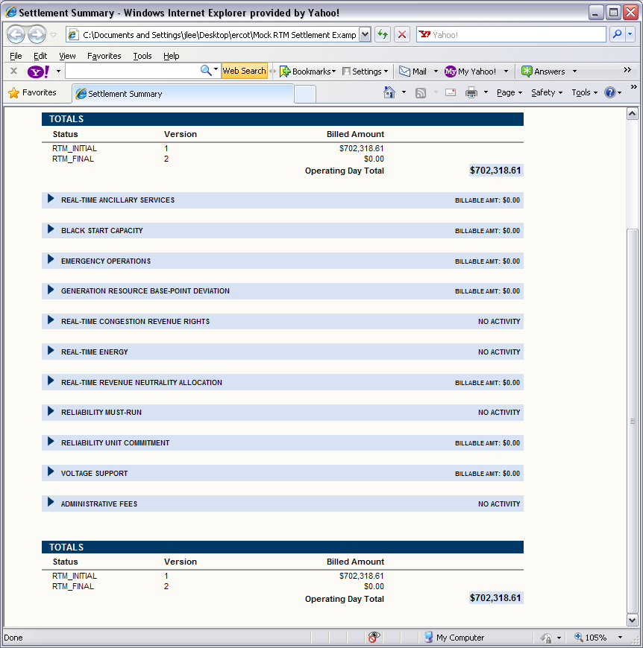
8.3.1.3 RTM True-Up Statement
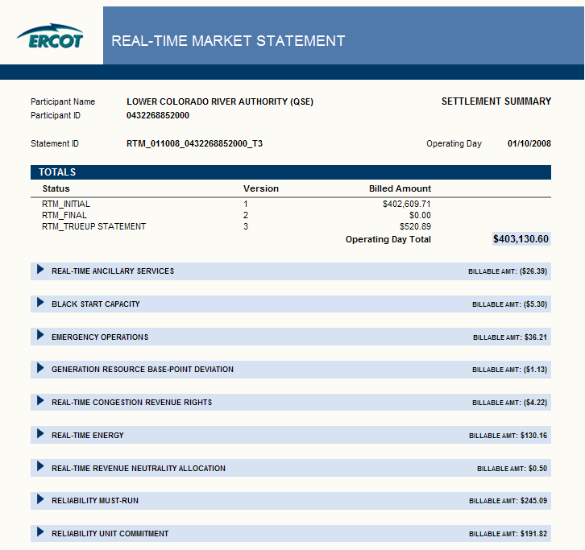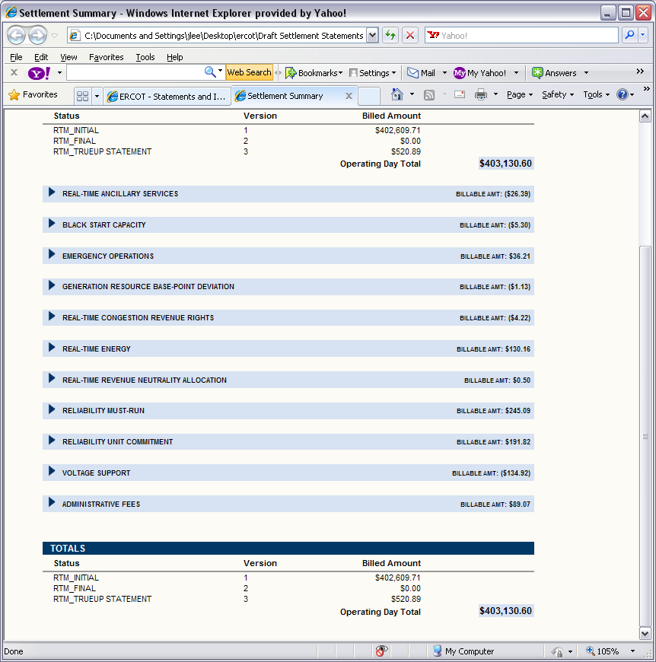
8.3.1.4 RTM Resettlement Statement

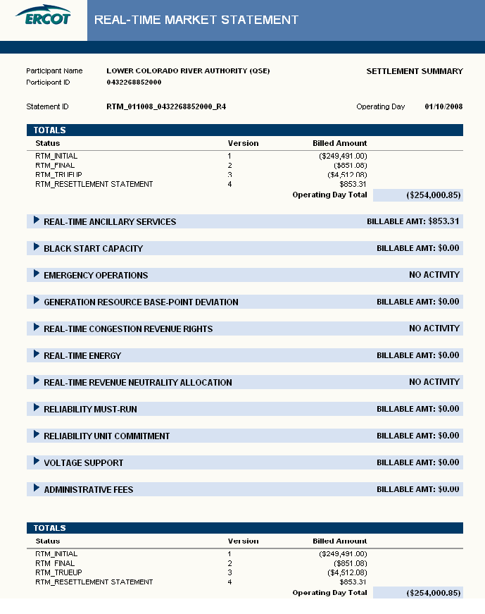

8.3.2 RTM Invoices
Refer to Protocol Section 9.6, Settlement Invoices for the Real-Time Market, for details regarding RTM Invoices.
8.3.2.1 RTM Settlement Invoice
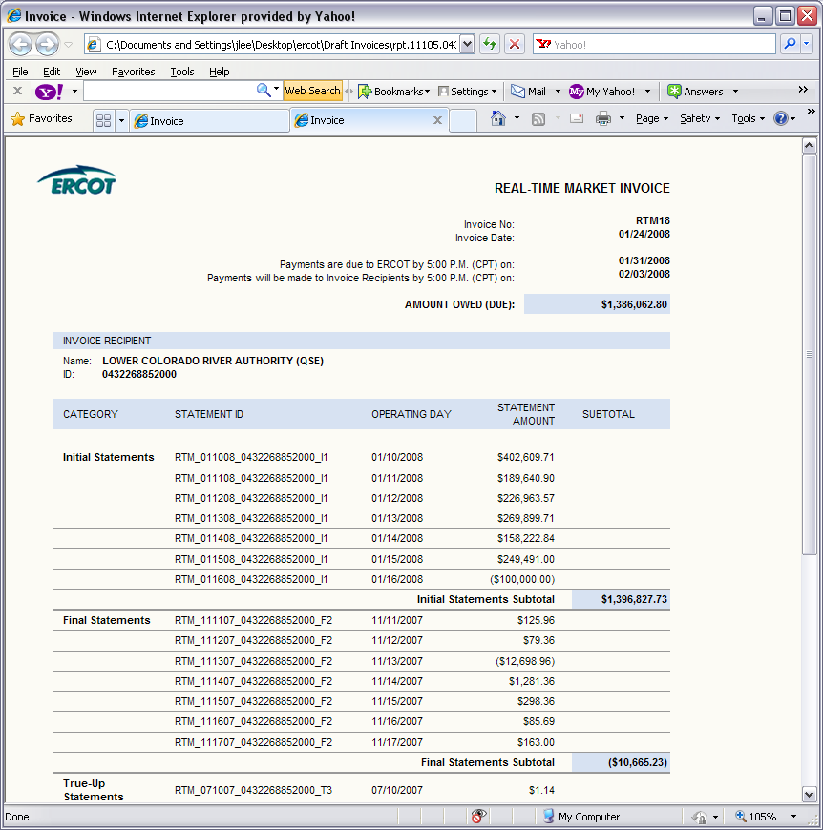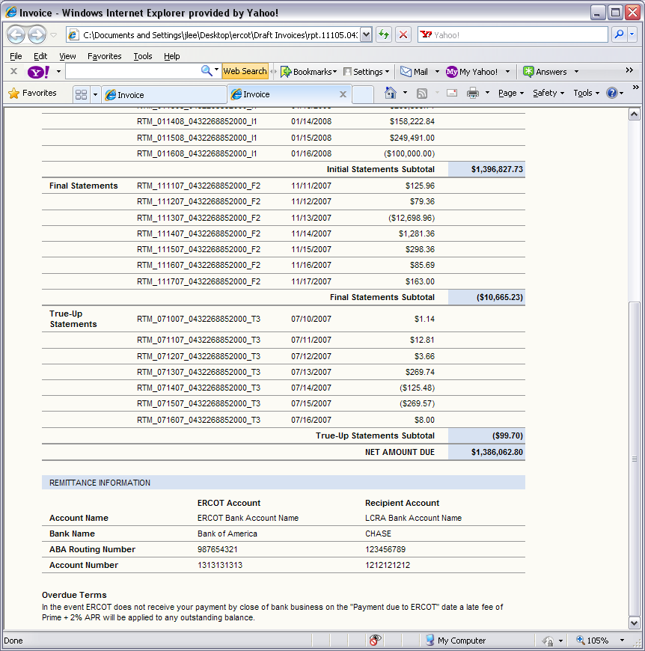
8.3.2.2 RTM Up-lift Invoice
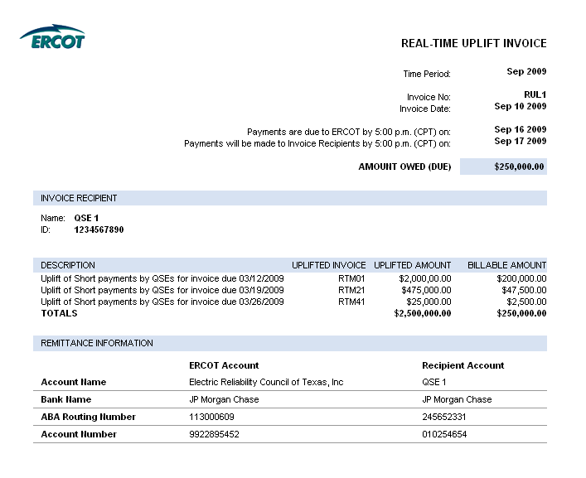
8.3.2.3 RTM Late Fee Invoice
