 |  |  |  | System Planning Division
Monthly Status Report
to
Reliability and Operations Subcommittee
for
August 2009

 |  | Report Highlights
Item
1. | - ERCOT is currently tracking 230 active generation interconnection requests totaling over 83,000 MW. This includes almost 48,000 MW of wind generation.
2. | - Regional Planning is currently reviewing proposed transmission improvements with a total cost of $1,162.34 Million  - Transmission Projects approved in 2009 total $134 Million  - All projects (in engineering, routing, licensing and construction) total approximately $9.2 Billion  - Transmission Projects energized in 2009 total about $416 million

Table of Contents
1. Generation Interconnection 1
1.1 New Generation Beginning Commercial Operations 1
1.2 New Generation Interconnection Agreements 1
1.3 Summary of Active Generation Interconnection Requests 1
1.4 Publicly Disclosed Generation Interconnection Projects 3
1.5 Generation Projects Undergoing Full Interconnection Studies 6
1.6 Wind Generation 7
2. Regional Planning Group Project Reviews 10
3. Other Notable Activities 11

1. Generation Interconnection
Additional information regarding detailed generation interconnection and impact studies is contained in the “Generation Project Interconnection Information” folder in the “Operations and System Planning” area on the ERCOT website: http://planning.ercot.com/login/login.

New Generation Registered for Commercial Operations

Oak Grove SES I Coal (09INR006a) for 817 MW in Robertson County

Barney Davis 2 Repowering Combined Cycle (09INR0038) for 380 MW in Nueces County

Panther Creek III Wind (11INR0015) for 200 MW in Sterling County

The total installed wind capacity is now 8,335 MW, of which 6,992 MW (84%) is located within the Western Congestion Management Zone.

New Generation Interconnection Agreements

None for August 2009

Summary of Active Generation Interconnection Requests
GENERATION INTERCONNECTION REQUESTS CURRENTLY BEING PROCESSED
Currently tracking 230 active generation interconnection or change requests
As of August 31, 2009 | North | South | West | Total
Security Screening Study | 7 | 4 | 10 | 21
SSS Completed | 2 | 9 | 17 | 28
Full Interconnect Study | 28 | 24 | 86 | 138
FIS Completed | 2 | 11 | 2 | 15
Interconnect Agreement Completed | 7 | 11 | 10 | 28
Capacity under Interconnection Agreements | 4,487 | 2,453 | 1,803 | 8,743
Capacity for Grid, MW | 22,474 | 23,173 | 38,027 | 83,674
Wind Capacity, MW | 4,124 | 8,401 | 35,394 | 47,919

Fuel Type | Confidential Projects (MW) | Projects Under Full Study (MW) | Projects w/ Interconnect Agreement/Public Letter (MW) | Grand Total (MW)
Gas-CC |  |  | 3,881 | 18,468
Gas-CT |  |  | 527 | 1,177
Total Gas | 1,279 | 13,958 | 4,408 | 19,645
Nuclear | 0 | 0 | 5,986 | 5,986
Coal | 0 | 3,712 | 2,958 | 6,670
Wind | 9,426 | 31,005 | 7,488 | 47,919
Solar | 623 | 459 | 0 | 1,082
Biomass | 0 | 50 | 145 | 195
Other | 977 | 1,200 | 0 | 2,177
Grand Total | 12,305 | 50,384 | 20,985 | 83,674

Publicly Disclosed Generation Interconnection Projects
The table below summarizes the publicly disclosed generation projects for the ERCOT region.
(IA=Interconnect Agreement, PL=Public Letter, XX= cancelled)
Generation Interconnections as of August 31, 2009
INR | SiteName | Status | County | Region | COD | Fuel | MW For Grid | Change from Last Report
09INR0015 | Comanche Peak 1&2 Upgrade | PL | Somervell | North | Oct-09 | Nuclear | 86
08INR0012a | Papalote Creek Wind Farm | IA | San Patricio | South | Oct-09 | Wind | 180
09INR0079 | Pearsall Expansion | IA | Frio | South | Oct-09 | Gas-CT | 200 | Date
09INR0072 | Dansby3 | PL | Brazos | North | Oct-09 | Gas-CT | 48 | Date
09INR0028 | V H Braunig 6 | IA | Bexar | South | Nov-09 | Gas-CT | 185 | Date
09INR0034 | Gatesville Wind Farm | PL | Coryell | North | Dec-09 | Wind | 200
09INR0047 | Loraine Windpark | IA | Mitchell | West | Dec-09 | Wind | 251
08INR0038 | M Bar Wind | PL | Andrews | West | Dec-09 | Wind | 194
10INR0026 | Langford Wind Power | IA | Tom Green | West | Dec-09 | Wind | 150
10INR0047 | Bluff-Kendall Windfarm | IA | Kendall | South | Jan-10 | wind | 0
11INR0014 | TECO Central Plant | IA | Harris | South | Feb-10 | Gas-CC | 50
09INR0037 | Scurry County Wind III | PL | Scurry | West | Mar-10 | Wind | 350
08INR0033 | Lufkin | IA | Angelina | North | Apr-10 | Biomass | 45 | Date
09INR0039 | Nueces Bay 7 Repowering | IA | Nueces | South | Apr-10 | Gas-CC | 327
09INR0006b | Oak Grove SES 2 | IA | Robertson | North | May-10 | Coal | 855
09INR0002 | J K Spruce 2 | IA | Bexar | South | Jun-10 | Coal | 750
09INR0045 | Sand Hill Peakers | IA | Travis | South | Jul-10 | Gas-CT | 94
06INR0012b | Sherbino Mesa Wind Farm 2 | IA | Pecos | West | Jul-10 | Wind | 150
05INR0015c | Gulf Wind 3 | PL | Kenedy | South | Sep-10 | Wind | 400
05INR0015b | Gulf Wind 2 | PL | Kenedy | South | Oct-10 | Wind | 400 | Date
08INR0011 | Senate Wind Project | IA | Jack | North | Nov-10 | Wind | 150
09INR0029 | CFB Power Plant Units 11&12 | IA | Calhoun | South | Dec-10 | Coal | 263
12INR0003 | Throckmorton Wind Farm | PL | Throckmorton | West | Dec-10 | Wind | 400
04INR0011b | Cedar Elm | IA | Shackelford | West | Dec-10 | Wind | 100 | Date
06INR0022c | Penascal Wind Farm 2 | IA | Kenedy | South | Dec-10 | Wind | 202
08INR0065 | Buffalo Gap 4 and 5 | PL | Nolan | West | Mar-11 | Wind | 465
07INR0036 | Coyote Run Windfarm | IA | Borden | West | Mar-11 | Wind | 225
0INR0020 | Panda Temple Power | PL | Bell | North | May-11 | Gas-CC | 1092
10INR0010 | Jack County 2 | IA | Jack | North | Jun-11 | Gas-CC | 620
08INR0018 | Gunsight Mountain | IA | Howard | West | Aug-11 | Wind | 120
09INR0055 | Rattlesnake Wind Farm | XX | McCulloch | West | Sep-11 | Wind | 200 | Cancelled
09INR0060 | Stephens Wind Farm | PL | Borden | West | Nov-11 | Wind | 141
04INR0011c | Cottonwood Wind | IA | Shackelford | West | Dec-11 | Wind | 136 | Date
06INR0026 | Wild Horse Mountain | IA | Howard | West | Dec-11 | Wind | 120
08INR0025 | Pistol Hill Energy Center | PL | Ector | West | Dec-11 | Wind | 300
06INR0022b | Penascal Wind Farm 3 | IA | Kenedy | South | Dec-11 | Wind | 202
09INR0007 | Nacogdoches Project | IA | Nacogdoches | North | Apr-12 | Biomass | 100
07INR0004 | Pampa Energy Center | PL | Gray | West | May-12 | Coal | 165
09INR0001 | Sandy Creek 1 | IA | McLennan | North | Jun-12 | Coal | 925
09INR0026a | Sterling Energy Center | PL | Sterling | West | Jun-12 | Wind | 200
09INR0026 | Sterling Energy Center | IA | Sterling | West | Jun-12 | Wind | 300
09INR0024 | B&B Panhandle Wind | PL | Carson | West | Jun-12 | Wind | 1001
12INR0004 | Fort Concho Wind Farm | PL | Tom Green | West | Jul-12 | Wind | 400
08INR0040 | Lenorah Project | IA | Martin | West | Sep-12 | Wind | 251
09INR0036 | McAdoo Energy Center II | PL | Dickens | West | Dec-12 | Wind | 500
06INR0006 | Cobisa-Greenville | IA | Hunt | North | May-13 | Gas-CC | 1792
15INR0002 | Comanche Peak 3 and 4 | PL | Somervel | North | Jan-15 | Nuclear | 3200
15INR0008 | STP 3 and 4 | PL | Matagorda | South | Jan-15 | Nuclear | 2700
 |  |  |  |  |  | TOTAL | 20,985

County Location of Installed Generation and Interconnection Requests (all fuels)

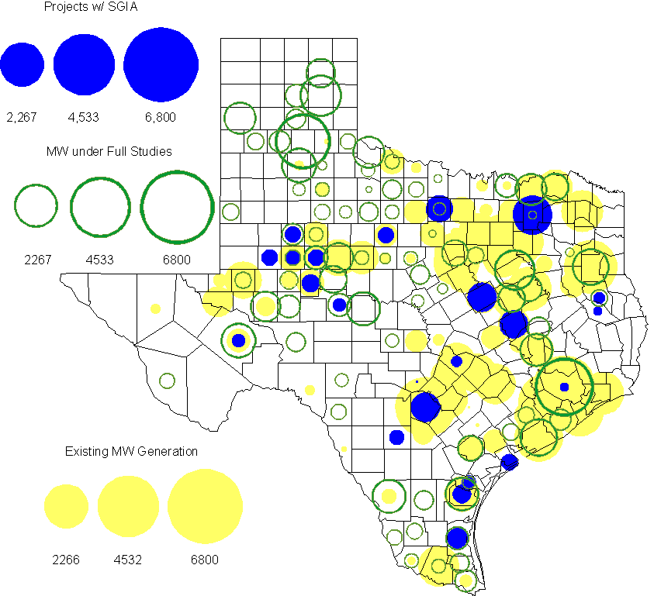

Generation Projects Undergoing Full Interconnection Studies
INR | County | Capacity | COD | Fuel |  | INR | County | Capacity | COD | Fuel
08INR0044 | Concho | 200 | TBD | Wind |  | 08INR0049 | Clay | 50 | TBD | Wind
09INR0064 | Borden | 41 | TBD | Wind |  | 08INR0041 | Coke | 200 | TBD | Wind
08INR0042 | Coke | 200 | TBD | Wind |  | 09INR0025 | Concho | 180 | TBD | Wind
09INR0048 | Jack | 150 | 10/31/2009 | Wind |  | 08INR0054 | Comanche | 401 | 10/31/2009 | Wind
09INR0073 | Scurry | 200 | 11/1/2009 | Wind |  | 08INR0031 | Childress | 100 | 11/1/2009 | Wind
09INR0082 | Webb | 300 | 12/1/2009 | Wind |  | 09INR0077 | Reagan | 500 | 12/1/2009 | Wind
11INR0013 | Mills | 150 | 12/1/2009 | Wind |  | 11INR0012 | Duval | 400 | 12/1/2009 | Wind
09INR0065 | Webb | 150 | 12/1/2009 | Wind |  | 09INR0061 | Kent | 258 | 12/1/2009 | Wind
09INR0058 | Howard | 250 | 12/1/2009 | Wind |  | 09INR0054 | Stonewall | 148.5 | 12/1/2009 | Wind
09INR0051 | Borden | 249 | 12/1/2009 | Wind |  | 08INR0056 | Nolan | 149 | 12/1/2009 | Wind
08INR0039 | Hamilton | 90 | 12/1/2009 | Wind |  | 08INR0012b | San Patricio | 151 | 12/1/2009 | Wind
08INR0022 | Floyd | 100 | 12/1/2009 | Wind |  | 08INR0023 | Floyd | 100 | 12/1/2009 | Wind
10INR0048 | Hardeman | 1000 | 1/1/2010 | Wind |  | 11INR0036a | Matagorda | 200 | 1/1/2010 | Wind
11INR0033a | Cameron | 200 | 1/1/2010 | Wind |  | 10INR0024 | Briscoe | 3000 | 1/1/2010 | Wind
10INR0011 | Johnson | 275 | 1/1/2010 | Gas |  | 10INR0045 | Webb | 734 | 4/1/2010 | Wind
10INR0046 | Jim Hogg | 264 | 4/1/2010 | Wind |  | 10INR0079 | Nolan | 60 | 5/1/2010 | Wind
10INR0062a | Pecos | 49.5 | 5/1/2010 | Wind |  | 10INR0054 | Palo Pinto | 36 | 5/1/2010 | Wind
09INR0070 | Reagan | 42 | 5/1/2010 | Wind |  | 09INR0069 | Reagan | 36 | 5/1/2010 | Wind
10INR0023 | Haskell | 386 | 5/1/2010 | Wind |  | 10INR0016 | Childress | 150 | 5/1/2010 | Wind
09INR0035 | Concho | 750 | 5/1/2010 | Wind |  | 09INR0018 | Concho | 249 | 5/1/2010 | Wind
07INR0032 | Tom Green | 249 | 5/1/2010 | Wind |  | 10INR0069 | Rusk | 818 | 5/15/2010 | Coal
09INR0081 | Rusk | 818 | 6/1/2010 | Coal |  | 10INR0035 | Harris | 416 | 6/1/2010 | Gas
10INR0029 | Hood | 810 | 6/1/2010 | Gas |  | 10INR0057 | Taylor | 200 | 7/1/2010 | Wind
10INR0052a | Knox | 21 | 7/1/2010 | Wind |  | 10INR0013 | Upton | 400 | 7/1/2010 | Wind
10INR0012 | Nacogdoches | 300 | 7/1/2010 | Gas |  | 10INR0038 | Glasscock | 350 | 8/1/2010 | Wind
10INR0071 | Matagorda | 88 | 9/1/2010 | Wind |  | 09INR0074 | Motley | 70 | 10/1/2010 | Wind
10INR0041 | Floyd | 135 | 10/1/2010 | Wind |  | 10INR0015 | Mitchell | 350 | 10/1/2010 | Wind
10INR0070 | Hunt | 50 | 11/1/2010 | Gas |  | 11INR0029 | Throckmorton | 200 | 11/1/2010 | Wind
10INR0039 | Dickens | 200 | 11/1/2010 | Wind |  | 10INR0080 | Presidio | 144 | 12/1/2010 | Solar
10INR0077 | Callahan | 101 | 12/1/2010 | Wind |  | 10INR0060 | Willacy | 400.5 | 12/1/2010 | Wind
10INR0059 | Zapata | 250.7 | 12/1/2010 | Wind |  | 10INR0056 | Borden | 249 | 12/1/2010 | Wind
10INR0051 | Brazoria | 200 | 12/1/2010 | Wind |  | 09INR0076 | Jackson | 300 | 12/1/2010 | Wind
10INR0042 | Mason | 170 | 12/1/2010 | Wind |  | 10INR0033 | Armstrong | 420 | 12/1/2010 | Wind
10INR0032 | Navarro | 800 | 12/1/2010 | Gas |  | 10INR0019 | Deaf Smith | 609 | 12/1/2010 | Wind
08INR0062 | Archer | 249 | 12/1/2010 | Wind |  | 08INR0061 | Hardeman | 200 | 12/1/2010 | Wind
09INR0031 | Ector | 275 | 12/1/2010 | Gas |  | 10INR0008 | Pecos | 500 | 12/1/2010 | Wind
07INR0035 | Tom Green | 270 | 12/1/2010 | Wind |  | 07INR0026 | Baylor | 400 | 12/1/2010 | Wind
07INR0015 | Foard | 180 | 12/1/2010 | Wind |  | 07INR0013 | Coke | 200 | 12/1/2010 | Wind
09INR0041 | Mitchell | 300 | 12/15/2010 | Wind |  | 11INR0036b | Matagorda | 200 | 1/1/2011 | Wind
11INR0033b | Cameron | 200 | 1/1/2011 | Wind |  | 11INR0050 | Crosby | 149 | 3/1/2011 | Wind
08INR0014 | Webb | 183 | 3/1/2011 | Wind |  | 11INR0049 | Wharton | 275 | 4/1/2011 | Gas
11INR0062 | Nueces | 149 | 5/1/2011 | Wind |  | 11INR0061 | Presidio | 90 | 5/1/2011 | Solar
11INR0060 | Tom Green | 90 | 5/1/2011 | Solar |  | 11INR0058 | Pecos | 135 | 5/1/2011 | Solar
11INR0048 | Harris | 300 | 5/1/2011 | Gas |  | 10INR0062b | Pecos | 49.5 | 5/1/2011 | Wind
11INR0046 | Brazoria | 300 | 5/1/2011 | Gas |  | 11INR0037 | Smith | 55 | 5/1/2011 | Biomass
09INR0075 | Kinney | 248 | 5/1/2011 | Wind |  | 11INR0028 | Grimes | 1280 | 5/1/2011 | Gas
10INR0009 | Castro | 300 | 5/1/2011 | Wind |  | 11INR0057 | Cameron | 144 | 6/1/2011 | Wind
11INR0019 | Upton | 200 | 6/1/2011 | Wind |  | 11INR0009 | Navarro | 1200 | 6/1/2011 | Gas
09INR0050 | Fannin | 1200 | 6/1/2011 | Gas |  | 08INR0020 | Eastland | 200 | 6/1/2011 | Wind
11INR0006 | Lamar | 579 | 7/1/2011 | Gas |  | 11INR0040 | freestone | 749 | 8/1/2011 | Gas
11INR0047 | Deaf Smith | 600 | 9/1/2011 | Wind |  | 11INR0039 | Starr | 201 | 9/1/2011 | Wind
11INR0008a | Roberts | 1000 | 9/1/2011 | Wind |  | 07INR0014b | Wilbarger | 70 | 10/1/2011 | Wind
07INR0014a | Wilbarger | 140 | 10/1/2011 | Wind |  | 10INR0021 | Grayson | 646 | 11/1/2011 | Gas
09INR0016 | Yoakum | 291 | 11/1/2011 | Gas |  | 11INR0043 | Coke | 300 | 12/1/2011 | Wind
11INR0025 | Crockett | 400 | 12/1/2011 | Wind |  | 11INR0005 | Upton | 500 | 12/1/2011 | Wind
06INR0022d | Kenedy | 200 | 12/1/2011 | Wind |  | 12INR0021 | Edwards | 165 | 1/1/2012 | Wind
10INR0018 | Madison | 550 | 3/1/2012 | Gas |  | 10INR0062c | Pecos | 201 | 5/1/2012 | Wind
12INR0007 | Lamar | 296 | 5/1/2012 | Gas |  | 10INR0022 | Harris | 3500 | 6/1/2012 | Gas
12INR0006 | Limestone | 875 | 6/1/2012 | Coal |  | 12INR0002 | Briscoe | 750 | 7/1/2012 | Wind
12INR0016 | Nueces | 1200 | 11/1/2012 | Other |  | 08INR0019c | Gray | 250 | 11/1/2012 | Wind
08INR0019b | Gray | 250 | 11/1/2012 | Wind |  | 08INR0019a | Gray | 250 | 11/1/2012 | Wind
12INR0022 | Hidalgo | 200 | 12/1/2012 | Wind |  | 12INR0018 | Gray | 600 | 12/1/2012 | Wind
12INR0005 | Floyd | 1100 | 12/1/2012 | Wind |  | 06INR0022f | Kenedy | 200 | 12/1/2012 | Wind
12INR0029 | Swisher | 500 | 12/31/2012 | Wind |  | 13INR0006 | Gray | 750 | 10/1/2013 | Wind
13INR0005 | Carson | 600 | 10/1/2013 | Wind |  | 06INR0022e | Kenedy | 200 | 12/1/2013 | Wind
14INR0002 | Goliad | 756 | 2/1/2014 | Coal |  | 14INR0003 | Nolan | 850 | 6/1/2014 | Coal
14INR0005 | Matagorda | 1200 | 7/1/2014 | Coal |  | 14INR0001 | Pecos | 500 | 12/1/2014 | Wind

Wind Generation
Wind Capacity Installed by Year

County Location of Installed Capacity and Interconnection Requests (Wind only)

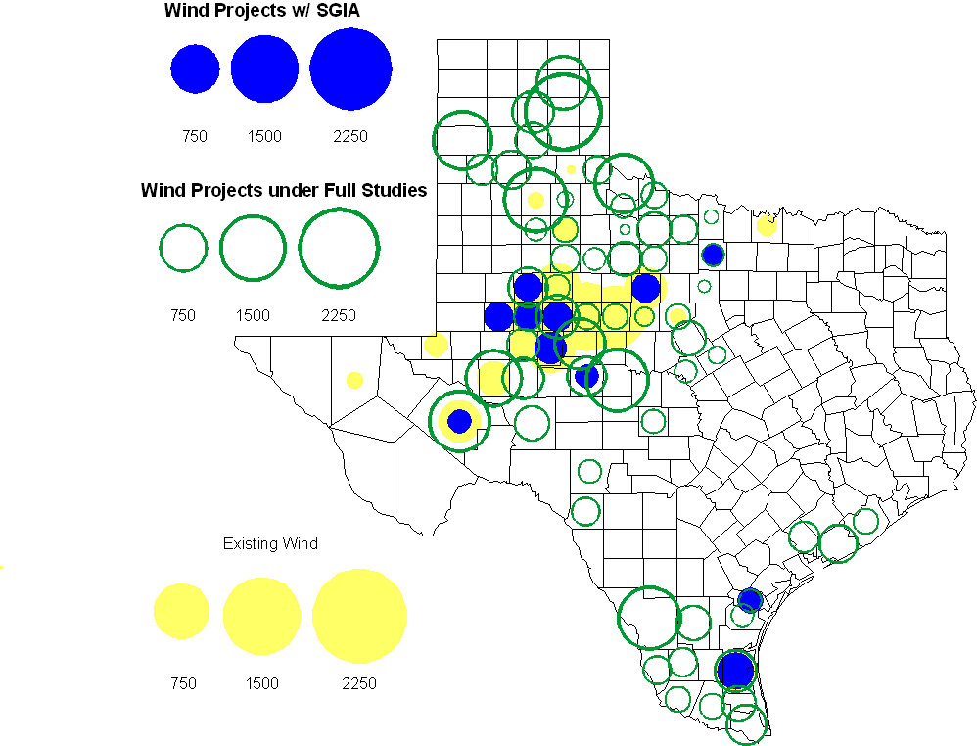

Regional Planning Group Project Reviews

American Electric Power Service Corporation submitted a project to construct 2 new 138 kV substations, rebuild a 138 kV circuit, build 2 new 138 kV circuits, and install a new 138/69 kV autotransformer in the Abilene/San Angelo area. The estimated cost of this project is $105.9 M. The review of this project is complete and an ERCOT Endorsement Letter has been sent.

Oncor submitted a project to relieve congestion related to new wind units in the Lamesa area. The project will upgrade the Lamesa to Bluff Creek 138 kV line, rebuild the Bluff Creek to China Grove 138 kV line, rebuild the Lamesa to Ackerly Vealmoor 69 kV line to 138/69 kV double circuit, rebuild the Lamesa 138 kV switching station, build a new 138 kV Ackerly Vealmoor station, add second circuits to all rebuilt lines and include station upgrades at China Grove and Big Spring. The cost of this project is $ 80.8 M. This project will be reviewed to ensure that the improvements fit into the likely CREZ transmission solution for the area. This project is in ERCOT Independent Review and will be studied as part of the 2009 Five-Year Transmission Plan.

Oncor submitted a project to add several 345 kV circuits to support the addition of Comanche Peak units 3 and 4 in 2015 at an estimated cost of $ 133 M. These upgrades include a new 345 kV double circuit line with one circuit in place from Comanche to Whitney, a new 345 kV line from Comanche to Johnson Switch, a new circuit on existing structures from Johnson Switch to Everman, a new 345 kV double circuit with one circuit in place from Comanche to DeCordova, and a new 345 kV line on existing structures from Comanche to Parker Switch. This project is in ERCOT Independent Review and will be studied when the 2009 Five-Year Transmission Plan is complete.

Sharyland Utilities submitted a project to construct and operate the ERCOT Southeast Loop facilities consisting of a 345 kV double circuit from Lufkin to Canal 345 kV substation on the northeast side of Houston. This project will cost $359 M with an estimated completion date of summer 2013. This project is in ERCOT Independent Review and will be studied as part of the 2009 Five-Year Transmission Plan.

Centerpoint Energy has submitted a project to expand the Zenith substation, add one 800 MVA autotransformer, connect Zenith to existing circuits near the Gertie substation and upgrade/reconfigure nearby 138 kV circuits. The estimated completion date of this project is summer 2012 and estimated cost is $ 26.6 M. This project is in ERCOT Independent Review.

American Electric Power Service Corporation submitted a project to construct several improvements in the Corpus Christi area. The estimated completion date of this project is June 2012 and estimated cost is $ 214 M. This project is in ERCOT Independent Review.

Centerpoint Energy submitted a project to upgrade the Garrott to Midtown to Polk underground 138 kV line. This project is estimated to be completed before summer peak 2011 and is estimated to cost $17.8 M. The comment period for this project is complete and an RPG Acceptance Letter has been sent.

Centerpoint Energy has submitted a project to construct a new 345 kV double circuit line to allow greater power imports into the Houston area. The project involves expanding the Fayetteville and Zenith substations and constructing a new 345 kV double circuit from Fayetteville to Zenith. The proposal also includes looping the Fayette Power Project to Salem 345 kV circuit into Fayetteville and upgrading the Fayette Power Project to Fayetteville 345 kV double circuit lines. The project is estimated to be complete by September 2014 at a cost of $222 M. This project is in ERCOT Independent Review.

Luminant Energy has submitted the Comanche Peak Area Congestion Mitigation Plan project to loop the future Parker to Everman 345 kV CREZ line into the Comanche Peak 345 kV switch station. Luminant Energy’s estimated completion date for this project is April 2010 and the estimated cost is $3 M. The comment period for this project has been completed and it is currently in study mode.

Congestion Costs
Dollars shown in graphs are settlement quality.

OOMC – last 13 months in million$

OOM Down – last 13 months in million$

Balancing Energy Down – last 13 months in million$

OOM Up – last 13 months in million$

Balancing Energy Up – last 13 months in million$

Replacement Reserve – last 13 months in thousand$

Binding Constraints – July, 2009
Contingency | Binding Element | Estimated Costs | Transmission Project
 | Capacity Shortage | $ 4,159,576
Temple Pecan Creek - Tradinghouse & Temple Switch - Lake Creek SES | San Angelo Power Station -Shrew Tap | $ 3,349,357 | San Angelo Power Station, to Menard 138 kV line improvements (09TPIT0212)
 | Maintenance | $ 954,856
Watermill - West Levee SW & Sargent Road | Norwood Autotransformer | $ 723,839 | Trinidad – Watermill 345kV line (07TPIT0140)
 | RPRS | $ 598,365
Dilley Switch - San Miguel 138kV  Bates - Pearsall 138kV | Derby - Pearsall 69kV | $ 345,245 | Pearsall to Dilley 69 kV Line Upgrade  (09TPIT0189)
 | Laredo Import | $ 273,432
North Denton 138/69kV Autotransformer | North Denton 138/69kV Autotransformer | $ 183,699
Jewett - Big Brown 345kV | Big Brown Sw | $ 174,798 | Jewett - Big Brown 345kV upgrade (09TPIT0082)
Skyline - Marion & Elm Creek 345kV  Hillcountry - Marion & Elm Creek 345kV | Schertz - Parkway 138kV | $ 167,019 | Parkway-Schertz build new 138kV line (10TPIT0064)

Binding Constraints – August, 2009
Contingency | Binding Element | Estimated Costs | Transmission Project
 | Capacity Shortage | $ 4,554,174
Temple Pecan Creek - Tradinghouse & Temple Switch - Lake Creek SES | San Angelo Power Station -Shrew Tap | $ 3,702,120 | San Angelo Power Station, to Menard 138 kV line improvements (09TPIT0212)
Watermill - West Levee SW & Sargent Road | Watermill – DeSoto | $ 1,545,708 | Trinidad – Watermill 345kV line (07TPIT0140)
Dilley Switch - San Miguel 138kV | Derby - Pearsall 69kV | $ 473,910 | Pearsall to Dilley 69 kV Line Upgrade  (09TPIT0189)
Watermill – Tricorner & Trinidad 345kV | Watermill – DeSoto | $ 390,506 | Trinidad – Watermill 345kV line (07TPIT0140)
North Denton 138/69kV Autotransformer | North Denton 138/69kV Autotransformer | $ 233,598
Austrop – Daffin & Decker 138kV | Austrop –Decker 138kV | $ 221,789 | Decker to Techridge 138kV Relocation (07TPIT0050)
Outages | Zorrillo Planned Outage | $ 175,321
RPRS |  | $ 62,646
W_N Stability |  | $ 59,422

Inter-zonal Congestion Costs – last 13 months

Other Notable Activities
- The reliability phase of the 2009 Five-Year Transmission Plan utilizing the latest SSWG base cases is nearly complete. Projects to eliminate unserved energy in 2014 have been identified and coordinated with ERCOT TSPs. Projects to eliminate unserved energy in the remaining years of the 5 year horizon have been identified and are being finalized. Projects to reduce congestion in 2010 and 2014 are currently being studied.

  - The Voltage Ride Through Study continues. Phase I of the study involves evaluating system reliability risks associated with wind plants that do not comply with ERCOT VRT requirements utilizing existing wind plant model data. Phase II involves reviewing and improving wind plant models. Work on both of these study phases is underway and scheduled for completion by the end of 2009. Phase III involves evaluating system reliability risks associated with wind plants that do not comply with ERCOT VRT requirements utilizing revised wind plant models and investigation of any modifications necessary to mitigate such risks. Notable accomplishments to date:

    - The flat start process to achieve an acceptable “no disturbance” simulation result incorporating detailed wind turbine dynamic models for both Phase I study cases is 100% and the simulations are on-going. A VRT study Data Request Form sent to each WGR (pre-populated with RARF data), 40% of the WGRs have responded with complete information as requested, another 35% with partial data/information and the remaining 25% have not responded at all. A second reminder with an associated data submission deadline has been communicated to all concerned WGRs.
    - Individual in-person and/or conference meetings with numerous WGRs have been conducted to understand and document various aspects of the operational philosophy associated with their wind farms with the same being reflected in the models developed for the said wind farms as part of the Phase II effort.

  - The West-to-North Stability Limit study Phase II - This study is to simulate the addition of PSS on selected generating units to obtain larger transfer limits from West Texas to North Texas. Pending approval of latest W-N stability limit study results as prepared by Operations Planning, System Planning is ready to start Phase II in September, 2009 and expect to complete it in three months.

  - ERCOT TPIT report for 2009 3rd quarter was posted on September 1, 2009.

