ERCOT Operations Report
August 2009 ROS & OWG

Frequency Control
Time | Freq(Hz) | Duration (s)
8/15/2009 21:18 | 59.87 | 60 | Multiple Unit trips with 500 MW & with 175 MW
8/27/2009 16:22 | 59.88 | 96 | Unit trip with 725 MW
8/27/2009 17:05 | 59.88 | 61 | Unit trip with 540 MW
Note: Time of frequency excursions outside the range of +/- 0.1 Hz.

Deployed Responsive (Reported Above)
Time deployed | Stop Time | Duration | Max | Details
8/7/09 14:13:59 | 8/7/09 14:21:03 | 0:07:04 | 337.94 | Unit Trip
8/15/09 21:18:55 | 8/15/09 21:35:39 | 0:16:44 | 712.81
8/15/09 22:00:41 | 8/15/09 22:16:33 | 0:15:52 | 332.6 | Slow Unit Response. SCE change -1050 MW in 4m.
8/23/09 19:05:50 | 8/23/09 19:24:02 | 0:18:12 | 348.49 | Unit Trip
8/25/09 15:19:18 | 8/25/09 15:26:18 | 0:07:00 | 337.94 | Unit Trip
8/27/09 16:22:12 | 8/27/09 16:49:58 | 0:27:46 | 644.17
8/27/09 17:05:18 | 8/27/09 17:21:30 | 0:16:12 | 691.68

Day-Ahead OOMC and RPRS Capacity Purchases
Details | OOMC | RPRS S1 | RPRS S2 | RPRS S1+S2 | RMR | Total
DFW | 24 | 16 | 65 | 81 | 0 | 105
North | 8 | 34 | 47 | 81 | 0 | 89
Western | 4 | 5 | 69 | 74 | 10 | 88
Houston | 4 | 5 | 66 | 71 | 0 | 75
Austin | 0 | 14 | 14 | 28 | 0 | 28
San Antonio | 0 | 5 | 5 | 10 | 0 | 10
E RIO | 1 | 6 | 0 | 6 | 0 | 7
South | 0 | 0 | 1 | 1 | 0 | 1
Bryan Area | 0 | 0 | 1 | 1 | 0 | 1
Northeast | 0 | 0 | 1 | 1 | 0 | 1
Laredo | 0 | 0 | 0 | 0 | 0 | 0
Corpus | 0 | 0 | 0 | 0 | 0 | 0
W RIO | 0 | 0 | 0 | 0 | 0 | 0
Total | 41 | 85 | 269 | 354 | 10 | 405

Historical Totals | Aug-09 | Aug-08 | Jul-09
Austin | 14 | 33 | 5
Bryan Area | 0 | 0 | 0
Corpus | 0 | 1 | 0
DFW | 40 | 12 | 28
E RIO | 7 | 0 | 9
Houston | 9 | 0 | 37
Laredo | 0 | 12 | 0
North | 42 | 57 | 46
Northeast | 0 | 0 | 2
San Antonio | 5 | 0 | 14
South | 0 | 2 | 13
W RIO | 0 | 0 | 0
Western | 19 | 9 | 19
Total | 136 | 126 | 173

http://www.ercot.com/mktinfo/services/rprsdr/index.html
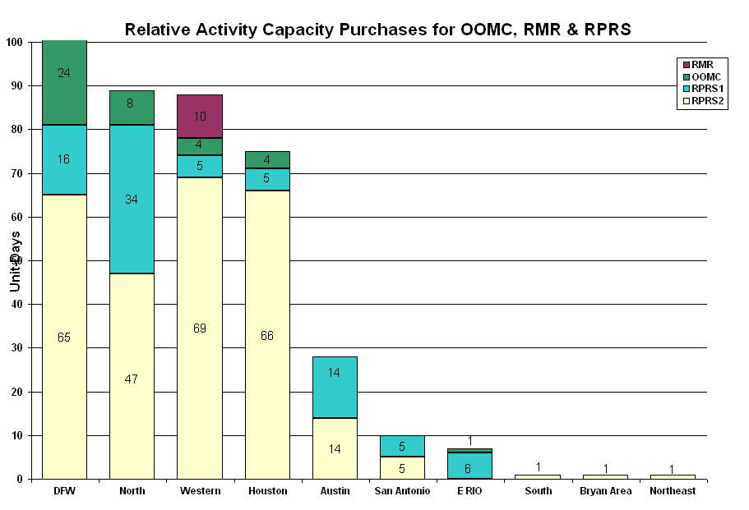

OOME and Congestion Management Activity
Congestion affected by outages Remedial action plan has been developed for the element
Contingency | Overloaded Element | Days
San Miguel - Dilley Switch 138KV | Derby - Pearsall 69KV | 31
Austrop - Daffin & Decker 138KV | Austrop - Decker 138KV | 25
Temple Pecan Creek - Tradinghouse and Lake Creek - Temple Switch 345KV | San Angelo Power Station - Shrew 138KV | 19
Aspermont - Spur 138KV | Jayton - Spur 69KV | 14
Graham - Long Creek 345KV | San Angelo Power Station - Shrew 138KV | 7
Big Brown SES - Jewett 345KV | Big Brown SES - Jewett 345KV | 4
Morgan Creek SES - Quail Switch and Longshore Switching Station 345KV | Stanton East Switching Station - Big Spring West138KV | 4
Enterprise - Trinidad and Martin Lake - Stryker Creek 345KV | Nacogdoches Southeast 345/138KV | 4
North Denton - West Denton 138KV | West Denton - Teasley 138KV | 4
South Abilene - South West Eskota 138KV | Merkel - Trent 69KV | 4
North Denton 138/69KV Auto #1 | North Denton 138/69KV Auto #2 | 3
San Miguel - San Miguel Switchyard 138KV | Dilley Switch 138/68KV autotransformer A1 | 3
Sandow Switch - Temple Switch 345KV | Hearne AT1 transformer 138/69KV | 3
Morgan Creek SES - Quail Switch and Longshore Switching Station 345KV | Midland East - Stanton East Switching Station 138KV | 2
Aspermont - Spur 138KV | Spur 138/69KV AT | 2
Base Case | Cauthorn - Sonora 138KV | 2
Lamesa 138/69KV Auto | Ackerly Vealmoor Switch - Ackerly 69KV | 2
San Miguel Switchyard 345/138KV autotransformer A | San Miguel Switchyard 345/138KV autotransformer B | 2
STP - Blessing 345KV | Columbus - Stafford Hill 69KV | 2
Jack County - Reno 138KV | Decatur - Decatur Tap 138KV | 1
Trinidad SES - Stryker SES and Mt. Enterprise 345 KV | Stryker Creek SES - Stryker Cherokee POI | 1
Aransas Pass - Ingleside 138KV | Gregory - Rincon 69KV | 1
Dilley Switch - North Laredo 138KV | Asherton - North Laredo 138KV | 1
Garfield - Onion Creek and Hicross 138KV | Austrop 345/138KV AT1 | 1
Hicross - Pilot Knob & Garfield 138KV | Grove - Advance 138KV | 1
Jack County - Reno 138KV | Decatur - Rhome 138KV | 1
Olinger - Ben Davis & Elm grove 138KV | Olinger - Firewheel 138KV | 1
Roanoke Switch - West Denton and Lewisville Switch 345KV | West Denton - Teasley 138KV | 1
Teasley - West Denton 138KV | Airport - West Denton 138 KV | 1
Zorn - McCarty Lane 138KV | Henne - Comal 138KV | 1

Zonal OC1
CSC | Days
West-North | 10
North-Houston | 4

New RAP, PCAP (Date indicates last update of RAP, PCAP not implementation date.)
None

New Procedures/Forms/Operations Bulletins
Date | Subject | Bulletin No.
08/04/2009 | Transmission and Security Desk V4 R4 | 432
08/04/2009 | Frequency Control Desk V4 R4 | 431
08/04/2009 | Shift Supervisor Desk V4 R4 | 430
08/04/2009 | Operating Period Desk V3 R4 | 429
08/04/2009 | Day-Ahead V4 R4 | 428

Blackout/Load Shed Incidences
None

EEA
None

Major System Voltage Problems
None

Major Computer Problems, Enhancements & Fixes
08/27 14:58 Held Real-time Balancing deployments for IE 15:15, resumed with IE 15:45 deployments.

08/26 22:30 Held IE 22:30 Real-time Balancing Market deployments for IE 22:45 which failed to execute, resumed with IE 23:00.Held Real-time Balancing deployments for interval ending 22:, resumed with interval ending 15:45 deployments.

Communication
None

ERCOT peak (Unofficial)
08/20 17:00 62,045 MW

Yearly MTLF Error Comparison
Yearly Mid-Term (Hourly) Load Forecast Error Comparison for the ERCOT Forecast
Month | MAPE for MTLF at 16:00 Day-Ahead
Month | 2006 | 2007 | 2008 | 2009
January | 4.79 | 4.55 | 3.30 | 4.11
February | 4.81 | 3.75 | 3.59 | 3.49
March | 4.95 | 2.70 | 3.29 | 3.24
April | 5.59 | 3.00 | 2.45 | 2.66
May | 3.59 | 3.22 | 3.01 | 2.90
June | 2.65 | 4.46 | 2.81 | 2.89
July | 2.62 | 4.29 | 2.55 | 2.83
August | 2.09 | 3.11 | 3.66 | 3.07
September | 4.03 | 3.78 | 4.99 | NA
October | 3.63 | 3.08 | 2.79 | NA
November | 3.28 | 2.95 | 2.60 | NA
December | 3.44 | 3.74 | 4.54 | NA
Annual Average | 3.79 | 3.55 | 3.29 | 3.14

OCN, Advisory, Watch & Emergency Notices
Capacity
Date | Start | End | Event
8/4/09 | 2:00 | 18:00 | OCN issued for projected reserve capacity shortage for HE 1700 - 1800.
8/5/09 | 2:00 | 11:00 | OCN issued for projected reserve capacity shortage for HE 1600 - 1900.
8/5/09 | 11:00 | 18:15 | Watch issued for a projected capacity reserve shortage for HE 1600 - 1900.
8/5/09 | 13:00 | 18:30 | OCN issued for projected Balancing Energy Service Bid shortage for HE 1400 - 2000.
8/5/09 | 13:30 | 18:15 | Advisory issued for ARRS below 3000 MW.
8/6/09 | 14:47 | 17:30 | OCN issued for projected Balancing Energy Service Bid shortage for HE 1400 - 2000.
8/6/09 | 15:35 | 17:30 | Advisory issued for ARRS below 3000 MW.
8/10/09 | 12:45 | 15:00 | OCN issued for projected reserve capacity shortage for HE 1600 & 1700.
8/14/09 | 3:50 | 15:00 | OCN issued for the projected reserve capacity shortage for HE 1400 - 1700.
8/15/09 | 10:00 | 10:30 | OCN issued for the projected reserve capacity shortage for HE 1400 - 1700.
8/15/09 | 10:30 | 15:00 | Watch issued for the projected reserve capacity shortage for HE 1400 - 1700.
8/15/09 | 15:10 | 18:37 | Advisory issued for ARRS below 3000 MW.
8/17/09 | 8:30 | 11:30 | Watch issued due to projected reserve capacity shortage for hours 1500 to 1700.
8/17/09 | 4:06 | 8:30 | OCN issued due to projected reserve capacity shortage for HE 1500 - 1700.
8/19/09 | 10:00 | 15:15 | Watch issued for projected reserve capacity shortage for HE 1600 - 1800.
8/19/09 | 4:00 | 10:00 | OCN issued for projected reserve capacity shortage for HE 1600 - 1800.
8/19/09 | 16:35 | 18:00 | Advisory issued for ARRS below 3000 MW.
8/20/09 | 14:37 | 17:54 | Advisory issued for ARRS below 3000 MW.
8/21/09 | 16:15 | 18:15 | Advisory issued for ARRS below 3000 MW.
8/22/09 | 9:05 | 18:00 | OCN issued due to projected reserve capacity shortage for hours 1600 - 1800.
8/23/09 | 15:30 | 18:45 | Advisory issued for ARRS below 3000 MW.
8/25/09 | 15:20 | 18:13 | Advisory issued for ARRS below 3000 MW.
8/23/09 | 13:54 | 19:00 | OCN issued due to projected reserve capacity shortage for hours 1600 - 1900.
8/27/09 | 17:10 | 18:00 | Advisory issued for ARRS below 3000 MW.

Transmission Watch

08/04 14:00 ERCOT issued a Transmission Watch issued due to the forced outage and the post contingency loss of Dilley Switch - San Miguel 138KV overloads Derby - Pearsall 69KV. ERCOT received emergency energy from CFE across the Laredo VFT.

08/05 13:10 ERCOT issued a Transmission Watch issued due to the forced outage and the post contingency loss of Dilley Switch - San Miguel 138KV overloads Derby - Pearsall 69KV. ERCOT received emergency energy from CFE across the Laredo VFT.

08/13 11:40 ERCOT issued a Transmission Watch issued due to the forced outage and the post contingency loss of Dilley Switch - North Laredo 138KV overloads North Laredo - Asherton 138KV. ERCOT received emergency energy from CFE across the Laredo VFT and Eagle Pass DC Tie.

08/13 16:00 ERCOT issued a Transmission Watch issued due to the forced outage and the post contingency loss of Dilley Switch - North Laredo 138KV overloads North Laredo - Asherton 138KV. ERCOT received emergency energy from CFE across the Laredo VFT.

08/20 07:45 ERCOT issued a Transmission Watch issued for the Willow Valley Switch - Lamesa area due to a planned outage. A block load transfer of up to 2 MW of ERCOT load to Southwest Power Pool (SPP) was performed.

08/20 16:10 ERCOT issued a Transmission Watch due to a planned transmission outage. The loss of the San Angelo College Hills 138/69KV autotransformer overloads San Angelo Concho 138/69KV autotransformer.

08/24 14:24 ERCOT issued a Transmission Watch issued for the post contingency loss of Hicross - Pilot Knob & Garfield 138KV overloads Grove - Advance 138KV and Advance - Burleson AEN 138KV caused by forced outage in area.

08/24 15:00 ERCOT issued a Transmission Watch issued for the post contingency loss of Austrop - Daffin & Decker 138KV overloads Decker - Sprinkle 138KV caused by forced outage in area.

Emergency Notice
08/31 13:30 Market Emergency Notice issued due to the procurement of the Ancillary Service Market for 9/1/09 did not meet the time requirement.

Texas RE Event Analysis
08/06 02:37 ERCOT EMS System down due to network traffic error.

08/07 03:05 ERCOT EMS System down due to network traffic error.

08/09 09:08 Loss of three 138 kV lines

08/11 16:17 Stanton Wind Farm SPS activated.
08/31 13:30 Market Emergency Notice issued for Ancillary Services Market delay.

