

2010 CSC Study

Version 0.7

Document Revisions
Date | Version | Description | Author(s)
07/16/2009 | 0.1 | First draft | Chris Ngai
07/17/2009 | 0.2 | Formatted and added congestion data. | Isabel Flores
07/20/2009 | 0.3 | Corrections to Section 3 & updated table of contents | Isabel Flores
07/23/2009 | 0.4 | Revised scenarios to reflect case update; added scenario 12 | Isabel Flores
07/30/2009 | 0.5 | Revised all scenarios to incorporate case corrections. | Isabel Flores
07/31/2009 | 0.6 | Added 5 scenarios & corrected scenarios SN1-4Z and SN1-5Z. | Isabel Flores
08/03/2009 | 0.7 | Updated scenarios FW1_WN1 & FW2_WN1. | Isabel Flores

Table of Contents
2010 CSC Study 1
2010 CSC Analysis 1
1. Background 1
2. 2010 Significant Changes to the ERCOT Grid 1
3. Transfer Study 3
4. Evaluation of Current Congestion Events 3
5. Projection of Future Congestion 6
6. Cluster Analysis 6
6.1. Scenario 1 8
6.2. Scenario 1a – Current 2009 CSCs 9
6.3. Scenario WN1-4Z 10
6.4. Scenario WN1-5Z 11
6.5. Scenario WN1-6Z 12
6.6. Scenario WN2-4Z 13
6.7. Scenario WN2-5Z 14
6.8. Scenario WN2-6Z 15
6.9. Scenario WN3-4Z 16
6.10. Scenario WN3-5Z 17
6.11. Scenario WN3-6Z 18
6.12. Scenario NH4L-4Z 19
6.13. Scenario SN1-4Z 20
6.14. Scenario SN1-5Z 21
6.15. Scenario FW1-5Z 22
6.16. Scenario FW2-5Z 23
6.17. Scenario FW1_WN1-5Z 24
6.18. Scenario FW2_WN1-5Z 25
6.19. Scenario WN2_SN1_NH4L 26

2010 CSC Analysis

Background
Protocol Section 7.2.1 requires ERCOT Staff to conduct an annual analysis to determine the upcoming year’s Commercially Significant Constraints (CSCs). This analysis may include a transfer study, an evaluation of past congestion costs, and a projection of congestion costs for the upcoming year; ERCOT’s analysis includes all of these features.

2010 Significant Changes to the ERCOT Grid
Per the May 2009 TPIT, these are the significant transmission projects scheduled to go in-service by the end of 2010:
- Hutto Switch and 345/138 kV autotransformer (June 2010)
- Sandow Switch - Sandow Third 138 kV line (May 2010)
- Sandow Switch Third 345/138 kV autotransformer (May 2010)
- Anderson to Westover Hills - New 138kV Transmission Line (June 2010)
- Sandow Switch - Elgin Switch 138 kV line (Oct 2010)
- Decker to Techridge 138kV Circuit Relocation (Nov 2010)
- Rothwood 345/138 kV substation (May 2010)
- Hutto - Salado new 345 (6/2010) #08TPIT0003
- Bowman - Jacksboro 345 reconductor (6/2010 -- a CREZ default project) #10TPIT0102
- Jacksboro - Willow Creek rebuild as DCKT 345 (2/2010 -- a CREZ default project) #09TPIT0124
- Willow Creek - Parker rebuild as DCKT 345 (12/2010 -- a CREZ default project) #10TPIT0101
- Loop Graham - Benbrook 345 into Parker (2/2010) #10TPIT0105
- Parker - Everman 345 (2/2010) also #10TPIT0105
- 138kV phase shifting transformer at Santa Anna (3/2010) #08-TPIT-0146
- San Miguel - Lobo 345kV line (4/2010) #09-TPIT-0003
- 138kV phase shifting transformer at Yellow Jacket (12/2009) #08-TPIT-0135
- 138kV phase shifting transformer at Big Lake (12/2009) #10-TPIT-0052

Generation projects scheduled to go in-service:
2010
Unit Name | Expected in-service | In case?
Oak Grove SES 2 | May-10 | yes
JK Spruce 2 | June-10 | yes
Formosa 11 | December-10 | no
Formosa 12 | December-10 | no
TECO Central Plant | February-10 | yes
Sandhill Peaking | July-10 | yes

2009
Unit Name | Expected in-service | In case?
Sandow 5 | March-09 | yes
Oak Grove SES 1 | November-09 | yes
Lufkin | September-09 | yes
Mont Belvieu (Warvue_GT1) | April-09 | yes
PEARSALL | August-09 | yes
Bosque 5 | March-09 | yes
Cedar Bayor 4 | June-09 | yes
Nueces Bay Repowering | April-10 | yes
B M Davis Repowering | November-09 | yes
Dansby 3 | August-09 | no
Braunig Peaking | October-09 | yes
Winchester Peaking | June-09 | yes

The generation reconnects of Horse Hollow and Callahan Divide from the West Zone to South Zone is included in the wind generation capacity provided below.

Wind generation capacity:
Zone | 2009 | 2010
West | 8339.2 | 8339.2 – 959 = 7380
North | 693.5 | 693.5
South | 773 | 871 + 959 = 1830

Generation being suspended after September 2009:
Name | MW | Bus
Tradinghouse Unit 1 | 563 | 3403
Morgan Creek Unit 5 | 137 | 1037
Sweetwater Cogen Unit 1 | 30 | 1416
Sweetwater CT1 | 72 | 1417
Sweetwater CT2 | 68 | 1418
Sweetwater CT3 | 61 | 1419
North Lake 1 | 156 | 2381
North Lake 2 | 181 | 2382
North Lake 3 | 329 | 2383
Decordova SES Unit 1 | 779 | 1889
Lake Creek SES Unit 1 | 75 | 3416
Lake Creek SES Unit 2 | 222 | 3417

Transfer Study
The Steady State Working Group (SSWG) Data Set A 2010 summer peak base case was used for the transfer analysis. A congestion management (CM) zone to CM zone transfer analysis was performed by mapping all generators to their respective 2009 CM zones. New generation units were mapped to their assumed CM zone.

Transfer analysis was performed for the following zone to zone generation transfers:
- West to North
- South to North
- North to South
- North to Houston
- North to West
- West to South
The results of the transfer studies are provided as a separate attachment.

Evaluation of Current Congestion Events
The tables (Table 1a-e) below contain estimated of scheduled net costs for inter-zonal congestion assigned to contingency and overloaded elements based on those identified when determining CSC limits during real-time operations for the period January through June, 2009. “True” costs were calculated for each CSC as the product of 15-minute average flows, Shadow Price, and 0.25.

North to South (Table 1a)
Contingency | Overloaded Element | Net Costs | “true” costs
Temple Pecan Creek - Trading house SES & Temple Switch – Lake Creek SES 345 kV | Waco Atco-Waco Woodway | $53,046,567 | $61,778,133
Temple Pecan Creek - Trading house SES & Temple Switch – Lake Creek SES 345 kV | Goldwaithe - Evant | $ 2,808,480 | $ 3,863,234
Temple Pecan Creek - Trading house SES & Temple Switch – Lake Creek SES 345 kV | Waco Atco-Cotton Belt | $ 173,144 | $ 183,152
Lake Creek SES-Temple Switch 345kV | Temple Pecan Crk-Tradinghouse 345kV | $ 120,326 | $ 124,024
Temple Pecan Creek - Trading house SES & Temple Switch – Lake Creek SES 345 kV | Temple-Temple Pecan Crk | $ 16,590 | $ 16,940

South to North (Table 1b)
Contingency | Overloaded Element | Net Cost | “true” costs
Temple Switch-Sandow Switch 345kV | Austrop – Sandow Switch 345kV | ($7,675,044) | $2,488,928

West to North (Table 1c)
Contingency | Overloaded Element | Net Cost | “true” costs
Stability Limit |  | $2,227,059 | $22,035,422
Graham-Long Creek | Murray - Paint Creek 138kV | $ 957,333 | $ 6,059,873
Note: Out of 2,403 binding intervals for the West to North CSC 2,032 have been due to the Stability Limit.

North to West (Table 1d)
Contingency | Overloaded Element | Net Cost | “true” costs
DCKT Long Creek – Sweetwater Cogen & Abilene Mulberry Creek 345 kV | Murray – Paint Creek 138kV | $ 986,176 | $2,610,732

North to Houston (Table 1e)
Contingency | Overloaded Element | Net Cost | “true” costs
Roans Prairie-King & Singleton-Tomball345kV | Singleton-TH Wharton345kV | $1,376,793 | $5,664,149
TH Wharton-Jewett & Obrien - Gibbons Creek 345kV | Voltage (VSAT) | $1,104,756 | $2,407,736
DCKT Gibbons Creek – O’Brien & Singleton – TH Wharton 345kV | Peters – Flewellen 138kV | $ 793,935 | $1,591,909
TH Wharton-Singleton & Jewett-Singleton 345kV | Peters – Flewellen 138kV | $ 456,052 | $1,236,495
Singleton – O'brien 345kV | Voltage (VSAT) | $ 239,267 | $ 499,587
O’Brien – Singleton 345kV | Jewett-Singleton 345kV | $ 49,113 | $ 166,408
O’Brien-THWharton345kV | Singleton-TH Wharton345kV | $ 19,693 | $ 45,586
Gibbons Creek – Singleton 345kV | Jewett-Singleton 345kV | $ 2,935 | $ 13,889

Recurring Congestion - days
Table 2 shows recurring congestion in days for the January through June, 2009 timeframe these are the top congested contingency and overloaded element pairs observed during real-time:

Contingency | Overloaded Element | Total
Aspermont - Spur 138KV | Jayton - Spur 69 kV | 61
San Miguel - Dilley Switch 138KV | Derby – Pearsall 69KV | 50
Abilene South - Eskota 138KV | Trent - Merkel 69KV | 43
Comanche Peak SES - Decordova SES & Wolf Hollow - Rocky Creek 345KV | Concord 345/138KV autotransformer | 39
Santa Anna - Ballinger 138KV | Ballinger - Humble 69KV | 34
Oasis - PH Robinson 345KV | Garrott - Midtown 138KV | 26
Basecase | Menard – San Angelo Power Station 138 kV | 25
Dilley Switch - North Laredo 138KV | North Laredo - Asherton 138KV | 25
Aspermont - Spur 138KV | Spur 138/69KV autotransformer | 21
Menard - Gillespie 138KV | Menard 138/69KV autotransformer | 19
Aspermont - Spur 138KV | Matador – Paducah 69KV | 18
Abilene South - Eskota Switch 138KV | Eskota Switch 138/69KV autotransformer | 17

Table 2: Counts provided are for the number of days these pairs appeared as congested.

For local congestion incurred during the period February through June, 2009, these are the top congested contingency and overload element pairs thus far:

Contingency | Overloaded Element | Cost
Base-case; Graham SES-Long Creek 345kV Sandow Switch-Austrop 345kV | SAPS - Menard 138kV | $ 12,006,612
Ballinger - Santa Anna 138kV | Ballinger - Humble 69kV | $ 8,513,994
Valley Import |  | $ 5,101,300
 | Capacity Shortage | $ 4,158,447
Comanche Peak SES - DeCordova SES & Wolf Hollow - Rocky Creek 345kV | Concord 345/138kV Autotransformer | $ 3,968,846
Menard - Gillespie 138kV | Menard Auto | $ 3,620,392
Watermill - DeSoto Switch - Cedar Hill Switch 345kV | Watermill - DeSoto | $ 3,549,488
Comanche Peak SES - DeCordova SES & Wolf Hollow - Rocky Creek 345kV | Venus Switch - Comanche Peak 345kV | $ 3,515,768
Skyline to Marion & Elm Creek 345 | Marion - Hill Country 345kV | $ 3,159,056
Ballinger - San Angelo Red Creek 138kV | Miles - Rowena 69kV | $ 3,074,447
Temple Pecan Creek - Tradinghouse & Temple Switch - Long Creek SES | San Angelo Power Station -Shrew Tap | $ 2,923,976
Watermill - West Levee SW & Sargent Road | Watermill - DeSoto | $ 1,832,359
Area Security - Valley |  | $ 1,718,466
Comanche Peak SES-DeCordova SES & Wolf Hollow-Rocky Creek 345kV | Comanche Peak SES - Parker Switch 345KV | $ 1,652,826
Comanche Peak SES-DeCordova SES-Wolf Hollow 345kV | Parker Switch - Benbrook Switch 345KV | $ 1,160,067
Lon Hill - Coleto Creek 345kV | Warburton - Victoria 138kV | $ 1,098,875
Lytton S/HC Tap | Austrop outage | $ 948,231
Watermill Swithch - DeSoto Switch-Cedar Hill Switch | West Levee Auto #5 | $ 914,588
Austrop - Lost Pines 345kV | Winchester - Fayetteville 138kV | $ 895,574
Oklaunion - Fisher Road - Bowman 345kV | Vernon - Grayback 69kV | $ 891,532
Roanoke Switch - West Denton & Lewisville Switch 345kV | West Denton - Airport 138kV | $ 872,109
Austrop 345/138kV Autotransformer T1/T2 | Austrop 345/138kV Autotransformer T2/T1 | $ 861,714
Tradinghouse - Venus Switch 345kV | Rogers Hill - Elm Mott 138kV | $ 839,174

Table 3: Dollars shown are estimates and not Settlement quality. Local congestion costs have totaled an estimated $100 million for January through June; the element pairs shown above represent 67% of the total estimated costs.

Projection of Future Congestion
The projected 2010 congestion study provided as a separate attachment uses the same case developed for the CSC analysis which is the 2010 Data Set A Summer peak case and updates made to include inadvertent deletions. The updates made include: the Long Creek bus tie, Lake Creek to Rattlesnake line, Willow Creek to Parker line, and use of the Permian Basin Units 5 and 6, which typically run during the summer. The elements in this report are sorted based on congestion cost.

Cluster Analysis
All clustering analyses were performed using the 2010 Data Set A Summer peak case. A summary of the scenarios follows. In most scenarios Horse Hollow and Callahan Divide clustered in the South zone; exceptions occurred when a central zone was created. All of the scenarios provided in this version of the analysis have been updated to incorporate corrections made to the 2010 Data Set A Summer peak case. The updates include: adding the Long Creek bus tie, Lake Creek to Rattlesnake line, and Willow Creek to Parker line. The case has been posted on the Planning and Operations Information site: http://planning.ercot.com/planning/tcrsc/csccmzd/

Scenario | W_N & N_W | N_S & S_N | N_H | Zones | Notes
1 | Sweetwater-Long Creek/ Abilene Mulberry Creek-Long Creek 345-kV dckt | Lake Creek-Temple/ Tradinghouse-Temple Pecan Creek 345-kV dckt | Singleton-Obrien/ Singleton-TH Wharton 345-kV dckt | 4 | Pre-contingency
1a | same as 1 | same as 1 | same as 1 | 4 | Post-contingency
WN1-4Z | Graham-Long Creek/ Graham-Cook Field Road 345-kV double circuit | same as 1 | same as 1 | 4
WN1-5Z | Graham-Long Creek/ Graham-Cook Field Road 345-kV double circuit | same as 1 | same as 1 | 5
WN1-6Z | Graham-Long Creek/ Graham-Cook Field Road 345-kV double circuit | same as 1 | same as 1 | 6
WN2-4Z | W-N stability limit interface; N-W removed | same as 1 | same as 1 | 4
WN2-5Z | W-N stability limit interface; N-W removed | same as 1 | same as 1 | 5
WN2-6Z | W-N stability limit interface; N-W removed | same as 1 | same as 1 | 6
WN3-4Z | Graham-Parker 345-kV double circuit | same as 1 | same as 1 | 4
WN3-5Z | Graham-Parker 1 & 2 345-kV double circuit | same as 1 | same as 1 | 5
WN3-6Z | Graham-Parker 345-kV double circuit | same as 1 | same as 1 | 6
NH4L-4Z | same as 1 | same as 1 | Singleton-Obrien  Singleton-TH Wharton  Singleton-Tombal  Roans-Kuydal | 4
SN1-4Z | same as 1 | N_S: no change  S_N: Sandow-Temple Switch DCKT | same as 1 | 4
SN1-5Z | same as 1 | N_S: no change  S_N: Sandow-Temple Switch DCKT | same as 1 | 5
FW1_5Z | same as 1 | same as 1 | same as 1 | 5 | W-FW: China-Radium & Bitter Creek-Mulberry Creek
FW2-5Z | same as 1 | same as 1 | same as 1 | 5 | W-FW: China-Radium & McElmur -Potter
FW1_WN1-5Z | Graham-Long Creek/ Graham-Cook Field Road 345-kV double circuit | same as 1 | same as 1 | 5 | W-FW: China-Radium & Bitter Creek-Mulberry Creek
FW2_WN1-5Z | Graham-Long Creek/ Graham-Cook Field Road 345-kV double circuit | same as 1 | same as 1 | 4 | W-FW: China-Radium & McElmur -Potter
WN2_SN1_NH4L | N_W & W_N: Stability limit interface | N_S: no change  S_N: Sandow-Temple Switch DCKT | Singleton-Obrien  Singleton-TH Wharton  Singleton-Tombal  Roans-Kuydal | 4

Scenario 1
Scenario 1 was clustered using the pre-contingency 2010 DSA SUM1 base case. The 2009 CSCs were used and the model was clustered into four zones.

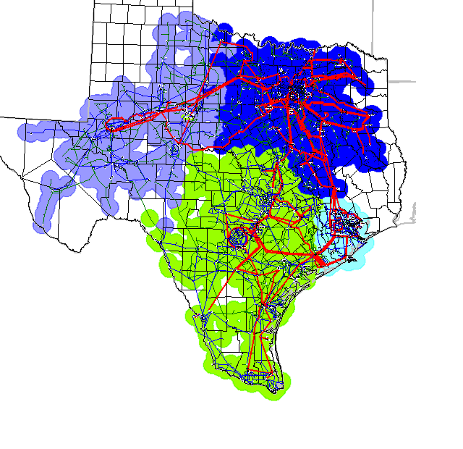

Scenario 1a – Current 2009 CSCs
Scenario 1a was clustered using the post-contingency with the Fisher to Bowman 345kV line 2010 DSA SUM1 base case. The 2009 CSCs were used and the model was clustered into four zones.

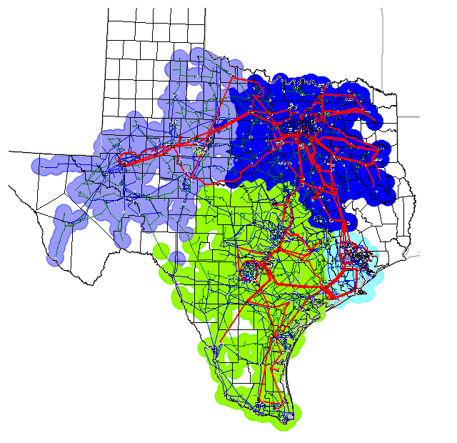

Scenario WN1-4Z
Scenario WN1-4Z was clustered using the pre-contingency 2010 DSA SUM1 base case. This is a 4 zone scenario with the 2009 CSCs for N_S, S_N, and N_H; the N_W and the W_N CSCs were modeled as the Long Creek to Graham and Cook Field to Graham 345kV lines.

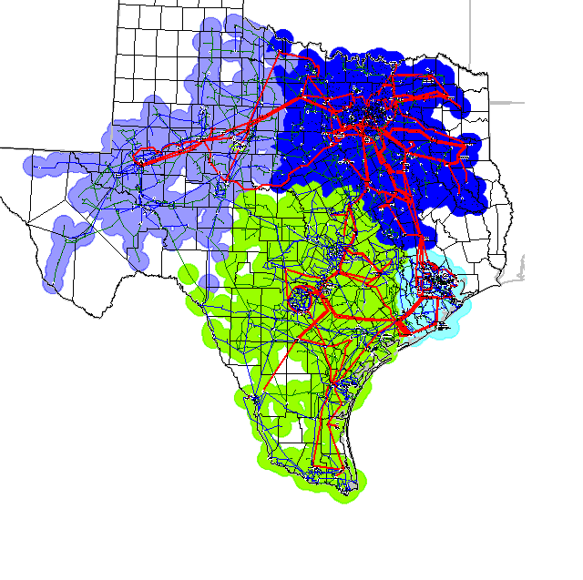

Scenario WN1-5Z
Scenario WN1-5Z was clustered using the pre-contingency 2010 DSA SUM1 base case. This is a 5 zone scenario with the 2009 CSCs for N_S, S_N, and N_H; the N_W and the W_N CSCs were modeled as the Long Creek to Graham and Cook Field to Graham 345kV lines.

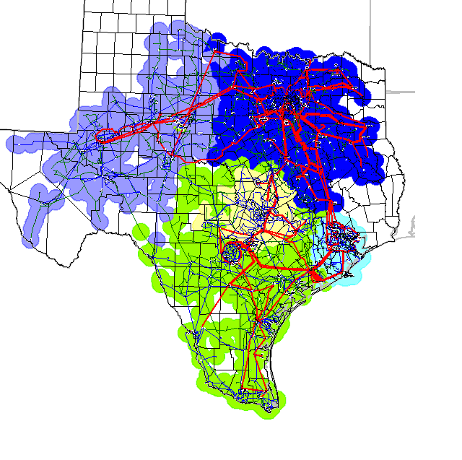

Scenario WN1-6Z
Scenario WN1-6Z was clustered using the pre-contingency 2010 DSA SUM1 base case. This is a 6 zone scenario with the 2009 CSCs for N_S, S_N, and N_H; the N_W and the W_N CSCs were modeled as the Long Creek to Graham and Cook Field to Graham 345kV lines.

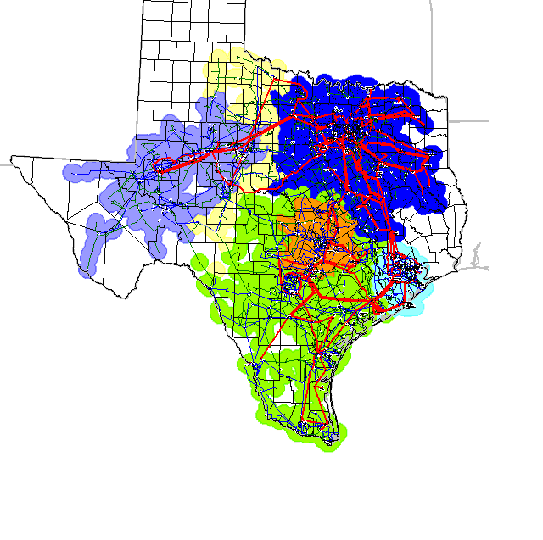

Scenario WN2-4Z
Scenario WN2-4Z was clustered using the pre-contingency 2010 DSA SUM1 base case. This is a 4 zone scenario with the 2009 CSCs for N_S, S_N, and N_H; the N_W CSC is excluded and the W_N CSC was modeled as the Stability interface. The Stability Limit monitored lines are:
- Graham – Cook Field
- Jacksboro – Bowman
- Graham – Tonkawa
- Bowman – Graham
- Comanche Switch – Red Creek
- Graham – Long Creek

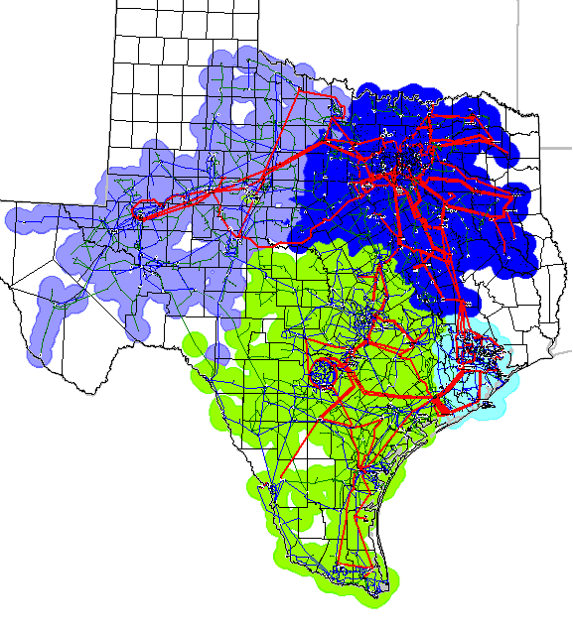

Scenario WN2-5Z
Scenario WN2-5Z was clustered using the pre-contingency 2010 DSA SUM1 base case. This is a 5 zone scenario with the 2009 CSCs for N_S, S_N, and N_H; the N_W CSC is excluded and the W_N CSC was modeled as the Stability interface.

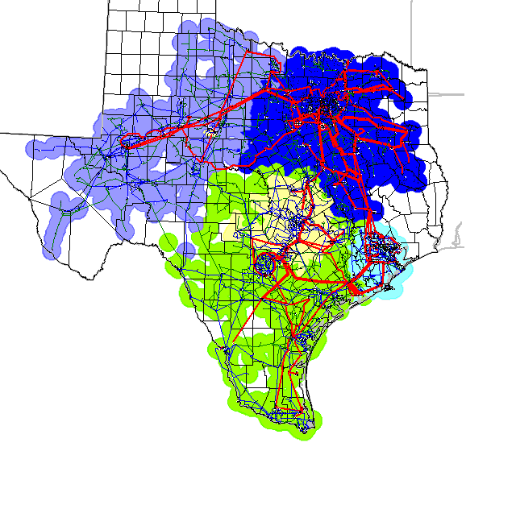

Scenario WN2-6Z
Scenario WN2-6Z was clustered using the pre-contingency 2010 DSA SUM1 base case. This is a 6 zone scenario with the 2009 CSCs for N_S, S_N, and N_H; the N_W CSC is excluded and the W_N CSC was modeled as the Stability interface.

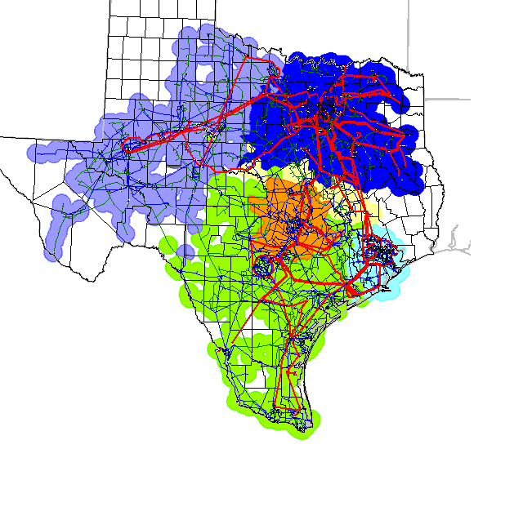

Scenario WN3-4Z
Scenario WN3-4Z was clustered using the pre-contingency 2010 DSA SUM1 base case. This is a 4 zone scenario with the 2009 CSCs for N_S, S_N, and N_H; the N_W and the W_N CSCs were modeled as the Graham to Parker double circuit

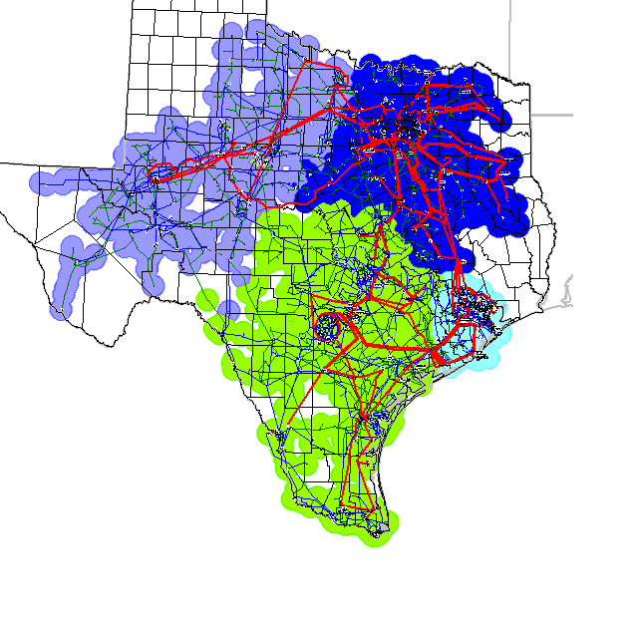

Scenario WN3-5Z
Scenario WN3-5Z was clustered using the pre-contingency 2010 DSA SUM1 base case. This is a 5 zone scenario with the 2009 CSCs for N_S, S_N, and N_H; the N_W and the W_N CSCs were modeled as the Graham to Parker double circuit

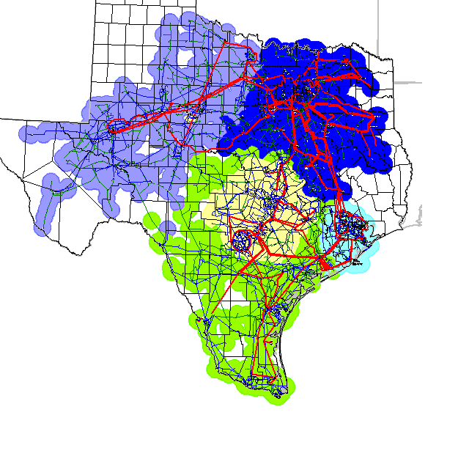

Scenario WN3-6Z
Scenario WN3-6Z was clustered using the pre-contingency 2010 DSA SUM1 base case. This is a 6 zone scenario with the 2009 CSCs for N_S, S_N, and N_H; the N_W and the W_N CSCs were modeled as the Graham to Parker double circuit

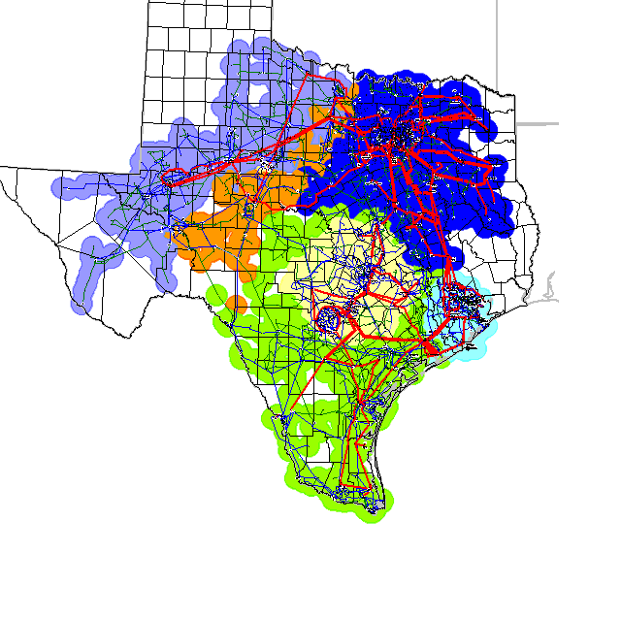

Scenario NH4L-4Z
Scenario NH4L-4Z was clustered using the pre-contingency 2010 DSA SUM1 base case. This is a 4 zone scenario with the 2009 CSCs for N_S, S_N, N_W, W_N, and with N_H clustered using the four lines that go into Houston.

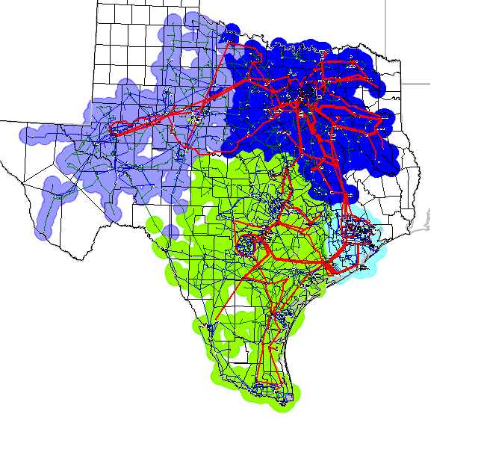

Scenario SN1-4Z
Scenario SN1-4Z was clustered using the pre-contingency 2010 DSA SUM1 base case. This is a 4 zone scenario with the 2009 CSCs for N_S, N_W, W_N, and N_H; the S_N CSC was defined as the Sandow-Temple Switch 345kV double circuit.

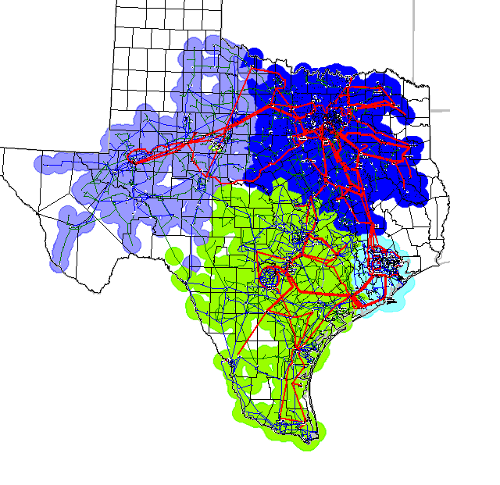

Scenario SN1-5Z
Scenario SN1-5Z was clustered using the pre-contingency 2010 DSA SUM1 base case. This is a 5 zone scenario with the 2009 CSCs for N_S, N_W, W_N, and N_H; the S_N CSC was defined as the Sandow-Temple Switch 345kV double circuit.

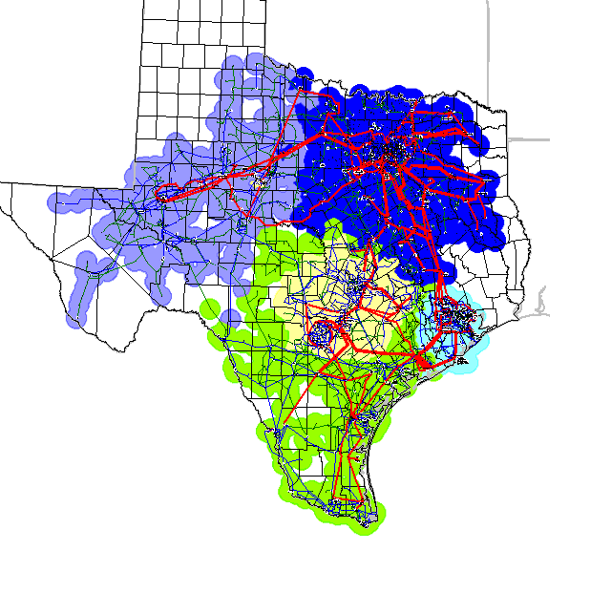

Scenario FW1-5Z
Scenario FW1-5Z was clustered using the pre-contingency 2010 DSA SUM1 base case. This is a 5 zone scenario with the 2009 CSCs for N_S, S_N, W_N, N_W, and N_H; the F_W CSC was defined as China Radium and Bitter Creek-Mulberry Creek.

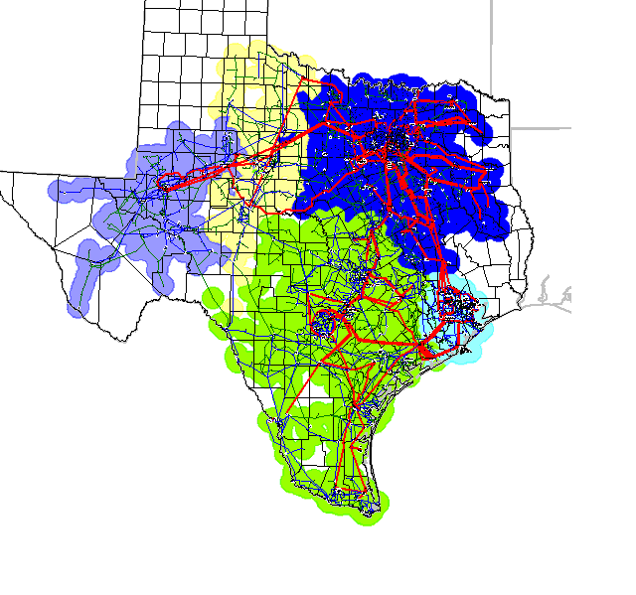

Scenario FW2-5Z
Scenario FW2-5Z was clustered using the pre-contingency 2010 DSA SUM1 base case. This is a 5 zone scenario with the 2009 CSCs for N_S, S_N, N_W, W_N, and N_H; the F_W CSC was defined as China Radium and McElmur-Potter.

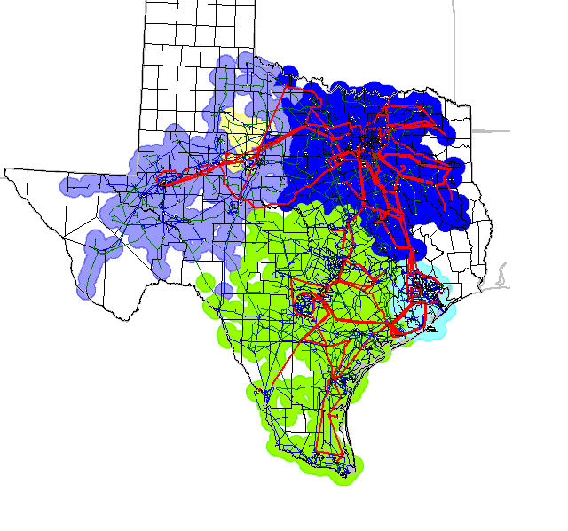

Scenario FW1_WN1-5Z
Scenario FW1_WN1-5Z was clustered using the pre-contingency 2010 DSA SUM1 base case. This is a 5 zone scenario with the 2009 CSCs for N_S, S_N and N_H; the W_N CSC is Long Creek to Graham and Cook Field to Graham 345kV lines and the F_W CSC was defined as China Radium and Bitter Creek-Mulberry Creek.

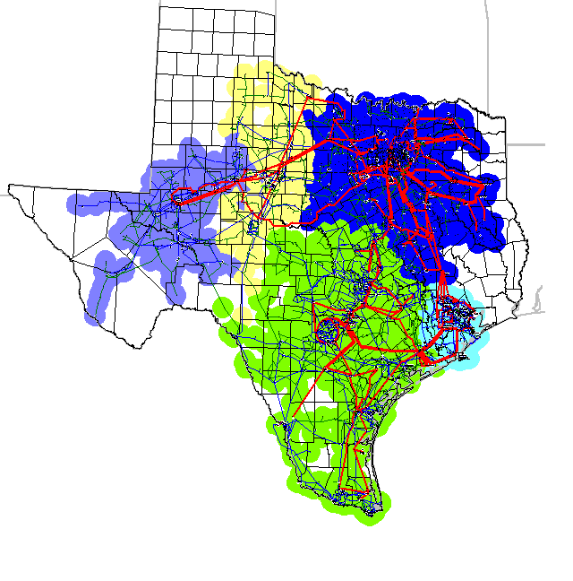

Scenario FW2_WN1-5Z
Scenario FW2_WN1-5Z was clustered using the pre-contingency 2010 DSA SUM1 base case. This is a 5 zone scenario with the 2009 CSCs for N_S, S_N and N_H; the W_N CSC is Long Creek to Graham and Cook Field to Graham 345kV lines and the F_W CSC was defined as China Radium and McElmur-Potter.

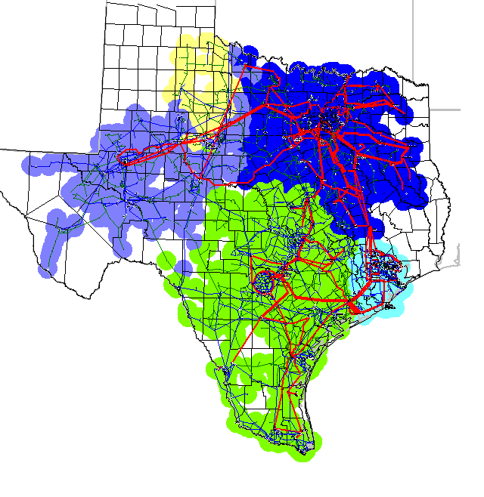

Scenario WN2_SN1_NH4L
Scenario WN2_SN1_NH4L was clustered using the pre-contingency 2010 DSA SUM1 base case. This is a 4 zone scenario with the 2009 CSC for N_S only; N_W and W_N were defined as the stability limit interface; N_H was defined with the 4 lines that import into Houston; the S_N CSC was defined as the Sandow-Temple Switch 345kV double circuit.

