Commercial Operations Market Guide
Section 8: Settlement Statements and Invoices
Month XX, 2009

8. Settlement Statements and Invoices 1
8.1 Congestion Revenue Rights (CRR) Settlement Statement and Invoice Examples 1
8.1.1 CRR Invoices 1
8.2 Day Ahead Market Statement/Invoice 5
8.2.1 DAM Statement/Invoice 6
8.2.2 DAM Late Fee Invoice 7
8.3 Real-Time Market Statements and Invoices 9
8.3.1 RTM Statements 9
8.3.2 RTM Invoices 11

Settlement Statements and Invoices
The Real-Time Market (RTM), Day–Ahead Market (DAM), and the Congestion Revenue Right (CRR)Auction are settled separately. There are three different settlement statements, three different invoices, and the potential for three different settlement timelines – Initial, Final and True-up.

The Settlements Calendar and Qualified Scheduling Entity (QSE) Settlement and CRR Account Holder Statements are available on the MIS. The Settlements Calendar is located in the Public Area for anyone to access and the QSE’s Settlement Statement is posted in the Secure Area for access by the QSE. When viewing QSE Settlement Statements, a negative amount represents a payment due to the QSE and a positive amount represents a payment due to ERCOT.

Information about the Settlements Calendar, Statements, and Invoices may be found in Protocol Section 9, Settlement and Billing.

8.1 Congestion Revenue Rights (CRR) Settlement Statement and Invoice Examples
ERCOT shall prepare invoices for each CRR Auction (CRR Auction Invoice) on a net basis. Invoices must be issued on the first Business Day following the completion of a CRR Auction on the date specified in the Settlement Calendar.
Payments for CRR Auction Invoices are due on the applicable payment due date, whether or not there is any Settlement and Billing dispute regarding the amount of the payment.

CRR Invoices
For each CRR Auction Invoice, the CRR Account Holder to whom the Invoice is addressed (“Invoice Recipient”) is either a net payee or net payor. The Invoice Recipient is responsible for accessing the CRR Auction Invoice on the MIS Certified Area once posted by ERCOT. If a Statement date occurs on a day that is not a bank Business Day, the statements will be issued on the next bank Business Day.
CRR Statement/Invoice Timeline
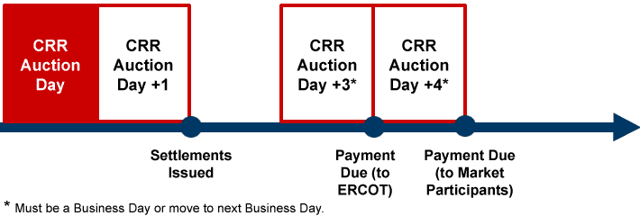

8.1.1.1 CRR Annual Auction Invoice
Monthly and Annual Invoices are issued as separate invoices, however the formatting is the same for each. The invoice will indicate whether it pertains to Monthly or Annual Auction.
8.1.1.2 CRR Monthly Auction Invoice
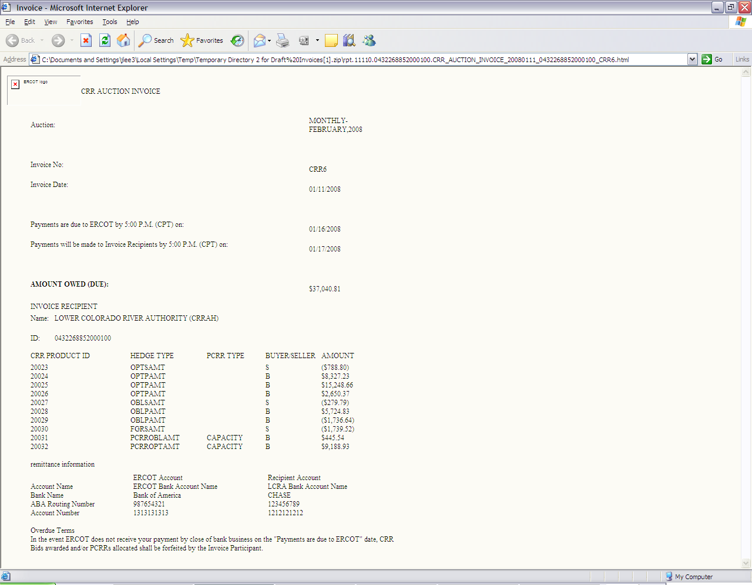
8.1.1.3 CRR Auction Revenue Distribution (CARD) Invoice
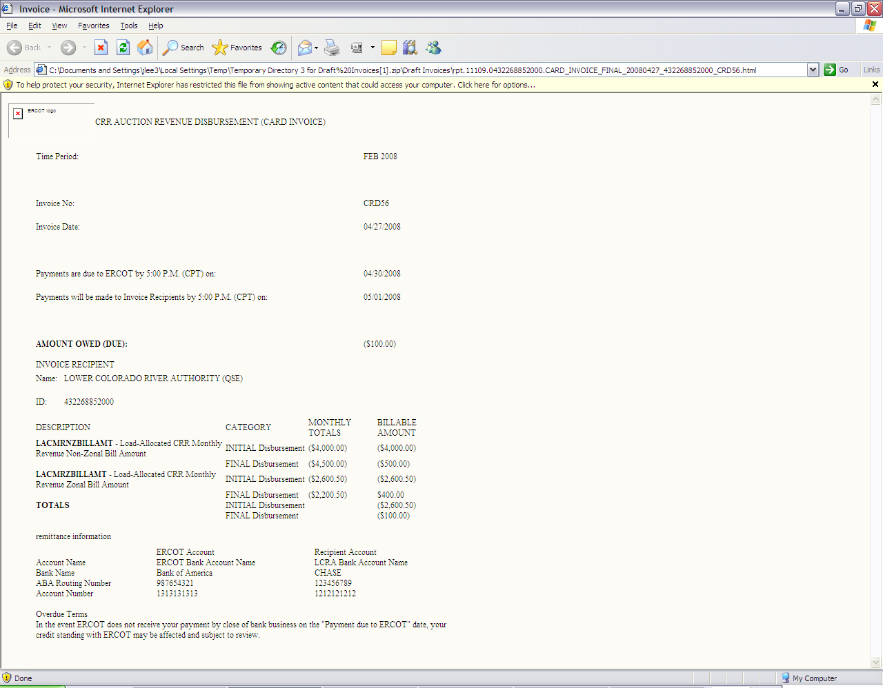

      - CRR Balancing Account Invoice
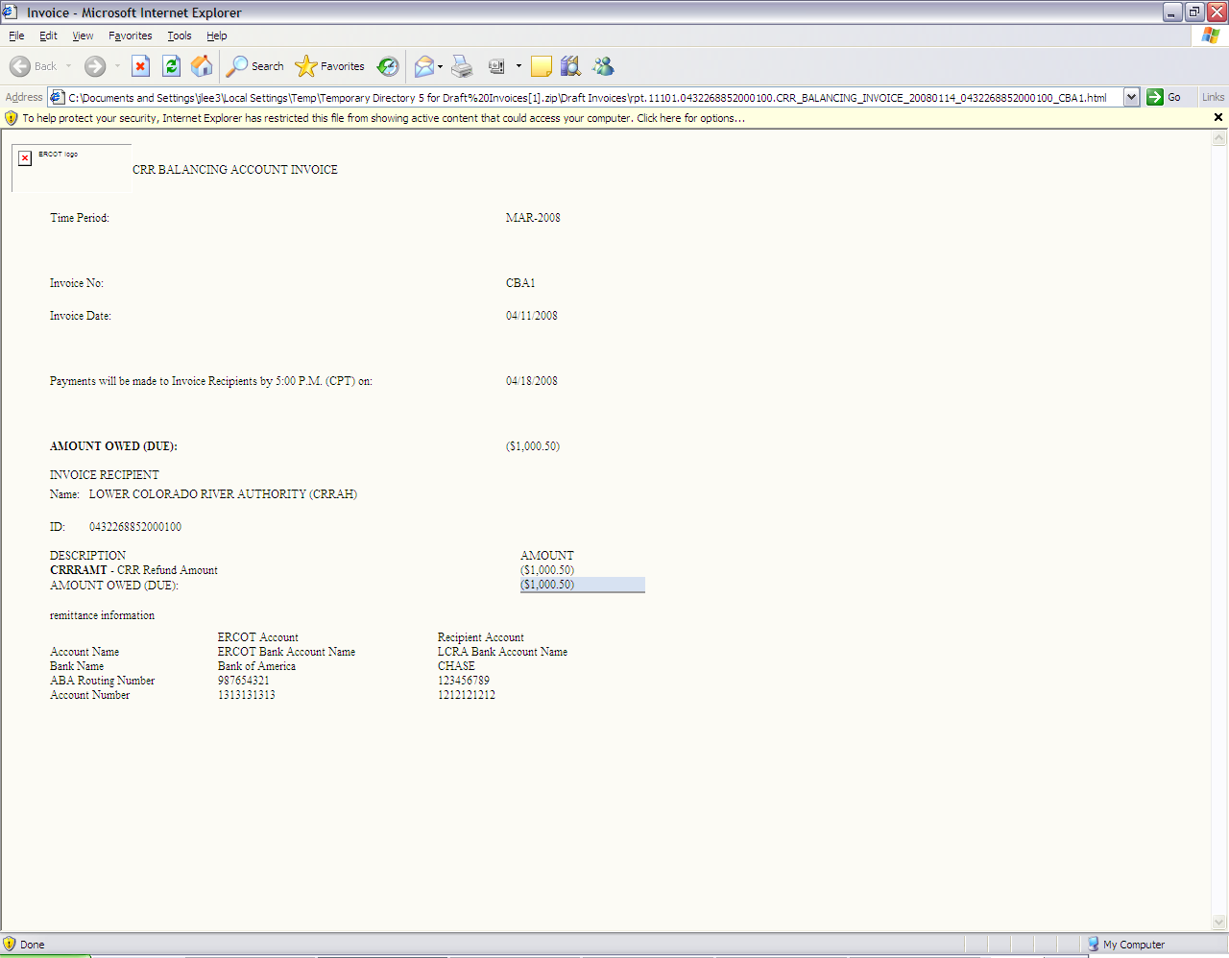

  - Day Ahead Market Statement/Invoice
The Day-Ahead Market (DAM) statements and invoices for CRR Account Holders and QSEs are issued two days after the operating day. Payments due to ERCOT shall occur on the 4th Business Day from receipt of invoice, which equals the Operating Day +6. On day seven, ERCOT pays those QSEs who are entitled to money from their participation in the DAM.

DAM Statement/Invoice Timeline
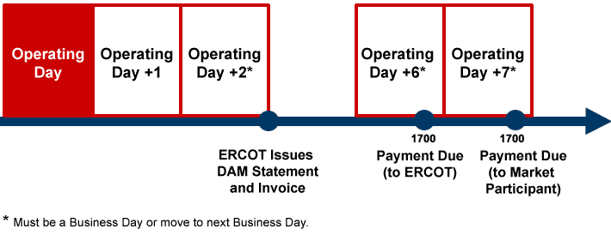

    - DAM Statement/Invoice
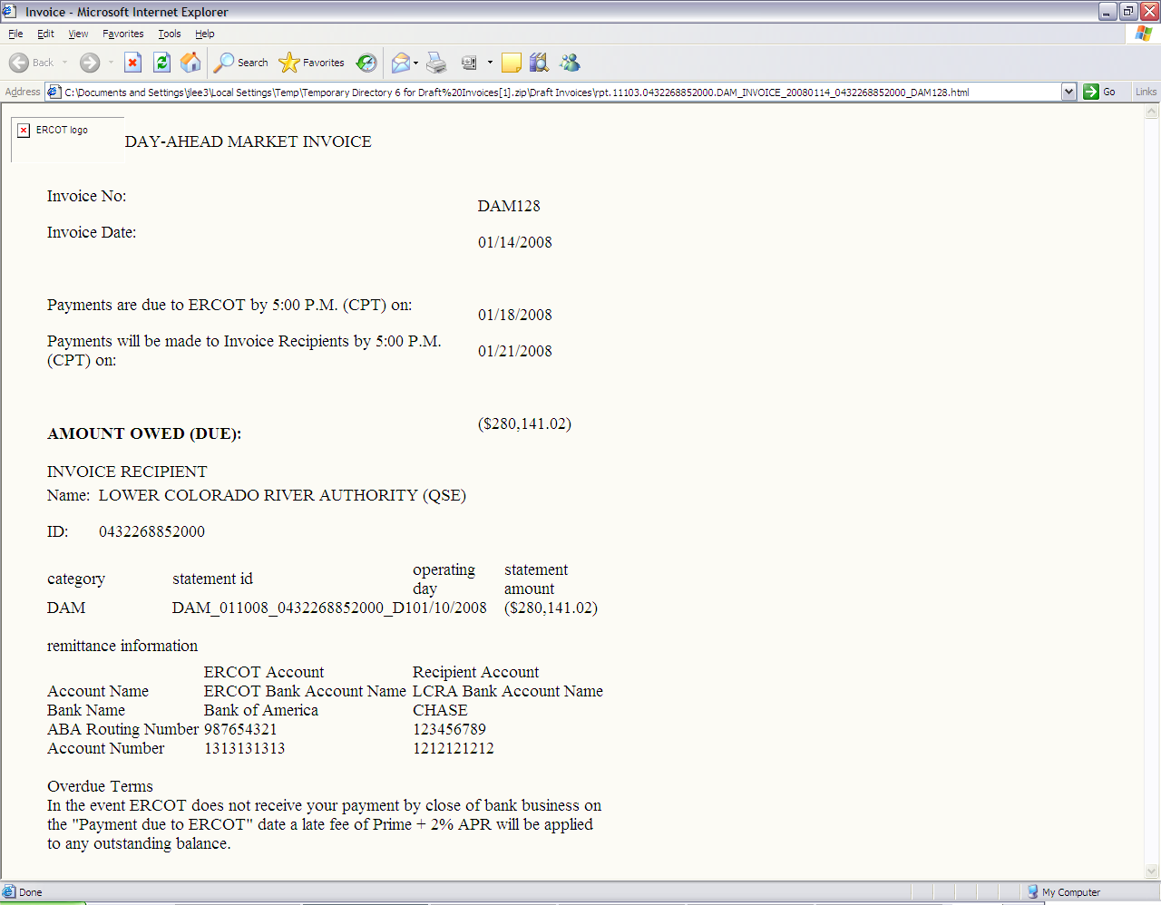

    - DAM Late Fee Invoice

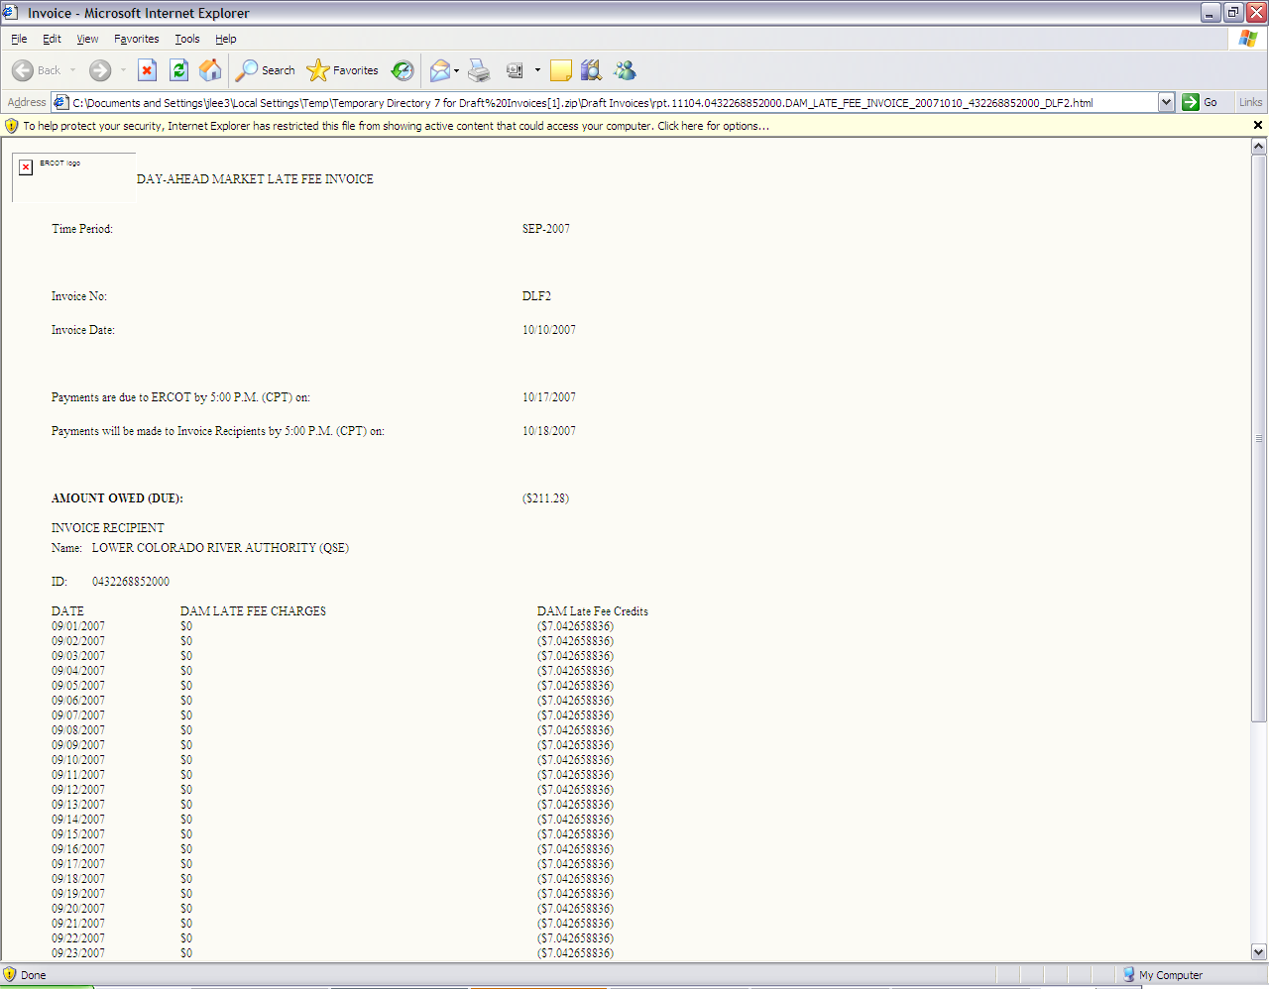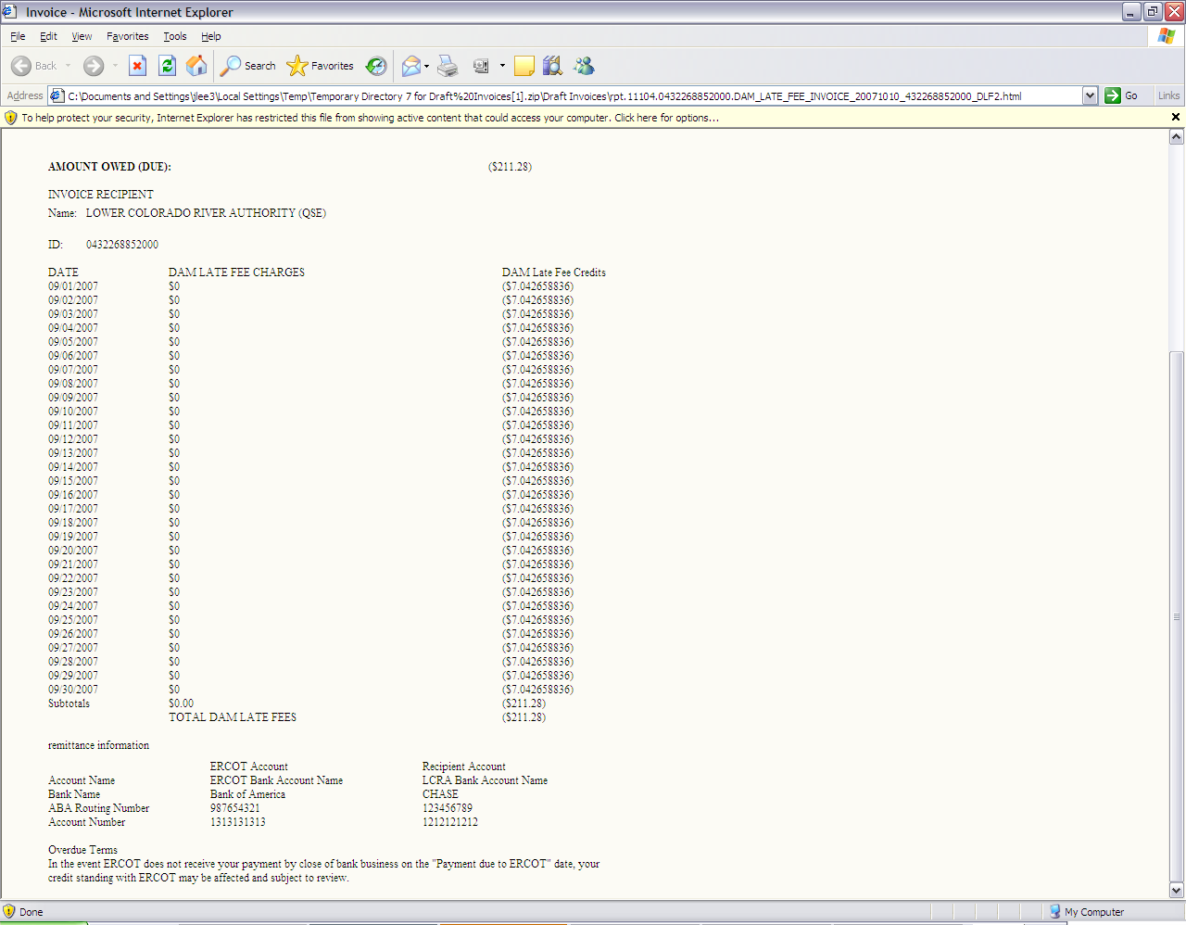

8.3 Real-Time Market Statements and Invoices
ERCOT shall produce daily Settlement Statements for the Real-Time Market (RTM), as defined in Nodal Protocol Section 9.5.2, Settlement Statements for the RTM, that show a breakdown of Charge Types incurred in the RTM, including any administrative and miscellaneous charges applicable to the RTM.

RTM Statement/Invoice Timeline

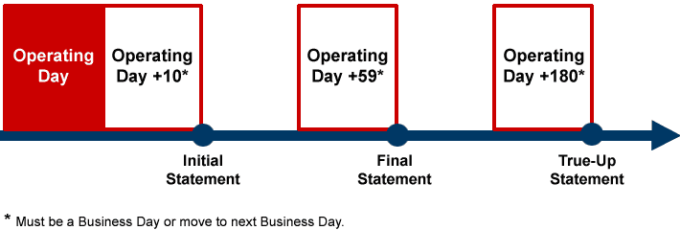

A Settlement Statement for the RTM can be:
(a) An “RTM Initial Statement,” which is the first iteration of a Settlement Statement issued for a particular Operating Day;
(b) An “RTM Final Statement,” which is the statement issued at the end of the 59th day following the Operating Day;
(c) An “RTM Resettlement Statement,” which is the statement using corrected Settlement data due to resolution of disputes and correction of data errors; or
(d) An “RTM True-Up Statement,” which is a statement issued at the end of the 180th day after the Operating Day.

8.3.1 RTM Statements
ERCOT shall make each Settlement Statement for the RTM for an Operating Day available on the date specified on the Settlement Calendar for that Operating Day by posting it to the Market Information System (MIS) Certified Area for the applicable Statement Recipient.
8.3.1.1 RTM Initial Statement
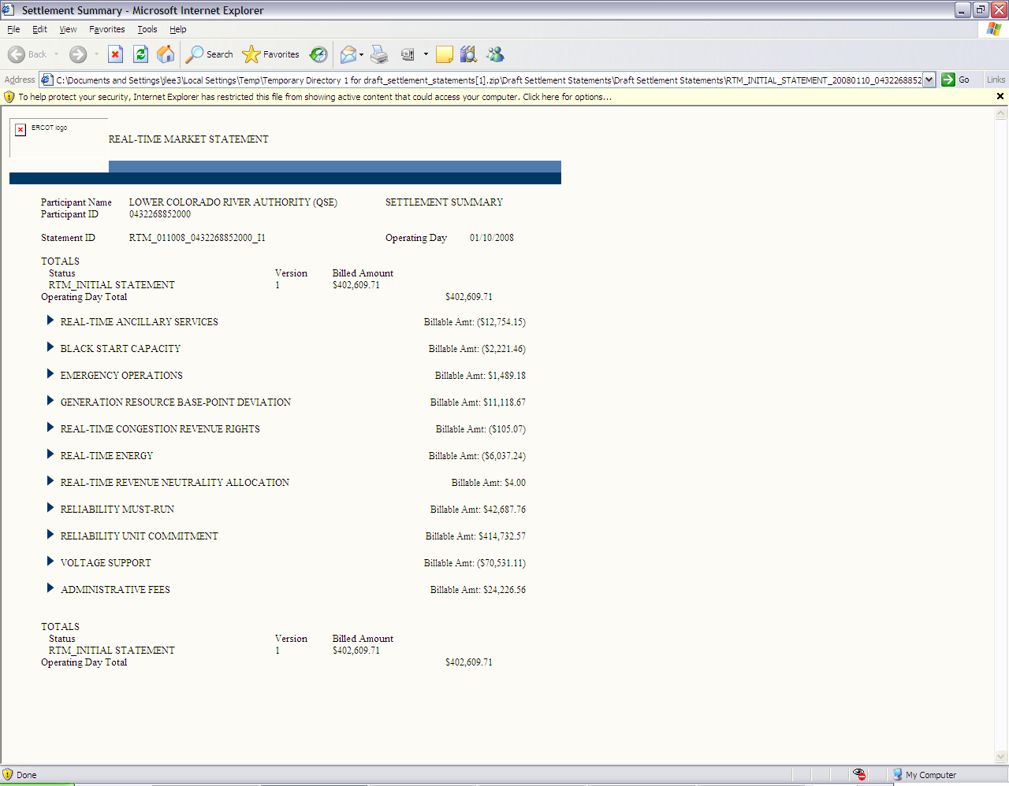
8.3.1.2 RTM Final Statement
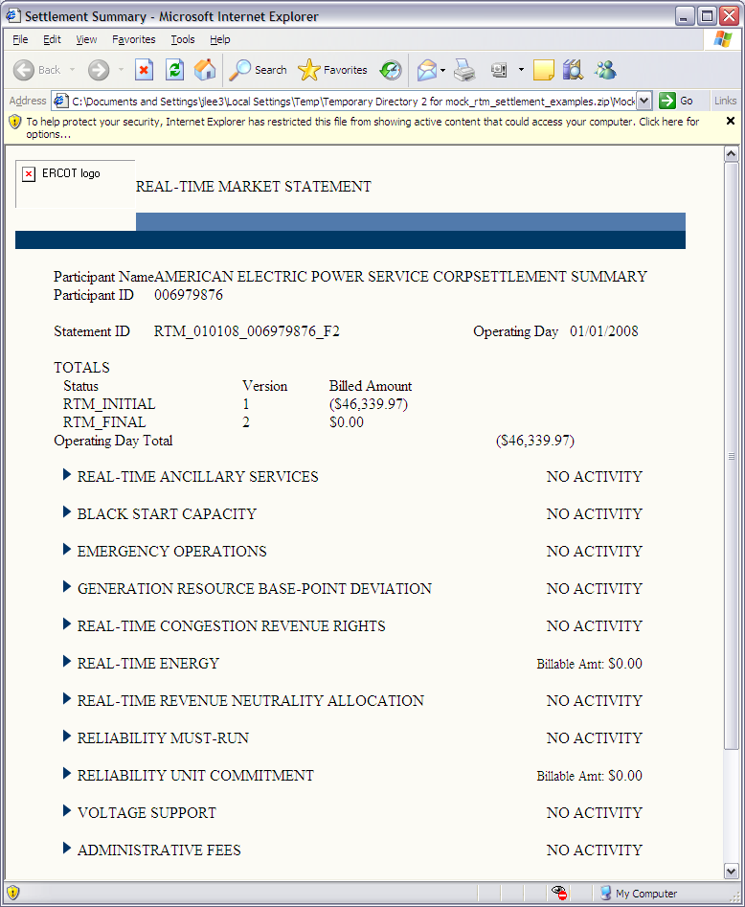
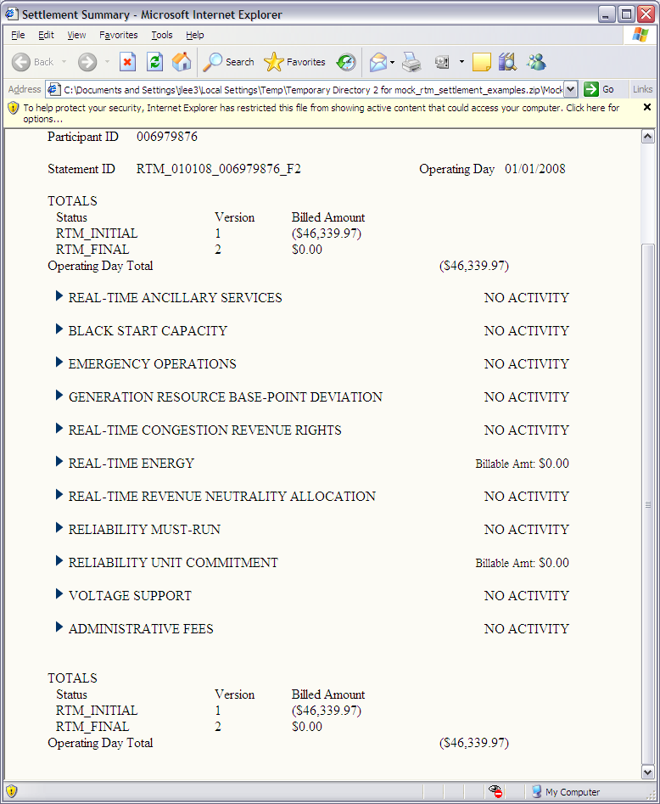
8.3.1.3 RTM True-Up Statement
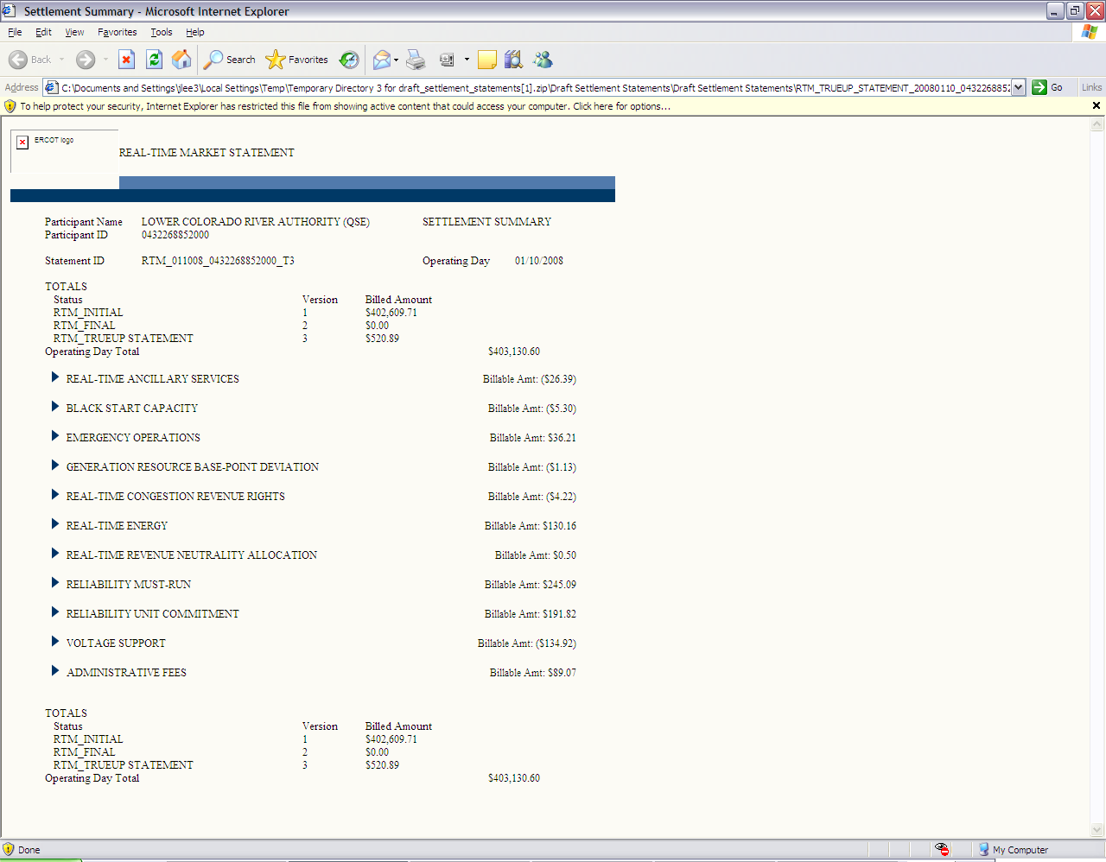
8.3.1.4 RTM Resettlement Statement
Provide Example

8.3.2 RTM Invoices
ERCOT shall prepare Settlement Invoices for the RTM (RTM Invoices) on a net basis for each Invoice cycle based on RTM Initial Statements, RTM Final Statements, RTM True-Up Statements and RTM Resettlement Statements. ERCOT must issue Invoices on a weekly basis on each Thursday, unless that Thursday is not a Business Day. If a Thursday is not a Business Day, ERCOT shall issue the RTM Invoices on the next Business Day after that Thursday.
ERCOT shall post RTM Invoices on the MIS Certified Area. The Invoice Recipient is responsible for accessing the RTM Invoice on the MIS Certified Area once posted by ERCOT.
8.3.2.1 RTM Settlement Invoice
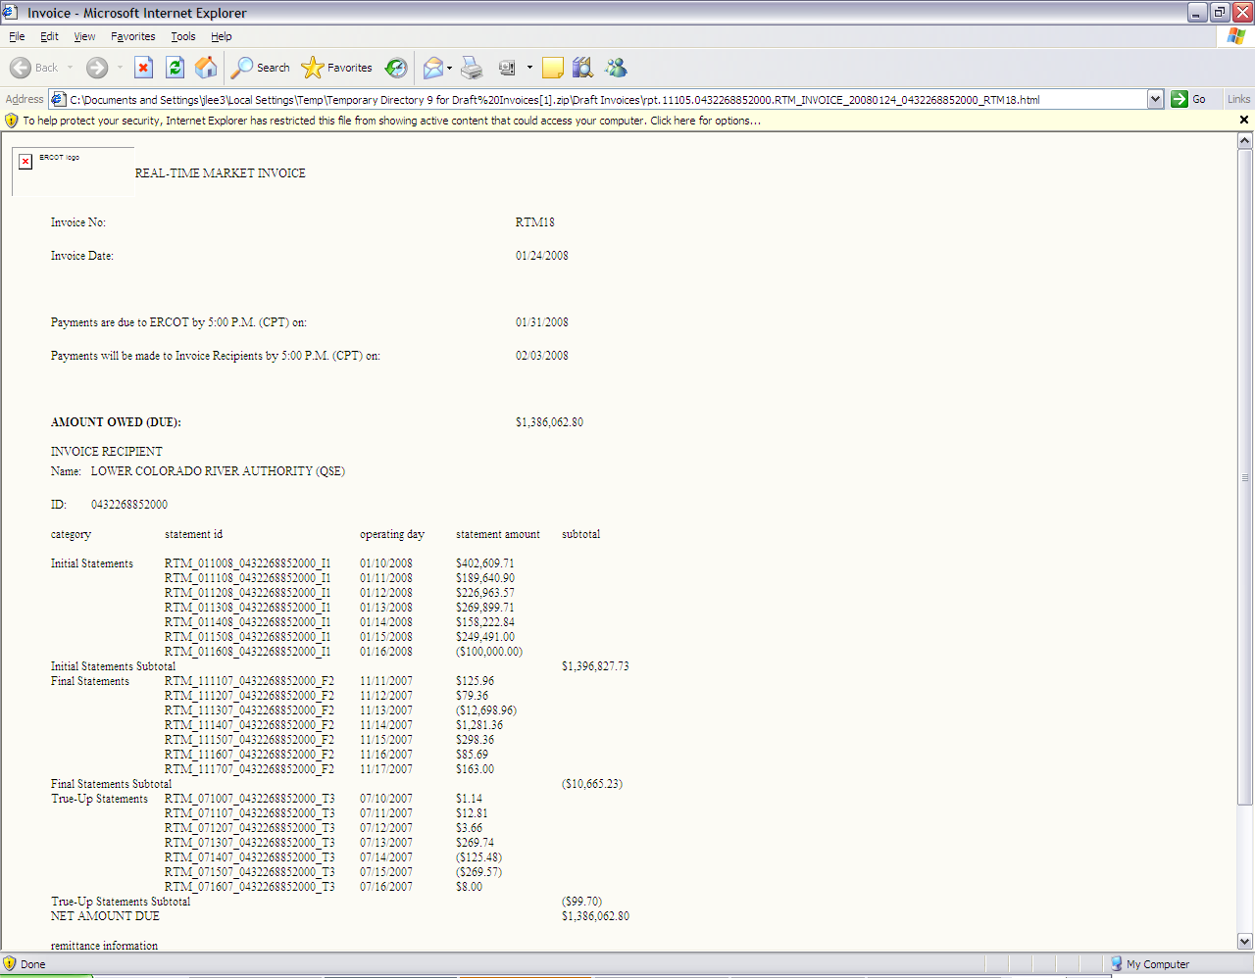
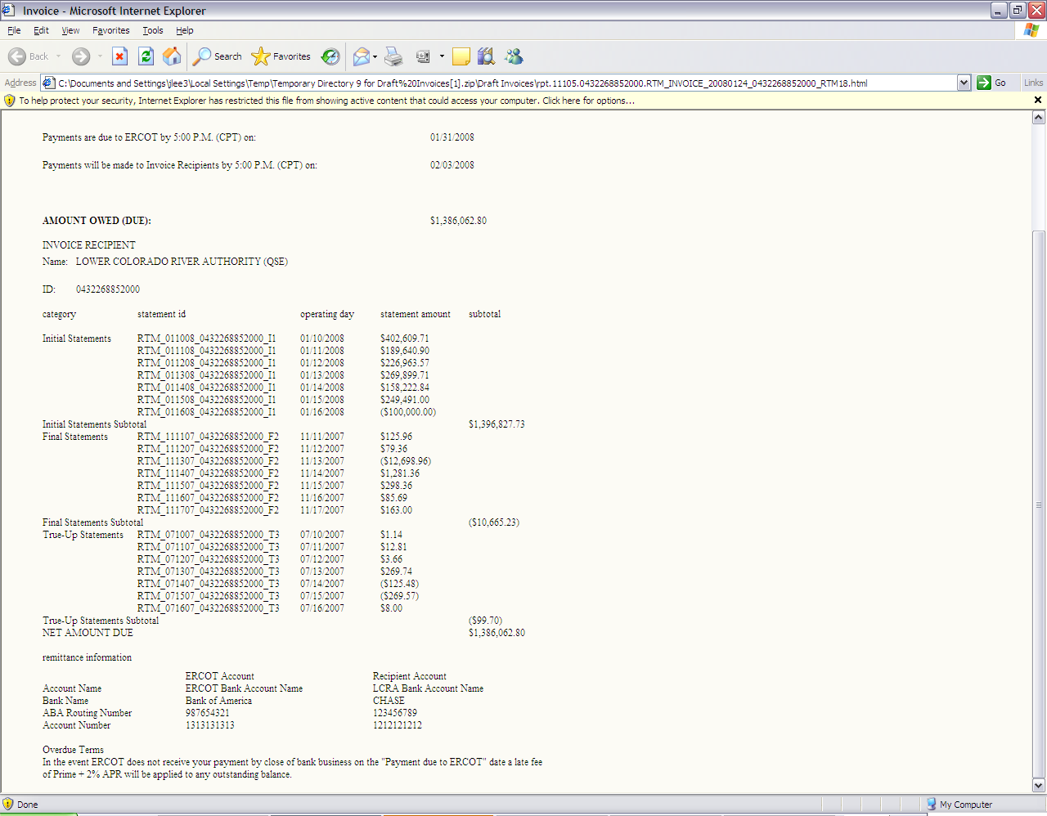

8.3.2.2 RTM Up-lift Invoice
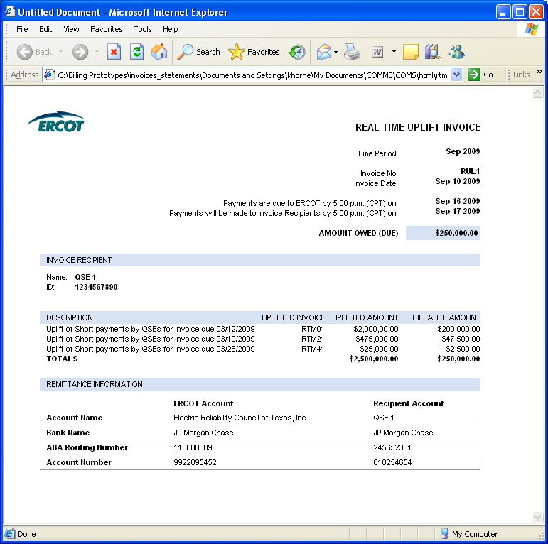
8.3.2.3 RTM Late Fee Invoice
