ERCOT Operations Report
June 2009 ROS & OWG

Frequency Control
Time | Freq(Hz) | Duration (s)
6/3/2009 3:59 | 60.109 | 1070 | SCE + 700 MW in 10 min. Out of Down Regulation
6/11/2009 23:02 | 60.102 | 504 | SCE +1700 MW in 30 mins, Out of Down Regulation
6/12/2009 0:02 | 60.102 | 150 | Out of Down Regulation.
6/16/2009 16:51 | 59.894 | 6 | Unit trip with 554 MW
6/20/2009 19:49 | 59.859 | 12 | Unit trip with 790 MW
6/28/2009 19:02 | 59.892 | 4 | Unit trip with 345 MW
Note: Time of frequency excursions outside the range of +/- 0.1 Hz.
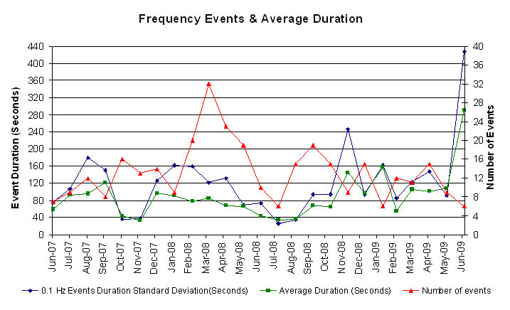
Deployed Responsive (Reported Above)
Time deployed | Stop Time | Duration | Max | Details
6/3/09 01:50:22 | 6/3/09 02:03:18 | 0:12:56 | 332.6 | Incorrect Offset.
6/12/09 03:20:16 | 6/12/09 03:38:04 | 0:17:48 | 332.6 | Out of up Reg.
6/15/09 08:05:32 | 6/15/09 08:18:32 | 0:13:00 | 322.8 | Large SCE change -1100MW in 10 min
6/16/09 00:02:08 | 6/16/09 00:12:06 | 0:09:58 | 332.6 | Large SCE change -1000MW in 8 min
6/16/09 16:51:30 | 6/16/09 17:11:20 | 0:19:50 | 411.7
6/18/09 21:04:48 | 6/18/09 21:20:20 | 0:15:32 | 348.5 | Out of up Reg.
6/18/09 23:20:24 | 6/18/09 23:47:22 | 0:26:58 | 348.5 | Out of up Reg.
6/19/09 00:02:12 | 6/19/09 00:07:44 | 0:05:32 | 322.1 | Large SCE change -600MW in 4 min
6/20/09 19:49:12 | 6/20/09 20:00:06 | 0:10:54 | 586.1
6/25/09 14:26:59 | 6/25/09 14:48:41 | 0:21:42 | 369.6 | Out of up Reg.
6/25/09 21:59:04 | 6/25/09 22:06:45 | 0:07:41 | 359.0 | Unit trip
6/26/09 09:11:17 | 6/26/09 09:20:04 | 0:08:47 | 364.3 | Unit trip
6/28/09 19:02:43 | 6/28/09 19:16:30 | 0:13:47 | 411.9

Day-Ahead OOMC and RPRS Capacity Purchases
Details | OOMC | RPRS S1 | RPRS S2 | RPRS S1+S2 | RMR | Total
DFW | 37 | 14 | 40 | 54 | 0 | 91
North | 8 | 29 | 32 | 61 | 0 | 69
Houston | 0 | 2 | 58 | 60 | 0 | 60
E RIO | 27 | 4 | 0 | 4 | 0 | 31
Western | 6 | 2 | 7 | 9 | 6 | 21
San Antonio | 0 | 12 | 4 | 16 | 0 | 16
Corpus | 14 | 1 | 0 | 1 | 0 | 15
Laredo | 0 | 14 | 1 | 15 | 0 | 15
South | 0 | 11 | 0 | 11 | 0 | 11
Austin | 1 | 4 | 3 | 7 | 0 | 8
Bryan Area | 5 | 0 | 2 | 2 | 0 | 7
W RIO | 0 | 1 | 0 | 1 | 0 | 1
Northeast | 0 | 0 | 1 | 1 | 0 | 1
Total | 98 | 94 | 148 | 242 | 6 | 346

Historical Totals | Jun-09 | Jun-08 | May-09
Austin | 5 | 66 | 9
Bryan Area | 5 | 10 | 2
Corpus | 15 | 0 | 10
DFW | 51 | 7 | 18
E RIO | 31 | 19 | 2
Houston | 2 | 8 | 31
Laredo | 14 | 81 | 13
North | 37 | 46 | 19
Northeast | 0 | 0 | 0
San Antonio | 12 | 63 | 10
South | 11 | 15 | 6
W RIO | 1 | 3 | 86
Western | 14 | 131 | 7
Total | 198 | 449 | 213

http://www.ercot.com/mktinfo/services/rprsdr/index.html
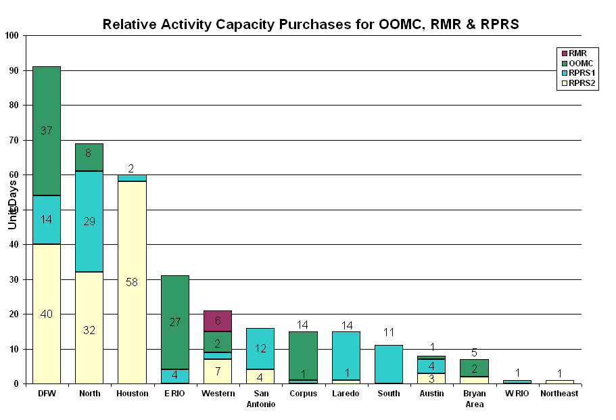
OOME and Congestion Management Activity
Congestion affected by outages. Remedial action plan has been developed for the element
Contingency | Overloaded Element | Days
Dilley Switch - San Miguel Switch 138KV | Derby - Pearsall 69KV | 23
Tradinghouse SES - Venus Switch 345KV | Rogers Hill TU - Bosque Switch 138KV | 15
Basecase | San Angelo Power Station - Shrew Tap 138KV | 13
Temple Pecan Creek - Tradinghouse & Temple Switch - Lake Creek 345KV | San Angelo Power Station - Shrew Tap 138KV | 13
Tradinghouse SES - Venus Switch 345KV | Rogers Hill TU - Elm Mott 138KV | 13
Abilene South - Eskota Switch 138KV | Merkel - Trent 69KV | 11
Skyline - Marion and Elm Creek 345KV | Hill Country - Marion 345KV | 10
Enterprise - Trinidad SES & Martin Lake SES - Stryker Creek SES 345KV | Nacogdoches 345/138KV autotransformer | 8
Menard - Gillespie 138KV | Menard 138/69KV autotransformer | 7
San Miguel Switchyard 345/138KV transformer A | San Miguel Switchyard 345/138KV transformer B | 7
Aspermont - Spur 138KV | Jayton CSW - Spur 69KV | 6
Chamber - King and Cedar Bayou - North Belt 345KV | Center - PH Robinson 345KV | 5
Austrop - Garfield and Zorn 345KV | Elgin Switch - Gilleland Creek 138KV | 5
Morgan Switch - Quail Switch - Longshore Switch 345KV | Midland East - Stanton East Switch 138KV | 5
Temple Pecan Creek - Tradinghouse SES & Temple Switch - Lake Creek 345KV | West Waco - Lorena 69KV | 5
Garfield - Onion Creek & Hicross 138KV | Pilot - Lytton Springs 138KV | 4
Hill Country - Marion & Elm Creek 345KV | Marion - Skyline 345KV | 4
Odessa EHV 345/138KV autotransformer #2 | Odessa EHV 345/138KV autotransformer #1 | 4
Oklaunion - Fisher Road - Bowman 345KV | Vernon - Grayback 69KV | 4
Temple Pecan Creek - Tradinghouse SES & Temple Switch - Lake Creek 345KV | Waco Woodway - Waco West 138KV | 4
Tradinghouse SES - Venus 345KV | Whitney - Lake Whitney 138KV | 4
Twin Buttes - San Angelo 345KV | Twin Buttes Transformer 1L | 4
Graham SES- Long Creek Switching Station 345KV | San Angelo Power Station - Shrew Tap 138KV | 3
San Angelo Red Creek 345/138KV transformer T2 | San Angelo Red Creek 345/138KV transformer T1 | 3
Aspermont - Spur 138KV | Spur 138/69KV transformer | 3
Austrop - Lost Pines 345KV | Fayetteville 345/138KV Autotransformer 2 | 3
Comanche Peak Units 1 and 2 | Bosque Switch - Lake Whitney 138KV | 3
Elm Mott - Whitney 138KVKV | Lake Whitney - Bosque Switch 138KV | 3
Falfurrias - North Edinburg 138KV | Alice - North Ella 69KV | 3
Pawnee - Lon Hill 345KV | Kennedy Sub - Kennedy Switch 69KV | 3
Kendall 345/138KV transformer T2 | Raymond F. Barker 138/69KV Autotransformer | 2
Skyline - Marion and Elm Creek 345KV | Schertz - Parkway 138KV | 2
Calaveras Facility Unit JT Dealy 1 138KV | Cagnon - Marbach Road 138KV | 2
Comanche Peak Units 1 and 2 | Whitney TU- Lake Whitney 138KV | 2
Austrop T1 345/138KV autotransformer | Garfield - Hicross 138KV | 1
Cagnon 345/138KV transformer T3 | Cagnon 345/138KV transformer T4 | 1
Comanche Peak - Decordova and Wolf Hollow - Rocky Creek 345KV | Concord 345/138KV transformer | 1
Denton 138/69KV transformer T1 | Woodrow - King Co 69KV | 1
Elkton - Tricorner - Martin Lake 345KV | Tyler Northeast - Delek POI | 1
Elkton - Tricorner - Martin Lake 345KV | Walnut Grove - Troup 138KV | 1
Jack County - Reno 138KV | Rhome TU - Decatur Tap 138KV | 1
Marion - Zorn and Clear Springs 345 KV | Schertz - Parkway 138KV | 1
Marion - Zorn and Clear Springs 345 KV | Seguin - Seguin West 138KV | 1
North Denton - West Denton 138KV | Teasley - West Denton 138KV | 1
Odessa EHV Switch - Moss Switch 138KV | Rexall - General Tire Switch 138KV | 1
Olinger - Ben Davis & Elm Grove 138KV | Olinger - Swindell 138KV | 1
Pawnee - Lon Hill - Coleto Creek 345KV | Kenedy Switch - Kenedy Sub 69KV | 1
Royse Switch - Farmersville 345KV | Farmersville - Royse Switch 345KV | 1
San Angelo Red Creek - San Angelo North 138KV | Twin Butte 345/138KV Transformer | 1
Fayette Plant 2 - Lytton Springs & Holman 345KV | Fayetteville autotransformer AT2 345/138KV | 1
Spring - Wolf Ridge 138KV | Decatur - Decatur Tap 138KV | 1
Aspermont - Paint Creek 138KV | Aspermont - Aspermont Continental 69KV | 1
Austrop - Garfield and Zorn 345KV | Austrop 345/138KV autotransformer 1 | 1
Austrop - Lost Pines 345KV | Holman - Fayette Plant 2 345KV | 1
Austrop - Lost Pines 345KV | Fayette - Winchester 138KV | 1
Austrop - Lost Pines 345KV | Piney Creek - Winchester 138KV | 1
Austrop - Sandow Switch and Sandow Switch 345/138 kV Auto #2 | Austrop 345/138KV Auto #1 | 1
Basecase | San Angelo Power Station - Menard 138KV | 1
Big Brown - Venus Switch 345KV | Jewett - Big Brown 345KV - 104 | 1
Garfield - Onion - Hicross 138KV | Austrop - Daffin | 1
Graham SES - Benbrook Switch and Graham SES - Parker Switch 345KV | San Angelo Power Station - Shrew Tap 138KV | 1
Jewett 345/138KV transformer | Palestine - Elkhart 69KV | 1
Lamesa - Willow Valley Switch 138KV | Ackerly Vealmoor Switch - Ackerly 69KV | 1
Lon Hill - Coleto Creek 345KV | Kennedy Switch - Beeville 69KV | 1
Midland - Odessa EHV Switch 345KV | Odessa - Odessa North 138KV | 1
Nelson Sharpe - Rio Hondo 345KV | Weslaco - MVEC Weslaco 138KV | 1
North Denton 138/69KV Auto #1 | North Denton 138/69KV Auto #2 | 1
San Angelo Red Creek-San Angelo N 138KV | Twin Butte 345/138KV Transformer | 1
Sandow Switch - Austro 345KV | Gilleland Creek - Elgin Switch 138KV | 1
South Lane City - Lane City 138KV | South Lane City - New Gulf 138KV | 1
Temple Pecan Creek - Tradinghouse and Temple Switch - Lake Creek 345KV | Waco Woodway - Waco Atco 138KV | 1
Temple Switch - Bell County Switch 138KV | Seaton 138/69KV Transformer AT1 | 1
Tradinghouse SES - Venus Switch 345KV | San Angelo Power Station - Shrew Tap 138KV | 1
Wells Branch - Round Rock 138KV | Wells Branch - Round Rock South 138KV | 1
Winchester - Fayetteville 138KV | Winchester - Piney Creek 138KV | 1
Zorn - Austrop - Lytton Springs 345KV | Garfield - Hicross 138KV | 1

Zonal OC1
CSC | Days
North-South | 16
West-North | 14
North-Houston | 7

New RAP (Date indicates last update of RAP not implementation date.)
None

New Procedures/Forms/Operations Bulletins
Date | Subject | Bulletin No.
06/18/2009 | Transmission and Security Desk V 4 Rev 2 | 422
06/18/2009 | Frequency Desk V 4 Rev 2 | 421
06/18/2009 | Shift Supervisor Desk V 4 Rev 2 | 420
06/18/2009 | Operating Period Desk V 3 Rev 2 | 419
06/18/2009 | Day-Ahead Desk V 4 Rev 2 | 418

Blackout/Load Shed Incidences
None

EECP
None

Major System Voltage Problems
None

Major Computer Problems, Enhancements & Fixes
06/29 00:45 Held IE 00:30 Real-time Balancing Market deployment for IE 00:45, resumed with IE 01:00.

Communication
None

ERCOT peak (Unofficial)
06/09 16:00 62,297 MW

Yearly MTLF Error Comparison
Yearly Mid-Term (Hourly) Load Forecast Error Comparison for the ERCOT Forecast
Month | MAPE for MTLF at 16:00 Day-Ahead
Month | 2006 | 2007 | 2008 | 2009
January | 4.79 | 4.55 | 3.30 | 4.11
February | 4.81 | 3.75 | 3.59 | 3.49
March | 4.95 | 2.70 | 3.29 | 3.24
April | 5.59 | 3.00 | 2.45 | 2.66
May | 3.59 | 3.22 | 3.01 | 2.90
June | 2.65 | 4.46 | 2.81 | 2.89
July | 2.62 | 4.29 | 2.55 | NA
August | 2.09 | 3.11 | 3.66 | NA
September | 4.03 | 3.78 | 4.99 | NA
October | 3.63 | 3.08 | 2.79 | NA
November | 3.28 | 2.95 | 2.60 | NA
December | 3.44 | 3.74 | 4.54 | NA
Annual Average | 3.79 | 3.55 | 3.29 | 3.21

OCN, Advisory, Watch & Emergency Notices
Capacity
Date | Start | End | Event
6/2/09 | 2:00 | 14:10 | OCN issued for a projected reserve capacity shortage for HE 1800-2100 and 2300.
6/2/09 | 10:10 | 14:10 | Watch issued for a projected reserve capacity shortage for HE 1700-2000.
6/15/09 | 10:41 | 13:45 | OCN issued for projected reserve capacity shortage for HE 1700.
6/15/09 | 13:45 | 17:00 | Watch issued for projected reserve capacity shortage for HE 1700.
6/20/09 | 9:18 | 13:25 | OCN issued for a projected reserve capacity shortage for HE 16:00-19:00.
6/20/09 | 13:25 | 16:15 | Watch issued for a projected reserve capacity shortage for HE 17:00-19:00.
6/22/09 | 10:45 | 12:45 | OCN issued for a projected reserve capacity shortage for HE 17:00.
6/22/09 | 12:45 | 17:30 | Watch issued for a projected reserve capacity shortage for HE 17:00.
6/25/09 | 11:30 | 0:00 | OCN issued due to high pressure continuing to dominate much of Texas weather. Heat advisories remain in effect for much of Texas. Currently ERCOT does not foresee any System reliability issues but this unusual heat has a reasonable expectation of leading ERCOT near record breaking demand. ERCOT will continue to monitor actual and forecasted weather.
6/25/09 | 14:28 | 19:00 | Advisory issued for ARRS below 3000 MW.
6/26/09 | 0:15 | 0:00 | OCN issued due to high pressure continuing to dominate much of Texas weather. Heat advisories remain in effect for much of Texas. Currently ERCOT does not foresee any System reliability issues but this unusual heat has a reasonable expectation of leading ERCOT near record breaking demand. ERCOT will continue to monitor actual and forecasted weather.
6/27/09 | 0:15 | 0:00 | OCN issued due to high pressure continuing to dominate much of Texas weather. Heat advisories remain in effect for much of Texas. ERCOT will continue to monitor actual and forecasted weather.
Transmission Watch
06/02 16:45 ERCOT issued a transmission Watch issued due to the forced outage. The loss of Dilley Switch – San Miguel Switch overloads Pearsall Switch – Derby Sub. ERCOT received emergency energy from CFE across the Laredo VFT.

06/03 15:45 ERCOT issued a transmission Watch issued due to the forced outage. Loss of San Miguel "A" 345/138KV autotransformer overloads - San Miguel "B" 345/138KV autotransformer. ERCOT received emergency energy from CFE across the Laredo VFT.

06/05 16:10 ERCOT issued a transmission Watch issued due to the forced outage. The loss of Dilley Switch – San Miguel Switch 138KV overloads Pearsall Switch – Derby Sub 69KV. ERCOT received emergency energy from CFE across the Laredo VFT.

06/10 12:00 ERCOT issued a Transmission Watch issued due to the forced outage. The loss of Dilley Switch – San Miguel Switch overloads Pearsall Switch – Derby Sub. ERCOT received emergency energy from CFE across the Laredo VFT. .

06/11 12:00 ERCOT issued a Transmission Watch issued due to the forced outage. The loss of Dilley Switch – San Miguel Switch overloads Pearsall Switch – Derby Sub. ERCOT received emergency energy from CFE across the Laredo VFT.

06/12 12:00 ERCOT issued a Transmission Watch issued due to the forced outage. The loss of Dilley Switch – San Miguel Switch overloads Pearsall Switch – Derby Sub. ERCOT received emergency energy from CFE across the Laredo VFT.

06/13 14:00 ERCOT issued a Transmission Watch issued due to the forced outage. The loss of Dilley Switch – San Miguel Switch overloads Pearsall Switch – Derby Sub. ERCOT received emergency energy from CFE across the Laredo VFT.

06/14 09:30 ERCOT issued a Transmission Watch issued due to the forced outage of transmission lines in the North West area ERCOT.

06/14 12:00 ERCOT issued a Transmission Watch issued due to the forced outage. The loss of Dilley Switch – San Miguel Switch overloads Pearsall Switch – Derby Sub. ERCOT received emergency energy from CFE across the Laredo VFT.

06/15 00:15 ERCOT issued a Transmission Watch issued due to the forced outage of transmission lines in the North West area ERCOT.

06/15 13:15 ERCOT issued a Transmission Watch issued due to the forced. The loss of Dilley Switch – San Miguel Switch overloads Pearsall Switch – Derby Sub. ERCOT received emergency energy from CFE across the Laredo VFT.

06/16 00:15 ERCOT issued a Transmission Watch issued due to the forced outage of transmission lines in the North West area ERCOT.

06/16 11:30 ERCOT issued a Transmission Watch issued due to the forced. The loss of Dilley Switch – San Miguel Switch overloads Pearsall Switch – Derby Sub. ERCOT received emergency energy from CFE across the Laredo VFT.

06/17 00:15 ERCOT issued a Transmission Watch issued due to the forced outage of transmission lines in the North West area ERCOT.

06/17 11:30 ERCOT issued a Transmission Watch issued due to the forced. The loss of Dilley Switch – San Miguel Switch overloads Pearsall Switch – Derby Sub. ERCOT received emergency energy from CFE across the Laredo VFT.

06/30 18:15 ERCOT issued a Transmission Watch issued due to the forced. The loss of Dilley Switch – San Miguel Switch overloads Pearsall Switch – Derby Sub. ERCOT received emergency energy from CFE across the Laredo VFT.

Emergency Notice

06/30 13:00 Market Emergency Notice issued for extending the procurement of the A/S Market due to communication issues.

Texas RE Event Analysis

06/11 16:36 Loss of three 138 kV lines and 345/138 kV auto transformer at Comanche Switch substation.

06/30 13:00 Market Emergency Notice issued for extending the procurement of the A/S Market due to communication issues.

Others
06/12 13:00 Held Real-time Balancing interval 13:00 deployments due incorrect off set. Resumed with the 13:30 interval deployments.

06/23 11:45 Held IE 11:45 Real-time Balancing Market deployments for IE 12:00, resumed with IE 12:15.

