 |  |  |  | System Planning Division
Monthly Status Report
to
Reliability and Operations Subcommittee
for
June 2009

 |  | Report Highlights
Item
1. | - ERCOT is currently tracking 242 active generation interconnection requests totaling almost 97,000 MW. This includes over 49,000 MW of wind generation.
2. | - Regional Planning is currently reviewing proposed transmission improvements with a total cost of $948.3 Million  - Transmission Projects approved in 2009 total $ 105 Million  - All projects (in engineering, routing, licensing and construction) totals approximately $4.1 Billion  - Transmission Projects energized in 2008 total about $453 million

Table of Contents
1. Generation Interconnection 1
1.1 New Generation Beginning Commercial Operations 1
1.2 New Generation Interconnection Agreements 1
1.3 Summary of Active Generation Interconnection Requests 1
1.4 Publicly Disclosed Generation Interconnection Projects 3
1.5 Generation Projects Undergoing Full Interconnection Studies 5
1.6 Wind Generation 6
2. Regional Planning Group Project Reviews 7
3. Other Notable Activities 12

1. Generation Interconnection
Additional information regarding detailed generation interconnection and impact studies is contained in the “Generation Project Interconnection Information” folder in the “Operations and System Planning” area on the ERCOT website: http://planning.ercot.com/login/login.

New Generation Beginning Commercial Operations - none for June 2009

The total installed wind capacity remains 8,135 MW, of which 7,477 (92%) is located within the Western Congestion Management Zone.

New Generation Interconnection Agreements

Rattlesnake Wind Farm (09INR0055) - 200 MW in McCulloch County

CFB Power Plant Units (09INR0029) - 263 MW in Calhoun County

Summary of Active Generation Interconnection Requests
GENERATION INTERCONNECTION REQUESTS CURRENTLY BEING PROCESSED
Currently tracking 242 active generation interconnection or change requests
As of June 30, 2009 | North | South | West | Total
Security Screening Study | 5 | 7 | 11 | 23
SSS Completed | 2 | 10 | 24 | 36
Full Interconnect Study | 29 | 34 | 79 | 142
FIS Completed | 2 | 4 | 4 | 10
Interconnect Agreement Completed | 8 | 11 | 12 | 31
Capacity under Interconnection Agreements | 5,342 | 2,813 | 2,203 | 10,358
Capacity for Grid, MW | 22,849 | 33,766 | 40,339 | 96,954
Wind Capacity, MW | 3,624 | 9,434 | 36,629 | 49,687

Fuel Type | Confidential Projects (MW) | Projects Under Full Study (MW) | Projects w/ Interconnect Agreement/Public Letter (MW) | Grand Total (MW)
Gas-CC |  |  | 4,241 | 21,937
Gas-CT |  |  | 527 | 1,277
Total Gas | 4,479 | 13,967 | 4,768 | 23,214
Nuclear |  | 3,200 | 9,186 | 12,386
Coal |  | 3,732 | 3,813 | 7,545
Wind | 11,701 | 30,098 | 7,888 | 49,687
Solar | 1,401 | 369 |  | 1,770
Biomass |  | 50 | 145 | 195
Other | 957 | 1,200 |  | 2,157
Grand Total | 18,538 | 52,616 | 25,800 | 96,954

Publicly Disclosed Generation Interconnection Projects
The table below summarizes the publicly disclosed generation projects for the ERCOT region.
(IA=Interconnect Agreement, PL=Public Letter, XX= cancelled)
Generation Interconnections as of June 30, 2009
INR | SiteName | Status | County | Region | COD | Fuel | MW For Grid | Change from Last Report
09INR0036 | McAdoo Energy Center II | PL | Dickens | West | Dec-12 | Wind | 500
09INR0079 | Pearsall Expansion | IA | Frio | South | Aug-09 | Gas-CT | 200
09INR0072 | Dansby3 | PL | Brazos | North | Aug-09 | Gas-CT | 48
08INR0033 | Lufkin | IA | Angelina | North | Sep-09 | Biomass | 45
05INR0015b | Gulf Wind 2 | PL | Kenedy | South | Sep-09 | Wind | 400
09INR0028 | V H Braunig 6 | IA | Bexar | South | Oct-09 | Gas-CT | 185
09INR0015 | Comanche Peak 1&2 Upgrade | PL | Somervell | North | Oct-09 | Nuclear | 86
08INR0012a | Papalote Creek Wind Farm | IA | San Patricio | South | Oct-09 | Wind | 180
09INR0038 | Barney Davis 2 Repowering | IA | Nueces | South | Nov-09 | Gas-CC | 360
11INR0015 | Panther Creek 3 | IA | Sterling | West | Nov-09 | Wind | 200
09INR0006a | Oak Grove SES 1 | IA | Robertson | North | Nov-09 | Coal | 855
09INR0047 | Loraine Windpark | IA | Mitchell | West | Dec-09 | Wind | 251
09INR0034 | Gatesville Wind Farm | PL | Coryell | North | Dec-09 | Wind | 200
08INR0038 | M Bar Wind | PL | Andrews | West | Dec-09 | Wind | 194
10INR0026 | Langford Wind Power | IA | Tom Green | West | Dec-09 | Wind | 150
11INR0014 | TECO Central Plant | IA | Harris | South | Feb-10 | Gas-CC | 50
09INR0037 | Scurry County Wind III | PL | Scurry | West | Mar-10 | Wind | 350
09INR0039 | Nueces Bay 7 Repowering | IA | Nueces | South | Apr-10 | Gas-CC | 327
09INR0006b | Oak Grove SES 2 | IA | Robertson | North | May-10 | Coal | 855
09INR0002 | J K Spruce 2 | IA | Bexar | South | Jun-10 | Coal | 750
09INR0045 | Sand Hill Peakers | IA | Travis | South | Jul-10 | Gas-CT | 94
06INR0012b | Sherbino Mesa Wind Farm 2 | IA | Pecos | West | Jul-10 | Wind | 150
05INR0015c | Gulf Wind 3 | PL | Kenedy | South | Sep-10 | Wind | 400
08INR0011 | Senate Wind Project | IA | Jack | North | Nov-10 | Wind | 150
09INR0029 | CFB Power Plant | IA | Calhoun | South | Dec-10 | Coal | 263 | new IA
12INR0003 | Throckmorton Wind Farm | PL | Throckmorton | West | Dec-10 | Wind | 400
06INR0022c | Penascal Wind Farm 2 | IA | Kenedy | South | Dec-10 | Wind | 202
08INR0065 | Buffalo Gap 4 and 5 | PL | Nolan | West | Mar-11 | Wind | 465
07INR0036 | Coyote Run Windfarm | IA | Borden | West | Mar-11 | Wind | 225
10INR0020 | Panda Temple Power | PL | Bell | North | May-11 | Gas-CC | 1,092
10INR0010 | Jack County 2 | IA | Jack | North | Jun-11 | Gas-CC | 620
08INR0018 | Gunsight Mountain | IA | Howard | West | Aug-11 | Wind | 120
09INR0055 | Rattlesnake Wind Farm | IA | McCulloch | West | Sep-11 | Wind | 200 | new IA
09INR0060 | Stephens Wind Farm | PL | Borden | West | Nov-11 | Wind | 141
06INR0026 | Wild Horse Mountain | IA | Howard | West | Dec-11 | Wind | 120
08INR0025 | Pistol Hill Energy Center | PL | Ector | West | Dec-11 | Wind | 300
06INR0022b | Penascal Wind Farm 3 | IA | Kenedy | South | Dec-11 | Wind | 202
09INR0007 | Nacogdoches Project | IA | Nacogdoches | North | Apr-12 | Biomass | 100
07INR0004 | Pampa Energy Center | PL | Gray | West | May-12 | Coal | 165
09INR0001 | Sandy Creek 1 | IA | McLennan | North | Jun-12 | Coal | 925
09INR0026a | Sterling Energy Center | PL | Sterling | West | Jun-12 | Wind | 200
09INR0026 | Sterling Energy Center | IA | Sterling | West | Jun-12 | Wind | 300
09INR0024 | B&B Panhandle Wind | PL | Carson | West | Jun-12 | Wind | 1,001
12INR0004 | Fort Concho Wind Farm | PL | Tom Green | West | Jul-12 | Wind | 400
08INR0040 | Lenorah Project | IA | Martin | West | Sep-12 | Wind | 251
06INR0006 | Cobisa-Greenville | IA | Hunt | North | May-13 | Gas-CC | 1,792
04INR0011c | Cottonwood Wind | IA | Shackelford | West | Jun-13 | Wind | 100
04INR0011b | Mesquite Wind Phase 4 | IA | Shackelford | West | Jun-13 | Wind | 136
11INR0011 | Victoria City Nuclear | PL | Victoria | South | Jan-15 | Nuclear | 3,200
15INR0008 | STP 3 and 4 | PL | Matagorda | South | Jan-15 | Nuclear | 2,700
15INR0002 | Comanche Peak 3 and 4 | PL | Somervel | North | Jan-15 | Nuclear | 3,200
 |  |  |  |  |  |  | 25,800

County Location of Installed Generation and Interconnection Requests (all fuels)

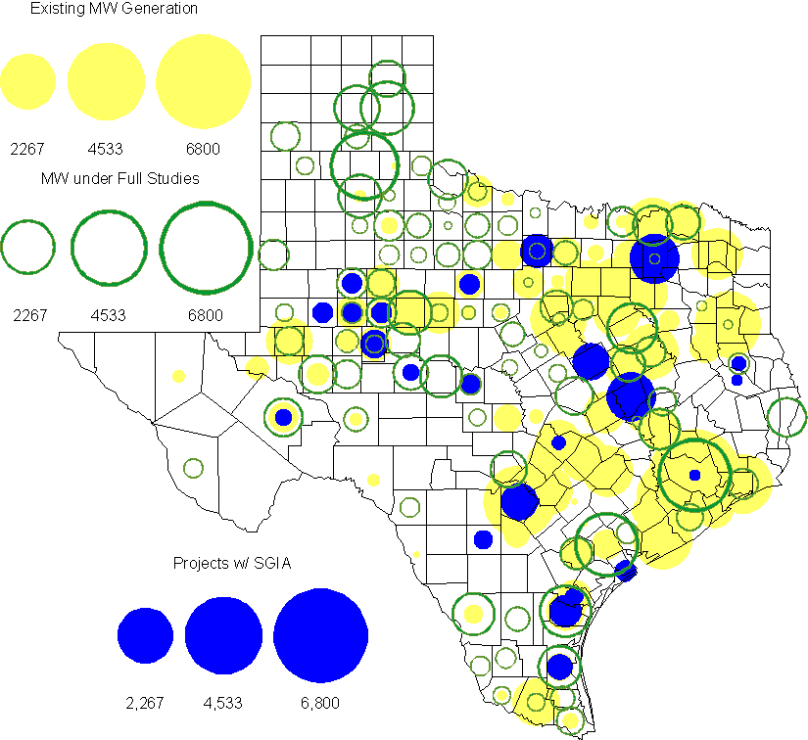

Generation Projects Undergoing Full Interconnection Studies
INR | County | Capacity | COD | Fuel |  | INR | County | Capacity | COD | Fuel
08INR0044 | Concho | 200 | TBD | Wind |  | 09INR0064 | Borden | 41 | TBD | Wind
08INR0042 | Coke | 200 | TBD | Wind |  | 08INR0041 | Coke | 200 | TBD | Wind
09INR0059 | Freestone | 20 | TBD | Coal |  | 09INR0025 | Concho | 180 | TBD | Wind
09INR0075 | Kinney | 248 | Oct-09 | Wind |  | 07INR0014b | Wilbarger | 70 | Oct-09 | Wind
10INR0027 | Nueces | 35 | Oct-09 | Wind |  | 09INR0041 | Mitchell | 300 | Oct-09 | Wind
07INR0014a | Wilbarger | 140 | Oct-09 | Wind |  | 09INR0048 | Jack | 150 | Oct-09 | Wind
08INR0054 | Comanche | 401 | Oct-09 | Wind |  | 09INR0073 | Scurry | 200 | Nov-09 | Wind
08INR0031 | Childress | 100 | Nov-09 | Wind |  | 09INR0082 | Webb | 300 | Dec-09 | Wind
09INR0077 | Reagan | 500 | Dec-09 | Wind |  | 11INR0013 | Mills | 150 | Dec-09 | Wind
11INR0012 | Duval | 400 | Dec-09 | Wind |  | 09INR0065 | Webb | 150 | Dec-09 | Wind
09INR0061 | Kent | 258 | Dec-09 | Wind |  | 09INR0058 | Howard | 250 | Dec-09 | Wind
09INR0054 | Stonewall | 148.5 | Dec-09 | Wind |  | 09INR0051 | Borden | 249 | Dec-09 | Wind
08INR0056 | Nolan | 149 | Dec-09 | Wind |  | 08INR0039 | Hamilton | 90 | Dec-09 | Wind
08INR0022 | Floyd | 100 | Dec-09 | Wind |  | 08INR0023 | Floyd | 100 | Dec-09 | Wind
10INR0011 | Johnson | 275 | Jan-10 | Gas |  | 10INR0048 | Hardeman | 1000 | Jan-10 | wind
10INR0047 | Kendall | 1000 | Jan-10 | wind |  | 11INR0036a | Matagorda | 200 | Jan-10 | Wind
11INR0033a | Cameron | 200 | Jan-10 | Wind |  | 10INR0024 | Briscoe | 3000 | Jan-10 | Wind
10INR0046 | Jim Hogg | 264 | Apr-10 | wind |  | 10INR0045 | Webb | 734 | Apr-10 | wind
10INR0079 | Nolan | 60 | May-10 | Wind |  | 10INR0054 | Palo Pinto | 36 | May-10 | Wind
09INR0069 | Reagan | 36 | May-10 | Wind |  | 09INR0070 | Reagan | 42 | May-10 | Wind
10INR0023 | Haskell | 386 | May-10 | Wind |  | 10INR0016 | Childress | 150 | May-10 | Wind
09INR0035 | Concho | 750 | May-10 | Wind |  | 09INR0018 | Concho | 249 | May-10 | Wind
07INR0032 | Tom Green | 249 | May-10 | Wind |  | 10INR0069 | Rusk | 818 | May-10 | Coal
09INR0081 | Rusk | 818 | Jun-10 | Coal |  | 10INR0035 | Harris | 416 | Jun-10 | Gas
10INR0029 | Hood | 810 | Jun-10 | Gas |  | 10INR0057 | Taylor | 200 | Jul-10 | Wind
10INR0052a | Knox | 21 | Jul-10 | Wind |  | 10INR0013 | Upton | 400 | Jul-10 | Wind
10INR0038 | Glasscock | 350 | Aug-10 | Wind |  | 10INR0071 | Matagorda | 88 | Sep-10 | Wind
09INR0074 | Motley | 70 | Oct-10 | Wind |  | 10INR0041 | Floyd | 135 | Oct-10 | Wind
10INR0015 | Mitchell | 350 | Oct-10 | Wind |  | 10INR0070 | Hunt | 50 | Nov-10 | Gas
11INR0029 | Throckmorton | 200 | Nov-10 | Wind |  | 10INR0039 | Dickens | 200 | Nov-10 | Wind
10INR0032 | Navarro | 800 | Dec-10 | Gas |  | 09INR0031 | Ector | 275 | Dec-10 | Gas
10INR0080 | Presidio | 144 | Dec-10 | Solar |  | 10INR0077 | Callahan | 101 | Dec-10 | Wind
10INR0060 | Willacy | 400.5 | Dec-10 | Wind |  | 10INR0059 | Zapata | 250.7 | Dec-10 | Wind
10INR0056 | Borden | 249 | Dec-10 | Wind |  | 10INR0051 | Brazoria | 200 | Dec-10 | wind
09INR0076 | Jackson | 300 | Dec-10 | Wind |  | 10INR0042 | Mason | 170 | Dec-10 | Wind
10INR0033 | Armstrong | 420 | Dec-10 | Wind |  | 10INR0019 | Deaf Smith | 609 | Dec-10 | Wind
08INR0062 | Archer | 249 | Dec-10 | Wind |  | 08INR0061 | Hardeman | 200 | Dec-10 | Wind
10INR0008 | Pecos | 500 | Dec-10 | Wind |  | 07INR0035 | Tom Green | 270 | Dec-10 | Wind
07INR0026 | Baylor | 400 | Dec-10 | Wind |  | 07INR0015 | Foard | 180 | Dec-10 | Wind
07INR0013 | Coke | 200 | Dec-10 | Wind |  | 11INR0036b | Matagorda | 200 | Jan-11 | Wind
11INR0033b | Cameron | 200 | Jan-11 | Wind |  | 11INR0050 | Crosby | 149 | Mar-11 | Wind
11INR0037 | Smith | 55 | May-11 | Biomass |  | 11INR0048 | Harris | 300 | May-11 | Gas
11INR0046 | Brazoria | 300 | May-11 | Gas |  | 11INR0028 | Grimes | 1280 | May-11 | Gas
11INR0061 | Presidio | 90 | May-11 | Solar |  | 11INR0058 | Pecos | 135 | May-11 | Solar
10INR0009 | Castro | 200 | May-11 | Wind |  | 11INR0009 | Navarro | 1200 | Jun-11 | Gas
09INR0050 | Fannin | 1200 | Jun-11 | Gas |  | 11INR0019 | Upton | 200 | Jun-11 | Wind
08INR0020 | Eastland | 200 | Jun-11 | Wind |  | 11INR0006 | Lamar | 579 | Jul-11 | Gas
11INR0040 | freestone | 749 | Aug-11 | Gas |  | 11INR0039 | Starr | 201 | Sep-11 | Wind
11INR0008a | Roberts | 1000 | Sep-11 | Wind |  | 10INR0021 | Grayson | 646 | Nov-11 | Gas
11INR0043 | Coke | 300 | Dec-11 | Wind |  | 11INR0025 | Crockett | 400 | Dec-11 | Wind
11INR0005 | Upton | 500 | Dec-11 | Wind |  | 06INR0022d | Kenedy | 200 | Dec-11 | Wind
10INR0018 | Madison | 550 | Mar-12 | Gas |  | 12INR0007 | Lamar | 296 | May-12 | Gas
12INR0006 | Limestone | 875 | Jun-12 | Coal |  | 10INR0022 | Harris | 3500 | Jun-12 | Gas
12INR0002 | Briscoe | 750 | Jul-12 | Wind |  | 12INR0016 | Nueces | 1200 | Nov-12 | Other
08INR0019c | Gray | 250 | Nov-12 | Wind |  | 08INR0019b | Gray | 250 | Nov-12 | Wind
08INR0019a | Gray | 250 | Nov-12 | Wind |  | 12INR0022 | Hidalgo | 200 | Dec-12 | Wind
12INR0018 | Gray | 600 | Dec-12 | Wind |  | 11INR0023 | King | 400 | Dec-12 | Wind
12INR0005 | Floyd | 1100 | Dec-12 | Wind |  | 06INR0022f | Kenedy | 200 | Dec-12 | Wind
12INR0009 | Nueces | 875 | May-13 | Gas |  | 13INR0006 | Gray | 750 | Oct-13 | Wind
13INR0005 | Carson | 600 | Oct-13 | Wind |  | 06INR0022e | Kenedy | 200 | Dec-13 | Wind
14INR0002 | Goliad | 756 | Feb-14 | Coal |  | 14INR0003 | Nolan | 850 | Jun-14 | Coal
14INR0005 | Matagorda | 1200 | Jul-14 | coal |  | 14INR0001 | Pecos | 500 | Dec-14 | Wind
15INR0003 | Matagorda | 3200 | Jan-15 | Nuclear

Wind Generation
Wind Capacity Installed by Year County Location of Installed Capacity and Interconnection Requests
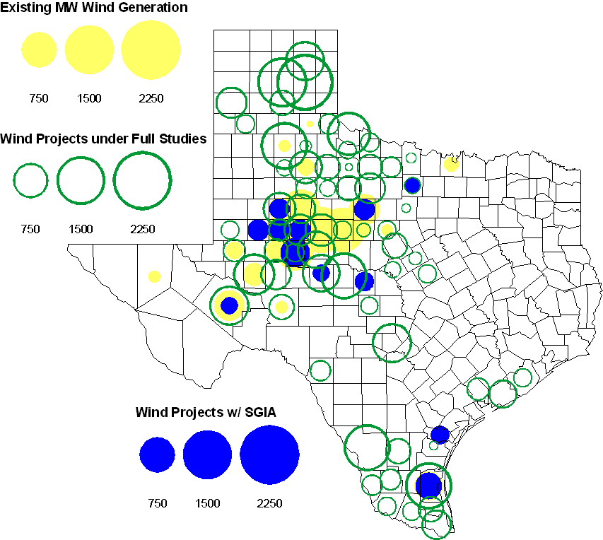

Regional Planning Group Project Reviews

American Electric Power Service Corporation submitted a project to construct 2 new 138 kV substations, rebuild a 138 kV circuit, build 2 new 138 kV circuits, and install a new 138/69 kV autotransformer in the Abilene/San Angelo area. The estimated cost of this project is $105.9 M. The review of this project is complete and an ERCOT Endorsement Letter is in process.

Oncor submitted a project to relieve congestion related to new wind units in the Lamesa area. The project will upgrade the Lamesa to Bluff Creek 138 kV line, rebuild the Bluff Creek to China Grove 138 kV line, rebuild the Lamesa to Ackerly Vealmoor 69 kV line to 138/69 kV double circuit, rebuild the Lamesa 138 kV switching station, build a new 138 kV Ackerly Vealmoor station, add second circuits to all rebuilt lines and include station upgrades at China Grove and Big Spring. The cost of this project is $ 80.8 M. This project will be reviewed to ensure that the improvements fit into the likely CREZ transmission solution for the area. This project is in ERCOT Independent Review and will be studied as part of the 2009 Five-Year Transmission Plan.

Oncor submitted a project to add several 345 kV circuits to support the addition of Comanche Peak units 3 and 4 in 2015 at an estimated cost of $ 133 M. These upgrades include a new 345 kV double circuit line with one circuit in place from Comanche to Whitney, a new 345 kV line from Comanche to Johnson Switch, a new circuit on existing structures from Johnson Switch to Everman, a new 345 kV double circuit with one circuit in place from Comanche to DeCordova, and a new 345 kV line on existing structures from Comanche to Parker Switch. This project is in ERCOT Independent Review and will be studied when the 2009 Five-Year Transmission Plan is complete.

Sharyland Utilities submitted a project to construct and operate the ERCOT Southeast Loop facilities consisting of a 345 kV double circuit from Lufkin to Canal 345 kV substation on the northeast side of Houston. This project will cost $359 M with an estimated completion date of summer 2013. This project is in ERCOT Independent Review and will be studied as part of the 2009 Five-Year Transmission Plan.
- Austin Energy submitted a project to relocate the Decker to Techridge circuit to new ROW so that the existing structures can be utilized for the new Gilleland to Techridge circuit. The estimated completion date of this project is November 2010 and estimated cost is $ 4.3 M. The review of this project is complete and an ERCOT Endorsement Letter is in process.

Centerpoint Energy has submitted a project to expand the Zenith substation, add one 800 MVA autotransformer, connect Zenith to existing circuits near the Gertie substation and upgrade/reconfigure nearby 138 kV circuits. The estimated completion date of this project is summer 2012 and estimated cost is $ 26.6 M. This project is in ERCOT Independent Review.

American Electric Power Service Corporation submitted a project to construct several improvements in the Corpus Christi area. The estimated completion date of this project is June 2012 and estimated cost is $ 214 M. This project is in ERCOT Independent Review.

Congestion Costs
Dollars shown in graphs are settlement quality.

OOMC – last 13 months in million$

OOM Down – last 13 months in million$

Balancing Energy Down – last 13 months in million$

OOM Up – last 13 months in million$

Balancing Energy Up – last 13 months in million$

Replacement Reserve – last 13 months in thousand$

Binding Constraints – June, 2009
Contingency | Binding Element | Estimated Costs | Transmission Project
Menard - Gillespie 138kV | Menard Auto | $ 3,620,392.10 | Yellowjacket, Add 2nd 69/138 kV Auto
Skyline to Marion & Elm Creek 345 | Marion - Hill Country 345kV | $ 3,159,056.69 | Hill Country to Skyline - 345 kV 2nd Circuit
Temple Pecan Creek - Tradinghouse & Temple Switch - Long Creek SES | San Angelo Power Station -Shrew Tap | $ 2,923,976.71 | San Angelo Power Station, to Menard 138 kV line improvements
 | Capacity Shortage | $ 2,545,381.69
Watermill - West Levee SW & Sargent Road | Watermill - DeSoto | $ 1,832,359.56 | Trinidad – Watermill 345kV line
Watermill - DeSoto Switch - Cedar Hill Switch 345kV | Watermill - DeSoto | $ 1,582,548.73 | Trinidad – Watermill 345kV line
Oklaunion - Fisher Road - Bowman 345kV | Vernon - Grayback 69kV | $ 891,532.81 | Fisher Road - Wichita Falls 138 kV line upgrade
Tradinghouse - Venus Switch 345kV | Rogers Hill - Elm Mott 138kV | $ 839,174.75 | Elm Mott - Waco Northcrest 138 kV line upgrade  N. Waco - NE. Waco 138 kV line upgrade
Dilley Switch - San Miguel 138kV | Derby - Pearsall 69kV | $ 704,606.56 | Pearsall to Dilley 69 kV Line Upgrade
Tradinghouse - Venus Switch 345kV | Rogers Hill - Bosque Switch 138kV | $ 513,791.87 | Elm Mott - Waco Northcrest 138 kV line upgrade  N. Waco - NE. Waco 138 kV line upgrade

Binding Constraints – May 2009
Contingency | Binding Element | Estimated Costs | Transmission Project
Comanche Peak SES - DeCordova SES & Wolf Hollow - Rocky Creek 345kV | Venus Switch - Comanche Peak 345kV | $ 3,515,768.74 | Venus - Cedar Hill 345 kV line upgrade
Watermill - DeSoto Switch - Cedar Hill Switch 345kV | Watermill - DeSoto | $ 1,966,940.07 | Trinidad – Watermill 345kV line
Comanche Peak SES-DeCordova SES & Wolf Hollow-Rocky Creek 345kV | Comanche Peak SES - Parker Switch 345KV | $ 1,652,826.07 | Willow Creek - Parker 345 kV line rebuild as double circuit
Capacity Shortage |  | $ 1,613,065.72
Comanche Peak SES-DeCordova SES-Wolf Hollow 345kV | Parker Switch - Benbrook Switch 345KV | $ 1,160,067.25 | Parker Switch - Everman 345 kV line
Comanche Peak SES-DeCordova SES & Wolf Hollow-Rocky Creek 345kV | Venus Switch - Johnson Switch TU 345kV | $ 744,535.01 | Venus - Cedar Hill 345 kV line upgrade
Valley Import |  | $ 732,379.13
PH Robinson 345/138kV Autotransformer #3 | PH Robinson AT1 345/138KV Transformer | $ 468,812.45 | P.H. Robinson - Oasis Ckt.99
Graham-Long Creek 345kV | San Angelo Power Station -Shrew Tap | $ 449,743.68 | San Angelo Power Station, to Menard 138 kV line improvements
Replacement Reserve Service |  | $ 444,068.87

Other Notable Activities
All postings referred to below can be found at http://planning.ercot.com/login/login unless otherwise indicated.

- The reliability phase of the 2009 Five-Year Transmission Plan utilizing the latest SSWG base cases is underway. Projects to eliminate unserved energy in 2014 have been identified and coordinated with ERCOT TSPs. Projects to eliminate unserved energy in the remaining years of the 5 year horizon are being studied along with projects needed to eliminate unserved energy in 2014 with specific generating units or combined cycle trains not available.

- RMR exit strategy development is almost complete for the Permian Basin RMR unit.

- The Voltage Ride Through Study has started. Phase I of the study was initiated with the contingency selection process. This is the first part of this phase needed to determine if more VRT capability is needed using the existing wind farm models. Phase II will consist of model improvement. Both of these phases are scheduled for completion by the End of 2009. Phase III involves simulating the VRT capabilities of the system with the revised models and investigation of any required changes.

- Steady-State Working Group Data Set A cases for the 2010 Summer and Winter 2011 peak are complete and posted on the Planning and Operations Information web site. The remainder of the cases will be completed and posted by July 14, 2009.

