Large Ramping Events and Low Ramp Rate Events
Summary
There are two results of the Wind-Powered Generation Ancillary service study that seem to need follow-up: first is the potential for significant drop off in wind generation in a short period of time and the second is the possibility that there will not be sufficient regulation capability available in high wind, low load situations. ERCOT has responded my initiating development of wind-event forecasts, modifying the ancillary service procurement procedures, and by developing a reliability assessment tool. Each of these steps is needed and they are most likely sufficient for the next few years. However, the regulation procurement procedures are essentially backward looking and are not designed to detect insufficient unit ramping capability. In addition, the response possibilities for the ramping down in wind output scenarios, even if forecast perfectly, have not been explored; nor have any needed tools been identified. A complete evaluation of these issues needs to be done before there is 15,000 MW of wind generation in West Texas and may be needed at the 10,000 MW level of development.
Rapid Decline in Wind-Powered Generation
The simulation of the ramp-down event of January 28,2006 with 15,000 MW of wind-powered generation is shown in Figure 7-1 from the GE Ancillary Service Study. That simulation shows a 9,000 MW drop-off in 3 hours. That alone is not alarming since even now we have load pick-up of over 10,000 MW in the same time period; it is the joint occurrence that can test the ability of ERCOT to maintain reliability.
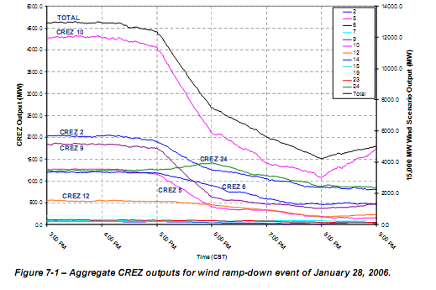
Assuming that the ability to forecast these joint events is reasonable, how would ERCOT manage a need for 20,000 MW of additional capacity in a 3 hour period? How would they prepare for the event assuming they new it was coming in 24 hours? What if the notice time is 6 hours?
A quick look at the available capacity to serve load shown in the chart below indicates that sufficient capacity will most likely be available during the seasons when wind-powered generation events might be most significant. The key to successfully deploying the available capacity will be anticipating the situation and the market response.
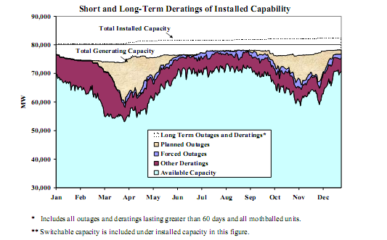
It seems prudent for ERCOT to commission a study to determine the possible ways to plan for such an occurrence. The study should provide for the following:
- Simulations allowing for various assumed load and wind-powered generation patterns for the next week;
- Realistic unit commitment scenarios replicating historic market responses to anticipated load and market conditions;
- Alternative Reliability Unit Commitment (RUC) and ancillary service procurement mechanisms to prepare for the possible event;
- Calculation tools to estimate the cost of various alternative scenarios and management strategies; and
- A tool for system operations to use to plan for the response to a forecasted event.
A second phase of the study might be needed to investigate how effective the market mechanisms can be to respond to the situation. Are there new notice mechanisms or market forecasts needed to inform the market so that an appropriate response can be anticipated? Are current reliability tools sufficient to manage the possible events? Are there new procedures needed to call on offline capacity without committing the units until their start-up time dictates? Are new ancillary services needed?
ERCOT routinely prepares for major winter events and hurricanes. A great deal of effort, planning, and simulations are involved including very expensive exercises. The winter and hurricane events have the dubious benefit of a great deal of real world experience to inform the planning process and provide the needed tools. Wind-powered generation at the level of over 10,000 MW is a new experience for ERCOT. It is not an exact parallel to the winter and hurricane events; but we can learn from those events. We need the same level of planning and preparedness as we have for winter operations and hurricanes. Since large wind-powered generation events are new to us, we need a lot of extra study and simulation to take the place of a lack of experience.

Insufficiency of Available Ramping Capability
One of the results of the GE Ancillary Service Study was the finding that at certain times of the year there may not be enough ramp rate capability when loads are low and wind generation is high. Figure 6-40 below, extracted from the GE study, shows the possible availability of 5 minute ramping capacity for a low load high wind scenario. In the hours of 93 to 99 there is no ramping capability available to provide regulation service. In many more hours, the ramping capability is much reduced.
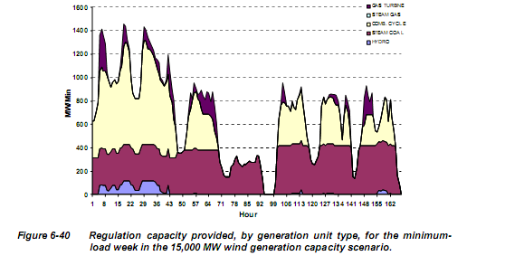

The nodal market design will not anticipate such occurrences. The following actions need to be taken now:
- ERCOT needs to develop a ramp rate forecasting mechanism;
- A simulation tool needs to be developed to analyze options for handling the low ramp rate availability situation with the following capabilities:
  - Simulations allowing for various assumed load and wind-powered generation patterns for the next week;
  - Realistic unit commitment scenarios replicating historic market responses to anticipated load and market conditions;
  - Alternative Reliability Unit Commitment (RUC) and ancillary service procurement mechanisms to prepare for the possible event;
  - Calculation tools to estimate the cost of various alternative scenarios and management strategies; and
  - A tool for system operations to use to plan for the response to a forecasted event;
- Alternatives to handling a low ramp rate situation need to be identified;
- Changes to the nodal market design need to be developed as needed.

