PWG Meeting Notes - DRAFT
Wednesday, June 24, 2009

Attendees
Kalyani Sahoo, Reliant Energy
Carl Raish, ERCOT
Ernie Podraza, Direct Energy
Calvin Opheim, ERCOT
Sonja Mingo, ERCOT
Adrian Marquez, ERCOT
Ron Hernandez, ERCOT
Eric Goff, Reliant Energy
Bill Boswell, ERCOT
Jim Lee, Direct Energy
Kyle Miller, CenterPoint
Diana Ott, ERCOT

Phone
Lloyd Young, AEP
Steven Bargas, Tenaska
Kelly Gilbert, TNMP
Ed Echols, Oncor
Darryl Nelson, Oncor
Bob Laningham, Oncor

Agenda Item 1: Meeting Open
Ernie Podraza welcomed everyone and read the antitrust admonition.

Carl Raish made an effort to make everyone aware of and understand the disclaimer at the bottom of the antitrust admonition document. The disclaimer states: “All presentations and materials submitted by Market Participants or any other Entity to ERCOT staff for this meeting are received and posted with the acknowledgement that the information will be considered public in accordance with the ERCOT Websites Content Management Operating Procedure.”

Agenda Item 2: COPS Meeting Update
Kyle Miller reviewed an email he sent to the PWG on which he listed COPS’ suggestions in response to a request for guidance from the PWG. From that email:
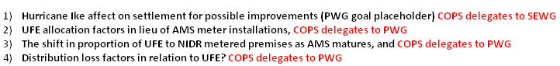

Agenda Item 3: Approval of the May 27 PWG Meeting Notes
The notes for the May 27 PWG meeting were approved after some capitalization changes and a change to reflect that Bob Laningham does indeed work for Oncor.

Agenda Item 4: Review LPGRR033 – Synchronize LPG with PRR804
Sonja Mingo reviewed LPGRR033, titled “Synchronization of Load Profiling Guide with PRR804, Revision to Section 21 Appeal Process.” This LPGRR further defines an appealable event. No one at the PWG voiced objections to this LPGRR.

Agenda Item 5: Draft LPGRR – Model Spreadsheets Calendar Update
Adrian Marquez briefly discussed a draft LPGRR related to the load profile model spreadsheets. Adrian stated that the calendar, holiday, and sunrise values in the load profile model spreadsheets currently cover through the year 2010. This draft LPGRR updates those variables through 2020. Ernie said he will sponsor the draft as an LPGRR and forward it to Market Rules.

ACTION ITEM: Ernie to sponsor an LPGRR for updated load profile model spreadsheets and forward it to Market Rules.

Agenda Item 6: RMWG Status Report on IDR to AMS for <= 700 kW
Calvin Opheim discussed a presentation (06. Retail Metering Working Group Update to RMS on 05_10_09 @ http://www.ercot.com/calendar/2009/06/20090610-RMS) presented by the Retail Metering Working Group (RMWG) at the June 10, 2009 RMS meeting.

Calvin focused in on what the RMWG presented as broad possibilities of how Advanced Meters should be treated in light of their similarities to IDRs. Change an IDR to AMS, but…Treat as IDR (without AMS features)? …Treat as AMS? …Treat as IDR (with AMS features)?

The RMWG had come to a consensus and made a recommendation that it should be the customer’s choice on how their Advanced Meter should be treated, from the available options. The RMWG presentation noted that only those not exceeding a demand of 700 kW in the preceding 12 months are eligible to make this choice.

Lloyd Young asked if this approach has been documented. Calvin replied that right now all we’ve got is what’s on the RMWG presentation but that the RMWG will be crafting language to formalize this process.

It was mentioned the IDR Requirement Report may have to be modified, depending on resulting rule changes.

Calvin suggested that we need better definitions for ‘IDR’—definitions that would be clear on what is included under certain rules. Darryl Nelson strongly supported Calvin’s suggestion.

Agenda Item 7: UFE – How Affected If No Ike-related Profile Adjustments?
Calvin said that ERCOT will be looking at an analysis on what would have happened to UFE had there not been an adjustment to the load profiles because of Hurricane Ike. Calvin said this is a significant amount of work and that ERCOT will provide an update to the SEWG in August.

Calvin talked a bit about how total UFE would not change, but rather how UFE would be aligned. The group touched on whether electricity prices should be considered in this analysis.

Agenda Item 8a and 8b: UFE – Shift in Proportion to NIDR as AMS Matures and UFE Allocation Factors in Lieu of AMS Installations
Ernie walked the group through a worksheet on which he performed a UFE allocation exercise (posted @ http://www.ercot.com/calendar/2009/06/20090624-PWG under UFE_Allocation_v03). Ernie explained that his worksheet alleviated his concern that there was a bias toward non-IDR ESI IDs in the application of UFE.

In the UFE discussions the group expressed slight frustration on the lack of information about the extent of electricity theft and its contribution to UFE.

Agenda Item 9: Distribution Loss Factors in Relation to UFE
The group discussed perceived pros and cons of various methods for deriving distribution loss factors.

The group looked at the graph found in the link ‘2009 TDSP Distribution Loss Factors – Methodology’ in the Key Documents section @ http://www.ercot.com/mktinfo/data_agg/. A screenprint of the graph is shown in Chart 1.

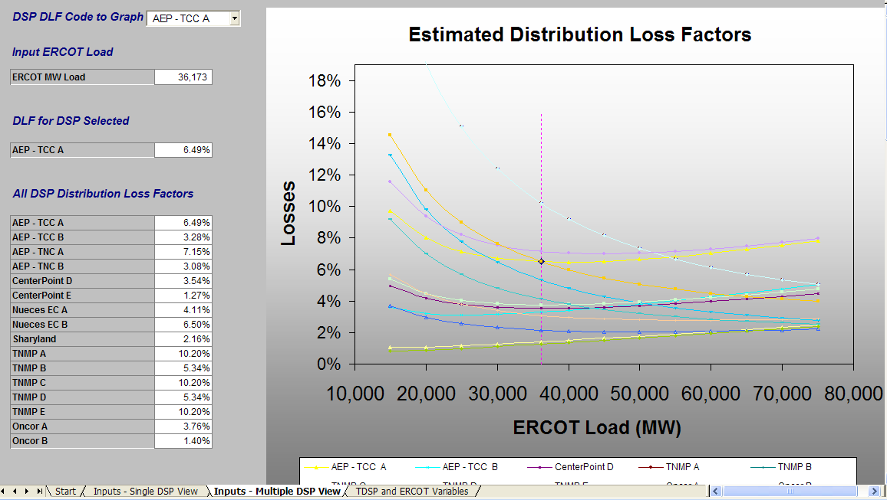
Chart 1

After looking at the graph, the notion of standardization in loss factor methodology was mentioned as being a preferred characteristic.

Carl suggested a methodology for doing a loss study is to do it at various load levels to come up with an accurate formula to represent the relationship between loss and load. Chart 2 is a rough approximation of what Carl drew on the whiteboard and illustrates Carl’s belief that the relationship of MWh loss vs. MWh load is parabolic.

Chart 2

Eventually, Ernie asked what direction the group wanted to take on this task. Darryl asked whether there was some way to quantify whether the loss factors are really a problem and if so, how to address them.

Eric Goff suggested reporting our discussion to COPS. Ernie said he’d like to discuss this issue at the next PWG meeting and that it would be helpful if the meeting notes were distributed fairly quickly so others could review them.

ACTION ITEM: Everyone to ponder issues related to distribution loss factors and be prepared to discuss at the July PWG meeting.

Agenda Item 10: Load Research Project Update
Bill Boswell presented the latest numbers for LRS interval data received by ERCOT.

Agenda Item 11: Annual Validation Update
Diana Ott said we are still on schedule for Annual Validation.

Next PWG Meeting
The next PWG meeting is scheduled for Wednesday, July 22, 2009.

