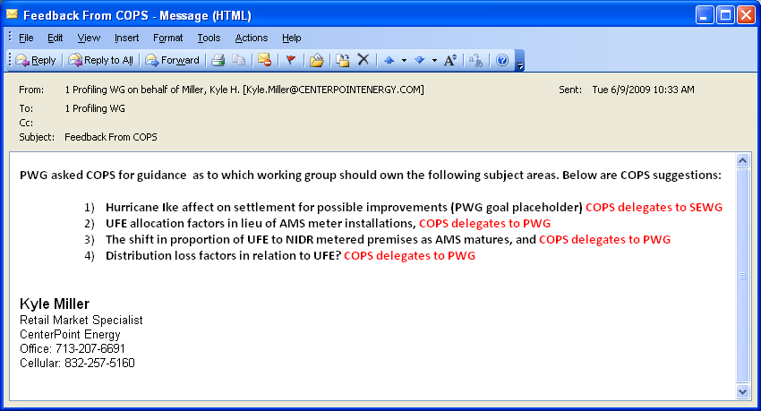

Disclaimer
All presentations and materials submitted by Market Participants or any other Entity to ERCOT staff for this meeting are received and posted with the acknowledgement that the information will be considered public in accordance with the ERCOT Websites Content Management Operating Procedure.

