ERCOT Operations Report
May 2009 ROS & OWG

Frequency Control
Time | Freq(Hz) | Duration (s)
5/11/2009 5:41 | 59.89 | 4 | Unit tripped with 350 MW
5/11/2009 6:50 | 60.101 | 162 | Ran out of Down Reg. and SCE change +600 MW in 10 minutes
5/11/2009 18:28 | 59.873 | 40 | Unit tripped with 606 MW
5/16/2009 2:11 | 60.102 | 234 | Out of Down Regulation, SCE change +2000 MW in 20 minutes
5/18/2009 3:20 | 59.849 | 2 | Unit tripped with 542MW
5/19/2009 0:03 | 60.103 | 215 | Out of Down Regulation and large base power schedule change
5/22/2009 10:05 | 60.102 | 30 | Generation schedule increased 1200 MW after HA study was run
5/25/2009 16:21 | 59.871 | 128 | Unit tripped with 470MW
5/31/2009 22:08 | 60.101 | 164 | Out of Down Regulation, large BES offset
Note: Time of frequency excursions outside the range of +/- 0.1 Hz.

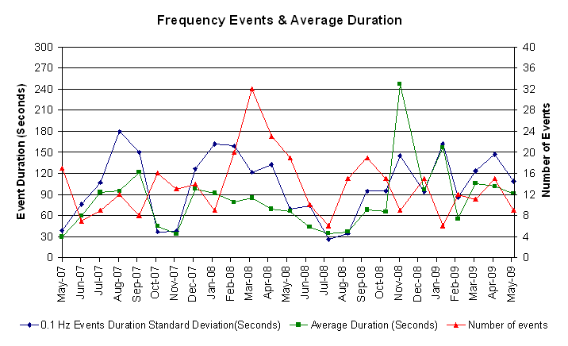

Deployed Responsive (Reported Above)
Time deployed | Stop Time | Duration | Max | Details
5/3/09 09:49:35 | 5/3/09 10:03:53 | 0:14:18 | 359.0 | Unit Trip
5/3/09 16:39:37 | 5/3/09 16:45:37 | 0:06:00 | 327.4 | Unit Trip
5/4/09 22:09:31 | 5/4/09 22:17:37 | 0:08:06 | 348.5 | Unit Trip
5/5/09 21:59:19 | 5/5/09 22:11:21 | 0:12:02 | 348.5 | SCE Change -600 MW in 4m
5/9/09 00:02:51 | 5/9/09 00:13:59 | 0:11:08 | 359.0 | SCE Change -1100 MW in 11m
5/11/09 05:41:17 | 5/11/09 05:52:35 | 0:11:18 | 422.4
5/11/09 09:04:13 | 5/11/09 09:22:37 | 0:18:24 | 332.6 | SCE change -660 MW in 19m & Out of URS at 09:00.
5/11/09 13:03:13 | 5/11/09 13:20:13 | 0:17:00 | 348.5 | Unit Trip at 12:46 and Out of URS at 12:55.
5/11/09 18:28:57 | 5/11/09 18:38:45 | 0:09:48 | 512.2
5/13/09 22:58:38 | 5/13/09 23:12:56 | 0:14:18 | 337.9 | SCE Change -700 MW in 7m
5/18/09 03:20:22 | 5/18/09 03:37:16 | 0:16:54 | 638.9
5/19/09 14:37:24 | 5/19/09 14:48:20 | 0:10:56 | 353.8 | Unit Trip
5/19/09 18:20:04 | 5/19/09 18:31:40 | 0:11:36 | 348.5 | Unit Trip
5/25/09 16:21:46 | 5/25/09 16:36:36 | 0:14:50 | 522.7
5/27/09 02:11:16 | 5/27/09 02:29:50 | 0:18:34 | 332.6 | Out of URS, SCE change -1000 MW in 12 min
5/29/09 07:06:08 | 5/29/09 07:14:54 | 0:08:46 | 327.4 | Large schedule change, large DBES offset entered to recover DRS

Day-Ahead OOMC and RPRS Capacity Purchases
Details | OOMC | RPRS S1 | RPRS S2 | RPRS S1+S2 | RMR | Total
W RIO | 83 | 3 | 2 | 5 | 0 | 88
DFW | 15 | 3 | 34 | 37 | 0 | 52
Houston | 6 | 25 | 15 | 40 | 0 | 46
Austin | 6 | 3 | 20 | 23 | 0 | 29
North | 6 | 13 | 5 | 18 | 0 | 24
San Antonio | 0 | 10 | 10 | 20 | 0 | 20
Laredo | 1 | 12 | 0 | 12 | 0 | 13
Corpus | 6 | 4 | 1 | 5 | 0 | 11
Western | 6 | 0 | 3 | 3 | 1 | 10
South | 0 | 6 | 0 | 6 | 0 | 6
Northeast | 0 | 0 | 5 | 5 | 0 | 5
E RIO | 0 | 2 | 0 | 2 | 0 | 2
Bryan Area | 0 | 2 | 0 | 2 | 0 | 2
Total | 129 | 83 | 95 | 178 | 1 | 308

Historical Totals | May-09 | May-08 | Apr-09
Austin | 9 | 33 | 28
Bryan Area | 2 | 2 | 0
Corpus | 10 | 1 | 8
DFW | 18 | 40 | 11
E RIO | 2 | 11 | 4
Houston | 31 | 2 | 9
Laredo | 13 | 64 | 12
North | 19 | 31 | 12
Northeast | 0 | 2 | 0
San Antonio | 10 | 34 | 0
South | 6 | 19 | 2
W RIO | 86 | 6 | 99
Western | 7 | 25 | 5
Total | 213 | 270 | 190
http://www.ercot.com/mktinfo/services/rprsdr/index.html

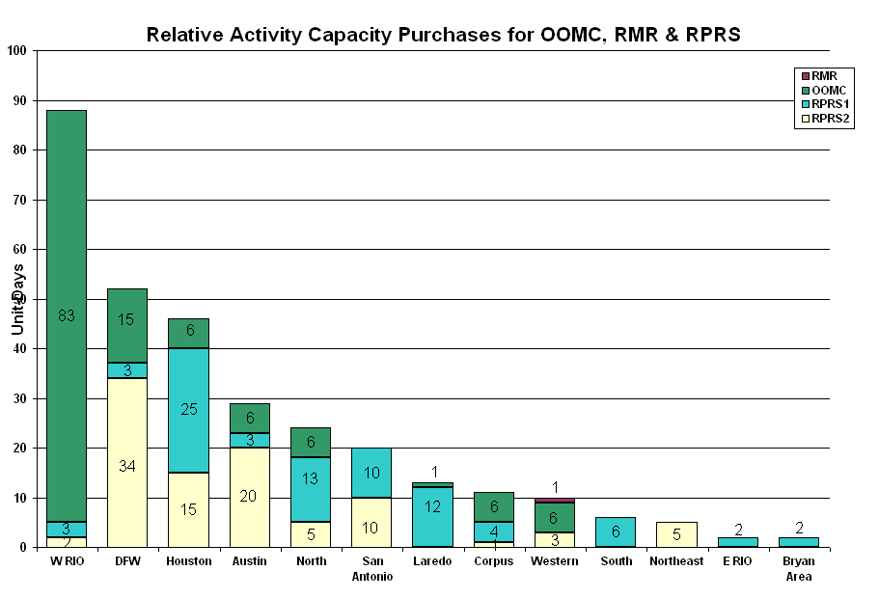

OOME and Congestion Management Activity
Congestion affected by outages
Remedial action plan has been developed for the element
Contingency | Overloaded Element | Days
Dilley Switch - San Miguel Switch 138KV | Derby - Pearsall 69KV | 12
P H Robinson 345/138KV T3 | P H Robinson 345/138KV T1 | 10
Abilene South - Eskota Switch 138KV | Eskota- Merkel - Trent 69KV | 8
Comanche Peak SES - Decordova SES and Wolf Hollow - Rocky Creek 345KV | Venus Switch - Comanche Peak 345KV | 8
Comanche Peak SES - Decordova SES and Wolf Hollow - Rocky Creek 345KV | Venus Switch - Johnson Switch TU 345KV | 7
Comanche Peak Units 1 and 2 | Whitney - Lake Whitney 138KV | 7
Comanche Peak SES - Decordova SES and Wolf Hollow - Rocky Creek 345KV | Comanche Peak SES - Parker Switch 345KV | 6
Menard - Gillespie 138KV | Menard 138/69KV autotransformer | 6
Zorn - Marion and Clear Springs 345KV | Seguin - Sequin West 138KV | 6
Aspermont - Spur 138KV overloads | Spur 138/69KV autotransformer | 4
San Miguel 345/138KV A Autotransformer | San Miguel 345/138KV B | 4
Dilley Switch - North Laredo 138KV | North Laredo - Asherton 138KV | 4
Morgan Creek - Sun Switch 138K | Morgan Creek - China Grove Switch 138 KV | 4
Austrop - Decker & Daffin Gin 138KV | Elgin Switch - Gilleland Creek 138KV | 3
Austrop T1 345/138KV | Austrop T2 345/138KV | 3
Comanche Peak SES - Decordova SES - Wolf Hollow 345KV | Parker Switch - Benbrook Switch 345KV | 3
Golden Switch - Bluff Creek Switch 138KV | Golden Switch - Sun Switch - Sacroc 138KV | 3
Graham - Long creek 345Kv | San Angelo Power Station - Shrew Tap 138KV | 3
Elm Mott - Bosque Switch 345KV | Olsen 138/69KV | 2
Aspermont - Spur 138KV | Spur - Girard Tap 69KV | 2
Austrop 345/138KV T2 Autotransformer | Elgin Switch - Gilleland Creek 138KV | 2
Austrop - Lost Pines 345KV | Elgin Switch - Gilleland Creek 138KV | 2
Austrop T1 345/138KV autotransformer | Austrop T2 345/138KV autotransformer | 2
Baytown Energy 345/138KV Autotransformer 1 | Baytown Energy 345/138KV Autotransformer 2 | 2
Dyann - South Lane City 138KV | Wallis - Sealy 138KV | 2
Elgin Switch - Sandow Switch 138KV | Sandow Switch - Salty 138KV | 2
Enterprise - Trinidad and Martin Lake - Stryker Creek 345KV | Nacogdoches Southeast 345/138KV transformer | 2
Morgan Creek - Quail Switch - Longshore Switch 345KV | Stanton East Switch - Big Spring West 138KV | 2
Oxychem Corpus Christi - Ingleside Cogen Switch 138KV | Ingleside Cogen Switch - DuPont PP1 Ingleside 138KV | 2
Temple Pecan Creek - Tradinghouse & Temple Switch - Lake Creek 345KV | San Angelo Power Station - Shrew Tap 138KV | 2
Willow Valley Switch - Bluff Creek 138KV | Ackerly Vealmoor Switch - Ackerly 69KV | 2
Comanche Peak SES - Johnson Switch 345KV | Rocky Creek - Wolf Hollow 345KV | 1
Sonora - Friend Ranch 138KV | Sonora - Friess Ranch 69KV | 1
Abilene South - Eskota Switch 138KV | Eskota Switch 138/69KV autotransformer | 1
Allen - Renner Switch - Plano Tennyson 345KV | Allen Switch - Plano Parker Road 138KV | 1
Allen Switch - Renner & Plano Tennyson 345KV | Plano Custer - Allen Switch 138KV | 1
Aspermont - Spur 138KV | Jayton - Spur 69KV | 1
Austrop - Sandow Switch 345KV | Elgin Switch - Gilleland Creek 138KV | 1
Barney Davis Unit G1 | Barney Davis - Nelson Sharpe 138KV | 1
Base Case | Bowie 138/69KV transformer | 1
Base Case | Evant - Goldthwaite 138KV | 1
Baytown Energy Center - Chambers 345KV | Baytown Energy Center Transformer AT2 | 1
Baytown Energy Center - Chambers 345KV | Baytown Energy 345/138KV Autotransformer 1 | 1
Benbrook - Sycamore - Rocky Creek 345KV | Edgecliff - Rogers Ft Worth 138KV | 1
Cagnon - Marbach 138KV | Five Points - Westside 138KV | 1
Cal Energy - Morgan Creek 345KV | Morgan Creek 345/138KV | 1
Cedar Hill Switch 345/138KV | Sherry Switch - Park Row 138KV | 1
Collin 345 - Anna Switch 345KV | Payne Switch - EPCO Poi 138KV | 1
Crane LCRA - Midkiff Switch 138KV | Permian Basin - Hackberry Draw 138KV | 1
Crane LCRA - Odessa EHV Switch 138KV | Crane TU - Crane Humble 69KV | 1
Dyann - East Bernard 138KV | South Lane City - New Gulf | 1
Elm Mott - Whitney TU 138KV | Bosque - Lake Whitney 138KV | 1
Garfield - Onion & Hicross 138KV | Elgin Switch - Gilleland Creek 138KV | 1
Lon Hill - Nelson Sharpe 345KV | Lon Hill - Kingsville 138KV | 1
Lon Hill - North Edinburg 345KV | Kleberg CSW - Loyola 138KV | 1
Lon Hill - Whitepoint 345KV | Nueces Bay - Whitepoint 138KV | 1
Lon Hill - North Edinburg 345KV | Ajo - Rio Hondo 345KV | 1
Military Highway - LaPalma 138KV | Military Highway 138/69KV Auto | 1
Monticello SES - Allen Switch & Sulphur Springs Switch 345KV | Farmersville TU - Royse Switch 345KV | 1
Morgan Creek - China Grove 138KV | Morgan Creek - China Grove 138KV | 1
Morgan Creek - Long Creek Switching Station 345KV | Stanton East Switching Station - Midland East | 1
Mount Enterprise - Trinidad and Stryker Creek - Martin Lake 345KV | Nacogdoches 345/138KV autotransformer | 1
North Edinburg - Rio Hondo 345 KV | Raymondville 1 -Raymondville 2 69 KV | 1
Odessa Basin - Odessa North 69KV | Odessa North - North Cowden 69KV | 1
Odessa EHV 345/138KV autotransformer #2 | Odessa EHV 345/138KV autotransformer #1 | 1
Pawnee - Lon Hill 345KV | Kennedy - Kennedy Switch 69KV | 1
Pawnee - Lon Hill 345KV | Kennedy - Kennedy Switch 69KV | 1
Rio Hondo - La Palma 138KV | Raymondville 2 - Raymondville 2 69KV | 1
Royse Switch - Farmersville TU 345KV | Royse Switch - Farmersville TU 345KV | 1
San Anglo Power Station - Live Oak 138 KV | San Angelo Concho - San Angelo Lake Nasworthy 69KV | 1
San Miguel - Sigmor 138KV | Pleasanton 138/69KV | 1
Sandow Switch - Austrop 345KV | Gilleland Creek - Elgin Switch 138KV | 1
Santa Anna - Ballinger 138KV | Ballinger - Humble Ballinger 69KV | 1
Scurry Switch - Spur 138KV | Matador - Paducah 69KV | 1
South Lane City - Lane City 138KV | Pledger - New Gulf 138KV | 1
South Texas Project - Hillje and Whitepoint | Victoria - Warburton 138KV | 1
Spur T1 138/69KV transformer | Jayton -Spur 69KV | 1
Temple Pecan Creek - Tradinghouse & Temple Switch - Lake Creek 345KV | San Angelo Power Station - Yellow Jacket 138KV | 1
Tradinghouse - Venus 345KV | Lake Whitney - Whitney TU | 1
Twin Buttes - Divide Switch 345KV | Colorado City - Loraine 69KV | 1
Watermill - Tricorner and Trinidad 345KV | Seagoville - Kleberg Tap 138KV | 1
Zorn - Marion and Clear Springs 345KV | Clear Springs 345/138KV | 1

Zonal OC1
CSC | Days
West-North | 12
North-South | 3
North-Houston | 2

New RAP (Date indicates last update of RAP not implementation date.)
None

New Procedures/Forms/Operations Bulletins
Date | Subject | Bulletin No.
05/20/2009 | Transmission & Security Desk V 4 Rev 1 | 416
05/20/2009 | Frequency Control Desk V 4 Rev 1 | 415
05/20/2009 | Shift Supervisor Desk V 4 Rev 1 | 414
05/20/2009 | Operating Period Desk V 3 Rev 1 | 413
05/20/2009 | Day Ahead Desk V 4 Rev 1 | 412
05/05/2009 | Frequency Control Desk V 4 Rev 0 | 405
05/01/2009 | Transmission & Security Desk V 4 Rev 0 | 409
05/01/2009 | Operating Period Desk V 4 Rev 0 | 408
05/01/2009 | Day-Ahead Desk V 4 Rev 0 | 407
05/01/2009 | Shift Supervisor Desk V 4 Rev 0 | 406

Blackout/Load Shed Incidences
None

EECP
None

Major System Voltage Problems
None

Major Computer Problems, Enhancements & Fixes

05/13 23:10 Held the 23:15 Real-time Balancing Energy deployments for interval 23:30 due to deployments not sent to QSE's. Resumed with the 23:45 interval.

Communication
None

ERCOT peak (Unofficial)
05/08 17:00 51,255 MW

Yearly MTLF Error Comparison
Yearly Mid-Term (Hourly) Load Forecast Error Comparison for the ERCOT Forecast
Month | MAPE for MTLF at 16:00 Day-Ahead
Month | 2006 | 2007 | 2008 | 2009
January | 4.79 | 4.55 | 3.30 | 4.11
February | 4.81 | 3.75 | 3.59 | 3.49
March | 4.95 | 2.70 | 3.29 | 3.24
April | 5.59 | 3.00 | 2.45 | 2.66
May | 3.59 | 3.22 | 3.01 | 2.90
June | 2.65 | 4.46 | 2.81 | NA
July | 2.62 | 4.29 | 2.55 | NA
August | 2.09 | 3.11 | 3.66 | NA
September | 4.03 | 3.78 | 4.99 | NA
October | 3.63 | 3.08 | 2.79 | NA
November | 3.28 | 2.95 | 2.60 | NA
December | 3.44 | 3.74 | 4.54 | NA
Annual Average | 3.79 | 3.55 | 3.29 | 3.28
OCN, Advisory, Watch & Emergency Notices
Capacity
Date | Start | End | Event
5/5/09 | 7:48 | 16:00 | OCN issued for a potential capacity shortage for HE 1600-2400.
5/13/09 | 21:00 | 23:00 | OCN issued for a projected reserve capacity shortage for HE 16-18 for operating day 05/14/09.
5/16/09 | 1:02 | 2:18 | Advisory issued due to ARRS below 3000 MW.
5/20/09 | 3:00 | 11:00 | OCN issued for projected reserve capacity shortage for HE 1700 - 1800.
5/25/09 | 12:50 | 20:10 | ERCOT issued an Advisory for ARRS below 3000 MW.
5/30/09 | 3:00 | 4:00 | OCN issued for projected reserve capacity shortage for HE1600 - 1800.
5/31/09 | 3:10 | 04:15 | OCN issued for projected reserve capacity shortage for HE 1600 - 1800.

Transmission Watch

05/02 12:24 ERCOT issued a Transmission Watch for the West Texas area due to numerous transmission outages caused by weather conditions.

05/02 16:55 ERCOT issued a Transmission Watch due to the forced outage of a 345KV bus in the North Zone. The loss of Comanche Peak SES - Johnson Switch 345KV or Concord 345/138KV autotransformer or Johnson Switch - Venus Switch 345KV overloads Rocky Creek - Wolf Hollow 345KV and Wolf Hollow - Comanche Peak SES 345KV.

05/20 15:50 ERCOT issued a Transmission Watch issued for the post contingency loss of Falfurrias - North Edinburg 138KV overloads Alice - Falfurrias 69KV. ERCOT received emergency energy from CFE across the Laredo VFT.

05/23 14:00 ERCOT issued a Transmission Watch due to an outage. The loss of Dilley Switch - San Miguel Switch 138KV overloads Pearsall Switch - Derby Sub 69KV. ERCOT received emergency energy from CFE across the Laredo VFT.

05/24 13:00 ERCOT issued a Transmission Watch due to an outage. The loss of Dilley Switch - San Miguel Switch 138KV overloads Pearsall Switch - Derby Sub 69KV. ERCOT received emergency energy from CFE across the Laredo VFT.

05/25 13:03 ERCOT issued a Transmission Watch due to an outage. Loss of San Miguel autotransformer #1 overloads San Miguel autotransformer #2. ERCOT received emergency energy from CFE across the Laredo VFT and South DC tie.

05/26 15:30 ERCOT issued a Transmission Watch due to an outage. The loss of Dilley Switch - San Miguel Switch 138KV overloads Pearsall Switch - Derby Sub 69KV. ERCOT received emergency energy from CFE across the Laredo VFT.

05/27 11:30 ERCOT issued a Transmission Watch due to outages. Loss of Nelson Sharpe - Rio Hondo 345KV overloads Lon Hill - North Edinburg 345KV.

05/27 14:30 ERCOT issued a Transmission Watch due to an outage. The loss of Dilley Switch - San Miguel Switch 138KV overloads Pearsall Switch - Derby Sub 69KV. ERCOT received emergency energy from CFE across the Laredo VFT

05/28 13:20 ERCOT issued a Transmission Watch due to a forced outage. The loss of Dilley Switch - San Miguel Switch 138KV overloads Pearsall Switch - Derby Sub 69KV. ERCOT received emergency energy from CFE across the Laredo VFT

05/29 14:30 ERCOT issued a Transmission Watch due to a forced outage. The loss of Dilley Switch - San Miguel Switch 138KV overloads Pearsall Switch - Derby Sub 69KV. ERCOT received emergency energy from CFE across the Laredo VFT

05/30 14:30 ERCOT issued a Watch issued for projected reserve capacity shortage for hour ending 1600 - 1900.

05/31 04:15 ERCOT issued a Watch issued for projected reserve capacity shortage for hour ending 1600 - 1800.

Emergency Notice

05/11 14:00 Transmission Emergency Notice issued for ERCOT sending 50 MW of emergency energy to CFE across the Railroad DC Tie.

05/15 15:35 Transmission Emergency Notice issued for the Laredo area. Emergency energy initiated from CFE to ERCOT across the Laredo VFT.

Texas RE Event Analysis

05/08 23:40 Capacitor bank failed at Airline CSW.

05/09 01:10 Stanton Switch SPS activated.

05/12 09:13 Drumwright SPS activated.

05/15 15:35 Transmission Emergency Notice issued for the Laredo Area. Laredo Import limit was approached and Emergency Energy (50 MW) from CFE to ERCOT was brought in across the Laredo VFT starting at 1600.

05/15 19:22 Simultaneous loss of two 138/69 kV transformers and two 138 kV lines.

05/26 20:52 Golden Switch SPS activated.

05/28 09:13 Loss of communications at ERCOT Taylor site.

