ERCOT Operations Report
April 2009 ROS & OWG

Frequency Control
Time | Freq(Hz) | Duration (s)
4/5/2009 1:22 | 60.125 | 384 | Out of down reg (DRS)
4/5/2009 7:09 | 59.885 | 6 | Multiple unit trips with 430 MW
4/7/2009 4:55 | 59.863 | 4 | Unit trip with 543 MW
4/8/2009 23:10 | 60.102 | 20 | Out of DRS.
4/9/2009 7:10 | 59.821 | 56 | Unit trip with 510 MW
4/12/2009 2:05 | 60.105 | 464 | SCE change +1000 MW in 20 minutes, out of DRS
4/15/2009 16:47 | 59.856 | 42 | Unit trip with 566 MW
4/17/2009 15:01 | 59.886 | 8 | Unit trip with 25 MW
4/18/2009 21:01 | 60.101 | 143 | SCE change +1100 MW in 5 minutes
4/18/2009 23:52 | 60.101 | 240 | Out of DRS
4/23/2009 1:07 | 59.872 | 7 | Unit trip with 394 MW
4/26/2009 2:43 | 59.893 | 4 | Unit trip with 357 MW
4/26/2009 11:24 | 59.849 | 8 | Unit trip with 520 MW
4/27/2009 7:33 | 60.102 | 36 | Ran out of URS and offset was entered to recall the up reg. Steel mill load dropped 110 MW
4/30/2009 22:13 | 59.888 | 106 | SCE change -2169 MW in 25 minutes. Out of URS
Note: Time of frequency excursions outside the range of +/- 0.1 Hz.
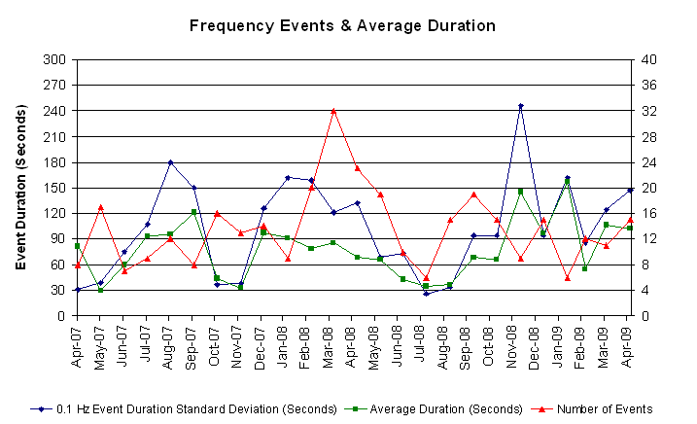

Deployed Responsive (Reported Above)
Time deployed | Stop Time | Duration | Max | Details
4/03 23:03:42 | 4/03 23:17:10 | 0:13:28 | 332.64 | Base power schedule change by -2000 MW.
4/05 07:09:22 | 4/05 07:20:32 | 0:11:10 | 448.82
4/06 20:08:28 | 4/06 20:17:08 | 0:08:40 | 322.08 | Out of Up Reg at 20:00.
4/07 04:55:30 | 4/07 05:18:46 | 0:23:16 | 564.97
4/08 06:07:28 | 4/08 06:16:24 | 0:08:56 | 332.64 | SCE Change -800 MW in 7 min
4/09 07:10:58 | 4/09 07:32:38 | 0:21:40 | 786.73
4/11 22:24:54 | 4/11 22:38:05 | 0:13:11 | 332.64 | SCE change -500 MW in 13m. Out of Up Reg at 22:18.
4/12 20:10:26 | 4/12 20:39:38 | 0:29:12 | 343.21 | Out of Up Reg
4/15 16:47:28 | 4/15 17:06:38 | 0:19:10 | 601.93
4/17 15:01:55 | 4/17 15:15:48 | 0:13:53 | 448.82
4/19 01:03:28 | 4/19 01:17:09 | 0:13:41 | 353.77 | SCE Change -600 MW in 20 min
4/19 01:49:53 | 4/19 02:28:33 | 0:38:40 | 343.21 | Unit Trip
4/23 01:07:37 | 4/23 01:21:05 | 0:13:28 | 517.44
4/26 02:43:33 | 4/26 02:55:05 | 0:11:32 | 406.56
4/26 11:24:19 | 4/26 11:42:05 | 0:17:46 | 638.89 | Unit Trip
4/27 13:02:04 | 4/27 13:34:11 | 0:32:07 | 359.04 | Input error.
4/30 22:03:42 | 4/30 22:30:57 | 0:27:15 | 438.24

Day-Ahead OOMC and RPRS Capacity Purchases
Details | OOMC | RPRS S1 | RPRS S2 | RPRS S1+S2 | Total
W RIO | 96 | 3 | 0 | 3 | 99
Austin | 27 | 1 | 7 | 8 | 35
DFW | 7 | 4 | 6 | 10 | 17
North | 12 | 0 | 4 | 4 | 16
Laredo | 0 | 12 | 3 | 15 | 15
Western | 5 | 0 | 6 | 6 | 11
Houston | 8 | 1 | 1 | 2 | 10
Northeast | 0 | 0 | 10 | 10 | 10
Corpus | 7 | 1 | 0 | 1 | 8
E RIO | 0 | 4 | 0 | 4 | 4
San Antonio | 0 | 0 | 4 | 4 | 4
South | 0 | 2 | 0 | 2 | 2
Bryan Area | 0 | 0 | 0 | 0 | 0
 | 162 | 28 | 41 | 69 | 231

Historical Totals | Apr-09 | Apr-08 | Mar-09
Austin | 28 | 0 | 26
Bryan Area | 0 | 13 | 7
Corpus | 8 | 0 | 2
DFW | 11 | 102 | 6
E RIO | 4 | 34 | 1
Houston | 9 | 28 | 2
Laredo | 12 | 59 | 9
North | 12 | 4 | 33
Northeast | 0 | 0 | 0
San Antonio | 0 | 0 | 0
South | 2 | 0 | 2
W RIO | 99 | 18 | 96
Western | 5 | 14 | 1
Total | 190 | 272 | 185
http://www.ercot.com/mktinfo/services/rprsdr/index.html
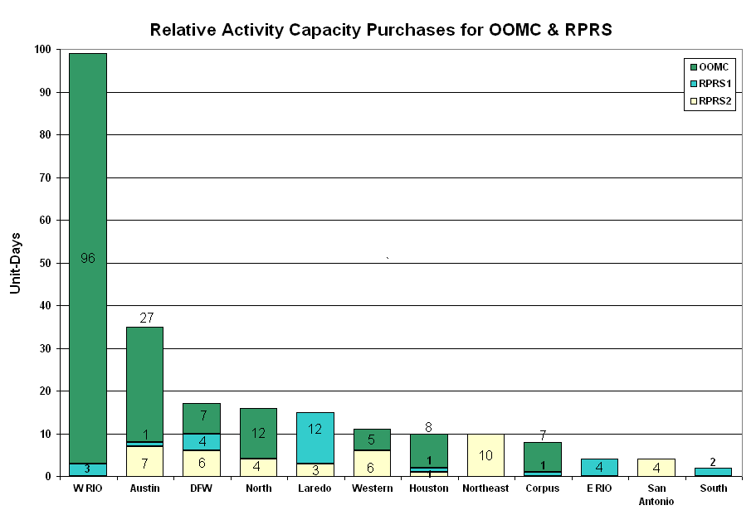OOME and Congestion Management Activity
Congestion affected by outages
Remedial action plan has been developed for the element
Contingency | Overloaded Element | Days
Abilene South - Eskota Switch 138KV | Trent - Merkel 69KV | 20
Santa Anna - Ballinger 138KV | Ballinger - Humble 69KV | 17
Dilley Switch - North Laredo 138KV | North Laredo - Asherton 138KV | 12
Aspermont - Spur 138KV | Matador - Paducah 69KV | 11
Lon Hill - Coleto Creek 345KV | Victoria - Warburton 138KV | 7
Oasis - PH Robinson 345KV | Garrott - Midtown 138KV | 6
Willow Valley - Bluff Creek 138KV | Ackerly Vealmoor - Ackerly | 6
Comanche Peak - Decordova SES and Wolf Hollow - Rocky Creek 345KV | Concord 345/138KV autotransformer | 5
Aspermont - Spur 138KV | Spur 138/69KV AT1 autotransformer | 4
Martin Lake SES - Stryker Creek SES and Mt. Enterprise 345KV | Tyler West - Tyler Northwest 138KV | 4
Morgan Creek - Sun Switch 138KV | Sun Switch - Sacroc 138KV | 4
Royse Switch - Farmersville 345KV | Royse Switch - Farmersville 345KV | 4
Parkdale - Prairie Creek 138KV | Prairie Creek - Prairie Creek Switch 138KV | 3
Aspermont - Spur 138KV | Jayton - Spur 69 KV | 3
Comanche Peak - Decordova & Wolf Hollow - Rocky Creek 345KV | Concord 345/138KV Auto | 3
Garfield - Onion & Hicross 138KV | Lytton Springs - Pilot Knob 138KV | 3
Morgan Creek SES - Odessa EHV and Quail Switch 345KV | Big Spring Switch - Big Spring West 138KV | 3
Sandow Switch - Austrop 345KV | Gilleland Creek - Elgin Switch 138KV | 3
Scurry Switch - Spur 138KV | Matador - Paducah 69KV | 3
Sonora - Friend Ranch 138KV | Friend Ranch - Ozona 69KV | 3
Austrop - Garfield - Zorn 345KV | Austrop 345/138KV T1 | 2
Lytton Springs - Zorn & Austrop - Zorn 345KV | Austrop Auto #2 | 2
Sonora - Friend Ranch 138KV | Friend Ranch - Crockett Heights 69KV | 2
Abilene Mulberry Creek & Long Creek - Sweetwater 345KV | Colorado City - Sweetwater 69KV | 2
Austrop 345/138KV autotransformer #2 | Austrop 345/138KV autotransformer #1 | 2
Basecase | Divide 345/138KV AT1 autotransformer | 2
Calaveras - Ball Park 138KV | Calaveras - Skyline 138KV | 2
Dilley Switch - San Miguel Switch 138KV | Pearsall Switch - Derby Sub 69KV | 2
Gibbons Creek - Obrien & Singleton - TH Wharton 345KV | Austrop - Sandow Switch 345KV | 2
Graham SES - Long Creek 345KV | Abilene Northwest - Abilene Mulberry Creek | 2
Odessa EHV - Morgan SES & Quail Switch 345KV | Morgan SES Auto #4 | 2
Odessa EHV - Morgan Switch & Quail Switch 345KV | Big Spring West to Big Spring Switch 138KV | 2
Sandow SES - Temple Switch 345KV | Hearne 138/69KV autotransformer | 2
Sandow Switch - Austrop 345KV and Sandow Switch 345/138KV autotransformer | Austrop 345/138KV autotransformer | 2
STP - Elm Creek 345KV | Blessing - Lolita 138KV | 2
Dilley Switch - San Miguel 138KV | Dilley Switch - Derby | 1
Spur T1 138/69KV transformer | Spur - Girard Tap 69KV | 1
Greens Bayou - Gable and Hardy - Crocket 138KV | Garrott - Midtown 138KV | 1
San Angelo - Comanche 345KV | San Angelo Concho - Veribest 69KV | 1
Watermill - Desoto Switch - Cedar Hill Switch 345KV | West Levee 345/138KV transformer 2 | 1
Bluff Creek - San Angelo Red Creek 345KV | Abilene Mulberry Creek - Bluff Creek 345KV | 1
Comanche Switch - Brownwood 138KV | Brownwood - Brownwood South 138KV | 1
Dilley Switch - North Laredo 138KV | North Laredo - Asherton 138KV | 1
Farmersville - Royse Switch 345KV | Payne Switch - EPCO POI 138KV | 1
Formosa 138/69KV autotransformer T1 | Formosa 138/69KV autotransformer T2 | 1
Garfield - Hicross 138KV | Lytton Springs - Pilot Knob 138KV | 1
Golden Bluff - Bluff Creek 138KV | Sun Switch - Sacroc | 1
Graham - Benbrook Switch and Graham - Parker Switch 345KV | Flat Creek - Leon Switch | 1
Marion - Zorn and Clear Springs 345KV | Schertz - Parkway 138kV | 1
Matador - Spur 69KV | Matador - Paducah 69KV | 1
Moore - Uvalde 138KV | Campwood - Leakey 69KV | 1
North Denton Auto #1 | North Denton Auto #2 | 1
Parkdale - Prairie Creek 138KV | Prairie Creek - Prairie Creek Switch 138KV | 1
PH Robinson AT3 345/138KV transformer | PH Robinson AT1 345/138KV transformer | 1
Renner & Plano Tennyson 345KV | Allen Switch - Plano Custer Road 138KV | 1
Royse Switch - Farmersville 345KV | Anna Switch - Collin 345KV | 1
San Miguel Switchyard 345/138KV autotransformer A | San Miguel autotransformer B | 1
Sandow - Austrop 345KV | Sandow - Elgin Switch 138KV | 1
STP - Hillje and STP - Whitepoint 345KV | Blessing - Lolita 138KV | 1

Zonal OC1
CSC | Days
West-North | 19
North-Houston | 6
North-South | 4
South-North | 2

New RAP (Date indicates last update of RAP not implementation date.)
None

New Procedures/Forms/Operations Bulletins
None

Blackout/Load Shed Incidences
None

EECP
None

Major System Voltage Problems
None

Major Computer Problems, Enhancements & Fixes

04/18 14:00 Held interval 13:45 deployments due to 14:00 interval RTBM failed to execute. Resumed with 14:15 interval.

04/20 14:45 Held Real-time Balancing deployments for interval ending 14:30 due to 14:45 failed to reach market participants. Resumed with interval ending 15:00.

04/20 17:45 Held Real-time Balancing deployments for interval ending 17:30 due to 17:45 failed to reach market participants. Resumed with interval ending 18:00.
Communication
None

ERCOT peak (Unofficial)
04/22 18:00 43,310 MW

Yearly MTLF Error Comparison
Yearly Mid-Term (Hourly) Load Forecast Error Comparison for the ERCOT Forecast
Month | MAPE for MTLF at 16:00 Day-Ahead
Month | 2006 | 2007 | 2008 | 2009
January | 4.79 | 4.55 | 3.30 | 4.11
February | 4.81 | 3.75 | 3.59 | 3.49
March | 4.95 | 2.70 | 3.29 | 3.24
April | 5.59 | 3.00 | 2.45 | 2.66
May | 3.59 | 3.22 | 3.01 | NA
June | 2.65 | 4.46 | 2.81 | NA
July | 2.62 | 4.29 | 2.55 | NA
August | 2.09 | 3.11 | 3.66 | NA
September | 4.03 | 3.78 | 4.99 | NA
October | 3.63 | 3.08 | 2.79 | NA
November | 3.28 | 2.95 | 2.60 | NA
December | 3.44 | 3.74 | 4.54 | NA
Annual Average | 3.79 | 3.55 | 3.29 | 3.37

OCN, Advisory, Alerts & Emergency Notices
Capacity
Date | Start | End | Event
4/4/09 | 7:45 | 14:41 | OCN issued for projected capacity shortage for HE 2100 & 2200.
4/4/09 | 14:41 | 16:15 | Alert Issued for project capacity shortage for HE 2100.
4/16/09 | 4:30 | 13:35 | OCN issued for a potential capacity shortage for HE 1400 - 1800.
4/17/09 | 10:40 | 12:15 | Advisory issued for ARRS below 3000 MW.
4/18/09 | 10:19 | 12:26 | Advisory issued for ARRS below 3000 MW.
4/20/09 | 2:00 | 3:25 | OCN issued for a projected capacity shortage for HE 1600 -1800.
4/20/09 | 3:25 | 6:10 | Alert issued for projected capacity shortage for HE 1600 - 1800.
4/22/09 | 11:18 | 19:57 | OCN issued for a potential capacity shortage for HE 1700 - 2100.
4/23/09 | 18:01 | 18:43 | Advisory issued for ARRS below 3000 MW.
4/27/09 | 8:30 | 10:45 | OCN issued for a projected capacity shortage for HE 1600-1800.

Transmission

04/09 16:33 Transmission Alert issued due to forced transmission outages in West Texas caused by wild fires.

04/09 23:48 Transmission Alert issued for post contingency overload of Odessa North 138/69KV autotransformer with no market solution and unsolved contingencies.

04/10 00:00 Transmission Alert issued for post contingency overload of Odessa North 138/69KV autotransformer with no market solution.

04/13 13:26 Transmission Alert issued for the loss Lon Hill - North Edinburg 345KV overloads Lon Hill - Nelson Sharpe 345KV.

04/30 17:50 Transmission Alert issued for loss of Munday East - Paducah Claire St. 138KV overloads Benjamin - Munday 69KV past first contingency limits

Emergency Notice

04/13 13:20 Transmission Emergency Notice issued for the loss Dilley Switch - North Laredo 138KV overloads North Laredo - Asherton 138KV beyond first contingency criteria with no market solution. ERCOT initiated an Emergency Schedule from Comision Federal De Electricidad (CFE) to ERCOT utilizing the Laredo VFT.

04/15 18:12 Transmission Emergency Notice issued for the loss Dilley Switch - North Laredo 138KV overloads North Laredo - Asherton 138KV beyond first contingency criteria with no market solution. ERCOT initiated an Emergency Schedule from Comision Federal De Electricidad (CFE) to ERCOT utilizing the Laredo VFT.

04/24 13:20 Emergency Notice issued for the Laredo Area. Laredo Import limit 100 MW due to planned outage. ERCOT initiated an Emergency Schedule from Comision Federal De Electricidad (CFE) to ERCOT utilizing the Laredo VFT.

04/25 13:30 Emergency Notice issued for the Laredo Area. Laredo Import limit 100 MW due to planned outage. ERCOT initiated an Emergency Schedule from Comision Federal De Electricidad (CFE) to ERCOT utilizing the Laredo VFT.

04/26 11:00 Emergency Notice issued for the Laredo Area. Laredo Import limit 100 MW due to planned outage. ERCOT initiated an Emergency Schedule from Comision Federal De Electricidad (CFE) to ERCOT utilizing the Laredo VFT.

04/27 11:30 Emergency Notice issued for the Laredo Area. Laredo Import limit 100 MW due to planned outage. ERCOT initiated an Emergency Schedule from Comision Federal De Electricidad (CFE) to ERCOT utilizing the Laredo VFT.

Texas RE Event Analysis

04/05 07:09 One 345 kV line tripped due to “A” phase to ground fault associated with a turkey vulture roost. This resulted in a loss of two generating units.

04/08 09:30 A market participant did a scheduled failover to their Disaster Recovery Control System. This caused incorrect resource status and data to be sent to ERCOT. Incorrect status and data caused ERCOT Real Time Contingency Analysis to solve with Invalid Solution 09:34 to 09:47

04/09 23:03 One 138 kV bus tripped due to breaker failure and 7 138 kV lines open-ended.

04/13 13:20 Transmission Emergency Notice issued for the loss Dilley Switch - North Laredo 138KV overloads North Laredo - Asherton 138KV beyond first contingency criteria with no market solution. ERCOT initiated an Emergency Energy from Comision Federal De Electricidad (CFE) to ERCOT utilizing the Laredo VFT.

04/15 18:12 Transmission Emergency Notice issued for the loss Dilley Switch - North Laredo 138KV overloads North Laredo - Asherton 138KV beyond first contingency criteria with no market solution. ERCOT initiated an Emergency Energy from Comision Federal De Electricidad (CFE) to ERCOT utilizing the Laredo VFT.

04/17 15:01 Unit trip along with associated transmission equipment due to static wire down caused by thunderstorms.

04/18 23:42 Stanton East SPS activated.

04/20 05:06 Simultaneous loss of two 345/138 kV transformers and eight 138 kV lines. PT failure caused the buses and lines to trip at Centerville Road Switch.

04/24 13:20 Emergency Notice issued for the Laredo Area. Laredo Import limit 100 MW due to planned outage. ERCOT initiated an Emergency Schedule from Comision Federal De Electricidad (CFE) to ERCOT utilizing the Laredo VFT.

04/25 13:30 Emergency Notice issued for the Laredo Area. Laredo Import limit 100 MW due to planned outage. ERCOT initiated an Emergency Schedule from Comision Federal De Electricidad (CFE) to ERCOT utilizing the Laredo VFT.

04/26 11:00 Emergency Notice issued for the Laredo Area. Laredo Import limit 100 MW due to planned outage. ERCOT initiated an Emergency Schedule from Comision Federal De Electricidad (CFE) to ERCOT utilizing the Laredo VFT.

04/27 11:30 Emergency Notice issued for the Laredo Area. Laredo Import limit 100 MW due to planned outage. ERCOT initiated an Emergency Schedule from Comision Federal De Electricidad (CFE) to ERCOT utilizing the Laredo VFT.

Other Events

04/15 14:38 ERCOT held Real-time Balancing Market IE 14:45 for IE 15:00 due to incorrect offset, resumed with IE 15:15.

04/15 18:30 ERCOT held Real-time Balancing Market IE 18:30 for IE 18:45 due to late deployments, resumed with IE 19:00.

