

Survey Request for CCWG

Purpose
The purpose of this document is to review and expand the questions presented to users in the 2008 Market Participant Survey. The survey questions were general and vague. ERCOT needs specific details from participants in order to fully comprehend what areas of ERCOT websites and Staff Communications need to be addressed to better serve the users.

Request
ERCOT values the opinion of all Market Participants. The ERCOT Web Team and WCS are requesting the CCWG assistance in writing questions for an ERCOT.com and ERCOT Staff Communications survey in order to improve. The following questions were asked in the recent 2008 Market Participant Survey. Please expand on these questions.

Section A: Website

- Timeliness of Posted Information
- Look of the Site
- Search Functionality
- Ease of Finding Documents and Information

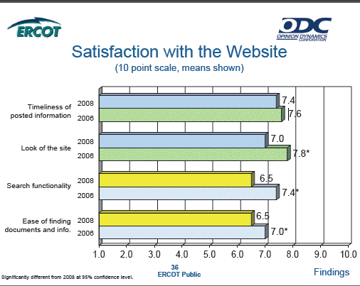

Section B: ERCOT Staff Communications
- Clarity of ERCOT Staff’s Messages

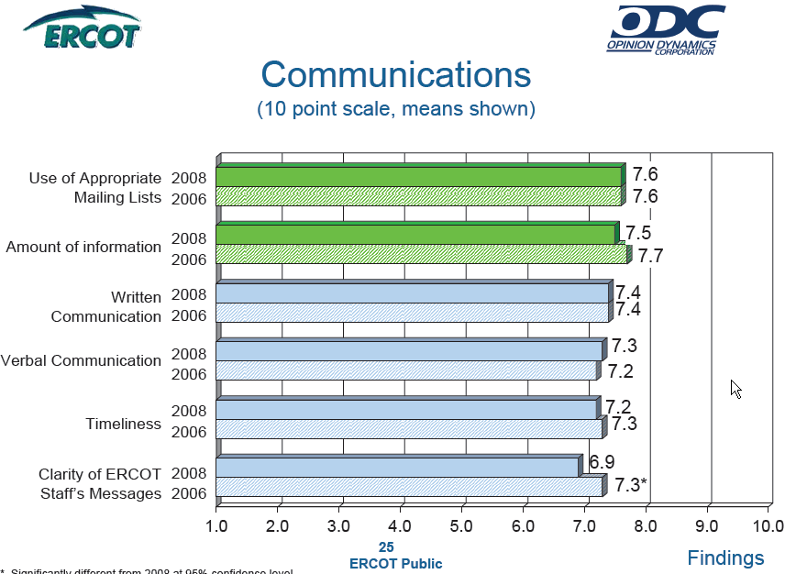

TAC Feedback:
- When searching, newest materials should be listed first.
- A search return should include information, if found, from Section 2 of the Protocols, Acronyms and Definitions.
- Archive older data. Documents should be archived after a period of time, so older documents are not returned as a result of a search. Also, consider including a search selectivity to include or not include ‘Archived’ documents. Searches should return the newest materials first, e.g. in chronological order. Market Participant training should be available for the website to improve response time and satisfaction level.
- Training should be an internet based tutorial to orient market participants on how the site is organized and to find information on the site. The website training should be accessible from the ERCOT.com home page.
- Active links on the website, as opposed to documents, should be the first priority return from a search (Show preference to relevant pages). Search the Protocols and return any Section or Subsection Headings relevant to the search. ERCOT should consider implementing the upgrade to the search engine prior to the implementation of the Nodal Market. The meeting calendar should have a month at a glance feature with ability to select a meeting title and link to the meeting details. Include RSS/Atom web feeds of the ERCOT Calendar, Meeting Details and Attachments, new Market PRRs, and new Market Comments to PRRs.

Possible questions for survey:

Section A: Website

1. Background of User (novice to expert)
- Rate your level of experience with ERCOT.com.
- How often do you visit ERCOT.com

2. Timeliness of Posted Information (strongly agree to strongly disagree)
- Documents appear on ERCOT.com when expected.
- Content bound by protocol is posted on time.
- Monthly reports, extracts, and documents are posted in a timely manner.
- Daily reports, extracts, and documents are posted in a timely manner.
- Calendar information is posted in a timely manner.
- Market Information is posted in a timely manner.
- Market Rules information is posted in a timely manner.

3. Look of ERCOT.com (very dissatisfied to very satisfied)

- Are you satisfied with the overall layout of ERCOT.com?
- Are you satisfied with the calendar layout?
- Are you satisfied with the ERCOT.com home page?

4. Search Functionality on ERCOT.com (strongly agree to strongly disagree)
- Meeting information is easy to locate.
- Links to other ERCOT websites are easy to locate.
- Results are returned from most relevant to least relevant.
- Results returned are most current to least current.

5. Ease of Finding Documents and Information on ERCOT.com (strongly agree to strongly disagree)

- Documents are easy to locate.
- Reports are easy to locate.
- Extracts are easy to locate.

Section B: ERCOT Staff Communications

1. Background of MP receiving ERCOT Communications
- Rate your level of Industry
- ERCOT staff messages lack guidance or instructions contained within notices.

2. ERCOT SLA’s

