 |  |  |  | System Planning Division
Monthly Status Report
to
Reliability and Operations Subcommittee
for
March 2009

 |  | Report Highlights
Item
1. | - ERCOT is currently tracking 262 active generation interconnection requests totaling over 105,000 MW. This includes almost 52,000 MW of wind generation.
2. | - Regional Planning is currently reviewing proposed transmission improvements with a total cost of $1,012.9 Million  - Transmission Projects approved in 2009 total $ 74 Million  - All projects (in engineering, routing, licensing and construction) totals approximately $4.1 Billion  - Transmission Projects energized in 2008 total about $453 million

Table of Contents
1. Generation Interconnection 1
1.1 New Generation Beginning Commercial Operations 1
1.2 New Generation Interconnection Agreements 1
1.3 Summary of Active Generation Interconnection Requests 1
1.4 Publicly Disclosed Generation Interconnection Projects 3
1.5 Generation Projects Undergoing Full Interconnection Studies 5
1.6 Wind Generation 7
2. Regional Planning Group Project Reviews 8
3. Other Notable Activities 9

1. Generation Interconnection
Additional information regarding detailed generation interconnection and impact studies is contained in the “Generation Project Interconnection Information” folder in the “Operations and System Planning” area on the ERCOT website: http://planning.ercot.com/login/login.

New Generation Beginning Commercial Operations

Cedar Bayou 4 (08INR0035) - 535 MW Combined Cycle in Chambers County

New Generation Interconnection Agreements

Sterling Energy Center - Wind (09INR0026) - 300 MW in Sterling County
- Langford Wind Power (10INR0026) – 150 MW in Tom Green County

TECO Central Plant (11INR0014) - 50 MW in Harris County

Panther Creek 3 Wind (11INR0015) - 200 MW in Concho County

Summary of Active Generation Interconnection Requests
GENERATION INTERCONNECTION REQUESTS CURRENTLY BEING PROCESSED
Currently tracking 262 active generation interconnection or change requests
As of March 31, 2009 | North | South | West | Total
Security Screening Study | 5 | 7 | 6 | 18
SSS Completed | 3 | 12 | 38 | 53
Full Interconnect Study | 34 | 37 | 78 | 149
FIS Completed | 2 | 10 | 1 | 13
Interconnect Agreement Completed | 8 | 8 | 13 | 29
Capacity under Interconnection Agreements | 5,458 | 2,089 | 2,163 | 9,710
Capacity for Grid, MW | 26,721 | 36,518 | 41,936 | 105,175
Wind Capacity, MW | 3,050 | 9,924 | 38,923 | 51,897

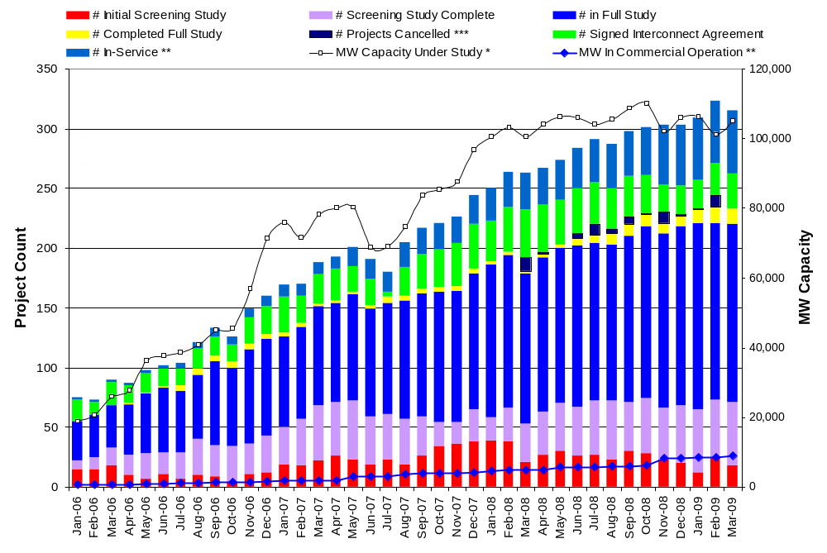

Fuel Type | Confidential Projects (MW) | Projects Under Full Study (MW) | Projects w/ Interconnect Agreement/Public Letter (MW) | Grand Total (MW)
Gas-CC | - | - | 4,740 | 4,740
Gas-CT | - | - | 720 | 720
Total Gas | 3,774 | 18,254 | 5,460 | 27,488
Nuclear | - | 3,200 | 9,186 | 12,386
Coal | 2,050 | 3,550 | 4,131 | 9,731
Wind | 13,688 | 30,691 | 7,518 | 51,897
Solar | 1,043 | - | - | 1,043
Biomass | - | 55 | 145 | 200
Other | 950 | 1,480 | - | 2,430
Grand Total | 21,505 | 57,230 | 26,440 | 105,175

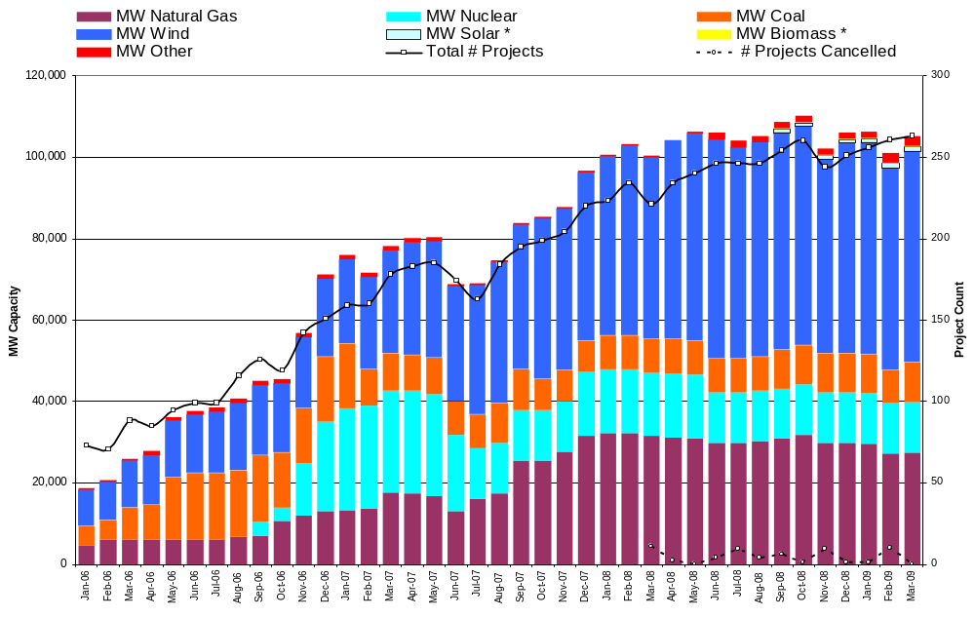

Publicly Disclosed Generation Interconnection Projects
The table below summarizes the publicly disclosed generation projects for the ERCOT region.
(IA=Interconnect Agreement, PL=Public Letter, XX= cancelled)
Generation Interconnections as of March 31, 2009
INR | SiteName | Status | County | Region | COD | Fuel | MW For Grid | Change from Last Report
07INR0036 | Coyote Run Windfarm | IA | Borden | West | Apr-09 | Wind | 225 | date
08INR0046 | Bosque Expansion | IA | Bosque | North | Apr-09 | Gas-CC | 255 | date
07INR0027 | S Houston Green Power Exp | IA | Galveston | South | Apr-09 | Gas-CC | 244
07INR0028b | Goat Wind - phase 2 | IA | Sterling | West | Apr-09 | Wind | 70
09INR0072 | Dansby3 | PL | Brazos | North | Apr-09 | Gas-CT | 48
10INR0025 | Mont Belvieu | IA | Chambers | South | Apr-09 | Gas-CT | 0
08INR0003 | Sandow 5 | IA | Milam | North | Apr-09 | Coal | 581
08INR0012a | Papalote Creek Wind Farm | IA | San Patricio | South | May-09 | Wind | 180
09INR0060 | Stephens Wind Farm | PL | Borden | West | May-09 | Wind | 141
09INR0027 | Winchester Power Park | IA | Fayette | South | Jun-09 | Gas-CT | 178
09INR0036 | McAdoo Energy Center II | PL | Dickens | West | Jun-09 | Wind | 500
09INR0006a | Oak Grove SES 1 | IA | Robertson | North | Jul-09 | Coal | 855
09INR0039 | Nueces Bay 7 Repowering | IA | Nueces | South | Jul-09 | Gas-CC | 327 | date
09INR0079 | Pearsall Expansion | PL | Frio | South | Aug-09 | Gas-CT | 200
05INR0015b | Gulf Wind 2 | PL | Kenedy | South | Sep-09 | Wind | 400
08INR0033 | Lufkin | IA | Angelina | North | Sep-09 | Biomass | 45
09INR0015 | Comanche Peak 1&2 Upgrade | PL | Somervell | North | Oct-09 | Nuclear | 86
09INR0028 | V H Braunig 6 | PL | Bexar | South | Oct-09 | Gas-CT | 185
09INR0038 | Barney Davis 2 Repowering | IA | Nueces | South | Nov-09 | Gas-CC | 360
11INR0015 | Panther Creek 3 | IA | Concho | West | Nov-09 | Wind | 200 | new
08INR0038 | M Bar Wind | PL | Andrews | West | Dec-09 | Wind | 194
09INR0034 | Gatesville Wind Farm | PL | Coryell | North | Dec-09 | Wind | 200
09INR0047 | Loraine Windpark | IA | Mitchell | West | Dec-09 | Wind | 251
10INR0026 | Langford Wind Power | IA | Tom Green | West | Dec-09 | Wind | 150 | new
06INR0029 | Jackson Mountain | IA | Nolan | West | Jan-10 | Wind | 90
09INR0006b | Oak Grove SES 2 | IA | Robertson | North | Jan-10 | Coal | 855
11INR0014 | TECO Central Plant | IA | Harris | South | Feb-10 | Gas-CC | 50 | new
09INR0037 | Scurry County Wind III | PL | Scurry | West | Mar-10 | Wind | 350
09INR0002 | J K Spruce 2 | IA | Bexar | South | Jun-10 | Coal | 750
09INR0045 | Sand Hill Peakers | PL | Travis | South | Jul-10 | Gas-CT | 94
05INR0015c | Gulf Wind 3 | PL | Kenedy | South | Sep-10 | Wind | 400
06INR0012b | Sherbino Mesa Wind Farm 2 | IA | Pecos | West | Oct-10 | Wind | 150
08INR0011 | Senate Wind Project | IA | Jack | North | Nov-10 | Wind | 150
12INR0003 | Throckmorton Wind Farm | PL | Throckmorton | West | Dec-10 | Wind | 400
08INR0065 | Buffalo Gap 4 and 5 | PL | Nolan | West | Mar-11 | Wind | 465 | date
10INR0020 | Panda Temple Power | PL | Bell | North | May-11 | Gas-CC | 1,092
10INR0010 | Jack County 2 | PL | Jack | North | Jun-11 | Gas-CC | 620
08INR0018 | Gunsight Mountain | IA | Howard | West | Aug-11 | Wind | 120 | date
06INR0026 | Wild Horse Mountain | IA | Howard | West | Dec-11 | Wind | 120
08INR0025 | Pistol Hill Energy Center | PL | Ector | West | Dec-11 | Wind | 300
09INR0007 | Nacogdoches Project | PL | Nacogdoches | North | Apr-12 | Biomass | 100
07INR0004 | Pampa Energy Center | PL | Gray | West | May-12 | Coal | 165
09INR0001 | Sandy Creek 1 | IA | McLennan | North | Jun-12 | Coal | 925
09INR0024 | B&B Panhandle Wind | PL | Carson | West | Jun-12 | Wind | 1,001
09INR0026 | Sterling Energy Center | IA | Sterling | West | Jun-12 | Wind | 300
09INR0026a | Sterling Energy Center | PL | Sterling | West | Jun-12 | Wind | 200
12INR0004 | Fort Concho Wind Farm | PL | Tom Green | West | Jul-12 | Wind | 400
08INR0040 | Lenorah Project | IA | Martin | West | Sep-12 | Wind | 251
06INR0006 | Cobisa-Greenville | IA | Hunt | North | May-13 | Gas-CC | 1,792
04INR0011b | Mesquite Wind Phase 4 | IA | Shackelford | West | Jun-13 | Wind | 136
04INR0011c | Cottonwood Wind | IA | Shackelford | West | Jun-13 | Wind | 100
11INR0011 | Victoria City Nuclear | PL | Victoria | South | Jan-15 | Nuclear | 3,200
15INR0002 | Comanche Peak 3 and 4 | PL | Somervel | North | Jan-15 | Nuclear | 3,200
15INR0008 | STP 3 and 4 | PL | Matagorda | South | Jan-15 | Nuclear | 2,700
 |  |  |  |  |  |  | 26,351

County Location of Installed Generation and Interconnection Requests (all fuels)

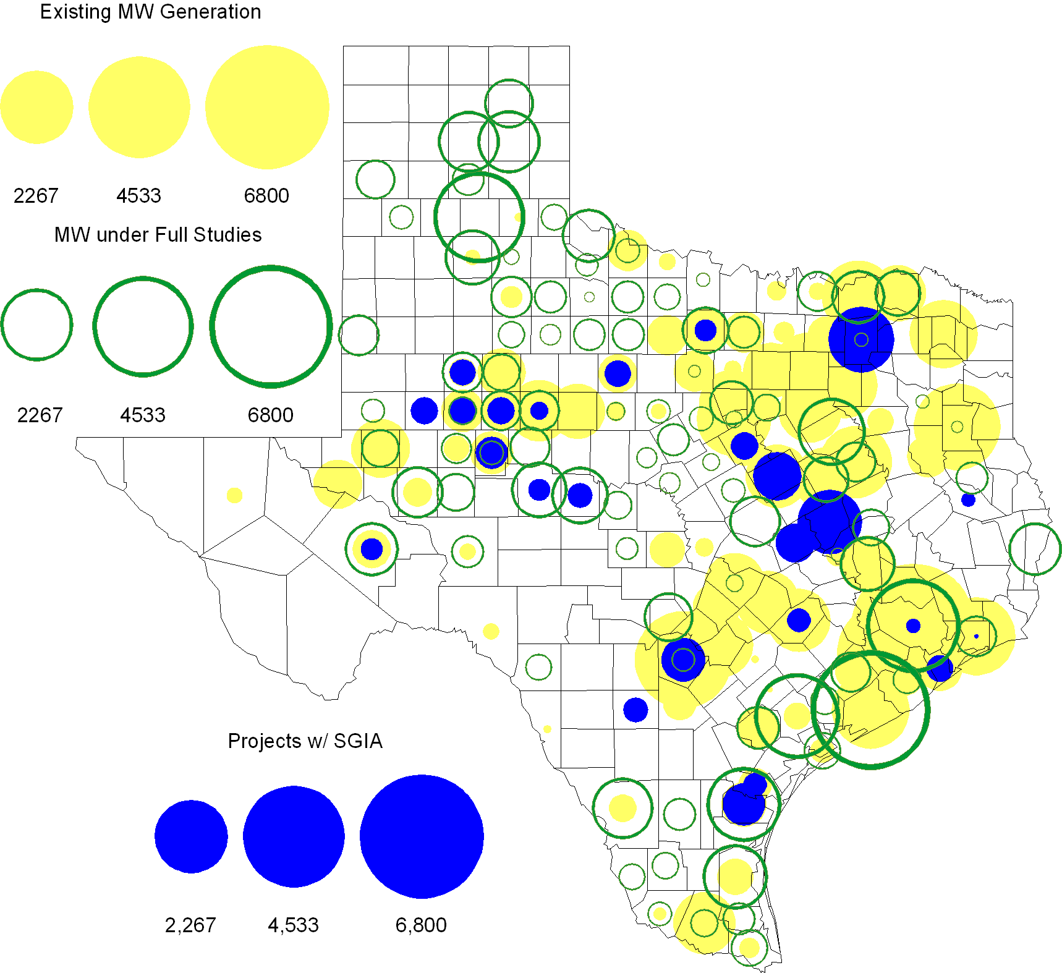

Generation Projects Undergoing Full Interconnection Studies
Project | County | Capacity (MW) | COD | Fuel |  | Project | County | Capacity (MW) | COD | Fuel
08INR0009 | Jack | 150 | TBD | Wind |  | 08INR0044 | Concho | 200 | TBD | Wind
08INR0049 | Clay | 50 | TBD | Wind |  | 06INR0022c | Kenedy | 200 | TBD | Wind
08INR0062 | Archer | 249 | TBD | Wind |  | 08INR0061 | Hardeman | 200 | TBD | Wind
08INR0020 | Eastland | 200 | TBD | Wind |  | 09INR0064 | Borden | 41 | TBD | Wind
08INR0042 | Coke | 200 | TBD | Wind |  | 08INR0041 | Coke | 200 | TBD | Wind
09INR0063 | Nueces | 289 | Apr-09 | Gas |  | 08INR0060 | Hidalgo | 279 | Apr-09 | Gas
09INR0005 | Calhoun | 280 | Apr-09 | Other |  | 09INR0059 | Freestone | 20 | May-09 | Coal
08INR0014 | Webb | 183 | May-09 | Wind |  | 07INR0026 | Baylor | 400 | May-09 | Wind
08INR0005 | Wise | 400 | Jun-09 | Gas |  | 09INR0025 | Concho | 180 | Jun-09 | Wind
09INR0044 | Coke | 60 | Sep-09 | Wind |  | 10INR0027 | Nueces | 35 | Oct-09 | Wind
09INR0075 | Kinney | 248 | Oct-09 | Wind |  | 09INR0055 | McCulloch | 299 | Oct-09 | Wind
09INR0041 | Mitchell | 300 | Oct-09 | Wind |  | 07INR0014b | Wilbarger | 70 | Oct-09 | Wind
07INR0014a | Wilbarger | 140 | Oct-09 | Wind |  | 09INR0048 | Jack | 150 | Oct-09 | Wind
08INR0054 | Comanche | 401 | Oct-09 | Wind |  | 11INR0015 | Concho | 200 | Nov-09 | Wind
09INR0073 | Scurry | 200 | Nov-09 | Wind |  | 08INR0031 | Childress | 100 | Nov-09 | Wind
09INR0029 | Calhoun | 263 | Dec-09 | Coal |  | 11INR0013 | Mills | 150 | Dec-09 | Wind
08INR0039 | Hamilton | 90 | Dec-09 | Wind |  | 09INR0082 | Webb | 300 | Dec-09 | Wind
11INR0012 | Duval | 400 | Dec-09 | Wind |  | 09INR0065 | Webb | 150 | Dec-09 | Wind
09INR0077 | Reagan | 500 | Dec-09 | Wind |  | 09INR0061 | Kent | 258 | Dec-09 | Wind
09INR0058 | Howard | 250 | Dec-09 | Wind |  | 09INR0054 | Stonewall | 149 | Dec-09 | Wind
09INR0051 | Borden | 249 | Dec-09 | Wind |  | 08INR0056 | Nolan | 149 | Dec-09 | Wind
08INR0023 | Floyd | 100 | Dec-09 | Wind |  | 08INR0022 | Floyd | 100 | Dec-09 | Wind
07INR0008 | Howard | 35 | Dec-09 | Wind |  | 10INR0011 | Johnson | 275 | Jan-10 | Gas
11INR0036a | Matagorda | 200 | Jan-10 | Wind |  | 11INR0033a | Cameron | 200 | Jan-10 | Wind
10INR0047 | Kendall | 1,000 | Jan-10 | Wind |  | 10INR0048 | Hardeman | 1,000 | Jan-10 | Wind
10INR0024 | Briscoe | 3,000 | Jan-10 | Wind |  | 10INR0022 | Harris | 3,500 | Mar-10 | Gas
09INR0062 | Brown | 140 | Mar-10 | Wind |  | 10INR0046 | Jim Hogg | 264 | Apr-10 | Wind
10INR0045 | Webb | 734 | Apr-10 | Wind |  | 10INR0017 | Chambers | 685 | May-10 | Gas
10INR0054 | Palo Pinto | 36 | May-10 | Wind |  | 10INR0079 | Nolan | 60 | May-10 | Wind
10INR0023 | Haskell | 386 | May-10 | Wind |  | 10INR0016 | Childress | 150 | May-10 | Wind
09INR0070 | Reagan | 42 | May-10 | Wind |  | 09INR0069 | Reagan | 36 | May-10 | Wind
09INR0035 | Concho | 750 | May-10 | Wind |  | 09INR0018 | Concho | 249 | May-10 | Wind
07INR0032 | Tom Green | 249 | May-10 | Wind |  | 10INR0069 | Rusk | 818 | May-10 | Coal
10INR0076 | Webb | 225 | May-10 | Wind |  | 09INR0081 | Rusk | 818 | Jun-10 | Coal
10INR0029 | Hood | 810 | Jun-10 | Gas |  | 10INR0035 | Harris | 416 | Jun-10 | Gas
10INR0012 | Nacogdoches | 300 | Jul-10 | Gas |  | 10INR0052a | Knox | 21 | Jul-10 | Wind
10INR0013 | Upton | 400 | Jul-10 | Wind |  | 10INR0038 | Glasscock | 350 | Aug-10 | Wind
10INR0071 | Matagorda | 88 | Sep-10 | Wind |  | 10INR0015 | Mitchell | 350 | Oct-10 | Wind
09INR0074 | Motley | 70 | Oct-10 | Wind |  | 10INR0070 | Hunt | 50 | Nov-10 | Gas
10INR0039 | Dickens | 200 | Nov-10 | Wind |  | 10INR0032 | Navarro | 800 | Dec-10 | Gas
09INR0031 | Ector | 275 | Dec-10 | Gas |  | 10INR0042 | Mason | 170 | Dec-10 | Wind
10INR0060 | Willacy | 401 | Dec-10 | Wind |  | 10INR0059 | Zapata | 251 | Dec-10 | Wind
09INR0076 | Jackson | 300 | Dec-10 | Wind |  | 10INR0077 | Callahan | 101 | Dec-10 | Wind
10INR0056 | Borden | 249 | Dec-10 | Wind |  | 10INR0049 | Pecos | 200 | Dec-10 | Wind
10INR0033 | Armstrong | 420 | Dec-10 | Wind |  | 10INR0019 | Deaf Smith | 609 | Dec-10 | Wind
10INR0008 | Pecos | 500 | Dec-10 | Wind |  | 07INR0035 | Tom Green | 270 | Dec-10 | Wind
07INR0017 | Erath | 210 | Dec-10 | Wind |  | 07INR0015 | Foard | 180 | Dec-10 | Wind
07INR0013 | Coke | 200 | Dec-10 | Wind |  | 11INR0036b | Matagorda | 200 | Jan-11 | Wind
11INR0033b | Cameron | 200 | Jan-11 | Wind |  | 11INR0037 | Smith | 55 | May-11 | Biomass
11INR0028 | Grimes | 1,280 | May-11 | Gas |  | 11INR0046 | Brazoria | 300 | May-11 | Gas
10INR0009 | Castro | 200 | May-11 | Wind |  | 11INR0009 | Navarro | 1,200 | Jun-11 | Gas
09INR0050 | Fannin | 1,200 | Jun-11 | Gas |  | 11INR0057 | Cameron | 144 | Jun-11 | Wind
11INR0022 | Tom Green | 200 | Jun-11 | Wind |  | 11INR0021 | Tom Green | 200 | Jun-11 | Wind
11INR0019 | Upton | 200 | Jun-11 | Wind |  | 11INR0006 | Lamar | 579 | Jul-11 | Gas
06INR0041 | Newton | 1,160 | Jul-11 | Gas |  | 11INR0040 | freestone | 749 | Aug-11 | Gas
11INR0039 | Starr | 201 | Sep-11 | Wind |  | 11INR0008a | Roberts | 1,000 | Sep-11 | Wind
10INR0021 | Grayson | 646 | Nov-11 | Gas |  | 09INR0016 | Yoakum | 680 | Nov-11 | Gas
06INR0022d | Kenedy | 200 | Dec-11 | Wind |  | 11INR0025 | Crockett | 400 | Dec-11 | Wind
11INR0005 | Upton | 500 | Dec-11 | Wind |  | 10INR0018 | Madison | 550 | Mar-12 | Gas
12INR0007 | Lamar | 296 | May-12 | Gas |  | 12INR0006 | Limestone | 875 | Jun-12 | Coal
12INR0020 | Wharton | 660 | Jun-12 | Gas |  | 12INR0002 | Briscoe | 750 | Jul-12 | Wind
12INR0016 | Nueces | 1,200 | Nov-12 | Other |  | 08INR0019c | Gray | 250 | Nov-12 | Wind
08INR0019b | Gray | 250 | Nov-12 | Wind |  | 08INR0019a | Gray | 250 | Nov-12 | Wind
06INR0022f | Kenedy | 200 | Dec-12 | Wind |  | 06INR0022b | Kenedy | 200 | Dec-12 | Wind
12INR0005 | Floyd | 1,100 | Dec-12 | Wind |  | 11INR0023 | King | 400 | Dec-12 | Wind
12INR0009 | Nueces | 875 | May-13 | Gas |  | 13INR0005 | Carson | 600 | Oct-13 | Wind
13INR0006 | Gray | 750 | Oct-13 | Wind |  | 06INR0022e | Kenedy | 200 | Dec-13 | Wind
14INR0002 | Goliad | 756 | Feb-14 | Coal |  | 14INR0001 | Pecos | 500 | Dec-14 | Wind
15INR0003 | Matagorda | 3,200 | Jan-15 | Nuclear

Wind Generation
Wind Capacity Installed by Year County Location of Installed Capacity and Interconnection Requests
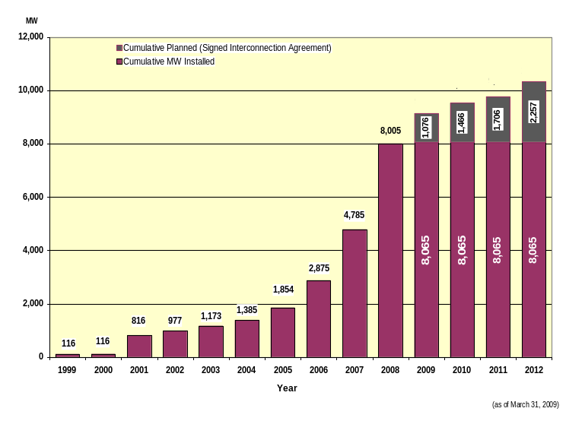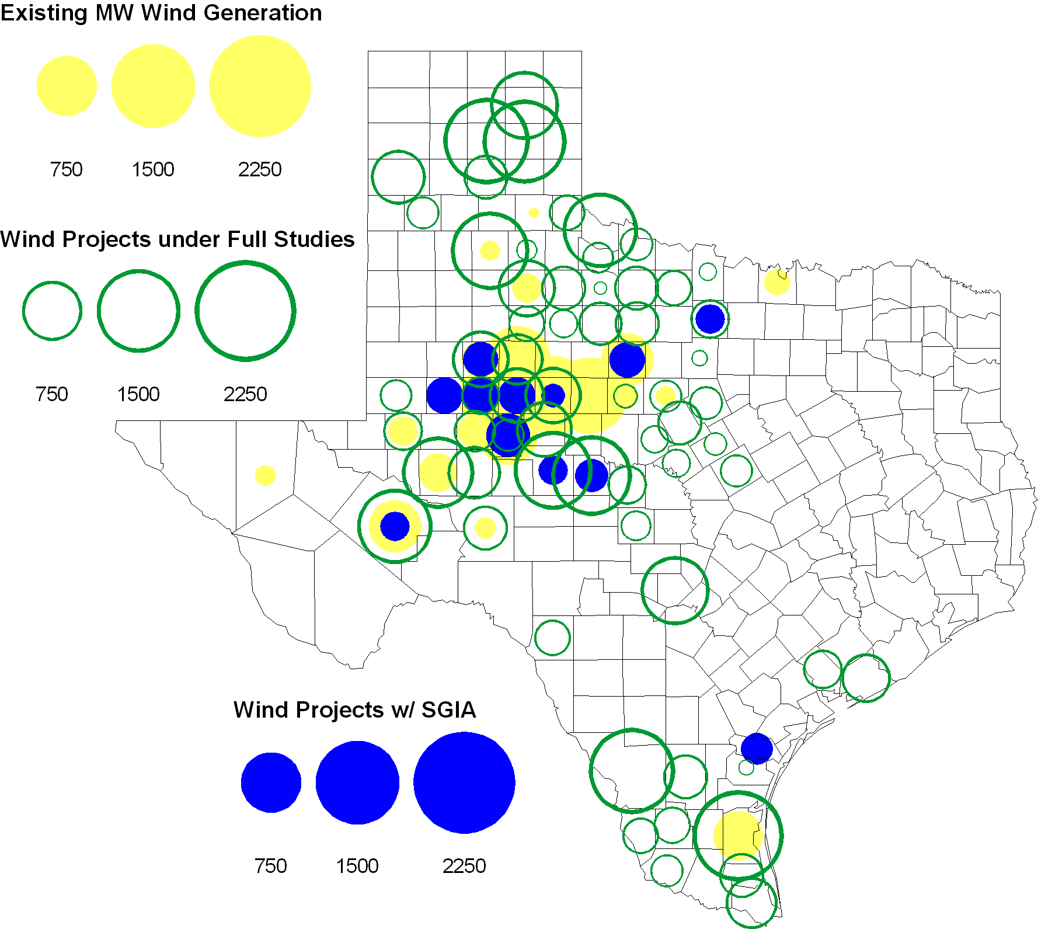

Regional Planning Group Project Reviews

American Electric Power Service Corporation submitted a project to construct 2 new 138 kV substations, rebuild a 138 kV circuit, build 2 new 138 kV circuits, and install a new 138/69 kV autotransformer in the Abilene/San Angelo area. The estimated cost of this project is $105.9 M. This project is in ERCOT Independent Review.

Luminant submitted a set of projects to reduce North to South Congestion. It consists of several 138 kV line upgrades and series reactor installations. The total cost for all projects is approximately $31 M. This project is in ERCOT Independent Review.

Oncor submitted a project to relieve congestion related to new wind units in the Lamesa area. The project will upgrade the Lamesa to Bluff Creek 138 kV line, rebuild the Bluff Creek to China Grove 138 kV line, rebuild the Lamesa to Ackerly Vealmoor 69 kV line to 138/69 kV double circuit, rebuild the Lamesa 138 kV switching station, build a new 138 kV Ackerly Vealmoor station, add second circuits to all rebuilt lines and include station upgrades at China Grove and Big Spring. The cost of this project is $ 80.8 M. This project will be reviewed to ensure that the improvements fit into the likely CREZ transmission solution for the area. This project is in ERCOT Independent Review and will be studied as part of the 2009 Five-Year Transmission Plan.

Oncor submitted a project to add several 345 kV circuits to support the addition of Comanche Peak units 3 and 4 in 2015 at an estimated cost of $ 133 M. These upgrades include a new 345 kV double circuit line with one circuit in place from Comanche to Whitney, a new 345 kV line from Comanche to Johnson Switch, a new circuit on existing structures from Johnson Switch to Everman, a new 345 kV double circuit with one circuit in place from Comanche to DeCordova, and a new 345 kV line on existing structures from Comanche to Parker Switch. This project is in ERCOT Independent Review and will be studied when the 2009 Five-Year Transmission Plan is complete.

Oncor submitted a project to add a 138/69 kV autotransformer at Stanton East into the Spraberry to Big Spring 69 kV line and rebuild the 138 kV line from Stanton East to Big Spring Switch. This project will cost $15 M with an estimated completion date no earlier than summer 2011. The review of this project is complete and a RPG Acceptance Letter has been completed.

Sharyland Utilities submitted a project to construct and operate the ERCOT Southeast Loop facilities consisting of a 345 kV double circuit from Lufkin to Canal 345 kV substation on the northeast side of Houston. This project will cost $359 M with an estimated completion date of summer 2013. This project is in ERCOT Independent Review and will be studied as part of the 2009 Five-Year Transmission Plan.
- Austin Energy submitted a project to relocate the Decker to Techridge circuit to new ROW so that the existing structures can be utilized for the new Gilleland to Techridge circuit. The estimated completion date of this project is November 2010 and estimated cost is $ 4.3 M. This project is in ERCOT Independent Review.

The Lower Colorado River Authority Transmission Services Company (LCRA TSC) submitted a project to construct a new 6.2 mile transmission line from Highway 123 to Cushman substation. The estimated completion date of this project is June 2014 and estimated cost is $ 11.6 M. This project is in ERCOT Independent Review.

The Lower Colorado River Authority Transmission Services Company (LCRA TSC) submitted a project to upgrade and convert a 27.7 mile Flatonia-Moulton-Henkhaus-Shiner-Yoakum Gartner Road 69 kV transmission line to 138 kV. The estimated completion date of this project is June 2011 and estimated cost is $ 18.6 M. The review of this project is complete and a RPG Acceptance Letter has been completed.

The Lower Colorado River Authority Transmission Services Company (LCRA TSC) submitted a project to construct a new 7.8 mile transmission line between the existing GPI and Parkway substations. The estimated completion date of this project is June 2013 and estimated cost is $ 12.9 M. This project is in ERCOT Independent Review.

Centerpoint Energy has submitted a project to expand the Zenith substation, add one 800 MVA autotransformer, connect Zenith to existing circuits near the Gertie substation and upgrade/reconfigure nearby 138 kV circuits. The estimated completion date of this project is summer 2012 and estimated cost is $ 26.6 M. This project is in ERCOT Independent Review.

American Electric Power Service Corporation submitted a project to construct several improvements in the Corpus Christi area. The estimated completion date of this project is June 2012 and estimated cost is $ 214 M. This project is in the comment period.

Other Notable Activities
All postings referred to below can be found at http://planning.ercot.com/login/login unless otherwise indicated.

- ERCOT Regional Planning has begun work on the 2009 Five-Year Transmission Plan utilizing the latest SSWG base cases. This work is in the conditioning phase where projects in the base cases requiring RPG review that have not undergone that review are removed. This phase is complete and the reliability phase will soon begin.

- Completed initial RMR determination on Luminant Notice of Suspension of Operations (NSO) submission and released 12 units. Studies to make a final determination on three other units are still ongoing.

- RMR determination studies are complete for which a Notice of Suspension of Operations (NSO) was received from CPS Energy for WB Tuttle units 1, 3, and 4. None of these units were found to be needed for RMR service.

- The Annual Load Data Request (ALDR) training was held on January 21, 2009.

- ERCOT TPIT report for 2009 first quarter was posted on March 2, 2009. A new column to identify the Planning Charter Tier has been added to TPIT. This column also identifies CREZ and CREZ modified projects.

- TPIT05012009 individual worksheets were sent to TO’s for their updates and changes. All data changes are due back to ERCOT by May 2, 2009.

- Updated SSWG 2009 Data Set A & Data Set B cases have been posted

- SPWG 2009 current year short circuit case has been posted

- ALDR data was compiled and made available to the SSWG members for their use in developing the 2010 base cases.

