ERCOT Operations Report
March 2009 ROS & OWG

Frequency Control
Time | Freq(Hz) | Duration (s)
3/1/2009 19:10 | 59.862 | 58 | Unit trip with 405 MW online
3/8/2009 8:02 | 60.11 | 425 | SCE change +1100 in 10 mins, out of DRS
3/9/2009 22:39 | 59.89 | 2 | Unit trip with 360 MW online
3/10/2009 23:51 | 59.898 | 18 | SCE change -1200 in 8 mins
3/13/2009 10:02 | 59.898 | 16 | Unit trip with 112 MW online and slow unit response
3/18/2009 7:14 | 59.823 | 168 | Unit trip with 765 MW online
3/20/2009 0:04 | 60.105 | 176 | SCE change +900 in 5 mins
3/22/2009 1:05 | 60.101 | 132 | Offset was calculated to compensate for the loss of 600 MW SCE, but SCE recovered on its own
3/26/2009 7:55 | 59.87 | 19 | Unit trip with 561 MW
3/27/2009 9:54 | 59.856 | 34 | Unit trip with 451 MW
3/29/2009 19:40 | 59.83 | 115 | Unit trip with 618 MW
Note: Time of frequency excursions outside the range of +/- 0.1 Hz.

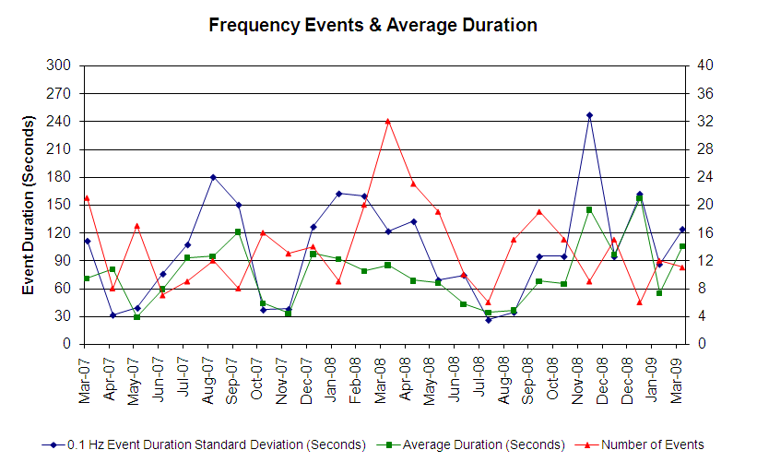

Deployed Responsive (Reported Above)
Time deployed | Stop Time | Duration | Max | Details
3/01 19:10:42 | 3/01 19:21:22 | 0:10:40 | 570.25
3/09 08:11:52 | 3/09 08:25:10 | 0:13:18 | 364.32 | Unit Trip (557 MW)
3/09 13:42:24 | 3/09 13:51:36 | 0:09:12 | 337.94 | Unit Trip (288 MW)
3/09 22:39:04 | 3/09 22:54:12 | 0:15:08 | 422.41
3/10 23:43:16 | 3/11 00:12:44 | 0:29:28 | 401.28
3/11 15:38:24 | 3/11 15:59:00 | 0:20:36 | 353.77 | Unit Trip (360 MW)
3/13 10:02:48 | 3/13 10:24:13 | 0:21:25 | 401.28
3/17 21:59:56 | 3/17 22:23:30 | 0:23:34 | 332.34 | SCE change -1200 MW in 5 min
3/18 07:14:02 | 3/18 07:30:54 | 0:16:52 | 855.37
3/20 23:58:31 | 3/21 00:12:51 | 0:14:20 | 327.36 | SCE change -700 MW in 5 min
3/26 07:55:05 | 3/26 08:12:07 | 0:17:02 | 528.01
3/26 22:04:06 | 3/26 22:22:32 | 0:18:26 | 343.21 | SCE change -1180 MW in 9 min
3/27 09:54:53 | 3/27 10:23:57 | 0:29:04 | 601.93
3/29 19:40:48 | 3/29 19:57:51 | 0:17:03 | 739.20

Day-Ahead OOMC and RPRS Capacity Purchases
Details | OOMC | RPRS S1 | RPRS S2 | RPRS S1+S2 | Total
W RIO | 96 | 0 | 0 | 0 | 96
North | 33 | 0 | 4 | 4 | 37
Austin | 26 | 0 | 1 | 1 | 27
Laredo | 0 | 9 | 5 | 14 | 14
DFW | 5 | 1 | 6 | 7 | 12
Western | 0 | 1 | 9 | 10 | 10
San Antonio | 0 | 0 | 10 | 10 | 10
Bryan Area | 7 | 0 | 0 | 0 | 7
Houston | 2 | 0 | 3 | 3 | 5
Corpus | 2 | 0 | 0 | 0 | 2
South | 0 | 2 | 0 | 2 | 2
Northeast | 0 | 0 | 2 | 2 | 2
E RIO | 0 | 1 | 0 | 1 | 1
 | 171 | 14 | 40 | 54 | 225

Historical Totals | Mar-09 | Mar-08 | Feb-09
Austin | 26 | 10 | 6
Bryan Area | 7 | 7 | 0
Corpus | 2 | 2 | 0
DFW | 6 | 6 | 43
E RIO | 1 | 19 | 3
Houston | 2 | 7 | 11
Laredo | 9 | 59 | 6
North | 33 | 4 | 17
Northeast | 0 | 10 | 5
San Antonio | 0 | 2 | 1
South | 2 | 0 | 1
W RIO | 96 | 0 | 93
Western | 1 | 60 | 8
Total | 185 | 186 | 194
http://www.ercot.com/mktinfo/services/rprsdr/index.html
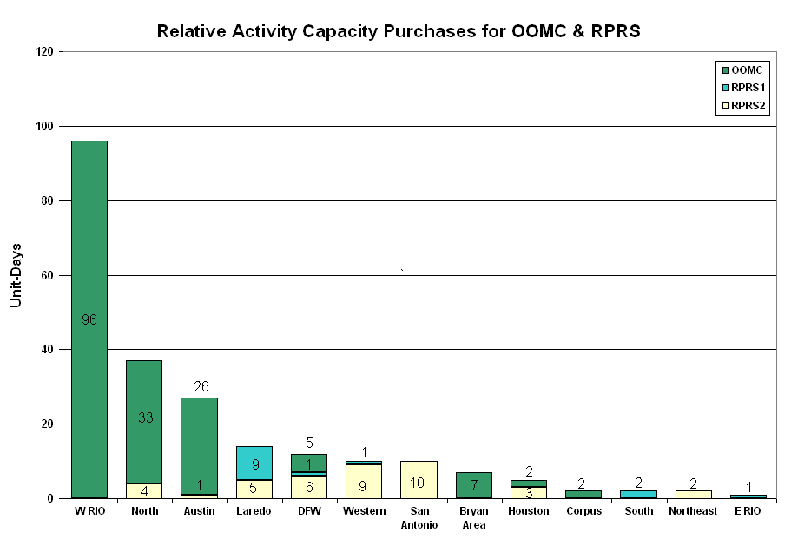
OOME and Congestion Management Activity
Congestion affected by outages
Remedial action plan has been developed for the element
Contingency | Overloaded Element | Days
Comanche Peak SES - Decordova SES & Wolf Hollow - Rocky Creek 345KV | Concord 345/138KV autotransformer | 30
Aspermont - Spur 138KV | Jayton - Spur 69 kV | 21
Santa Anna - Ballinger 138KV | Ballinger - Humble 69KV | 16
Abilene South - Eskota Switch 138KV | Eskota Switch 138/69KV autotransformer | 12
Ballinger - San Angelo Red Creek 138KV | Miles - Rowena 69KV | 11
Jack County - Reno 138KV | Rhome - Decatur Tap 138KV | 10
Baytown Energy Center - Chambers 345KV | Baytown Energy Center 345/138KV Autotransformer AT2 | 8
Aspermont - Spur 138KV | Matador - Paducah 69KV | 7
Dilley Switch - North Laredo 138KV | North Laredo - Asherton 138KV | 6
Roanoke Switch - West Denton and Lewisville Switch 345KV | West Denton - Airport 138KV | 6
STP - Hillje and STP - White Point 345KV | Blessing - Lolita 138KV | 6
Lon Hill - Coleto Creek 345KV | Victoria - Warburton 138KV | 5
Oasis - PH Robinson 345KV | Garrott - Midtown 138KV | 5
Austrop - Lost Pines 345KV | Winchester - Fayetteville 138KV | 4
Austrop - Sandow Switch 345kV | Sandow Switch - Elgin Switch 138KV | 3
Baytown Energy Center 345/138KV Autotransformer AT2 | Baytown Energy Center 345/138KV Autotransformer AT1. | 3
Golden Switch - Bluff Creek 138KV | Sun Switch - Sacroc 138KV | 3
San Angelo Red Creek - Ballinger 138KV | Ballinger - Miles 69KV | 3
Austrop 345/138KV autotransformer #2 | Austrop 345/138KV autotransformer #1 | 2
Decatur - Wise County 138KV | Bowie TMPP 138/69KV autotransformer | 2
Dilley Switch - San Miguel 138KV | Derby - Pearsall 69KV | 2
Graham - Long Creek 345KV | Paint Creek - Murray 138KV | 2
Graham - Long Creek 345KV | Putnam 138/69KV autotransformer | 2
Greenbelt - Comanche 138KV | Heights - Texas City Water Treat Sub 69KV | 2
Jack County - Reno 138KV | Agnes Switch - Weatherford Switch 138KV | 2
Royse Switch - Farmersville 345KV | Royse Switch - Farmersville 345KV | 2
Wichita Falls South Switch - Patton Street - Lone Star 138KV | Bowie 138/69KV autotransformer | 2
Abilene South - Eskota 138KV | Trent - Merkel 69KV | 1
Angleton - West Columbia 138KV | West Columbia 138/69KV Auto | 1
Austrop - Sandow 345KV | Elgin Switch - Butler 138KV | 1
Basecase | Jayton CSW - Spur 69KV | 1
Bosque Switch - Whitney 138KV | Lake Whitney - Whitney 138KV | 1
Coleto 345/138KV auto T1 | Coleto - Victoria 138KV | 1
Dyann - South Lane City 138KV | Brazos Valley - Fort Bend 138KV | 1
Eagle Mountain - Roanoke Switch - Parker Switch 345KV | West Denton - Roanoke Switch 345KV | 1
Falcon Switch - Zapata 138KV | North Laredo Switch - Asherton 138KV | 1
Ferguson - Gillespie 138KV | Lake way - Marshall Ford 138KV | 1
Gibbons Creek - Obrien and Singleton - TH Wharton 345KV | Campwood - Rock Springs 69KV | 1
Graham - Long Creek 345KV | Cisco - Putnam 69KV | 1
Graham - Long Creek 345KV | Putnam - Abilene South 138KV | 1
Graham SES - Long Creek Switching Station and Cook Field Road Switching Station 345KV | Albany - Hubbard BSTR 2 69KV | 1
Jack County - Reno 138KV | Decatur Tap - Decatur 138KV | 1
Jewett - Singleton and Gibbons Creek - Singleton 345KV | Sutton - Tabor 69KV | 1
Kendall 345/138KV Autotransformer | Raymond F Barker - Comfort 138KV | 1
Lon Hill - Coleto Creek 345KV | Kennedy Switch - Kennedy Sub 69KV | 1
Lon Hill - North Edinburg 345KV | MVEC Burns - MVEC Heidelberg 138KV | 1
Lon Hill - North Edinburg 345KV | MVEC Burns - Rio Hondo 138KV | 1
Long Shore Switch - Odessa Ector 345KV | Morgan Creek 345/138KV Auto #1 | 1
Moore - Uvalde 138KV | Leakey - Campwood 69KV | 1
Morgan Creek - McDonald 138KV | McDonald - Forsan Tap 138KV | 1
Nelson Sharpe - Rio Hondo 345KV | Raymondville 1 - Raymondville 2 69KV | 1
Odessa EHV - Morgan Creek SES and Quail Switch 345KV | Big Spring Switch - Big Spring West 138KV | 1
Roanoke Switch - Lewisville Switch 345KV | Teasley - West Denton 138KV | 1
San Angelo Power Station - Live Oak 138KV | San Angelo Concho - San Angelo Lake Nasworthy 69KV | 1
San Miguel 345/138KV Auto | Pleasanton 138/69KV Auto | 1
STP - Hillje and STP - White Point 345KV | Blessing - Port Lavaca 69KV | 1
STP - Hillje and STP - White Point 345KV | Formosa - Lolita 138KV | 1
TH Wharton - Jewett & Obrien - Gibbons Creek 345KV | Ridge - Watson Chapel | 1
Tradinghouse - Temple Pecan Creek 345KV | Seaton 138/69KV Transformer | 1
Tradinghouse - Venus Switch 345KV | Goldthwaite - Evant 138KV | 1
Twin Buttes - San Angelo 345KV | Big Lake - Twin Buttes 138KV | 1
Twin Oak Switch - Gibbons Creek and Twin Oak Switch - Jack Creek 345kV | Ridge - Robertson 138KV | 1
Watermill - West Levee & Todd Sargent Road 345KV | Cedar Hill Switch - Mountain Creek SES 138KV | 1
TH Wharton - Jewett & Obrien - Gibbons Creek 345KV | Potential voltage collapse | 1
LaPalma 138/69KV autotransformer #1 | Harlingen Switch - Harlingen #1 69KV | 1
Sun Switch - Golden Switch 138KV | China Grove Switch - Bluff Creek Switch 138KV | 1

Zonal OC1
CSC | Days
West-North | 20
North-Houston | 9
North-South | 6
South-North | 3
North-West | 1

New RAP (Date indicates last update of RAP not implementation date.)
None

New Procedures/Forms/Operations Bulletins
Date | Subject | Bulletin No.
03/18/2009 | Transmission & Security Desk V 3 Rev 100 | 404
03/06/2009 | Frequency Control Desk V 3 Rev 74 | 403

Blackout/Load Shed Incidences
None

EECP
None

Major System Voltage Problems
None

Major Computer Problems, Enhancements & Fixes
None

Communication
None

ERCOT peak (Unofficial)
03/02 08:00 39,309 MW

Yearly MTLF Error Comparison
Yearly Mid-Term (Hourly) Load Forecast Error Comparison for the ERCOT Forecast
Month | MAPE for MTLF at 16:00 Day-Ahead
Month | 2006 | 2007 | 2008 | 2009
January | 4.79 | 4.55 | 3.30 | 4.11
February | 4.81 | 3.75 | 3.59 | 3.49
March | 4.95 | 2.70 | 3.29 | 3.24
April | 5.59 | 3.00 | 2.45 | NA
May | 3.59 | 3.22 | 3.01 | NA
June | 2.65 | 4.46 | 2.81 | NA
July | 2.62 | 4.29 | 2.55 | NA
August | 2.09 | 3.11 | 3.66 | NA
September | 4.03 | 3.78 | 4.99 | NA
October | 3.63 | 3.08 | 2.79 | NA
November | 3.28 | 2.95 | 2.60 | NA
December | 3.44 | 3.74 | 4.54 | NA
Annual Average | 3.79 | 3.55 | 3.29 | 3.61

OCN, Advisory, Alerts & Emergency Notices
Capacity
Date | Start | End | Event
3/6/09 | 11:59 | 15:08 | OCN issued for possible capacity shortage for HE 1500 - 1700.
3/8/09 | 7:15 | 18:15 | OCN issued for projected capacity shortage for HE 1300 - 2100.
3/11/09 | 17:50 | 22:15 | OCN issued for projected capacity shortage.
3/11/09 | 20:15 | 21:45 | Deployed NSRS in all zones due to deployment of all Balancing Energy bids.
3/24/09 | 5:15 | 7:00 | Deployed NSRS due to VSAT results for Houston. Loss of Singleton - Obrien 345KV would result in voltage collapse.

Transmission

03/27 04:44 Transmission Alert in Turkey area due to a forced outage in Matador area with no market solution.

03/27 13:47 Transmission Alert for the loss of Lon Hill - Coleto Creek 345KV overloads Warburton - Victoria 138KV beyond first contingency criteria.

03/27 13:47 Transmission Alert for the loss of Ballinger 138/69KV auto beyond first contingency criteria with no market solution.

Emergency Notice

03/04 13:30 Emergency Notice issued due to Ancillary Service Market for 03/05/09 did not meet the time line.

03/04 18:00 Emergency Notice issued due to RPRS Market for 03/05/09 failed to meet the time line.

03/08 17:50 Emergency Notice issued due to RPRS Market for 03/09/09 failed to meet the time line.

03/19 13:30 Emergency Notice issued due to Ancillary Service Market for 03/20/09 did not meet the time line.

03/21 13:00 Emergency Notice issued due to Ancillary Service Market for 03/21/09 did not meet the time line.

Texas RE Event Analysis

03/04 13:30 Emergency Notice issued due to Ancillary Service Market for 03/05/09 did not meet the time line.

03/04 18:00 Emergency Notice issued due to RPRS Market for 03/05/09 failed to meet the time line.

03/08 17:50 Emergency Notice issued due to RPRS Market for 03/09/09 failed to meet the time line.

03/09 10:18 Ocotillo Wind Farm SPS activated.

03/18 07:14 Station breaker failed resulting in unit trips.

03/19 13:30 Emergency Notice issued due to Ancillary Service Market for 03/20/09 did not meet the time line.

03/21 13:00 Emergency Notice issued due to Ancillary Service Market for 03/21/09 did not meet the time line.

