Electric Reliability Council of Texas

IE 6.0 Configuration Guide

EFFECTIVE: 1 April 2009

Document Revisions
Date | Version | Description | Author(s)
01/13/08 | 0.01 | Initial | D. Roehl
03/03/08 | 0.02 | Review | T. Felton

1. Introduction

The purpose of this document is to define configuration settings for client browsers accessing ERCOT Retail Market IT systems. ERCOT maintains its Retail Market IT systems to support most commonly-used web browsers. Enterprise Architecture manages the overall technology lifecycle for ERCOT systems, which includes platform compatibility. A matrix for browser compatibility can be found at: http://www.ercot.com/services/mdt/userguides/

2. Scope
The scope of this Guide applies to the following IT Services:

- MarkeTrak
- TML
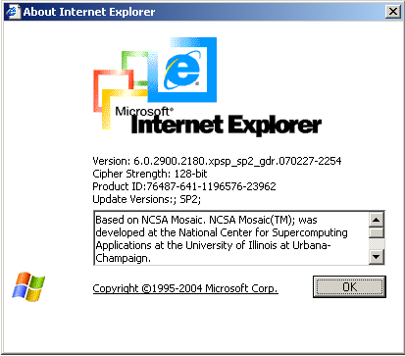

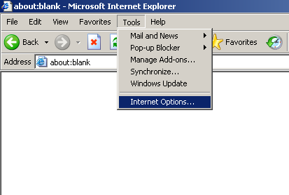

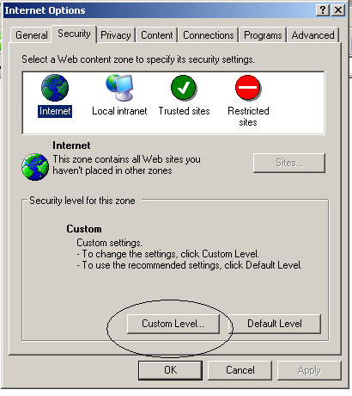

- Click on Reset button to reset to default Medium Level and then apply each individual setting as shown below.

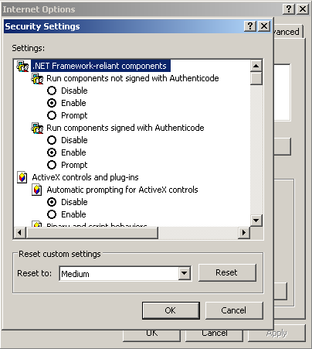

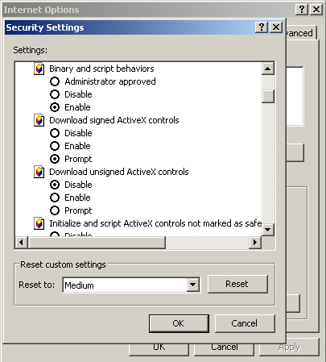

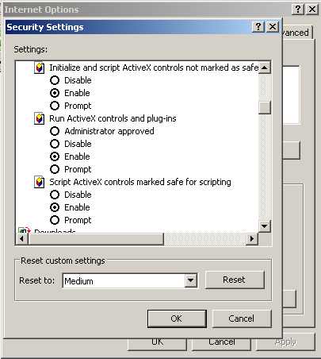

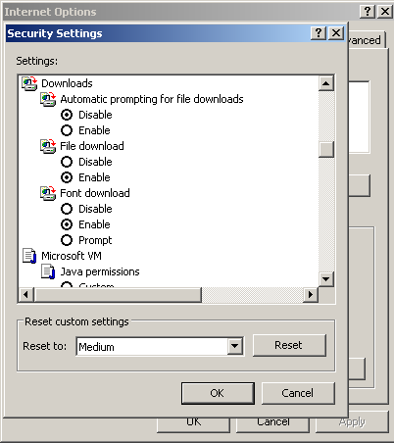

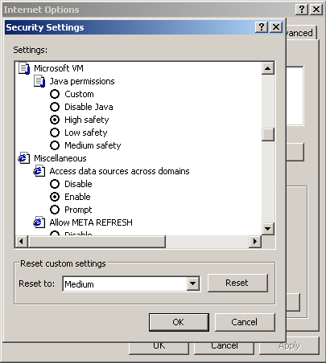

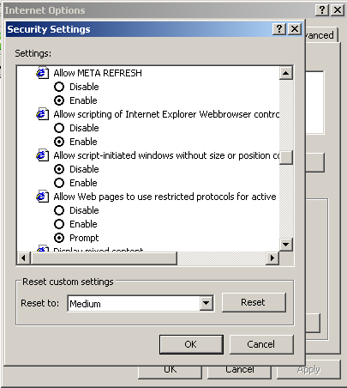

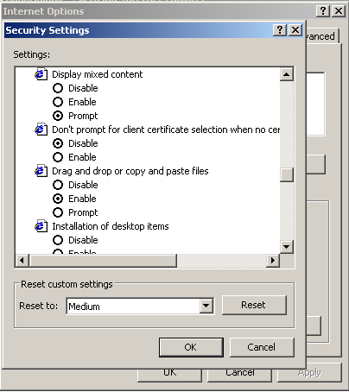

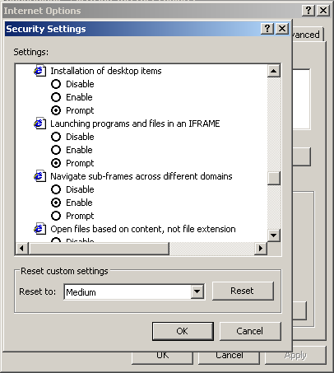

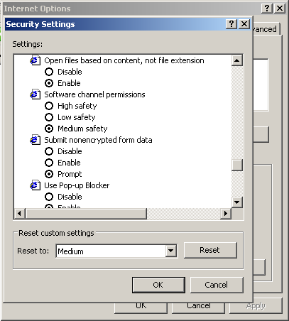

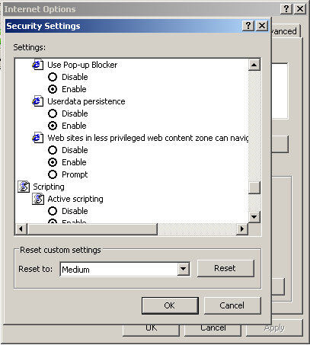

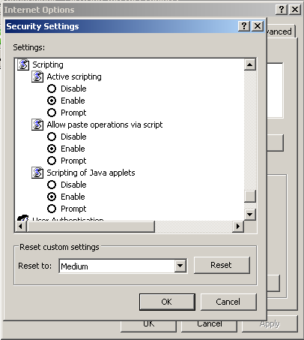

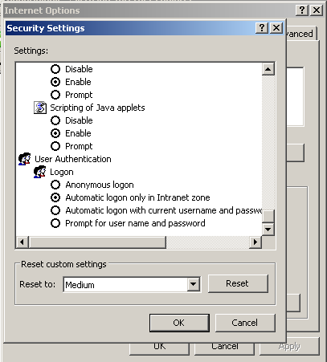

5. Reviews and Approvals
Area of Responsibility | Name | Reviewed / Approved | Date
RMS | Kyle Patrick
TDTWG | J. Robertson
IT Account Manager | T. Felton

