GOVERNOR/AGC MODEL
With and Without Governor Deadbands

These instructions accompany a numerical and graphical model of three generator governors developed in MS EXCEL. The model simulates how the steady-state MW output of a unit changes in response to a change in system load or a change in governor set-point. This representation, without time-varying dynamics, is thought by the author to be the best way to illustrate the interaction between localized governor control and centralized Automatic Generation Control (AGC).
These instructions cover the first tab in enough detail to orient the user. The cells shaded in light yellow can accept manual entry of a value. The other cells are formulas and should not be edited.

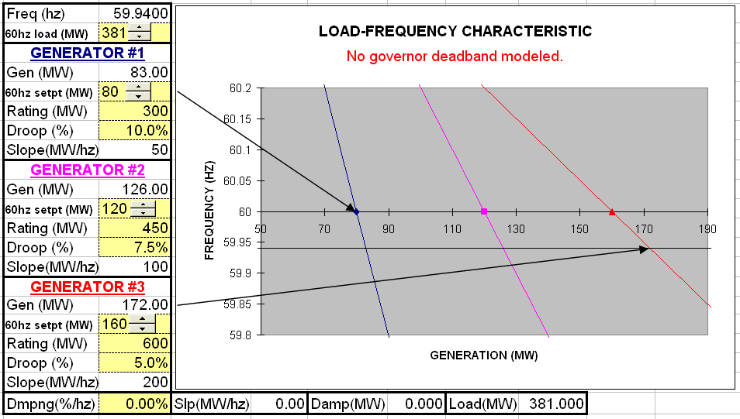

- Setup: Open the file named “Governor Deadband Model” and immediately create a clone by executing File/Save As “govdb.” The original file is not write-protected and you can inadvertently write over a formula, thereby destroying the model. If you do mess up the cloned version, close the file and start over again. Select the first worksheet (tab named “Without DB”) which shows the steady-state speed regulation (droop) curve for three units. The default “zoom” in the tool bar is set to 145%, which fills a screen with 1024 x 768 pixels. If your display is set for something else, adjust the zoom accordingly.

- Model validation: Confirm that the MW/hz slope of each governor characteristic is a function of rated capacity (Rating), % Droop and Rated Frequency.
  - Note the formulas for cells B8, B14 and B20.
  - Increase the Droop for Gen #2 to 10%. Note that “Gov” changes from 100 to 75 MW/hz and that the slope of the graph changes also. Return the droop back to 7.5% by clicking “Undo.”
  - Increase the Rating for Gen #1 to 400 MW. Note that “Gov” changes from 50 to 66 2/3 MW/hz both numerically and graphically. Return the Rating back to 300 MW.
- Frequency and unit output response to load changes: First, notice that when the load is equal to the sum of the unit set-points, the frequency is equal to the rated frequency (60hz). Next, observe how the governors change the MW output of the units for changes in system load. Increase (by clicking on the up arrow) the load by 21 MW to a value of 381 MW. Verify that the actual frequency changes to 59.94 hz and that the MW of each unit increases such that the total increase in generation equals the increase in load.
  - Gen #1 changes from 80 to 83 MW
  - Gen #2 changes from 120 to 126 MW
  - Gen #3 changes from 160 to 172 MW
Finally, reduce the load back to 360 MW and watch the unit output MW return to their original values.
- Frequency and unit output response to set-point changes: The 60HZ set-point of a unit is where the steady-state speed characteristic curve crosses the rated frequency (60HZ) axis. In other words, the governor will control the output of a unit to the set-point value when frequency is equal to the rated value. The set-point for each unit can be increased or decreased by clicking on the adjacent up or down arrow. This action represents the manual supplemental control performed by a plant operator or the raise or lower pulses sent by AGC. Increase the 60HZ set-point for unit #1 by 5 MW to 85 MW and back to 80 MW. Notice how the curve shifts to the right and then to the left. The slope does not change. The slope of the governor characteristic is not a function of the position of the set-point.
Experience how actual frequency can be reset to the rated value by changing the value of the set-points. First, increase the load to 381 MW. Next, increase the set-points such that the total increase in the set-points equals 21 MW (the increase in load). Verify that any combination of set-point changes that equals 21 MW will return frequency to the rated value.
- Load changes in response to changes in frequency: As frequency decreases, system load decreases and visa versa. This is called Load Damping. In ERCOT, following a generating unit trip, it has been calculated that the change in load is about 2.44% per 0.1 HZ. To add this effect to the simulation, enter 2.44 into the field labeled Dmpng at the bottom of the display. For the case in step 3, with load equal to 381 and set-points equal to 80, 120 and 160, the frequency was 59.94. By adding the load damping, load drops to 380.475 and frequency increases to 59.9416.

Summary:
As load changes, the governors change the MW output of the units so that the steady-state total generation will equal the load. The actual frequency is the common value that will cause the total of the unit outputs to equal the system load. A change in unit MW output due to changes in system load is response to governor control.
When actual frequency is not at the rated value, it can be changed to the rated value by supplemental control (AGC) that changes the set-points so that the sum of the set-points equals the system load. The change in unit MW output due to changes in the set-points is response to supplemental or AGC control.

Outline of Spreadsheet Tabs [Pages]:
- Without Deadband: This illustrates an isolated system with 3 units that do not have governor deadband. ERCOT’s Constant Frequency Control can be illustrated.
- With Deadband: The same three units are modeled with 0.036 HZ deadband. This illustrates how ERCOT frequency (and hence generation units) would vary if all units in ERCOT had 0.036 HZ deadbands.
- With and without deadband: Generators #1 and #2 are modeled with 0.036 HZ deadband and Generator #3 does not have a governor deadband. This illustrates how some units [#3] pick up the load when frequency deviations are within the prevailing deadband and more units [#1 and #2] respond for larger deviations such as those encountered when there is a unit trip.
- Unstable: The three units are modeled with 0.036 HZ deadband but the deadband configuration is more typical of operational generating units. The MW target sent to the turbine is held constant until frequency reaches the frequency threshold and then jumps to the MW value on the droop curve for the current frequency. This means that the frequency deadband also creates a corresponding MW output deadband. If all the units on a system had this kind of deadband, the system would be unstable. There would be a range of load values [deadband] for which there would not be a stable set of operating points.
- ERCOT: Generators #1 and #2 are modeled with the same 0.036 HZ deadband modeled on the Unstable tab and Generator #3 does not have a governor deadband. This is more typical of operations on an interconnected system such as ERCOT. The model show that when increasing load causes the frequency to exceed the deadband, the MW output deadband is input to the power system and frequency actually increases rather than continue to decrease. This means that there needs to be some hysterisis [deadband] around the governor deadband limits to keep the turbine target MW on the droop curve rather than dropping back to the 60HZ setpoint value.

RKG 01/17/2008

