COPMGRR Number | 012 | COPMGRR Title | Creating Section 11, Disputes and Data Extract Variances
Date |  | March 27, 2009
Submitter’s Information
Name |  | Michelle Trenary on behalf of the CCWG
E-mail Address |  | mtrenary@tnsk.com
Company |  | Tenaska Power Services
Phone Number |  | 817-303-3613
Cell Number
Market Segment |  | Independent Power Marketer (IPM)

Comments

CCWG proposes the following comments:

- Section 11.2, Data Extract Variances - Edits to and removal of language since detailed information as it pertains to the types and sub-types of Data Extract Variance and the DEV Resolution Process can be found in Retail Market Guide (RMG) Section 7.1.3, MarkeTrak Data Extract Variance Processes, and the MarkeTrak User Guide Sections 5, LSE DEV and 6, Non LSE DEV.
- Added language to include the location to access the True-Up Settlement and Variance Request Calendar.
CCWG would also like to point out that once this COPGMRR is approved, Section 11.1, ERCOT Disputes, will be greyboxed and will become effective upon Nodal Implementation. Section 11.2 will be effective upon approval since this market process currently exist.

Overall Market Benefit | Improve availability of information concerning Disputes and Data Extract Variances.
Overall Market Impact | Improves availability of information concerning the Dispute and Data Extract Variance Processes.
Consumer Impact | None.

Revised Proposed Guide Language
Commercial Operations Market Guide
Section 11: Disputes and Data Extract Variances
Month XX, 2009

11. Disputes and data extract variances 1
11.1 ERCOT Disputes 1
11.1.1 Overview 1
11.1.2 Settlement Calendar 1
11.1.3 Dispute Filing 1
11.1.4 How to Create a Dispute Using the Portal 1
11.1.5 Dispute Items 1
11.1.6 Valid Dispute Statuses and Resolutions 1
11.1.7 How to View a Submitted Dispute Using the Portal 1
11.1.8 Dispute Extracts 1
11.2 DATA EXTRACT VARIANCES 1
11.2.1 Overview 1
11.2.2 DEV Resolution Process 1

11. Disputes and data extract variances

11.1 ERCOT Disputes
Section 9, Settlement and Billing of the ERCOT Protocols describes the various requirements for the implementation and maintenance of the Dispute Management Process. Qualified Scheduling Entities (QSEs) in the Day-Ahead Market (DAM) and Real-Time Market (RTM) and QSEs and Congestion Revenue Right (CRR) Account Holders for the DAM, RTM, and CRR markets are responsible for the review of their Settlement Statements and Settlement Invoices to verify the accuracy of the Settlement data used to produce the Settlement Statement and Settlement Invoice. Recipients must submit any dispute related to the Settlement Statement or Settlement Invoice data. All communication to ERCOT and from ERCOT concerning disputes must be through either the Market Information System (MIS) certified area or other electronic communications. Recipients shall be able to file the dispute, create the dispute-associated activities and be able to view the progress on the dispute.

ERCOT will issue Resettlement Statements as soon as possible due to data error other than prices that result in an impact greater than two percent (2%) of the total payments due to ERCOT, otherwise ERCOT will wait until the next scheduled settlement. Protocol Sections 9.2.5, DAM Resettlement Statement and 9.5.6, RTM Resettlement Statement, describes the timing of resettlements due to Settlement and Billing Disputes.

Overview
The following figures illustrate an overview of the process flow of the Dispute Management system, detailed process flows based on the type of statement being disputed, and the process for a denied dispute. Section 9.14, Settlement and Billing Dispute Process also describes the timing of disputes.

Dispute Management System Process Flow Overview

Process for Disputing a Real-Time Statement and Invoice

Process for Disputing Statements and Invoices Other than Real-Time

Process for a Denied Dispute

Settlement Calendar
The Settlement Calendar provides the dates by which ERCOT will post, process payments, and administer disputes for Settlement Statements and Invoices, including:
- Settlement Statements for the DAM and RTM;
- DAM, RTM, Late Fee, CRR and CRR Auction Revenue Distribution (CARD);
The Settlement Calendar is provided as an extract and can be found on the MIS under Settlements Information (Public).

Dispute Filing
There are two methods available for filing a dispute, MIS Web Portal and Application Programming Interface (API).
- MIS Web Portal – The web portal utilizes the Market Participant’s digital certificate for access and identity. The disputes area can be found by clicking on Markets | Settlements. From this window, you can Create or View Settlement Disputes.
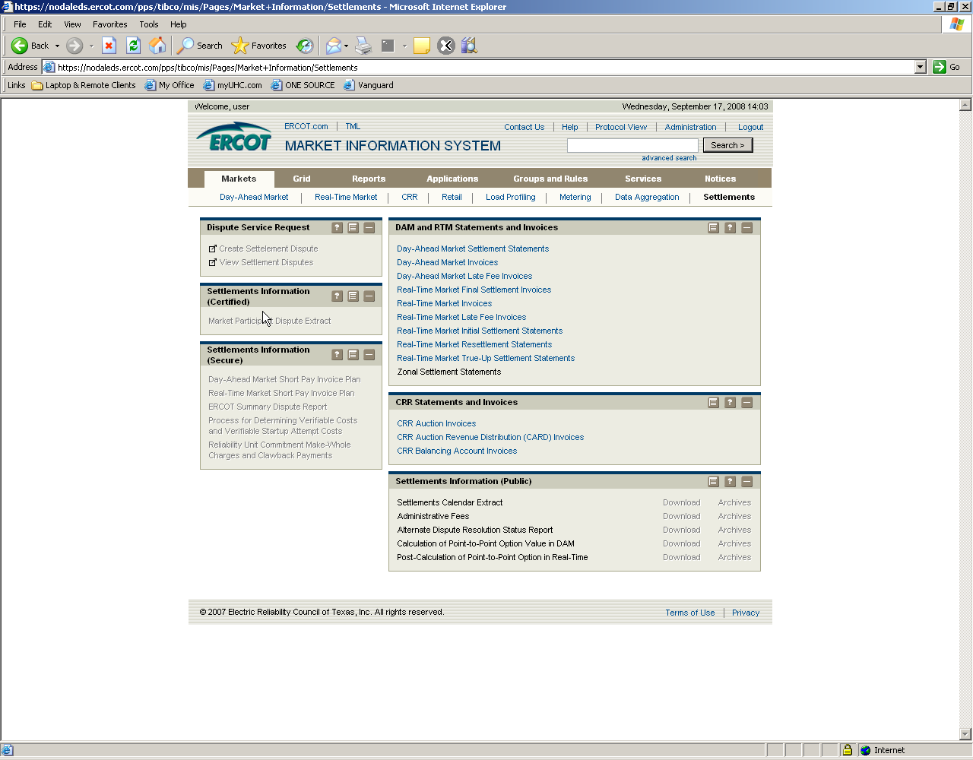

- API – Allows you to utilize a third-party application to submit and query your disputes to and from ERCOT. See the EIP – External Interfaces Specification document on the ERCOT.com Website for the API technical requirements.

How to Create a Dispute Using the Portal
From the Settlement Dispute window, complete the required fields and then click Submit. Once you have submitted the dispute, you will be able to attach supporting files. See diagram below.
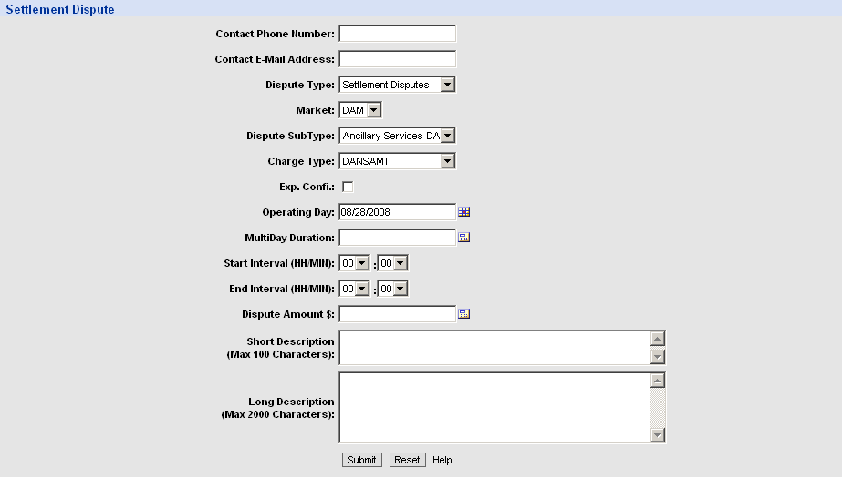
Below are descriptions of the Settlement Dispute Fields:
Contact Phone Number – Phone number used to contact the person filing the dispute. This field is required.
Contact Email Address – Email address of the person to be contacted regarding the dispute. This field is optional.
Dispute Type – The only valid entry is Settlement Dispute and is automatically populated. This is a required field.
Market – The valid markets are CRR, DAM, RTM and Misc. This is a required field.
Dispute Sub Type- The values are dependant on the market selected. This is a required field. Valid values are:
CRR – CRR Auction, CRR Auction Revenue Dist., CRR Balancing Account, Congestion Revenue Rights – RTM.
DAM – Ancillary Services – DAM, Congestion Revenue Rights – DAM, DAM-Invoice, Energy-DAM, Make-Whole.
RTM – Administrative Fees, Ancillary Services – RTM, Black Start Capacity, CRR No DAM, Congestion Revenue Rights-RTM, Emergency Operations, Energy-RTM, Gene. Res. Base Pt. Deviation, RTM-Invoice, Reliability Must Run, Reliability Unit Commitment, Revenue Neutrality Allocation, Voltage Support.
Misc. – Invoice
Exp. Confi. – This field is checked if the Expiration of Confidentially Rule is invoked. See protocol Section 9.14.2, Notice of Dispute. The Market Participant has 60 days after the date confidential information becomes available to file a dispute and should ensure this flag is checked. If the Exp. Confi. Flag is not checked, the dispute will not be accepted if the dispute is not timely. This field is optional.
Operating Day - The day during which energy flows. This is a required field.
MultiDay Duration - Operating Days being disputed. For disputes submitted for a range of Operating Days, if any Operating Day within the dispute is not timely according to Section 9.14.2, then the entire dispute is not timely. For multiple Operating Days, the days must be contiguous. This field is optional.
Start Interval (HH/MIN) - The first interval in hours and minutes being disputed. This is a required field.
End Interval (HH/MIN) – The last interval in hours and minutes being disputed. This is a required field.
Dispute Amount $ - The dollar amount being disputed. This is a required field.
Short Description – Short description of the reason for the dispute. This is a required field.
Long Description – Long description of the reason for the dispute. This is a required field.
After you click Submit in the previous screen, you are able to review the dispute information, Add attachments (Supporting Documentation including but not limited to schedules, extract data, spreadsheets, etc.), Withdraw Disputes, Query other disputes or add a New dispute.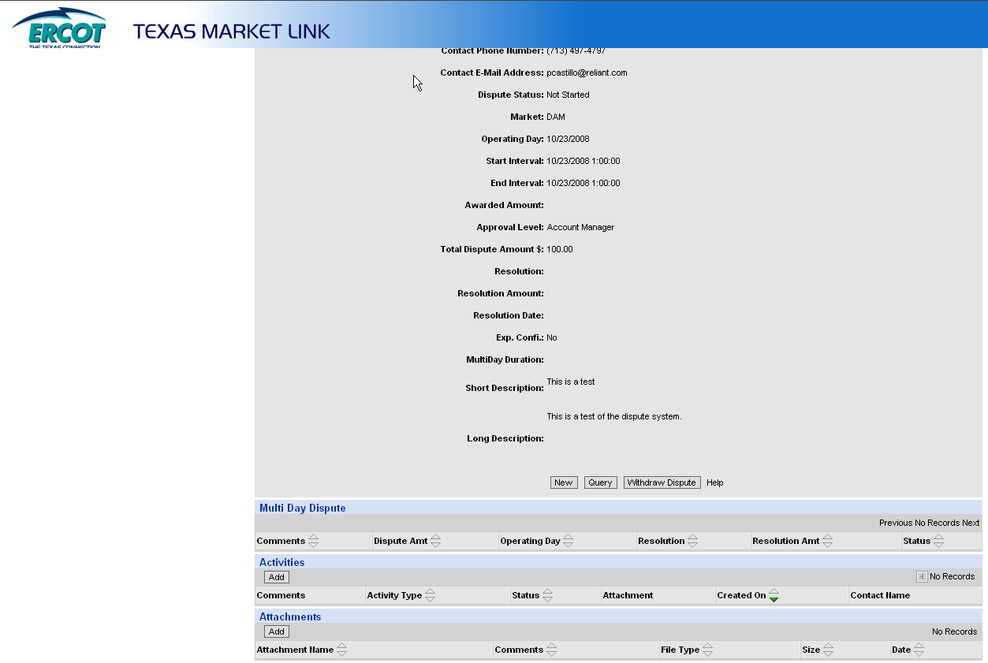
For multiple days, you are able to enter comments and dispute amounts per day.
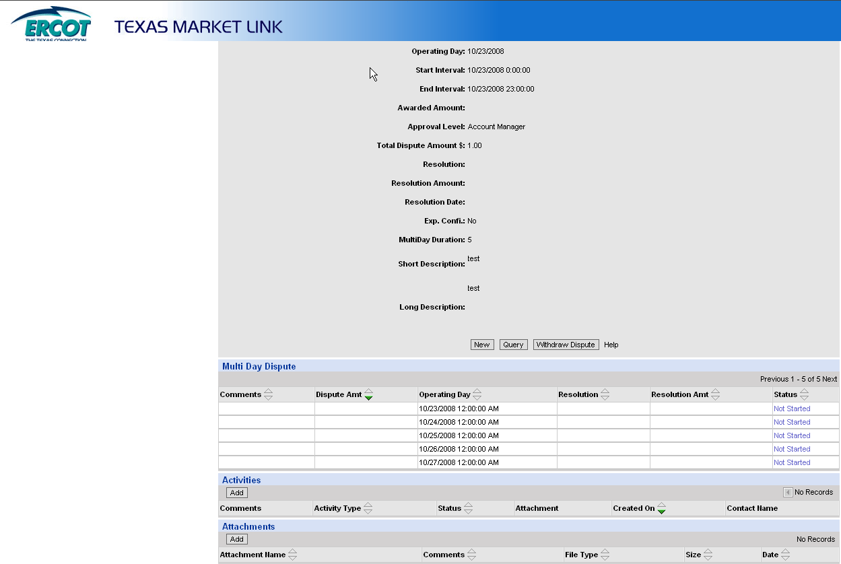

Dispute Items
The following are a list of the items that can be disputed. For Invoices, the items not listed on the statements can be disputed such as interest.
- DAM Statement
- DAM Resettlement Statement
- DAM Invoice
- DAM Late Fee Invoice
- RTM Initial Statement
- RTM Final Statement
- RTM Trueup Statement
- Any RTM Resettlement Statement issued after the RTM Trueup Statement
- RTM Invoice
- RTM Uplift Invoice
- CRR Auction Invoice
- CARD Invoice; and
- CRR Balancing Account Invoice

Valid Dispute Statuses and Resolutions
An automatic Notification will be sent to the disputing Entity if there is a change in the dispute resolution or dispute status.
Statuses:
- Not Started – The initial status of the dispute when it is submitted to ERCOT.
- Rejected – The dispute is not timely and is rejected by ERCOT.
- Open – ERCOT has begun to work on the issue.
- Alternative Dispute Resolution (ADR) – The Market Participant begins the ADR process once ERCOT has denied a dispute.
- Closed – The dispute has been resolved.
Resolutions:
- Withdrawn – Market Participant withdraws the dispute.
- Granted – ERCOT grants the dispute and the adjustments display on the next Settlement Statement for the Operating Day.
- Granted with Exceptions – ERCOT grants a partial adjustment of the disputed amount. The Market Participant is notified of the exception(s).
- Denied – ERCOT rejects the dispute. An automatic Notification will be sent to the disputing Market Participant.

How to View a Submitted Dispute Using the Portal
The Find Settlement Dispute screen allows you to enter the search criteria for a submitted dispute. You can search by dispute ID or other criteria. Click the Find button once you have entered your search criteria. Click the Reset button to clear the fields. For more information on how to use the window, click the Help button.
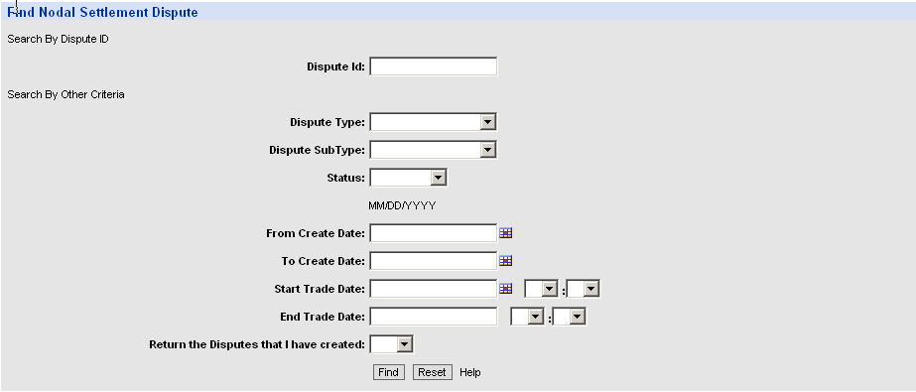

After clicking the Find button in the previous screen, disputes based on your search criteria are displayed. From this screen, you can click on the Dispute ID to view, update or withdraw the dispute. You can also create a new dispute by clicking the New button, or go back to the Find Settlement Dispute screen by clicking the Query button.
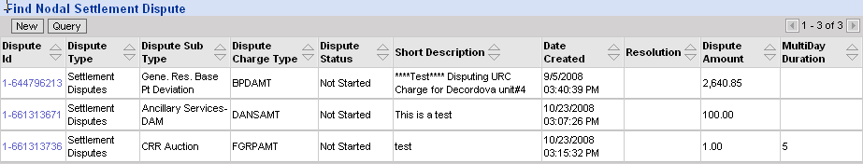

After clicking the Dispute ID, you are able to review the dispute information and Add attachments, Withdraw Disputes, Query other disputes or add a New dispute.

Dispute Extracts
ERCOT will post to the MIS two dispute extracts:
- Certified Dispute Extract – This extract provides QSEs and CRR Account Holders with the current status of all disputes that are not closed or withdrawn, and all disputes closed or withdrawn within the last 120 days.
- Secure Dispute Extract – This extract is a summary by charge type with cumulative total by Operating Day and status and resolution and count of disputes and market type (DAM, RTM). For Granted & Granted with Exception, these will ‘roll off’ once the status changes to ‘CLOSED’ or ‘Withdrawn’.

DATA EXTRACT VARIANCES

Overview
The Data Extract Variance or “DEV” is a type of MarkeTrak used to assist in the expedited resolution of ESI ID level data variances between ERCOT and Market Participant systems. The DEV should only be utilized after transactions have been attempted by comparing the information provided in the daily ERCOT ESI ID Service History & Usage Extract (727 Data Extract) and the Market Participants internal system data. The ESI ID Service History & Usage Extract is provided by ERCOT through the Market Information System (MIS). The Data Definition Language (DDL) description file for this extract is located on the ERCOT.com website under DDLs. Manual intervention will only be accepted after all other resolution paths have been exhausted.
If a variance submitted according to the ERCOT MarkeTrak User Guide is not resolved prior to the True-up Settlement, a Market Participant may seek correction of the ESI ID service history, usage information and resettlement pursuant to the provisions of Protocols Section 20, Alternative Dispute Resolution Procedure. The True-up Settlement timelines and variance request deadlines are available on the True-Up Settlement and Variance Request Calendar located on ERCOT.com, http://www.ercot.com.

For more information on types and subtypes of DEV issues and the DEV resolution process refer to the Retail Market Guide (RMG) Section 7.1.3, MarkeTrak Data Extract Variance Processes and the MarkeTrak Users Guide, Sections 5, DEV LSE and 6, Non LSE DEV available on ERCOT.com, http://www.ercot.com.
The MarkeTrak User Guide can be found on ERCOT.com:
- Select Services
- Select Client Services
- Select MarkeTrak Information
- Select MarkeTrak Users Guide

