

NMMS:
ERCOT Modeling Guidelines
for Market Participant
Network Model NOMCR Submissions
Version 0.02
March 19, 2009

Document Revisions
Date | Version | Description | Author(s)
1/13/09 | 0.01 | Initial draft | Terry Nielsen
3/15/09 | 0.02 | Revisions | Keith Smith

Table of Contents

1 OVERVIEW 3
1.1 Document Organization 3
1.1.1 Major Sections 3
1.1.2 Modeling Approach Subsection 3
1.1.3 Standard Approach Subsection 3
1.1.4 Classes Not Used Subsection 3
1.1.5 Classes Not Allowed 3
1.1.6 Appendix A - Validation Rules for Required Fields 3
1.1.7 Appendix B – Complex Validation Rules 3
1.1.8 Relevant reference documents: 3
2.0 PROJECT TRACKER AND COORDINATOR 3
2.1 PTC PROJECT 3
2.2 Network Operations model change Request 3
3.0 INFORMATION MODEL MANAGER 3
3.1 Model Changes 3
3.2 IMM Tools 3
4.0 Modeling Breakers 3
4.1 Modeling Approach 3
4.2 Attributes breaker 3
4.3 Linkage breaker 3
Appendix A - Validation Rules – Required Fields 3
Appendix B - Validation Rules – Required Linkages 3
Appendix C - Validation Rules – COMPLEX rules 3
Appendix D – CLASSES modeled According to STANDARD 3
Appendix E – COMPLETE LIST OF CLASSES NOT USED 3
Appendix F – COMPLETE LIST OF CLASSES NOT ALLOWED 3

OVERVIEW
This document provides guidelines for the creation of network models that are to be submitted to ERCOT. The models may be either created using the Information Model Management (IMM) editor component of the Network Model Management System (NMMS) or by submitting a file that is in Common Information Model (CIM) XML format.

Document Organization
Since the ERCOT network model is based upon extensions to the CIM standard, this document focuses primarily on clarifying how to use the new data attributes, associations and classes defined in the ERCOT extensions.

Major Sections
The document is broken down into major sections (Section 2, 3, etc.) that map to a single CIM package or a subsection of a package. This breaks down the document into logical subsections that cover areas such as generation, loads, etc.

Modeling Approach Subsection
The modeling approach section will describe the approach a user should take for modeling this object type. It covers what associations and attributes are needed and how they should be defined. For more complex modeling concepts, it may include flowcharts or other diagrams necessary to explain the modeling approach.
The document will further elaborate on how standard CIM classes, attributes and associations are used if they are used in a non-standard way. These will also be documented in a modeling approach section.

Standard Approach Subsection
If a particular class is modeled with no deviations from the standard approach documented in the CPSM profile, the class is listed in the subsection titled “classes modeled with standard approach”.

Classes Not Allowed
If a particular CIM class is not used in the ERCOT systems and would potentially break the ERCOT model, the class will be listed in the subsection titled “classes not allowed”. The complete list of classes that are not used are also listed in Appendix F.
The appendix of this document contains the complete listing of validation rules that run against each NMMS NOMCR submission. If any of these rules do not pass, the NOMCR will not be allowed to be submitted and the user must make the necessary corrections. These rules document any minimally required attributes, valid data ranges. The validation also ensures that the submission meets the cardinality defined in the latest ERCOT data dictionary.

Appendix A - Validation Rules for Required Fields
Appendix A lists all of the validation rules for attributes that must be defined for a specific class. It also lists any validation for attributes that must be within a specific value range.

Automatic Validation Performed by NMMS Based Upon Data Dictionary
The list of validation rules does not include the validation that is automatically performed by NMMS for links between objects. These links are validated based upon the data dictionary definition of the cardinality between the associated objects. There are two cardinality definitions that are validated, the first is the CardinalityRoleA and the second CardinalityRoleB. CardinalityRoleA defines the number of objects of the first Class that may exist related to the second Class.
For instance, in the data dictionary, the link between ThermalGeneratingUnit to CombinedCyclePlant CardinalityRoleA has a value of “0..n”. This means that there may be anything between 0 and n ThermalGeneratingUnits associated with a CombinedCyclePlant. The same association has a CardinalityRoleB of “0..1” which means that there may be between 0 and 1 CombinedCyclePlants associated with a ThermalGeneratingUnit.
This validation performed by NMMS follows the inheritance tree and the same validation is done for all objects that inherit from the object which has the cardinality definition.
For instance, in the data dictionary, a GeneratingUnit has a link to a ResourceNode that has a CardinalityRoleA defined as 1..n. This means that validation would be performed checking that there are one or more GeneratingUnits associated with a ResourceNode. It also means that validation would be performed for HydroGeneratingUnit, ThermalGeneratingUnit, WindGeneratingUnit and NuclearGeneratingUnit because these classes inherit from GeneratingUnit. Note: that the cardinality is not defined explicitly for each inherited class.

Appendix C – Complex Validation Rules
Appendix B lists all of the validation rules that are more complex than required fields and range checks. These include validation rules that are conditional based upon certain conditions, involve associations with other attributes, and those that describe specific data relationships. The validation rule is explained descriptively and not in a formal language.

Relevant reference documents:
IEC CIM docs, 61970-?, CPSM, etc. ???
ERCOT CIM Data Dictionary 1.21
ICCP Handbook ???
NMMS user guide?
NMMS process documents?
???

2.0 PROJECT TRACKER AND COORDINATOR
The Project Tracker and Coordinator(PTC) is the single entry point for Operations Model changes. Modeling data and change requests are initially received in the PTC, where each submission is tracked through any corrections, resubmission, validation, testing and review.
Upon login to the PTC, the user will see that Project Summary screen shown below in Figure 1. The Project Summary screen is the base display for the PTC and provides the user the ability to view, edit, and create both change requests and projects.
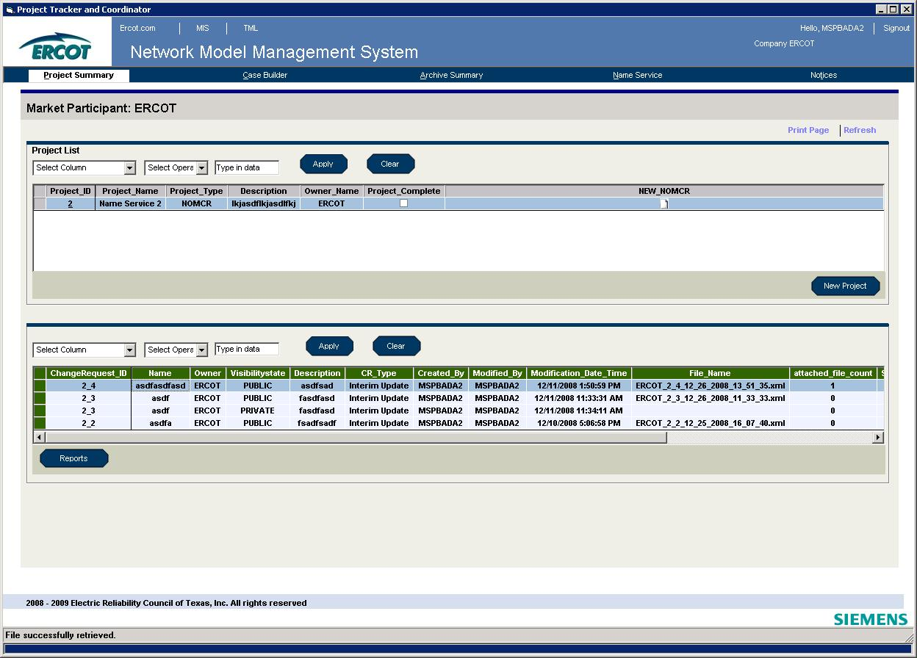
Figure 1: Project Summary Display

PTC PROJECT

A PTC project is a container that is used to group similar change requests. It is a requirement that every change request has belongs to a project, even if it is the only change request in the project. To create a new project the user will click the New Project button on the Project Summary Display screen. The Create New Project screen shown below in Figure 2 will appear. The user must designate the project as a NOMCR(Network Operations Model Change Request) project or a SAMR(Special Action Model Request) project. Required fields are marked with an asterisk. For modeling purposes, we will only cover a NOMCR project. After the required fields are populated, the project can be saved.

Figure 2: Create New Project Display

Once a project is created, the Edit Project screen can be opened by clicking on the Project ID on the Project Summary Screen. The Edit Project screen is shown below in Figure 3. Here the user can make changes to the project, create a new change request, or edit an existing change request.

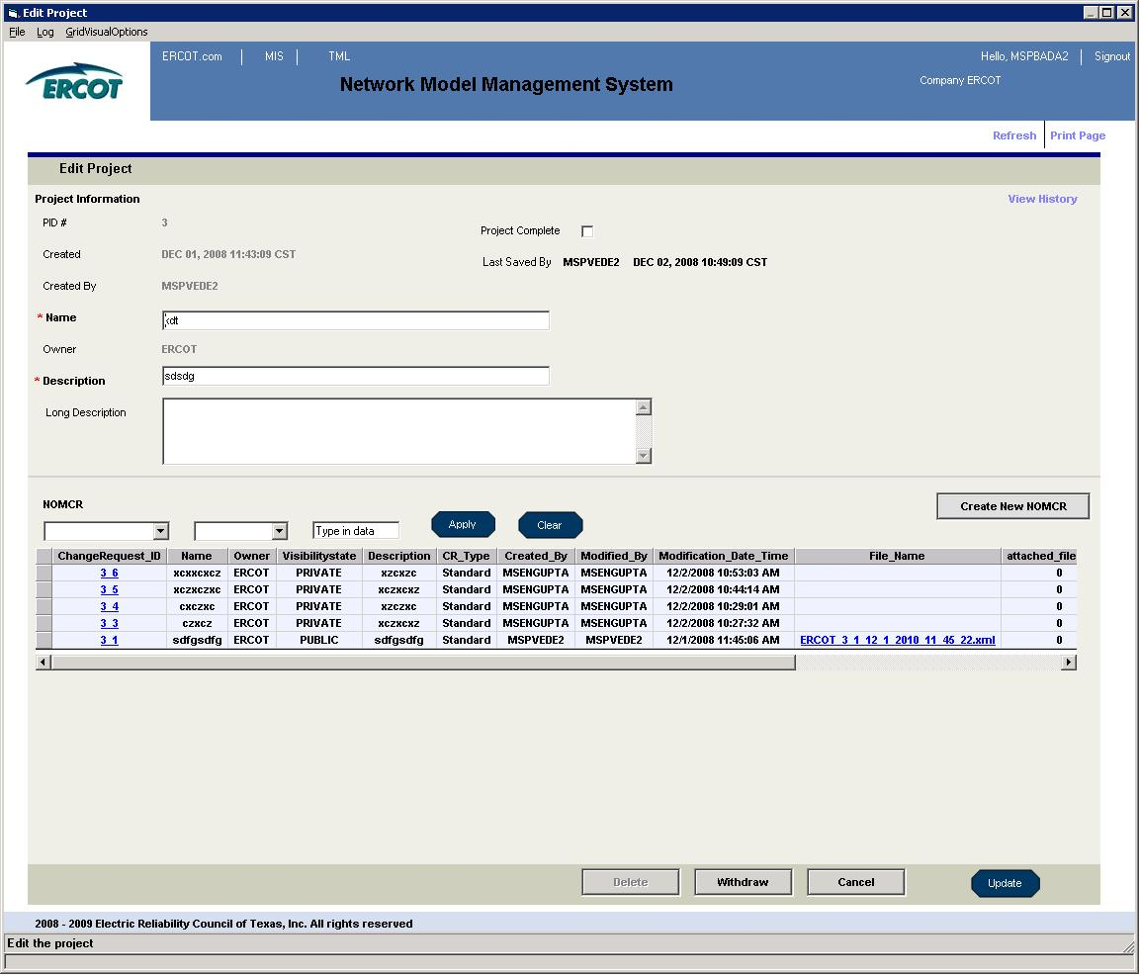
Figure 3: Edit Project Display

Network Operations model change Request
Transmission Service Providers(TSPs) will submit all types of modeling changes using a Network Operations Model Change Request(NOMCR). These changes include topological changes, limit/rating changes, telemetry mapping, and telemetry definitions. The NOMCR process is defined in the Nodal Protocols and outlines submission deadlines, formats, and procedures.
A new NOMCR can be created from the Project Summary Screen, the Create New Project Screen, or the Edit Project Screen. Once a NOMCR is created, the Edit NOMCR screen shown in Figure 4 will appear. All NOMCR information can be added/edited from this screen.

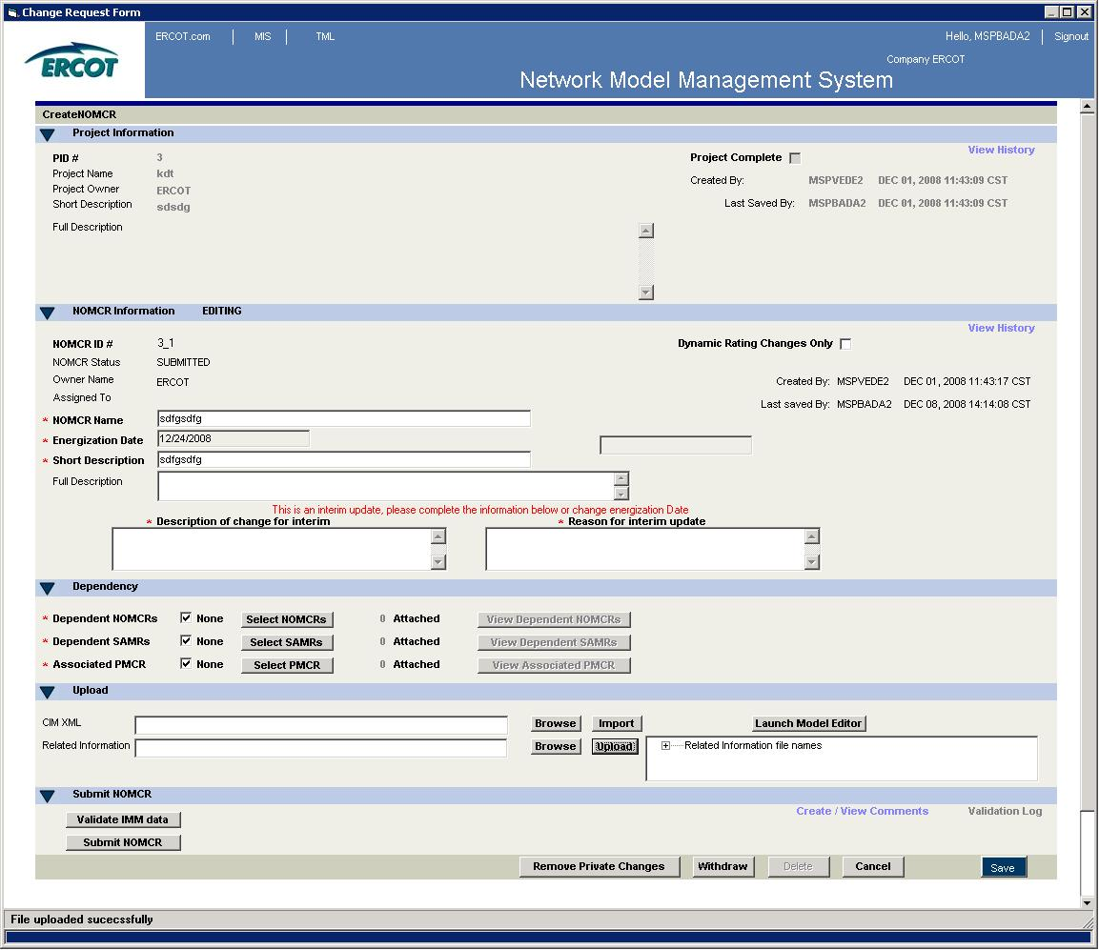
Figure 4: Edit NOMCR Display

Once data is entered into the required fields in the Edit NOMCR screen, the user can make changes to the model. The most common method for making changes to the model is by clicking the Launch Model Editor button on the Edit NOMCR screen, which will open the Information Model Manager(IMM). Once model changes have been made in the IMM, the NOMCR must be validated and submitted for the model changes to be applied to the Network Operations Model. Validation is performed by clicking the Validate IMM Data button. If the model changes pass validation, the NOMCR can be submitted by clicking the Submit NOMCR. If the model changes fail validation, an error message will appear in the bottom left corner of the screen on the status bar. The validation errors can be viewed by clicking on the Validation Log button. These errors must be corrected before the NOMCR can be submitted.
Another option for making changes to the model is importing a CIM XML file. This can be done by clicking the Browse button next to the CIM XML data field in the Upload section of the Edit NOMCR screen. Once a CIM XML file is selected, the file is imported by clicking the Import button next to the Browse button. After the file is imported successfully, the NOMCR can be validated and submitted.

INFORMATION MODEL MANAGER
The Information Model Manager(IMM) is the user interface used to add and modify data in the Network Operations Model database. The IMM can be accessed by clicking the “Launch Model Editor” button on the Edit NOMCR screen seen in Figure 4. The IMM, as shown below in Figure 5 will appear.

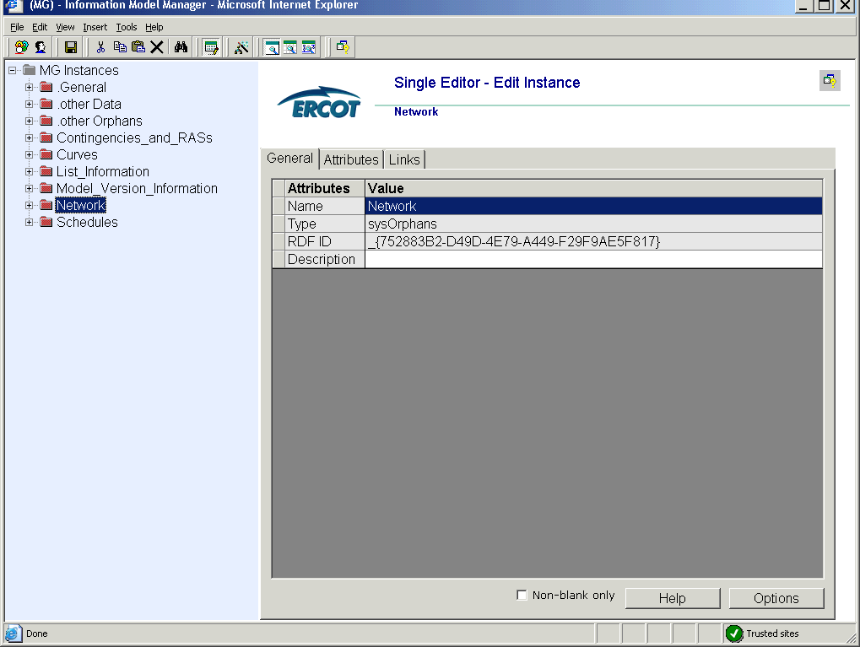
Figure 5: IMM Main Screen
Market Participants will be responsible for maintaining only a small number of the instances that are seen in the IMM. A majority of these instances will be in the IMM under the path Network/Ercot Texas Network. Figure 6 shows the IMM model expanded to show the full ERCOT Texas Network. The ERCOT Texas Network includes substations, AC lines, and series compensators, all of which will be modeled by the Market Participants.
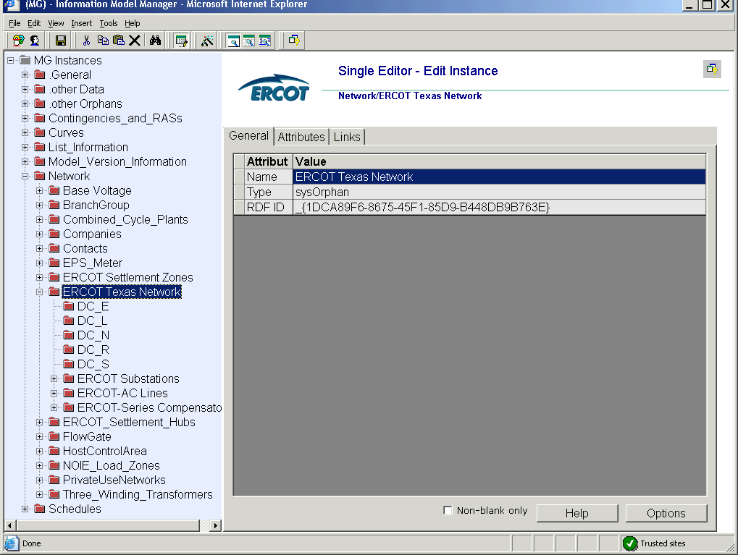
Figure 6: ERCOT Texas Network

3.1 Model Changes
This section will cover the process of making model changes in the IMM by creating and editing a generic device. For simplicity purposes we will use a substation as an example at this time. The modeling of more complex scenarios and devices will be covered in Section 4.
3.1.1 Create New Instance
In order to find where in the model hierarchy a device is modeled it is best to look at the section on Substations. Here we see that a substation is modeled under a weather zone. To create a new substation right-click on a weather zone and select New, as seen below in Figure 7.

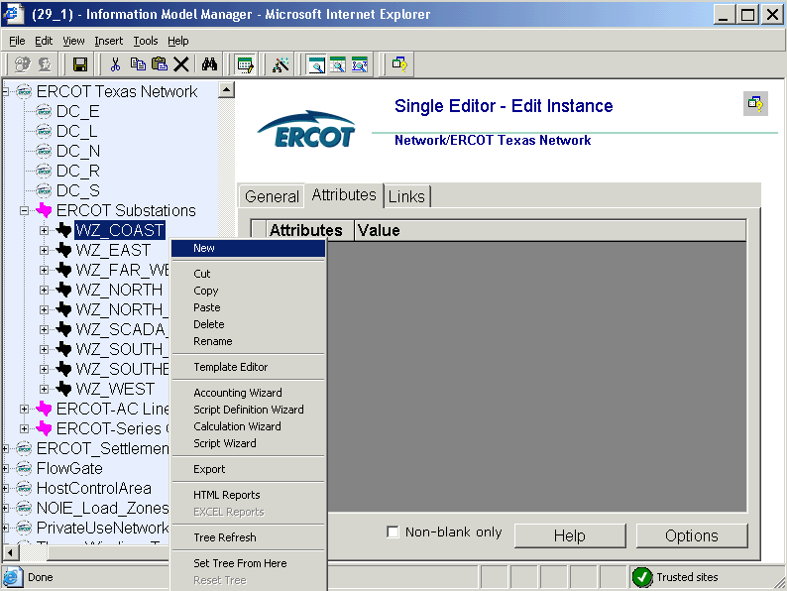
Figure 7: Create New Instance
The screen seen in Figure 8 will appear in the IMM prompting the user to select an instance type. Select substation and click the Create Instance button.
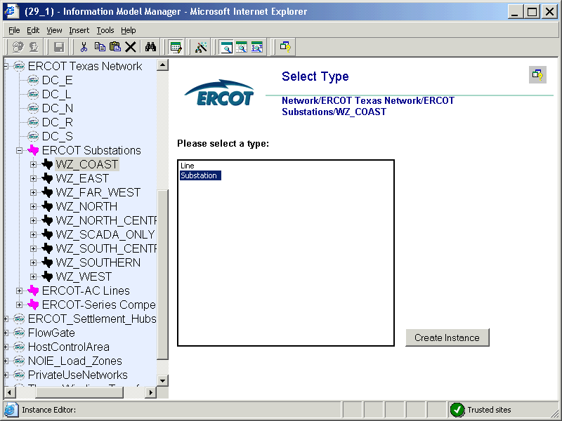
Figure 8: Create New Substation
Once the substation is created the General Edit Instance screen shown below in Figure 9 will appear. A name must be entered for the instance before the instance can be saved in the model. Upon saving the new instance, the substation will appear in the model hierarchy.
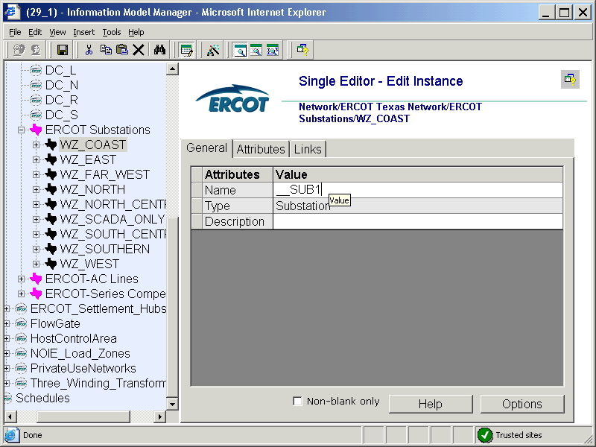
Figure 9: General Edit Instance Screen
The updated model hierarchy with new substation __SUB1 is shown below in Figure 10.
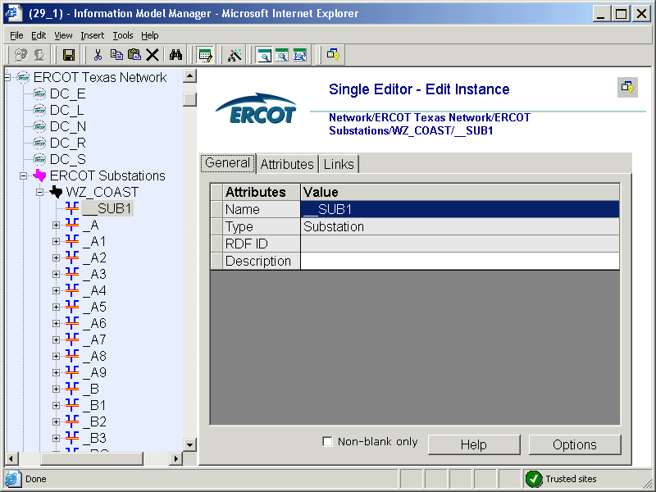
Figure 10: __SUB1 in Model Hierarchy
3.1.1.1 Add Attributes
Once the substation has been created and saved, attributes for the substation must be entered into the required attribute fields. Required attributes for each device can be found in a table in the device section. Looking at the section on Substations, it is found that the required attributes for a substation are forNetwork and forScada. These fields must be populated for the model changes to pass IMM validation.
Many of the attribute fields are auto-populated by the IMM. Figure 11 shows the attributes screen for a newly created substation. The auto-populated fields are populated in this figure. The IMM will prevent data that is not of the correct data type or size from being saved in the model.

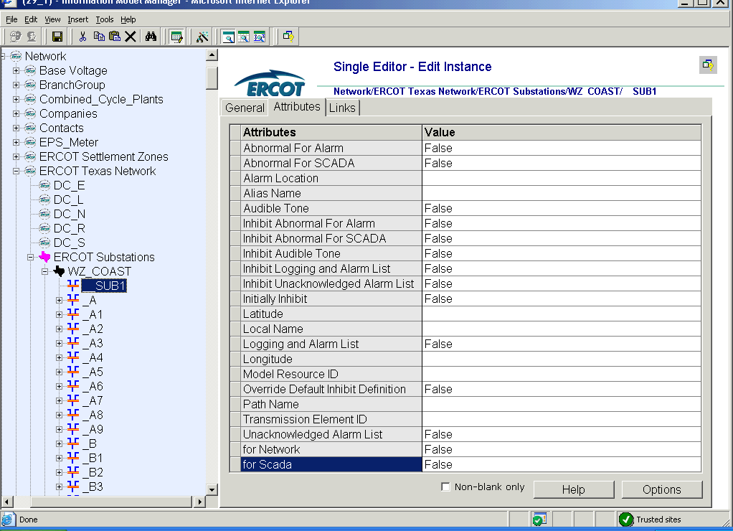
Figure 11: Substation Attributes
3.1.1.2 Add Links
As with attributes, for every device there are required link fields that must be populated for the model changes to pass the IMM validation. The required links for a substation can be found in the table named required links in the substation section of this document. Looking at this table, it is found that the required links for a substation are Ownership, Operatorship, and PermissionArea. Figure 12 shows the links screen for a newly created substation.

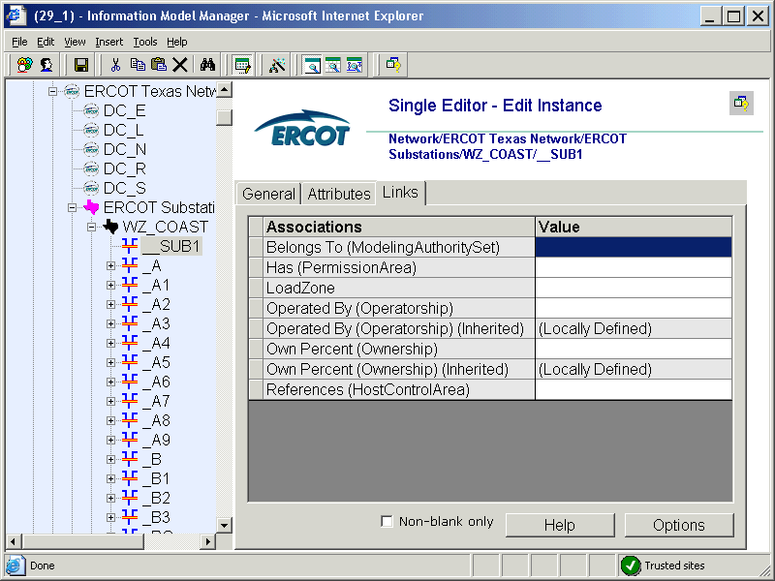
Figure 12: Substation Links
Links cannot be manually entered into the value column. All of the links must be added using the drag and drop method or the copy/paste method. The path for all of the required links can be found in the Required Links table. With the links screen shown in Figure 12 up in the IMM, navigate to the desired link in the IMM and left-click on the link holding down the mouse button. Drag the selected link into the desired field and release the mouse button. The value field will be populated with the link. Save the change and move forward populating all of the required links in a similar manner. The screen shot in Figure 13 shows the ERCOT_Operator and ERCOT_Owner links in the __SUB1 Operatorship and Ownership fields.
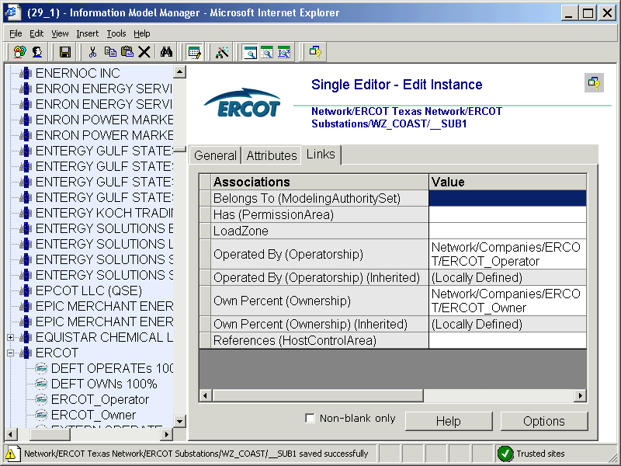
Figure 13: __SUB1 Links Populated

    - Rename Instance
To rename an instance right-click on the instance and selecting Rename. A popup screen will appear prompting the user to enter a new instance name. This popup screen is shown in Figure 14. After the name is entered and the user selects the OK button, the instance name will be updated in the model hierarchy.
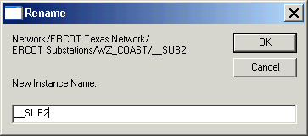
Figure 14: Rename Substation

    - Delete Instance
To delete an instance right-click on the instance and select Delete. The warning message shown in Figure 15 will appear. If the instance or children of the instance are modified in a later job, the user will not be able to delete the instance.
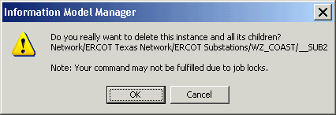
Figure 15: Delete Substation

IMM Tools
    - Templates

    - Auto Layout

Modeling Breakers

Modeling Approach
The ERCOT CIM model defines a breaker as a mechanical switching device capable of making, carrying, and breaking currents under normal circuit conditions and also making, carrying for a specified time, and breaking currents under specified abnormal circuit conditions e.g. those of short circuit.
A breaker is modeled under a VoltageLevel in a Substation. Two terminals are modeled under the breaker as connection points to the circuit. SCADA values modeled under the terminals provide the Open/Close status of the breakers to the model. Figure 2 below shows a breaker modeled in the IMM model hierarchy with parent/child associations labeled. For more information on modeling SCADA values, refer to Section 18 of this document.
Figure 2

Attributes breaker
The attributes for a breaker are shown in the table below. Required attributes are listed at the top of the table in bold text. Most of the Boolean values will have default values upon creation. These values are listed in the table along with sample data for the field.

Attribute | Description | Data Type | Default Value | Sample Data
TEID | Transmission Element ID | Integer | Auto-populated
normalOpen | The attribute is used in cases when no Measurement for the status value is present. | Boolean | False
initiallyOpen | T = The initial breaker state for the online switching device model is open. | Boolean | False
inTransitTime | The transition time from open to close, in seconds. | Float | 0
Alias Name | Free text name of the object or instance. | String | None
Current Flow | Fault interrupting rating in amperes.
DAM Monitored | The Boolean flags to indicate which process(s) monitor the branch devices and by which process the devices is secured. | Boolean | False
DAM Secured | The Boolean flags to indicate which process(s) monitor the branch devices and by which process the devices is secured. | Boolean | True
Enable Manual Switching | T = Enables manual switching capability for the device. | Boolean | True
Latitude | Latiitude coordinates. | Float | None
Local Name | The localName is a human readable name of the object. It is only used with objects organized in a naming hierarchy. The simplest naming hierarchy has just one parent (the root) giving a flat naming hierarchy. However, the naming hierarchy usually has several levels, e.g. Substation, VoltageLevel, Equipment etc. Children of the same parent have names that are unique among them. If the uniqueness requirement cannot be met IdentifiedObject.localName shall not be used, use IdentifiedObject.name instead. | String | None
Longitude | Longitude coordinates. | Float | None
Model Resource ID | A Model Authority issues mRIDs. Given that each Model Authority has a unique id and this id is part of the mRID, then the mRID is globally unique. | Integer | None
Normal Open | The attribute is used in cases when no Measurement for the status value is present. If the Switch has a status measurment the Measurement.normalValue is expected to match with the Switch.normalOpen. | Boolean | False
OUS Priority | An Outage Scheduler priority is included in all ConductingEquipment classes except BusbarSection and TransformerWinding.
Path Name | The pathname is a system unique name composed from all IdentifiedObject.names in a standard naming hierarchy path from the object to the root.
Phases | Describes the phases carried by a conducting equipment. Possible values { ABCN , ABC, ABN, ACN, BCN, AB, AC, BC, AN, BN, CN, A, B, C, N }.
PSS®E ID | Attribute will give IMM modelers control over the PSS®E ID that the Topology Processor uses to properly name units, loads, branches, and transformers
Remove | The equipment is removed from the network. | Boolean | False
Remove Enable | The equipment can be removed from the network. | Boolean | False
RUC Monitored | The Boolean flags to indicate which process(s) monitor the branch devices and by which process the devices is secured. | Boolean | False
RUC Secured | The Boolean flags to indicate which process(s) monitor the branch devices and by which process the devices is secured. | Boolean | True
Switch On Count | The switch on count since the switch was last reset or initialized. | Integer | None
Switch On Date | The date and time when the switch was last switched on. | Date/Time | None
Switch Operation Over | Over Limit Violation Switch Operation (Open/Close). | Boolean | None
Switch Operation Under | Under Limit Violation Switch Operation (Open/Close). | Boolean | None
Switched By Schedule | T = The switch will follow a switching schedule to change state in the network applications. | Boolean | False
Trigger Network Sequence | T = The switch will trigger the real?time network application sequence when the switch changes state in SCADA. | Boolean | False
Trip Lockout | Lockout after trip. | Boolean | None
Zero Impedance Branch? | Mark Switching devices that should be converted to Zero Impedance Branches in Connectivity Node to Bus Processing Option 1. | Boolean | False

Linkage breaker
The required links for a breaker are defined in Table 2 below. The path name shows where the links can be found in the model. Definitions for all of the links can be found by clicking on the help button at the bottom of the links screen.

Link Name | Description | Path Name
BaseVoltage | A link to a BaseVoltage is only necessary when there is no VoltageLevel container used. If a VoltageLevel container is used the disconnector will inherit a BaseVoltage from the VoltageLevel. | Network/Base Voltage
Operatorship | The Operatorship link is used for permission rights. The Operator of equipment has the right to edit the equipment. An operator can only be assigned by the creator or owner of the equipment. | Network/Companies
Ownership | The Ownership link is used for permission rights. The owner of equipment has editing and administrative rights. An owner can only be assigned by the creator of the equipment. | Network/Companies

Appendix A - Validation Rules – Required Fields
This appendix lists all of the validation rules for attributes that must be defined for a specific class. It also lists any validation for attributes that must be within a specific value range.

ClassName | Attributes | Range
AccumulatorLimit | value | >=0
AccumulatorValue | cstatus
ACLineSegment | r | >= -500 and <= 500
ACLineSegment | x | >= -1000 and <= 1000
ACLineSegment | teid | >=0 and <= 999999999
Address | City
Address | PostalCode
Address | State
Address | Street1
AggregateHub | hubCalculationMethod
AirCompressor | teid | >=0 and <= 999999999
AlternateLimit | highLimit
AlternateLimit | lowLimit
Analog | teid | >=0 and <= 999999999
AnalogValue | cstatus
AreaReserveSpec | lowerRegMarginReqt | >= 0
AreaReserveSpec | opReserveReqt | >= 0
AreaReserveSpec | primaryReserveReqt | >= 0
AreaReserveSpec | raiseRegMarginReqt | >= 0
AreaReserveSpec | spinningReserveReqt | >= 0
BasePower | basePower
BaseVoltage | nominalVoltage | >=0 and <= 1100
BasicIntervalSchedule | startTime
BasicIntervalSchedule | value1Unit
BasicIntervalSchedule | value2Unit
Bay | teid | >=0 and <= 999999999
BranchGroup | maximumActivePower
BranchGroup | maximumReactivePower
BranchGroup | minimumReactivePower
BranchGroup | monitorActivePower
BranchGroup | teid | >=0 and <= 999999999
BranchGroupTerminal | positiveFlowIn
Breaker | InTransitTime
Breaker | teid | >=0 and <= 999999999
BusbarSection | teid | >=0 and <= 999999999
BWRSteamSupply | teid | >=0 and <= 999999999
CAESPlant | teid | >=0 and <= 999999999
CogenerationPlant | teid | >=0 and <= 999999999
CombinedCyclePlant | LogicalResourceNodeName
CombinedCyclePlant | teid | >=0 and <= 999999999
CombinedCyclePlant | aliasName
CombustionTurbine | teid | >=0 and <= 999999999
CommunicationLink | teid | >=0 and <= 999999999
Company | companyType
Company | DUNS
Company | PrimaryPhone
Company | teid | >=0 and <= 999999999
Company | aliasName
CompositeSwitch | teid | >=0 and <= 999999999
ConductingEquipment | teid | >=0 and <= 999999999
Conductor | teid | >=0 and <= 999999999
Configuration | highReasonabilityLimit | >= lowReasonabilityLimit
Configuration | highReasonabilityRampRateLimit | >= lowReasonabilityRampRateLimit
Configuration | hotintTime
Configuration | hotStartTime | <= intStartTime
Configuration | intColdTime
Configuration | intStartTime | <= coldStartTime
Configuration | lowReasonabilityLimit | >= 0
Configuration | lowReasonabilityRampRateLimit
Configuration | maxDailyStarts
Configuration | maxONTime
Configuration | maxWeeklyEnergy
Configuration | maxWeeklyStarts | >= maxDailyStarts
Configuration | minOFFTime
Configuration | minONTime | <= maxONTime
Configuration | primaryConfiguration
Configuration | qualificationStatus
Configuration | seasonalMaxEmergencyRating
Configuration | seasonalMaxSustainableRating | >= seasonalMinSustainableRating
Configuration | seasonalMinEmergencyRating
Configuration | seasonalMinSustainableRating
ConformLoad | conformingLoadFlag
ConformLoad | pfixedPct
ConformLoad | pnomPct
ConformLoad | powerFactor
ConformLoad | qfixed
ConformLoad | qnomPct
ConformLoad | teid | >=0 and <= 999999999
ConformLoadSchedule | startTime
ConformLoadSchedule | value1Unit
ConformLoadSchedule | value2Unit
ConformLoadSchedule | aliasName
ConnectivityNode | teid | >=0 and <= 999999999
ConnectivityNodeGroup | PSSEBusNumber | can not be between 9400-9999 and 94000-99999
ConnectivityNodeGroup | teid | >=0 and <= 999999999
Connector | teid | >=0 and <= 999999999
Contact | EmailAddress
Contact | FirstName
Contact | LastName
Contact | PrimaryPhone
Contact | City
Contact | PostalCode
Contact | State
Contact | Street1
Contingency | DeviceName
Contingency | DeviceType
ControlHouseEquipment | teid | >=0 and <= 999999999
ControllableLoadResource | maxDeploymentTime
ControllableLoadResource | maxWeeklyEnergy
ControllableLoadResource | minNoticeTime
ControllableLoadResource | rampRateSlopeDownLimit
ControllableLoadResource | rampRateSlopeUpLimit
ControllableLoadResource | maxDailyDeployment
ControllableLoadResource | maxInterruptionTime
ControllableLoadResource | maxWeeklyDeployment
ControllableLoadResource | minInterruptionTime
ControllableLoadResource | minRestorationTime
ControllableLoadResource | teid | >=0 and <= 999999999
ControllableLoadResource | aliasName
CurrentRelay | teid | >=0 and <= 999999999
Curve | curveStyle
Curve | xUnit
Curve | y1Unit
Curve | y2Unit
CurveData | xvalue
CurveData | y1value
CurveData | y2value
CustomerLoad | conformingLoadFlag
CustomerLoad | pfixedPct
CustomerLoad | pnomPct
CustomerLoad | qfixed
CustomerLoad | qnomPct
CustomerLoad | teid | >=0 and <= 999999999
DayType | FriFlag
DayType | MonFlag
DayType | SatFlag
DayType | SunFlag
DayType | ThursFlag
DayType | TuesFlag
DayType | WedFlag
DCLineSegment | r
DCLineSegment | teid | >=0 and <= 999999999
Disconnector | initiallyOpen
Disconnector | normalOpen
Disconnector | teid | >=0 and <= 999999999
Discrete | teid | >=0 and <= 999999999
DiscreteValue | cstatus
DrumBoiler | teid | >=0 and <= 999999999
EndCap | teid | >=0 and <= 999999999
EnergyConsumer | conformingLoadFlag
EnergyConsumer | pfixedPct
EnergyConsumer | pnomPct
EnergyConsumer | qfixed
EnergyConsumer | qnomPct
EnergyConsumer | teid | >=0 and <= 999999999
EnergyConsumerAltConnection | percentTransfer
EnergyConsumerResource | maxDailyDeployment | >= maxDailyDeployment
EnergyConsumerResource | maxInterruptionTime | <= maxInterruptionTime
EnergyConsumerResource | maxWeeklyDeployment
EnergyConsumerResource | minInterruptionTime
EnergyConsumerResource | minRestorationTime
EnergyConsumerResource | teid | >=0 and <= 999999999
EPSMeter | AcceptedStatus
EPSMeter | RID
EPSMeter | teid | >=0 and <= 999999999
Equipment | teid | >=0 and <= 999999999
EquipmentContainer | teid | >=0 and <= 999999999
EquivalentSource | teid | >=0 and <= 999999999
ERCOTVersion | ContactEmail
ERCOTVersion | ContactPhoneNumber
ERCOTVersion | date
ERCOTVersion | ModelAdmin
ERCOTVersion | version
Feeder | teid | >=0 and <= 999999999
FlowgateElement | biddable
FlowgateElement | endDate
FlowgateElement | monitored
FlowgateElement | rating
FlowgateElement | startDate
FlowgateGroup | infB
FlowgateGroup | infC
FlowgateGroup | teid | >=0 and <= 999999999
FossilSteamSupply | teid | >=0 and <= 999999999
FrequencyConverter | teid | >=0 and <= 999999999
FrequencyRelay | teid | >=0 and <= 999999999
Fuse | initiallyOpen
Fuse | normalOpen
Fuse | teid | >=0 and <= 999999999
Gate | thresholdValue
GeneratingUnit | coldStartTime
GeneratingUnit | controlPulseHigh
GeneratingUnit | controlPulseLow
GeneratingUnit | controlResponseRate
GeneratingUnit | efficiency | >= 0.001 and <= 1.2
GeneratingUnit | freqBias
GeneratingUnit | freqDevDeadband
GeneratingUnit | governorMPL
GeneratingUnit | governorSCD
GeneratingUnit | highReasonabilityLimit | >= lowReasonabilityLimit
GeneratingUnit | highReasonabilityRampRateLimit | >= lowReasonabilityRampRateLimit
GeneratingUnit | hotintTime
GeneratingUnit | hotStartTime | <= intStartTime
GeneratingUnit | intColdTime
GeneratingUnit | intStartTime | <= coldStartTime
GeneratingUnit | lowReasonabilityLimit | >= 0
GeneratingUnit | lowReasonabilityRampRateLimit
GeneratingUnit | maxDailyStarts
GeneratingUnit | maximumOperatingMW | equal to highReasonabilityLimit
GeneratingUnit | maxONTime
GeneratingUnit | maxWeeklyEnergy
GeneratingUnit | maxWeeklyStarts | >= maxDailyStarts
GeneratingUnit | minimumOperatingMW | >=0 and <= 999 and equal to lowReasonabilityLimit
GeneratingUnit | minOFFTime
GeneratingUnit | minONTime | <= maxONTime
GeneratingUnit | modelDetail
GeneratingUnit | penaltyFactor
GeneratingUnit | seasonalMaxSustainableRating | >= seasonalMinSustainableRating
GeneratingUnit | seasonalMinEmergencyRating
GeneratingUnit | seasonalMinSustainableRating
GeneratingUnit | stepChange
GeneratingUnit | teid | >=0 and <= 999999999
GenericEquipment | teid | >=0 and <= 999999999
GenericUnderfrequencyRelay | relayDelayTime
GenericUnderfrequencyRelay | teid | >=0 and <= 999999999
Ground | teid | >=0 and <= 999999999
GroundDisconnector | initiallyOpen
GroundDisconnector | normalOpen
GroundDisconnector | teid | >=0 and <= 999999999
HeatExchanger | teid | >=0 and <= 999999999
HeatRecoveryBoiler | teid | >=0 and <= 999999999
HostControlArea | areaControlMode
HostControlArea | forGeneration
HostControlArea | forNetwork
HostControlArea | teid | >=0 and <= 999999999
HydroGeneratingUnit | coldStartTime
HydroGeneratingUnit | controlPulseHigh
HydroGeneratingUnit | controlPulseLow
HydroGeneratingUnit | controlResponseRate
HydroGeneratingUnit | efficiency | >= 0.001 and <= 1.2
HydroGeneratingUnit | freqBias
HydroGeneratingUnit | freqDevDeadband
HydroGeneratingUnit | governorMPL
HydroGeneratingUnit | governorSCD
HydroGeneratingUnit | highReasonabilityLimit | >= lowReasonabilityLimit
HydroGeneratingUnit | highReasonabilityRampRateLimit | >= lowReasonabilityRampRateLimit
HydroGeneratingUnit | hotintTime
HydroGeneratingUnit | hotStartTime | <= intStartTime
HydroGeneratingUnit | intColdTime
HydroGeneratingUnit | intStartTime | <= coldStartTime
HydroGeneratingUnit | lowReasonabilityLimit | >= 0
HydroGeneratingUnit | lowReasonabilityRampRateLimit
HydroGeneratingUnit | maxDailyStarts
HydroGeneratingUnit | maximumOperatingMW | equal to highReasonabilityLimit
HydroGeneratingUnit | maxONTime
HydroGeneratingUnit | maxWeeklyEnergy
HydroGeneratingUnit | maxWeeklyStarts | >= maxDailyStarts
HydroGeneratingUnit | minimumOperatingMW | >=0 and <= 999 and equal to lowReasonabilityLimit
HydroGeneratingUnit | minOFFTime
HydroGeneratingUnit | minONTime | <= maxONTime
HydroGeneratingUnit | modelDetail
HydroGeneratingUnit | penaltyFactor
HydroGeneratingUnit | seasonalMaxSustainableRating | >= seasonalMinSustainableRating
HydroGeneratingUnit | seasonalMinEmergencyRating
HydroGeneratingUnit | seasonalMinSustainableRating
HydroGeneratingUnit | stepChange
HydroGeneratingUnit | teid | >=0 and <= 999999999
HydroPowerPlant | teid | >=0 and <= 999999999
HydroPump | teid | >=0 and <= 999999999
HydroTurbine | teid | >=0 and <= 999999999
InductionMotorLoad | conformingLoadFlag
InductionMotorLoad | pfixedPct
InductionMotorLoad | pnomPct
InductionMotorLoad | qfixed
InductionMotorLoad | qnomPct
InductionMotorLoad | teid | >=0 and <= 999999999
IrregularIntervalSchedule | startTime
IrregularIntervalSchedule | value1Unit
IrregularIntervalSchedule | value2Unit
IrregularTimePoint | time
IrregularTimePoint | value1
IrregularTimePoint | value2
Jumper | initiallyOpen
Jumper | normalOpen
Jumper | teid | >=0 and <= 999999999
Junction | teid | >=0 and <= 999999999
LevelVsVolumeCurve | curveStyle
LevelVsVolumeCurve | xUnit
LevelVsVolumeCurve | y1Unit
LevelVsVolumeCurve | y2Unit
Line | teid | >=0 and <= 999999999
Load | conformingLoadFlag
Load | pfixedPct
Load | pnomPct
Load | qfixedPct
Load | qnomPct
Load | teid | >=0 and <= 999999999
LoadBasedRegulationCurve | curveStyle
LoadBasedRegulationCurve | xUnit
LoadBasedRegulationCurve | y1Unit
LoadBasedRegulationCurve | y2Unit
LoadBasedRegulationCurve | aliasName
LoadBreakSwitch | initiallyOpen
LoadBreakSwitch | normalOpen
LoadBreakSwitch | teid | >=0 and <= 999999999
LoadDemandModel | startTime
LoadDemandModel | value1Unit
LoadDemandModel | value2Unit
LoadResource | maxWeeklyEnergy
LoadResource | minNoticeTime
LoadResource | maxDailyDeployment
LoadResource | maxInterruptionTime
LoadResource | maxWeeklyDeployment
LoadResource | minInterruptionTime
LoadResource | teid | >=0 and <= 999999999
LoadResource | aliasName
MeasurementArgument | referenceName | Required if ReferenceFlag = True
MeasurementValue | cstatus
MeasurementValueQuality | hasCOV
MeasurementValueQuality | hasQuality
MeasurementValueQuality | hasTimestamp
MeasurementValueSource | biverAus
MeasurementValueSource | biverTay
MeasurementValueSource | BufferTime
MeasurementValueSource | defaultDataSetPeriod
MeasurementValueSource | GraceTime
MeasurementValueSource | iccpDomainAus
MeasurementValueSource | iccpDomainTay
MeasurementValueSource | IntegrityPeriod
MeasurementValueSource | lnkapp
MeasurementValueSource | MaxDisPerDataset
MeasurementValueSource | maxScanRate
MeasurementValueSource | protocolVersion
MeasurementValueSource | remoteIdAus
MeasurementValueSource | remoteIdTay
MeasurementValueSource | savecaseType
MeasurementValueSource | trsfr
ModelVersion | date
ModelVersion | information
ModelVersion | version
MVArCapabilityCurve | curveStyle
MVArCapabilityCurve | xUnit
MVArCapabilityCurve | y1Unit
MVArCapabilityCurve | y2Unit
MVArCapabilityCurve | aliasName
NonConformLoad | conformingLoadFlag
NonConformLoad | pfixedPct
NonConformLoad | pnomPct
NonConformLoad | qfixedPct
NonConformLoad | qnomPct
NonConformLoad | teid | >=0 and <= 999999999
NuclearGeneratingUnit | coldStartTime
NuclearGeneratingUnit | controlPulseHigh
NuclearGeneratingUnit | controlPulseLow
NuclearGeneratingUnit | controlResponseRate
NuclearGeneratingUnit | efficiency | >= 0.001 and <= 1.2
NuclearGeneratingUnit | freqBias
NuclearGeneratingUnit | freqDevDeadband
NuclearGeneratingUnit | governorMPL
NuclearGeneratingUnit | governorSCD
NuclearGeneratingUnit | highReasonabilityLimit | >= lowReasonabilityLimit
NuclearGeneratingUnit | highReasonabilityRampRateLimit | >= lowReasonabilityRampRateLimit
NuclearGeneratingUnit | hotintTime
NuclearGeneratingUnit | hotStartTime | <= intStartTime
NuclearGeneratingUnit | intColdTime
NuclearGeneratingUnit | intStartTime | <= coldStartTime
NuclearGeneratingUnit | lowReasonabilityLimit | >= 0
NuclearGeneratingUnit | lowReasonabilityRampRateLimit
NuclearGeneratingUnit | maxDailyStarts
NuclearGeneratingUnit | maximumOperatingMW | equal to highReasonabilityLimit
NuclearGeneratingUnit | maxONTime
NuclearGeneratingUnit | maxWeeklyEnergy
NuclearGeneratingUnit | maxWeeklyStarts | >= maxDailyStarts
NuclearGeneratingUnit | minimumOperatingMW | >=0 and <= 999 and equal to lowReasonabilityLimit
NuclearGeneratingUnit | minOFFTime
NuclearGeneratingUnit | minONTime | <= maxONTime
NuclearGeneratingUnit | modelDetail
NuclearGeneratingUnit | penaltyFactor
NuclearGeneratingUnit | seasonalMaxSustainableRating | >= seasonalMinSustainableRating
NuclearGeneratingUnit | seasonalMinEmergencyRating
NuclearGeneratingUnit | seasonalMinSustainableRating
NuclearGeneratingUnit | stepChange
NuclearGeneratingUnit | teid | >=0 and <= 999999999
OwnerShareLimits | highReasonabilityLimit | >= lowReasonabilityLimit
OwnerShareLimits | lowReasonabilityLimit
OwnerShareLimits | maxWeeklyEnergy
OwnerShareLimits | teid | >=0 and <= 999999999
OwnerShareLimits | aliasName
OwnerShareRating | teid | >=0 and <= 999999999
Ownership | ownPercent
Ownership | teid | >=0 and <= 999999999
PenstockLossCurve | curveStyle
PenstockLossCurve | xUnit
PenstockLossCurve | y1Unit
PenstockLossCurve | y2Unit
PhaseShifterImpedanceCurve | curveStyle
PhaseShifterImpedanceCurve | xUnit
PhaseShifterImpedanceCurve | y1Unit
PhaseShifterImpedanceCurve | y2Unit
PhaseShifterImpedanceCurve | aliasName
PhysicalTiePoint | teid | >=0 and <= 999999999
PlanningBay | teid | >=0 and <= 999999999
Plant | teid | >=0 and <= 999999999
PowerCutZone | teid | >=0 and <= 999999999
PowerSystemResource | teid | >=0 and <= 999999999
PowerTransformer | bmagSat
PowerTransformer | transformerType
PowerTransformer | voltageSensitivity
PowerTransformer | teid | >=0 and <= 999999999
PricingVector | teid | >=0 and <= 999999999
PrimeMover | teid | >=0 and <= 999999999
ProtectedSwitch | initiallyOpen
ProtectedSwitch | normalOpen
ProtectedSwitch | teid | >=0 and <= 999999999
ProtectionEquipment | teid | >=0 and <= 999999999
PseudoCompany | teid | >=0 and <= 999999999
PWRSteamSupply | teid | >=0 and <= 999999999
RampRateCurve | Emergency
RampRateCurve | curveStyle
RampRateCurve | xUnit
RampRateCurve | y1Unit
RampRateCurve | y2Unit
RampRateCurve | aliasName
Rating | ratingType
Rating | TempPoint
Rating | forNetwork
RectifierInverter | teid | >=0 and <= 999999999
RegularIntervalSchedule | startTime
RegularIntervalSchedule | value1Unit
RegularIntervalSchedule | value2Unit
RegulatingCondEq | teid | >=0 and <= 999999999
RegulationSchedule | startTime
RegulationSchedule | value1Unit
RegulationSchedule | value2Unit
RemedialActionScheme | active
RemedialActionScheme | isRAP
RemedialActionScheme | isRAS
RemoteUnit | teid | >=0 and <= 999999999
Reservoir | teid | >=0 and <= 999999999
ResourceController | externalJointUnit
ResourceController | frequencyBias
ResourceController | gross
ResourceController | jointUnit
ResourceController | physical
ResourceController | teid | >=0 and <= 999999999
SeasonDayTypeSchedule | startTime
SeasonDayTypeSchedule | value1Unit
SeasonDayTypeSchedule | value2Unit
SeriesCompensator | r
SeriesCompensator | x
SeriesCompensator | teid | >=0 and <= 999999999
ShuntCompensator | aVRDelay
ShuntCompensator | maximumkV
ShuntCompensator | minimumkV
ShuntCompensator | nominalkV
ShuntCompensator | nominalMVAr
ShuntCompensator | switchingPriority
ShuntCompensator | voltSensitivity
ShuntCompensator | avrEnabled
ShuntCompensator | teid | >=0 and <= 999999999
StaticVarCompensator | b
StaticVarCompensator | capacitiveRating | > 0
StaticVarCompensator | fixedMVAr | < 0
StaticVarCompensator | highVoltageChangeThreshold
StaticVarCompensator | inductiveRating | < 0
StaticVarCompensator | lowVoltageChangeThreshold
StaticVarCompensator | maximumkV
StaticVarCompensator | minimumkV
StaticVarCompensator | steadyStateMVARMax | postContingencyMVARMax >steadyStateMVARMax > steadyStateMVARMin > postContingencyMVARMin
StaticVarCompensator | steadyStateMVARMin | postContingencyMVARMax >steadyStateMVARMax > steadyStateMVARMin > postContingencyMVARMin
StaticVarCompensator | teid | >=0 and <= 999999999
StationSupply | conformingLoadFlag
StationSupply | pfixedPct
StationSupply | pnomPct
StationSupply | qfixed
StationSupply | qnomPct
StationSupply | teid | >=0 and <= 999999999
StationSupplyWRCurve | aliasName
SteamSupply | teid | >=0 and <= 999999999
SteamTurbine | teid | >=0 and <= 999999999
SubControlArea | ControlAreaNumber
SubControlArea | teid | >=0 and <= 999999999
Subcritical | teid | >=0 and <= 999999999
SubGeographicalRegion | isWeatherZone
SubGeographicalRegion | aliasName | if isWeatherZone=true
Substation | forNetwork
Substation | forScada
Substation | teid | >=0 and <= 999999999
Supercritical | teid | >=0 and <= 999999999
Switch | teid | >=0 and <= 999999999
SynchrocheckRelay | teid | >=0 and <= 999999999
SynchronousMachine | baseMVAr
SynchronousMachine | inertia
SynchronousMachine | maximumKV | >=0 and <= 1100
SynchronousMachine | maximumMVAr
SynchronousMachine | minimumKV | >=0 and <= 1100
SynchronousMachine | minimumMVAr
SynchronousMachine | r
SynchronousMachine | ratedMVA | >= maximumMVAr
SynchronousMachine | x | >=0 and <= 500
SynchronousMachine | xSubtrans
SynchronousMachine | xTrans
SynchronousMachine | teid | >=0 and <= 999999999
TapChanger | avrEnabled
TapChanger | awrEnabled
TapChanger | highStep | >=0 and <= 99
TapChanger | initialDelay
TapChanger | lowStep | >=0 and <= 99
TapChanger | maximumkV
TapChanger | minimumkV
TapChanger | neutralAngle
TapChanger | neutralKV | >=0 and <= 1100
TapChanger | neutralStep | >=0 and <= 99
TapChanger | normalStep | >=-99 and <= 99 , >= lowStep and <= highStep
TapChanger | stepVoltageIncrement | >=0 and <= 100
TapChanger | subsequentDelay
TapChanger | teid | >=0 and <= 999999999
ThermalGeneratingUnit | coldStartTime
ThermalGeneratingUnit | controlPulseHigh
ThermalGeneratingUnit | controlPulseLow
ThermalGeneratingUnit | controlResponseRate
ThermalGeneratingUnit | efficiency | >= 0.001 and <= 1.2
ThermalGeneratingUnit | freqBias
ThermalGeneratingUnit | freqDevDeadband
ThermalGeneratingUnit | governorMPL
ThermalGeneratingUnit | governorSCD
ThermalGeneratingUnit | highReasonabilityLimit | >= lowReasonabilityLimit
ThermalGeneratingUnit | highReasonabilityRampRateLimit | >= lowReasonabilityRampRateLimit
ThermalGeneratingUnit | hotintTime
ThermalGeneratingUnit | hotStartTime | <= intStartTime
ThermalGeneratingUnit | intColdTime
ThermalGeneratingUnit | intStartTime | <= coldStartTime
ThermalGeneratingUnit | lowReasonabilityLimit | >= 0
ThermalGeneratingUnit | lowReasonabilityRampRateLimit
ThermalGeneratingUnit | maxDailyStarts
ThermalGeneratingUnit | maximumOperatingMW | equal to highReasonabilityLimit
ThermalGeneratingUnit | maxONTime
ThermalGeneratingUnit | maxWeeklyEnergy
ThermalGeneratingUnit | maxWeeklyStarts | >= maxDailyStarts
ThermalGeneratingUnit | minimumOperatingMW | >=0 and <= 999 and equal to lowReasonabilityLimit
ThermalGeneratingUnit | minOFFTime
ThermalGeneratingUnit | minONTime | <= maxONTime
ThermalGeneratingUnit | modelDetail
ThermalGeneratingUnit | penaltyFactor
ThermalGeneratingUnit | seasonalMaxSustainableRating | >= seasonalMinSustainableRating
ThermalGeneratingUnit | seasonalMinEmergencyRating
ThermalGeneratingUnit | seasonalMinSustainableRating
ThermalGeneratingUnit | stepChange
ThermalGeneratingUnit | teid | >=0 and <= 999999999
TieCorridor | teid | >=0 and <= 999999999
TieEnd | teid | >=0 and <= 999999999
TieLine | teid | >=0 and <= 999999999
TransformerWinding | b | >=-100 and <= 100
TransformerWinding | connectionType
TransformerWinding | emergencyMVA | <= shortTermMVA
TransformerWinding | g | >=0 and <= 999
TransformerWinding | grounded
TransformerWinding | r | >=-50 and <= 500
TransformerWinding | r0 | >=-5000 and <= 5000
TransformerWinding | ratedMVA
TransformerWinding | rground | >=0 and <= 10
TransformerWinding | shortTermMVA
TransformerWinding | x | >= -1000 and <= 1000
TransformerWinding | x0 | >= -10000 and <= 10000
TransformerWinding | teid | >=0 and <= 999999999
VoltageControlZone | teid | >=0 and <= 999999999
VoltageLevel | teid | >=0 and <= 999999999
VoltageRelay | teid | >=0 and <= 999999999
WindGeneratingUnit | coldStartTime
WindGeneratingUnit | controlPulseHigh
WindGeneratingUnit | controlPulseLow
WindGeneratingUnit | controlResponseRate
WindGeneratingUnit | efficiency | >= 0.001 and <= 1.2
WindGeneratingUnit | freqBias
WindGeneratingUnit | freqDevDeadband
WindGeneratingUnit | governorMPL
WindGeneratingUnit | governorSCD
WindGeneratingUnit | highReasonabilityLimit | >= lowReasonabilityLimit
WindGeneratingUnit | highReasonabilityRampRateLimit | >= lowReasonabilityRampRateLimit
WindGeneratingUnit | hotintTime
WindGeneratingUnit | hotStartTime | <= intStartTime
WindGeneratingUnit | intColdTime
WindGeneratingUnit | intStartTime | <= coldStartTime
WindGeneratingUnit | lowReasonabilityLimit | >= 0
WindGeneratingUnit | lowReasonabilityRampRateLimit
WindGeneratingUnit | maxDailyStarts
WindGeneratingUnit | maximumOperatingMW | equal to highReasonabilityLimit
WindGeneratingUnit | maxONTime
WindGeneratingUnit | maxWeeklyEnergy
WindGeneratingUnit | maxWeeklyStarts | >= maxDailyStarts
WindGeneratingUnit | minimumOperatingMW | >=0 and <= 999 and equal to lowReasonabilityLimit
WindGeneratingUnit | minOFFTime
WindGeneratingUnit | minONTime | <= maxONTime
WindGeneratingUnit | modelDetail
WindGeneratingUnit | penaltyFactor
WindGeneratingUnit | seasonalMaxSustainableRating | >= seasonalMinSustainableRating
WindGeneratingUnit | seasonalMinEmergencyRating
WindGeneratingUnit | seasonalMinSustainableRating
WindGeneratingUnit | stepChange
WindGeneratingUnit | teid | >=0 and <= 999999999

Appendix B - Validation Rules – Required Linkages
This appendix lists all of the validation rules for associations that must be defined for a specific class.

ClassA | ClassB
Accumulator | MeasurementType
Accumulator | Operatorship
Accumulator | Ownership
Accumulator | Terminal
Accumulator | Unit
AccumulatorLimit | AccumulatorLimitSet
AccumulatorLimitSet | Accumulator
AccumulatorValue | Accumulator
AccumulatorValue | MeasurementGroup
AccumulatorValue | MeasurementValueSource
AccumulatorValue | PermissionArea
AccumulatorValue | RemoteSource
AccumulatorValue | SitePermission
ACLineSegment | BaseVoltage
ACLineSegment | EquipmentContainer
ACLineSegment | Operatorship
ACLineSegment | Ownership
AlternateLimit | AlternateLimitSet
Analog | Operatorship
Analog | Ownership
Analog | Unit
AnalogLimit | AnalogLimitSet
AnalogLimitSet | Analog
AnalogValue | AccuracyClass
AnalogValue | Analog
AnalogValue | AnalogLimit
AnalogValue | AnalogName
AnalogValue | IccpQualityConversionSet
AnalogValue | SitePermission
AngleDifference | MonitoredGroup
Bay | VoltageLevel
Bay | Operatorship
Bay | Ownership
BranchGroup | Terminal
BranchGroup | MonitoredGroup
Breaker | EquipmentContainer
Breaker | Operatorship
Breaker | Ownership
BusbarSection | BaseVoltage
BusbarSection | EquipmentContainer
BusbarSection | Operatorship
BusbarSection | Ownership
BWRSteamSupply | Operatorship
BWRSteamSupply | Ownership
CAESPlant | Operatorship
CAESPlant | Ownership
Calculation | Function
Calculation | MeasurementLocation
Calculation | MeasurementValue
CogenerationPlant | Operatorship
CogenerationPlant | Ownership
CombinedCyclePlant | Operatorship
CombinedCyclePlant | Ownership
CombustionTurbine | Operatorship
CombustionTurbine | Ownership
Configuration | LogicalConfiguration
ConfigurationMember | Configuration
ConfigurationMember | ThermalGeneratingUnit
ConformLoad | ConformLoadGroup
ConformLoadGroup | SubLoadArea
ConformLoadSchedule | ConformLoadGroup
ConformLoadSchedule | DayType
ConformLoadSchedule | Season
ConnectivityNode | ConnectivityNodeGroup
ConnectivityNode | EquipmentContainer
ConnectivityNodeGroup | VoltageLevel
Connector | Operatorship
Connector | Ownership
ConstantArgument | ConstantValue
ConstantArgument | Calculation
ConstantArgument | FunctionArgument
ConstantValue | Calculation
ContingencyElement | Contingency
ContingencyGroupMember | Contingency
ContingencyGroupMember | ContingencyGroup
ControllableLoadResource | EnergyConsumer
ControllableLoadResource | HostControlArea
ControllableLoadResource | Operatorship
ControllableLoadResource | Ownership
ControllableLoadResource | EquipmentContainer
CurrentRelay | ProtectedSwitch
CurrentRelay | Unit
CurrentRelay | EquipmentContainer
CurrentRelay | Operatorship
CurrentRelay | Ownership
CurveData | Curve
CustomerLoad | ConformLoadGroup
CustomerLoad | EquipmentContainer
CustomerLoad | Operatorship
CustomerLoad | Ownership
Disconnector | EquipmentContainer
Disconnector | Operatorship
Disconnector | Ownership
Discrete | MeasurementType
Discrete | Operatorship
Discrete | Ownership
Discrete | PowerSystemResource
Discrete | Terminal
Discrete | Unit
DiscreteValue | ConversionTable
DiscreteValue | Discrete
DiscreteValue | IccpQualityConversionSet
ElectricalBus | ConnectivityNode
EndCap | EquipmentContainer
EndCap | Operatorship
EndCap | Ownership
EnergyConsumerAltConnection | EnergyConsumer
EnergyConsumerResource | Operatorship
EnergyConsumerResource | Ownership
EPSMeter | GeneratingUnit
EPSMeter | PricingVector
FlowgateElement | ConductingEquipment
FlowgateElement | FlowgateGroup
FlowgateElement | Terminal
FlowgateGroup | MonitoredGroup
FunctionArgument | Function
Gate | TriggerCondition
GateInputPin | Gate
HostControlArea | Operatorship
HostControlArea | Ownership
HUBBus | ConnectivityNodeGroup
HUBBus | SettlementHUB
HydroGeneratingUnit | ResourceNode
HydroGeneratingUnit | EquipmentContainer
HydroGeneratingUnit | Operatorship
HydroGeneratingUnit | Ownership
InductionMotorLoad | NonConformLoadGroup
InductionMotorLoad | EquipmentContainer
InductionMotorLoad | Operatorship
InductionMotorLoad | Ownership
IrregularTimePoint | IrregularIntervalSchedule
Junction | Operatorship
Line | SubGeographicalRegion
Load | ConformLoadGroup
Load | LoadArea
Load | LoadType
Load | EquipmentContainer
Load | Operatorship
Load | Ownership
LoadResource | EnergyConsumer
LoadResource | Operatorship
LoadResource | Ownership
LoadResource | EquipmentContainer
LogicalConfiguration | CombinedCyclePlant
Measurement | Unit
MeasurementArgument | MeasurementValue
MeasurementArgument | Calculation
MeasurementArgument | FunctionArgument
MeasurementGroup | MeasurementLocation
MeasurementLocation | PermissionArea
MeasurementLocation | PowerSystemResource
Monitored | MonitoredGroup
MonitoredRating | MonitoredGroup
MVArCapabilityCurve | SynchronousMachine
NonConformLoadGroup | SubLoadArea
NonConformLoadSchedule | NonConformLoadGroup
NonConformLoadSchedule | DayType
NonConformLoadSchedule | Season
NuclearGeneratingUnit | ResourceNode
NuclearGeneratingUnit | EquipmentContainer
NuclearGeneratingUnit | Operatorship
NuclearGeneratingUnit | Ownership
Operatorship | Company
OwnerShareLimits | Operatorship
OwnerShareLimits | Ownership
Ownership | Company
PhysicalTiePoint | Terminal
PhysicalTiePoint | Operatorship
PhysicalTiePoint | Ownership
PinBranchGroup | BranchGroup
PinBranchGroup | Gate
PinFlow | Terminal
PinFlow | Gate
PinGate | Gate
PinSwitch | Switch
PinTriggerCondition | TriggerCondition
PinVoltage | ConnectivityNode
PinVoltage | Gate
PlanningBay | VoltageLevel
PlanningZone | PlanningZoneGroup
Plant | Operatorship
Plant | Ownership
PowerCutZone | Operatorship
PowerCutZone | Ownership
PowerTransformer | EquipmentContainer
PowerTransformer | EquipmentType
PowerTransformer | Operatorship
PowerTransformer | Ownership
PricingVector | ElectricalBus
PrimeMover | Operatorship
PrimeMover | Ownership
ProtActSeriesCompensator | SeriesCompensator
ProtActSwitch | Switch
ProtActSynchronousMachine | SynchronousMachine
ProtActTransformerWinding | TransformerWinding
ProtectedSwitch | EquipmentContainer
ProtectedSwitch | EquipmentType
ProtectedSwitch | Operatorship
ProtectedSwitch | Ownership
ProtectionEquipment | EquipmentContainer
ProtectionEquipment | EquipmentType
ProtectionEquipment | Operatorship
ProtectionEquipment | Ownership
Rating | OwnerShareRating
RegularTimePoint | RegularIntervalSchedule
RegulatingCondEq | RegulationSchedule
RegulatingCondEq | Terminal
RegulatingCondEq | EquipmentContainer
RegulatingCondEq | EquipmentType
RegulatingCondEq | Operatorship
RegulatingCondEq | Ownership
RegulationSchedule | DayType
RemedialActionScheme | Contingency
RemoteUnit | CommunicationLink
ResourceController | Operatorship
ResourceController | Ownership
ResourceNode | ElectricalBus
SeasonDayTypeSchedule | DayType
SeriesCompensator | EquipmentContainer
SeriesCompensator | EquipmentType
SeriesCompensator | Operatorship
SeriesCompensator | Ownership
SettlementLoadZone | Substation
ShuntCompensator | Switch
ShuntCompensator | Terminal
ShuntCompensator | EquipmentContainer
ShuntCompensator | EquipmentType
ShuntCompensator | Operatorship
ShuntCompensator | Ownership
Stage | RemedialActionScheme
StageTrigger | Stage
StageTrigger | TriggerCondition
StaticVarCompensator | Terminal
StaticVarCompensator | EquipmentContainer
StaticVarCompensator | EquipmentType
StaticVarCompensator | Operatorship
StaticVarCompensator | Ownership
StationSupply | EquipmentContainer
StationSupply | EquipmentType
StationSupply | Operatorship
StationSupply | Ownership
StringMeasurement | Unit
StringMeasurementValue | PermissionArea
SubGeographicalRegion | GeographicalRegion
SubGeographicalRegion | HostControlArea
Substation | SubGeographicalRegion
Substation | Operatorship
Substation | Ownership
SynchronousMachine | GeneratingUnit
SynchronousMachine | MVArCapabilityCurve
SynchronousMachine | EquipmentContainer
SynchronousMachine | EquipmentType
SynchronousMachine | Operatorship
SynchronousMachine | Ownership
TapChanger | LoadBasedRegulationCurve
TapChanger | Terminal
TapChanger | TransformerWinding
TapChanger | Operatorship
TapChanger | Ownership
TapSchedule | DayType
Terminal | ConductingEquipment
Terminal | ConnectivityNode
ThermalGeneratingUnit | CombinedCyclePlant
ThermalGeneratingUnit | ResourceNode
ThermalGeneratingUnit | EquipmentContainer
ThermalGeneratingUnit | EquipmentType
ThermalGeneratingUnit | Operatorship
ThermalGeneratingUnit | Ownership
TieCorridor | HostControlArea
TieEnd | Operatorship
TieEnd | Ownership
TieLine | Terminal
TieLine | TieCorridor
TransformerKluge | PowerTransformer
TransformerWinding | PowerTransformer
TransformerWinding | BaseVoltage
TransformerWinding | EquipmentContainer
TransformerWinding | EquipmentType
TransformerWinding | Operatorship
TransformerWinding | Ownership
TransmissionPath | ServicePoint
TransmissionPath | ServicePoint
TransState | Configuration
VLSBusBarMonitored | MonitoredGroup
VoltageLevel | BaseVoltage
VoltageLevel | Substation
VoltageLevel | Operatorship
VoltageLevel | Ownership
VoltageMonitored | MonitoredGroup
WindGeneratingUnit | ResourceNode
WindGeneratingUnit | EquipmentContainer
WindGeneratingUnit | EquipmentType
WindGeneratingUnit | Operatorship
WindGeneratingUnit | Ownership

Appendix C - Validation Rules – COMPLEX rules
This appendix lists all of the validation rules that are more complex than required fields and range checks. These include validation rules that are conditional based upon certain conditions, involve associations with other attributes, and those that describe specific data relationships. The validation rule is explained descriptively and not in a formal language.

Rule No. | Validation Rule Description
1 | The abstract classes GeneratingUnit, Switch, EnergyConsumer,EnergyCosumerResource etc should not be used. Only the classes representing the actual classes should be used. For ex: Only instances of ThermalGeneratingUnit, NuclearGeneratingUnit, HydroGeneratingUnit or WindGeneratingUnit should be created instead of the generic GeneratingUnit Class
2 | Each PowerTransformer and its associated TransformerWindings and TapChangers must be contained within one substation.
3 | A PowerTransformer must be contained by a Substation. A TransformerWinding must be contained by a PowerTransformer. A TapChanger must be contained by a TransformerWinding( Check for associations between transformer, winding and tap.
4 | A Measurement must be associated with a PowerSystemResource to convey containment information for the Measurement.
5 | Transmission line measurements should be associated with an ACLineSegment or SeriesCompensator not with a Line. Transmission line measurements must be associated with a terminal.
6 | Transformer measurements should be associated with a PowerTransformer. Transformer Windings should not have measurements.
7 | A Measurement can be associated with at most one Terminal.
8 | Combined Cycle configuration names for a given combined cycle plant should be unique
9 | ConnectivityNodes may only be placed within ConnectivityNodeGroup.
10 | SynchronousMachine's minimumMVAr and maximumMVAr attributes and the minimum/maximum MVAr value specified in the associated MVArCapabilityCurve data should match.
11 | Classes associated to BaseVoltage should be unique
12 | Terminals connected to the same piece of Equipment can not be connected to the same connectivitynode
13 | Voltage Levels can't be empty.
14 | The normal and neutral tap of the transformer must be within low and high steps
15 | TapChanger master associations can't point to each other.
16 | Winding's associated basevoltage must be equal to connectivitynodes base voltage
17 | Connectivity nodes must be associated to atl east 2 terminals.
18 | Terminal associated to a any given equipment should have unique names.
19 | ACLinesegment cannot go between different voltage levels.
20 | Seriescompensator cannot go between different voltage levels and should be contained within one substation
21 | The regulated terminal of a shuntcompensator must be in the same substation as the shuntcompensator's terminal (RegulatingCondEq->Terminal)
22 | A shuntcompensator's SwitchedBy switch's terminal must be connected to shuntcompensator's terminal through a connectivitynode.
23 | Limits must follow nested limit rules. Limit1 <= Limit2
24 | Sum of Ownership.ownershippercent should total 100% for SplitGenerationUnits(SGR). An SGR will have 1 record in one of the GeneratingUnit classes and "n" number of OwnerShareLimits that are associated to that GeneratingUnit. Each OwnerShareLimit will point to a OwnerShip record. The sum of all these ownership.ownershippercent should be equal to 100.
25 | DCTie Psuedo Load breaker default value must be "Closed".
26 | BLT(BlockLoadTransfer) must only group loads and only zero or one psuedo GeneratingUnit per BLT. The breaker for this psuedo gen if modeleld must have a default value of OPEN.
27 | HubBus must have atleast one electrical bus.
28 | The ConnectivityNodes in a ConnectivityNodeGroup must be in the SAME STATION i.e. ConnectivityNodes in a given ConnectivityNodeGroup cannot span multiple Stations.
29 | If a HubBus is associated to more than 1 ConnectivityNodeGroup then ALL the associated ConnectivityNodeGroups must belong to the same station.
30 | SynchronousMachine's 'ratedMVA' attribute should be greater than or equal to the 'baseMW' attribute of the GeneratingUnit it is associated to.
31 | Check the baseVoltage (if not null) of each conducting equipment connected to a connectivityNode to be the same.
32 | Only AnalogLimit instances that are children of an AnalogLimitSet instance with the LimitSet.forNetwork = False/Null should have the LimitAlarmCategory and AnalogLimitName associations populated.  OR  If the parent AnalogLimitSet instance’s the LimitSet.forNetwork = True of if the AnalogLimit instance’s parent is a Rating instance, the two associations do not need to be populated.
33 | The energy consumer that is part of the DCTie must have ONE and ONLY one controllable load resource mapped to it. This energyconsumer can NOT be associated to a "non-controllable load resource". It has to be associated only to "controllable load resource".
34 | Only AnalogLimit instances that are children of an AnalogLimitSet instance with the LimitSet.forNetwork = False/Null should have the lower and upper thresholds
35 | Substation names should not exceed 8 chars.
36 | The target voltage setting specified by the regulation schedules must be within 80% to 120% of the rated kV
37 | The number of CurveData associated with the MVArCapabilityCurves and RampRateCurve should not exceed 10
38 | Two RampRateCurves (one with Emergency = True) should be associated with a ControllableLoadResource, a Configuration and a ThermalGeneratingUnit / HydroGeneratingUnit / NuclearGeneratingUnit / WindGeneratingUnit which has no association to a DCTie and a PrivateAreaNetwork (NetworkType: Non Modeled Generation, Mothballed, Retired) or a CombinedCyclePlant.
39 | The FromConfig and ToConfig of a TransState shouldn't be same
40 | FromConfig and ToConfig of a TransState must belong to the same CombinedCyclePlant
41 | A Contingency can’t contain duplicate ContingencyElements
42 | The controllable load resource must be associated with exactly two RampRateCurves, one for normal condition and the other for emergency condition
43 | There is no duplicated CC configuration, i.e. there should not be 2 CC configurations that contain the same CCU combination with exactly same status of Primary/Alternate flag
44 | Each CC plant must have at least one CC configuration to startup/shutdown
45 | If a ThermalGeneratingUnit is a unit in a CombinedCyclePlant, then it cannot be a SplitGenerationResource.
46 | If any Measurement instance has more than one (MeasurementValue instance that is associted with MeasurementValueSource instance) then only one can have Company != ERCOT
47 | Each CustomerLoad instance should be associated with  One instance of SettlementNOIELoadZone, Or  One instance of DCTie, Or  Its parent Substation should be associated with one instance of SettlementLoadZone
48 | For any instance of MeasurementArgument with ReferenceFlag = True, the Calculation link on the associated MeasurementValue instance should not be same as the parent Calculation instance of the MeasurementArgument instance.
49 | MeasurementValue instances that are sourced from or output of a calculation should have its Primary Site as “DE”.
50 | Every ElectricalBus should be in a load zone or a NOIE load zone
51 | PsuedoTerminal shoud not be Associated to a connectivityNode
52 | Psuedoterminal should not be associated to a RegulatingconductingEquipment
53 | EnergyConsumerResource(LoadResource and ControllableLoadResource) should not have any association to ResourceNode
54 | If PAN.networktype = retired or mothbolled, then there should be only one genunit associated to it.
55 | x/r ratio for ACLineSegment should follow these rules. For 345kv x/r > 7, 138kv x/r> 1.5, 69kv x/r > 1
56 | A resourceNode that is associated to a PrivateUseNetwork(PUN), should not be associated to any Physical Generating Unit
57 | Every GeneratingUnit(Thermal, Hydro, Nuclear, Wind) should have an association to a ResourceNode unless the GeneratingUnit is associated to a DCTie, NonModelledGeneration or BlockLoadType resource.
58 | If a Load is assigned to a NOIE load zone, then its electrical bus can ONLY have loads that are assigned to the same NOIE load zone, i.e. cannot have other loads at the same electrical bus assigned to different load zone  In other words, all loads that connect to the same EB must belong to the same load zone. All those loads must either be associated to the same NOIE load zone, or none of them has this association.
59 | DCTIE ElectricalBus can ONLY connect to DCTIE load. The EB connecting to terminal of DCTIE pseudo load (DCTIE attribute of CUSTOMERLOAD instance) cannot have other loads connect to it
60 | Each CombinedCyclePlant Configuration instance should have at least one association to a ConfigurationMember instance
61 | PricingVector's should have a unique name
62 | MeasurementGroup and Calculation instances associated to a Zonal MeasurementLocation should have unique names. Similarly MeasurementGroup and Calculation instances associated to a Nodal MeasurementLocation should have unique names
63 | Measurementargument and ConstantArgument instances associated to a Calculation should have unique names
64 | Zonal Measurements associated to the same terminal need a unique name.
65 | Nodal Measurements associated to the same terminal need a unique name.
66 | At least one Ownersharelimits instance should be associated with every LoadResource, ControllableLoadResource, ThermalGeneratingUnit, HydroGeneratingUnit, WindGeneratingUnit, NuclearGeneratingUnit,
67 | Every zonal AnalogLimitSet should be associated with a zonal analog - Every Nodal AnalogLimitSet should be associated with Nodal Analog.
68 | Every Zonal AnalogValue with no association to a AnalogName should be associated with a zonal MeasurementValueQuality. Every Nodal AnalogValue with no association to a AnalogName should be associated with a Nonal MeasurementValueQuality.
69 | Every zonal AnalogValue with no association to a AnalogName should be associated with a zonal MeasurementValueSource - Every Nodal AnalogValue with no association to a AnalogName should be associated with a Nodal MeasurementValueSource
70 | Every zonal AnalogValue with association to a AnalogName should be associated with a zonal site and should be associated to atleast one zonal MeasurementGroup or one zonal Calculation - Every Nodal AnalogValue with association to a AnalogName should be associated with a zonal site and should be associated to atleast one Nodal MeasurementGroup or one Nodal Calculation
71 | Every zonal DiscreteValue with association to a DiscreteName should be associated with a zonal site and should be associated to atleast one zonal MeasurementGroup or one zonal Calculation - Every Nodal discreteValue with association to a discreteName should be associated with a zonal site and should be associated to atleast one Nodal MeasurementGroup or one Nodal Calculation
72 | Every zonal Analog should be associated with a zonal AnalogValue - Every Nodal Analog should be associated with a Nodal AnalogValue
73 | Every zonal AnalogLimit should be associated with a zonal AnalogLimitSet - Every Nodal AnalogLimit should be associated with a Nodal AnalogLimitSet. Check for only AnalogLimit's with association to AnalogLimitName
74 | Every zonal MeasurementArgument and ConstantArgument should be associated with a zonal Calculation - Every Nodal MeasurementArgument and ConstantArgument should be associated with a Nodal Calculation
75 | Every zonal ConstantValue should be associated with a zonal ConstantArgument - Every Nodal ConstantValue should be associated with a Nodal ConstantArgument
76 | Every configuration should either be able to StartUp or Shutdown or transition into another configuration, else it is invalid.
77 | Attributes, HightReasonabilityLimit, LowReasonabilityLimit and MaxWeeklyenergy should be populated for any ownersharelimits associated with a LoadResource, a ControllableLoadResource, and a ThermalGeneratingUnit / HydroGeneratingUnit / NuclearGeneratingUnit / WindGeneratingUnit which has no association to a DCTie and a PrivateAreaNetwork (NetworkType: Non Modeled Generation Retired, Mothballed, BlockLoadTransfer).
78 | Attributes (Operational Resource Parameters), MinOnlineTime, minOfflineTime, hotstartTime, IntStartTime, ColdStartTime, Maxweeklystarts, maxonlinetime, maxdailystarts, maxweeklystarts, hotinttime, intcoldtime, syscondensercapable should be populated for any Configuration and any ThermalGeneratingUnit / HydroGeneratingUnit / NuclearGeneratingUnit / WindGeneratingUnit which has no association to a CombinedCyclePlant, a DCTie and a PrivateAreaNetwork (NetworkType: Non Modeled Generation, Retired, Mothballed, BlockLoadTransfer) .
79 | Attributes (Resource Parameters), HighReasonabilityLimit, LowReasonabilityLimit, HighReasonabilityRampRateLimit, LowReasonabilityRampRateLimit, MaxSustainableRating, MinSustainableRating, MaxEmergencyRating, MinEmergencyRating should be populated for any Configuration and any ThermalGeneratingUnit / HydroGeneratingUnit / NuclearGeneratingUnit / WindGeneratingUnit which has no association to a DCTie and a PrivateAreaNetwork (NetworkType: Non Modeled Generation, Retired, Mothballed, BlockLoadTransfer).
80 | Each Configuration must have at least one PRIMARY CCU (defined as CONFIGURATIONMEMBER with PRIMARY flag = ‘TRUE’ )
81 | Each CombinedCyclePlant must have at least one configuration that can start up (i.e. STARTUPFLAG = ‘TRUE’)
82 | Each CombinedCyclePlant must have at least one configuration that can shut down (i.e. SHUTDOWNFLAG = ‘TRUE’)
83 | Each Configuration must satisfy at least one of the two conditions a) have at least one in-transstate (i.e. transstate with that configuration as TOCONFIG_CONFIGURATION) or b) its STARTUPFLAG is set to ‘True’
84 | Each Configuration must have at least one of the two conditions a) have at least one out-transstate (i.e. transstate with that configuration as FROMCONFIG_CONFIGURATION) or b) its SHUTDNFLAG is set to ‘True’
85 | All Configurations must have path to transit from start-up configuration AND transit to shut-down figuration in some way. This can be direct transstate or through other configurations. This is to prevent CC Plant being trapped ONLINE or OFFLINE
86 | Validate the UpTransition Attribute on a TransState:  If UpTransition = True, count of primary members in the FromConfiguration < count of primary members in the ToConfiguration  and if UpTransition = False, count of primary members in the FromConfiguration > count of primary members in the ToConfiguration.
87 | For both TransState_ToConfig and TransState_FromConfig association, loosen the cardinalityA to "ZeroToMany" instead of "OnetoMany" in light of the “valid” configuration definition (or points 5 and 6 in the email below)
88 | Every Zonal DiscreteValue with no association to a DiscreteName should be associated with a zonal MeasurementValueQuality. Every Nodal DiscreteValue with no association to a DiscreteName should be associated with a Nonal MeasurementValueQuality.
89 | Every zonal DiscreteValue with no association to a DiscreteName should be associated with a zonal MeasurementValueSource - Every Nodal DiscreteValue with no association to a DiscreteName should be associated with a Nodal MeasurementValueSource
90 | All x_axisdata data points in a MVArCapabilityCurve should be unique
91 | Only one y1_axisdata point in a MVArCapabilityCurve can be 0.
92 | Only one y2_axisdata point in a MVArCapabilityCurve can be 0.
93 | For every ICCPQualityConversion instance,  a. Only One amongst ICalculated, IManual, IEstimated, ICalculated should be true, and  b. Only One amongst IValid, INotValid, ISuspect, IHeld should be true, and  c. Only One amongst OValid, ONotValid, OSuspect, OHeld should be true, and  d. Only One amongst OCalculated, OManual, OEstimated, OCalculated should be true.
94 | There should be atleast one swing bus in the model. i.e. atleast one connectivity node with SlackBusPriority = True
95 | There should be no Pricingvector associated to a BusbarSection or a Endcap.
96 | For an EnercyConsumer (CustomerLoad or StationSupply), if conformingLoadFlag = True, then the EnergyConsumer should be associated to a ConformLoadGroup
97 | For every MeasurementGroup, the associated AnalogValue and DiscreteValue instances should be associated to the same terminal.  For example  1. MeasGroup1 -> AnalogValue1 –> Analog1–> Terminal1  2. MeasGroup1 -> AnalogValue2 –> Analog2–> Terminal1
98 | For every Calculation, when associated with more than one MeasurementArgument with referenceFlag = Flag, the measurementvalues associated to such MeasurementArguments should be linked to the same terminal.  For example  1. Calc1 -> MeasArg1 (ref = False) ->AnalogValue1 –> Analog1–> Terminal1  2. Calc1 -> MeasArg2 (ref = False) -> AnalogValue2 –> Analog2–> Terminal1
99 | When a MeasurementLocation has more than one children (MeasurementGroup or Calculation),  (All analogvalues and discretevalues associated to the child MeasurementGroup) and (All Analogvalues and discretevalues associated with measurementargument having referencefalg = False within the child calculation) should be associated to the same terminal.  For example  1. MeasLoc1 -> MeasGrp1 -> AnalogValue1 ->Analog1 ->Terminal1  2. MeasLoc1 -> MeasGrp1 -> AnalogValue2 ->Analog2->Terminal1  3. MeasLoc1 -> Calc1 -> MeasArg1 (referenceflag = false) -> AnalogValue3 ->Analog3 ->Terminal1  4. MeasLoc1 -> Calc1 -> MeasArg1 (referenceflag = false) -> AnalogValue4 ->Analog4->Terminal1

Appendix D – CLASSES modeled According to STANDARD
This appendix lists all of the classes that are modeled with the standard CIM approach.

Appendix E – COMPLETE LIST OF CLASSES NOT USED
This appendix lists all of the CIM classes in the ERCOT CIM model that are not used.

Appendix F – COMPLETE LIST OF CLASSES NOT ALLOWED
This appendix lists all of the CIM classes in the ERCOT CIM model that are not allowed.

