ERCOT Operations Report
February 2009 ROS & OWG

Frequency Control
Time | Freq(Hz) | Duration (s)
2/5/2009 0:18 | 59.881 | 32 | Unit trip with 540 MW
2/5/2009 16:31 | 59.871 | 2 | Unit trip with 396 MW
2/8/2009 23:36 | 59.866 | 6 | Unit trip with 405 MW
2/9/2009 10:41 | 59.838 | 96 | Unit trip with 831 MW
2/9/2009 11:39 | 60.106 | 60 | Out of Down Regulation
2/14/2009 20:17 | 59.831 | 39 | Unit trip with 510 MW
2/19/2009 0:07 | 60.104 | 16 | Out of Down Regulation, Wind picking up 1053 MW
2/23/2009 16:43 | 59.822 | 62 | Unit trip with 780 MW
2/27/2009 11:02 | 60.106 | 4 | SCE +200 MW in 1 min
2/27/2009 14:40 | 59.894 | 6 | Unit trip with 615 MW
2/27/2009 22:56 | 60.102 | 26 | Out of DRS
2/28/2009 0:00 | 59.897 | 312 | -920 MW of DBES deployed to recover DRS.
Note: Time of frequency excursions outside the range of +/- 0.1 Hz.
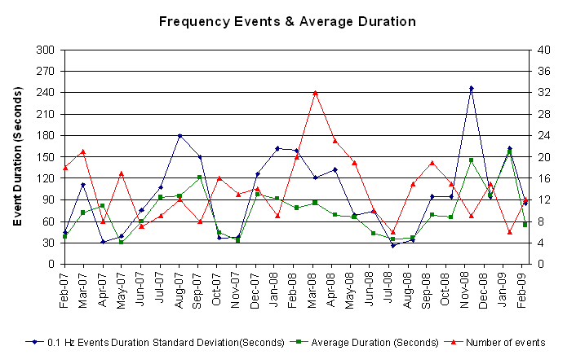

Deployed Responsive (Reported Above)
Time deployed | Stop Time | Duration | Max | Details
2/05 00:18:08 | 2/05 00:34:24 | 0:16:16 | 469.92
2/05 16:31:40 | 2/05 16:54:14 | 0:22:34 | 522.73
2/08 23:36:26 | 2/08 23:53:20 | 0:16:54 | 549.12
2/09 01:18:08 | 2/09 01:33:10 | 0:15:02 | 343.21 | Slow Unit Response. SCE change -1100 MW in 1 hr and 7min. Out of URS.
2/09 10:41:50 | 2/09 11:03:46 | 0:21:56 | 696.96
2/11 21:19:02 | 2/11 21:23:44 | 0:04:42 | 337.94 | Unit Trip
2/12 09:18:40 | 2/12 09:31:06 | 0:12:26 | 322.08 | Steel Mill Load pick up 140 MW, SCE change -300 MW in 1 min
2/14 06:28:48 | 2/14 06:36:32 | 0:07:44 | 364.32 | Unit Trip, SCE change -200 MW in 1 min
2/14 20:17:16 | 2/14 20:37:24 | 0:20:08 | 733.92
2/16 12:59:32 | 2/16 13:17:20 | 0:17:48 | 337.94 | Projected Short-term Load Forecast is lower than actual load
2/18 08:04:24 | 2/18 08:17:42 | 0:13:18 | 322.08 | Projected Short-term Load Forecast is lower than actual load
2/18 09:03:34 | 2/18 09:21:28 | 0:17:54 | 337.94 | Out of URS, SCE change -360 MW in 8 min
2/19 22:03:49 | 2/19 22:16:00 | 0:12:11 | 337.94 | SCE change -1000 MW in 5 min
2/23 16:43:34 | 2/23 17:03:49 | 0:20:15 | 781.45
2/24 21:59:44 | 2/24 22:07:56 | 0:08:12 | 353.77 | SCE change -725 MW in 3 min
2/25 23:06:46 | 2/25 23:17:44 | 0:10:58 | 343.21 | SCE change -600 MW in 3 min
2/27 05:01:42 | 2/27 05:10:54 | 0:09:12 | 337.94 | SCE change -610 MW in 3 min
2/27 07:13:26 | 2/27 07:20:54 | 0:07:28 | 364.32 | Unit Trip
2/27 13:03:46 | 2/27 13:17:58 | 0:14:12 | 343.21 | Unit Trip
2/27 14:40:05 | 2/27 15:01:30 | 0:21:25 | 417.13
2/27 23:57:28 | 2/28 00:27:32 | 0:30:04 | 506.88 | Wind OOME while recalling 1060 MW of DRS.

Day-Ahead OOMC and RPRS Capacity Purchases
Details | OOMC | RPRS S1 | RPRS S2 | RPRS S1+S2 | Total
W RIO | 90 | 3 | 0 | 3 | 93
DFW | 28 | 15 | 5 | 20 | 48
North | 4 | 13 | 6 | 19 | 23
Houston | 4 | 7 | 0 | 7 | 11
Western | 1 | 7 | 3 | 10 | 11
Austin | 6 | 0 | 2 | 2 | 8
Northeast | 4 | 1 | 3 | 4 | 8
Laredo | 0 | 6 | 0 | 6 | 6
South | 0 | 1 | 4 | 5 | 5
E RIO | 0 | 3 | 0 | 3 | 3
San Antonio | 0 | 1 | 0 | 1 | 1
Corpus | 0 | 0 | 0 | 0 | 0
Bryan Area | 0 | 0 | 0 | 0 | 0
 | 137 | 57 | 23 | 80 | 217

Historical Totals | Feb-09 | Jan-09 | Feb-08
Austin | 43 | 19 | 5
Bryan Area | 0 | 0 | 0
Corpus | 1 | 2 | 0
DFW | 5 | 28 | 1
E RIO | 11 | 22 | 1
Houston | 6 | 1 | 0
Laredo | 17 | 16 | 38
North | 6 | 8 | 6
Northeast | 0 | 0 | 0
San Antonio | 1 | 0 | 0
South | 3 | 7 | 0
W RIO | 93 | 137 | 0
Western | 8 | 3 | 8
Total | 194 | 243 | 59
http://www.ercot.com/mktinfo/services/rprsdr/index.html
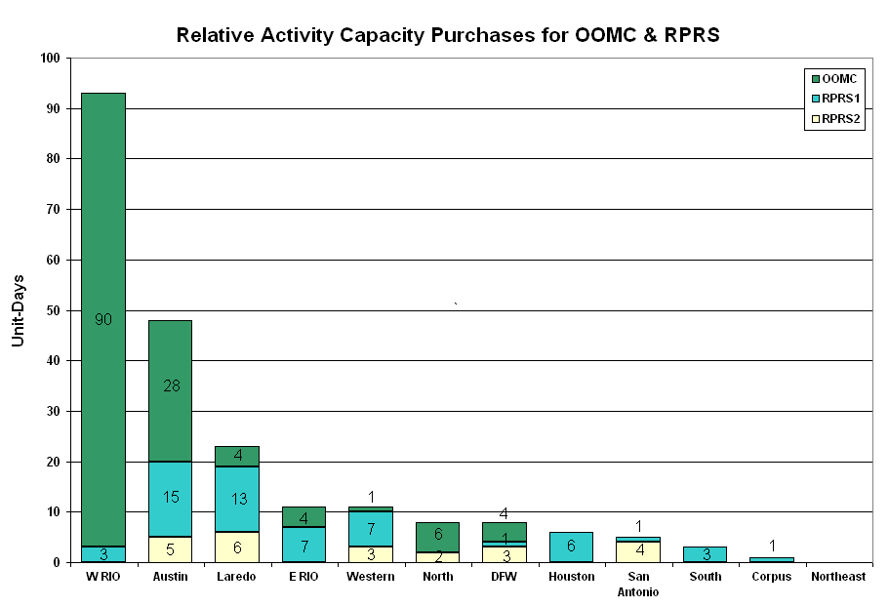
OOME and Congestion Management Activity
Congestion affected by outages
Remedial action plan has been developed for the element
Contingency | Overloaded Element | Days
Basecase | Menard - San Angelo Power Station 138kV | 24
Oasis - PH Robinson 345KV | Garrott - Midtown 138KV | 13
Aspermont - Spur 138KV | Jayton - Spur 69 kV | 11
Abilene South - Eskota Switch 138KV | Merkel - Trent 69KV | 9
Scurry Switch - Spur 138KV | Jayton - Spur 69 kV | 6
San Miguel - Dilley Switch 138KV | Derby - Pearsall 69KV | 6
Austrop 345/138KV autotransformer #2 | Austrop 345/138KV autotransformer #1 | 6
Aspermont - Spur 138KV | Spur 138/69KV transformer | 5
Morgan Creek - Sun Switch 138KV | Sun Switch - Sacroc 138KV | 5
Basecase | Long Creek Post Oak 345/138KV transformer | 5
Graham - Long Creek 345KV | Menard - San Angelo Power Station 138KV | 4
King - Kuykendahl - Roans Prairie and Jewett - Tomball 345KV | Midtown - Garrott 138kV | 4
Temple Pecan Creek - Tradinghouse SES & Temple Switch - Lake Creek SES | Menard - San Angelo Power Station 138KV | 4
Daffin - Decker - Austrop 138KV | Austrop - Decker 138KV | 3
Watermill - Desoto Switch & Cedar Hill 345KV | West Levee Auto #2 | 2
Scurry Switch - Spur 138KV | Spur 138/69KV autotransformer | 2
Abilene Mulberry - Bluff Creek 345KV | Abilene Northwest - Callahan 138KV | 2
Abilene South - Eskota Switch 138KV | Eskota Switch 138/69KV transformer | 2
Abilene Mulberry Creek - Bitter Creek & Long Creek Switch - Sweetwater 345KV | Jayton - Spur 69KV | 2
Victoria - Victoria DuPont Switch 138KV | Formosa - Lolita 138KV | 2
Dilley Switch - North Laredo 138KV | North Laredo - Asherton 138KV | 2
Dilley Switch - Asherton 138KV | Moore - Downey 138KV | 1
Austrop - Lost Pines 345KV | Fayette - Winchester 138KV | 1
Garfield - Onion - Hicross 138KV | Austrop 345/138KV Transformer #1 | 1
Austrop - Daffin and Decker 138KV | Austrop 345/138KV Autotransformer T1 | 1
Bosque Switch - Whitney 138KV | Lake Whitney - Whitney 138KV | 1
Morgan SES - Quail Switch and Longshore Switch 345KV | Midland East - Stanton Switch 138KV | 1
DuPont Switch Ingleside - Ingleside Cogen 138KV | Ingleside DuPont - DuPont PP1 Ingleside 138KV | 1
Graham - Graham Switch 138KV | Graham - Olney 69KV | 1
Marion - Hill Country and Skyline 345KV | Marion - Elm Creek 345KV | 1
Jack County - Reno 138KV | Rhome TU - Decatur Tap 138KV | 1
Marion - Hill Country and Skyline 345KV | Marion - Elm Creek 345KV | 1
Elm Creek - Hill Country - Skyline 345KV | Skyline - Marion 345KV | 1
Monticello SES - Farmersville TU 345KV | Monticello SES - Sulphur Springs Switch 345KV | 1
Trinidad - Stryker - Mount Enterprise 345KV | Elkton - Athens 138KV | 1
Formosa unit | Formosa - Lolita 138KV | 1
STP - Elm Creek 345KV | Blessing - Lolita 138KV | 1
STP - Whitepoint 345KV | Blessing - Lolita 138KV | 1
Abilene Mulberry Creek - Bitter Creek and Long Creek - Sweetwater 345KV | Anson - Radium 69KV | 1
Morgan Creek - Longshore Switch - Quail Switch 345KV | Stanton East - Big Spring West 138KV | 1
Elm Mott 345/138KV Autotransformer | Rogers Hill - Elm Mott 138KV | 1
Austrop - Lost Pines 345KV | Lytton Springs - Pilot Knob 138KV | 1
Bosque Switch - Whitney 138KV | Bosque Switch - Lake Whitney 138KV | 1
Marion - Hill Country - Elm Creek 345KV | Schertz - Parkway 138KV | 1
Monticello - Allen Switch & Sulphur Springs 345KV | Anna Switch - Collin 345KV | 1

Zonal OC1
CSC | Days
West-North | 14
North – West | 1

New RAP (Date indicates last update of RAP not implementation date.)
None

New Procedures/Forms/Operations Bulletins
None

Blackout/Load Shed Incidences
None

EECP
None

Major System Voltage Problems
None

Major Computer Problems, Enhancements & Fixes
None

Communication
None

ERCOT peak (Unofficial)
2/03 08:00 40949 MW

Yearly MTLF Error Comparison
Yearly Mid-Term (Hourly) Load Forecast Error Comparison for the ERCOT Forecast
Month | MAPE for MTLF at 16:00 Day-Ahead
Month | 2006 | 2007 | 2008 | 2009
January | 4.79 | 4.55 | 3.30 | 4.11
February | 4.81 | 3.75 | 3.59 | 3.49
March | 4.95 | 2.70 | 3.29 | NA
April | 5.59 | 3.00 | 2.45 | NA
May | 3.59 | 3.22 | 3.01 | NA
June | 2.65 | 4.46 | 2.81 | NA
July | 2.62 | 4.29 | 2.55 | NA
August | 2.09 | 3.11 | 3.66 | NA
September | 4.03 | 3.78 | 4.99 | NA
October | 3.63 | 3.08 | 2.79 | NA
November | 3.28 | 2.95 | 2.60 | NA
December | 3.44 | 3.74 | 4.54 | NA
Annual Average | 3.79 | 3.55 | 3.18 | 3.80

OCN, Advisory, Alerts & Emergency Notices
Capacity
Date | Start | End | Event
2/14/09 | 2:55 | 5:00 | OCN issued for projected capacity shortage for HE 10:00 & 11:00.
2/14/09 | 22:18 | 23:24 | Advisory ARR below 3000 MW.
2/18/09 | 4:13 | 17:15 | OCN issued for projected capacity shortage for HE 19:00 & 20:00.
2/18/09 | 7:00 | 17:15 | Advisory issued for projected capacity shortage for HE 19:00 & 20:00.
2/21/09 | 19:36 | 23:59 | Advisory ARR below 3000 MW.
2/22/09 | 7:08 | 10:00 | OCN issued for projected capacity shortage for HE 09:00 & 10:00.

Emergency Notice

02/16 13:33 Emergency Notice issued due to Ancillary Service Market for 02/17/09 did not meet the time line.

Texas RE Event Analysis

02/16 13:30 Emergency Notice issued due to procurement for the Ancillary Service Market for 02/17/09 did not meet the timeline.

Other

02/04 14:15 Held real-time balancing energy deployments for IE 14:15 and resumed with IE 14:45.

