

Electric Reliability Council of Texas

Retail Market IT Services

Summary:

Availability targets and related service information for the IT services provided by ERCOT that facilitate retail customer choice in the ERCOT market.

EFFECTIVE: 1/1/2009

Document Revisions
Date | Version |  | Description | Author(s)
March 23rd, 2006 | .9 |  | First draft | Aaron Smallwood
March 28th, 2006 | .91 |  | Revised draft | Aaron Smallwood
June 1st, 2006 | 1.0 |  | Final Version | Aaron Smallwood
June 15th, 2006 | 1.1 |  | Revised final version | Aaron Smallwood
May 1, 2007 | 2.0 |  | 2007 annual review revisions with ERCOT business and Market input | Aaron Smallwood
June 25th, 2007 | 2.1 |  | Revised following further Market input | Aaron Smallwood
June 18th, 2008 | 2.2 |  | Revised for 2008 | Trey Felton
July 31st, 2008 | 2.21 |  | Updated | Trey Felton
Aug28th, 2008 |  | 2.22 | Revisions from TDTWG | Trey Felton
Sept 25th, 2008 |  | 2.3 | Final revisions for TDTWG | Trey Felton
Oct 1st, 2008 |  | 2.4 | TDTWG approval with changes | Trey Felton
Oct 15th, 2008 |  | 3.0 | Approved by RMS | Trey Felton
Feb 22nd, 2009 |  | 3.1 | Quarterly Update | Trey Felton

Table of Contents:

- Introduction
- Retail Market IT Services
  - Retail Transaction Processing
    - Service Scope
    - Service Availability
    - Market Notification and Reporting
  - MarkeTrak
    - Service Scope
    - Service Availability
    - Market Notification and Reporting
  - Texas Market Link (TML)
    - Service Scope
    - Service Availability
    - Market Notification and Reporting
- Retail Market IT Services Reporting
- Browser Compatibility
- Service Availability Renegotiations and Change Control Process
- Annual Review Process
- Approvals

Appendix A: Definitions

Appendix B: System Architecture Diagram

1. Introduction

This document describes the service availability targets, operating hours and reporting mechanisms for several IT services provided by ERCOT to the Texas competitive retail electric market.

Where applicable, these availability targets build upon the requirements outlined in ERCOT Protocols Section 15 and the Retail Market Guide to provide additional guidance to Competitive Retailers and Transmission/Distribution Service Providers (TDSPs) regarding several IT services provided by ERCOT for the Texas competitive retail electric market.

In the event of a conflict between this document and the ERCOT Protocols, Retail Market Guide or PUCT Substantive Rules, the Protocols or PUCT Substantive Rules take precedence over this document.

2. Retail Market IT Services

2.1 Retail Transaction Processing

2.1.1 Service Scope
Retail Transaction Processing Services is the flow of retail transactions between ERCOT and Market Participants. The service is provided by an integrated group of applications and includes the following components:

- NAESB Proxy Servers
- NAESB
- Electronic Data Interchange (EDI)
- Enterprise Application Integration (EAI)
- Customer Registration Database
- ERCOT maintained infrastructure supporting retail transaction processing

Refer to Appendix B for further application and system architecture information.

Excluded from the scope of the retail transaction processing service are the following systems that communicate with, but are not a primary component of, retail market transaction processing services:

- Enterprise Data Warehouse (EDW)
- Settlements & Billing Services (Lodestar)
- Web Services (e.g. TML, MarkeTrak, ERCOT.com)

2.1.2 Service Availability
ERCOT targets retail transaction processing services to be available at least 99.9% of the time outside of scheduled maintenance and release outage windows. Outages included in the retail transaction processing service availability metrics will be reported as follows:

Any outage regardless of duration
- NAESB Proxy Servers
- NAESB

Outages greater than 15 minutes
- Electronic Data Interchange (EDI)
- Enterprise Application Integration (EAI)
- Customer Registration Database
- ERCOT maintained infrastructure supporting retail transaction processing

ERCOT reserves the following times as maintenance and release outage windows:

Maintenance Windows:
- 1st and 2nd Sunday—6:00am until 9:00pm (15 hours)
- 3rd and 5th Sunday—8:00am until 8:00pm (12 hours)

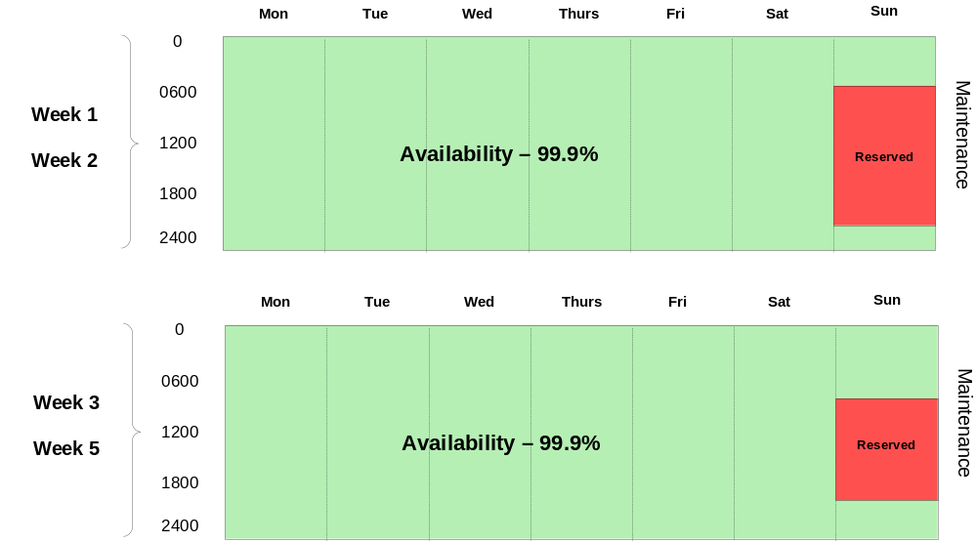

Release Window:
- 4th weekend*– 12:00pm Saturday until 12:00am Monday (36 hours)

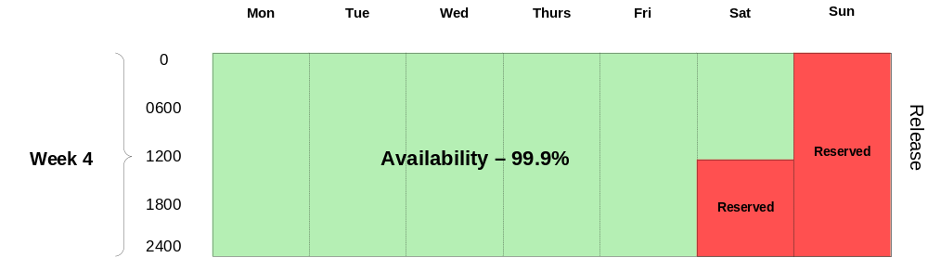

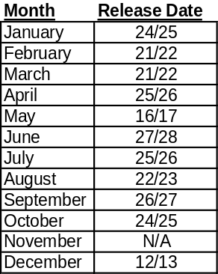

*Exceptions:
To accommodate Thanksgiving, the 2009 November Release window will be moved to the 2nd week of December. Similarly, to accommodate for Memorial Day, the May Release will be moved to Week 3 (See chart). Outages excluded from the availability metric which do not count as unplanned outage time include any market-wide releases requiring Market Participants and ERCOT to coordinate system outages for major upgrades, such as TX SET implementations. ERCOT will coordinate and communicate such market-wide releases and outage expectations unique to each release via the stakeholder process. Exceptions for extended maintenance and release windows will be requested by ERCOT at a Retail Market Subcommittee meeting prior to the extended outage. Approved SLA exceptions will be tracked for reporting purposes (see example below).

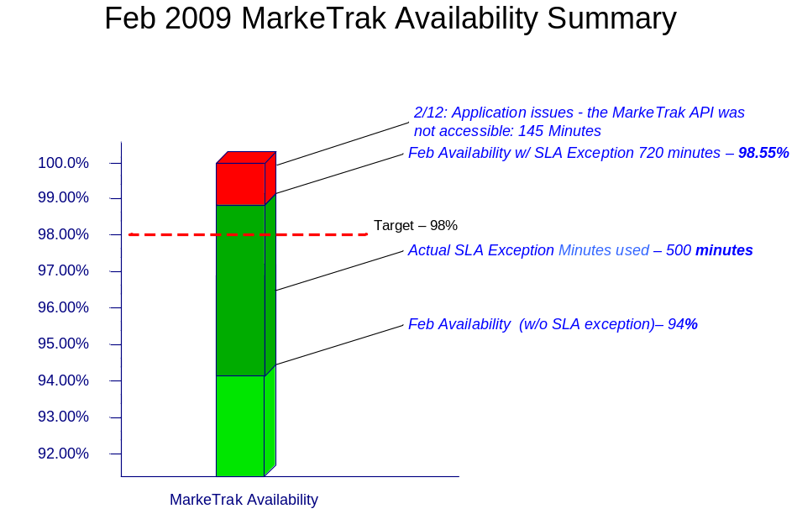
SAMPLE – Not Real Data

Availability Breakdown:
Service availability will be measured as a percentage of minutes that the service is available compared to the total number of minutes, excluding used maintenance and release outage window time.

Gross minutes per year = 525,600

Reserved maintenance outage minutes per year = 32,940

Reserved release outage minutes per year = 23,760

525,600 – 56,700 = 468,900 net availability minutes per year

99.9% availability = 469 unplanned outage minutes per year, or 7.82 hours (if all available maintenance and release windows are used)

Example Service Availability Calculation:

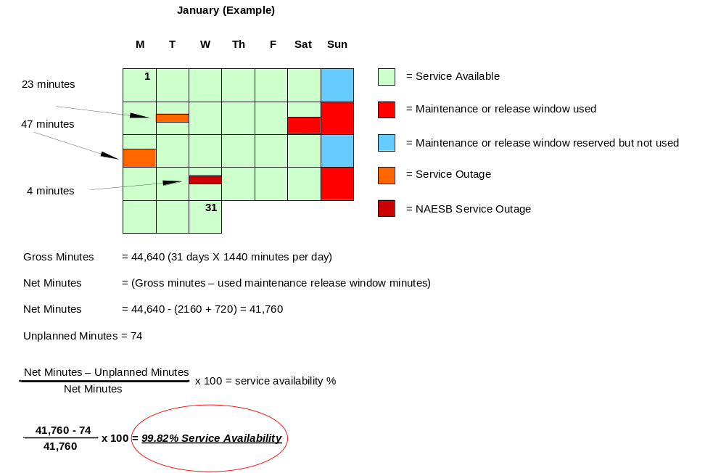

2.1.3 Market Notification and Reporting

ERCOT will measure and report monthly retail transaction processing service availability and track annual service availability for each calendar year. These results will be reported monthly through the ERCOT governance process that includes the Texas Data Transport Working Group, the Retail Market Subcommittee, Technical Advisory Committee, and ERCOT Board of Directors.

ERCOT will maintain a log containing retail transaction processing market notices that will be updated monthly and made available on the ERCOT Service Level Agreement website (http://www.ercot.com/services/sla/). This log will include service availability and detailed information regarding each notice related to retail transaction processing.

2.2 MarkeTrak

2.2.1 Service Scope

The MarkeTrak tool is a web-based database application used to track, manage, and store data utilized by ERCOT and the Market Participants (MPs). This tool is the supported method to track ERCOT Retail market issue management and data discrepancies in the market.

Included in the scope of the MarkeTrak service are the user interfaces that MPs use to create, contribute to, and resolve issues. These are the API (application programmatic interface) and the GUI (graphical user interface).

2.2.2 Service Availability

ERCOT targets MarkeTrak and its user interfaces, both the GUI and API, to be available 98% of the time from 7:00am – 7:00pm during retail business days and Saturday 8:00am – 12:00pm. ERCOT intends for MarkeTrak and its user interfaces to be available outside of this time frame, however this time will not be included in the service availability metric for MarkeTrak. Outages of any duration that occur within the operating window specified above will be counted against the MarkeTrak service availability metric.

Maintenance Windows:
Maintenance can be performed anytime outside of the availability timeframe (7:00am -7:00pm retail business days and Saturday 8:00am – 12:00pm). Market notices will be sent prior to performing any planned maintenance.

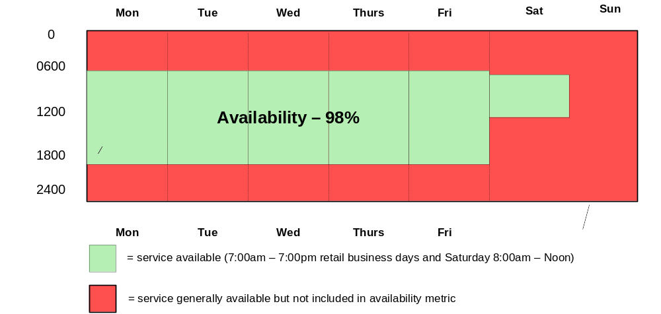

Release Windows
Major releases and any release that includes changes to web services definition language (WSDL) configuration will be conducted during the retail transaction processing maintenance or release windows:

Maintenance Windows:
- 1st and 2nd Sunday—6:00am until 9:00pm (15 hours)
- 3rd and 5th Sunday—8:00am until 8:00pm (12 hours)
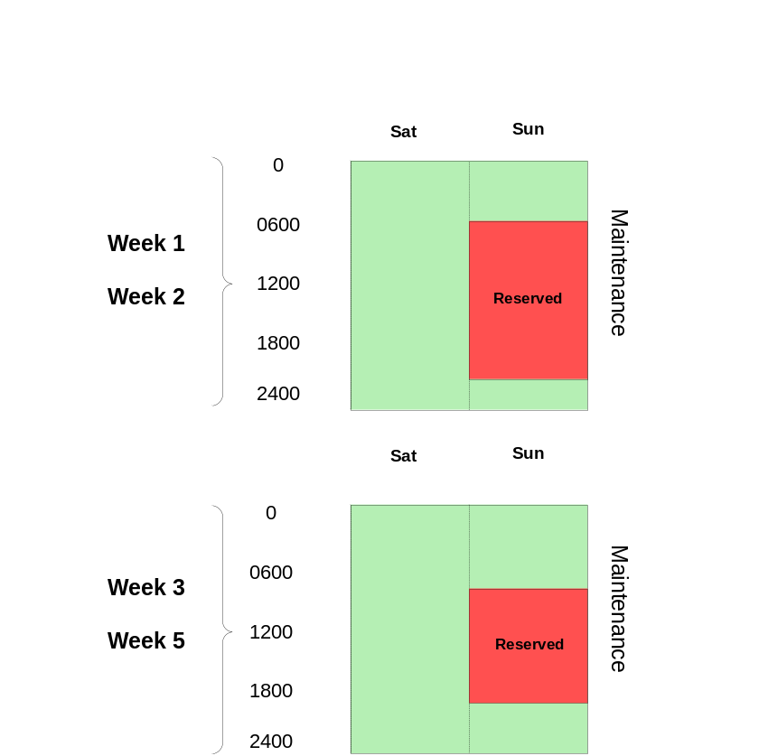

Release Window:
- 4th weekend*– 12:00pm Saturday until 12:00am Monday (36 hours)
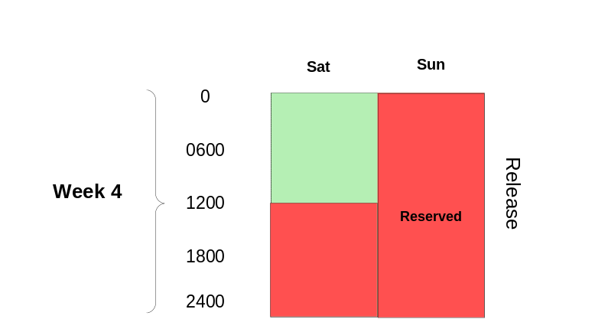

*Exceptions: Refer to Page 5

Availability Breakdown:
Annual available minutes (7:00am – 7:00pm Retail Business Days and Saturday 8:00am – 12:00pm) = 199,680

98% availability = 3,993 unplanned outage minutes per year, or 66.6 hours (if all available maintenance and release windows are used)

2.2.3 Market Notification and Reporting

ERCOT will measure and report monthly MarkeTrak and user interface service availability and track annual service availability for each calendar year. These results will be reported monthly through the ERCOT governance process and includes the Texas Data Transport Working Group, the Retail Market Subcommittee, the Technical Advisory Committee, and the ERCOT Board of Directors.

ERCOT will also maintain a log containing details of market notices that will be updated monthly and made available on the ERCOT Service Level Agreement website (http://www.ercot.com/services/sla/). This log will also include service availability performance metrics and detailed information regarding each notice related to MarkeTrak performance.

Additionally, ERCOT will track response time for API Query List, Query Detail, Update and Submit, and also GUI. This data will be monitored from the Ercot network perimeter at 5 minute intervals, and reported monthly. Once data has been analyzed for a period of 3 months, TDTWG will recommend a benchmark for degradation level of API and GUI no later than the end of 1Q 2009.

2.3 Texas Market Link (TML)

2.3.1 Service Scope

TML is the market information system that provides ERCOT market participants with a web-based application for retrieving general market information, as well as secured access to market participant data. Included in the scope of the TML service is the GUI (graphical user interface). The API (application programmatic interface) for TML is included in the Data Extracts and Reports Service Level Agreement.

2.3.2 Service Availability

ERCOT targets TML to be available 99% of the time outside of scheduled maintenance and release windows. TML maintenance and release windows are the same as the retail transaction processing maintenance and release windows. Outages of any duration of the TML GUI will be counted against the TML service availability metric.

Maintenance Windows:
- 1st and 2nd Sunday– 6:00am until 9:00pm Sunday (15 hours)
- 3rd and 5th Sunday—8:00am until 8:00pm (12 hours)

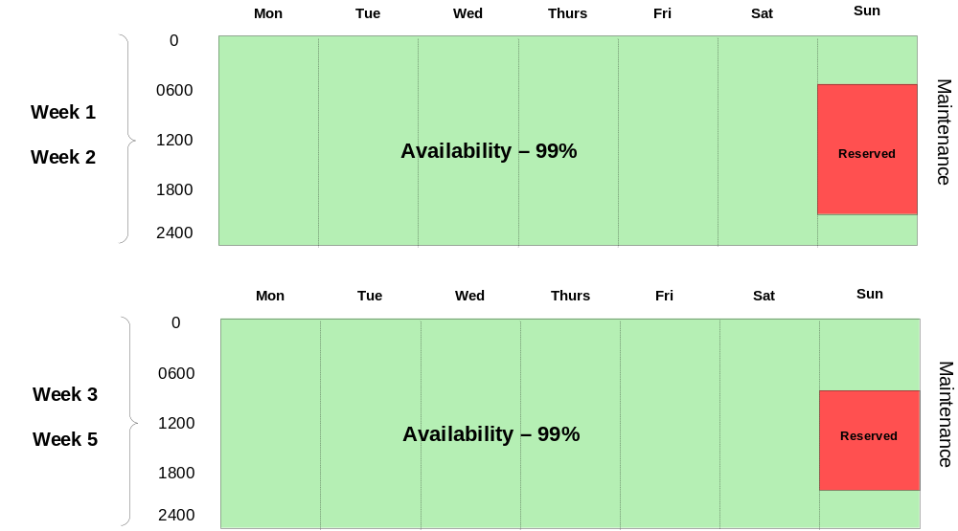

Release Window:
- *4th weekend– 12:00pm Saturday until 12:00am Monday (36 hours)
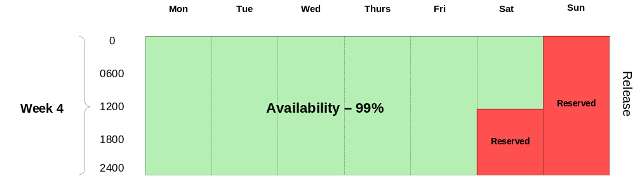

*Exceptions: See Page 5

Availability Breakdown:
Service availability will be measured as a percentage of minutes that the service is available compared to the total number of minutes, excluding used maintenance and release outage window time.

Gross minutes per year = 525,600

Reserved maintenance outage minutes per year = 36,360

Reserved release outage minutes per year = 23,760

525,600 – 60,120 = 465,480 net availability minutes per year

99.9% availability = 465 unplanned outage minutes per year, or 7.76 hours (if all available maintenance and release windows are used)

2.3.3 Market Notification and Reporting

ERCOT will measure and report each month’s TML availability and track annual service availability for each calendar year. These results will be reported monthly through the ERCOT governance process and includes the Texas Data Transport Working Group, the Retail Market Subcommittee, the Technical Advisory Committee, and the ERCOT Board of Directors.

ERCOT will also maintain a log containing details of market notices that will be updated monthly and made available on the ERCOT Service Level Agreement website (http://www.ercot.com/services/sla/). This log will also include service availability performance metrics and detailed information regarding each notice related to TML performance.

Additionally, ERCOT will track response time for the TML public web service. This data will be monitored from the ERCOT network perimeter at 5 minute intervals, and reported monthly. Once data has been analyzed for a period of 3 months, TDTWG will recommend a benchmark for degradation level no later than the end of 1Q 2009.

3. Retail Market IT Services Reporting

Service availability and impacting events related to the Retail Market IT services described in this document will be reported monthly to the Texas Data Transport Working Group, the Technical Advisory Committee and the Retail Market Subcommittee. The availability metrics and detailed market notice log will be updated monthly and posted to the Retail Market Subcommittee website on www.ercot.com.

Elements included in the Detailed report are:

- Outage/Incident date
- Date of initial Market Notice (if applicable)
- Market Notice ID tag (if applicable)
- Incident start and end times and duration
- Service(s) affected
- Issue description
- SLA Impacted
- Identification method – the way that ERCOT learned of the incident (i.e.…monitoring, notification from market participant, etc…)
- Impact to the affected service
- Market impact – total out of protocol for the SWI, MVI, MESI, PMVI, and MVO
- Resolution status
- Root cause when identified
- Date of any identified fix to be implemented
- Additional comments or notes

The report also summarizes the market notice data by type in monthly and annual breakdowns.

Market Participants may provide data and information regarding the impacts of an incident to ERCOT to be included in the monthly report detailed above. Information provided to ERCOT for the purposes of inclusion in the incident log will be treated as confidential and may be submitted to ERCOTRetailIncidentLog@ercot.com.

4. Browser Compatibility

ERCOT maintains its Retail IT Systems to support most commonly-used web browsers. Enterprise Architecture manages the overall technology lifecycle for ERCOT systems, which includes platform compatibility.

Upon a request from the Texas Data Transport Working Group (TDTWG), ERCOT will either certify or have a plan to certify ERCOT systems to support TDTWG-recommended browsers within six (6) months of the browser’s release date or request by the working group. ERCOT’s Divisional Project Office will work with IT Customer Service to determine level of effort, and if the request requires a separate project. A configuration guide for the client browsers for each application will be created and posted to Ercot.com. Additionally, ERCOT will work with the TDTWG to identify browser versions for which supportability can be discontinued. ERCOT will post configuration guides for browser versions to http://www.ercot.com/services/userguides/

5. Service Availability Renegotiations and Change Control Process

Renegotiations of ERCOT retail market IT services can be initiated by either Market Participants or ERCOT management by making a request to the Retail Market Subcommittee.

Version control in the form of document version numbering will be maintained in this document as a means of providing a change control process.

6. Annual Review Process

ERCOT is committed to providing IT services to the competitive electric market in Texas. ERCOT intends that the IT services described in this document align with market participant requirements to the extent that is operationally feasible. To maintain alignment between the requirements of the market participants and the retail market IT services delivered by ERCOT, the service availability targets defined in this document will be reviewed at least annually.

7. Approvals

Area of Responsibility | Name | Reviewed / Approved | Date
Business Sponsor – RMS | Blake Gross | RMS Approval | 15 Oct 08
Director – Commercial Operations | Betty Day
Senior Director –Information Technology Services | David Forfia
Director – IT Strategic Services | Aaron Smallwood
Manager – Retail Customer Choice | Karen Farley

Appendix A: Definitions

This section contains definitions of the systems referred to in this document and of the commonly used acronyms.
- Availability: The ability of a component or IT service to perform its required function over a stated period of time
- Degradation: An event that causes the normal levels of ERCOT IT systems to be impacted while still allowing for minimal processing of or access to these systems
- EDI: Electronic Data Interchange – the transfer of data electronically
- Gross minutes - total minutes in a month
- Exception outage minutes: minutes outside of the maintenance and release outage windows that have been granted exception from the availability metric (e.g. additional minutes granted for necessary changes)
- Incident: Any event that causes the agreed levels of service of ERCOT IT systems to be impacted
- Integration: The creation of links between previously separate computer systems, applications, services or processes
- NAESB: The North American Energy Standards Board (NAESB) serves as an industry forum for the development and promotion of standards which will lead to a seamless marketplace for wholesale and retail natural gas and electricity. The Texas electric market has implemented NAESB EDM v1.6 as the required data transport mechanism.
- Net minutes: gross minutes minus planned outage minutes
- PaperFree: The data validation and transformation engine utilized in ERCOT’s retail transaction processing system
- Planned outage minutes - minutes used by ERCOT during the maintenance and release windows
- Planned Outage: A planned change in ERCOT IT systems that prevents users from being able to access the systems
- Proxy Server: a server which services the requests of its clients by forwarding requests to other servers
- Retail Transactions:
  - 814 – Enrollment transaction used for registration in the retail market
  - 867 – Usage transaction used for reporting consumption or generation of electricity
  - 824 – Application advice transaction used for responding to errors on 867 usage transactions
  - 997 – Acknowledgement transaction
- Service availability percent: the percent of time that retail transaction processing services were available, not including planned outage minutes
- Siebel: ERCOT’s customer relationship management system
- TIBCO: ERCOT’s enterprise application integration software
- Unplanned Outage: An unplanned change in ERCOT IT systems that prevents users from being able to access the systems
- Unplanned Outage minutes: minutes retail transaction processing services were not available that are outside of the planned use of the maintenance and release windows
- WSDL: Web Services Definition Language, WSDL is an XML based markup language used to describe and define Web Services.

Appendix B: Retail Market Systems Architecture Diagram



