ERCOT Operations Report
January 2009 ROS & OWG

Frequency Control
Time | Freq(Hz) | Duration (s)
1/10/2009 0:01 | 60.136 | 303 | Out of Down Regulation, SCE change +200 in 2 mins
1/16/2009 6:13 | 59.811 | 86 | Unit trip with 793 MW
1/20/2009 21:29 | 60.156 | 410 | Ramping out of 1227MW of Non-Spin slower than Balancing Energy Schedule increase.
1/23/2009 20:59 | 59.898 | 4 | Balancing Energy Schedule change -1700 MW
1/25/2009 8:19 | 59.837 | 97 | Unit trip with 545 MW
1/28/2009 4:54 | 59.859 | 43 | Unit trip with 775 MW

Note: Time of frequency excursions outside the range of +/- 0.1 Hz.

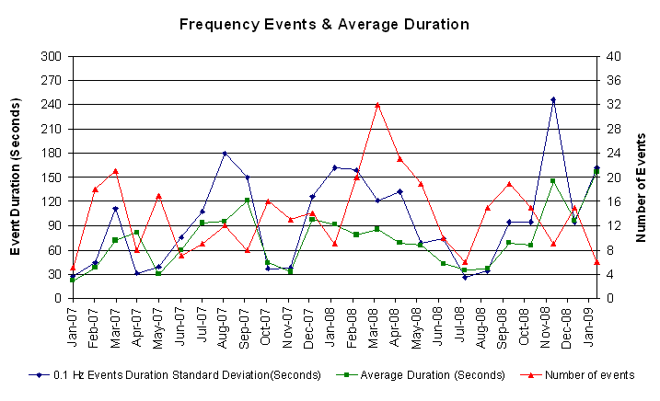

Deployed Responsive (Reported Above)
Time deployed | Stop Time | Duration | Max | Details
1/06 22:04:48 | 1/06 22:16:10 | 0:11:22 | 359.04 | Projected Load is lower than actual load.
1/08 03:18:32 | 1/08 03:30:16 | 0:11:44 | 422.41 | Unit Trip.
1/09 20:01:38 | 1/09 20:24:40 | 0:23:02 | 327.36 | SCE change -770 MW in 6 min.
1/16 06:13:56 | 1/16 06:27:48 | 0:13:52 | 826.55
1/16 21:17:02 | 1/16 21:36:04 | 0:19:02 | 322.08 | Out of URS.
1/17 07:13:08 | 1/17 07:30:03 | 0:16:55 | 327.47 | Out of URS, SCE change -80 MW in 2 min, Steel Mill Load pick up 50 MW in 4 min.
1/18 18:06:36 | 1/18 18:19:08 | 0:12:32 | 327.24 | Out of URS, SCE change -170 MW in 5 min, Steel Mill Load pick up 50 MW in 1 min.
1/19 18:16:50 | 1/19 18:31:06 | 0:14:16 | 322.08 | SCE change -420 MW in 10 min caused depletion of URS.
1/20 19:07:01 | 1/20 19:16:45 | 0:09:44 | 353.77 | Out of Up Reg at 19:04. Steel Mill Load pick up 180 MW in 5 min.
1/20 19:29:59 | 1/20 19:44:07 | 0:14:08 | 327.36 | Projected Load is lower than actual load.
1/20 22:01:47 | 1/20 22:28:51 | 0:27:04 | 359.04 | SCE change -520 MW in 5m and Slow Unit Response
1/23 20:59:13 | 1/23 21:30:41 | 0:31:28 | 374.90 | SCE change -1000 MW in 7 min.
1/25 08:19:42 | 1/25 08:38:37 | 0:18:55 | 702.24
1/26 06:10:42 | 1/26 06:28:25 | 00:17:43 | 337.94 | Out of Up Reg at 6:10.
1/28 04:54:51 | 1/28 05:14:34 | 0:19:43 | 586.08

Day-Ahead OOMC and RPRS Capacity Purchases
Details | OOMC |  | RPRS S1 |  | RPRS S2 |  | RPRS S1+S2 |  | Total
W RIO | 124 |  | 13 |  | 0 |  | 13 |  | 137
DFW | 26 |  | 2 |  | 23 |  | 25 |  | 51
North | 2 |  | 6 |  | 25 |  | 31 |  | 33
Austin | 19 |  | 0 |  | 12 |  | 12 |  | 31
E RIO | 18 |  | 4 |  | 0 |  | 4 |  | 22
Laredo | 0 |  | 16 |  | 2 |  | 18 |  | 18
Western | 0 |  | 3 |  | 11 |  | 14 |  | 14
Houston | 1 |  | 0 |  | 11 |  | 11 |  | 12
San Antonio | 0 |  | 0 |  | 10 |  | 10 |  | 10
South | 0 |  | 7 |  | 0 |  | 7 |  | 7
Northeast | 0 |  | 0 |  | 6 |  | 6 |  | 6
Corpus | 0 |  | 2 |  | 0 |  | 2 |  | 2
Bryan Area | 0 |  | 0 |  | 0 |  | 0 |  | 0
Total | 190 |  | 53 |  | 100 |  | 153 |  | 343
Historical Totals |  | Jan-09 |  | Jan-08 |  | Dec-08
Austin |  | 19 |  | 1 |  | 9
Bryan Area |  | 0 |  | 7 |  | 0
Corpus |  | 2 |  | 0 |  | 1
DFW |  | 28 |  | 0 |  | 24
E RIO |  | 22 |  | 0 |  | 8
Houston |  | 1 |  | 0 |  | 1
Laredo |  | 16 |  | 51 |  | 14
North |  | 8 |  | 0 |  | 17
Northeast |  | 0 |  | 2 |  | 0
San Antonio |  | 0 |  | 1 |  | 0
South |  | 0 |  | 0 |  | 10
W RIO |  | 137 |  | 0 |  | 107
Western |  | 3 |  | 4 |  | 7
Total |  | 243 |  | 66 |  | 198

http://www.ercot.com/mktinfo/services/rprsdr/index.html
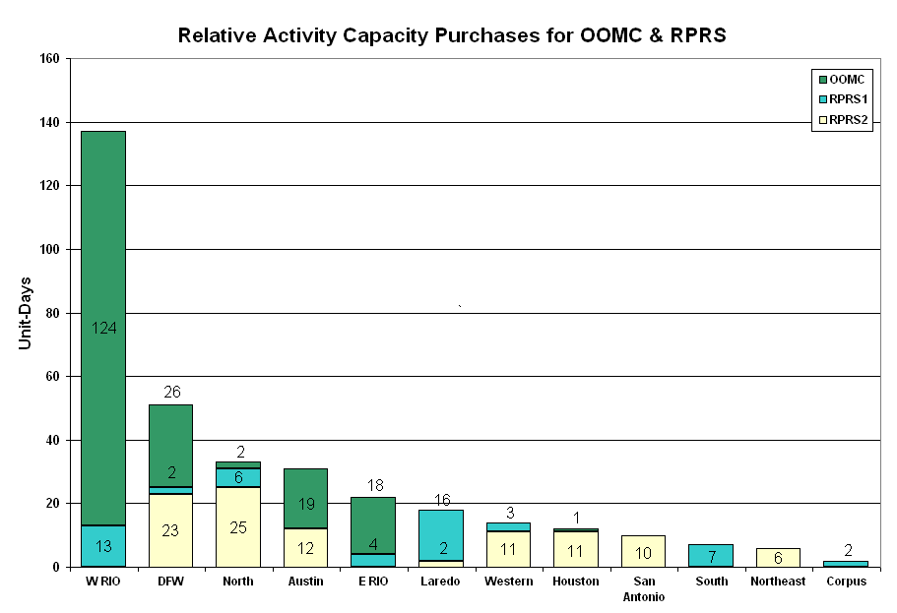

OOME and Congestion Management Activity
Congestion affected by outages
Remedial action plan has been developed for the element
Contingency | Overloaded Element | Days
Aspermont - Spur 138KV | Jayton - Spur 69 kV | 19
Sandow Switch - Austrop 345KV | Sandow Switch - Elgin Switch 138 kV | 10
Victoria - Victoria DuPont 138KV | Formosa - Lolita 138KV | 8
Garfield 345/138KV Transformer T1 | Garfield 345/138KV Transformer T2 | 8
Bosque Switch - Whitney TU 138KV | Lake Whitney - Bosque Switch 138 kV | 7
Menard - Gillespie 138KV | Menard autotransformer 138/69KV | 6
Aspermont - Spur 138KV | Spur autotransformer 69/138KV | 5
Elgin Switch - Gilleland Creek 138KV | Elgin Switch - Taylor 138 kV | 5
Sandow Switch - Austrop Switch 345KV | Austrop 345/138KV Autotransformer T1 | 5
Sun Switch - Morgan SES 138KV | Sun Switch - Sacroc 138 kV | 5
Dilley Switch - San Miguel 138KV | Derby - Pearsall 69KV | 4
Garfield - Onion - Hicross 138KV | Austrop 138KV T2 | 3
San Angelo - Live Oak 138KV | San Angelo Concho - San Angelo Lake Nasworthy 69KV | 3
Abilene South - Eskota Switch 138KV | Merkel - Trent 69KV | 2
Abilene South - Eskota Switch 138KV | Eskota Switch 138/69KV autotransformer | 2
Austrop - Daffin and Decker 138KV | Elgin - Taylor 138KV | 2
Crane LCRA - Spudder Flats 138KV | Crane LCRA - Rio Pecos 138KV | 2
Golden Switch - Bluff Creek 138KV | Sun Switch - Sacroc 138KV | 2
Graham - Benbrook and Parker Switch 345KV | Flat Creek - Leon Switch 138KV | 2
Jack County - Reno 138 KV | Bowie 138/69KV transformer | 2
Lamesa 138/69KV autotransformer | Bluff Creek Switch - Sharon Ridge 138KV | 2
Oasis - PH Robinson 345KV | Garrott - Midtown 138KV | 2
Temple Pecan Creek - Tradinghouse and Temple Switch - Lake Creek 345KV | Menard - San Angelo Power Station 138KV | 2
Royse Switch - Farmersville 345KV | Farmersville - Royse Switch 345KV | 1
Asherton - West Batesville 138KV | Asherton 138/69KV autotransformer | 1
Austrop - Lost Pines 345KV | Fayetteville 345/138KV Auto | 1
Calavers - Skyline and Walzem Road 138KV | Westside - Five Points 138KV | 1
Dilley Switch - Asherton 138KV | Camp Woods - Leakey 69KV | 1
Graham - Long Creek 345KV | Menard - San Angelo Power Station 138KV | 1
Jewett - Tomball 345KV | Garrott - Midtown 138KV | 1
Joslin - North Carbide 138KV | Victoria DuPont Switch - Joslin 138KV | 1
Lon Hill - Whitepoint 345KV | Nueces Bay - Whitepoint 138KV | 1
Moore - Uvalde 138KV | Camp Woods – Leakey 69 kV | 1
Morgan Creek – Sun Switch 138KV | Menard – San Angelo Power Station 138KV | 1
Odessa EHV autotransformer #2 345/138KV | Odessa EHV autotransformer #1 345/138KV | 1
Odessa EHV – Morgan SES and Quail Switch 345kV | Big Spring Switch – Big Spring West 138kV | 1
Sandow Switch - Austrop 345KV | Menard – San Angelo Power Station 138 kV | 1
Sandow Switch - Austrop Switch 345KV | Elgin Switch - Butler 345/138KV | 1
South Channel - Jefferson 138KV | Jefferson - Crown 138KV | 1
South Channel - Jefferson 138KV | Crown - Galena Park 138KV | 1
West Columbia - Sweeny 138KV | Sweeny Sub - Old Ocean 69KV | 1
West Levee - 800/900 NWK 138KV | West Levee - Dealey Street 138KV | 1
Zorn - Marion - Clearsprings 345KV | Clearsprings 345/138KV Auto #1 | 1

Zonal OC1
CSC | Days
West-North | 18
North – South | 2

New RAP (Date indicates last update of RAP not implementation date.)
None

New Procedures/Forms/Operations Bulletins
Date | Subject | Bulletin No.
01/30/2009 | Frequency Control Desk V 3 Rev 73 | 402
01/30/2009 | Transmission & Security Desk V 3 Rev 99 | 401
01/30/2009 | Shift Supervisor Desk V 3 Rev 54 | 400
01/30/2009 | Operating Period Desk V 2 Rev 25 | 399
01/30/2009 | Day-Ahead Desk V 3 Rev 39 | 398

Blackout/Load Shed Incidences
None

EECP
None

Major System Voltage Problems
None

Major Computer Problems, Enhancements & Fixes
None

Communication
None

ERCOT peak (Unofficial)
1/29 08:00 45,442 MW

Yearly MTLF Error Comparison
Yearly Mid-Term (Hourly) Load Forecast Error Comparison for the ERCOT Forecast
Month | MAPE for MTLF at 16:00 Day-Ahead
Month | 2006 | 2007 | 2008 | 2009
January | 4.79 | 4.55 | 3.30 | 4.11
February | 4.81 | 3.75 | 3.59 | NA
March | 4.95 | 2.70 | 3.29 | NA
April | 5.59 | 3.00 | 2.45 | NA
May | 3.59 | 3.22 | 3.01 | NA
June | 2.65 | 4.46 | 2.81 | NA
July | 2.62 | 4.29 | 2.55 | NA
August | 2.09 | 3.11 | 3.66 | NA
September | 4.03 | 3.78 | 4.99 | NA
October | 3.63 | 3.08 | 2.79 | NA
November | 3.28 | 2.95 | 2.60 | NA
December | 3.44 | 3.74 | 4.54 | NA
Annual Average | 3.79 | 3.55 | 3.18 | 4.11

OCN, Advisory, Alerts & Emergency Notices
Capacity
Date | Start | End | Event
1/3/09 | 9:11 | 14:15 | OCN potential capacity shortage for operating hour 19:00.
1/4/09 | 8:30 | 10:30 | OCN potential capacity shortage for operating hours 19:00 - 23:00.
1/4/09 | 10:30 | 12:15 | Alert potential capacity shortage for hours 19:00 to 23:00.
1/4/09 | 17:35 | 21:20 | Advisory ARR below 3000 MW.
1/7/09 | 6:10 | 8:15 | Deployed NSRS in Houston, North and South zones due to depletion of Up Balancing Energy bids.
1/7/09 | 6:54 | 8:25 | Advisory ARR below 3000 MW.
1/8/09 | 7:05 | 9:00 | Advisory ARR below 3000 MW.
1/20/09 | 17:56 | 23:00 | Advisory ARR below 3000 MW.
1/20/09 | 18:36 | 21:30 | Deployed NSRS in all zones for IE 19:15 due to depletion of UBES.
1/21/09 | 7:00 | 10:00 | Advisory ARR below 3000 MW
1/24/09 | 3:45 | 14:45 | OCN projected capacity shortage for HE12:00 - 13:00 & 18:00.
1/24/09 | 10:13 | 14:45 | Advisory ARR below 3000 MW.
1/26/09 | 7:03 | 9:00 | Advisory ARR below 3000 MW
1/26/09 | 19:00 | 0:00 | OCN anticipated freezing precipitation in the ERCOT region.
1/27/09 | 18:38 | 0:00 | Advisory freezing precipitation across the ERCOT Region.
1/27/09 | 0:15 | 18:38 | OCN anticipated freezing precipitation in the ERCOT region.
1/28/09 | 0:15 | 11:21 | Advisory freezing precipitation across the ERCOT Region.

Transmission

01/27 08:52 Transmission Alert issued for post-contingency overload of San Angelo - Big Lake 69 kV due to forced outage.

Emergency Notice

01/16 18:10 Emergency Notice issued due to Replacement Reserve Service (RPRS) did not meet Market time line.

Texas RE Event Analysis

01/04 01:08 SPS at Whirlwind Energy Center activated.

01/04 02:00 SPS at Stanton Wind Energy Center activated.

01/09 08:42 SPS at Ocotillo Wind Farm activated.

01/16 18:10 Emergency Notice issued due to the Replacement Reserve Service did not meet Market time line.

01/23 02:00 Austin EMMS Servers were unavailable

Other

01/07 06:25 Held IE 06:30 real-time balancing deployments for IE 06:45 due to an incorrect off-set calculation, resumed with IE 07:00 deployments.

