MarkeTrak Users Guide

Section 7: Admin

Table of Contents
MarkeTrak Users Guide 1
7.1 MarkeTrak Administrator’s Guide 3
7.1.1 Add a New User 3
7.1.2 Editing an User 11
7.1.3 Copy a User 14
7.1.4 Remove User Access 16
7.1.5 Rolodex Management 19
7.1.6 Administrator Change 19
7.1.7 Administrator Reporting Responsibilities 21
7.1.8 Clearing Administrator Locks 22

7.1 MarkeTrak Administrator’s Guide
MarkeTrak Participant Administrator Roles and Responsibilities

The MP Administrator will be responsible for establishing and maintaining the users associated with their Market Participant organization. This section of the MP User Guide will provide detailed instruction for adding, copying, editing and deleting users from the MarkeTrak system. MP Administrators will only be able to establish or maintain users associated with their organization.

The MP Administrator will be responsible for maintaining the MarkeTrak Rolodex. This is the list owned by each MP Administrator which determines the destination of Notification Emails. Please refer to Section 7 for detailed instructions

The MP Administrator will be responsible for maintaining the MarkeTrak Contacts List. This is the list owned by each MP Administrator which provides contact information for each MarkeTrak user for that company. Please refer to Section 7

The MP Administrator will also be responsible for Report Management. – creating reports for use by multiple users registered under the same DUNS.

The MP Administrator is responsible for clearing Locks

Note: ERCOT must establish the MP Administrator account and the Rolodex contact affiliations for a particular MP organization before any of these instructions can be accomplished.

7.1.1 Add a New User
The addition of a new user is a process by which the MP Administrator will establish a user profile based on the digital certificate, which provides the user contact information (“General” tab), assigns privileges (“Membership” tab), set display settings ( “Preference” tab) associates the user to the MP company record.

- In order to add a user, the MP Administrator must have the user’s employee id. The Employee ID can be found on the user’s Digital Certificate by following these instructions. These instructions must be done on the user’s computer where the digital certificate is loaded.
  - Open Internet Explorer.
  - On the taskbar, click Tools
  - Select Internet Options
  - In the new window, Select the ‘Content’ tab
  - Select Certificates, the certificate window will show all the digital certificates installed on that computer
  - Highlight the digital certificate, then click View
  - Click the ‘Detail’ tab within the next window
  - In the window, highlight the ‘Subject’ line
  - All details, such as the Employee ID are located here

- The MP Administrator logs into MarkeTrak and selects the Administrator link (Fig 7.1.1a)

Fig 7.1.1a
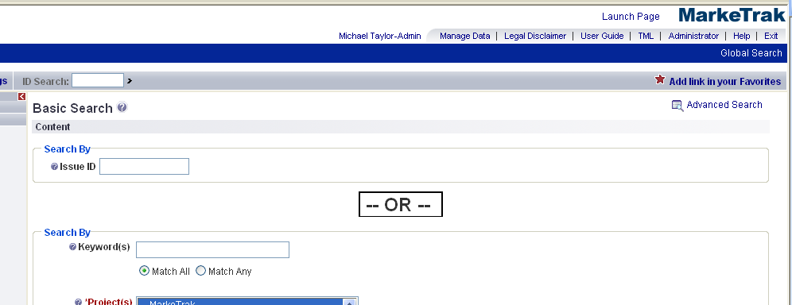

- In the new window, select the Add User link (Fig 7.1.1b)

Fig 7.1.1b
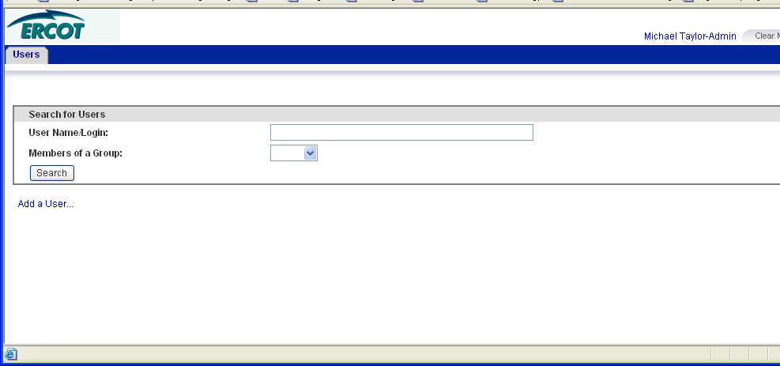

- On the General Tab, key in the user information requested.
Login ID: Please include the Login ID in the following format:
DUNS$Employee ID
Example: 123456789$JDoe0506
Please note employee id must match the digital certificate exactly.
Follow the process as outlined in step number 1 to find the user’s employee id.

Password: This field should be left blank. Please note that when this field is left blank, asterisk will appear.

Full Name: Please include the name in the following format.
First Name (space) Last Name-DUNS
Example: Jane Doe-123456789
Please note do not leave a space between the Last Name, dash and DUNS. This identifies who the user is logged in as in MarkeTrak. It is very important to include the DUNS at the end of the name.

Phone: Please include the user’s phone number.

E-mail: Please include the user’s e-mail address

E-mail Aliases: Please include the user’s alias e-mail address if applicable.

Product Access: Select User

Associated Contact: Select Create/Update Record from user

Fig 7.1.1c
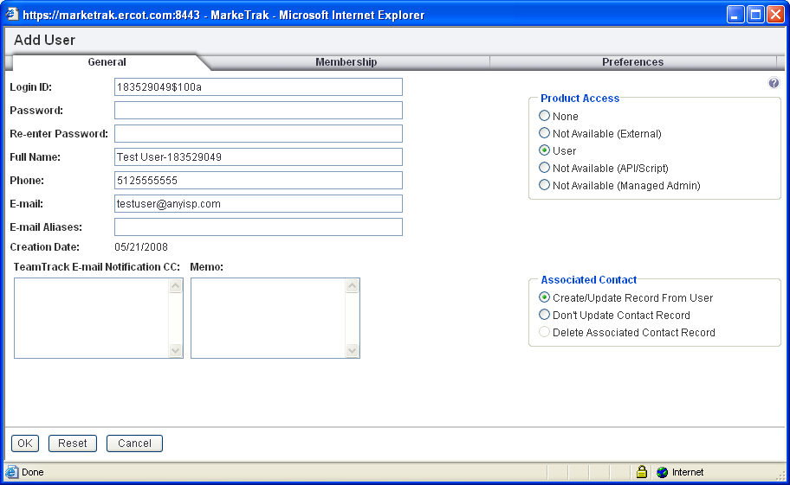

- On the Membership tab, from the Not a Member of column, select DUNS, All FT_ALL Users – External (TDSP/CR), Detailed Report Privilege and your MP type queue (either TDSP queue or CR queue) and use the right arrow to move these selections to the Member of column. (Fig 7.1.1d)

Fig 7.1.1d
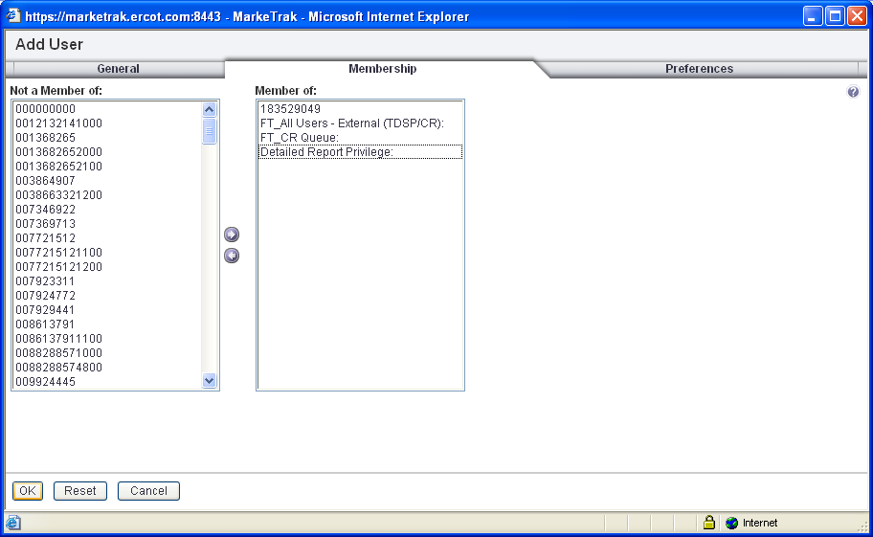

- On the preferences tab, select use 24 hour clock. Use this screen shot as a starting point for other preferences settings. Click the OK button when complete. (Fig 7.1.1e)

Fig 7.1.1e
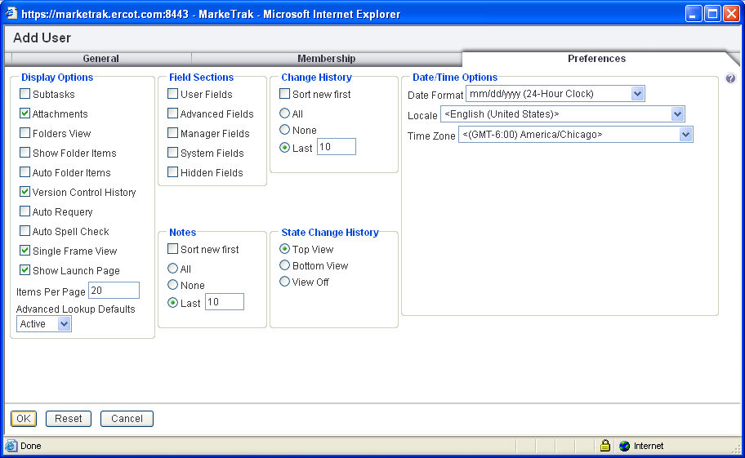

- The next step in the user creation process is to associate the newly created user with your company. This step is accomplished by selecting Manage Data from the MarkeTrak main screen. (Fig 7.1.1f)

Fig 7.1.1f

- *** To complete the setup – Go to the Manage Data screen, select Contacts from the Manage drop down list. Lookup the user that you just created by first and/or last name. Select the user you created and click the Update button. (Fig 7.1.1g)

Fig 7.1.1g
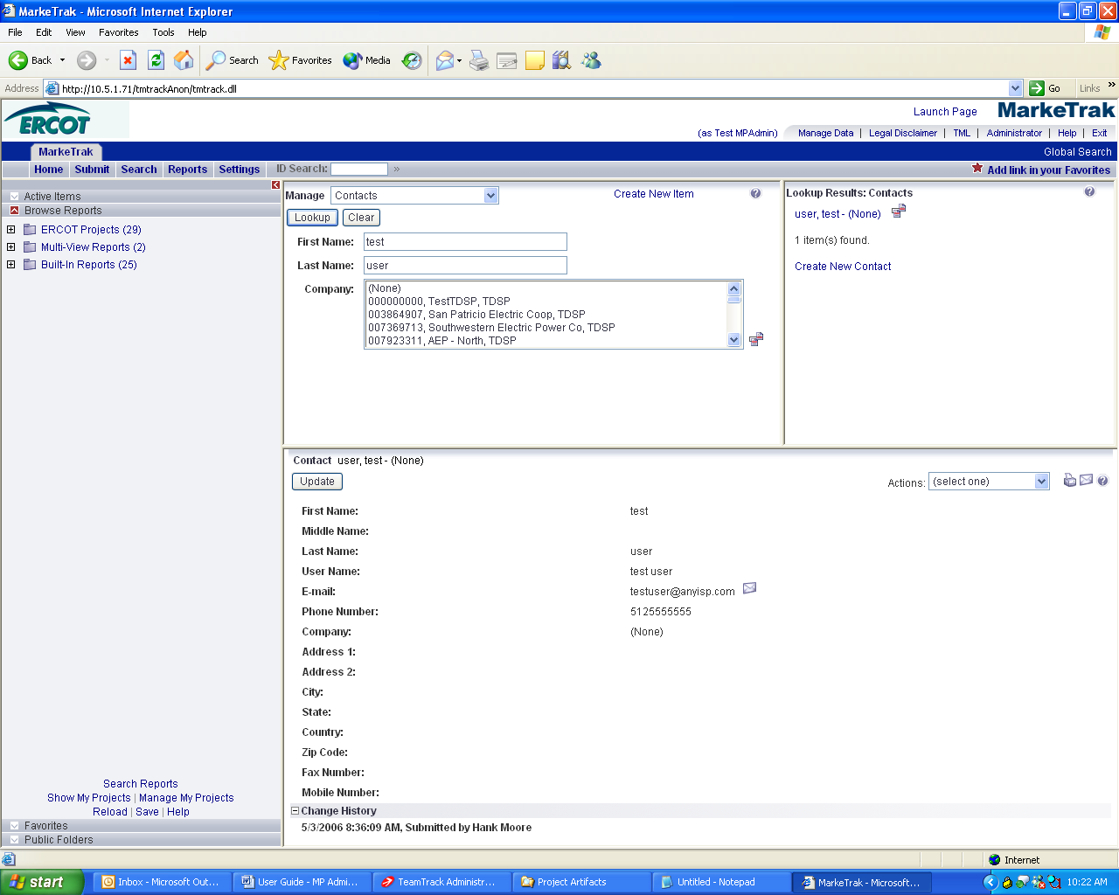

- You are required to select a company record to associate the new user to. You can search by DUNs, company name or MP type. For simplicity, it is recommended you search by DUNs for the company search. Once the appropriate company has been selected, click the OK button to complete this step. (Fig 7.1.1h)

Fig 7.1.1h
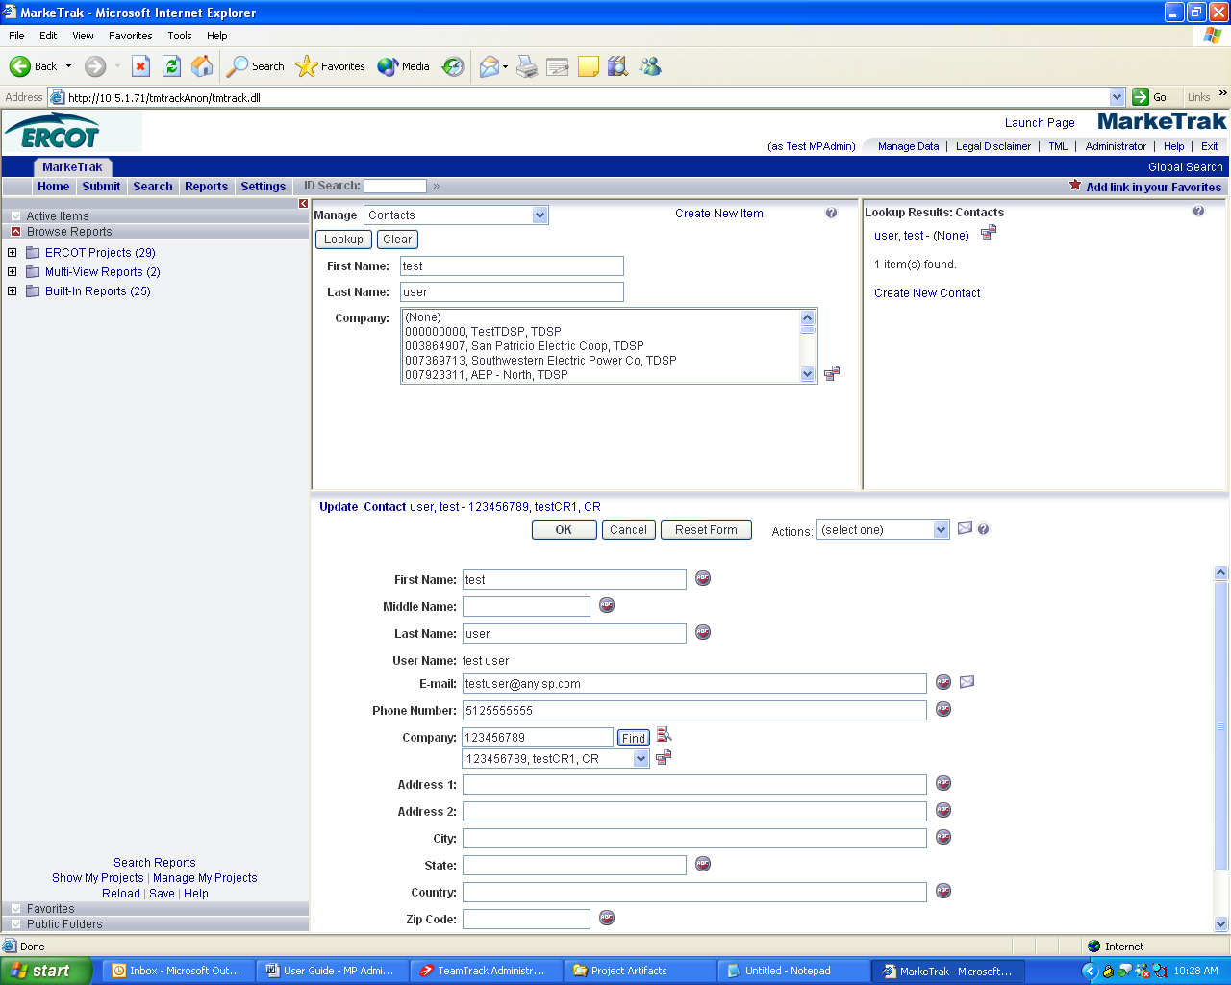

- The new user will not be able to see MarkeTrak issues that have been submitted prior to the user creation date. In order for the new user to see prior issues, they can either “touch” all of the issues by running an ERCOT public report to place a comment or transition all prior issues, or run the Background Report called ‘New User Issue Access’
Touching all Issues
- Select the Reports tab, search for the report named: Find Issues prior to “Last Modified Date” Selected (this report will pull back all issues included bulk issues) or Find Issues prior to “Last Modified Date” Without Bulk (this report will pull back only D2D and DEV issues)
- Select the report, add the user’s creation date and then run the report.
- Then perform a Mass Update by following the steps in Section 1.4.3.

Background Report
  - Select ‘Background Report’ from the Submit Tree. (Fig 7.1.1i)

Fig 7.1.1i
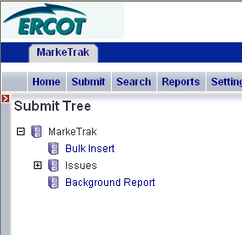
  - Select New User Issue Access from the Report Name drop down list, enter comments and select OK to Submit. (Fig 7.1.1j)

Fig 7.1.1j
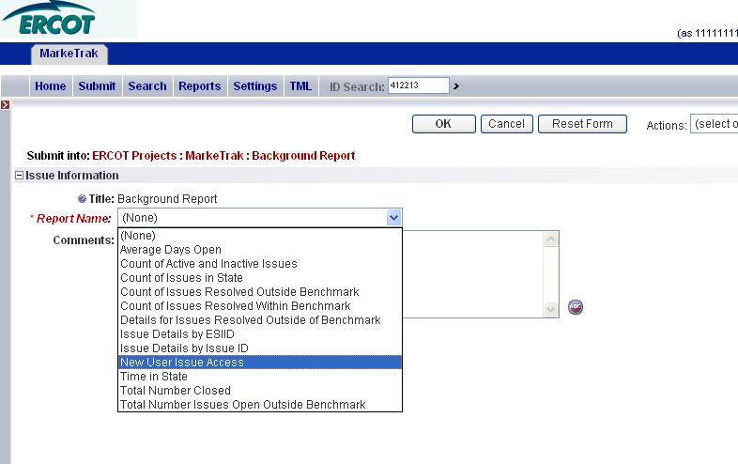

  - The user can view what information is required for a successful submission of the report under Issue Information. Select ‘Provide Parameters’ to continue. (Fig 7.1.1k)

Fig 7.1.1k
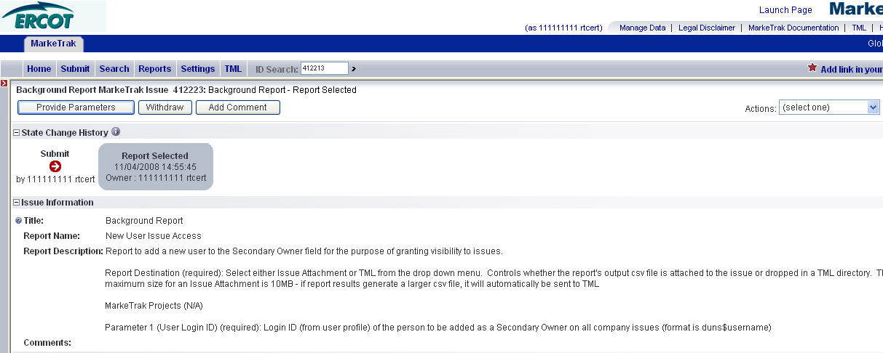

  - Select the Report Destination of the Report (TML or issue Attachment) and enter in the newly added User’s Login ID (DUNS$Employee_id) into Parameter 1 field. Select ‘OK’ to submit Parameter information. (Fig 7.1.1l)

Fig 7.1.1l
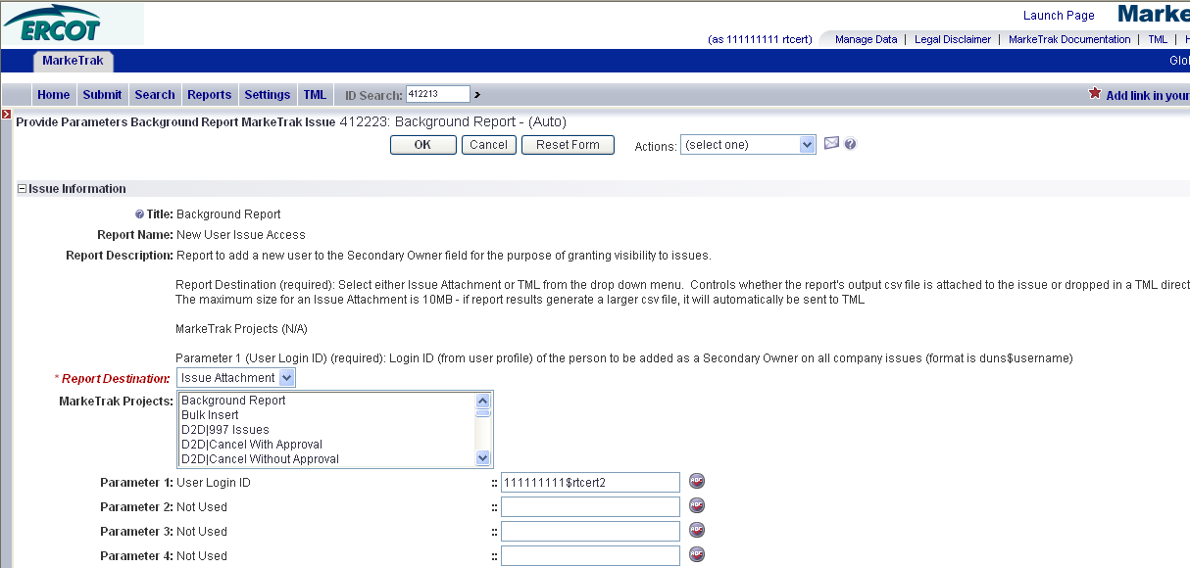

  - Select ‘Submit Report’. (Fig 7.1.1m)

Fig 7.1.1.m
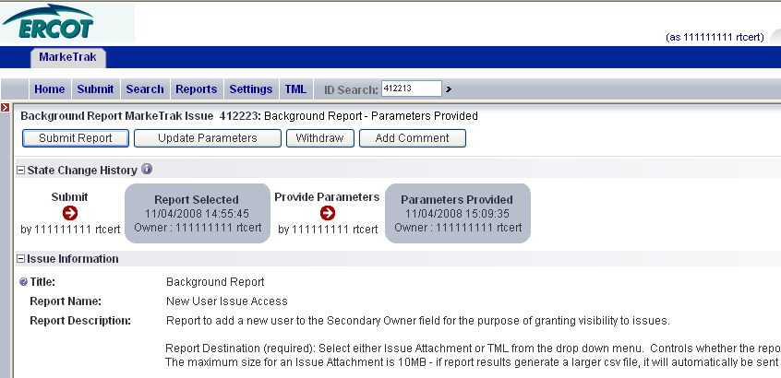

  - When the issue has been completed, the issue will be closed with the report csv file attached or posted to TML – Background Report Results Folder, whichever was chosen during submittal. The newly added user will automatically be added to the Secondary Owner to all issues prior to them gaining MarkeTrak access, therefore granting them viewing rights. (Fig 7.1.1n)

Fig 7.1.1n
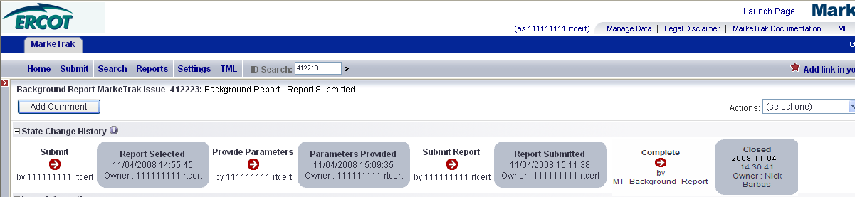

7.1.2 Editing an User
The MarkeTrak Administrator may update a user’s profile at any time. This includes the information on the General, Membership and Preference tabs. For an example, the user receives a new digital certificate and their login ID needs to be updated to reflect the new employee id.

1. The MP Administrator logs into MarkeTrak and selects the Administrator link (Fig 7.1.2a)

Fig 7.1.2a

In the new window, search for the user by user name or login id (Fig 7.1.2b)

Fig 7.1.2b
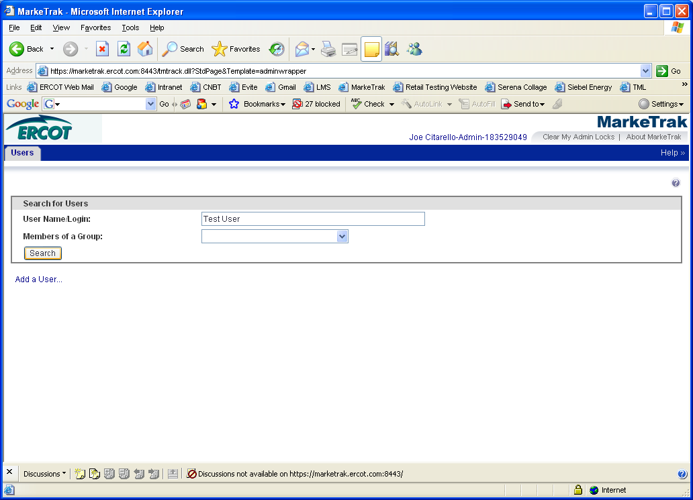

3. Highlight the user and select the Edit User link located at the bottom of the page.

Fig 7.1.2c
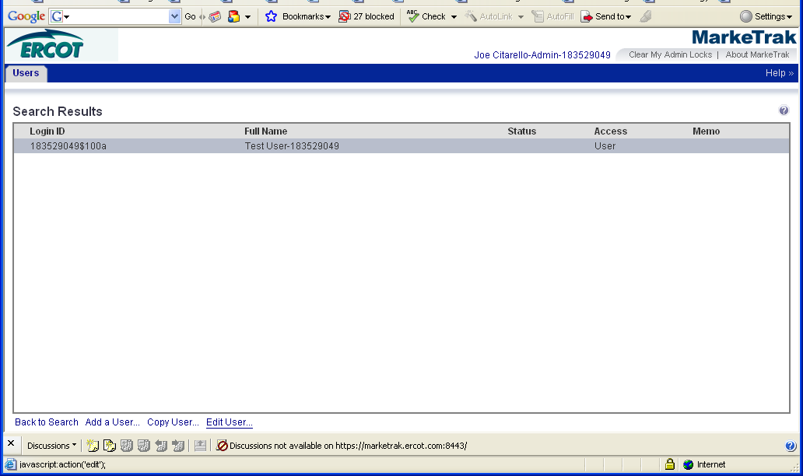

4. Any field on the General, Membership and Preference tab can be updated. (Fig 7.1.2d)

Fig 7.1.2d
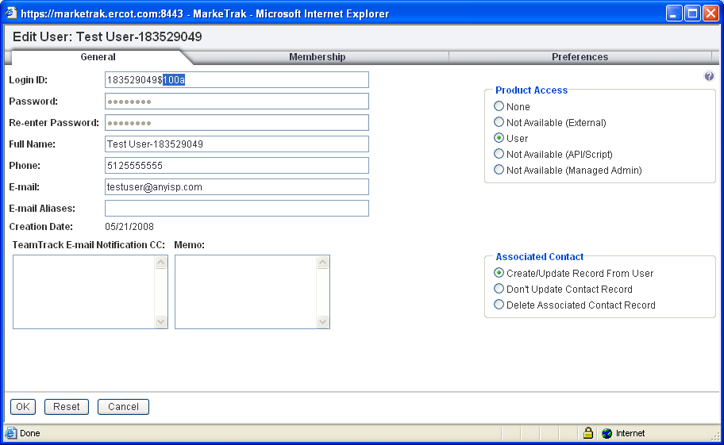

5. Once the update has been made, select OK to save the changes.

Fig 7.1.2e
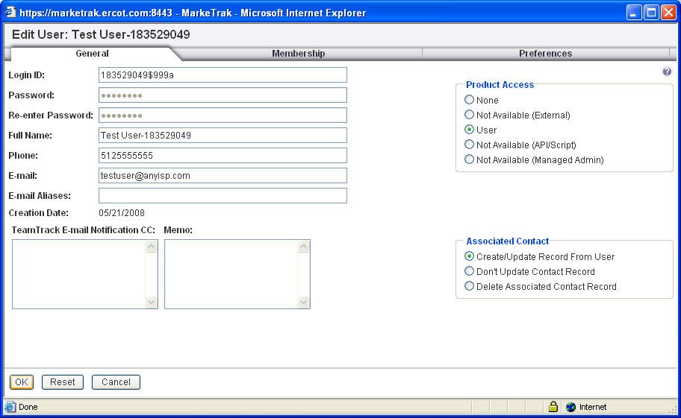

7.1.3 Copy a User
The MarkeTrak Administrator has the ability to add multiple users by using the copy user feature. This will create a new profile, which automatically populates the Membership and Preference tabs. Updates will need to be made to the General tab only.

1. The MP Administrator logs into MarkeTrak and selects the Administrator link (Fig 7.1.3a)

Fig 7.1.3a

In the new window, search for an existing user by the user’s name or login id (Fig 7.1.3b)

Fig 7.1.3b

3. Highlight the user and select the Copy User Link, located at the bottom of the page.

Fig 7.1.3c
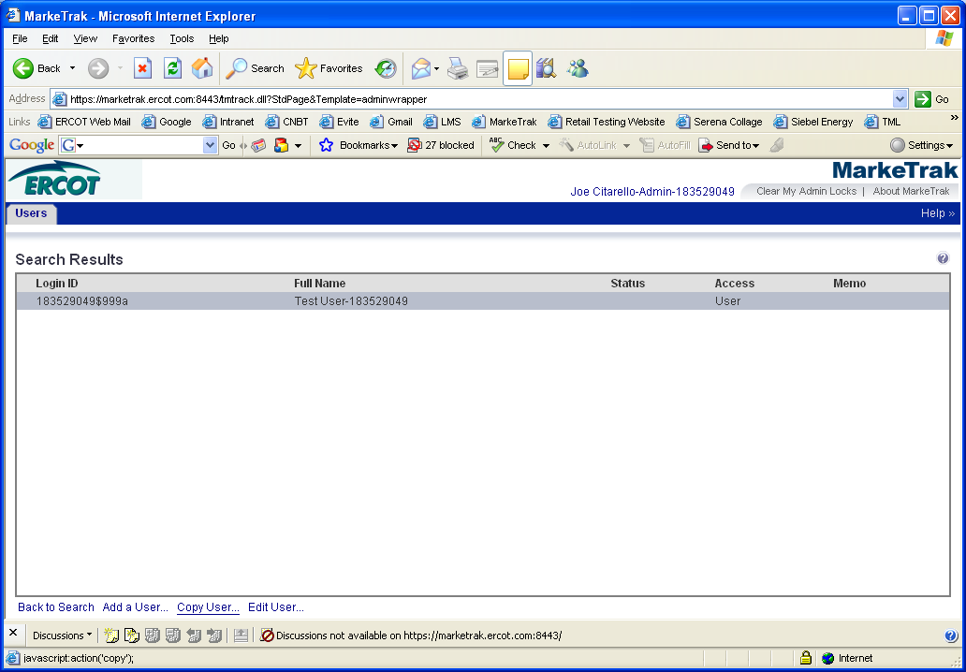

4. This will create a new profile, which automatically populates the Membership and Preference tabs. Updates will need to be made to the General tab only. Follow formatting outlined in Add a New User.

5. Once the information has been inputted on the General tab, select OK to save the changes.

7.1.4 Remove User Access
The removal of an existing MarkeTrak user’s access is a process by which the MP Administrator will remove product membership associated with their company. The user’s contact record, located in the Manage Data section of MarkeTrak, must be deleted.

Note: Extreme caution should be used when executing this process. ERCOT assistance will be required if a mistake occurs.

- The MP Administrator logs into MarkeTrak and selects the Administrator link (Fig 7.1.4a)

Fig 7.1.4a
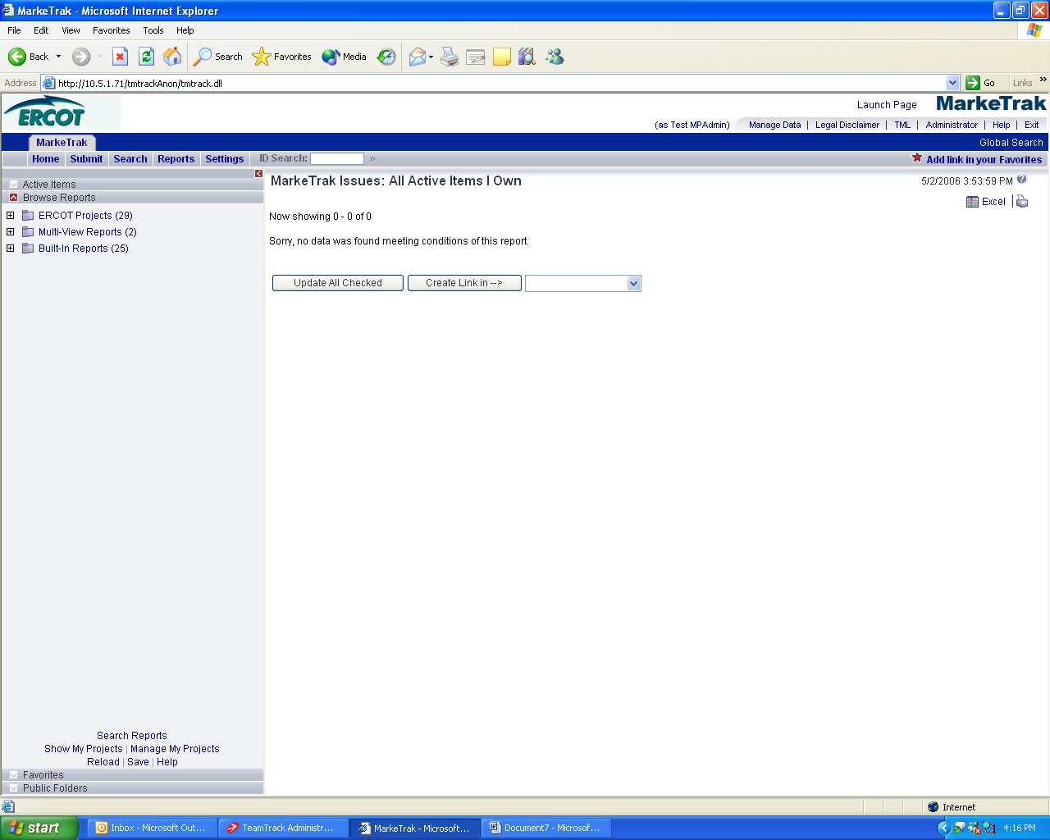

- Search for the user by either username or Login ID. (Fig 7.1.4b)

Fig 7.1.4b
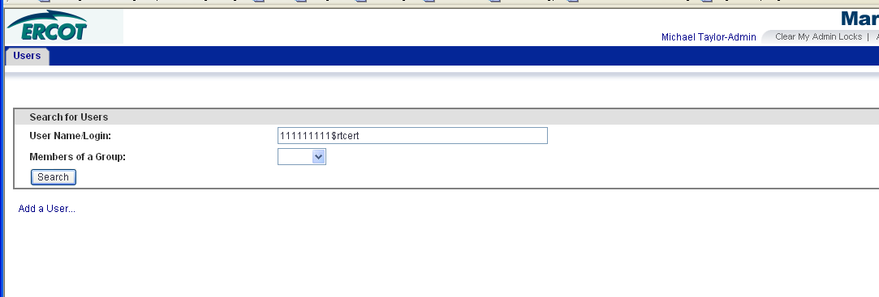

- Highlight the user and click the Edit User link. (Fig 7.1.4c)

Fig 7.1.4c
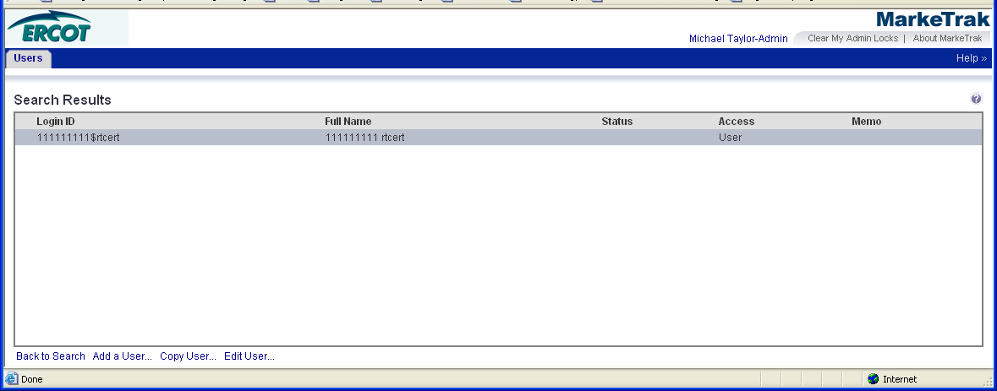

4. On the General Tab, edit the Login ID and Full Name fields and add “-DEACTIVATED” to the end of the existing text. (Leave Product Access as ‘User’ and Associated Contact as ‘Create/Update Record From User’). Once this is complete click the OK button the complete the process. (Fig 7.1.4d)

Fig 7.1.4d
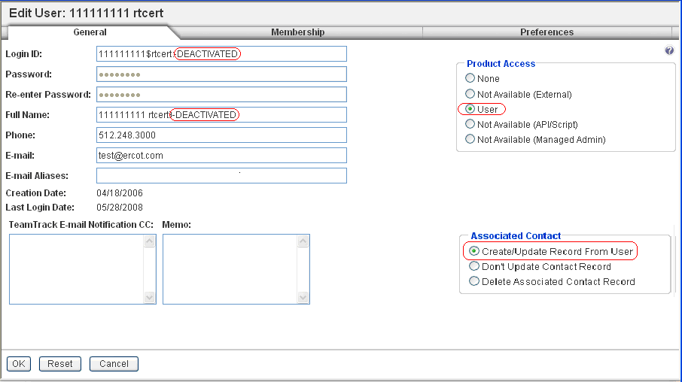

5. The user’s Status and Access will remain the same. Adding the ‘-DEACTIVATED’ text will act as the visual clue for no membership access for that user. The system will no longer allow this user access to MarkeTrak. (Fig 7.1.4e)

Fig 7.1.4e

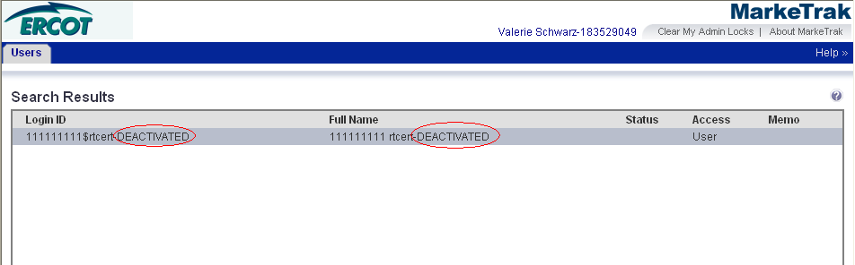

6. If the “deleted” user was assigned to a Rolodex category, the administrator must now update the Rolodex with a new contact. Please follow the steps outlined in Section 1.7 MarkeTrak Rolodex.

7.1.5 Rolodex Management

The MarkeTrak Administrator for each company is also responsible for managing the MarkeTrak Contact Rolodex, which is contained in the Manage Data section in MarkeTrak. Please follow the steps outlined in Section 1.7 MarkeTrak Rolodex to manage the following contact types.

Contact Category Issue Type Sub Type
D2D – Inadvertent = D2D Inadvertent Gain (IAG)
D2D – Safety Net = D2D NONE
D2D – Other = D2D All Besides IAG
DEV – LSE = DEV LSE
DEV – IDR & non IDR = DEV IDR Usage, Non-IDR Usage
DEV – Other = DEV All besides LSE, IDR Usage, Non-IDR Usage
LPA - Other =DEV Load Profile

It is very important to keep these records up to date since these are the recipients of the automatic notification e-mails. The timelines for these emails are outlined in Section 1.9.2

7.1.6 Administrator Change

Each Market Participant can assign individuals to act as their primary and backup MarkeTrak Administrators. To change the MarkeTrak Administrators, please follow the steps below.

1. The primary business contact for your company will need to complete the ‘MarkeTrak Administrator Change spreadsheet’

The ‘MarkeTrak Administrator Change Spreadsheet’ can be found on the MarkeTrak Information Page
http://www.ercot.com/services/client_svcs/mktrk_info/MarkeTrak_Administrator_Change_Delete_Form.xls

2. Please complete Row 10 of the ‘MarkeTrak Administrator Change Spreadsheet’ accordingly
Row Type – This is required. Each company will have one Primary MarkeTrak administrator and an optional Backup MarkeTrak Administrator.

Action – populate this field with CHANGING

Existing Administrator – If Action = CHANGING, should the existing MarkeTrak Administrator rights to be deleted or updated as a user? Please indicate DELETE or USER in this column

Primary/Backup - If PRIMARY, should be the individual chosen to be the primary MarkeTrak Administrator for your company. If BACKUP, should be the individual chosen to be the backup MarkeTrak Administrator to the Primary.

MP Type - Indicate if the MP is a CR or a TDSP

Company DUNS – This is a required field for the MarkeTrak Administrator. Only populate this field with one DUNS number.

Employee ID from Digital Certificate – This is a required field for the MarkeTrak Administrator. Employee ID field must be unique for the MarkeTrak Administrator. The Employee ID can be found on the Digital Certificate by following the steps out lined in Section 7.1.1

Employee First Name – This is a required field. Populate this field with the first name of the employee

Employee Last Name- This is a required field. Populate this field with the last name of the employee

Employee Email – This is a required field. Populate this field with the employee’s work email address

Employee Business Phone – This is a required field. Populate this field with the employee’s business phone number.

New DC Issued since 4/15/06 – Populate this field with a Y

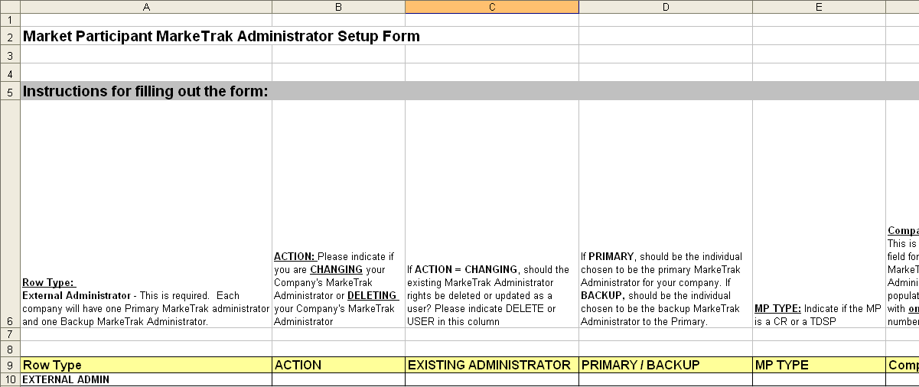

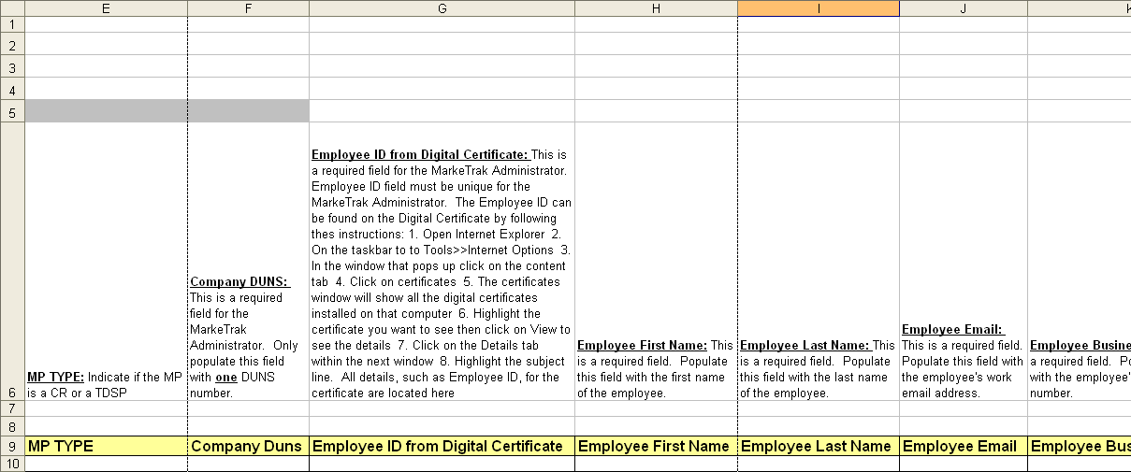
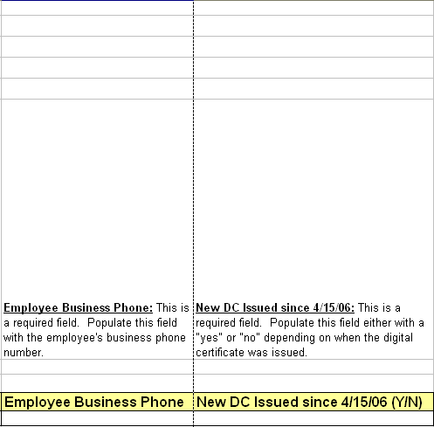

3. Send the completed ‘MarkeTrak Administrator Change Spreadsheet’ to your Retail Account Manager at ERCOT.

4. ERCOT’s MarkeTrak Administrator will make the change based off the information given in the spreadsheet.

5. Your Retail Account Manager will notify the primary business contact when the change has been made.

6. The new MarkeTrak Administrator will have Administrator rights immediately following the change.

7.1.7 Administrator Reporting Responsibilities

The MarkeTrak application contains a vast amount of reporting options. Many of the reports that a user will find useful have already been created and saved into the application. The user can also create and save ad hoc reports.

The Company’s MarkeTrak Administrator can create ad hoc reports and allow all users within that company to access these reports by selecting ‘User’ under the Privilege Category or the Administrator has the option of making them private, so that they may be the only one allowed to view them.

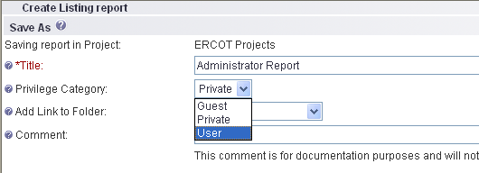

7.1.8 Clearing Administrator Locks

Administrative locks block access to certain functions that are being performed by other administrators. For example, only one administrator can edit a specific user account at once.

In the Browser Administrator, you can break your own administrative locks, but not locks of other administrators. You may establish a lock if you close the browser without clicking Exit.

If you attempt to edit a user account that is locked, you receive a message stating who is editing the item, when the lock was acquired, and why access has been denied. The name of the administrator who acquired the lock may also be available. Locks established by other administrators must be cleared by the other administrator.

Users are typically not affected by administrative locks, but if an administrator is modifying a user account, that user cannot access the User Profile page in the browser. If a browser user is editing the User Profile page, an administrator can access the user's account and the browser user loses the lock on the profile and changes the user makes the User Profile page may be lost.

To clear an administrative lock that you established:

Click the Clear My Admin Locks button located on the toolbar.
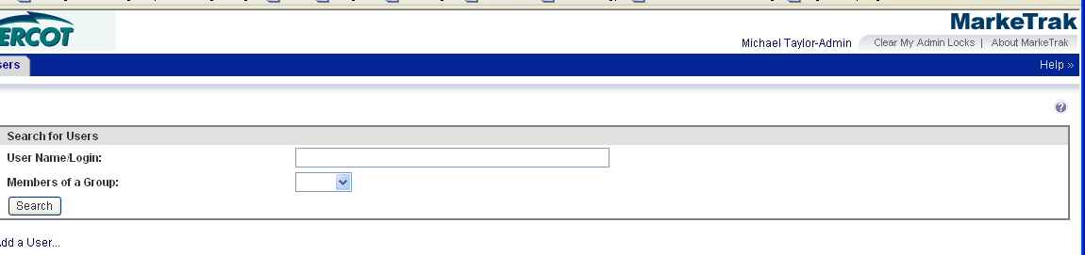
Click OK to acknowledge the warning that you will lose any changes you have not yet saved in the Browser Administrator or Administrator client.
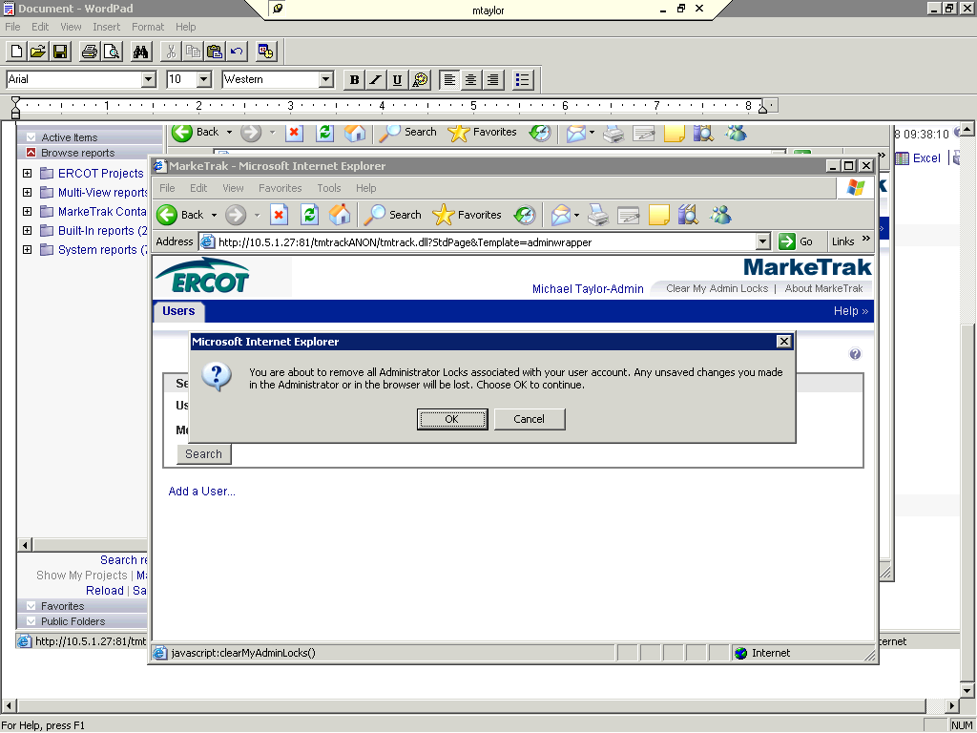
A pop-up window opens, acknowledging that your administrator locks were cleared. Close this window.

