Commercial Operations Market Guide
Section 11: Disputes and Data Extract Variances
Month XX, 2008

11. Disputes and data extract variances 1
11.1 Ercot Disputes 1
11.1.1 Overview 1
11.1.2 Settlement Calendar 2
11.1.3 Methods 2
11.1.4 How to Create a Dispute Using the Portal 3
11.1.5 Dispute Items 5
11.1.6 Valid Dispute Status 6
11.1.7 How to View a Submitted Dispute Using the Portal 7
11.1.8 Output 8
11.2 DATA EXTRACT VARIANCES 9
11.2.1 Overview 9
11.2.2 DEV Resolution Process 9

11. Disputes and data extract variances

11.1 Ercot Disputes
Section 9 of the Nodal Protocols describes the various requirements for the implementation and maintenance of the Dispute Management Process. Statement recipients in the DAM and RTM and invoice recipients for the DAM, RTM, and CRR markets are responsible for the review of their Settlement Statements and Settlement Invoices to verify the accuracy of the Settlement data used to produce the Settlement Statement and Settlement Invoice. They must submit any dispute related to the Settlement Statement or Settlement Invoice data. All communication to ERCOT and from ERCOT concerning disputes must be through either the MIS certified area or other electronic communications. The statement recipients and invoice recipients shall be able to file the dispute, create the dispute-associated activities and be able to view the progress on the dispute.

Overview
The following figure illustrates the process flow of the Dispute Management system. See Section 9.14 of protocols for information regarding the timing of disputes.

Settlement Calendar
The Settlement Calendar provides the dates by which ERCOT will post, process payments, and administer disputes for Settlement Statements and Invoices, including:
- Settlement Statements for the DAM and RTM;
- DAM, RTM, Late Fee, CRR and CARD Invoices;
It can be found in the Public Information section under Settlements.

Methods
- MIS Web Portal – The web portal utilizes the market participant’s certificate. The disputes area can be found by clicking on Markets | Settlements. From this window, you can Create Settlement Disputes or View Settlement Disputes.
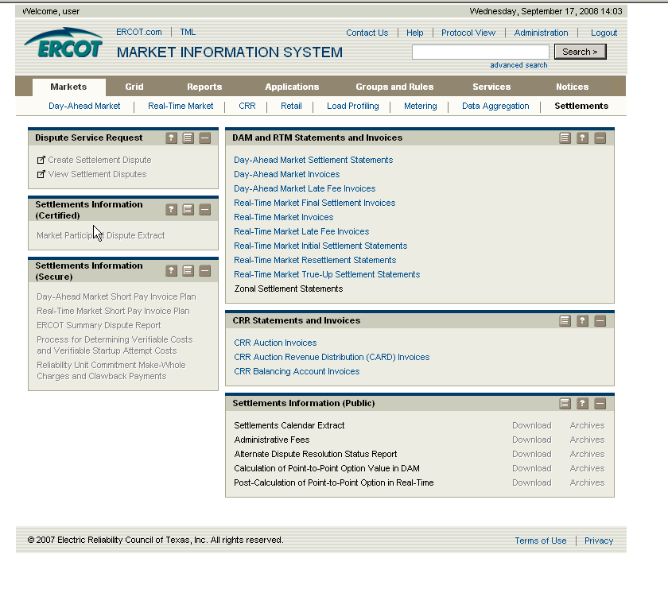

- API – The application programming interface allows you to utilize a third-party application to submit and query your disputes to and from ERCOT.

How to Create a Dispute Using the Portal
From the Settlement Dispute window, complete the required fields and then click Submit.
The Exp. Confi. Field is checked if the Expiration of Confidentially Rule is invoked. The market participant has sixty days after the date information became available to file a dispute and should ensure this flag is checked.
For disputes submitted for a range of Operating Days, if any Operating Day within the dispute is not timely according to Nodal Protocol Section 9.14.2, Notice of Dispute, then the entire dispute is not timely. For multiple Operating Days, the days must be contiguous. Multiple invoices of the same type may be disputed together on the same dispute as long as they are being disputed for the same reason and all invoice dates are within a calendar months.
Once you have entered the dispute information, click the Submit button to submit the dispute, Reset to clear the screen or Help for more information.
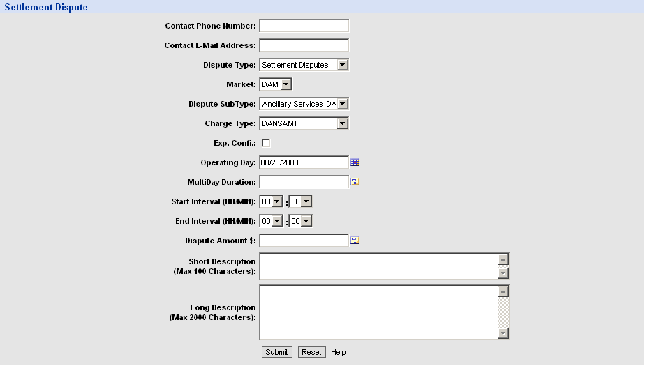
After you click Submit in the previous screen, you are able to review the dispute information, Add attachments, Withdraw Disputes, Query other disputes or add a New dispute.
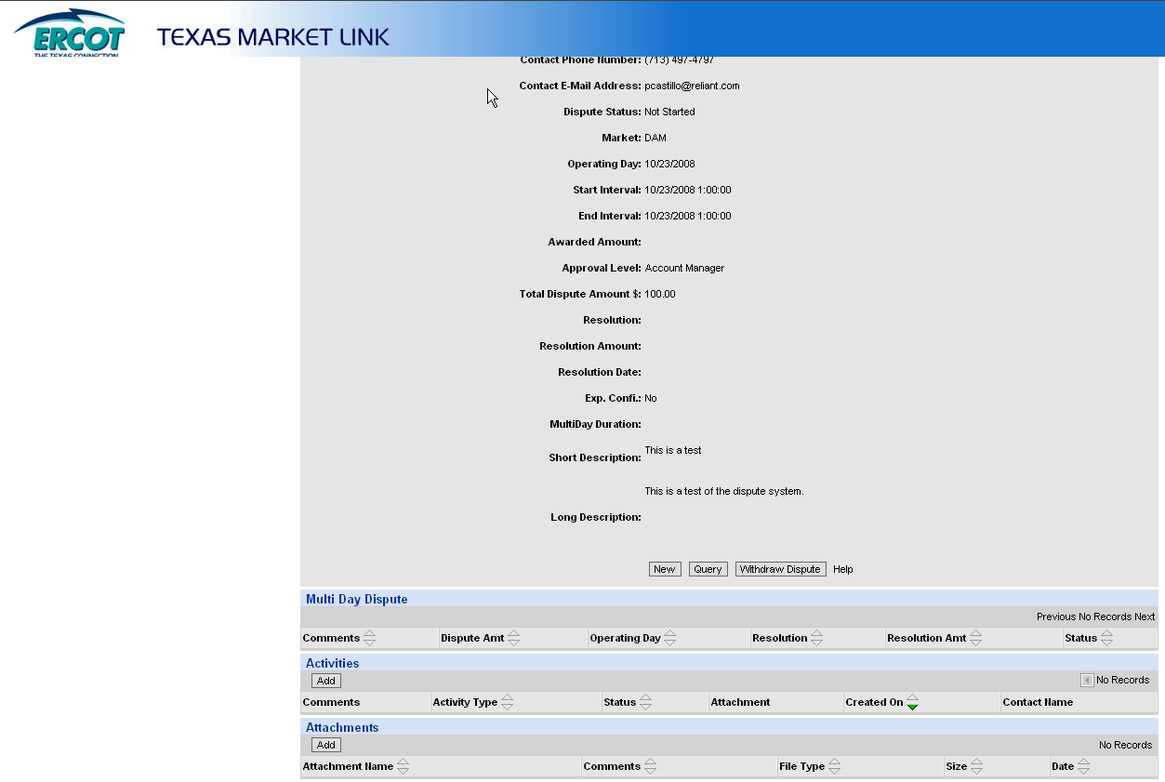
For multiple days, you are able to enter comments and dispute amounts per day.
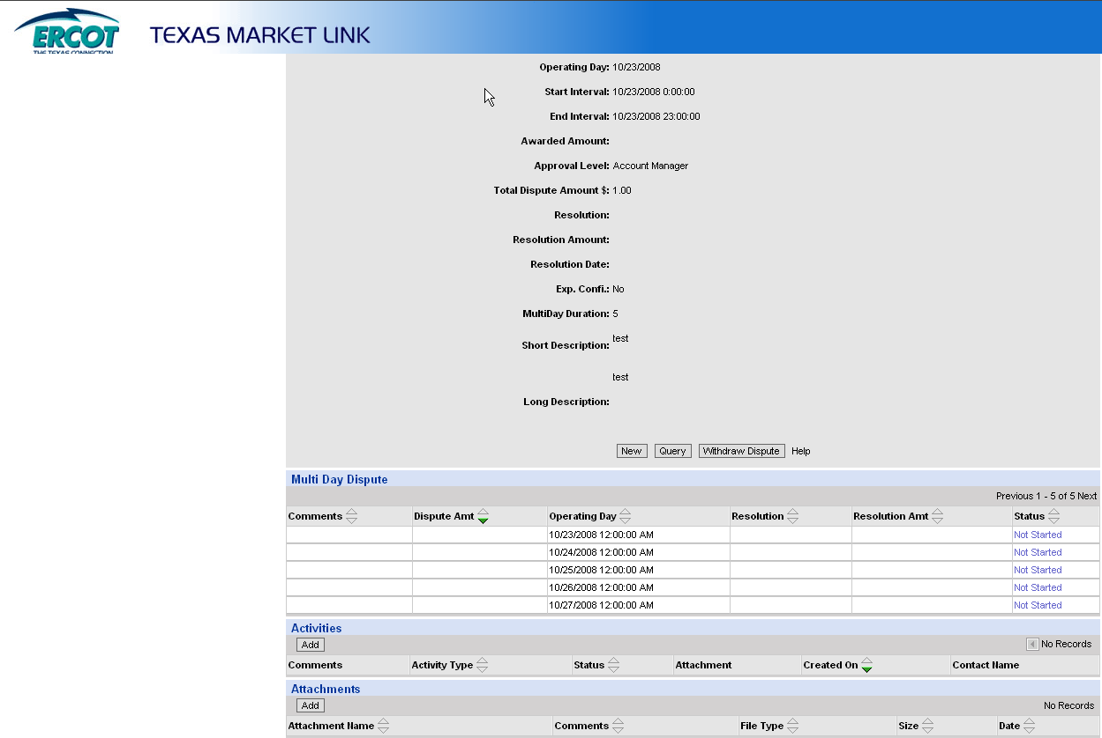

Dispute Items
The following are a list of the items that can be disputed. For invoices, the items not listed on the statements can be disputed such as interest.
- DAM Statement
- DAM Resettlement Statement
- DAM Invoice
- DAM Late Fee Invoice
- RTM Initial
- RTM Final
- RTM Trueup
- Any RTM Resettlement issued after the RTM Trueup
- RTM Invoice
- RTM Uplift Invoice
- CRR Auction Invoice
- CARD Invoice
- CRR Balancing Account Invoice

Valid Dispute Status
An automatic notification will be sent to the disputing entity if there is a change in the dispute resolution or dispute status.
- Not Started – The initial status of the dispute when it is submitted to ERCOT.
- Rejected – The dispute is not timely and is rejected by ERCOT.
- Open – ERCOT has begun to work on the issue.
- Withdrawn – Market Participant withdraws the dispute.
- Granted – ERCOT grants the dispute and the adjustments display on the next Settlement Statement for the operating day.
- Granted with Exceptions – ERCOT grants a partial adjustment of the disputed amount. The Market Participant is notified of the exception(s).
- Denied – ERCOT rejects the dispute. An automatic notification will be sent to the disputing Market Participant.
- ADR – The Market Participant begins the ADR process once ERCOT has denied a dispute.
- Closed – The dispute has been resolved.

How to View a Submitted Dispute Using the Portal
The Find Nodal Settlement Dispute screen allows you to enter the search criteria for a submitted dispute. You can search by dispute ID or other criteria. Click the Find button once you have entered your search criteria. Click the Reset button to clear the fields. For more information on how to use the window, click the Help button.
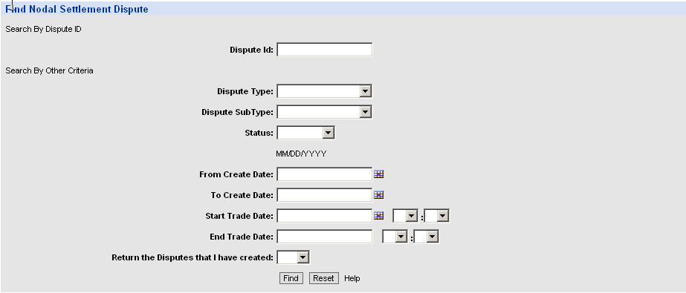

After clicking the Find button in the previous screen, disputes based on your search criteria are displayed. From this screen, you can click on the Dispute ID to view, update or withdraw the dispute. You can also create a new dispute by clicking the New button, or go back to the Find Nodal Settlement Dispute screen by clicking the Query button.
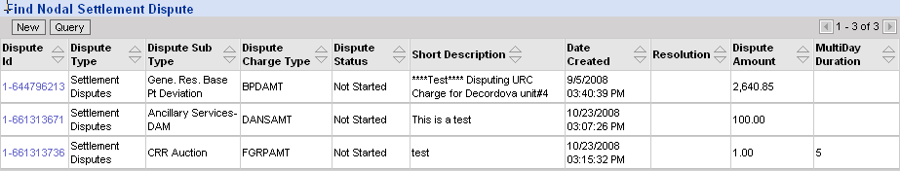

After clicking the Dispute ID, you are able to review the dispute information and Add attachments, Withdraw Disputes, Query other disputes or add a New dispute.

Output
ERCOT will post to the MIS two dispute extracts:
- Certified Dispute Extract – This extract provides QSEs and CRRs with the current status of all disputes that are not closed or withdrawn, and all disputes closed or withdrawn within the last 120 days.
- Secure Dispute Extract – This extract is a summary by charge type with cumulative total by operating day and status and resolution and count of disputes and market type (DAM, RTM). For granted & granted with exception, these will ‘roll off’ once the status changes to ‘CLOSED’ or ‘Withdrawn’.

DATA EXTRACT VARIANCES

Overview
The Data Extract Variance or “DEV” is a type of MarkeTrak used to assist in the expedited resolution of ESI ID level data variances between ERCOT and market participant systems. The DEV should only be utilized after transactions have been attempted by comparing the ERCOT 727 Data Extract and the Market participants internal system. Manual intervention will only be accepted after all other resolution paths have been exhausted. The five main DEV categories are as follows:
- DEV LSE
- DEV Characteristics
- DEV Existence
- DEV IDR Usage
- DEV NON-IDR Usage

Once a market participant has determined that there is a variance between the data extract provided by ERCOT and the market participant’s system, the market participant may seek correction of that variance by submitting a variance resolution request through the ERCOT MarkeTrak System (i.e. DEV). This system is the tool used by market participants for communications concerning variances. For more information on processing variances, please go to: http://www.ercot.com
- Select Services
- Select Client Services
- Select MarkeTrak Information
- Select MarkeTrak Users Guide

If a variance submitted according to the ERCOT MarkeTrak user manual is not resolved prior to the true-up settlement, a market participant may seek correction of the ESI ID service history, usage information and resettlement pursuant to the provisions of Protocols Section 20, Alternative Dispute Resolution Procedure. The variance deadline calendar for true-up settlements can be located by going to: http://www.ercot.com

- Select Market Information
- Select Settlements
- Select True Up Settlement and Variance Request Calendar

DEV Resolution Process
Per the 10-16-2003 RMS directive, a 75 calendar day deadline for completion of each issue will be implemented. Each MP (including ERCOT) will complete the DEV process in accordance with the timelines and other requirements of the DEV manual. Variance must be submitted at least 75 calendar days prior to the scheduled True-Up settlement/resettlement to allow the full 75 calendar day resolution period for the various parties Variances submitted in less than 75 calendar days from the scheduled resettlement of the True-Up settlement/resettlement may not be fully resolved prior to the True-Up settlement/resettlement. For more information regarding turnaround deadlines for DEV issues, please refer to MarkeTrak users guide section 11.3 (page 118).
DEV issues will be resolved through manual corrections in ERCOT systems. The MP will be notified by a MarkeTrak update and/or by email notification of the manual correction when the update is complete.

