ERCOT Operations Report
December 2008 ROS & OWG

Frequency Control
Time | Freq(Hz) | Duration (s)
12/1/2008 23:20 | 59.88 | 2 | Multiple Unit trips with 456 MW online
12/2/2008 6:33 | 60.10 | 12 | SCE changed +500 in 3 mins, steel mill load drop 170 MW in 1 min
12/6/2008 6:30 | 59.88 | 52 | Unit trip with 800 MW
12/6/2008 7:38 | 59.87 | 35 | Unit trip with 553 MW
12/14/2008 1:23 | 59.88 | 4 | Unit trip with 340 MW
12/15/2008 5:43 | 60.10 | 144 | SCE changed +730 MW in 5 mins
12/15/2008 5:47 | 60.10 | 356 | SCE change +340 MW in 3 mins
12/15/2008 21:59 | 59.89 | 172 | Incorrect offset
12/16/2008 15:45 | 59.70 | 145 | Multiple unit trips with 1576 MW
12/17/2008 17:57 | 59.89 | 4 | Unit trip with 300 MW
12/17/2008 18:00 | 59.89 | 88 | Unit trip with 800 MW
12/18/2008 7:05 | 59.88 | 12 | Unit trip with 800 MW
12/18/2008 22:01 | 60.10 | 156 | SCE change + 870 MW in 5 mins, Steel Mill Load drop 90 MW in 30 secs
12/28/2008 13:47 | 59.86 | 78 | Unit trip 800 MW
12/29/2008 6:07 | 60.10 | 151 | Out of down regulation. Balancing energy schedule change of 3000mw. Base Power schedule increase of 3400 MW
Note: Time of frequency excursions outside the range of +/- 0.1 Hz.
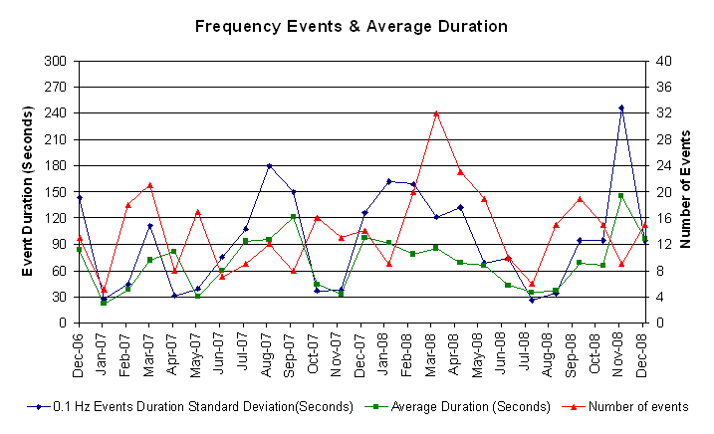

Deployed Responsive (Reported Above)
Time deployed | Stop Time | Duration | Max | Details
12/01 23:20:38 | 12/01 23:35:46 | 0:15:08 | 463.52
12/06 06:30:49 | 12/06 06:48:12 | 0:17:23 | 583.29
12/06 07:38:00 | 12/06 07:58:29 | 0:20:29 | 682.25
12/13 22:58:21 | 12/13 23:07:38 | 0:09:17 | 348.94 | SCE -600 in 3 mins
12/14 01:23:07 | 12/14 01:46:38 | 0:23:31 | 453.11
12/15 21:59:42 | 12/15 22:21:05 | 0:21:23 | 479.15
12/16 15:45:35 | 12/16 16:34:42 | 0:49:07 | 1276.00
12/17 17:57:21 | 12/17 18:24:56 | 0:27:35 | 557.27
12/17 19:03:08 | 12/17 19:14:40 | 0:11:32 | 333.33 | SCE -400 in 4 mins
12/17 23:59:49 | 12/18 00:13:49 | 0:14:00 | 364.56 | SCE -660 in 4 mins
12/18 05:15:47 | 12/18 05:27:57 | 0:12:10 | 322.9 | SCE -480 in 16 mins & Out of Up Reg at 5:10
12/18 07:05:55 | 12/18 07:17:08 | 0:11:13 | 432.26
12/18 10:44:22 | 12/18 10:56:51 | 0:12:29 | 328.1 | Wind OOME down
12/19 21:59:45 | 12/19 22:17:43 | 0:17:58 | 322.9 | SCE -800 in 10 mins, Steel mill load pickup of 120 MW in 1 min
12/20 10:32:47 | 12/20 10:42:51 | 0:10:04 | 343.74 | Unit trip, STLF was 1800 lower
12/28 13:47:20 | 12/28 13:47:20 | 0:00:00 | 1046.8

Day-Ahead OOMC and RMR Capacity Purchases
Details | OOMC | RPRS S1 | RPRS S2 | Total
W RIO | 94 | 13 | 0 | 107
DFW | 22 | 2 | 10 | 34
North | 7 | 10 | 15 | 32
Houston | 0 | 1 | 31 | 32
Western | 3 | 4 | 18 | 25
Austin | 8 | 1 | 14 | 23
Northeast | 0 | 0 | 20 | 20
Laredo | 0 | 14 | 0 | 14
South | 0 | 10 | 0 | 10
E RIO | 2 | 6 | 0 | 8
San Antonio | 0 | 0 | 5 | 5
Corpus | 0 | 1 | 0 | 1
Bryan Area | 0 | 0 | 0 | 0
 | 136 | 62 | 113 | 311

Historical Totals | Dec-07 | Nov-08 | Dec-08
Austin | 10 | 11 | 23
Bryan Area | 0 | 0 | 0
Corpus | 0 | 0 | 1
DFW | 13 | 15 | 34
E RIO | 3 | 8 | 8
Houston | 8 | 4 | 32
Laredo | 47 | 3 | 14
North | 10 | 2 | 32
Northeast | 2 | 2 | 20
San Antonio | 3 | 10 | 5
South | 0 | 6 | 10
W RIO | 39 | 65 | 107
Western | 48 | 14 | 25
Total | 183 | 140 | 311

http://www.ercot.com/mktinfo/services/rprsdr/index.html
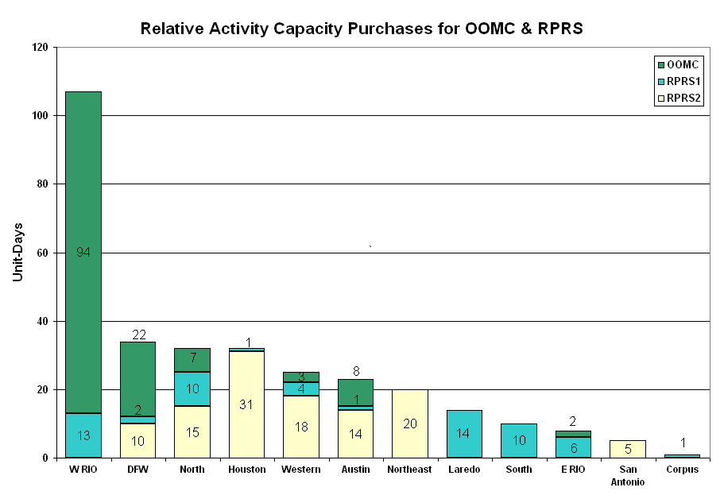
OOME and Congestion Management Activity
Congestion affected by outages
Remedial action plan has been developed for the element
Contingency | Overloaded Element | Days
Aspermont – Spur 138 kV | Jayton – Spur 69 kV | 24
Menard - Gillespie 138KV | Menard 138/69KV transformer 1 | 17
Sandow - Austrop 345KV | Sandow Switch - Elgin Switch 138KV | 11
Dilley Switch - San Miguel 138KV | Derby Switch - Pearsall 69KV | 11
Golden Switch - Bluff Creek Switch 138KV | Sun Switch - Snyder 138KV | 7
Oasis - PH Robinson 345KV | Garrott - Midtown 138KV | 6
STP - Hillje and Whitepoint 345KV | Blessing - Lolita 138KV | 6
South Channel - Jefferson 138KV | Crown - Galena Park / Jefferson 138KV | 5
Odessa EHV - Morgan Switch & Quail Switch 345KV | Big Spring - Big Spring West 138KV | 4
Sun Switch - Scurry Switch | Girard tap - Spur 69KV | 4
Comanche Peak - Venus 345KV | Comanche Peak - Decordova 345KV | 3
STP - White Point 345KV | Blessing - Lolita 138KV | 3
Jack County - Reno 138KV | Bowie TMPP 138/69KV autotransformer | 3
Austrop 345/138KV Auto #2 | Austrop 345/138KV Auto #1 | 2
Moss Switch - Holt Switch 138KV | Odessa North - North Cowden 69KV #1 | 2
Quail Switch - Odessa EHV 345KV | Big Spring Switch - Big Springs West 138KV | 2
Moss Switch - Holt Switch 138KV | Odessa North 138/69KV autotransformer #1 | 2
North Denton 138/69 kV auto #1 | North Denton 138/69 kV auto #2 | 2
Elgin Switch - Gilleland Creek 138KV | Elgin Switch to Taylor 138KV | 2
Collin - Anna Switch 345KV | Anna Switch 345/138KV transformer | 2
Watermill Switch - Desoto Switch and Cedar Hill Switch 345KV overloads | West Levee 345/138KV autotransformer 2 | 2
West Levee 345/138KV autotransformer 1 | West Levee 345/138KV autotransformer 2 | 2
Sun Switch - Golden Switch 138KV | Ackerly Vealmoor Switch - Ackerly 69KV | 2
Jewett - TH Wharton 345KV | Menard - San Angelo Power Plant 138KV | 2
Santa Anna - Ballinger 138KV | Ballinger - Humble Ballinger 69KV | 2
Scurry Switch - Spur 138KV | Jayton - Spur 69KV | 1
Sandow - Austrop 345KV | Ridge - Watson Chapel 138KV | 1
Cagon - Calavers - Braunig 345KV | Hill Country - La Sierra 138KV | 1
Gibbons Creek - Roans Prairie and Tomball - Jewett 345KV | Garrott - Midtown 138KV | 1
Austrop - Sandow 345KV | Temple Switch - Bell County Switch | 1
Jewett - TH Wharton and Tomball 345KV | Lake Creek - Temple Switch 345KV | 1
Tradinghouse - Venus Switch 345KV | Bosque Switch - Rogers Hill TU 138KV | 1
Laredo VFT - Crestonio 138KV | North Laredo - Asherton 138KV | 1
Wolf Hollow - Rocky Creek 345KV | Comanche Peak - Decordova 345KV | 1
Tri Corner - Watermill 345KV | Richland Chambers - Big Brown 345KV | 1
San Miguel Switchyard 345/138KV autotransformer "A" | San Miguel Switchyard 345/138KV autotransformer "B" | 1
South Texas Project - Hillje & Elm Creek 345KV | Blessing - Lolita 138KV | 1
Enterprise - Trinidad - Martin Lake - Stryker Creek 345KV | Nacogdoches 345/138KV autotransformer 1 | 1
Graham - Long Creek 345KV | Abilene - Potosi 138KV | 1
Decker - Sprinkle and Dessau to Daffin 138KV | Decker - McNeil 138KV | 1
West Columbia Main - Sweeny Cogen 138KV | West Columbia Main - West Columbia 138KV | 1
Snyder - China Grove 138KV | Snyder - Scurry Santa Fe 69KV | 1
West Columbia - Angleton 138KV | West Columbia - Pledger 138KV | 1
Austrop - Sandow 345KV | Killeen Fort Hood West - Killeen Clark Road 138KV | 1
Garfield - Onion and Hicross 138KV | Lytton Springs - Pilot Knob 138KV | 1
Austrop 345/138KV autotransformer #2 | Austrop 345/138KV autotransformer #1 | 1
San Miguel Switch - Dilley Switch 138KV | Leaky - Campwood 69KV - 105% | 1
Dilley - North Laredo 138KV | North Laredo - Asherton 138KV | 1
Morgan Creek SES - Longshore Switching Station 345KV | Lamesa - Paul Davis Tap 138KV | 1
Abilene - Mulberry Bluff Creek 345KV | Oak Creek - Nicole 138KV | 1

Zonal OC1
CSC | Days
West-North | 20

New RAP (Date indicates last update of RAP not implementation date.)
None

New Procedures/Forms/Operations Bulletins
Date | Subject | Bulletin No.
12/19/2008 | Operating Period Desk V 2 Rev 24 | 397
12/19/2008 | Shift Supervisor Desk V 3 Rev 53 | 396
12/19/2008 | Day-Ahead Desk V 3 Rev 38 | 395
12/19/2008 | Transmission & Security Desk V 3 Rev 98 | 394
12/19/2008 | Frequency Control Desk V 3 Rev 72 | 393

Blackout/Load Shed Incidences
None

EECP
None

Major System Voltage Problems
None

Major Computer Problems, Enhancements & Fixes

12/08 15:10 ERCOT held the deployments for IE 15:15 and resumed with the deployments for IE 15:45.

Communication
None

ERCOT peak (Unofficial)
12/15 20:00 47,748 MW

Yearly MTLF Error Comparison
Yearly Mid-Term (Hourly) Load Forecast Error Comparison for the ERCOT Forecast
Month | MAPE for MTLF at 16:00 Day-Ahead
Month | 2005 | 2006 | 2007 | 2008
January | 5.02 | 4.79 | 4.55 | 3.30
February | 3.47 | 4.81 | 3.75 | 3.59
March | 3.41 | 4.95 | 2.70 | 3.29
April | 3.37 | 5.59 | 3.00 | 2.45
May | 4.21 | 3.59 | 3.22 | 3.01
June | 3.91 | 2.65 | 4.46 | 2.81
July | 5.22 | 2.62 | 4.29 | 2.55
August | 4.86 | 2.09 | 3.11 | 3.66
September | 6.24 | 4.03 | 3.78 | 4.99
October | 4.51 | 3.63 | 3.08 | 2.79
November | 4.53 | 3.28 | 2.95 | 2.60
December | 5.95 | 3.44 | 3.74 | 4.54
Annual Average | 4.56 | 3.79 | 3.55 | 3.18

OCN, Advisory, Alerts & Emergency Notices
Capacity
Date | Start | End | Event
12/1/08 | 17:57 | 20:00 | NSRS deployed in Houston, North, and South zones for depletion of UBES.
12/1/08 | 18:01 | 20:00 | NSRS deployed in West zone for depletion of UBES.
12/2/08 | 4:00 | 6:50 | Alert issued for projected capacity shortage for HE 07:00 - 08:00.
12/2/08 | 2:45 | 6:50 | OCN issued for projected capacity shortage for HE 07:00 - 08:00.
12/6/08 | 1:02 | 11:45 | Advisory issued for ARR below 3000 MW.
12/6/08 | 19:38 | 22:55 | Advisory issued for ARR below 3000 MW.
12/6/08 | 4:50 | 11:00 | NSRS deployed all in zones for depletion of UBES.
12/6/08 | 8:35 | 10:00 | OCN issued for projected capacity shortage for HE 10:00.
12/9/08 | 15:46 | 21:00 | Alert issued for projected capacity shortage for HE 18:00 - 21:00.
12/9/08 | 15:03 | 15:45 | OCN issued for projected capacity shortage for HE 18:00 - 21:00.
12/10/08 | 7:04 | 12:40 | Advisory issued for ARR below 3000 MW.
12/10/08 | 16:50 | 22:00 | Advisory issued for ARR below 3000 MW.
12/10/08 | 17:42 | 21:00 | NSRS deployed in West and Houston zones for depletion of UBES bids.
12/10/08 | 17:46 | 21:00 | NSRS deployed in South and North zones for depletion of UBES bids.
12/10/08 | 7:00 | 11:38 | OCN issued for projection of insufficient UBES bids for HE 11:00 - 15:00.
12/11/08 | 6:40 | 9:00 | Advisory issued for ARR below 3000 MW.
12/12/08 | 5:13 | 6:11 | Advisory issued for ARR below 3000 MW.
12/12/08 | 6:32 | 7:42 | Advisory issued for ARR below 3000 MW.
12/13/08 | 0:38 | 14:32 | Advisory issued for ARR below 3000 MW.
12/13/08 | 3:51 | 14:32 | Alert issued for projected capacity shortage for HE 0900, 1100, and 1900 - 2100.
12/13/08 | 1:30 | 3:51 | OCN issued for projected capacity shortage for HE 0900 - 1200 and 1900 - 2100.
12/15/08 | 5:07 | 14:29 | Advisory issued for ARR below 3000 MW.
12/15/08 | 14:57 | 0:00 | ERCOT issued an advisory for freezing precipitation across the ERCOT Region.
12/15/08 | 5:24 | 9:12 | Alert issued for ARR below 2500 MW.
12/15/08 | 7:28 | 9:12 | Alert issued for projected capacity Insufficiency for HE 1100 - 2400.
12/15/08 | 5:24 | 7:15 | NSRS was deployed in all zones for ARR below 2500 MW.
12/15/08 | 17:54 | 21:00 | NSRS was deployed in all zones for depletion of up balancing energy bids.
12/15/08 | 3:18 | 9:12 | OCN issued for projected capacity Insufficiency for HE 1100 - 2400.
12/15/08 | 16:50 | 20:45 | OCN issued for projected capacity Insufficiency for HE 1900 - 2000.
12/16/08 | 6:55 | 9:10 | Advisory issued for ARR below 3000 MW.
12/16/08 | 16:47 | 22:25 | Advisory issued for ARR below 3000 MW.
12/16/08 | 0:15 | 24:00 | ERCOT issued an advisory for freezing precipitation across the ERCOT Region.
12/16/08 | 2:45 | 14:45 | OCN issued for insufficient balancing energy bids for HE 0800 - 1300 and HE 1900 - 2000.
12/17/08 | 18:01 | 20:00 | Advisory issued for ARR below 3000 MW.
12/17/08 | 0:15 | 9:10 | ERCOT issued an advisory for freezing precipitation across the ERCOT Region.
12/18/08 | 7:11 | 9:32 | Advisory issued for ARR below 3000 MW.
12/21/08 | 11:00 | 0:00 | OCN issued for anticipated freezing temperatures expected to impact the ERCOT region through tomorrow morning.
12/22/08 | 0:15 | 13:00 | OCN issued for anticipated freezing temperatures expected to impact the ERCOT region through tomorrow morning.
12/26/08 | 18:30 | 21:00 | Advisory issued for ARR below 3000 MW.
12/27/08 | 18:50 | 21:10 | Advisory issued for ARR below 3000 MW.
12/28/08 | 17:50 | 23:00 | Advisory issued for ARR below 3000 MW.
12/28/08 | 18:26 | 21:45 | Alert issued for ARR below 2500 MW.
12/28/08 | 18:21 | 21:00 | NSRS deployed in all zones for Alert for ARR below 2500 MW.

Transmission

12/05 11:00 Transmission Alert issued for Northwest Texas Cheyenne – No Trees Switch 138 kV due to forced outage.

12/09 14:07 Transmission Alert issued for the Turkey and Turkey Lighthouse areas due to a forced transmission outage. Block Load Transfer (BLT) was implemented with 2 MW of ERCOT load picked up by Southwest Power Pool (SPP).

Texas RE Event Analysis

12/01 23:20 One 138 kV bus tripped due to burnt switch and simultaneous loss of three generating units.

12/02 18:30 SPS at Stanton Wind Energy Center Activated.

12/14 19:15 SPS at Golden Switch Activated.

12/14 20:30 SPS at Stanton Wind Energy Center Activated.

12/16 15:45 Potential DCS event due to loss of multiple units and one 345 kV line.

12/19 16:00 Loss of 345 kV bus (Temple Switch) and a 345/138 kV transformer caused three 345 kV lines to be opened.

12/30 7:14 McDonald Road Switching Station SPS Activated.

12/30 7:14 Drumright Switch SPS Activated.

Other

12/02 06:45 Held Real-time Balancing Market IE 06:45 resumed with IE 07:15.

