Adjusted Capacity Monitor

Background
With the increase in wind power capacity, and since wind power is not as steady as other sources of energy, it is increasingly important that ERCOT grid operators have an accurate view of the current and forecasted wind generation and its impact on regulation.

To address this need, in the Zonal EMS an Excel based tool was developed. The tool gathers various data from the Zonal Market System and the wind power forecast from the Wind Power (AWS Truewind) web services to displays aggregated, system wide results to the operator. A snippet of the Zonal spreadsheet is shown in Figure 1.

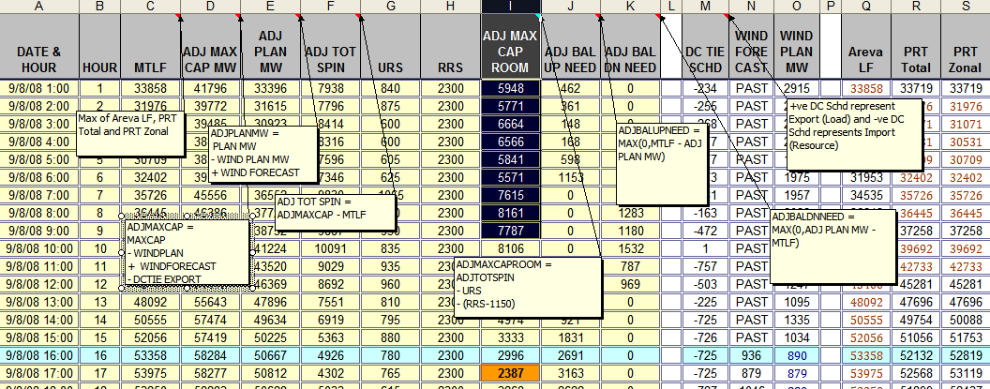
Figure 1: Zonal MAI

Among the multiple spreadsheet columns, the main one is the column (I) that for each hour of the current operating day compares the capacity of committed resources against its various uses, and alerts the operator via a change in color, when the capacity is low. In graphical form, when translated to the Nodal situation, the capacity comparison looks as shown in Figure 2 below.

Figure 2: Adjusted Capacity vs. Obligations

The term adjusted is to reflect the fact that wind power forecast is being updated with the latest information, while the total capacity is as used in DAM; also the adjustment is made to account for the extra load on the ties (when exporting), or extra capacity (when importing).

The Zonal EMS tool is named Market Analyst Interface (MAI, currently the name is Adjusted MAI), to reflect the major source of data, Market Operating System. This name does not really reflect the function as much as the source of data. Since the source will be altered in the Nodal project, the name is only significant for legacy reasons, and thus in this note it will be used as an acronym, MAI.

In order to facilitate the translation of this functionality into the Nodal environment, and adhere to the Nodal Program processes, a request to the Nodal Change Control Board was made with the justification as follows:

A new integrated MAI interface should be developed in Nodal to replace the existing solution which uses MS Excel.

It should be noted that the interface part from the CCB request refers to the user interface, as the data interface infrastructure required to bring the needed data already exists within the EMS.

EMS Nodal Team

November 21, 2008

