Commercial Operations Market Guide
Section 12: Renewable Energy Credits (RECs)
Month XX, 2008

12. RENEWABLE ENERGY CREDITS (RECS) 1
12.1 Purpose and History 1
12.1.1 PUCT 1
12.1.2 Renewable Resource Generation 1
12.1.3 Renewable Energy Credit (REC) Program Overview 2
12.1.4 Renewable Energy Credit (REC) Attributes and Uses 2
12.1.5 Renewable Energy Credit (REC) Offsets 3
12.2 Determining REC Requirements for Competitive Retailers 3
12.2.1 Timing for Notification of Final REC Requirement (FRR) and Mandatory Retirement 3
12.2.2 ERCOT Reporting to the PUCT and PUCT Penalties and Enforcement 3
12.2.3 Process for Determining REC Requirements for Competitive Retailers 3
12.2.4 Public Data 4
12.3 Texas REC System Functionality 5
12.3.1 REC Account Holder Assistance 5
12.3.2 REC Website 5

12. RENEWABLE ENERGY CREDITS (RECS)
The ERCOT Protocols address the State of Texas Renewable Energy Credit Trading Program in Section 14.
In support of the State of Texas’ goals related to installation of generating capacity from renewable energy technologies, ERCOT administers the Renewable Energy Credit (REC) program. As part of the REC program each Competitive Retailer (CR) with load in ERCOT is assigned an annual REC requirement.

12.1 Purpose and History
The State of Texas’ Renewable Energy Credit Trading Program was developed as a result of legislative action in Senate Bill 7, Texas Electricity Energy Restructuring. The objective of this part of the Bill was to increase the capacity of renewable resource generation in Texas to 2,880 MWs by the year 2009 from an already existing 880 MWs.
The State of Texas’ Renewable Energy Credit Trading Program was extended and expanded on September 1, 2005 as a result of legislative action in Senate Bill 20. This bill increased the goal of capacity of renewable resource generation in Texas to 5,880 MWs by 2015 and 10,000 MWs by 2025. This bill also stipulates a goal that 500 MWs of the target MWs will be from non-wind renewable generation. This goal is to further promote solar power and biomass technologies.
Due to the optimum locations of wind generation resources in Texas, transmission congestion can limit the flow of renewable generation to the electric grid. In July 2007, the Public Utility Commission of Texas (PUCT) announced its approval for additional transmission lines that can deliver 10,000 more MWs of renewable power by 2012. The goal of the Energy Transmission Plan is to increase transmission capacity to get clean energy from remote areas to cities. Competitive Renewable Energy Zones (CREZs) were designated in the optimum areas in the state and it is to these locations that electric transmission infrastructure will be constructed.

12.1.1 PUCT
For more information on the PUCT ruling and goals see PUCT Chapter 25. Substantive Rules Applicable to Electric Service Providers, Subchapter H. Electrical Planning, Division 1. Renewable Energy Resources and use of Natural Gas, 25.173 Goal for Renewable Energy.

12.1.2 Renewable Resource Generation
Renewable resource generation is generation that is not derived from fossil fuels, waste products from fossil fuels, or waste products from inorganic sources. Renewable resource generation technology relies on an energy source that is naturally regenerated, for example, the sun, wind, geothermal, hydroelectric, tidal energy, biomass, and biomass-based waste products.

12.1.3 Renewable Energy Credit (REC) Program Overview
The Texas REC Program is open to anyone wanting to buy or sell RECs. Only generators that serve load in Texas can earn RECs, and only Texas Competitive Retailers are required to retire RECs annually for Compliance.
The REC Program applies to Competitive Retailers which include Retail Electric Providers (REPs), Generation and Transmission Cooperatives that offer Customer Choice, and Investor Owned Utilities that have unbundled pursuant to PURA Change 30. Also, Municipally Owned Unities (MOUs) may participate if they choose.
Renewable resource generators wishing to participate are required to be certified by the PUCT. The PUCT certification forms are available at the PUCT’s website at http://www.puc.state.tx.us/electric/business/rec/rec.cfm. See ERCOT Protocol Section 14 for reporting requirements of REC generators and REC offset generators and the process for the awarding of RECs.

12.1.3.1 Participant Responsibilities
Participant responsibilities for ERCOT, PUCT, Generators, Competitive Retailers, and other entities are described in ERCOT Protocol Section 14, State of Texas Renewable Energy Credit Trading Program. Other entities may participate if they are legal entities in the State of Texas, they sign an agreement with ERCOT to participate in the Market, and they establish a REC account with ERCOT.

12.1.4 Renewable Energy Credit (REC) Attributes and Uses
Attributes of RECs, including how they are defined and how they are described by vintage year, quarter, technology type, resource, facility identification, quantity, and REC number, may be found in ERCOT Protocol Section 14, State of Texas Renewable Energy Credit Trading Program.
RECs have a useful life of three (3) Compliance Periods. A Compliance Period is a calendar year beginning January 1 and ending December 31 of a year in which RECs are required to be retired by a CR. See the ERCOT Protocol Section 14 for an example.
Uses for RECs include, but are not limited to:
- Annual REC compliance requirements for Competitive Retailers
- Financial Instrument Tradable on the REC Market
- PUC Labeling Initiative: RECs can be used for verification of advertising claims for green power programs

12.1.5 Renewable Energy Credit (REC) Offsets
See ERCOT Protocol Section 14 for more information on how Generators qualified for REC offsets prior to June 1, 2001 in the REC Program.

12.2 Determining REC Requirements for Competitive Retailers
As the REC Program Administrator, ERCOT determines the annual REC requirement for each CR in Texas using the formulas set forth in Section 14 of the ERCOT Protocols.

12.2.1 Timing for Notification of Final REC Requirement (FRR) and Mandatory Retirement
As set forth in the PUCT Subst. Rule 25.173(1)(1), ERCOT will notify each CR of its total final adjusted REC requirement for the previous Compliance Period on January 31st.
As set forth in the PUCT Subst. Rule 25.173(1)(2), each CR must submit to ERCOT (Retire) from its REC account a quantity of RECs equal to its FRR for the previous Compliance Period by March 31st.

12.2.2 ERCOT Reporting to the PUCT and PUCT Penalties and Enforcement
See Section 14 of the ERCOT Protocols for more information about ERCOT reporting to the PUCT and PUCT penalties and enforcement.

12.2.3 Process for Determining REC Requirements for Competitive Retailers
First, a Statewide REC Requirement (SRR) is determined, using the Annual Capacity Target (ACT), the number of hours in a year, 8,760 hours, and the Capacity Conversion Factor (CCF). Plus, the Compliance Premiums used for the previous year’s mandate are added back into the SRR. See Public Data Section below for more information on the CCF.
Second, a Preliminary REC Requirement (PRR) for each CR is determined, using the Statewide REC requirement, the sales of the specific CR, in MWhs, to Texas Customers during the Compliance Period (CRS, Customers’ Retail Sales), and the Total Sales (TS) of all CRs, in MWhs, to Texas Customers during the Compliance Period. The sum of the Preliminary REC Requirements for all CRs will equal the Statewide REC Requirement.
Third, ERCOT determines the Adjusted REC Requirement (ARR) due to offsets assigned to CRs, using the PRR and the Total Offsets the CR is entitled to (EO, Entities’ Offsets) receive during the Compliance Period. ERCOT also determines the Total Usable Offsets (TUO), using the SRR and the sum of all of the ARRs.
Last, ERCOT determines the Final REC Requirement (FRR) for each CR, using the ARR, TUO, CRS, TS, and any previous year’s adjustments.
This is an iterative process that will solve until the optimal allocation is reached with all FRRs resolved to the nearest whole REC.

12.2.4 Public Data
A Texas REC system account is not required to access the following public data:
- Total Competitive Energy Sales in Texas
At https://www.texasrenewables.com under ‘Public Reports’ under ‘Load’ is the Total Competitive Energy sales in Texas. Click on Total Competitive Energy Sales in Texas. Total Competitive Energy Sales is the total Un-adjusted Metered Load of all competitive retail sales of Retail Entities (in MWh) to Texas Customers. The Load Meter data is provided by year, both monthly and year-to-date, and is updated each month by ERCOT. The posted values will change as load changes with consecutive settlements and will become constant when used in the Final REC Requirement (FRR) calculation.
- Current Capacity Conversion Factor (CCF)
ERCOT revises the Capacity Conversion Factor (CCF) every two years, with PUCT approval. The CCF is used in the calculation to determine the Statewide REC Requirement (SRR) and the SRR is used in the calculations to determine the Preliminary REC Requirement for Competitive Retailers, Total Usable Offsets, and Final REC Requirement. The current CCF may be found at https://www.texasrenewables.com => REC Message Board ‘Read All Messages’ => CCF for Compliance Periods YYYY and YYYY.
- Quarterly/Annual Renewable Energy Generation in Texas by Technology Type
At https://www.texasrenewables.com under Public Reports under Generator is the Quarter & Annual Renewable Energy Generation in Texas by Technology Type. Click on Quarter & Annual Renewable Energy Generation in Texas by Technology Type.
- Other Public Information available includes:
- List of Account Holders
- Accounts by Type
- Accounts by Technology Type
- REC Generators, Repowered Facilities
- Existing/New Capacity
- Quarter and Annual Renewable Energy Generation in Texas by Technology Type
- REC Message Board

12.3 Texas REC System Functionality
Through the texasrenewables.com website is a secure portal for REC account holders to manage their REC inventory. Account holders may view, sort, batch or singly identify RECs to transfer or retire. All activities are available online, including account registration. There are no limits on the number of REC accounts. All data is available online for at least three (3) years.

12.3.1 REC Account Holder Assistance
Contact the ERCOT REC Administrator at 512-248-3004 or email recadmin@texasrenewables.com for REC Account Holder assistance.

12.3.2 REC Website
The Texas REC system website may be accessed via the ERCOT website, www.ercot.com. Go to the ERCOT website, www.ercot.com, select view other ERCOT websites, select Renewable Energy Credits Program, texasrenewables.com, and then select login. New Users will need to register.
The Texas REC system website may also be accessed directly from Windows Internet Explorer at www.texasrenewables.com.

12.3.1.1 Registration, Login Name, and Password
Registration - Go to www.texasrenewables.com and click on the ‘Register Now’ button on the home page or click on the ‘Login’ button and then click on ‘Not a member? Register Here’. The New Account Application form will be presented. Follow the instructions provided to submit the form to ERCOT.
New Account Application – In order to participate in the REC program, you must submit two signed originals of the REC Participation Agreement. Download and print two copies of the REC Participation Agreement, fill in the blanks, sign both copies, and mail the originals to ERCOT at the address shown on Page 2 of the agreement. The REC Participation Agreement can be found under Public Reports on the Texas REC System home page. Fill-in the information required on the New Account Application and “Submit for Approval”.
On the New Account Application form there are three categories of Account Holders:
- Generators:
REC Generator – Any generator that relies on “renewable energy technology”. Renewable energy technology is any technology that exclusively relies on an energy source that is naturally regenerated over a short period of time and does not rely on energy resources derived from fossil fuels, waste products from fossil fuels, or waste products from inorganic sources.
REC Offset Generator – Existing generation using renewable technology placed in service prior to September 1, 1999.
Mixed Generator – A facility with more than one renewable resource generator, part of which were previously existing and are “offset” generators and part of which are made up of new generation.
REC Aggregator – An entity managing the participation of two or more microgenerators in the REC Trading Program. A microgenerator is a generator with less than 1 MW of capacity.
- Competitive Retailers:
Competitive Retailer - Municipally Owned Utility or an Electric Cooperative that offers Customer Choice and sells electric energy at retail in the restructured electric power market in Texas; or a Retail Electric Provider (REP) as defined in 25.5 of the PUCT Substantive rules.
- Trading Accounts:
REC Broker - Entities that serve the function of “brokers”, marketing products for other entities. Brokers do not take ownership of the RECs but simply arrange or broker financial deals between parties.
REC Trader – Entities that perform “trading” functions, buying and selling RECs in the market. Traders usually take ownership of the RECs they purchase.
REC Trading Exchange – Entities that perform the same function of a broker and a trader and also sometimes handle the financial management of the money associated with the buys and sells and also tracks energy pricing for Market Participants.
Other – An entity that does not fall into one of the categories described above.
In the event you do not have a DUNS Number, you may use your Company Name.
Generators and Aggregators will be asked for their PUCT Certification Number and Date.
Below is a screenshot of the New Account Application Form:
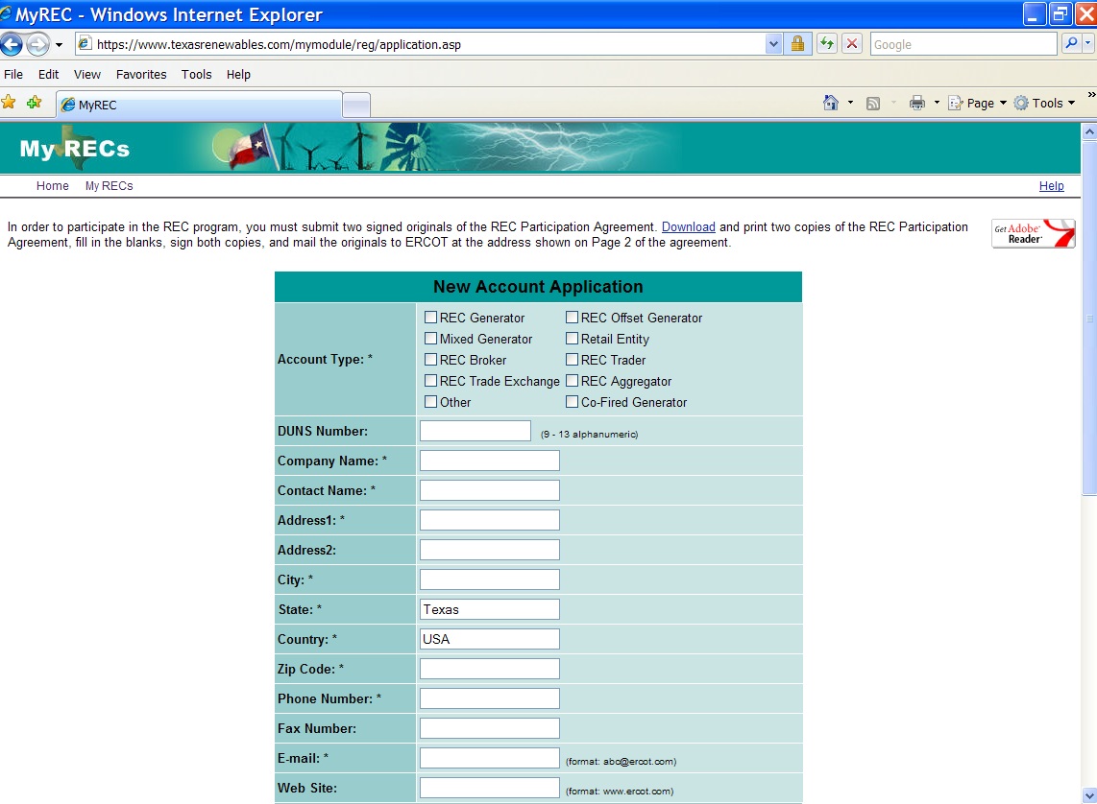
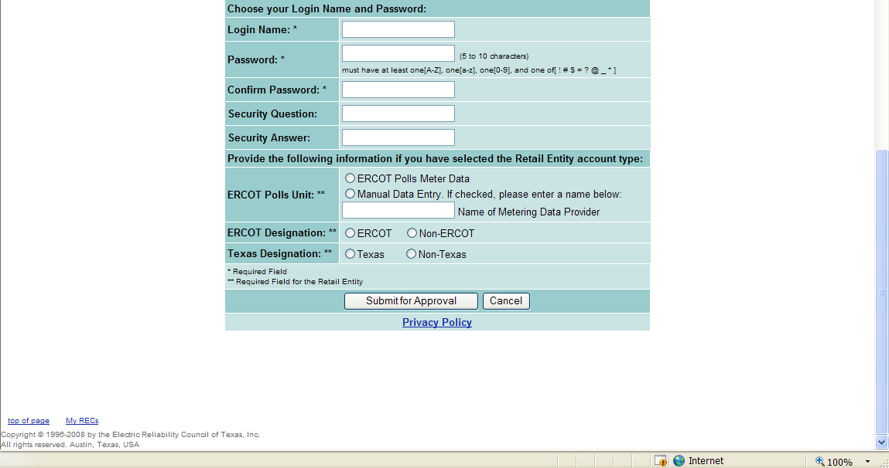
After submitting your ‘New Account Application’, you will see the message ‘Your account has been created. However, it must be activated and approved before you can access the full functionality of the Texas REC system. The ERCOT Administrator will send you an e-mail message containing a link to activate your account.’

12.3.1.2 Logging-in to the Texas REC System and Other System Functionality
Login to the Texas REC System - Go to www.texasrenewables.com, click the “Login” button, enter your Login Name and Password and click on the “Login” button to access the ‘My RECs’ page.
Below is a screenshot of the Login window of the Texas REC system:
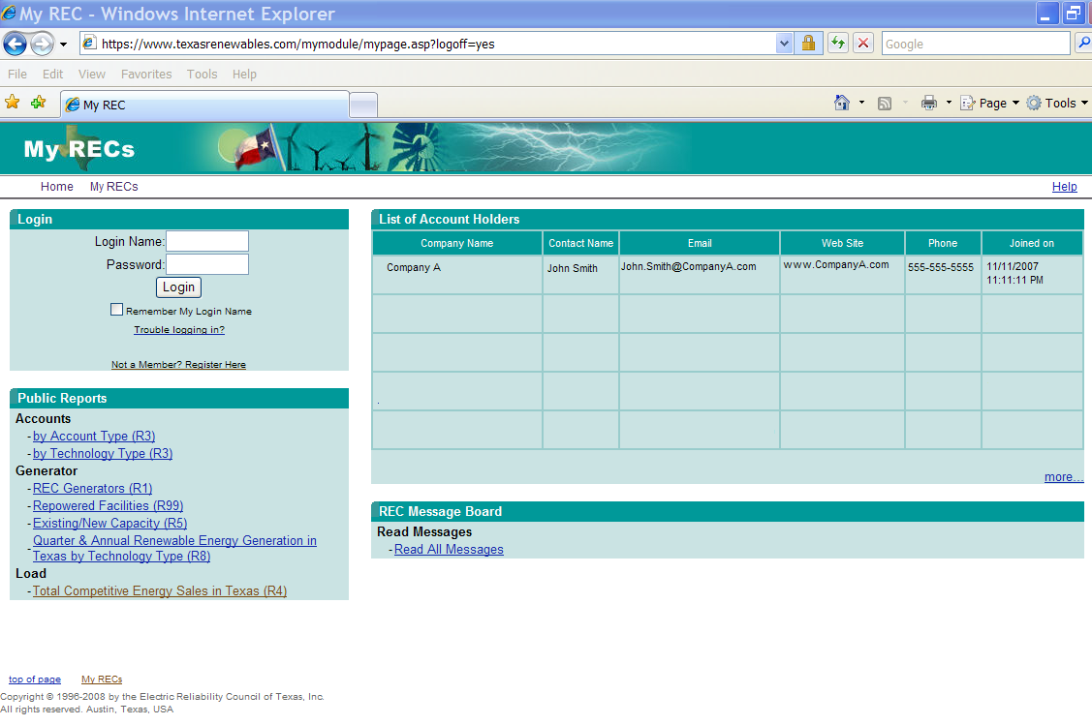
My RECs Page for Account Holders -- Public Reports are available from the ‘My RECs’ page as well as sections for Account Holder Reports, a REC Summary log which shows transactions and inventory, a REC Inbox (Incoming), a REC Outbox (Outgoing), a Transfer RECs section, a Retire RECs section, a List of Account Holders section and also for Generators an Account Information section.
Customize My Page – To customize the information displayed on your My Page, click on the Customer My Page box in the upper left of the screen and then use the checkbox to indicate which modules you would like to see. Click the “Save” button to save the changes and return to you’re my REC page, or use the “Change Layout” tool in the bottom half of the screen.
Change Password – From the My Page screen click on Change Password in the upper right of your screen. Enter your Current Password, New Password, Reenter New Password, and click on the “Change” button.
Note: Passwords must be 5 to 10 characters and must have at least one [A-Z], at least one [a-z], at least one [0-9], and at least one of [ ! # $ = ? @ _ * ].
Help – The Help function in the Texas REC system is very detailed and should be used as a reference. To access the Help function click on Help in the top right of the screen.
Below is a screenshot of the My Page window of the Texas REC system for Generators:

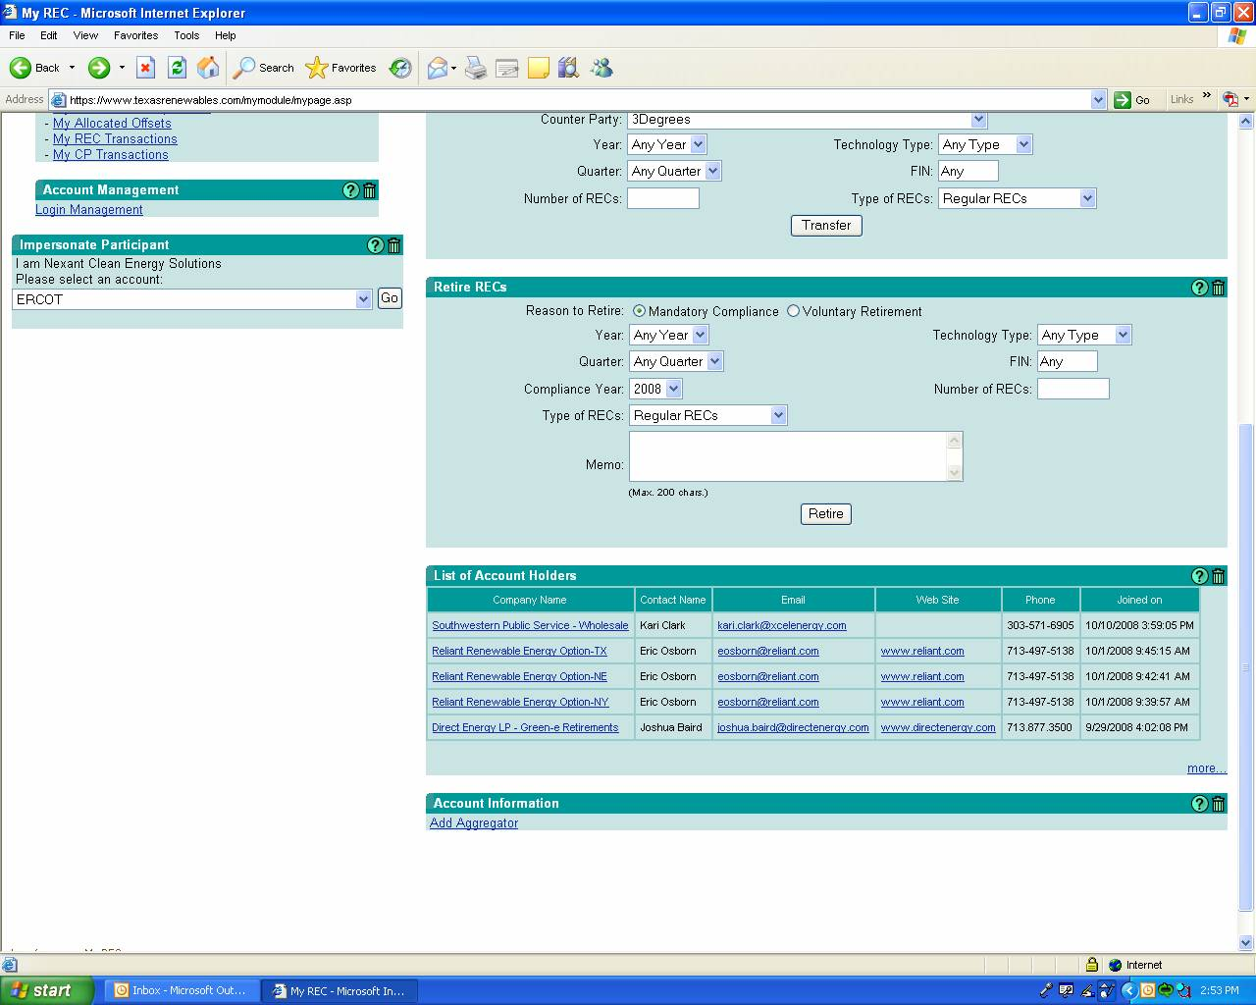

Below is a screenshot of the My Page window of the Texas REC system for Competitive Retailers:
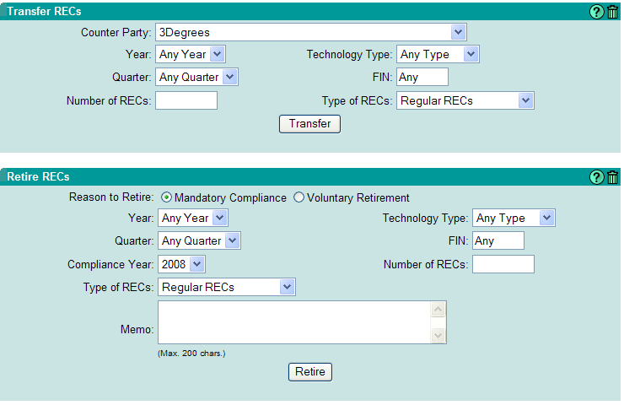
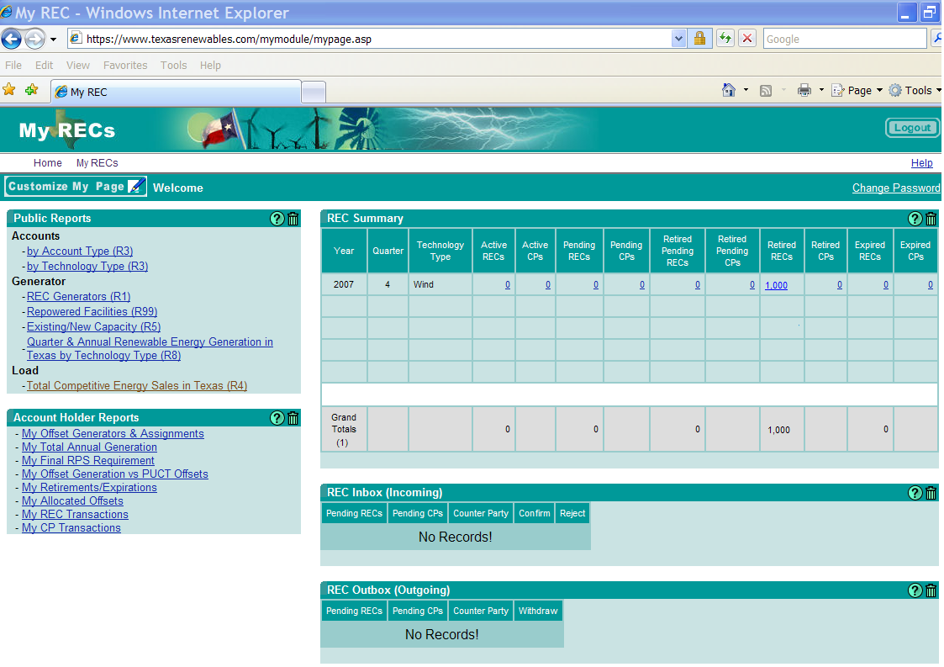

12.3.1.3 Adding Generators
Add Generators – To add Generators select “Add generator” and fill-in the information required on the Generator Registration Form and click on the “Submit” button. Submit one form for each Generator. The ERCOT Administrator will notify the participant their generators have been approved and inform them to input the Generator’s historical generation data. Enter the Generator’s historical data by selecting ‘View Extract”, select “Add New Monthly Meter Data”, and fill-in the information required, year, month, and generation MWhs for all months where this generator produced generation from September 1, 1999 until the date of registration.
Below is a screen shot of the Generator Registration Form:

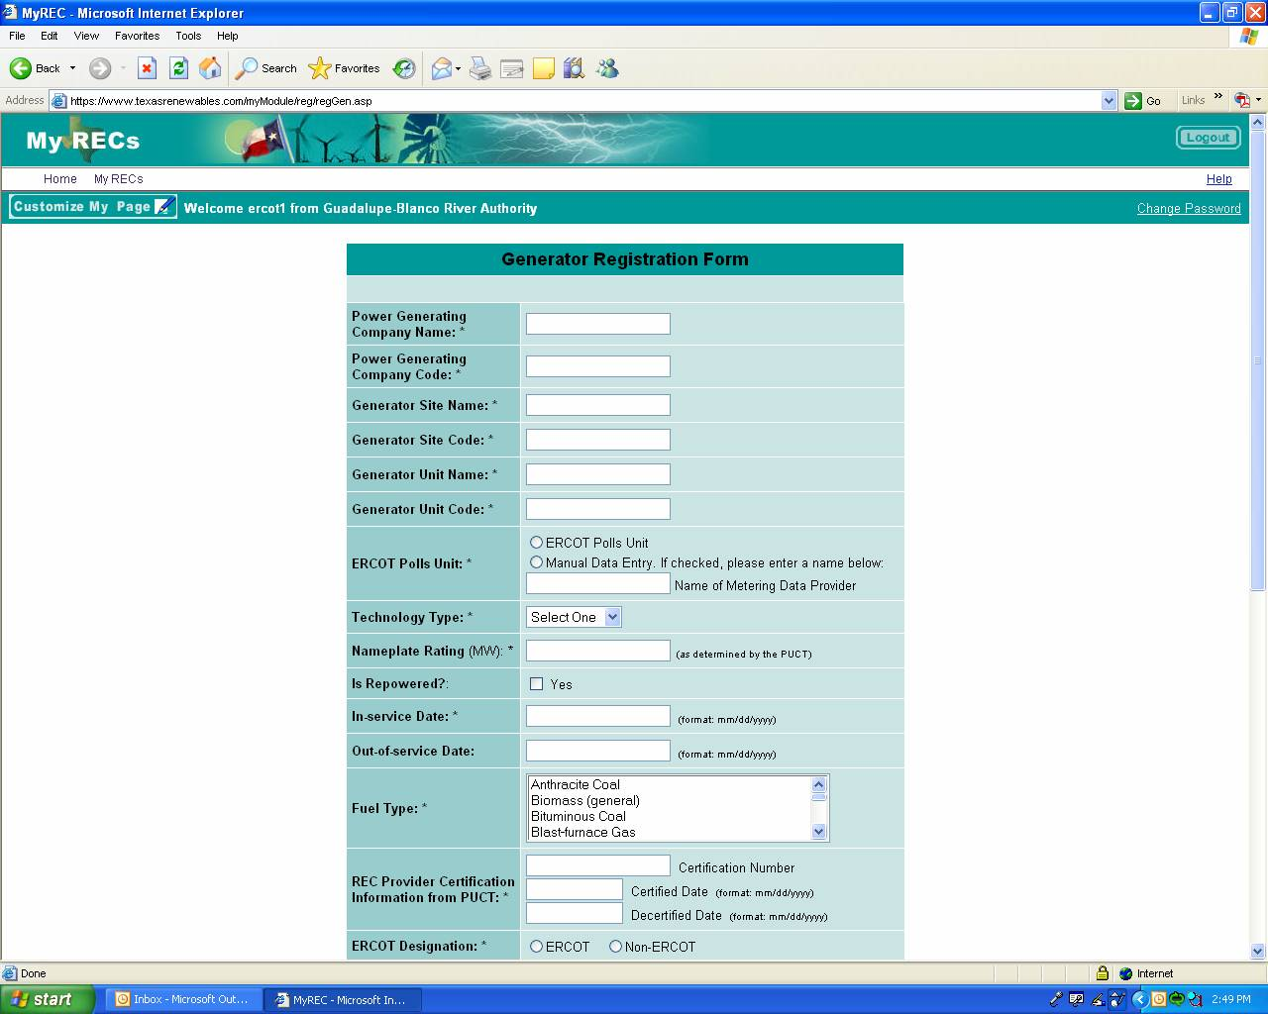

12.3.1.4 Trading, Transferring, and Confirming Transactions
Trades are done bi-laterally through contracts outside of the Texas REC system, however, after the contract is executed, the transaction is performed in the Texas REC system. The selling party transfers the RECs to the buying party using the ‘Transfer RECs’ section on the ‘My RECs’ page.
The selling counter party completes the fields which include the attributes listed below and clicks on the ‘Transfer’ button.
The only required fields in the Transfer RECs section are Counter party and Number of RECs.
After processing, the transferred RECs will appear in the REC Outbox (Outgoing) until the purchasing counter party ‘Confirms’ them using the REC Inbox (Incoming) section of their My RECs page by clicking on ‘Confirm’. The Texas REC system will send confirmation emails to the Account Holder upon completion of transactions.
REC attribute details of RECs reported in the ‘REC Summary’ can be found by clicking on the quantity under the Active RECs, Pending RECs, Retired Pending RECs, Retired Pending CPs, Retired RECs, or Retired CPs column headings.
- Purchasing Counter Party Account Holder Name (Counter Party) – Drop down menu provided
- Vintage year and quarter of the RECs (Year and Quarter) – Drop down menu provided. The Vintage is a time stamp assigned to the RECs when they are issued to the Generators.
- Technology Type (Technology Type) – Drop down menu provided which includes Any Type, Biomass, Geothermal, Hydro, Landfill Gas, Other, Solar, Tidal, and Wind
- Facility Identifier of the facility that generated the renewable power (FIN) – The FIN may be found by clicking on the ‘Active RECs’ quantity in the REC Summary under the column heading ‘Facility ID’.
- Quantity of RECs (Number of RECs) – Number of RECs contractually to be traded.
- Type of REC (Type of RECs) – Drop down menu provided which includes Regular or Compliance Premiums. The PUCT defines a Compliance Premium REC as a REC generated from a non-wind renewable generation facility that came online to the ERCOT grid after September 30, 2005. There are no differences between Regular RECs and Compliance Premium RECs in the way they are traded, sold, or retired. ERCOT requests that RECs be reported as Regular or Compliance Premium for tracking and reporting to the PUCT.
Note: REC transactions are not complete until both parties have acknowledged (Confirmed) the transaction. Also, the selling party may withdraw a transaction before the buyer officially receives it. The buying party may also reject a transaction if it was sent in error. Once the transaction is acknowledged by both parties, it is final.

12.3.1.5 Retirement of RECs
Mandatory retirement, voluntary retirement, deficit banking, and retirement of Unused RECs are explained in Section 14 of the ERCOT Protocols.
To retire RECs in the Texas REC system, use the Retire RECs section on the My RECs page. Select the appropriate Reason to Retire and complete the remaining fields of the Retire RECs section, which include the REC attributes and the Number of RECs to be retired.
The only required fields in the Retire RECs section are Reason for Retire, Compliance Year, Number of RECs, and Type of RECs. If Quarter is not specified the Texas REC system will automatically retire RECs with the oldest vintages.
After completing the Retire REC section click on the ‘Retire” button. The RECs will be moved in the REC Summary from the ‘Active RECs’ column to the ‘Retired Pending RECs’ column. After ERCOT confirms the retirement, the RECs will move to the ‘Retired RECs’ column of the REC Summary.

12.3.1.5 Tracking
The REC Summary on the My RECs page in the Texas REC system may be used to track REC transactions and REC inventories.
To view the number of RECs required to be retired for a specific Account Holder, click on “My Final RPS Requirement” under Account Holders Reports on the My RECs page of the Texas REC system. The Statewide Annual RPS Requirement is shown by year on the first half of the page and the Individual RPS Requirement for a specific CR is shown by year on the bottom half of the page. ERCOT also notes whether Compliance was achieved.
Other Account Holder Reports available on the My RECs page of the Texas REC system include:
- My Offset Generations and Assignments (Offset Generator List)
- My Total Annual Generation (Annual Unit Generation Report)
- My Offset Generation vs. PUCT Offsets (REC Offset Generator Comparison Between Meter Data Generation and PUCT Allowable Offsets)
- My Retirements/Expirations (REC Retirement Tables)
- My Allocated Offsets
- My REC Transactions (REC Transaction Detail)
- My CP Transactions (CP Transaction Detail)

