OGRR Number | 208 | OGRR Title | Voltage Ride-Through (VRT) Requirement
Timeline | Normal | Action |  | Appeal Granted
Date of Decision |  | November 17, 2008

Operating Guide Section Appealed | 3.1.4.6.1, Protective Relaying Requirement and Voltage Ride-Through Requirement for Wind-powered Generation Resources
Effective Date | December 1, 2008
Priority and Rank Assigned | Not applicable.
Appeal Description | Appeal of OGRR208 language approved by TAC on October 2, 2008 that implemented a new requirement for VRT capability.
Procedural History | - On 4/15/08, OGRR208 was posted.  - On 4/21/08, the Operations Working Group (OWG) comments were posted.  - On 5/02/08, ERCOT Staff comments were posted.  - On 5/12/08, CenterPoint Energy comments were posted.  - On 5/15/08, Luminant comments were posted.  - On 5/16/08, the Wind Coalition comments were posted.  - On 5/20/08, the Operating Guides Revision Task Force (OGRTF) comments were posted.  - On 5/21/08, the OWG considered OGRR208.  - On 6/17/08, a second set of OGRTF comments were posted.  - On 6/18/08, the OWG again considered OGRR208.  - On 7/9/08, a Preliminary Impact Analysis was posted.  - On 7/16/08, the OWG considered the OWG Recommendation Report and the Preliminary Impact Analysis.  - On 8/14/08, ROS considered OGRR208.  - On 8/19/08, a third set of OGRTF comments were posted.  - On 8/20/08, OWG again considered OGRR208.  - On 9/11/08, ROS again considered OGRR208.  - On 9/19/08, a second set of Wind Coalition comments were posted.  - On 9/23/08, an Impact Analysis was posted.  - On 9/25/08, a revised Impact Analysis was posted.  - On 9/25/08, Invenergy comments were posted.  - On 9/30/08, Oncor comments were posted.  - On 9/30/08, Horizon Wind Energy comments were posted.  - On 9/30/08, E. ON comments were posted.  - On 10/1/08, AES Wind Generation comments were posted.  - On 10/2/08, TAC considered OGRR208.  - On 10/15/08, the Invenergy appeal was posted.  - On 10/16/08, the E.ON appeal was posted.  - On 10/16/08, the FPL Energy appeal was posted.  - On 10/16/08, the Horizon Wind Energy appeal was posted.  - On 11/05/08, Babcock & Brown comments were posted.  - On 11/07/08, ERCOT, E.ON, Invenergy, & Horizon comments were posted.  - On 11/07/08, TAC comments were posted.  - On 11/07/08, Iberdrola Renewables, Inc. comments were posted.  - On 11/07/08, E.ON, Invenergy, & Horizon comments were posted.  - On 11/07/08, Eurus Energy comments were posted.  - On 11/10/08, FPL Energy comments were posted.  - On 11/17/08, the ERCOT Board considered the appeals for OGRR208.
OWG Decision | On 5/21/08, the OWG was in consensus to defer action on OGRR208 as recommended by the OGRTF comments.  On 6/18/08, the OWG was in consensus to recommend approval of OGRR208 as amended by the 061708 OGRTF comments and contingent upon resolution of the issues identified in the 061708 OGRTF comments by ROS.  On 7/16/08, the OWG was in consensus to forward the OWG Recommendation Report and the Preliminary Impact Analysis to the ROS for consideration.  On 8/20/08, the OWG was in consensus to forward OGRR208 to ROS as amended by the 081908 OGRTF comments and as revised by OWG.
Summary of OWG Discussion | On 05/21/08, the OGRTF chair explained that at its 5/20/08 meeting, OGRTF considered the comments that had been submitted on OGRR208. OGRTF consolidated the comments and made suggested revisions. OGRTF recommended that this draft document be reviewed at its June 17th meeting to address issues surrounding site specificity and low VRT timing requirements. OGRTF requested that representatives from AEP, Oncor, ERCOT Staff, the System Protection Working Group (SPWG), and the Wind Coalition be present at the June 17th OGRTF meeting.  On 6/18/08, the OGRTF chair reviewed the 061708 OGRTF comments and identified the issues that OGRTF could not come to consensus on. The OGRTF chair recommended that these issues be taken to ROS for resolution.  On 7/16/08, ERCOT Staff stated that the Preliminary Impact Analysis did not take into consideration the unresolved issues surrounding OGRR208 and that depending on ROS resolution, the Preliminary Impact Analysis might have to be updated prior to TAC consideration.  On 8/20/08, the OWG reviewed the 081908 OGRTF comments. Concerns were raised regarding compliance of Wind-powered Generation Resources (WGRs). It was suggested that WGRs provide a status and implementation plan of compliance to ERCOT.
ROS Decision | On 8/14/08, ROS unanimously voted to remand OGRR208 to OWG as revised by ROS with the directive that “grandfathering” and compliance issues be addressed. All Market Segments were present for the vote.  On 9/11/08, ROS unanimously voted to recommend approval of OGRR208 as recommended by OWG and as revised by ROS. The Consumer Market Segment was not present for the vote.
Summary of ROS Discussion | On 8/14/08, ROS addressed issues identified in the 061708 OGRTF comments. ROS came to consensus on all issues with the exception of grandfathering and compliance of WGRs. ROS asked that this issue be resolved and language be developed by OGRTF and ERCOT Staff and brought to the September 11th ROS meeting.  On 9/11/08, concerns were raised regarding the retrofit and retro-application of the VRT standard. It was suggested that a dynamic study be performed to justify the standard and to determine specifics of the problem. ERCOT stated that the proposal is to complete site-specific studies which would be extremely challenging and time consuming for ERCOT. ERCOT did not believe this was a practical proposal. A Market Participant pointed out that the Operating Guides could be modified in the future if the requirements did not meet the actual need of the market. Language revisions were proposed to update the compliance dates.
TAC Decision | On 10/2/08, TAC voted to approve OGRR208 as recommended by ROS with three opposing votes from the Independent Power Marketer (IPM) (2) and Independent Generator Market Segments and three abstentions from the Independent Retail Electric Provider (IREP) (2) and IPM Market Segments. All Market Segments were present for the vote.
Summary of TAC Discussion | On 10/2/08, concerns were expressed by the Wind Coalition regarding the retroactive application of the low VRT requirement proposed by OGRR208. It was stated that studies have not been completed to justify the retroactive application of low VRT and that it would essentially require WGRs to retrofit some of their equipment which could incur significant costs. A participant stated that the reliability of the ERCOT grid had to be taken into consideration. It was stated that the low VRT requirement was a large part of successful system planning and would in turn support the reliability of the ERCOT grid. It was emphasized that compliance for WGRs that signed Generation Interconnection Agreements between January 1, 2003 and November 1, 2008 was not required until 2015 and that if issues did come up, the Operating Guide standards could be changed.
Board Decision | On 11/17/08, the ERCOT Board granted the appeal of OGRR208 as amended by the 11/07/08 TAC comments and as revised by the ERCOT Board.

ERCOT/Market Segment Impacts and Benefits

Assumptions | 1
Assumptions | 2
Assumptions | 3
Assumptions | 4
Market Cost |  | Impact Area | Monetary Impact
Market Cost | 1 | Power Generation Companies will have to design their generation plants to meet the new standard which will result in some added capital cost but the transmission system reliability will be greater resulting in additional revenue for the generators since Outages should be reduced
Market Cost | 2
Market Cost | 3
Market Cost | 4
Market Benefit |  | Impact Area | Monetary Impact
Market Benefit | 1 | Maintain system reliability as new generators are added to the ERCOT System.
Market Benefit | 2
Market Benefit | 3
Market Benefit | 4
Additional Qualitative Information | 1
Additional Qualitative Information | 2
Additional Qualitative Information | 3
Additional Qualitative Information | 4
Other Comments | 1
Other Comments | 2
Other Comments | 3
Other Comments | 4

Original Sponsor
Name | Walter J. Reid on behalf of the Wind Coalition
E-mail Address | w.j.reid@ieee.org
Company | Wind Coalition

Comments/Appeals Received
Comment Author | Comment Description
OWG 042108 | Recommended that the focus/scope of OGRR208 be narrowed to the consideration of wind generation only.
ERCOT Staff 050208 | Proposed minor changes to reflect ERCOT and transmission owner concerns; Stated that VRT capability is needed across the ERCOT Transmission Grid.
CenterPoint Energy 051208 | Supported ERCOT’s comments with minor changes and proposed clarifying language.
Luminant 051508 | Proposed language to narrow scope of OGRR208 to wind generation only.
Wind Coalition 051608 | Proposed language to convert to a relay standard and not a performance standard; to clarify that this is applicable to voltages at the point of interconnection; and to allow for additional equipment protection for generators experiencing significant low voltages.
OGRTF 052008 | Recommended that OWG defer action until issues surrounding OGRR208 can be resolved.
OGRTF 061708 | Recommended approval of OGRR208 as amended by CenterPoint Energy, ERCOT, and Wind Coalition comments and as revised by the OGRTF contingent upon resolution of issues by ROS.
OGRTF 081908 | Proposed dates for WGR compliance with requirements in Section 3.1.4.6.1.
Wind Coalition 091908 | Proposed language regarding evaluation and study of low VRT compliance requirement.
Invenergy 092508 | Requested that retroactive requirements be struck.
Oncor 093008 | Supported requirement for low VRT and presented brief studies.
Horizon Wind Energy 093008 | Opposed retroactive application of low VRT requirements.
E.ON 093008 | Supported new VRT requirements going forward; Opposed retroactive application of low VRT requirements.
AES Wind Generation 100108 | Supported new VRT requirements going forward; Opposed retroactive application of low VRT requirements.
Invenergy Appeal 101508 | Appealed the October 2, 2008 TAC decision.
E.ON Appeal 101608 | Appealed the October 2, 2008 TAC decision.
FPL Energy Appeal 101608 | Appealed the October 2, 2008 TAC decision.
Horizon Wind Energy Appeal 101608 | Appealed the October 2, 2008 TAC decision.
Babcock & Brown 110508 | Supported the Invenergy, E.ON, FPL Energy, and Horizon Wind Energy appeals.
ERCOT, E.ON, Invenergy, & Horizon 110708 | Proposed language revisions in response to appeals.
TAC 110708 | Recommended that ERCOT Board adopt ERCOT, E.ON, Invenergy, & Horizon Wind Energy 110708 comments as revised by TAC.
Ibredrola Renewables 110708 | Supported the Invenergy, E.ON, FPL Energy, and Horizon Wind Energy appeals.
E.ON, Invenergy, & Horizon 110708 | Endorsed TAC 110708 comments.
Eurus Energy 110708 | Supported prospective application of VRT standard.
FPL Energy 111008 | Endorsed ERCOT, E.ON, Invenergy, & Horizon 110708 comments.

Proposed Guide Language Revision

3.1.4.6.1 Protective Relaying Requirement and Voltage Ride-Through Requirement for Wind-powered Generation Resources

  - Wind-powered Generation Resources (WGRs) specified below are required to set generator voltage relays to remain in-service during all transmission faults (no more than nine (9) cycles) in accordance with Figure 1, Voltage Ride-Through Boundaries For Wind-powered Generation Resources, below. Faults on individual phases with delayed clearing (zone 2) may result in phase voltages outside this boundary but if the phase voltages remain inside this boundary then generator voltage relays are required to be set to remain connected and recover within the voltage recovery boundary of Figure 1.
  - WGR voltage relays shall be set to remain interconnected during three-phase faults on the transmission system for a voltage level as low as zero volts with a duration no more than nine (9) cycles as measured at the point of interconnection as shown in Figure 1. The clearing time requirement for a three-phase fault will be specific to the generating plant point of interconnection, as determined by and documented by the transmission provider in conjunction with the interconnection agreement. This requirement does not apply to faults that would occur between the generator terminals and the transmission voltage side of the generation step-up transformer or when clearing the fault effectively disconnects the generator from the system.
  - WGRs may be tripped after the fault period if this action is intended as part of a special protection system.
  - WGRs may meet the VRT requirements of Figure 1 by the performance of the generators or by installing additional equipment (e.g., Static VAr Compensator) within the generating plant or by a combination of generator performance and additional equipment.
  - WGRs that have had over 50 seconds cumulative operation over the life of the WGR below 10% of nominal voltage at the point of interconnection shall be allowed, with ERCOT’s approval, to set generator voltage relays to provide sufficient protection to the WGR to comply with warranty requirements and to retain the expected life of the resource.
  - Existing individual WGRs that are replaced are required to meet the requirements of Figure 1.

  - WGRs that are part of a Generation Interconnect Agreement signed after November 1, 2008 shall meet the requirements of Section 3.1.4.6.1, Protective Relaying Requirement and Voltage Ride-Through Requirement for Wind-powered Generation Resources. All such WGRs shall provide a status of compliance to ERCOT System Planning by July 1, 2009.
  - WGRs that are part of a Generation Interconnect Agreement signed prior to November 1, 2008 shall provide information requested by ERCOT, including existing WGR VRT capabilities, for a study to evaluate the need for additional protective relaying and VRT requirements applicable to some or all such WGRs. The study will be conducted using the 2009-2010 transmission system as determined by ERCOT. The study shall be conducted by a qualified organization having no real or apparent bias and with no financial interest in the outcome of the study. ERCOT shall publish study results and provide recommendations to ROS no later than the scheduled ROS meeting of June 2010. If the results of the study demonstrate the need, this Operating Guide shall be revised on an expedited basis to establish those requirements. Those WGRs requiring retrofit to meet a revised Operating Guide shall install the required retrofits within 18 months after the effective date of the revised Operating Guide.

  - Notwithstanding any of the foregoing provisions, existing individual WGRs that meet the requirements of Figure 1 on November 1, 2008 shall continue to meet the requirements of Figure 1.
  - If, due to a system disturbance, a WGR come off-line within the boundaries of the VRT requirement of Figure 1, then the WGR owner and the TSP shall be required to investigate and report to ERCOT on the cause of the WGR trip identifying a reasonable mitigation plan and timeline.

ERCOT and the TSP shall be notified of any equipment changes that affect the reactive capability of an operating WGR no less than sixty (60) days prior to implementation. of the changes, and any such changes that decrease the reactive capability of the WGR below the required level and changes that decrease the Voltage Ride-Through (VRT) capability of the plant must be approved by ERCOT prior to implementation.
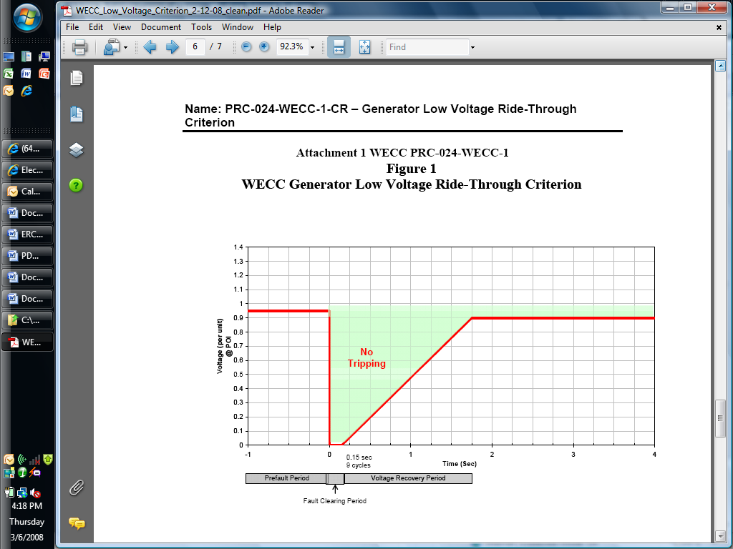
High Voltage Boundary

Figure 1: Voltage Ride-Through Boundaries For Wind-powered Generation Resources

