ERCOT Operations Report
October 2008 ROS & OWG

Frequency Control

Time | Freq(Hz) | Duration (s)
10/1/2008 5:47 | 60.105 | 249 | SCE changed +340 in 10m. Bad offset.
10/1/2008 6:09 | 59.896 | 11 | Slow regulation deployment.
10/2/2008 7:02 | 60.101 | 323 | SCE changed +600 in 4m and depletion of DRS. Steel mill load drop of 200 MW in 1m
10/2/2008 11:10 | 59.891 | 8 | East DC Tie tripped with 374 MW
10/2/2008 23:58 | 59.896 | 4 | SCE changed -520 MW in 5m and steel mill load pickup 210 MW in 5m
10/6/2008 20:12 | 59.885 | 44 | Unit trip with 589 MW online
10/7/2008 14:59 | 59.89 | 7 | Unit trip with 420 MW online
10/10/2008 7:02 | 59.884 | 80 | SCE changed -520 in 5m, then unit trip with 463 MW online
10/10/2008 8:05 | 59.897 | 36 | Instantaneous two units ramp down of 200 MW online Steel mill load pickup of 150 MW in 1m. Slow regulation deployment.
10/18/2008 9:34 | 59.84 | 63 | Unit trip with 637 MW online
10/19/2008 5:54 | 60.106 | 69 | SCE changed +600 in 6m. Steel mill load drop of 100 MW in 1m
10/21/2008 22:03 | 59.894 | 14 | SCE changed -450 in 3m
10/22/2008 7:12 | 59.899 | 5 | Unit trip with 343 MW online, unit emergency shutdown with 250 MW online, out of URS.
10/22/2008 12:02 | 59.851 | 11 | Unit trip with 697 MW online
10/30/2008 15:14 | 59.864 | 54 | Unit trip with 594 MW online

Note: Time of frequency excursions outside the range of +/- 0.1 Hz.

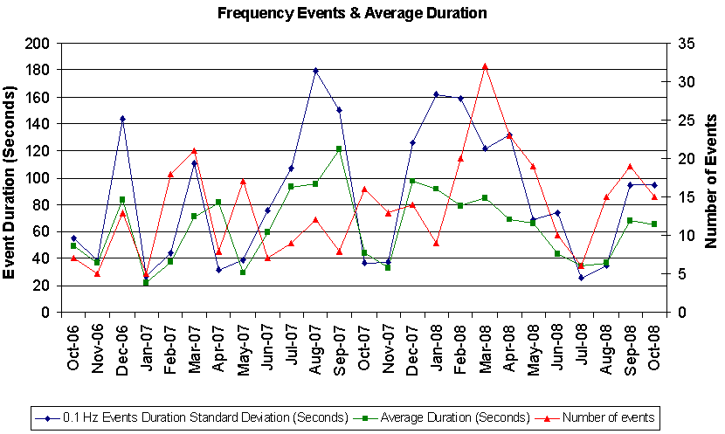

Deployed Responsive (Reported Above)
Time deployed | Stop Time | Duration | Max | Details
10/01 06:01:40 | 10/01 06:20:38 | 0:18:58 | 385.40 | Input Error in Offset Calculation
10/02 11:10:17 | 10/02 11:26:53 | 0:16:36 | 411.44
10/02 15:41:53 | 10/02 15:50:24 | 0:08:31 | 328.10 | Unit Trip
10/02 23:58:05 | 10/03 00:34:09 | 0:36:04 | 385.40
10/03 22:13:44 | 10/03 22:29:03 | 0:15:19 | 328.10 | SCE change -700 MW in 5m
10/06 20:12:57 | 10/06 20:27:03 | 0:14:06 | 442.70
10/06 22:00:02 | 10/06 22:17:19 | 0:17:17 | 359.35 | SCE change -600 MW in 5m
10/07 14:59:37 | 10/07 15:18:19 | 0:18:42 | 416.65
10/10 07:02:02 | 10/10 07:18:56 | 0:16:54 | 541.63
10/10 08:00:22 | 10/10 08:28:00 | 0:27:38 | 458.31 | Steel Mill Load pick up 150 MW. SCE change -330 MW in 3m
10/10 22:06:42 | 10/10 22:26:00 | 0:19:18 | 359.35 | SCE change -800 in 5m.
10/15 12:52:09 | 10/15 13:00:35 | 0:08:26 | 322.9 | Unit Trip
10/18 09:34:24 | 10/18 09:59:34 | 0:25:10 | 692.66
10/20 11:11:46 | 10/20 11:29:54 | 0:18:08 | 364.56 | Unit Trip
10/20 23:47:16 | 10/21 00:05:46 | 0:18:30 | 333.33 | SCE Change -630 MW in 14m.
10/21 06:06:16 | 10/21 06:16:14 | 0:09:58 | 317.69 | Base Power schedule Change 5250 MW. SCE changed – 475 in 10m
10/21 21:59:01 | 10/21 22:19:10 | 0:20:09 | 395.81
10/22 07:12:46 | 10/22 7:24:54 | 0:12:08 | 369.78
10/22 9:02:12 | 10/22 9:18:04 | 0:15:52 | 333.33 | SCE change -500 MW in 5m
10/22 12:02:56 | 10/22 12:30:28 | 0:27:32 | 671.84
10/26 13:02:36 | 10/26 13:20:38 | 0:18:02 | 322.9 | Out of Up Reg. Held 3 intervals 12:15 resumed 13:15 interval.
10/26 18:59:52 | 10/26 19:32:08 | 0:32:16 | 333.33 | Out of Up Reg. Bad offset
10/30 15:14:40 | 10/30 15:35:02 | 0:20:22 | 645.79
10/31 17:46:24 | 10/31 17:57:48 | 0:11:24 | 421.85 | Unit Trip

Day-Ahead OOMC and RMR Capacity Purchases

Details | RMR | OOMC | RPRS S1 | RPRS S2 | Total
W RIO | 0 | 89 | 6 | 0 | 95
Corpus | 0 | 19 | 0 | 0 | 19
Western | 0 | 1 | 5 | 1 | 7
Austin | 0 | 0 | 2 | 4 | 6
E RIO | 0 | 0 | 5 | 0 | 5
San Antonio | 0 | 0 | 0 | 5 | 5
DFW | 0 | 0 | 0 | 3 | 3
Laredo | 0 | 0 | 2 | 0 | 2
North | 0 | 0 | 2 | 0 | 2
South | 0 | 0 | 2 | 0 | 2
Bryan Area | 0 | 0 | 0 | 0 | 0
Houston | 0 | 0 | 0 | 0 | 0
Northeast | 0 | 0 | 0 | 0 | 0
 | 0 | 109 | 24 | 13 | 146

Historical Totals | Oct-07 | Sept-08 | Oct-08
Austin | 45 | 22 | 6
Bryan Area | 1 | 0 | 0
Corpus | 0 | 16 | 19
DFW | 16 | 49 | 3
E RIO | 10 | 2 | 5
Houston | 44 | 40 | 0
Laredo | 71 | 11 | 2
North | 26 | 45 | 2
Northeast | 1 | 20 | 0
San Antonio | 18 | 17 | 5
South | 0 | 2 | 2
W RIO | 15 | 0 | 95
Western | 17 | 16 | 7
Total | 264 | 240 | 146

http://www.ercot.com/mktinfo/services/rprsdr/index.html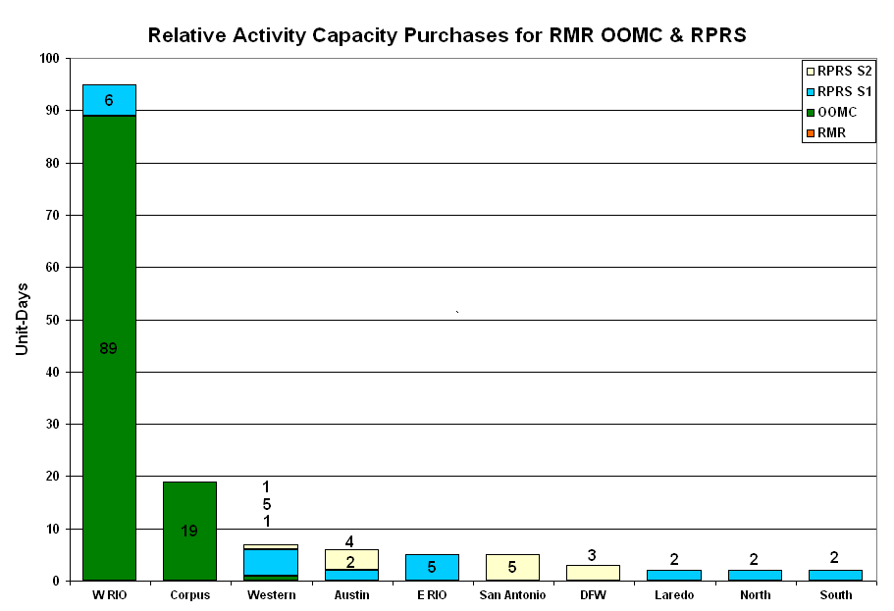
OOME and Congestion Management Activity
Congestion affected by outages
Remedial action plan has been developed for the element
Contingency | Overloaded Element | Days
Elm Creek - San Miguel 345kV | Calaveras Facility - Pawnee 345kV | 22
Sandow Switch - Austrop 345kV | Elgin Switch - Sandow Switch 138kV | 16
Farmersville - Royse Switch #1 345kV | Farmersville - Royse Switch #2 345kV | 14
Menard - Gillespie 138KV | Menard 138/69KV transformer | 13
Marion - Clear Springs - Zorn 345kV | Seguin - Zorn 138kV | 13
Sandow Switch - Austrop 345kV | Sandow Switch - Salty 138kV | 12
Lon Hill - North Edinburg 345kV | Lon Hill - Kingsville 138kV | 10
Aspermont - Spur 138 kV | Girard Tap - DKEC Jayton 69kV | 7
Dilley Switch - North Laredo 138KV | North Laredo - Asherton 138KV | 5
Moss Switch - Holt Switch 138KV | Odessa North 138/69KV autotransformer | 5
Spur - Aspermont 138kV | Girard - Spur 69kV | 5
STP - Blessing 345kV | Columbus - Stafford Hill 69kV | 5
Dyann - East Bernard 138kV | Blessing - Lane City 138kV | 5
Austrop Auto AT2 | Austrop Auto AT1 | 4
Mt. Enterprise - Trinidad and Martin Lake - Stryker Creek 345kV | Nacogdoches SE 345/138kV autotransformer | 4
Tradinghouse SES - Venus Switch 345kV | Rogers Hill - Elmot 138kV | 4
Temple Pecan Creek - Tradinghouse SES and Temple Switch - Lake Creek SES 345kV | Ridge - Watson Chapel 138kV | 4
Royse Switch - Farmersville 345kV | Payne Switch - Alla Hubbard 138kV | 4
Matador - Paducah Claire 69KV | Spur - Gidard Tap 69KV | 4
Fort Mason 138/69kV autotransformer | Menard 138/69KV transformer | 3
Lon Hill - North Edinburg 345kV | Barney Davis - Alazan 138kV | 3
Matador - Paduka 69KV | Girard Tap - Jayton 69KV | 3
Moss Switch - Holt Switch 138KV | Odessa North - North Cowden 69KV | 2
Comanche Peak - Venus 345kV | Wolf Hollow - Rocky Creek 345kV | 2
Snyder - China Grove Switch 138kV | Snyder - Scurry Santa Fe Tap 69kV | 2
Morgan Creek - Sun Switch 138kV | Sun Switch - Saroc 138kV | 2
Morgan Creek SES - Quail Switch & Longshore Switching Station 345kV | Stanton East Switching Station - Big Spring west 138kV | 2
Calaveras - Walzem Road - Skyline 138KV | Broadview - Five Points 138KV | 2
Falcon Switch - Zapata 138kV | North Laredo - Asherton 138kV | 2
King Ranch - Falfurrias 138KV | North Laredo - Asherton | 2
Matador - Spur 69KV | Spur - Jayton 69KV | 2
Laredo Plant - North Laredo 138KV | Freer - San Diego 69KV | 1
San Angelo Power Station - Live Oak 138KV | San Angelo Concho - San Angelo Lake Nasworthy 69KV | 1
Calaveras -Skyline and Walzem 138KV | Calaveras - Ball Park 138KV | 1
Dyann - East Bernard 138kV | Newton - Texas Gulf Sulphur 138kV | 1
Jack County - Reno 138kV | Rhome - Decatur Tap 138KV | 1
Monticello - Allen - Sulphur Springs 345kV | Royse Switch - Farmersville 345kV | 1
Trinidad SES - Stryker Creek SES & Mount Enterprise 345kV | Elkton - Athens 138kV | 1
Marion - Guadalupe Gen 345kV | Marion - Clearsprings - 109% | 1
Twin Oak - Gibbons Creek - Jack Creek 345KV | Ridge - Watsons Chapel | 1
Elm Mott T1 345/138KV transformer | Rogers Hill - Elm Mott 138KV | 1
Tradinghouse - Elm Mott 345KV | Rogers Hill - Elm Mott 138KV | 1
Roma - Falcon Switch 138KV | North Laredo - Asherton 138KV | 1
Allen Switch - Royse Switch - Monticello 345KV | Forney Switch - Seagoville Switch 345KV | 1
Allen Switch - Royse Switch - Monticello 345KV | Centerville Road Switch 345/138KV autotransformer | 1
North Edinburg - Rio Hondo 345KV | Stewart - Weslaco 138KV | 1
Elm Mont - Bosque Switch 345KV | Elm Mont - Bosque Switch 138KV | 1
Elm Mont - Bosque Switch 345KV | Elm Mont - Rogers Hill 138KV | 1
Garfield - Onion Creek - Hycross 138KV | Lytton Springs - Pilot 138KV | 1
Royse Switch - Farmersville 345kV | Anna Switch 345/138kV autotransformer | 1
Graham - Long Creek | Menard - San Angelo 138KV | 1
Watermill - Tricorner & Trinidad SES 345KV | Seagoville - Kleberg Tap 138KV | 1
North Edinburg - Rio Hondo 345KV | MVEC Palmhurst - North Edinburg 138KV | 1
King - Kuykendahl - Roans Prairie REIT & Jewett - Tomball 345KV | Midtown - Garrott 138KV | 1

Zonal OC1

CSC | Days
North-Houston | 15
West-North | 13

New RAP (Date indicates last update of RAP not implementation date.)

None

New Procedures/Forms/Operations Bulletins

Date | Subject | Bulletin No.
10/02/2008 | Transmission & Security Desk V 3 Rev 96 | 388 (439 KB .doc)
10/02/2008 | Frequency Control Desk V 3 Rev 70 | 387 (618.5 KB .doc)
10/02/2008 | Shift Supervisor Desk V 3 Rev 51 | 386 (169.5 KB .doc)

Blackout/Load Shed Incidences
None

EECP
None

Major System Voltage Problems
None

Major Computer Problems, Enhancements & Fixes

10/26 12:20 Alert issued due to the real-time balancing market failed. Held IE 12:15 and resumed with IE 13:15.
13:50 Emergency Notice issued due to Day-Ahead Ancillary Service Market did not meet time-line.

Communication
None

ERCOT peak (Unofficial)
10/03 17:00 46,564 MW

Yearly MTLF Error Comparison
Yearly Mid-Term (Hourly) Load Forecast Error Comparison for the ERCOT Forecast
Month | MAPE for MTLF at 16:00 Day-Ahead
Month | 2005 | 2006 | 2007 | 2008
January | 5.02 | 4.79 | 4.55 | 3.30
February | 3.47 | 4.81 | 3.75 | 3.59
March | 3.41 | 4.95 | 2.70 | 3.29
April | 3.37 | 5.59 | 3.00 | 2.45
May | 4.21 | 3.59 | 3.22 | 3.01
June | 3.91 | 2.65 | 4.46 | 2.81
July | 5.22 | 2.62 | 4.29 | 2.55
August | 4.86 | 2.09 | 3.11 | 3.66
September | 6.24 | 4.03 | 3.78 | 4.99
October | 4.51 | 3.63 | 3.08 | 2.79
Annual Average | 4.56 | 3.79 | 3.55 | 3.24
OCN, Advisory, Alerts & Emergency Notices

Capacity

Date | Start | End | Event
10/1/08 | 16:10 | 20:00 | Advisory ARR below 3000 MW.
10/2/08 | 15:53 | 19:00 | Deployed Non-Spin Reserve Service (NSRS) in North and South zones due to depletion of up balancing bids.
10/7/08 | 15:05 | 18:00 | Advisory ARR below 3000 MW.
10/7/08 | 15:40 | 18:00 | Deployed NSRS in Houston and South zones due to depletion of up balancing bids.
10/10/08 | 14:04 | 17:30 | Deployed NSRS in all zones due to depletion of up balancing bids.
10/13/08 | 9:35 | 18:05 | Operating Condition Notice (OCN) issued for projected capacity shortage for hour ending 1600 - 1800.
10/13/08 | 14:27 | 18:00 | Deployed NSRS in all zones due to depletion of up balancing bids.
10/13/08 | 14:35 | 18:05 | Alert issued for projected capacity shortage for hour ending 1700 - 1800.
10/14/08 | 6:00 | 16:00 | OCN issued for projected capacity shortage for hour ending 1700.
10/14/08 | 16:05 | 17:45 | Advisory ARR below 3000 MW.
10/22/08 | 7:25 | 8:00 | Advisory ARR below 3000 MW.
10/26/08 | 16:12 | 20:18 | Advisory ARR below 3000 MW.

Texas RE Event Analysis

10/03 22:03 Stanton Wind Energy Center SPS Activation: ERCOT determination operated as intended.

Other

10/13 18:45 ERCOT held 18:30 balancing energy deployments for 18:45 due to input error in offset calculation.

