Advanced Metering Interim Solution Use Cases

Use Case Number: 12 | Related Business Requirements:  BR-009 |  | Date: 10/27/2008 | Version: .01
High Level Description |  | Market Participants can use web services to identify gaps in interval data loading.
Requirement |  | BR-009: Ability for a TDSP to identify which ESIIDs have gaps in the interval data loaded at ERCOT and what the gaps are.
Pre-Conditions/Trigger |  | Market Participant has a valid digital certificate and can access the extract scheduler.
Scenario 1: TDSP requests a list of all their ESI IDs that are missing IDR data (load or generation) for a specified day. |  | - TDSP requests a list of all their ESI IDs that are missing IDR data (load or generation) for a specified day.  - Extract is scheduled and delivered to the TDSP. Extract contains a list of every ESI ID the TDSP owns that is missing IDR data (load or generation) for the specified operating day.
Scenario 2: TDSP uploads a list of ESI IDs and requests to know which of the ESI IDs are missing IDR data (load or generation) on a specified day. |  | - TDSP uploads a list of ESI IDs and requests to know which are missing IDR data (load or generation) on a specified day. The TDSP owns all the ESI IDs on the list.  - Extract is scheduled and delivered to TDSP. Extract contains a list of every ESI IDs from the uploaded list that is missing IDR data (load or generation) for the specified day.
Scenario 3: TDSP uploads a list of ESI IDs and requests to know which of the ESI IDs are missing IDR data (load or generation) on a specified day. The TDSP owns some of the requested ESI IDs. |  | - TDSP uploads a list of ESI IDs and requests to know which are missing IDR data (load or generation) on a specified day. TDSP owns some of the requested ESI IDs.  - Extract is scheduled and delivered to TDSP. Extract contains a list of every ESI IDs from the uploaded list that is missing IDR data (load or generation) for the specified day and is owned by the requesting TDSP. No information is provided for the other ESI IDs.
Scenario 4: CR requests a list of all their ESI IDs that are missing IDR data (load or generation) for a specified day |  | - CR requests a list of all their ESI IDs that are missing IDR data (load or generation) on a specified day. CR is the Rep of Record for one or more IDR ESI IDs on the specified operating day.  - Extract is scheduled and delivered to CR. Extract contains a list of every ESI ID that is missing IDR data (load or generation) for the specified day and has the requesting CR as rep of record.
Scenario 5: CR uploads a list of ESI IDs and requests to know which of the ESI IDs are missing IDR data (load or generation) on a specified day. |  | - CR uploads a list of ESI IDs and requests to know which are missing IDR data (load or generation) on a specified day. The CR is Rep of Record for all the ESI IDs on the list for the specified day.  - Extract is scheduled and delivered to CR. Extract contains a list of every ESI IDs from the uploaded list that is missing IDR data (load or generation) for the specified day.
Scenario 6: CR uploads a list of ESI IDs and requests to know which of the ESI IDs are missing IDR data (load or generation) on a specified day. CR is Rep of Record for some of the requested ESI IDs. |  | - CR uploads a list of ESI IDs and requests to know which are missing IDR data (load or generation) on a specified day. The CR is the Rep of Record for some of the requested ESI IDs.  - Extract is scheduled and delivered to CR. Extract contains a list of every ESI IDs from the uploaded list that is missing IDR data (load or generation) for the specified day and has the requesting CR as rep of record. No information is provided for the other ESI IDs.
Scenario 7: CR requests a list of all their ESI IDs that are missing IDR data (load or generation) on a specified day. CR is not the rep of record for any IDR ESI IDs on that operating day. |  | - CR requests a list of all their ESI IDs that are missing IDR data (load or generation) on a specified day. CR is not the Rep of Record for any IDR ESI IDs for the specified operating day.  - Extract is scheduled and an empty file is delivered to CR.

From Market Data Transparency Users Guide:

Provide ESIIDs where IDR usage data not loaded for a trade date
Purpose: The purpose of this request is to provide the user with a list of ESIIDs owned that do not have IDR usage data loaded as of a particular point-in-time (PITS), for a certain channel, for a particular trade date (operating day.)

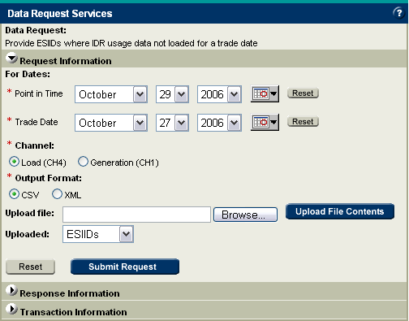

Required Inputs: The user is required to provide the point in time and the trade date in question. Both the point in time and trade date boxes will default to the most current dates available. Additionally, the user is required to specify the channel which will default to Load (CH4).

Optional Inputs: The user can narrow the search by uploading a list of 1,000 or less ESIIDs or UIDESIIDs.

Upload File: All Upload File fields are required and must be in upper case. The Upload File must be in CSV and formatted as follows:

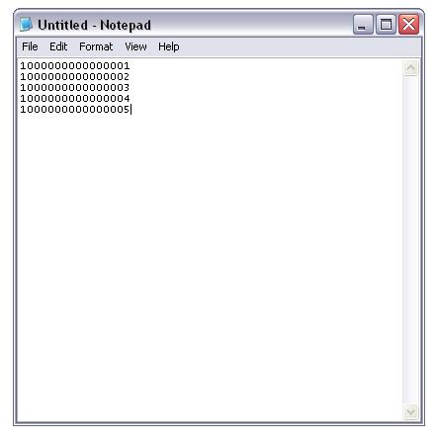

Output Types: This data request provides an output file which is a list of ESIIDs that do not have IDR usage data loaded for the trade date in question.

After choosing the output results and output format, click the “Submit” button to place the data request in the queue. A return screen will verify that the request has been submitted successfully and provide the user with an audit ID. The audit ID is similar to an order number and should be recorded to identify the data request going forward. Selecting the “Clear” button will reset the web form to its default settings.

Delivery: The output files will be posted to the TML for download. The turnaround time is less than three business days.

Example use of request:
- Determine usage data not loaded for a specific trade date for all ESIIDs owned
- Verify 867_03 cancelled usage data for ESIIDs for a specific trade date

